Supplementary materials
Appendix A
The HRNet model maintains a high-resolution representation of a branch throughout the network, reducing information loss during the resolution recovery process, and performs repeated feature fusion between multiple sub-networks of different resolutions connected in parallel to enhance the representation. However, in the HRNet structure, the fixed receptive field of standard convolution limits its ability to adapt to dynamic changes and complex shapes in the image. Especially in the face of non-rigid deformation and irregular objects in the image, it cannot capture enough contextual information. In addition, HRNet employs bilinear interpolation for the upscaling of feature maps to achieve the fusion of features at different scales, while ignoring the detailed information in low-resolution feature maps. Microscopic details in original features, such as edge sharpness, texture, etc., are often smoothed during the interpolation process, resulting in visual information weakened or lost in the enlarged feature map. Based on the HRNet structure, we introduce a multi-scale feature fusion (MFF) module and a spatial pyramid pooling (ASPP) module and develop a new semantic segmentation model DS-HRNet to improve the segmentation accuracy in complex street scenes. The MFF module employs deformable convolutions to learn the features of irregularly shaped targets, and to prevent loss of detailed information. Meanwhile the model utilizes deconvolution to restore the image resolution for further feature fusion process. The detailed structure of MFF is shown in Figure A1.
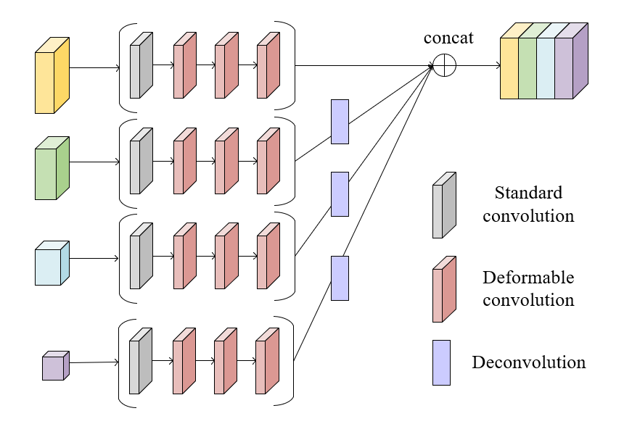
Figure A1 The structure of the MFF module
As shown in Figure B1, the MFF module has four branches, corresponding to the branches in the HRNet network. The starting layer of each branch uses a 3×3 standard convolution to perform preliminary feature extraction on the input feature map. To further improve the model's ability to identify irregularly shaped targets, three 3x3 deformable convolution units in series are introduced into each branch to enrich the diversity of the receptive field. Considering the processing needs of feature maps with different resolutions, each branch is configured with different channel numbers, namely 48, 96, 192 and 384, to ensure that the channel dimensions of each output layer are consistent with the input. In addition, each convolution unit is equipped with a BN layer and a ReLU activation function to enhance the network's nonlinear processing capabilities and the stability of training. The low-resolution layer is then upsampled via deconvolution. Finally, features of different resolutions are connected to achieve feature fusion.
To enhance the ability of the network to capture multi-scale features, we use the ASPP module in the fourth stage output layer of the HRNet network. The ASPP module applies dilated convolutions to expand the receptive field. By configuring multiple convolutions with different expansion rates in parallel, feature information from different scales can be effectively captured and fused, without imposing a substantial increment in computational demands or model parameter volume. The structure of the ASPP module is shown in Figure A2.
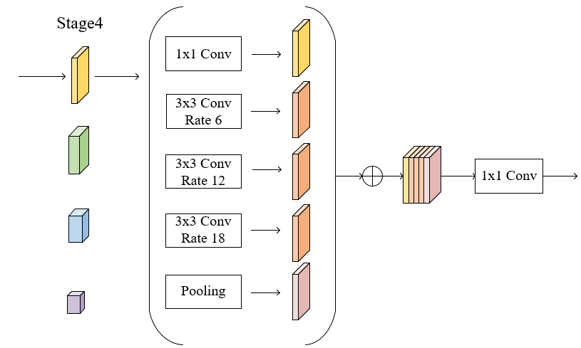
Figure A2 ASPP module
As shown in Figure B2, the ASPP module takes the feature map output by the fourth stage of HRNet as input and performs feature extraction through a 1×1 convolution, three 3 × 3 convolutions with different dilation rates (6, 12, and 18 respectively) and a global average pooling layer. Then, the output feature maps of these five parallel parts are added through an element-by-element sequence. And the number of channels is reduced through a 1×1 convolution. The integration of the ASPP module enables the model to effectively integrate context information at different scales and enhances the model's ability to identify targets at various scales.
Appendix B
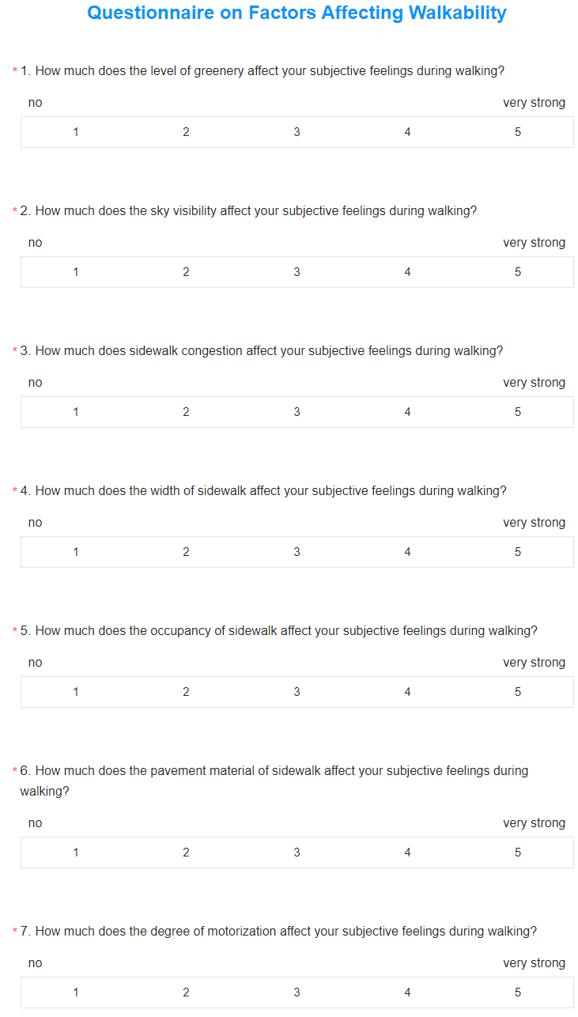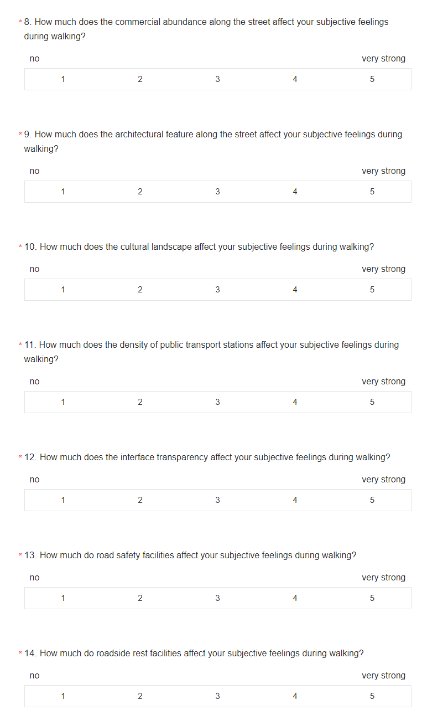

Appendix C
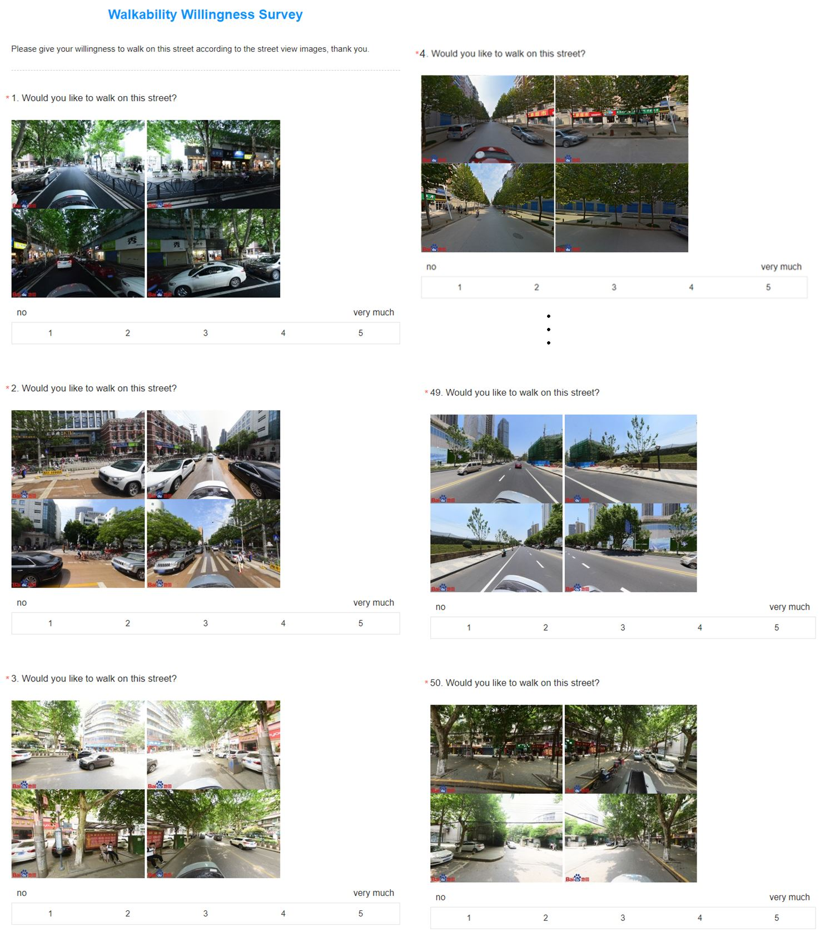

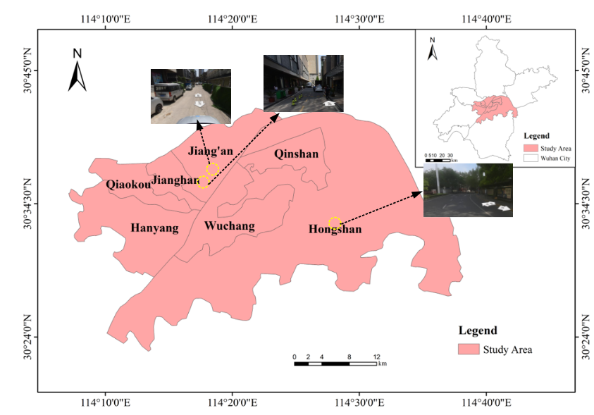
Figure S1 Study area

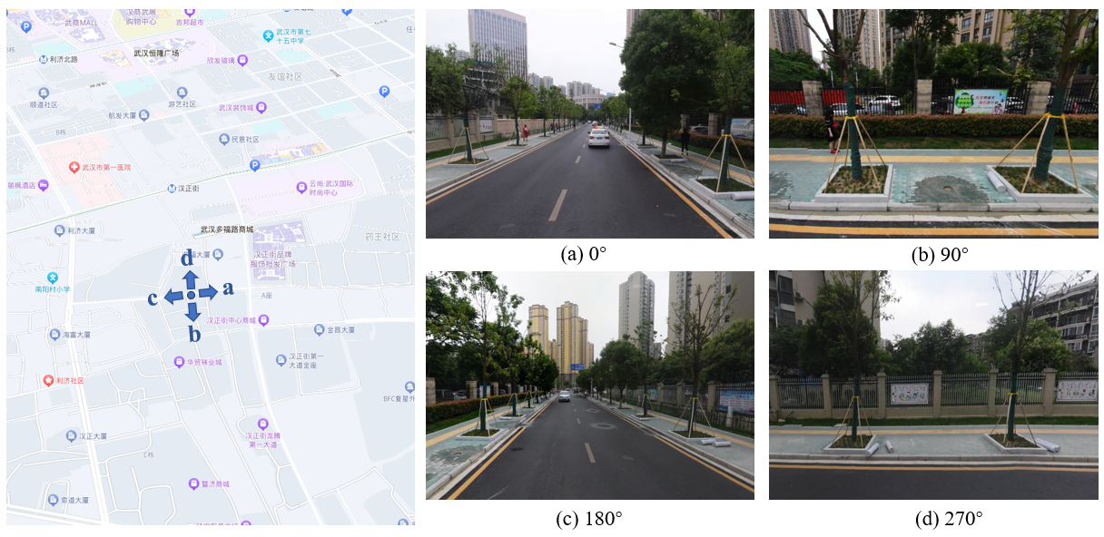
Figure S2 The example of street view from four directions at a sample point

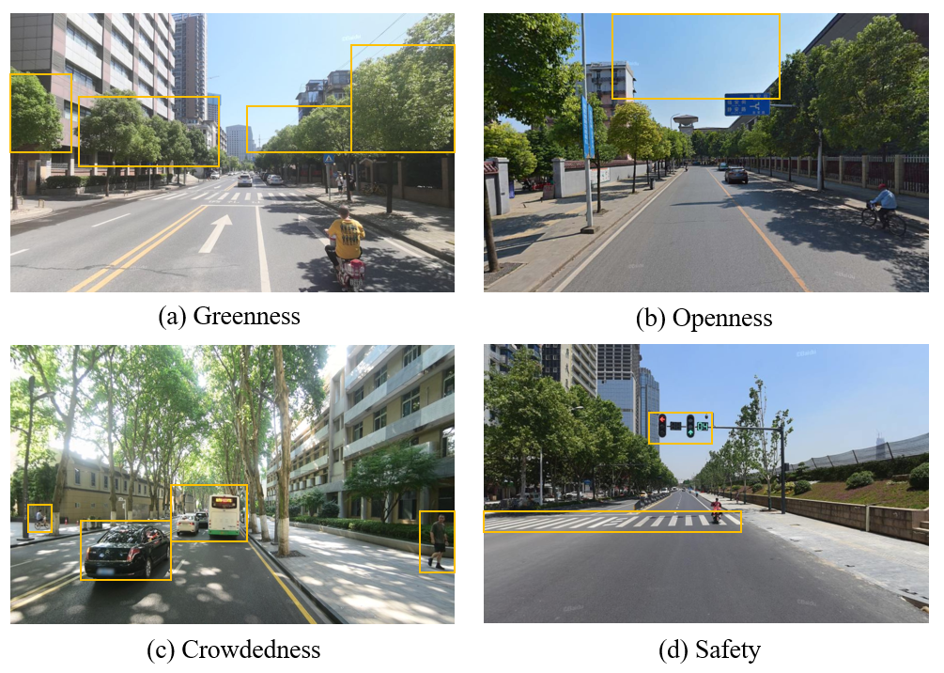
Figure S3 The example representing four aspects of Street View perception

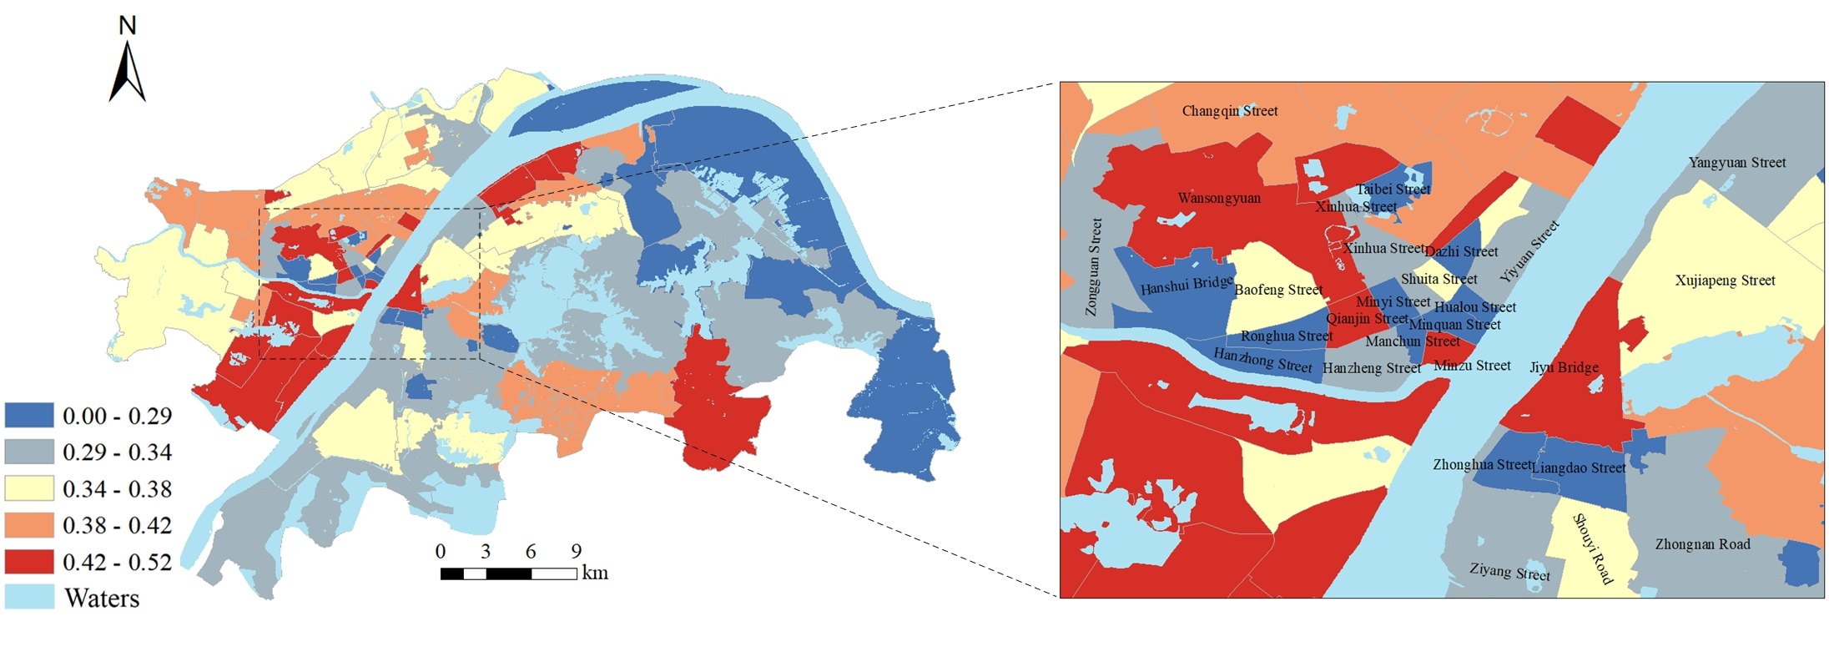
Figure S4 Spatial distribution and details of walkability at community scale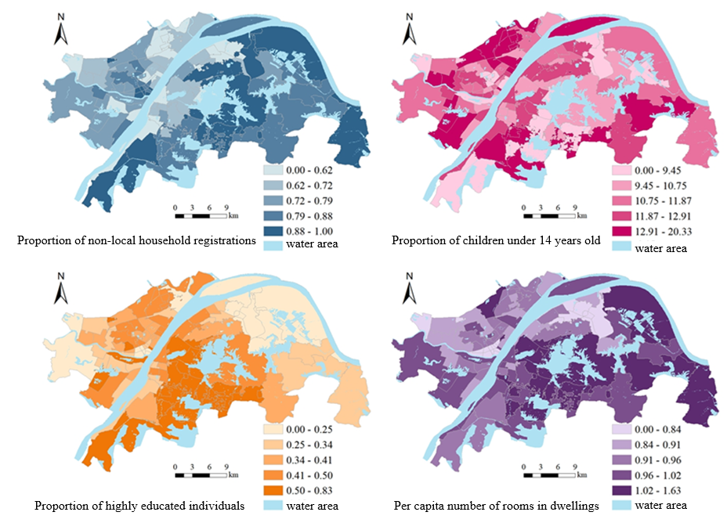
Figure S5 Spatial distribution of sociodemographic features

