Figure S1 Inferred secondary structures of tRNAs in the mt genome of An. hyrcanus (A) and An. messeae (B), with corresponding amino acids labeled next to the tRNAs.
A
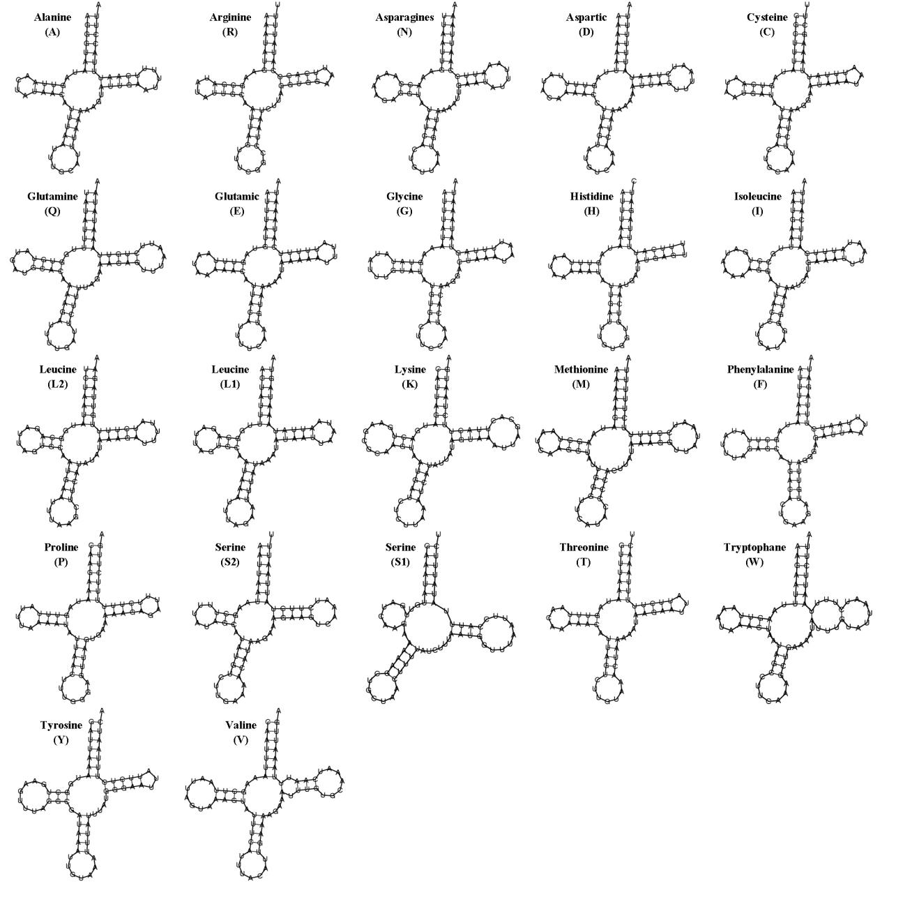

B
