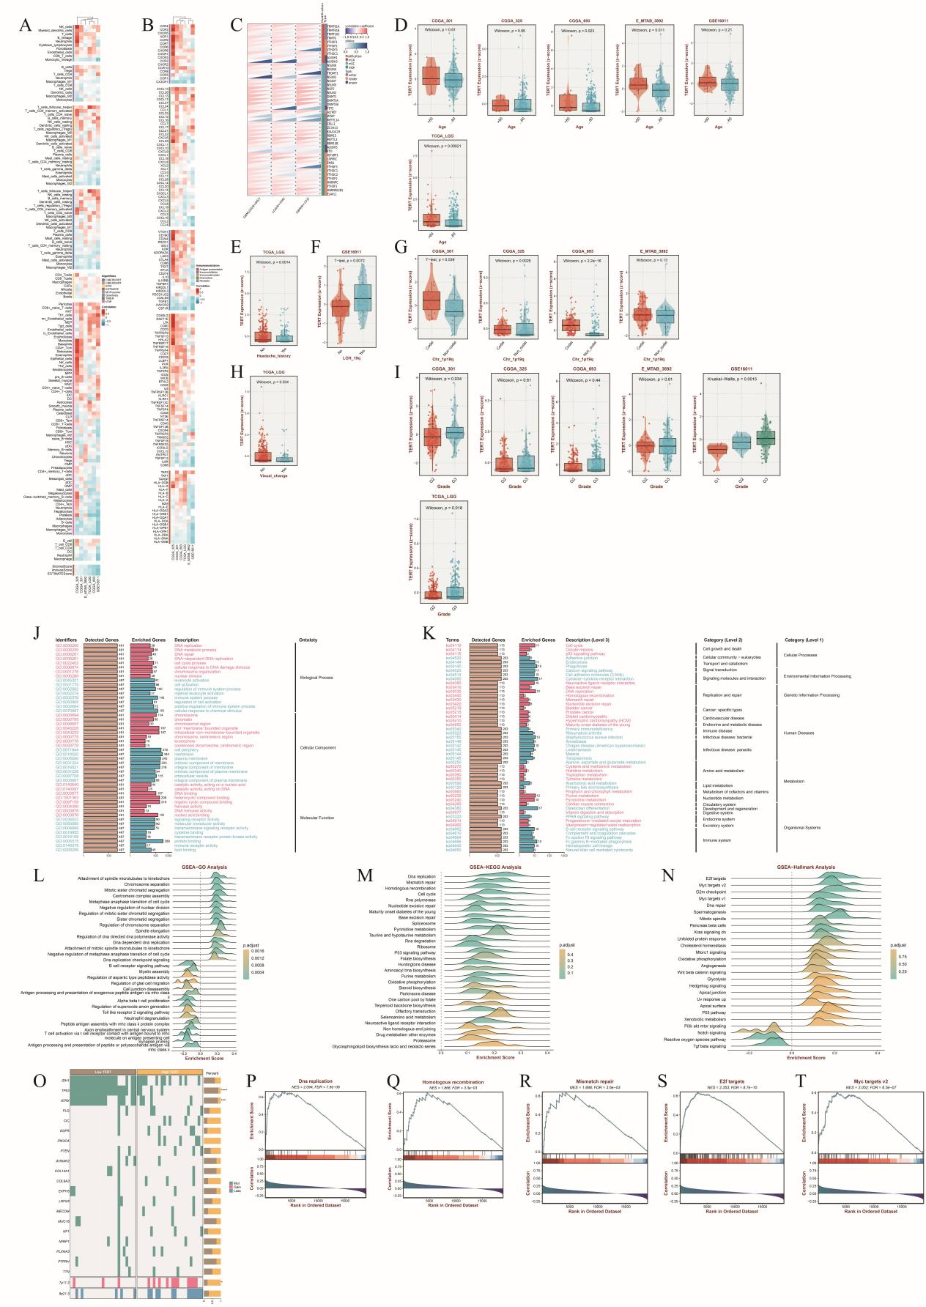
Figure S1. TERT Gene Expression in LGG Cohorts.
The expression of the TERT gene is associated with DNA repair and DNA replication processes.

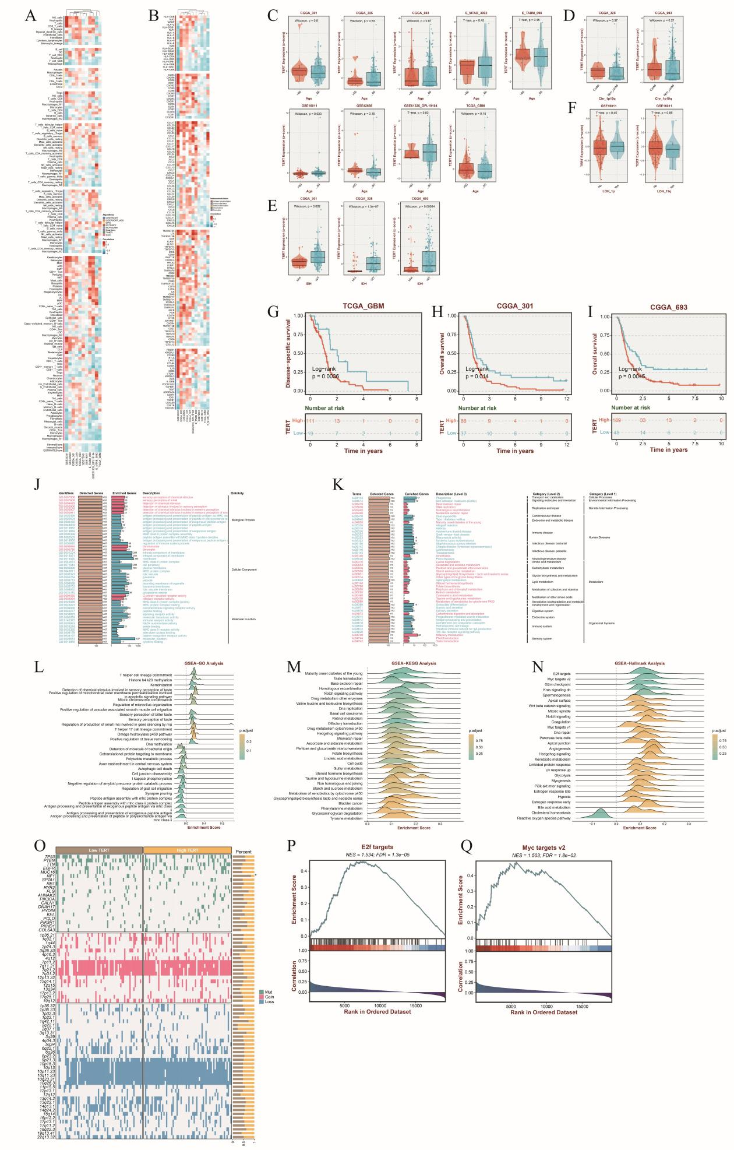
Figure S2. TERT Gene Expression in GBM Cohorts
Similar to LGG, TERT gene expression in GBM cohorts is also linked to DNA repair and DNA replication pathways.

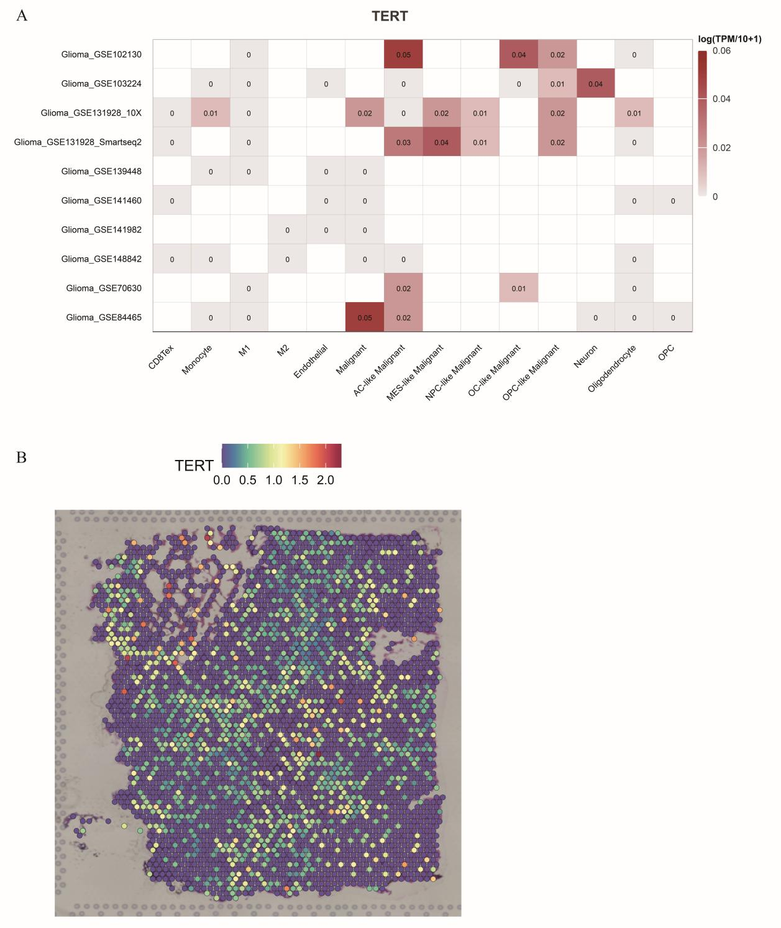
Figure S3. Localization of TERT Gene Expression at Single-Cell and Spatial Transcriptomic Levels.
The localization of TERT gene expression is examined at the single-cell level (using the TISCH2 database) and at the spatial transcriptomic level (via the SpatialTME database).

Table S1. Co-occurrence of CDKN2A, CDKN2B, and CDKN2B-AS1 Mutations in LGG and GBM

TCGA-LGG
A | B | Neither | A Not B | B Not A | Both | Log2 Odds Ratio | p-Value | q-Value | Tendency
CDKN2B | CDKN2B-AS1 | 455 | 0 | 0 | 56 | >3 | <0.001 | <0.001 | Co-occurrence
CDKN2A | CDKN2B | 453 | 2 | 1 | 55 | >3 | <0.001 | <0.001 | Co-occurrence
CDKN2A | CDKN2B-AS1 | 453 | 2 | 1 | 55 | >3 | <0.001 | <0.001 | Co-occurrence
TCGA-GBM
A | B | Neither | A Not B | B Not A | Both | Log2 Odds Ratio | p-Value | q-Value | Tendency
CDKN2B | CDKN2B-AS1 | 164 | 1 | 4 | 209 | >3 | <0.001 | <0.001 | Co-occurrence
CDKN2A | CDKN2B-AS1 | 158 | 7 | 1 | 212 | >3 | <0.001 | <0.001 | Co-occurrence
CDKN2A | CDKN2B | 159 | 9 | 0 | 210 | >3 | <0.001 | <0.001 | Co-occurrence
CPTAC Glioma
A | B | Neither | A Not B | B Not A | Both | Log2 Odds Ratio | p-Value | q-Value | Tendency
CDKN2B | CDKN2B-AS1 | 41 | 0 | 2 | 53 | >3 | <0.001 | <0.001 | Co-occurrence
CDKN2A | CDKN2B | 39 | 4 | 0 | 53 | >3 | <0.001 | <0.001 | Co-occurrence
CDKN2A | CDKN2B-AS1 | 38 | 3 | 1 | 54 | >3 | <0.001 | <0.001 | Co-occurrence

