Supplementary Material

Table S1. Sequences of primers and a probe used in this study.
Primer name | Sequence
SgfI-LHBs | 5’-AGT CGC GAT CGC CAT GGG GCA GAA TCT TTC C-3’
PmeI-LHBs | 5’-TGA CGT TTA AAC AAT GTA TAC CCA AAG ACA AAA G-3’
SgfI-HBc | 5’-AGT CGC GAT CGC CAT GGA CAT CGA CCC TTA TAA AG-3’
PmeI-HBc | 5’-AGT CGT TTA AAC ACA TTG AGG TTC CCG AGA-3’
HBV-S-Forward | 5’-ACT CAC CAA CCT CTT GTC CT-3’
HBV-S-Reverse | 5’-GAC AAA CGG GCA ACA TAC CT-3’
TaqMan probe | 5’-FAM-TAT CGC TGG ATG TGT CTG CGG CGT-TAMRA-3’
HBVF | 5’-GAC CAC CAA ATG CCC CTA T-3’
HBVR | 5’-CGA GAT TGA GAT CTT CTG CGA C-3’
PCP | 5'-GGGT CTG CGC ACC AGC ACC-3'
BC1 | 5'-GGA AAG AAG TCA GAA GGC AA-3'
PGP | 5'-CAC CTC TGC CTA ATC ATC-3'
GAPDH-F | 5'-GGG CGT CTT CAC CAC CTG GAG-3'
GAPDH-R | 5'-AAG TTG TCA TGG ATG ACC TTG GC-3'

Table S2. Z-scores in compounds in the primary screening.

Z-scores were obtained by subtracting the mean from the corresponding value in the data group and dividing by the standard deviation for the BRET ratio and cell viability.
Compound No. | BRET ratio | Cell viability |  | Compound No. | BRET ratio | Cell viability
1 | -1.007 | -0.980 |  | 21 | -3.170 | 0.374
2 | -2.703 | -0.494 |  | 22 | -3.323 | 0.525
3 | -3.061 | -0.971 |  | 23 | -3.410 | 0.423
4 | -2.750 | 0.065 |  | 24 | -3.699 | 0.575
5 | -2.858 | -0.513 |  | 25 | -3.608 | 0.976
6 | -2.902 | -0.616 |  | 26 | -3.752 | 0.339
7 | -2.349 | -0.183 |  | 27 | -3.494 | 0.869
8 | -2.603 | 0.342 |  | 28 | -3.189 | 0.519
9 | -2.673 | 0.213 |  | 29 | -2.888 | -0.278
10 | -3.083 | 0.566 |  | 30 | -2.948 | -0.249
11 | -2.905 | 1.114 |  | 31 | -2.692 | 0.261
12 | -2.650 | 0.496 |  | 32 | -2.896 | 0.380
13 | -2.690 | 0.996 |  | 33 | -2.637 | 0.518
14 | -1.885 | 0.675 |  | 34 | -1.706 | 0.221
15 | -3.224 | 0.214 |  | 35 | -2.864 | -0.303
16 | -1.239 | 0.689 |  | 36 | -2.800 | 1.073
17 | -2.270 | 0.360 |  | 37 | -2.244 | -0.351
18 | -3.167 | 0.203 |  | 38 | -2.685 | -0.428
19 | -2.706 | 0.788 |  | 39 | -2.765 | -0.227
20 | -3.546 | 1.945 |  | 40 | -2.754 | -0.425

Figure S1. NanoBRET assay using a mutant HBc.

It has been shown to have a reduced interaction with LHBs. Results of BRET ratios to assess the strength of the interaction between large hepatitis B surface (LHBs) and hepatitis B core (HBc) proteins are shown; wild-type (Wt) and mutant (L60A) plasmids were used for the HBc protein. * p<0.05.

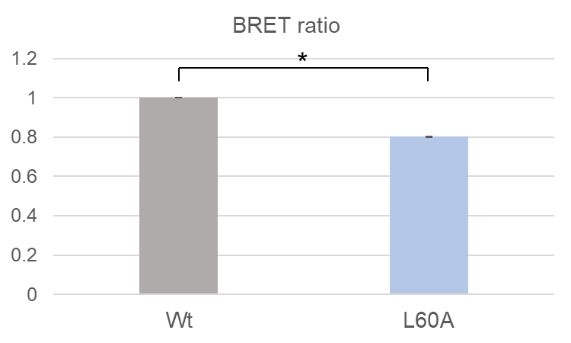

Figure S2. HBV DNA levels measured by RT-PCR in culture supernatants from the secondary screening before immunoprecipitation.

HBV-expressing HepG2.2.15.7 cells were treated with 40 compounds (10 µM) and the levels of HBV DNA in the culture supernatant without immunoprecipitation were quantified (n = 3). Green dots indicate cell viability.

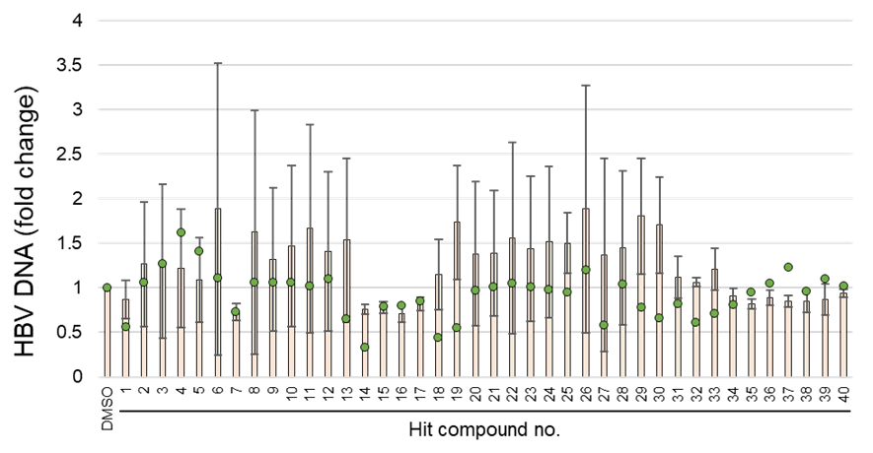

Figure S3. Dose dependent effects on HBV with a control compound.

HepG2.2.15.7 cells were treated with (A) entecavir (ETV) at doses of 0.0003 µM, 0.001 µM, 0.003 µM, 0.01 µM, 0.03 µM, 0.1 µM, 0.3 µM, and (B) a capsid assembly modulator NVR 3-778 at doses of 0.03 µM, 0.1 µM, 0.3 µM, 1 µM, 3 µM, 10 µM, and 30 µM. The levels of HBV DNA after the immunoprecipitation and the levels of cell viability are shown (n = 3). Based on these results, 50% inhibitory concentration (IC50) and 50% cytotoxic concentration (CC50) were calculated.
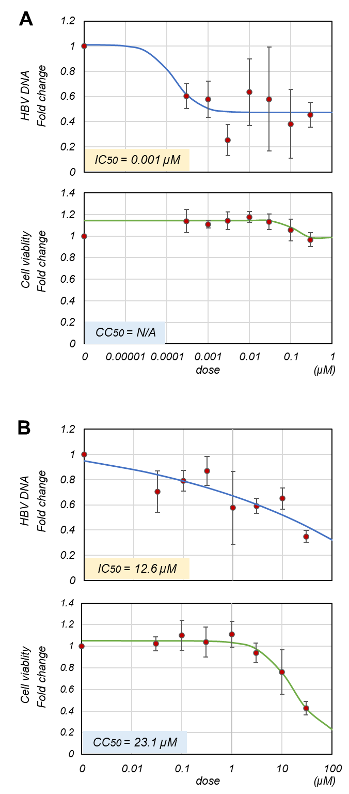

Figure S4. Images of whole membranes for western blot analysis in Fig. 6A.

