Supplementary Figures

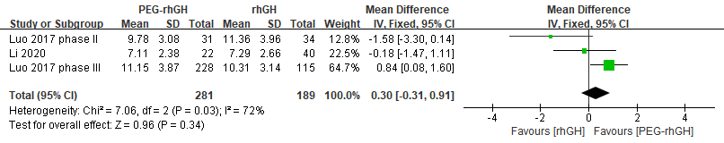
Figure S1. Meta-analysis results of ∆HV (cm/y) for RCTs after 6 months.

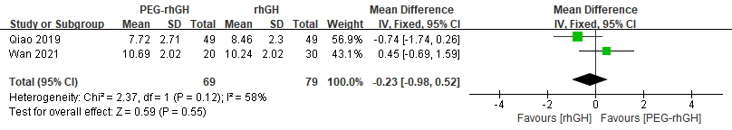
Figure S2. Meta-analysis results of ∆HV (cm/y) for cohort studies after 6 months.

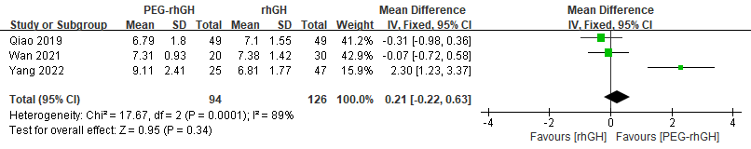
Figure S3. Meta-analysis results of ∆HV (cm/y) for cohort studies after 12 months.

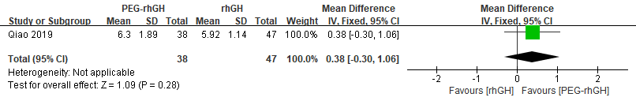
Figure S4. Meta-analysis results of ∆HV (cm/y) for cohort studies after 24 months.

