Supplementary file: Application of image guided analyses to monitor fecal microbial composition and diversity in a human cohort
Short title: Smartphone Microbiome Evaluation and Analysis in Rapid time
Konstantina Zafeiropoulou^{1,2,3$}, Bas Voermans^{3$}, Huy Ngo³, Javier Moreno³, Donghyeok Lee³,
Joep P. M. Derikx², Misha Luyer^{5,6}, Aeilko H. Zwinderman⁷, Max Nieuwdorp⁴, Marcus de Goffau^{1,3,4,8}, Wouter J. de Jonge^{1,9}, Evgeni Levin^{3,*}
¹ Tytgat Institute for Liver and Intestinal Research, Amsterdam Gastroenterology Endocrinology and Metabolism, Amsterdam University Medical Centers, University of Amsterdam, Amsterdam, The Netherlands
² Department of Pediatric Surgery, Emma Children's Hospital, Amsterdam University Medical Centers, University of Amsterdam, Amsterdam, The Netherlands
³ HORAIZON Technology BV, Delft, The Netherlands
⁴ Department of Internal and Vascular Medicine, Amsterdam University Medical Centers, University of Amsterdam, Amsterdam, the Netherlands
⁵ Department of Surgery, Catharina Hospital, Eindhoven, The Netherlands
⁶ Department of Electrical Engineering, University of Technology Eindhoven, Eindhoven, The Netherlands
⁷ Department of Clinical Epidemiology and Biostatistics, Amsterdam University Medical Centers, Amsterdam, The Netherlands
⁸ Wellcome Sanger Institute, Cambridge, United Kingdom
⁹ Department of General, Visceral-, Thoracic and Vascular Surgery, University Hospital Bonn, Bonn, Germany
$ Authors share co-first authorship
*Corresponding author
Evgeni Levin
HORAIZON Technology BV, Delft, The Netherlands
Tel: 0031 657 909 802
Email: evgeni.levin@horaizon.nl
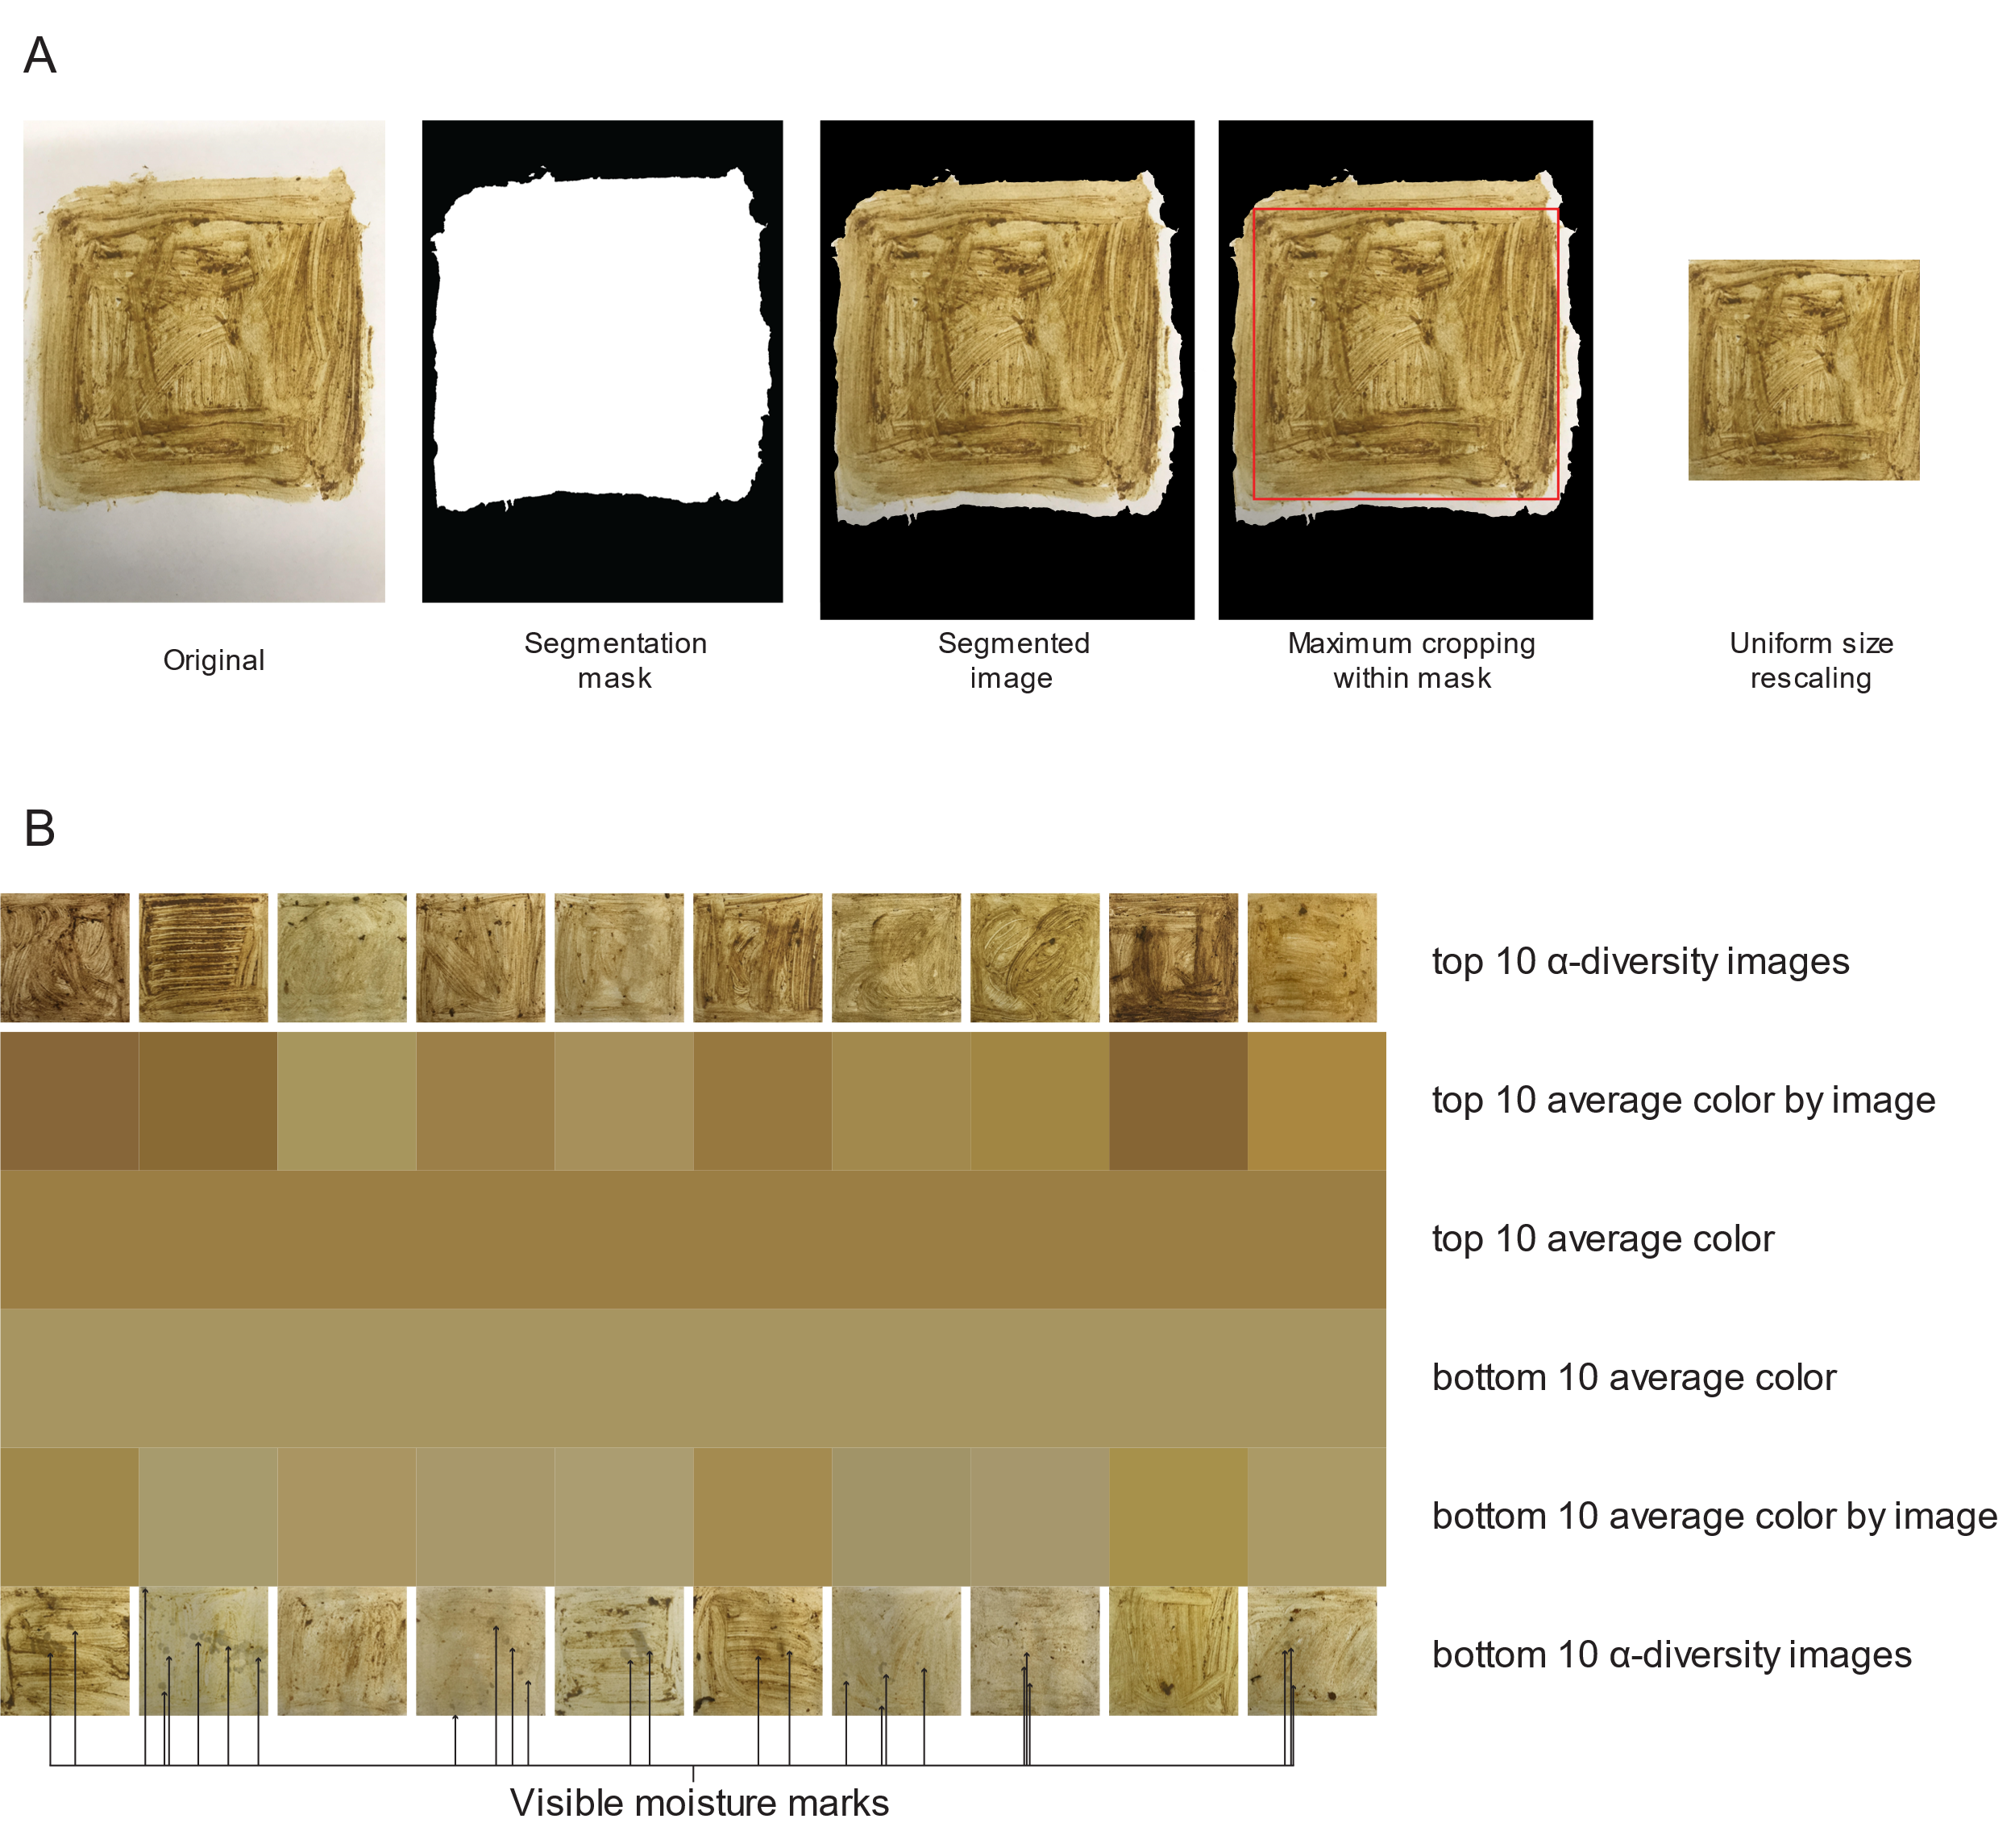
Supplementary Figure 1. Raw and processed fecal smear images. A, Example of the segmentation pipeline used to extract uniform images containing no background from the original fecal smear images. B, Images of the ten highest and lowest ɑ-diversity samples. Average color values per image and as an aggregate for high and low are shown. As can be seen, high diversity samples have darker average colors. In addition, 8 out of 10 low diversity samples show moisture marks where moisture has stained the paper, while none of the high diversity samples do.

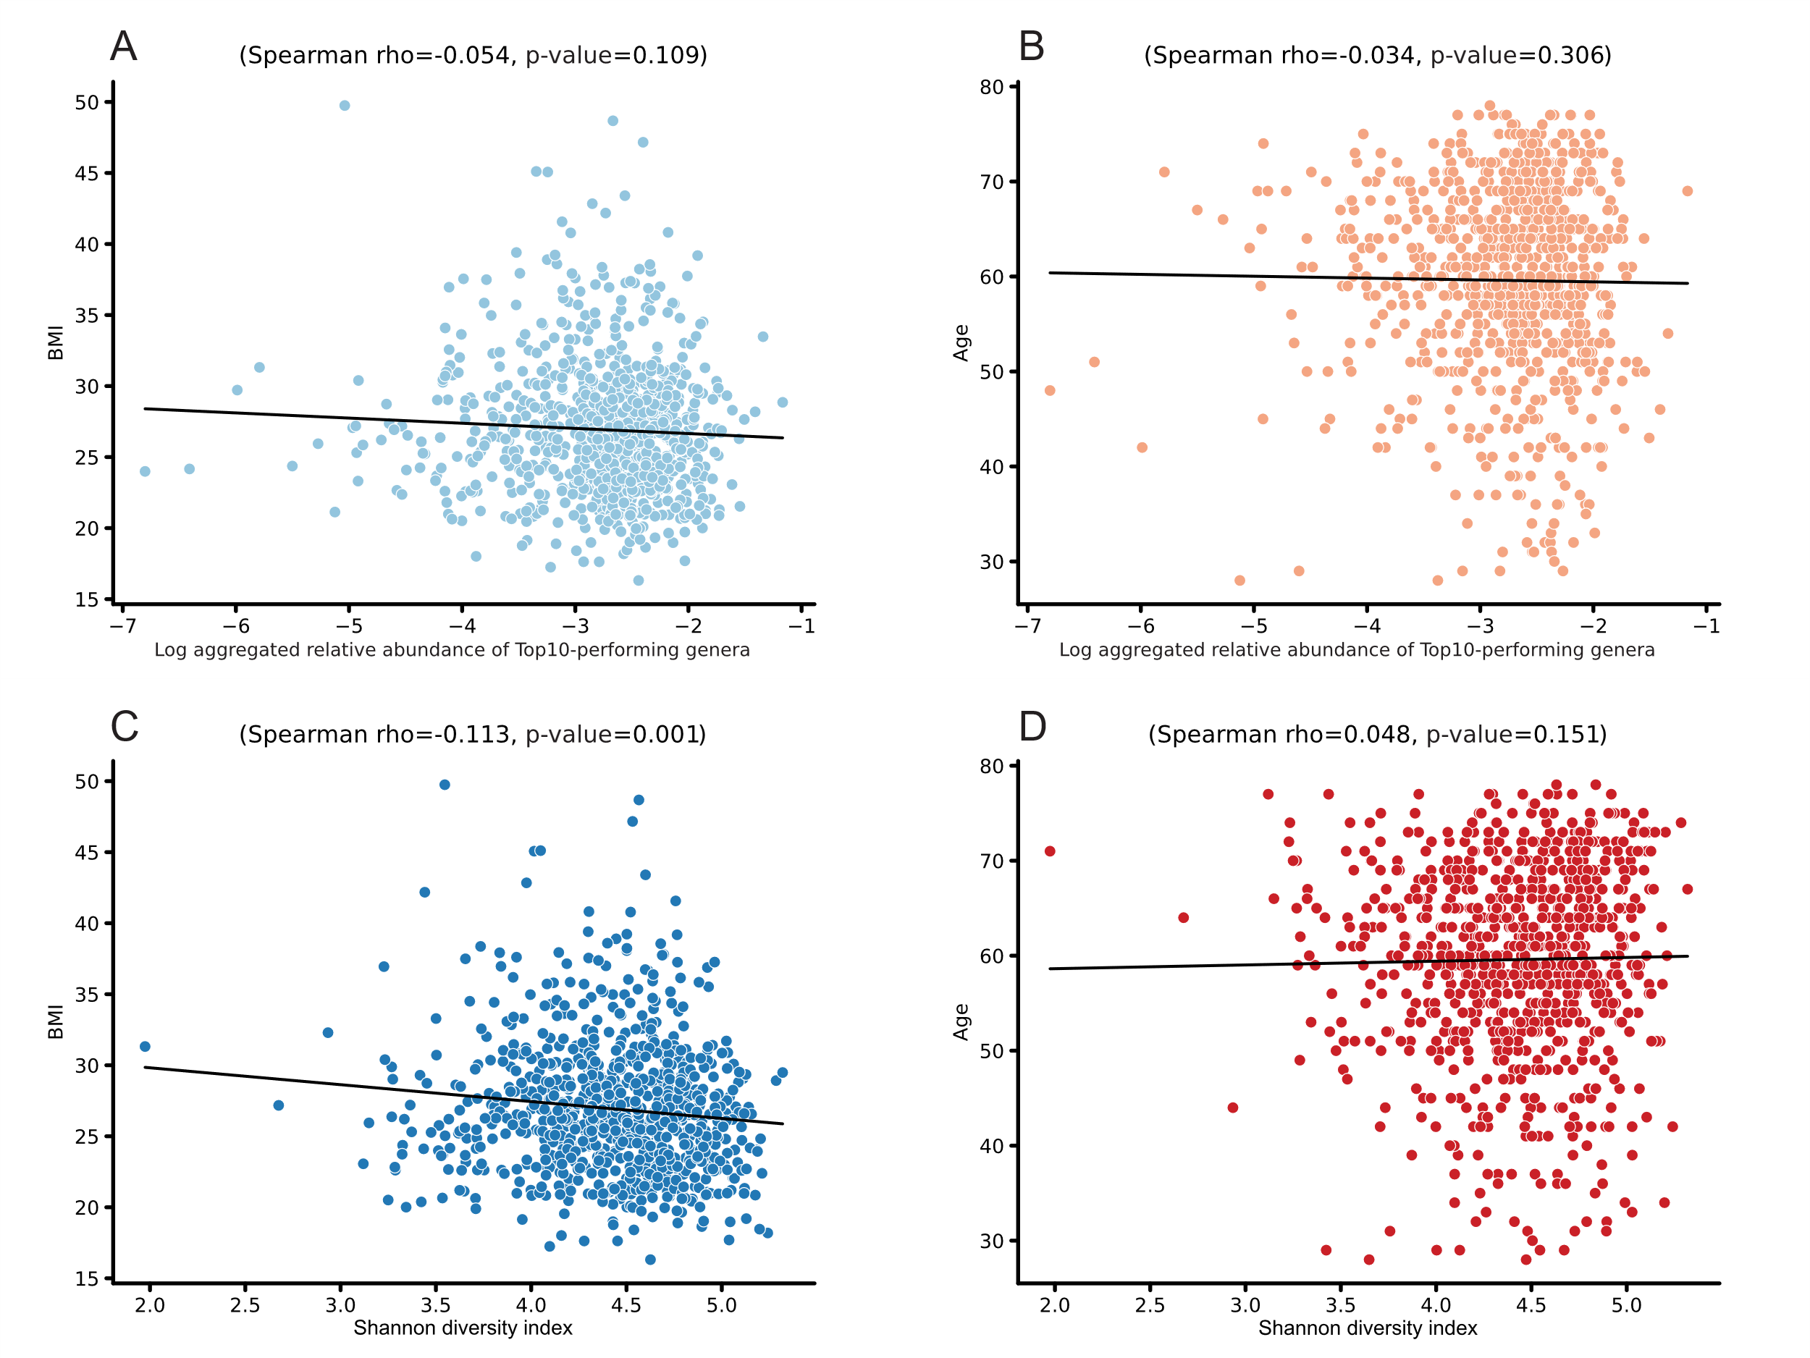
Supplementary Figure 2. A, Scatterplot of the log-scaled aggregated relative abundance of the Top10-performing genera versus BMI. B, Scatterplot of the log-scaled aggregated relative abundance of the Top10-performing genera versus age. C, Scatterplot of Shannon-index versus BMI the Spearman rho correlation coefficient between BMI and Shannon-index was shown to be significant (Spearman rho = -0.113, p-value < 0.001). D, Scatterplot of Shannon-index versus age.

