Supplementary Material
Figure Captions
Figure S1. Overall workflow of the study.
Figure S2. PI3K-AKT signalling pathway generated from the KEGG mapper database. Key targets along the pathway are marked in red text to emphasise their importance⁴⁷.
Figure S3. Validation of key genes in an external dataset. (A) Heatmap of 9 hub genes from the TCGA-PRAD dataset. Non-cancerous prostate tissue samples (normal) are shown on the left, and PCa samples are on the right of the black bar. (B) Overall survival and disease-free survival analysis of TP53 gene. (C) Promoter methylation status of PIK3CA gene in prostate cancer (UALCAN). (D) (i) cBioPortal "oncoprint" representation of alterations in 9 hub genes identified in prostate cancer. (ii) Genetic alterations frequency of hub targets in prostate cancer patients. (E) Distribution of (i) EGFR and (ii) HIF1A among different immune subtypes. NOTE: C1: wound healing, C2: IFN- dominant, C3: inflammatory, and C4: lymphocyte depleted. (F) Immunohistochemistry of four (AKT1, CTNNB1, EGFR, PIK3CA) genes from the HPA. Representative images showing the expression of each gene in PRAD tissues versus normal prostate tissues. (G) Correlation between hub genes and immune cell infiltration (TIMER).

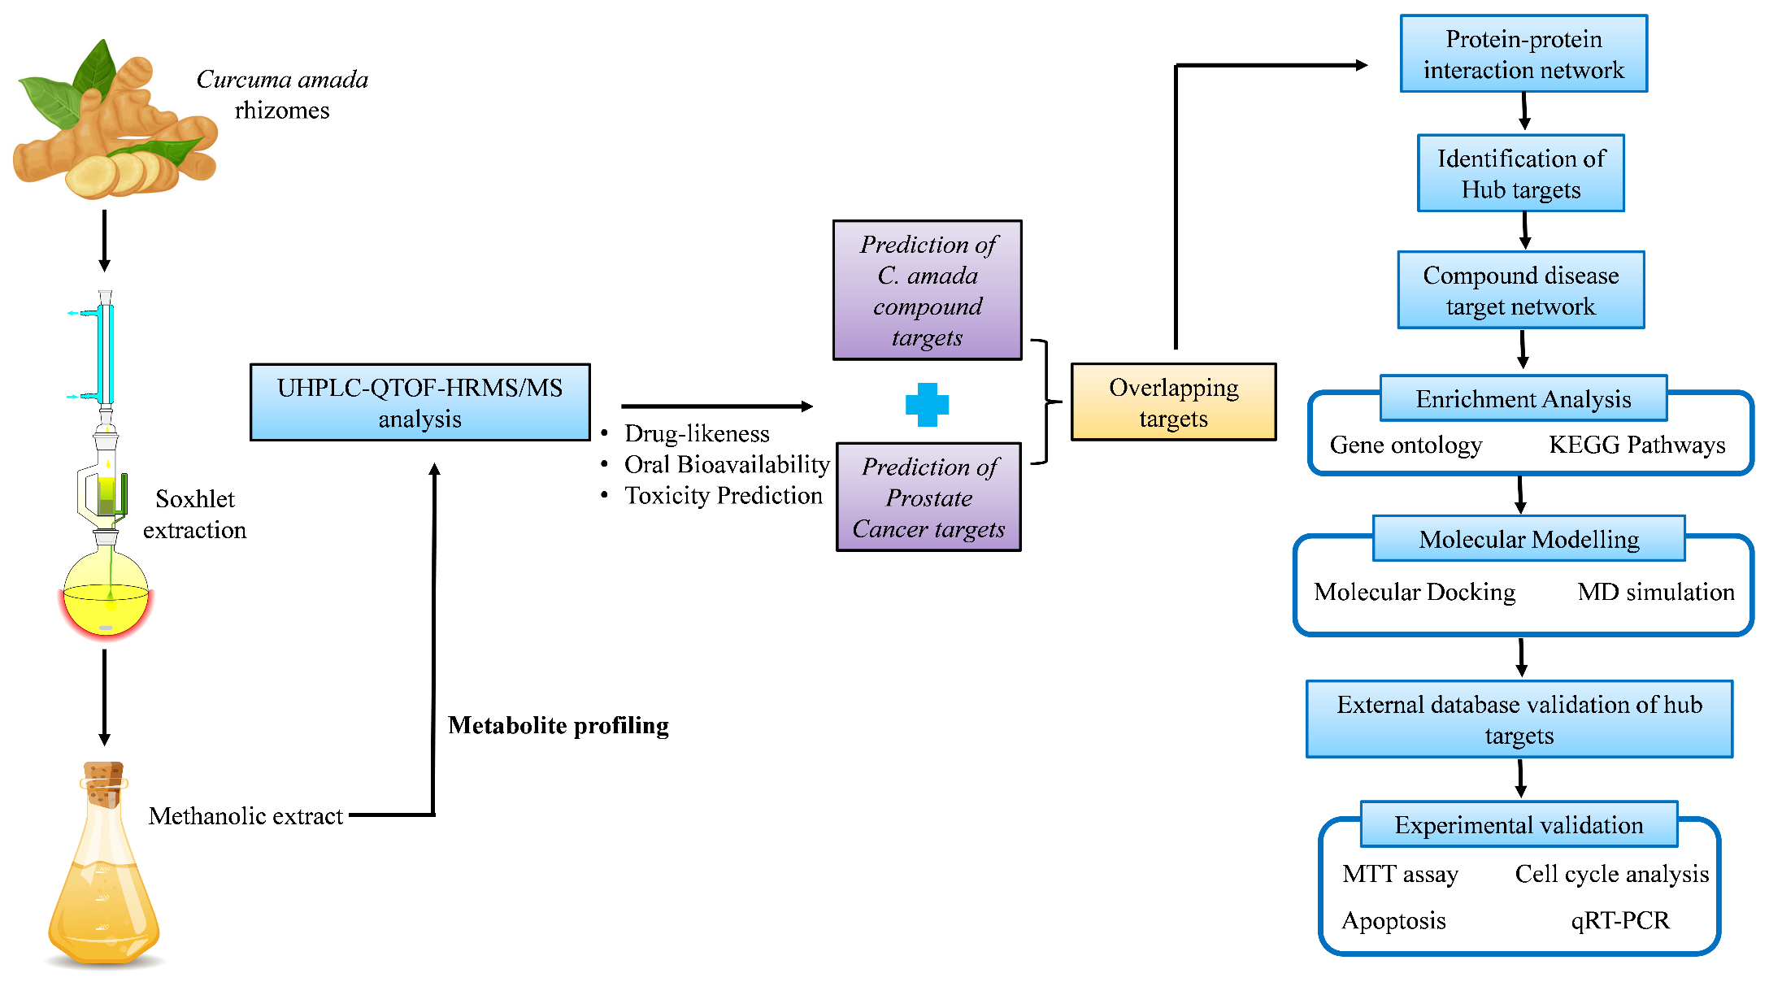
Figure S1.

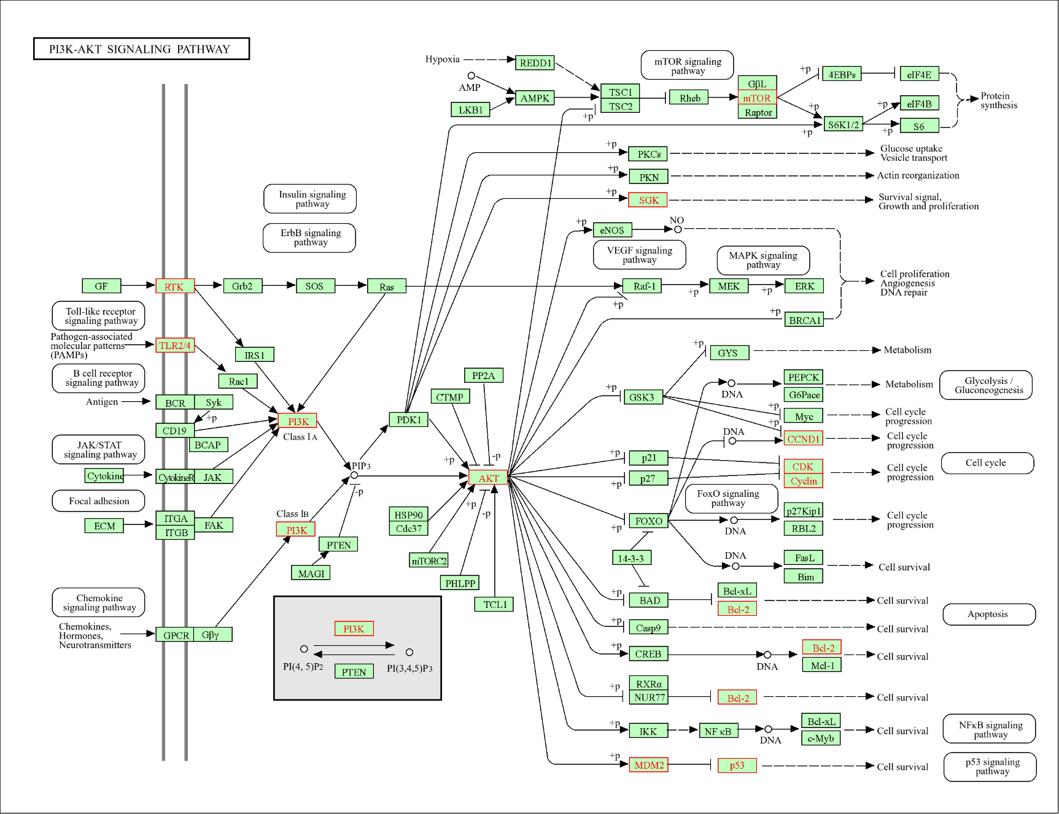
Figure S2.
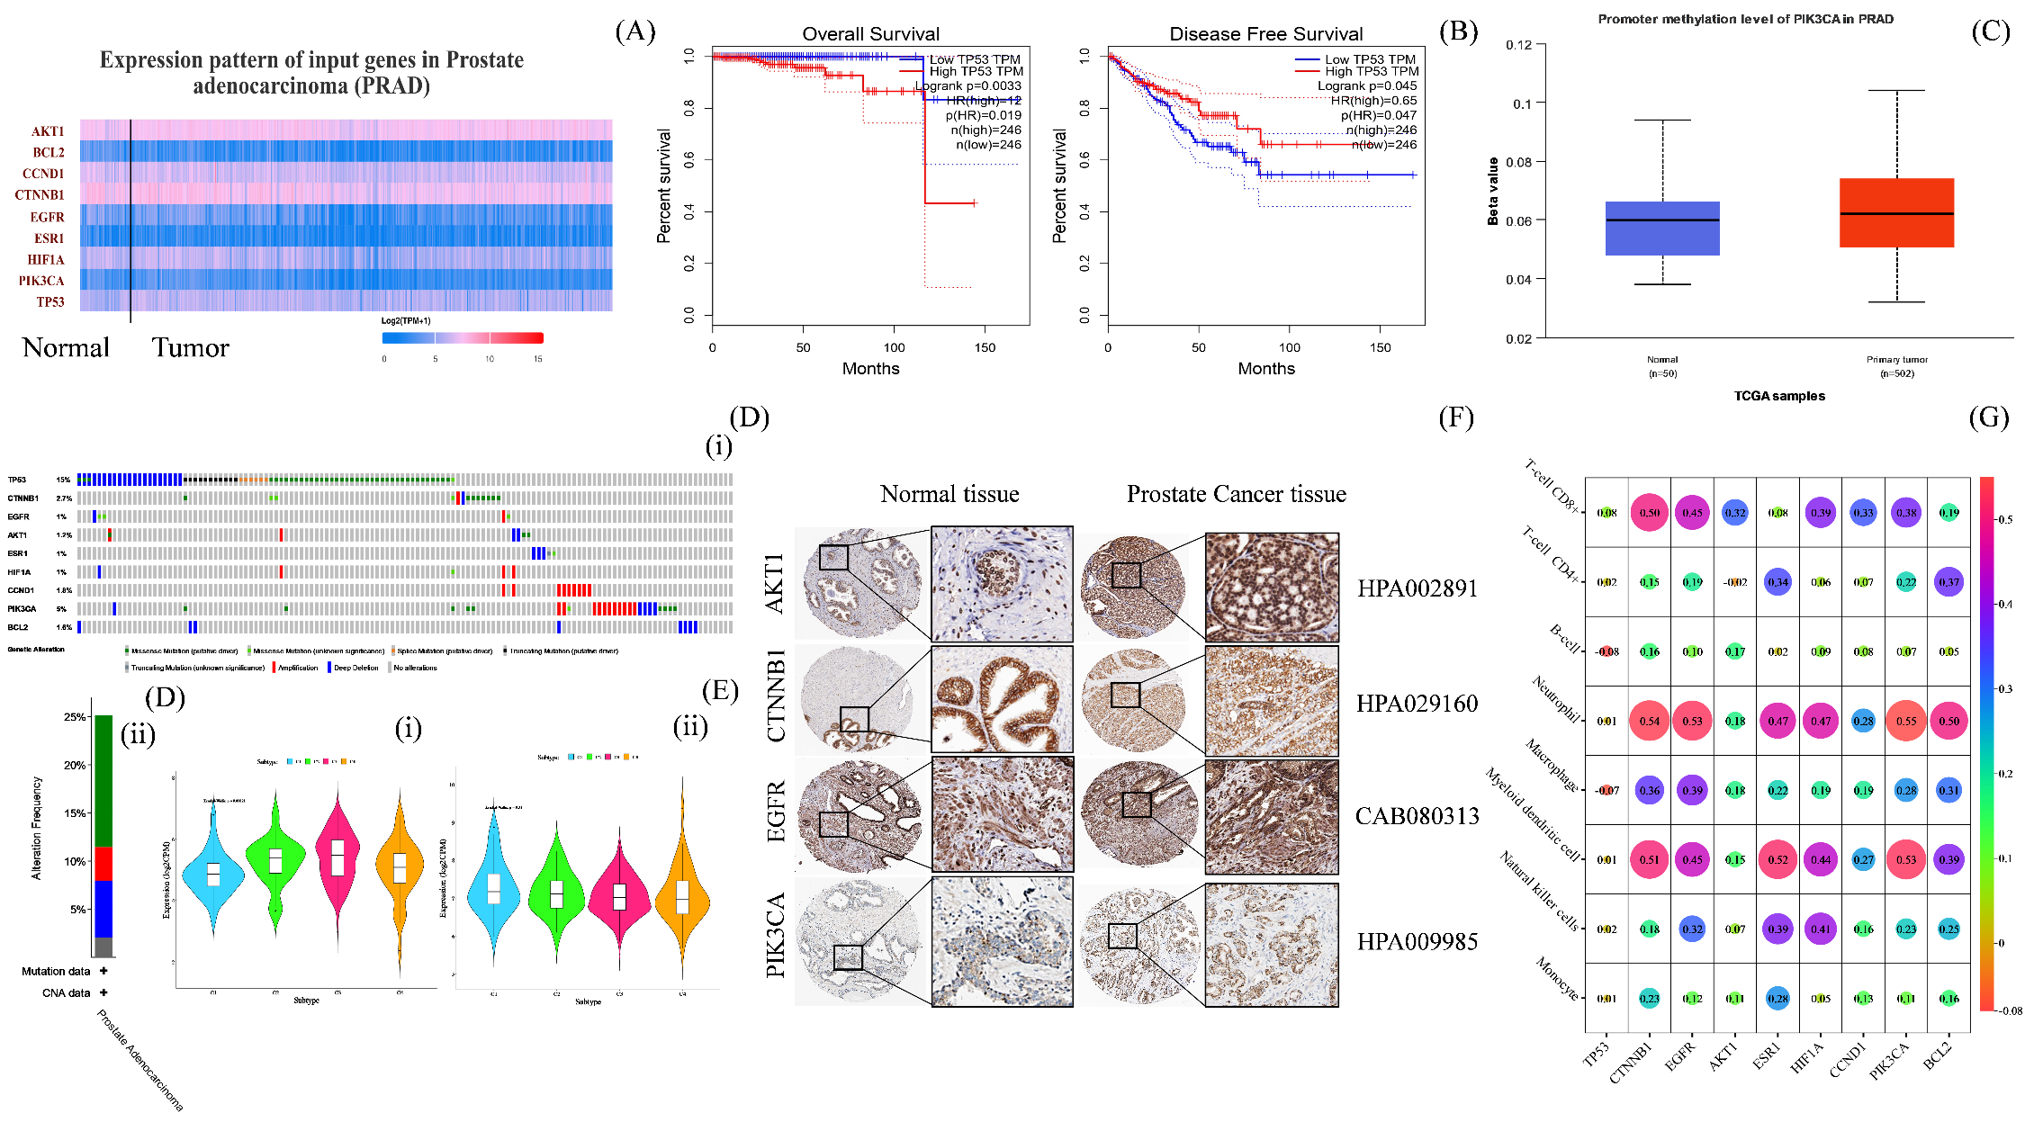
Figure S3.

