IL-37 ameliorates acetaminophen-induced acute liver injury by limiting MAPK/NF-κB signalling-mediated liver inflammation.

Juan Fu^{1,2†}, Qiuhong Huang^{1†}, Changfeng Sun², Shuyi Li¹, Qingsong Wang¹, Yunjian Sheng²*, Binfeng He¹*, Zaichun You¹*
¹Department of General Medicine, Xinqiao Hospital, Third Military Medical University, Chongqing 400037, China
²Department of Infectious Diseases, The Affiliated Hospital of Southwest Medical University, Luzhou 646000, China

* Corresponding author.
Binfeng He, Department of General Practice, Xinqiao Hospital, Third Military Medical University (Army Medical University), Chongqing 400037, China
Email: ldhbf@tmmu.edu.cn
Zaichun You, Department of General Practice, Xinqiao Hospital, Third Military Medical University (Army Medical University), Chongqing 400037, China
Email: youzaichun619@163.com
Yunjian Sheng, Department of Infectious Diseases, The Affiliated Hospital of Southwest Medical University
Email: sheng200410@163.com.
†These authors contributed equally to this work

Supplement Table 1. Primer sequence
Primer name |  | Primer sequence (5'-3')
CYP2E1 | Forward | AGGCTGTCAAGGAGGTGCTACT
CYP2E1 | Reverse | AAAACCTCCGCACGTCCTTCCA
GAPDH | Forward | CCTCGTCCCGTAGACAAAATG
GAPDH | Reverse | TGAGGTCAATGAAGGGGTCGT
IL-6 | Forward | GCCACTTGTAGTTTCTTGCC
IL-6 | Reverse | GTTCCCTTCCTAGACCTCCT
IL-8 | Forward | CACCTCAAGAACATCCAGAGCT
IL-8 | Reverse | CAAGCAGAACTGAACTACCATCG
IL-10 | Forward | AAGTTTCCAATAAGGCTCCA
IL-10 | Reverse | GACCTCCATACCAGTTCCAG
TGF-β1 | Forward | CTTCAGCTCCACAGAGAAGAACTGC
TGF-β1 | Reverse | CACGATCATGTTGGACAACTGCTCC
TNF-α | Forward | ATGAGCACAGAAAGCATGATC
TNF-α | Reverse | TACAGGCTTGTCACTCGAATT
GAPDH | Forward | CCTTCATTGACCTCAACTACATGGT
GAPDH | Reverse | TCATTGTCATACCAGGAAATGAGCT

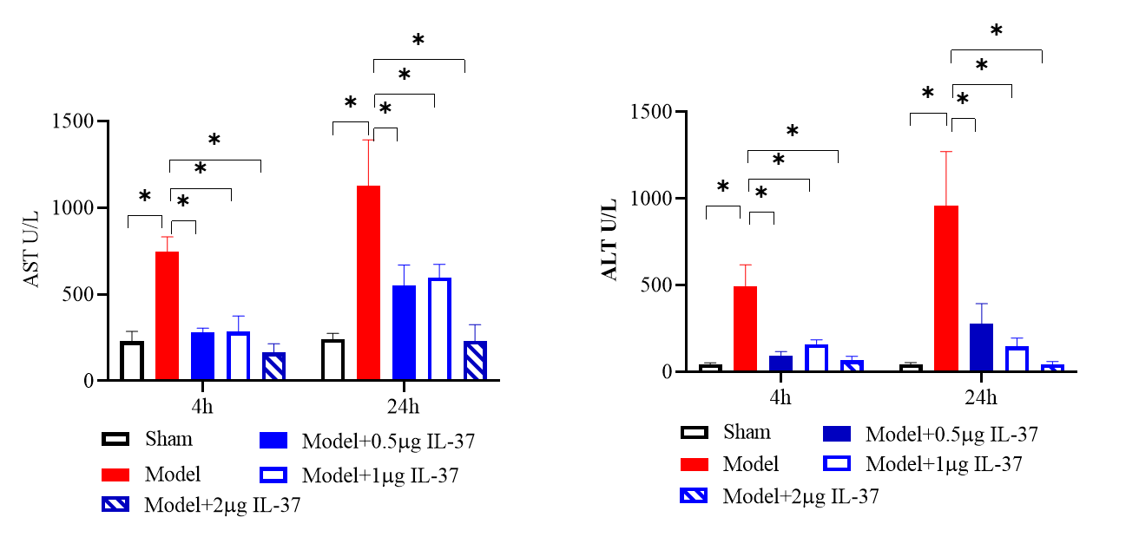
Supplement Figure 1. The differences in serum alanine aminotransferase (ALT) and aspartate aminotransferase (AST) levels among the sham group, model group, model groups treated with different doses of IL-37 (0.5 μg, 1.0 μg, 2.0 μg), and the sham+ IL-37 group in mice at 4 hours and 24 hours after treatment.

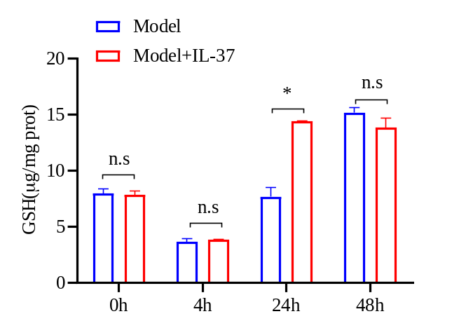
Supplement Figure 2. The level of GSH in liver tissue homogenate suspension was analyzed at 0,4 ,24 and 48hours after exposure to APAP and IL-37.

