Retrospective Study of Onychomycosis Patients Treated with Ciclopirox 8% HPCH and Oral Antifungals Applying Artificial Intelligence to Electronic Health Records
Gastón Roustan ¹, José Luis López Estébaranz ², Pablo De La Cueva ³, Savana Research Group ⁴, Francesca Pajuelo ⁵, María Luisa Tamarit ⁶, Aida Valmaseda ⁷, and Jordi Galván ^{7,}*
¹ Dermatology Department, Hospital Puerta de Hierro Majadahonda, Madrid, Spain; groustan@gmail.com.
² Dermatology Department, Hospital Universitario Fundación Alcorcón, Madrid, Spain; jlestebaranz@salud.madrid.org.
³ Dermatology Department, Hospital Universitario Infanta Leonor, Madrid, Spain; pdelacueva@yahoo.com.
⁴ Savana Research S.L., Madrid, Spain. mposso@savanamed.com
⁵ Almirall S.A., Medical Affairs Department, Barcelona, Spain. francesca.pajuelo@almirall.com
⁶ Almirall S.A., Research and Development Center, Sant Feliu de Llobregat, Barcelona, Spain. marialuisa.tamarit@almirall.com
⁷ Almirall S.A., Global Medical Affairs Department, Barcelona, Spain aida.valmasedafreixa@almirall.com & jordi.galvan@almirall.com

*Correspondence: jordi.galvan@almirall.com.

Supplementary Table 1. Sensitivity analysis regarding sociodemographic characteristics, comorbidities, and risk factors at the index date of the subpopulation of patients having the mention of culture as diagnostic method
 | Subpopulation, N = 231 | Study population, N = 408
Gender, n (%)
Female | 126 (54.5) | 222 (54.4)
Male | 105 (45.5) | 186 (45.6)
Age
Mean (SD) | 50.61 (14.22) | 51.1 (14.8)
Body Mass Index
Mean (SD) | 28.20 (5.30) | 27.9 (5.3)
Smoking habit, n (%)
Current smoker | 25 (10.8) | 42 (10.3)
Never and non-smoker | 27 (11.7) | 47 (11.5)
Missing | 179 (77.5) | 319 (78.2)
Alcohol habit, n (%)
Current alcohol users | 3 (1.3) | 4 (1.0)
Never and non-alcohol users | 3 (1.3) | 6 (1.5)
Missing | 225 (97.4) | 398 (97.5)
Comorbidities, n (%)
Dermatological
Tinea pedis interdigitalis | 28 (12.1) | 50 (12.3)
Psoriasis | 14 (6.1) | 22 (5.4)
Nail psoriasis | 3 (1.3) | 3 (0.7)
Vitiligo | 1 (0.4) | 2 (0.5)
Other comorbidities
Hypertension | 41 (17.7) | 71 (17.4)
Dyslipidemia | 40 (17.3) | 59 (14.5)
Obesity, BMI > 29.9 kg/m² | 30 (13.0) | 49 (12.0)
Diabetes mellitus | 22 (9.5) | 36 (8.8)
Hypothyroidism | 18 (7.8) | 21 (5.1)
Chronic renal disease | 8 (3.5) | 13 (3.2)
Ischemic heart disease | 5 (2.2) | 6 (1.5)
Solid cancer | 3 (1.3) | 6 (1.5)
Without any of the previous detected comorbidities | 123 (53.2) | 211 (51.7)
Risk factors for onychomycosis, n (%)
Repeated nail trauma | 22 (9.5) | 29 (7.1)
Chemotherapy | 3 (1.3) | 8 (2.0)
Hallux valgus | 2 (0.9) | 4 (1.0)
Hyperhidrosis | 1 (0.4) | 2 (0.5)
Renal transplant | 1 (0.4) | 1 (0.2)
Without any of the previous detected risk factors | 203 (87.9) | 366 (89.7)
SD: standard deviation, BMI: body mass index. Age at index and gender were examined without a window. All other variables were analyzed as the closest value at index with a window of Index [-6mo,]. Body Mass Index was calculated from weight and height reports as well as directly extracted from patients Electronic Health Records (EHRs).

Supplementary Table 2. Sensitivity analysis regarding clinical characteristics, diagnostic tests, and causative pathogens at the index date of the subpopulation of patients having the mention of culture as diagnostic method
 | Subpopulation, N = 231 | Study population, N = 408
Clinical signs and symptoms, n (%)
Subungual hyperkeratosis | 75 (32.5) | 107 (26.2)
Onycholysis | 48 (20.8) | 76 (18.6)
Nail discoloration | 13 (5.6) | 19 (4.7)
Leukonychia | 12 (5.2) | 18 (4.4)
Dermatophytoma | 3 (1.3) | 7 (1.7)
Without any of the previously described signs and symptoms | 118 (51.1) | 229 (56.1)
Diagnostic method, n (%)
Fungal culture | 231 (100.0) | 231 (56.6)
Dermatophyte test strip | 27 (11.7) | 54 (13.2)
Skin biopsy | 4 (1.7) | 6 (1.5)
Onychoscopy dermatoscopy | 1 (0.4) | 1 (0.2)
Without any of the previously described diagnostic methods | 0 (0.0) | 148 (36.3)
Causative pathogens, n (%)
Dermatophytes
Trichophyton rubrum | 109 (47.2) | 138 (33.8)
Trichophyton interdigitale mentagrophytes | 7 (3.0) | 10 (2.5)
Trichophyton tonsurans | 0 (0.0) | 4 (1.0)
Epidermophyton floccosum | 1 (0.4) | 1 (0.2)
Yeasts
Candida albicans | 4 (1.7) | 8 (2.0)
Candida parapsilosis | 3 (1.3) | 6 (1.5)
Trichosporon spp. | 2 (0.9) | 2 (0.5)
Moulds
Aspergillus spp. | 3 (1.3) | 6 (1.5)
Acremonium | 3 (1.3) | 5 (1.2)
Fusarium spp. | 2 (0.9) | 3 (0.7)
Alternaria alternate | 1 (0.4) | 2 (0.5)
Scopulariopsis brevicaulis | 1 (0.4) | 1 (0.2)
No information on the causative pathogen | 131 (56.7) | 232 (56.9)
The presence of each variable was analyzed at index. For clinical signs and symptoms, the time window ranged from -6 months to +6 months around the index date, while for diagnostic methods and causative pathogens, the time window ranged from -12 months to +6months around the index date.

Supplementary Table 3. Sensitivity analysis regarding response in the subpopulation of patients having the mention of culture and the study population according to synchronicity of combined treatment

Subpopulation
Clinical response | Synchronicity of treatment |  |  | Overall  (N = 231)
Clinical response | Concomitant start of oral antifungals and CPX 8% HPCH  (N = 117) | Initial oral antifungal  (N = 75) | Initial CPX 8% HPCH  (N = 39) | Overall  (N = 231)
Clinical response, n (%)
Positive | 21 (17.9) | 11 (14.7) | 6 (15.4) | 38 (16.5)
Presumed positive | 64 (54.7) | 53 (70.7) | 26 (66.7) | 143 (61.9)
Partial | 2 (1.7) | 0 (0.0) | 0 (0.0) | 2 (0.9)
Negative | 1 (0.9) | 0 (0.0) | 0 (0.0) | 1 (0.4)
Missing | 29 (24.8) | 11 (14.7) | 7 (17.9) | 47 (20.3)
Study population
Clinical response | Synchronicity of treatment |  |  | Overall  (N = 408)
Clinical response | Concomitant start of oral antifungals and CPX 8% HPCH  (N = 241) | Initial oral antifungal  (N = 114) | Initial CPX 8% HPCH  (N = 53) | Overall  (N = 408)
Clinical response, n (%)
Positive | 36 (14.9) | 19 (16.7) | 9 (17.0) | 64 (15.7)
Presumed positive | 135 (56.0) | 77 (67.5) | 32 (60.4) | 244 (59.8)
Partial | 2 (0.8) | 2 (1.8) | 0 (0.0) | 4 (1.0)
Negative | 2 (0.8) | 0 (0.0) | 0 (0.0) | 2 (0.5)
Missing | 66 (27.4) | 16 (14.0) | 12 (22.6) | 94 (23.0)
CPX 8% HPCH: ciclopirox 8% hydroxypropyl chitosan. The presence of each variable was analyzed over the study period (from the index date to end of follow-up). Positive response referred to terms related with positive response as well as with cure. “Presumed positive” response refers to a non-confirmed response, inferred as potential improvement of the disease given these patients were referred to Primary Care Physicians for follow-up.

Supplementary Table 4. Sensitivity analysis regarding response to treatment in the group of patients having the mention of culture and the study population according to the type of oral antifungal

Subpopulation
(n = 231)
Clinical response | Terbinafine +  CPX 8% HPCH  (N = 156) | Itraconazole +  CPX 8% HPCH  (N = 52) | Fluconazole +  CPX 8% HPCH  (N = 23)
Clinical response, n (%)
Positive | 24 (15.7) | 11 (21.2) | 3 (13.0)
Presumed positive | 92 (59.0) | 33 (63.5) | 18 (78.3)
Partial | 1 (0.6) | 1 (1.9) | 0 (0.0)
Negative | 1 (0.6) | 0 (0.0) | 0 (0.0)
Missing | 38 (24.4) | 7 (13.5) | 2 (8.7)
Study population
(n = 408)
Clinical response | Terbinafine +  CPX 8% HPCH  (N = 276) | Itraconazole +  CPX 8% HPCH  (N = 85) | Fluconazole +  CPX 8% HPCH  (N = 47)
Clinical response, n (%)
Positive | 41 (14.9) | 17 (20.0) | 6 (12.8)
Presumed positive | 158 (57.2) | 52 (61.2) | 34 (72.3)
Partial | 3 (1.1) | 1 (1.2) | 0 (0.0)
Negative | 2 (0.7) | 0 (0.0) | 0 (0.0)
Missing | 72 (26.1) | 15 (17.6) | 7 (14.9)
CPX 8% HPCH: ciclopirox 8% hydroxypropyl chitosan. The presence of each variable was analyzed over the study period (from the index date to end of follow-up). Positive response referred to terms related with positive response as well as with cure. “Presumed positive” response refers to a non-confirmed response, inferred as potential improvement of the disease given these patients were referred to Primary Care Physicians for follow-up.

Supplementary Table 5 Sensitivity analysis regarding treatment persistence of combination therapy and of each treatment component (oral antifungal and CPX 8% HPCH) in the group of patients having the mention of culture and the entire study population

Subpopulation
(N = 231)
Treatment, N = 231 | n (%) | Median (Q1, Q3)
Combined treatment persistence, months* | 31 (13.4) | 2.75 (0.25, 4.26)
Time to cure with combined treatment | 15 (6.5) | 3.87 (0.70, 5.52)
Time to oral antifungal switch | 8 (3.5) | 0.79 (0.00, 2.70)
Time to oral antifungal severe potential AE | 4 (1.7) | 1.21 (0.55, 2.59)
Time to oral antifungal stop | 3 (1.3) | 3.44 (2.61, 3.56)
Time to CPX 8% HPCH stop | 1 (0.4) | NA
Oral antifungal treatment persistence, months** | 30 (13.0) | 3.25 (0.78, 6.05)
Time to cure | 15 (6.5) | 5.97 (1.90, 7.13)
Time to switch | 8 (3.5) | 2.61 (0.00, 5.43)
Time to severe potential AE | 4 (1.7) | 1.21 (0.55, 2.82)
Time to stop | 3 (1.3) | 3.44 (2.61, 3.56)
CPX 8% HPCH treatment persistence, months*** | 16 (6.9) | 4.25 (0.88, 5.45)
Time to cure | 15 (6.5) | 3.87 (0.70, 5.52)
Time to stop | 1 (0.4) | NA
Study population
(N = 408)
Treatment, N = 408 | n (%) | Median (Q1, Q3)
Combined treatment persistence, months* | 54 (13.2) | 2.72 (0.95, 4.72)
Time to cure with combined treatment | 25 (6.1) | 4.62 (1.38, 6.07)
Time to oral antifungal switch | 12 (2.9) | 0.79 (0.00, 2.70)
Time to oral antifungal severe potential AE | 13 (3.2) | 1.74 (1.54, 2.98)
Time to oral antifungal stop | 3 (0.7) | 3.44 (2.61, 3.56)
Time to CPX 8% HPCH stop | 1 (0.2) | NA
Oral antifungal treatment persistence, months** | 53 (13.0) | 2.93 (1.38, 6.07)
Time to cure | 25 (6.1) | 5.97 (1.57, 7.51)
Time to switch | 12 (2.9) | 2.15 (0.00, 3.52)
Time to severe potential AE | 13 (3.2) | 2.56 (1.64, 3.51)
Time to stop | 3 (0.7) | 3.44 (2.61, 3.56)
CPX 8% HPCH treatment persistence, months*** | 27 (6.6) | 4.98 (1.48, 6.77)
Time to cure | 25 (6.1) | 4.75 (1.38, 6.62)
Time to stop | 2 (0.5) | 6.10 (5.69, 6.51)
AE: adverse event. CPX 8% HPCH: ciclopirox 8% hydroxypropyl chitosan. NA: not applicable. Q: quartile. *Calculated from patients with available data from the date in which the last treatment component was mentioned until the earliest discontinuation of any of them due to cure, switch, severe potential AE or stop. **Calculated from patients with available data from the earliest mention of oral antifungal (either previous, at index or posterior to index) until mention of cure, stop, switch, or severe potential AE. ***Calculated from patients with available data from the index date until cure or stop (switch and severe potential AE were not detected). Severe potential adverse event (AE) includes "Liver failure", "Thrombocytopenia", "Neutropenia", "Leukopenia", "Pancreatitis", "Rhabdomyolysis", "Allergic reaction”, Anaphylaxis", "Cardiac arrhythmia" and "Hepatotoxicity". NA: not applicable. “Cure, Switch, and Stop” categories were created using data directly extracted from EHRs.

Supplementary Table 6. Sensitivity analysis regarding adverse events recorded during the study in the group of patients having the mention of culture and the entire study population and in the subgroups of CPX 8% HPCH combined with each oral antifungal agent.

Subpopulation
(N = 231)
Potential adverse event | Terbinafine +  CPX 8% HPCH  (N = 156) | Itraconazole +  CPX 8% HPCH (N = 52) | Fluconazole +  CPX 8% HPCH  (N = 23) | Patients having the mention of culture  (N = 231)
Cutaneous, n (%)
Erythema | 4 (2.6) | 3 (5.8) | 0 (0.0) | 7 (3.0)
Itching | 3 (1.9) | 0 (0.0) | 0 (0.0) | 3 (1.3)
Rash | 3 (1.9) | 0 (0.0) | 0 (0.0) | 3 (1.3)
Eczema | 4 (2.6) | 1 (1.9) | 0 (0.0) | 5 (2.2)
Irritation | 4 (2.6) | 1 (1.9) | 0 (0.0) | 5 (2.2)
Swelling | 2 (1.3) | 0 (0.0) | 0 (0.0) | 2 (0.9)
Blistering | 1 (0.6) | 0 (0.0) | 0 (0.0) | 1 (0.4)
Alopecia | 0 (0.0) | 1 (1.9) | 0 (0.0) | 1 (0.4)
Non-cutaneous, n (%)
Potentially severe*
Liver failure | 2 (1.3) | 1 (1.9) | 0 (0.0) | 3 (1.3)
Thrombocytopenia | 1 (0.6) | 1 (1.9) | 0 (0.0) | 2 (0.9)
Neutropenia | 0 (0.0) | 0 (0.0) | 0 (0.0) | 0 (0.0)
Pancreatitis | 1 (0.6) | 0 (0.0) | 0 (0.0) | 1 (0.4)
Rhabdomyolysis | 0 (0.0) | 1 (1.9) | 0 (0.0) | 1 (0.4)
Allergic reaction anaphylaxis | 0 (0.0) | 0 (0.0) | 0 (0.0) | 0 (0.0)
Cardiac arrhythmia | 0 (0.0) | 0 (0.0) | 0 (0.0) | 0 (0.0)
Leukopenia | 1 (0.6) | 0 (0.0) | 0 (0.0) | 1 (0.4)
Potentially mild to moderate*
Diarrhea | 5 (3.2) | 4 (7.7) | 1 (4.3) | 10 (4.3)
Fever | 7 (4.5) | 3 (5.8) | 0 (0.0) | 10 (4.3)
Asthenia | 6 (3.8) | 1 (1.9) | 1 (4.3) | 8 (3.5)
Headache | 3 (1.9) | 6 (11.5) | 1 (4.3) | 10 (4.3)
Nausea | 4 (2.6) | 3 (5.8) | 0 (0.0) | 7 (3.0)
High blood pressure | 4 (2.6) | 1 (1.9) | 0 (0.0) | 5 (2.2)
Constipation | 3 (1.9) | 1 (1.9) | 1 (4.3) | 5 (2.2)
Vomiting | 1 (0.6) | 4 (7.7) | 0 (0.0) | 5 (2.2)
Arthralgia | 2 (1.3) | 1 (1.9) | 0 (0.0) | 3 (1.3)
Dyspepsia | 3 (1.9) | 0 (0.0) | 0 (0.0) | 3 (1.3)
Anorexia | 2 (1.3) | 0 (0.0) | 0 (0.0) | 2 (0.9)
Peripheral edema | 1 (0.6) | 1 (1.9) | 0 (0.0) | 2 (0.9)
Study population
(N = 408)
Potential adverse event | Terbinafine +  CPX 8% HPCH  (N = 276) | Itraconazole +  CPX 8% HPCH (N = 85) | Fluconazole +  CPX 8% HPCH  (N = 47) | Entire study population  (N = 408)
Cutaneous, n (%)
Erythema | 13 (4.7) | 6 (7.1) | 4 (8.5) | 23 (5.6)
Itching | 11 (4.0) | 0 (0.0) | 1 (2.1) | 12 (2.9)
Rash | 7 (2.5) | 0 (0.0) | 0 (0.0) | 7 (1.7)
Eczema | 6 (2.2) | 1 (1.2) | 0 (0.0) | 7 (1.7)
Irritation | 4 (1.4) | 1 (1.2) | 1 (2.1) | 6 (1.5)
Swelling | 4 (1.4) | 1 (1.2) | 0 (0.0) | 5 (1.2)
Blistering | 3 (1.1) | 0 (0.0) | 0 (0.0) | 3 (0.7)
Alopecia | 0 (0.0) | 1 (1.2) | 0 (0.0) | 1 (0.2)
Non-cutaneous, n (%)
Potentially severe*
Liver failure | 3 (1.1) | 3 (3.5) | 0 (0.0) | 6 (1.5)
Thrombocytopenia | 2 (0.7) | 1 (1.2) | 1 (1.2) | 4 (1.0)
Neutropenia | 1 (0.4) | 0 (0.0) | 1 (1.2) | 2 (0.5)
Pancreatitis | 1 (0.4) | 1 (1.2) | 0 (0.0) | 2 (0.5)
Rhabdomyolysis | 1 (0.4) | 1 (1.2) | 0 (0.0) | 2 (0.5)
Allergic reaction anaphylaxis | 0 (0.0) | 0 (0.0) | 1 (2.1) | 1 (2.1)
Cardiac arrhythmia | 1 (0.4) | 0 (0.0) | 0 (0.0) | 1 (0.2)
Leukopenia | 1 (0.4) | 0 (0.0) | 0 (0.0) | 1 (0.2)
Potentially mild to moderate*
Diarrhea | 12 (4.3) | 5 (5.9) | 3 (6.4) | 20 (4.9)
Fever | 13 (4.7) | 3 (3.5) | 1 (2.1) | 17 (4.2)
Asthenia | 12 (4.3) | 1 (1.2) | 3 (6.4) | 16 (3.9)
Headache | 7 (2.5) | 7 (8.2) | 2 (4.3) | 16 (3.9)
Nausea | 11 (4.0) | 3 (3.5) | 1 (2.1) | 15 (3.7)
High blood pressure | 10 (3.6) | 1 (1.2) | 1 (2.1) | 12 (2.9)
Constipation | 6 (2.2) | 1 (1.2) | 1 (2.1) | 8 (2.0)
Vomiting | 3 (1.1) | 4 (4.7) | 0 (0.0) | 7 (1.7)
Arthralgia | 3 (1.1) | 2 (2.4) | 0 (0.0) | 5 (1.2)
Dyspepsia | 5 (1.8) | 0 (0.0) | 0 (0.0) | 5 (1.2)
Anorexia | 2 (0.7) | 0 (0.0) | 2 (4.3) | 4 (1.0)
Peripheral edema | 1 (0.4) | 1 (1.2) | 1 (2.1) | 3 (0.7)
CPX 8% HPCH: ciclopirox 8% hydroxypropyl chitosan. The presence of each variable was analyzed over the study period (from the index date to end of follow-up). To infer association with the onychomycosis treatment, the AE were retrieved at a maximum of 6 months from the first treatment mention. The variables “Hepatotoxicity”, “Agranulocytosis”, “Allergic dermatitis”, “Burning”, “Discoloration of nail”, “Erythema multiforme”, “Myalgia”, “Nail growth abnormal”, “Nail pain”, “Peripheral neuropathy”, “Petechiae”, “Seizures”, “Stevens Johnson syndrome”, “Toxic epidermal necrolysis” and “Tumour lysis syndrome” were not found on the EHRs and thus are not represented in the Table. *No data about severity was directly collected from EHR.

Supplementary Table 7: Evaluation metrics of EHRead® performance identifying key variables
Variable | TP | FP | FN | Precision | Recall | F1 Score | IAA
Onychomycosis (disease) | 480 | 20 | 23 | 0.96 | 0.954274 | 0.957129 | 0.984868
Diabetes mellitus | 308 | 62 | 41 | 0.832432 | 0.882521 | 0.856745 | 0.915842
Dyslipidaemia | 216 | 42 | 16 | 0.837209 | 0.931034 | 0.881633 | 0.935473
Terbinafine | 49 | 5 | 5 | 0.907407 | 0.907407 | 0.907407 | 0.94325
Itraconazole | 45 | 1 | 5 | 0.978261 | 0.9 | 0.9375 | 0.924324
Fluconazole | 47 | 1 | 1 | 0.979167 | 0.979167 | 0.979167 | 0.916667
Onycholysis (symptom) | 41 | 1 | 3 | 0.97619 | 0.931818 | 0.953488 | 0.993464
Ciclopirox HPCH | 27 | 0 | 11 | 1 | 0.710526 | 0.830769 | 0.906634
Tinea pedis (disease) | 17 | 0 | 4 | 1 | 0.809524 | 0.894737 | 0.958203
Trichophyton rubrum | 11 | 0 | 2 | 1 | 0.846154 | 0.916667 | 0.859259
Clotrimazole | 8 | 1 | 0 | 0.888889 | 1 | 0.941176 | 1
Miconazole | 6 | 1 | 0 | 0.857143 | 1 | 0.923077 | 0.888889
TP (number of true positives); FP (number of false positives); FN (number of false negatives); IAA (Inter Annotator Agreement). Note: The external validation was focused on the selected set of variables, including some common variables regarding descriptive characteristics of patients as “diabetes mellitus” or “dyslipidaemia” and critical variables needed to identify the study population or the primary objectives. The aim of this annotation process was to measure IAA and to ensure the reliability of the annotated parameters. The results of the annotations were used to generate the standard to be compared with the EHRead detected terms. Precision = tp/(tp+fp), indicates the accuracy of the information the system retrieves. Recall = tp/(tp+fn), indicates the amount of information the system retrieves. F1-Score = (2×Precision×Recall)/(Precision+Recall), is the overall performance indicator of information retrieval.

Supplementary Figure 1. Sensitivity analysis regarding time to positive response in a) the subpopulation of patients having the mention of culture and b) the entire study population, who registered positive response within the study period for the combination of oral antifungal agents and CPX 8% HPCH nail lacquer. The median time to positive response was 6.0 and 5.08 months for the combination of CPX 8% HPCH and oral antifungals in patients having the mention of culture or in the entire population, respectively and who registered a positive response (including cure) within the study period.

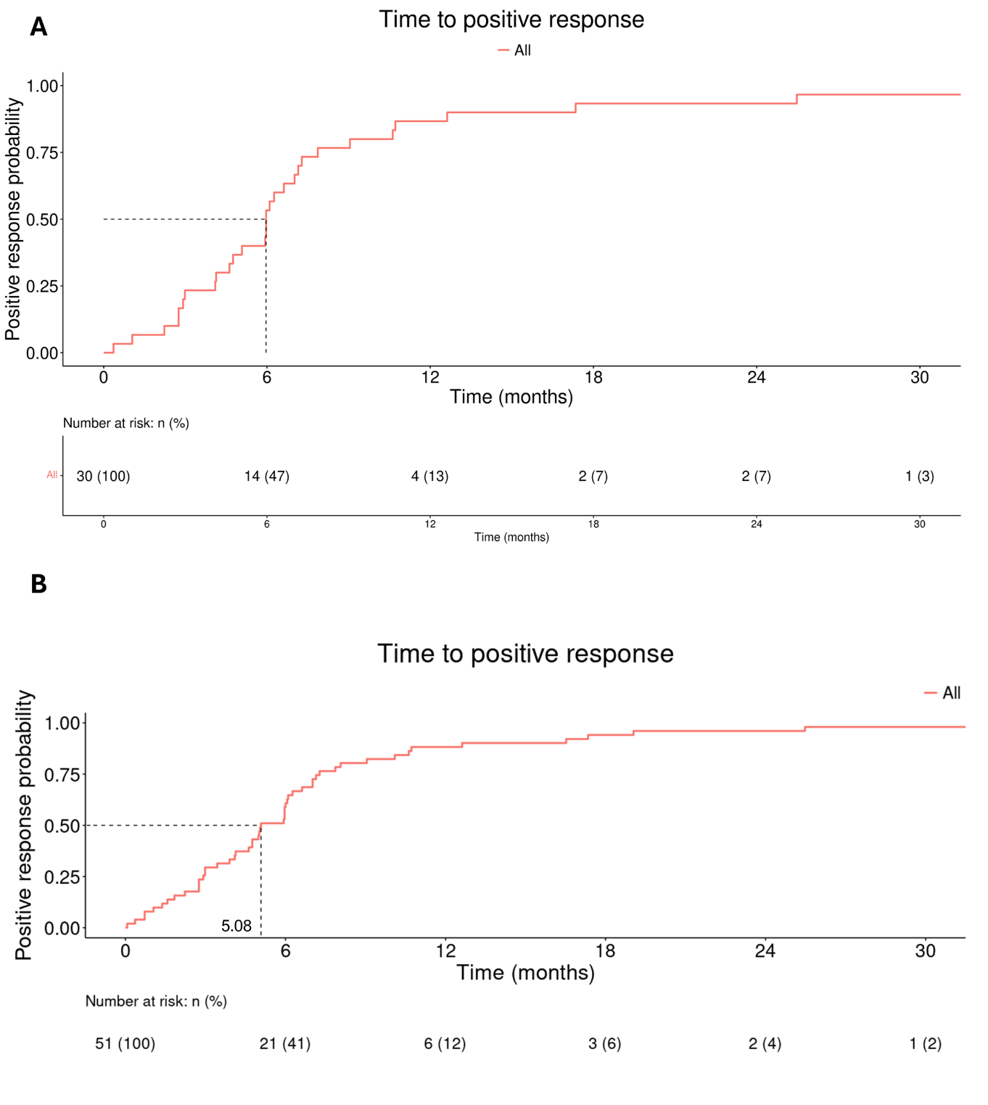

Supplementary Figure 2. Sensitivity analysis regarding time to CPX 8% HPCH and oral antifungal combination discontinuation in a) the subpopulation of patients having the mention of culture and b) in the entire study population. The probability of discontinuation reached 0.11 and 0.13 at the 24-month point for patients having the mention of culture and in the entire population, respectively.

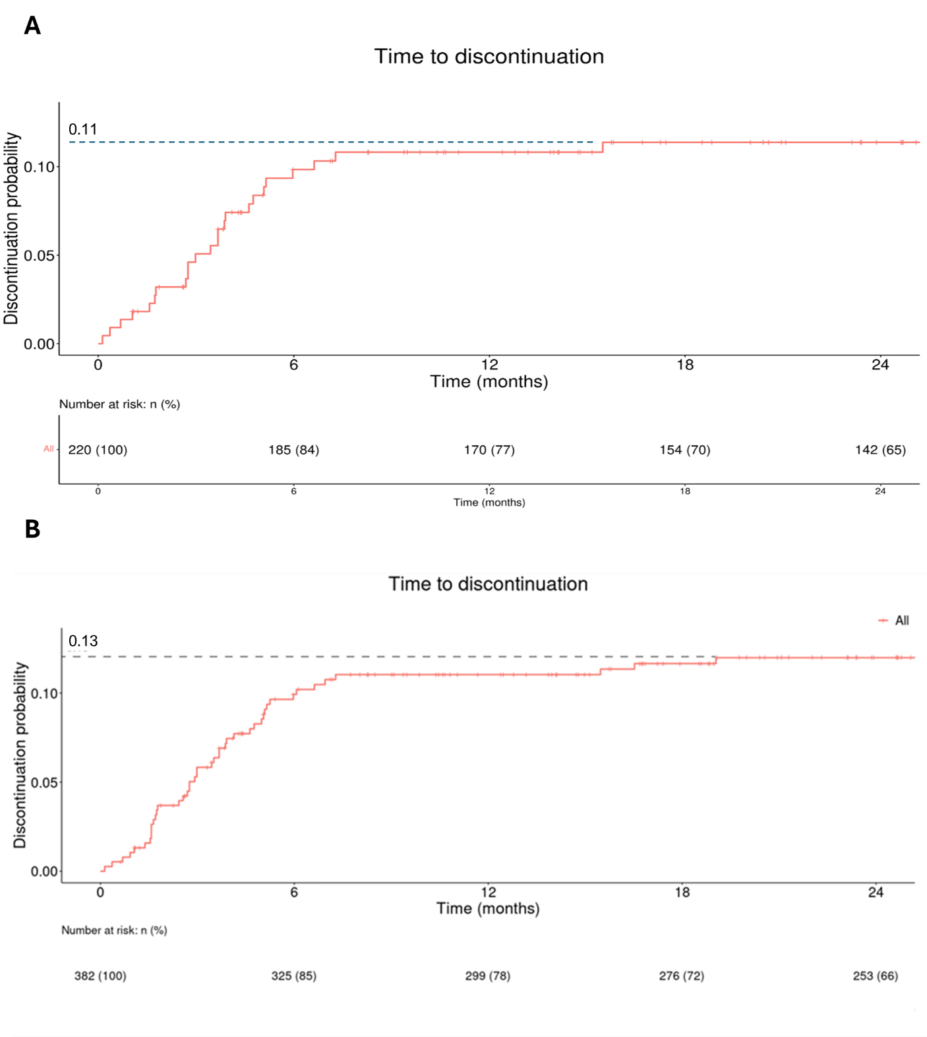

Supplementary Figure 3. Sensitivity analysis regarding time to CPX 8% HPCH and oral antifungal combination discontinuation in a) the subpopulation of patients having the mention of culture and b) in the entire population with registered positive response. The median time to discontinuation was 3.5 and 3.21 months in patients having the mention of culture and in the entire population, respectively, with registered positive response.

