Appendix – table of contents

Details on registries…………………………………………………………………………….2
Details on exposures……………………………………………………………………………2
Definition of hospitalization……………………………………………………………………2
Patient and public involvement…………………………………………………………….......2
Statistical analysis – evaluating linearity assumptions………………………………………….2
Supplement Table 1………………………………………………………………………….....3
Supplement Table 2…………………………………………………………………………….3
Supplement Table 3…………………………………………………………………………….3
Supplement Table 4…………………………………………………………………………….4
Supplement Table 5…………………………………………………………………………….4
Supplement Table 6…………………………………………………………………………….4
Supplement Table 7…………………………………………………………………………….5
Supplement Table 8…………………………………………………………………………….5
Supplement Figure 1..………………………………………………………………………….6
Supplement Figure 2..………………………………………………………………………….7
Supplement Figure 3..………………………………………………………………………….8
Supplement Figure 4..………………………………………………………………………….9
Supplement Figure 5..…………………………………………………………………………10
Supplement Figure 6..…………………………………………………………………………11
Supplement Figure 7..…………………………………………………………………………12
References…………………………………………………………………………………….13

Assessment of relevant diagnoses in registries
Cancer diagnoses were identified by linkage with the Danish Cancer Registry ([1]). Ischemic heart disease and cerebrovascular disease cases were identified through the Danish National Patient Registry (DNPR), which contains information on examinations and treatments in Danish hospitals ([2]). Date of hospitalization was used as the date of diagnosis. We identified cases with type 1 diabetes (at baseline for exclusion and during follow-up for censoring), type 2 diabetes, asthma, COPD, and dementia from the Registry for Selected Chronic Diseases and Severe Mental Disorders (RUKS), which contains holds information on prevalence and incidence of selected chronic diseases ([3]) based on data from the DNPR ([4]) and The Danish National Prescription Registry ([5]), which was valid only from 1997. Therefore, the baseline was 1 July 1997. The Danish Register of Causes of Death ([6]) was used to identify deaths.

Exposure assessment – health behaviors
Sport activity was assessed by questions covering average weekly leisure time spent on activities such as jogging, football, and swimming during summer and winter. Activities included in this category were presumed to be of moderate to high intensity. Both alcohol intake and dietary habits were derived from a validated food frequency questionnaire ([7]). Alcohol consumption was estimated from intake of beer, wine, and liquor to calculate the total amount of alcohol per day (1 unit=12 g) and scored according to former sex-specific Danish recommendations (applicable in 2010 to 2022).
Diet was included based on four dietary recommendations with good evidence to support a role in lifestyle-related disease: whole grains, fruit and vegetables ([8]), red meat, and processed meat ([9]). For each item, questions containing relevant foods were summed. Whole-grain foods included oatmeal and muesli, rye bread, and whole-grain bread with the recommendation of 75 g/day (per 10 MJ/day). All fruits and vegetables (fresh and frozen), excluding juices, were summed for a daily average with the recommendation of a minimum 600 g/day regardless of the proportion between the two. For red meat (beef, pork, and lamb), the recommendation is to limit intake to a maximum 350 g/week. For processed meat, the current recommendation is to avoid or limit intake as much as possible, which we defined to be a maximum 10 g/d. Waist circumference was grouped according to official Europid sex-specific cut-off values ([10]) for low, moderate, and high risk of cardio-metabolic diseases.

Definition of hospitalization and duration of stay
For each of the patient entries, the difference between in and out time was calculated in hours and number of calendar days, respectively. Missing in or out times were imputed for each entry according to the documentation but slightly revised to avoid negative time. The total patient time spent at the hospital was summed and divided by years of follow-up to obtain an average number of days per year for each patient. Only participants with at least 1 year of follow-up were included. As an alternative measure, we calculated the number of bed days, which is a hospitalization load used by the Danish Health Authorities. This calculation was carried out on the same entries as defined previously; in accordance with DNPR documentation, this was the difference in calendar days between in and out time of the registry entry, with values of 0 bed days set to 1 bed day ([11]).

Patient and public involvement
The idea for the current study was presented to the Danish Cancer Institute’s Patient and Public Panel through a focus group session in the initial project phase. We received constructive feedback and focused on the importance of a broad reach for dissemination, with a balance between targeting the individual, public health, and health economy. Upon publication, the Panel will be informed of the results and different media platforms used to inform the broader public.

Statistical analysis evaluating linearity
To formally assess the linearity assumptions regarding the effect of health score and age, we visually inspected the Pearson residuals and evaluated the significance of both log and second- and third-order terms using likelihood ratio tests.

Supplement Table 1. Difference in life expectancy with and without disease in multiple models including interaction between health score and age, cohabitation status, and education level.
 | Difference in years (95% confidence interval)
Men | Life expectancy without disease | Life expectancy with disease | Life expectancy with one disease | Life expectancy with two or more diseases
Cohabitation*
Together | Reference | Reference | Reference | Reference
Alone | -0.99 (-1.21 to -0.77) | -0.12 (-0.32 to 0.08) | -0.21 (-0.38 to -0.04) | 0.08 (-0.02 to 0.18)
Education level†
Short | -0.68 (-0.93 to -0.42) | 0.29 (0.06 to 0.53) | 0.14 (-0.06 to 0.33) | 0.15 (0.03 to 0.28)
Medium | Reference | Reference | Reference | Reference
Long | 0.67 (0.49 to 0.86) | -0.32 (-0.49 to -0.14) | -0.06 (-0.21 to 0.09) | -0.25 (-0.33 to -0.17)
Women
Cohabitation
Together | Reference | Reference | Reference | Reference
Alone | -0.93 (-1.10 to -0.76) | 0.47 (0.32 to 0.63) | 0.24 (0.10 to 0.38) | 0.22 (0.15 to 0.29)
Education level
Short | -0.61 (-0.82 to -0.40) | 0.38 (0.18 to 0.57) | 0.18 (0.01 to 0.35) | 0.19 (0.10 to 0.28)
Medium | Reference | Reference | Reference | Reference
Long | 0.66 (0.47 to 0.84) | -0.47 (-0.64 to -0.30) | -0.22 (-0.38 to -0.07) | -0.24 (-0.31 to -0.17)
*Cohabitation status was based on information from household registries and defined as living with a partner or not. †Education level was grouped into short (i.e., primary school), middle (i.e., high school, primary school longer than the 7 years mandatory for Danish citizens born before 1958, vocational education, supplementary education), and long (i.e., higher education).

Supplement Table 2. Smoking status and life expectancy without disease

Men – 60 years | Years (95% CI)
Current | -1.96 (-2.19 to -1.74)
Former | Reference
Never | 0.80 (0.55 to 1.05)
Women – 60 years
Current | -2.30 (-2.54 to -2.06)
Former | Reference
Never | 0.73 (0.51 to 0.95)
Men – 55 years
Current | -1.82 (-2.05 to -1.58)
Former | Reference
Never | 0.52 (0.28 to 0.75)
Women – 55 years
Current | -1.78 (-2.05 to -1.52)
Former | Reference
Never | 0.53 (0.29 to 0.76)

Supplement Table 3. Smoking status and life expectancy with disease

Men – 60 years | Years (95% CI)
Current | 0.33 (0.12 to 0.54)
Former | Reference
Never | -0.52 (-0.75 to -0.29)
Men – 55 years
Current | 0.85 (0.64 to 1.07)
Former | Reference
Never | -0.33 (-0.55 to -0.11)

Supplement Table 4. Waist circumference and life expectancy with disease

Men – 60 years | Years (95% CI)
High | 0.77 (0.52 to 1.02)
Middle | Reference
Low | -0.72 (-0.92 to -0.51)
Men – 55 years
High | 1.30 (1.02 to 1.57)
Middle | Reference
Low | -0.83 (-1.03 to -0.63)
Women – 60 years
High | 1.06 (0.83 to 1.30)
Middle | Reference
Low | -0.39 (-0.59 to -0.20)
Women – 55 years
High | 1.36 (1.09 to 1.62)
Middle | Reference
Low | -0.38 (-0.58 to -0.17)

Supplement Table 5. Sensitivity analysis with non-strict diet for life expectancy without disease (no interaction with age)
Men | Years (95% CI)
diet_nonstrict (0 points) | -0.06 (-0.29 to 0.16)
diet_nonstrict (1 point) | Reference
diet_nonstrict (2–4 points) | 0.39 (-0.06 to 0.83)
Women
diet_nonstrict (0 points) | -0.14 (-0.32 to 0.04)
diet_nonstrict (1 point) | Reference
diet_nonstrict (2–4 points) | 0.32 (0.10 to 0.54)

Supplement Table 6. Sensitivity analysis with non-strict diet for life expectancy with disease (no interaction with age)
Men | Years (95% CI)
diet_nonstrict (0 points) | 0.13 (-0.07 to 0.34)
diet_nonstrict (1 point) | Reference
diet_nonstrict (2–4 points) | -0.24 (-0.64 to 0.16)
Women
diet_nonstrict (0 points) | 0.17 (0.005 to 0.34)
diet_nonstrict (1 point) | Reference
diet_nonstrict (2–4 points) | -0.14 (-0.35 to 0.06)

Supplement Table 7. Sensitivity analysis with BMI for life expectancy without disease (no interaction with age)
Men | Years (95% CI)
BMI (>30 kg/m²) | -2.02 (-2.27 to -1.76)
BMI (25–30 kg/m²) | Reference
BMI (<25 kg/m²) | 0.78 (0.60 to 0.96)
Women
BMI (>30 kg/m²) | -1.71 (-1.98 to -1.44)
BMI (25–30 kg/m²) | Reference
BMI (<25 kg/m²) | 0.49 (0.32 to 0.66)

Supplement Table 8. Sensitivity analysis with BMI for life expectancy with disease (interaction with age) in 65-year-olds
Men | Years (95% CI)
BMI (>30 kg/m²) | 0.45 (-0.02 to 0.92)
BMI (25–30 kg/m²) | Reference
BMI (<25 kg/m²) | -0.62 (-0.94 to -0.29)
Women
BMI (>30 kg/m²) | 0.99 (0.55 to 1.44)
BMI (25–30 kg/m²) | Reference
BMI (<25 kg/m²) | -0.37 (-0.67 to -0.07)

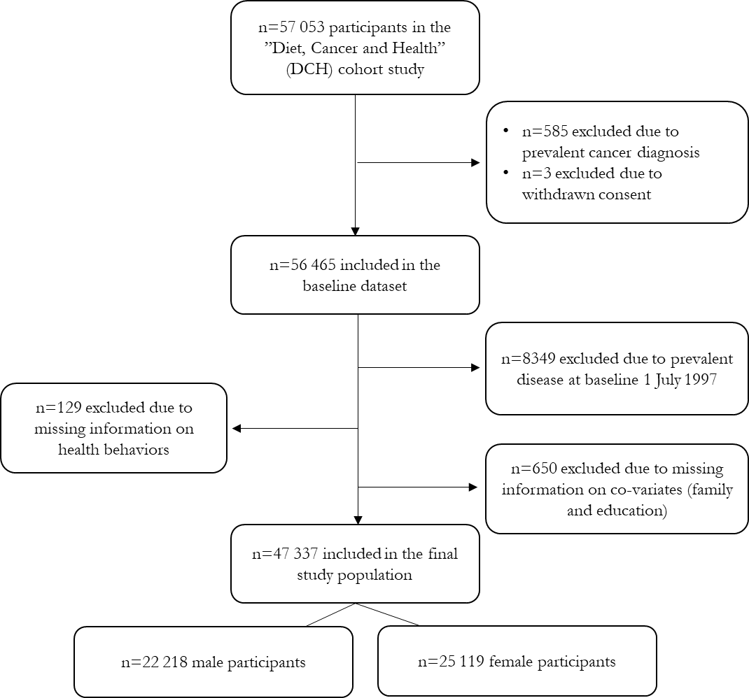

Supplement Figure 1. Flow diagram of participant inclusion.

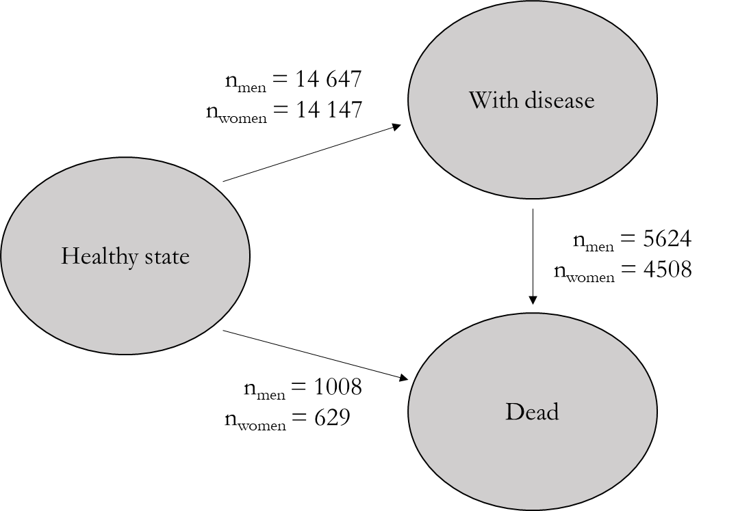

Supplement Figure 2. The illness-death multi-state model allows transitions from “Healthy state” to “With disease” or “Dead”, and from “With disease” to “Dead”. The number of transitions between stages during follow-up is presented for men and women separately.

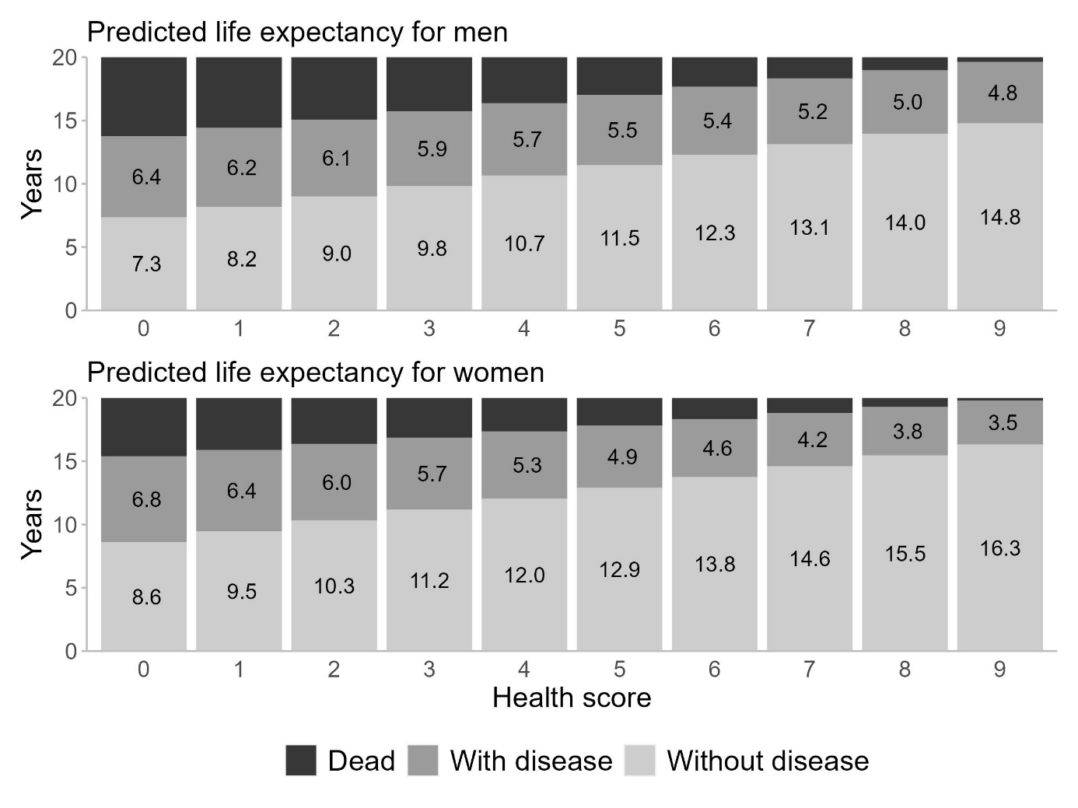

Supplement Figure 3. Predicted life expectancy with and without disease by health score for men (top) and women (bottom) aged 65 years at baseline with cohabitation status “living together” and education level “medium”.

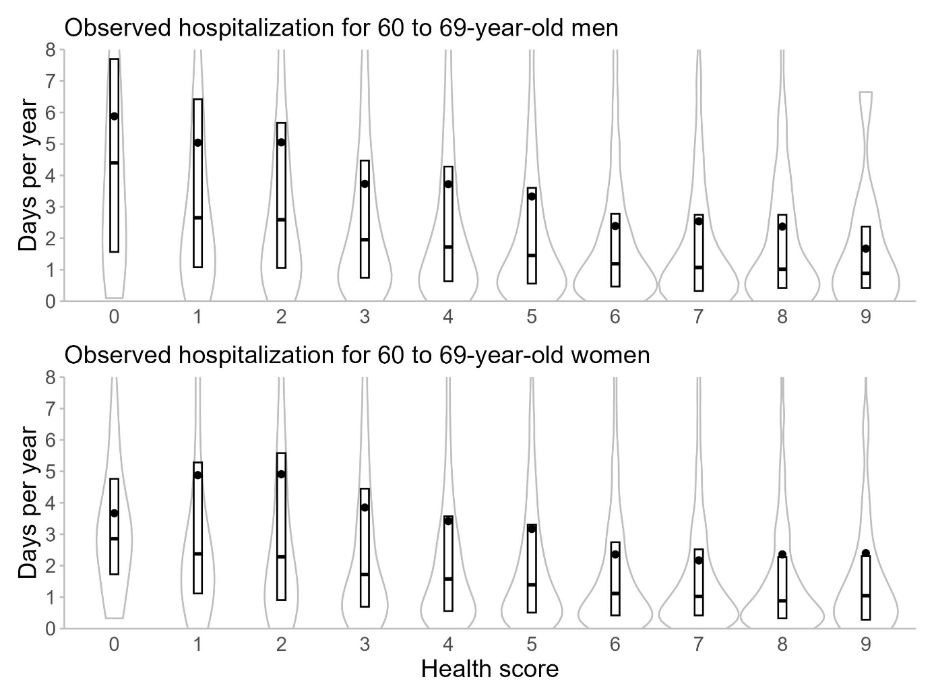
Supplement Figure 4. Distribution of observed number of days of hospitalization by health score for men (above) and women (below) aged 60 to 69 years at baseline. The box represents the interquartile range and the small horizontal line the median. The dot indicates the mean. The grey outlines are violin plots showing the distribution with the right end (high number of days per year) not shown. For age 50 to 55 years and 55 to 60 years, the numbers of days of hospitalization were lower for all health scores compared with 60 to 69-year-olds.

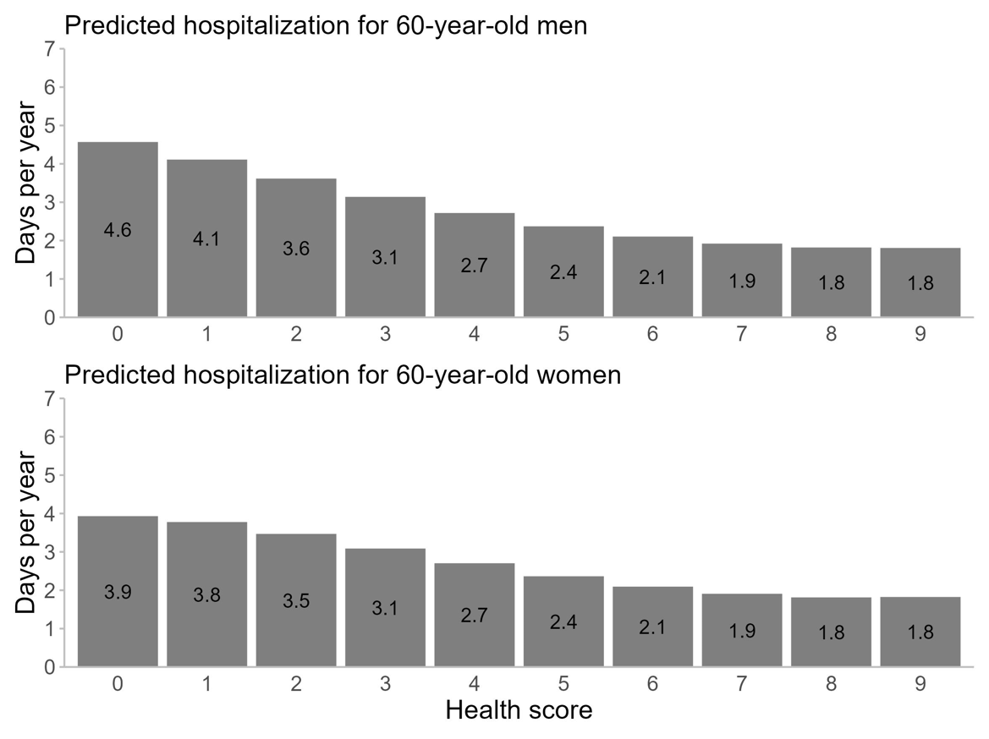

Supplement Figure 5. Predicted number of days of hospitalization per year by health score for men (top) and women (bottom) aged 60 years at baseline with cohabitation status “living together” and education level “medium”.

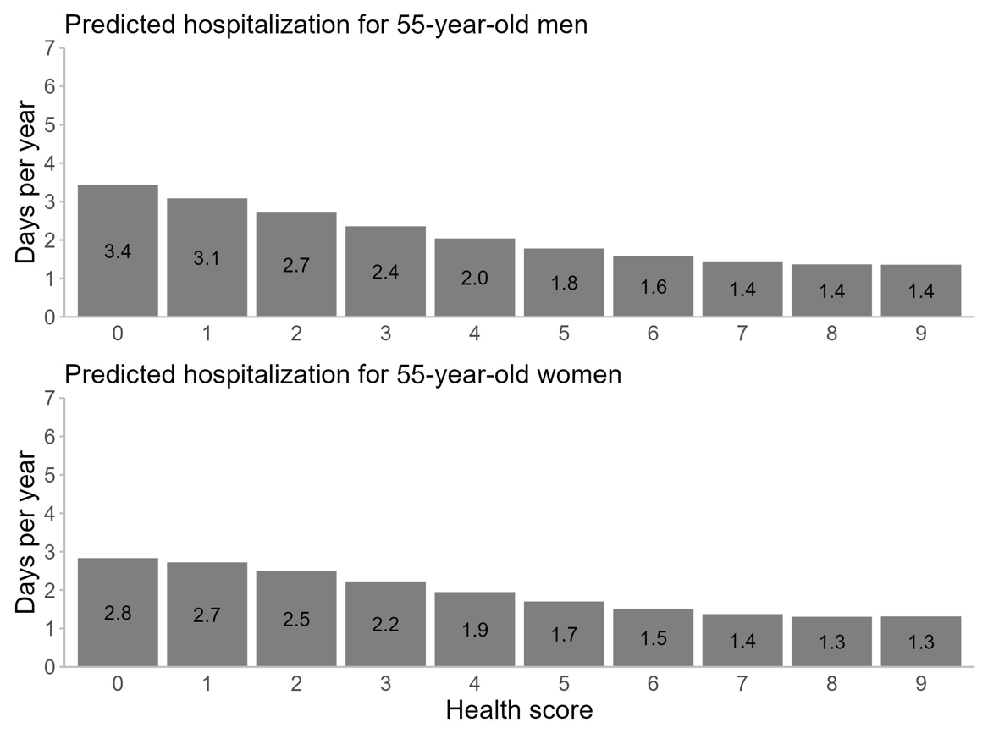

Supplement Figure 6. Predicted number of days of hospitalization per year by health score for men (top) and women (bottom) aged 55 years at baseline with cohabitation status “living together” and education level “medium”.

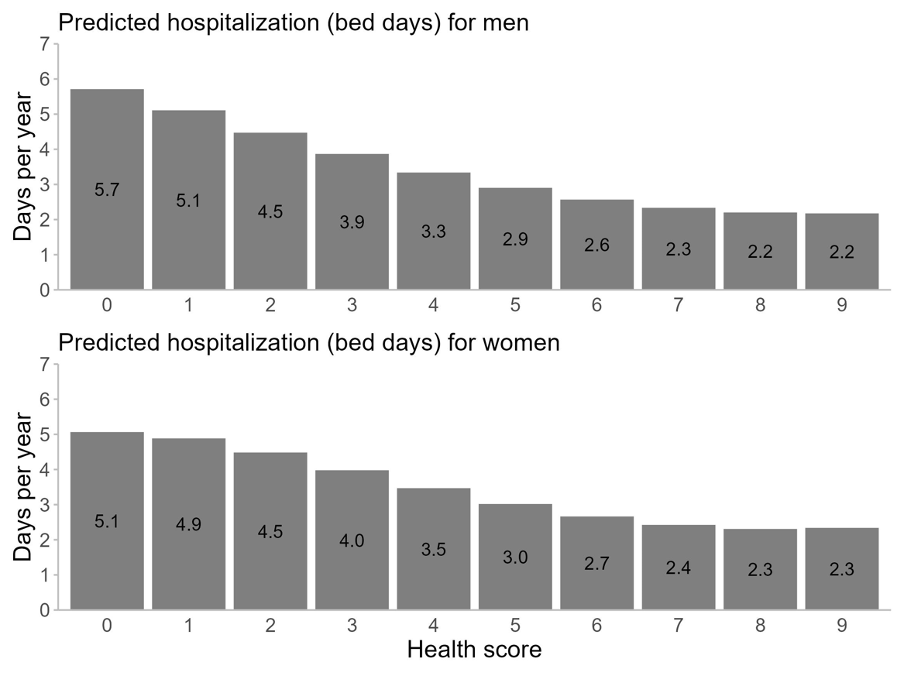

Supplement Figure 7. Predicted number of bed days of hospitalization per year by health score for men (top) and women (bottom) aged 65 years at baseline with cohabitation status “living together” and education level “medium”.

References
1. Gjerstorff ML. The Danish Cancer Registry. Scand J Public Health. 2011;39(7 Suppl):42-5. Epub 2011/08/04. doi: 10.1177/1403494810393562. PubMed PMID: 21775350.
2. Schmidt M, Schmidt SAJ, Sandegaard JL, Ehrenstein V, Pedersen L, Sørensen HT. The Danish National Patient Registry: a review of content, data quality, and research potential. Clinical epidemiology. 2015;7:449-90. doi: 10.2147/CLEP.S91125. PubMed PMID: 26604824.
3. Authority DHD. Documentation of registries https://www.esundhed.dk/Dokumentation/DocumentationExtended?id=292017.
4. Lynge E, Sandegaard JL, Rebolj M. The Danish National Patient Register. Scand J Public Health. 2011;39(7 Suppl):30-3. Epub 2011/08/04. doi: 10.1177/1403494811401482. PubMed PMID: 21775347.
5. Kildemoes HW, Sorensen HT, Hallas J. The Danish National Prescription Registry. Scand J Public Health. 2011;39(7 Suppl):38-41. doi: 10.1177/1403494810394717. PubMed PMID: 21775349.
6. Helweg-Larsen K. The Danish Register of Causes of Death. Scand J Public Health. 2011;39(7 Suppl):26-9. Epub 2011/08/04. doi: 10.1177/1403494811399958. PubMed PMID: 21775346.
7. Tjonneland A, Overvad K, Haraldsdottir J, Bang S, Ewertz M, Jensen OM. Validation of a semiquantitative food frequency questionnaire developed in Denmark. Int J Epidemiol. 1991;20(4):906-12. PubMed PMID: 1800429.
8. Health effects of dietary risks in 195 countries, 1990-2017: a systematic analysis for the Global Burden of Disease Study 2017. Lancet (London, England). 2019;393(10184):1958-72. Epub 2019/04/08. doi: 10.1016/s0140-6736(19)30041-8. PubMed PMID: 30954305; PubMed Central PMCID: PMCPMC6899507.
9. Shi W, Huang X, Schooling CM, Zhao JV. Red meat consumption, cardiovascular diseases, and diabetes: a systematic review and meta-analysis. European heart journal. 2023;44(28):2626-35. doi: 10.1093/eurheartj/ehad336.
10. Organization WH. Waist Circumference and Waist-Hip Ratio. Report of a WHO Expert Consultation. Geneva: World Health Organization: 2011.
11. Documentation of registries [Internet]. 2016 [cited 12-12-2023]. Available from: https://www.esundhed.dk/Dokumentation/DocumentationExtended?id=5#table7variable84.

