Synthesis, Crystal Structure, DFT Calculations, In-vitro and In-silico Studies of Novel Chromone-Isoxazoline Conjugates as Antibacterial and Anti-Inflammatory agents

Rachid Bouzammit^{1*}, Naoufal El Hachlafi², Mohamed El Fadili³, Mouna El khabchi^{4*}, Youssra Kanzouai¹, Rachid Salghi⁵, Mohammed M. Alanazi⁶, Mohammed Chalkha^{1,7}, Alexandra M. Pop⁸, Emese Gal⁹, Luiza Gaina Ioana⁹, Ghali Al Houari¹

¹ Engineering Laboratory of Organometallic and Molecular Materials and Environment, Faculty of Sciences Dhar EL Mahraz, University Sidi Mohamed Ben Abdellah, P.O. Box 1796 (Atlas), 30000 Fes, Morocco.
² Faculty of Sciences and Technologies, Sidi Mohamed Ben Abdellah University, P.O. Box 2202, Imouzzer Road, Fez, Morocco.
³ LIMAS Laboratory, Chemistry Department, Faculty of Sciences Dhar EL Mahraz, Sidi Mohamed Ben Abdellah University, 30000 Fez, Morocco.
⁴ School of Science and Engineering, Al Akhawayn University in Ifrane, Ifrane 53000, Morocco.
⁵ Laboratory of Applied Chemistry and Environment, ENSA, University Ibn Zohr, PO Box 1136, Agadir 80000, Morocco.
⁶ Department of Pharmaceutical Chemistry, College of Pharmacy, King Saud University, Riyadh 11451, Saudi Arabia.
⁷ Laboratory of Materials Engineering for the Environment and Natural Ressources, Faculty of Sciences and Techniques, University of Moulay Ismail of Meknès, B.P 509, Boutalamine, 52000, Errachidia, Morocco.
⁸ Babes-Bolyai University, Faculty of Chemistry and Chemical Engineering, 11 Arany Janos, 400028 Cluj-Napoca, Romania.
⁹ Research Center on Fundamental and Applied Heterochemistry, Faculty of Chemistry and Chemical Engineering, Babeş-Bolyai University, 11 Arany Janos str, RO-400028 Cluj-Napoca, Romania.

* Corresponding author. E-mail addresses: mouna.elkhabchi@usmba.ac.ma (M. EL Khabchi), rachid.bouzammit@usmba.ac.ma (R. Bouzammit), mmalanazi@ksu.edu.sa (M. M. Alanazi).

.

Table S1. Crystal data and structure refinement for C₂₃H₂₁BrN₂O_{7.}
Compound |  | 5d
Molecular formula |  | C₂₃H₂₁BrN₂O₇
Formula weight |  | 517.33
Crystal size / mm³ |  | 0.067 x 0.204 x 0.210
Crystal habit |  | colorless block
λ(MoK_{α}) / Å |  | 0.71073
T / K |  | 99.(2)
Crystal system |  | monoclinic
Space group |  | P21/c
a / Å |  | 7.5836(2)
b / Å |  | 29.3368(11)
c / Å |  | 9.9840(4)
α / ° |  | 90
β / ° |  | 107.5620(10)
γ / ° |  | 90
V / Å³ |  | 2117.70(13)
Z |  | 4
D_{calc} / g cm⁻³ |  | 1.623
μ / mm⁻¹ |  | 1.992
θ range for data collections (°) |  | 2.5508 - 28.2806
F(000) |  | 1056
T_{max} / T_{min} |  | 0.88 / 0.78
Refl. collected / unique / R_{int} |  | 56985 / 0.0355
Completeness to θ |  | 99.8%
Refinement method |  | Full-matrix least-squares on F²
Data / restraints / parameters |  | 5260 / 0 / 3012
Goodness-of-fit, S |  | 1.284
Final R indices [I>2σ(I)] |  | R₁ = 0.0672
Final R indices [I>2σ(I)] |  | wR₂ = 0.1635
R indices (all data) |  | R₁ = 0.0697
R indices (all data) |  | wR₂ = 0.1645
Δρ_{max}, Δρ_{min} / e Å⁻³ |  | 1.345 / -1.662
CCDC No. |  |  | 2420417

a

Figure S1(a). Dimeric association in the crystal of 5d [Symmetry equivalent atoms (1–x, 1–y, 1–z) are given by “prime”].

b
Figure S1(b). O∙∙∙H interactions in 5d [Symmetry equivalent atoms (2–x,1/2+y, 3/2–z), (1+x,1/2–y, 1/2+z) and (x,1/2–y, 1/2+z) are given by “prime”, “double prime” and “triple prime”].

- Copies of ¹H, ¹³C-NMR and HRMS spectra of synthesized.
- Spectra of 2-(allylamino)-4-oxo-4H-chromene-3-carbaldehyde 3.
Figure S2. ¹H NMR spectrum (400 MHz, CDCl₃) of compound 3.
Figure S3. ¹³C NMR spectrum (100 MHz, CDCl₃) of compound 3.

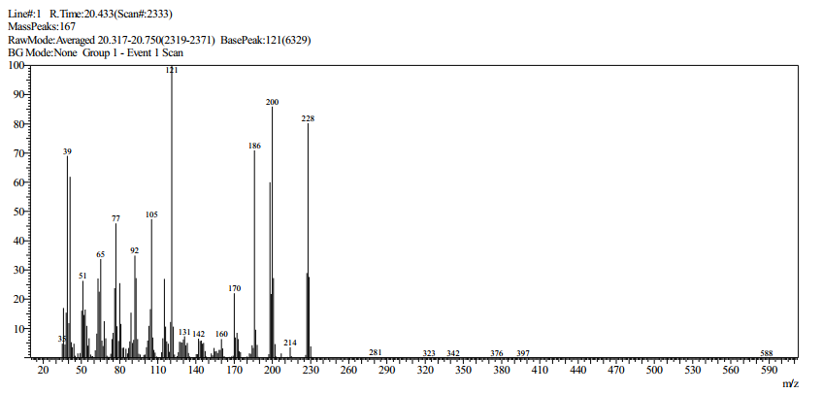
Figure S4. Mass spectrum of compound 3.
- Spectra of compound 5a-e.
- Spectra of 4-oxo-2-(((3-(4-(trifluoromethyl)phenyl)-4,5-dihydroisoxazol-5-yl)methyl)amino)-4H-chromene-3-carbaldehyde 5a.
Figure S5. ¹H NMR spectrum (600 MHz, CDCl₃) of compound 5a.

Figure S6. ¹³C NMR spectrum (150 MHz, CDCl₃) of compound 5a.

Figure S7. Mass spectrum of compound 5a.
- Spectra of 2-(((3-(2-chlorophenyl)-4,5-dihydroisoxazol-5-yl)methyl)amino)-4-oxo-4H-chromene-3-carbaldehyde 5b.
Figure S8. ¹H NMR spectrum (600 MHz, CDCl₃) of compound 5b.
Figure S9. ¹³C NMR spectrum (150 MHz, CDCl₃) of compound 5b.
Figure S10. Mass spectrum of compound 5b.

- Spectra of 2-(((3-(2-nitrophenyl)-4,5-dihydroisoxazol-5-yl)methyl)amino)-4-oxo-4H-chromene-3-carbaldehyde 5c.
Figure S11. ¹H NMR spectrum (600 MHz, CDCl₃) of compound 5c.
Figure S12. ¹³C NMR spectrum (150 MHz, CDCl₃) of compound 5c.
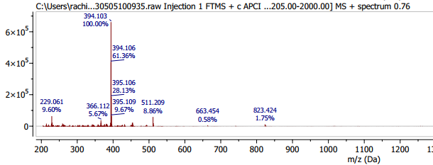
Figure S13. Mass spectrum of compound 5c.
- Spectra 2-(((3-(2-bromo-3,4,5-trimethoxyphenyl)-4,5-dihydroisoxazol-5-yl)methyl)amino)-4-oxo-4H-chromene-3-carbaldehyde 5d.
Figure S14. ¹H NMR spectrum (600 MHz, CDCl₃) of compound 5d.

Figure S15. ¹³C NMR spectrum (150 MHz, CDCl₃) of compound 5d.
Figure S16. Mass spectrum of compound 5d.
- Spectra of 2-(((3-(4-bromophenyl)isoxazol-5-yl)methyl)amino)-4-oxo-4H-chromene-3-carbaldehyde 5e.
Figure S17. ¹H NMR spectrum (600 MHz, CDCl₃) of compound 5e.
Figure S18. ¹³C NMR spectrum (150 MHz, CDCl₃) of compound 5e.
Figure S19. Mass spectrum of compound 5e.

