Supplementary Figures

Supplementary Figure S1. Multivariate Cox correlation analysis of the three prognostic genes.

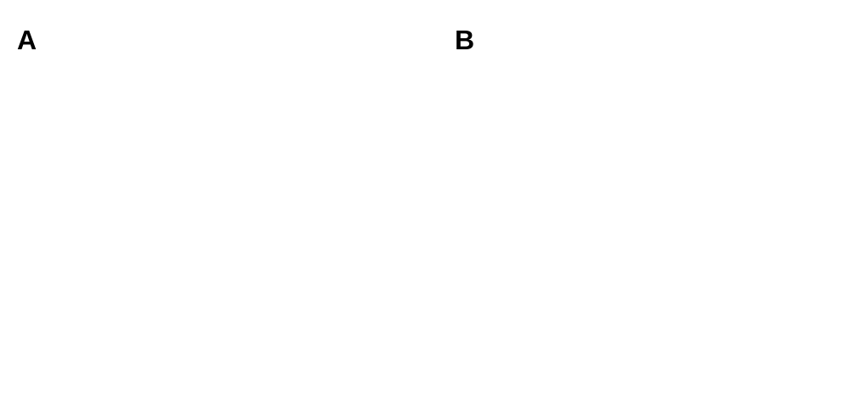

Supplementary Figure S2. Time-dependent ROC curves for overall survival prediction. (A) Time-dependent ROC curves of HBPS score for predicting 3-year and 5-year survival; (B) Time-dependent ROC curves of stage for predicting 3-year and 5-year survival.

Supplementary Figure S3. Spearman correlation analyses between three genes (CDKN2C, BRINP1, and SYCP2) and well-established cell cycle-related genes from the G2M checkpoint and E2F targets. The figure displays the top 5 most significantly correlated cell cycle-related genes for each of the three genes.

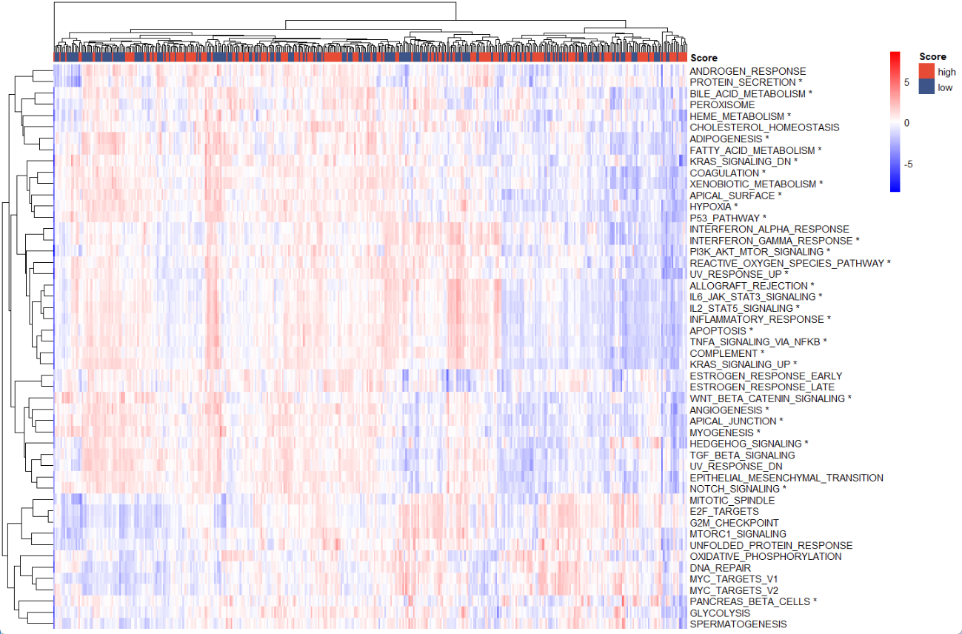

Supplementary Figure S4. Correlation analysis between Hallmark pathways and HBPS scores. Heatmap displaying 30 significantly dysregulated hallmark pathways (ssGSEA analysis usingTCGA RNA-seq data) between high- and low-HBPS score groups. *: P ≤ 0.05.
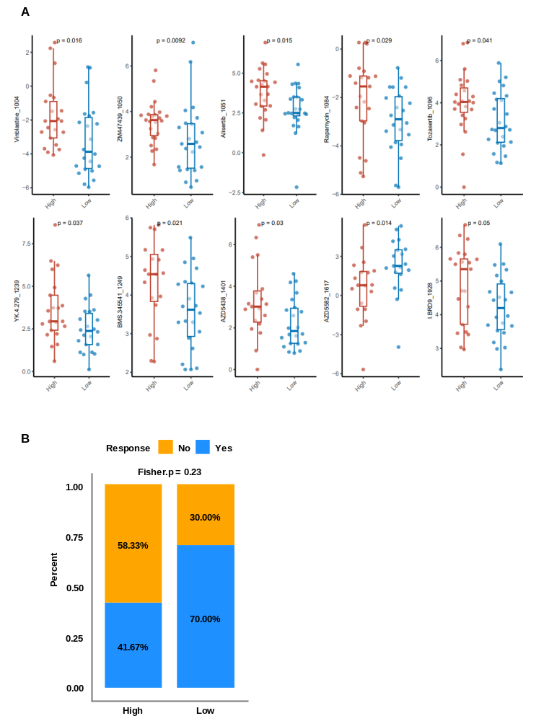

Supplementary Figure S5. Drug sensitivity and response prediction. (A) Significant differences in the estimated log(IC50) values of 10 drugs between two risk score groups across 51 breast cancer cell lines in GDSC based on HBPS scores stratification; (B) Immunotherapy response between the two groups based on HBPS scores stratification in the metastatic urothelial cancers cohort.

