Supplementary information

Machine Learning Analysis of Molecular Dynamics Properties Influencing Drug Solubility
Zeinab Sodaei¹, Saeid Ekrami², Seyed Majid Hashemianzadeh^{3*}
Department of Chemistry, Iran University of Science and Technology, Tehran, Iran
*Email: hashemianzadeh@iust.ac.ir

 | count | mean | std | min | 0.25 | median | 0.75 | max
Solubility (Mol/L) | 199 | -2.93 | 1.46 | -5.82 | -4.155 | -2.9 | -1.84 | 0.54
LogP * | 199 | 1.83 | 1.72 | -2.3 | 0.331 | 1.9 | 3.09 | 5.90
LJ (KJ/Mol) | 199 | -72.68 | 26.64 | -162.02 | -88.77 | -69.85 | -56.578 | -9.02
Coulombic (KJ/Mol) | 199 | -116.29 | 59.23 | -320.72 | -134.66 | -123.85 | -73.601 | -11.95
LJ-t (KJ/Mol) | 199 | 19777.9 | 55.43 | 19596.2 | 19744.45 | 19778.3 | 19819.95 | 19884.0
Coulombic-t (KJ/Mol) | 199 | -119975.67 | 416.19 | -120840 | -120282 | -120032 | -119683 | -118615
DGSolv (KJ/Mol.nm²) | 199 | 12.67 | 6.89 | -1.458 | 7.426 | 12.557 | 17.32 | 31.95
Hbond * | 199 | 3.89 | 1.95 | 0.079 | 2.523 | 3.991 | 4.958 | 9.95
RMSD (nm) | 199 | 0.072 | 0.04 | 0.011 | 0.0325 | 0.062 | 0.101 | 0.28
SASA (nm²) | 199 | 4.31 | 0.96 | 2.584 | 3.443 | 4.3114 | 5.0338 | 7.01
Sorient * | 199 | 0.13 | 0.32 | -0.57 | -0.09 | 0.11 | 0.33 | 0.95
Avg Shell * | 199 | 6.80 | 1.99 | 2.9 | 5.4 | 6.4 | 8.15 | 12.5

Table S1: Dataset statistical description

*: Dimensionless parameter

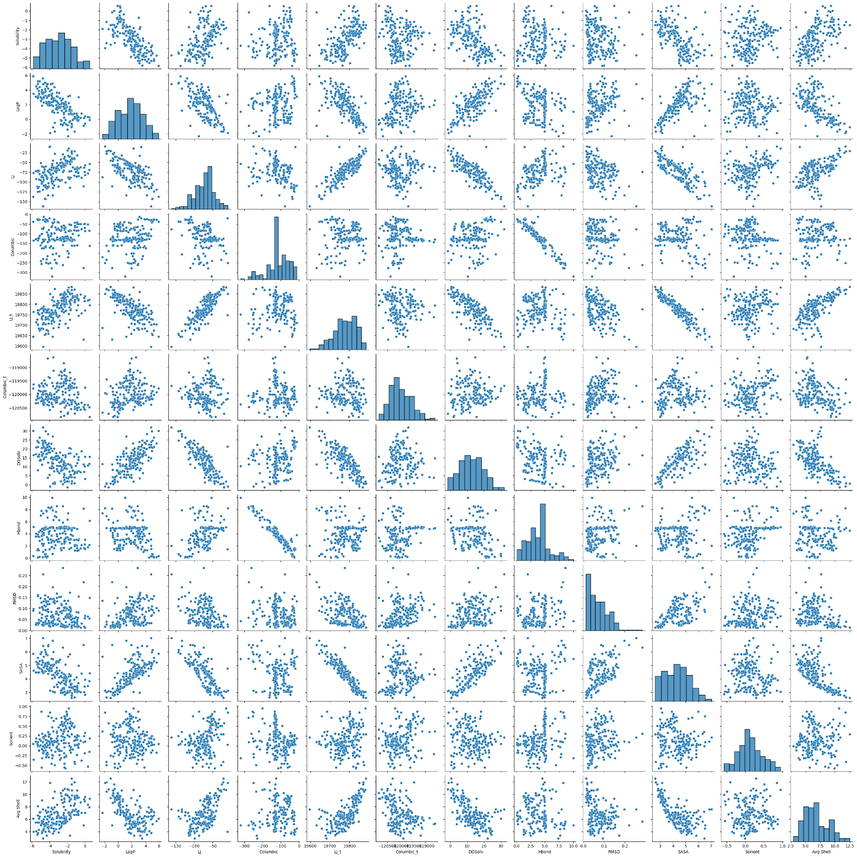
Figure S1: pairwise relationships between variables
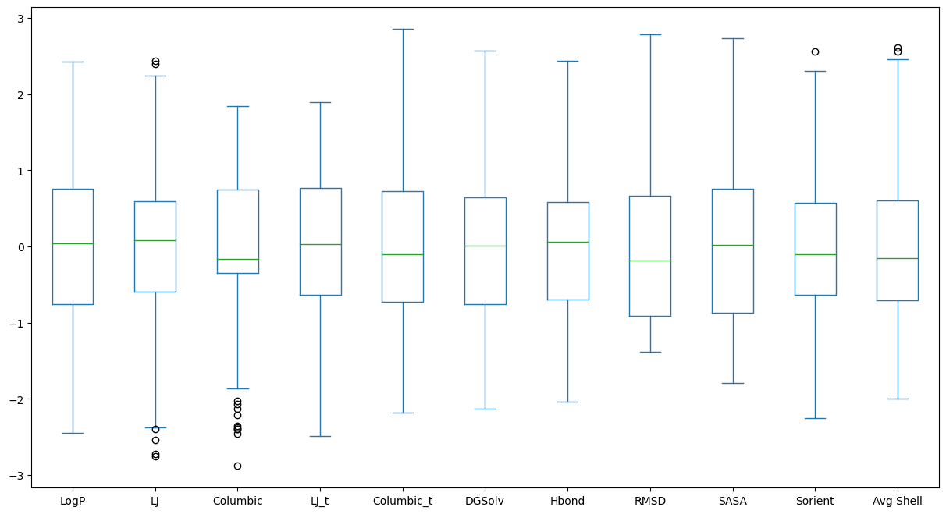
Figure S2: Box plots

Table S2: List of hyperparameter sets used in different ML algorithms.
Algorithms | Hyperparameter | Search Domain | selected | Default
Random Forest | n_estimators | In the interval between (100, 400), with a step size of 10 | 360 | 100
Random Forest | max_depth | In the interval between (1,11), with a step size of 2 | 9 | None
Extra Trees | n_estimators | In the interval between (100, 900), with a step size of 50 | 850 | 100
Extra Trees | min_sample_leaf | [1, 2] | 2 | 1
XGBoost RF | n_estimators | [5, 23, 27] | 23 | 100
XGBoost RF | subsample | In the interval between (0.6 ,0.7), with a step size of 0.01 | 0.66 | 0.8
XGBoost RF | max_depth | [7, 8, 9] | 9 | None
Gradient Boosting | min_sample_leaf | [2, 3, 5, 7] | 7 | 1
Gradient Boosting | subsample | In the interval between (0.7 ,0.8), with a step size of 0.01 | 0.79 | 1.0
Gradient Boosting | max_depth | [7, 8, 9] | 7 | 3
Gradient Boosting | n_estimators | In the interval between (80, 100), with a step size of 1 | 80 | 100

Table S3. Selected features corresponding to Figure 6.
Methods | Selected Features
SFS-4 | Log P, LJ_t, Coulombic_t, Hbond
SFS-5 | Log P, SASA, Coulombic_t, Avg Shell, DGSolv
SFS-6 | Log P, SASA, LJ, Coulombic_t, Avg Shell, DGSolv
SFS-7 | Log P, SASA, LJ, Coulombic_t, RMSD, Avg Shell, DGSolv
SBS-4 | Log P, SASA, Coulombic_t, DGSolv
SBS-5 | Log P, LJ_t, Coulombic, RMSD, Sorient
SBS-6 | Log P, LJ_t, Coulombic, RMSD, Avg Shell, DGSolv
SBS-7 | Log P, SASA, LJ, Coulombic_t, RMSD, Avg Shell, DGSolv
RFECV | Log P, SASA, LJ_t, Coulombic, Coulombic_t, Avg Shell, DGSolv

a)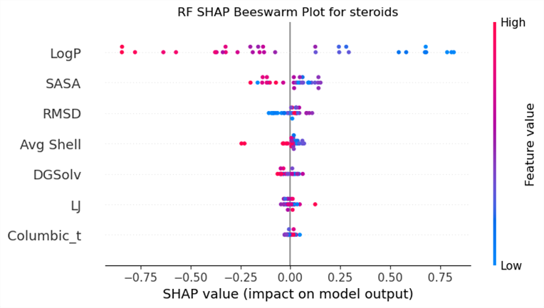
b) 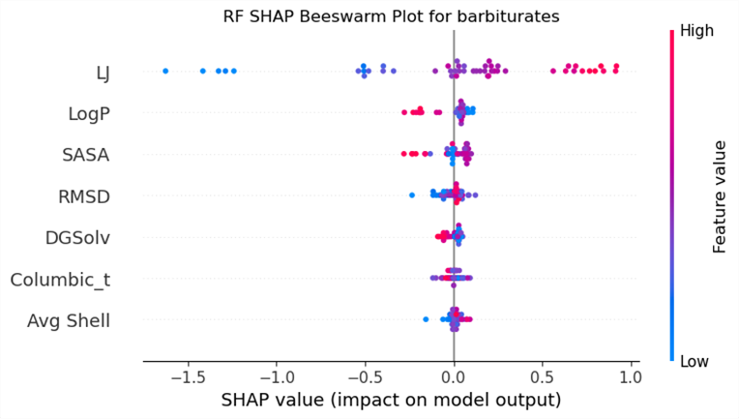
Figure S3. SHAP figure and extracted features for a) steroids subclass, b) barbiturates subclass.

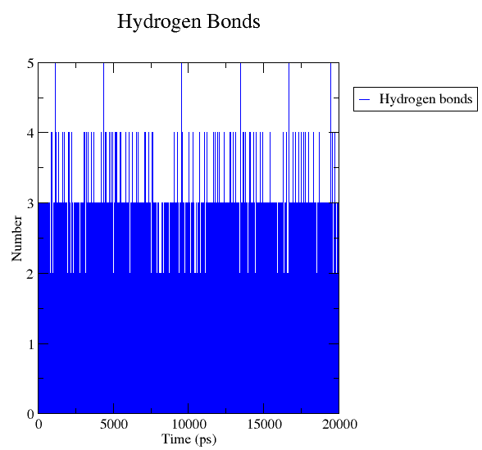
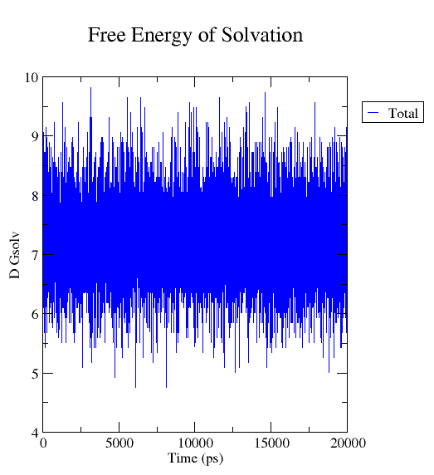
Figure S4. Estimated free energy of solvation of 6-chlorpteridine
Figure S5. Number of Hydrogen Bonds for 6-chlorpteridine
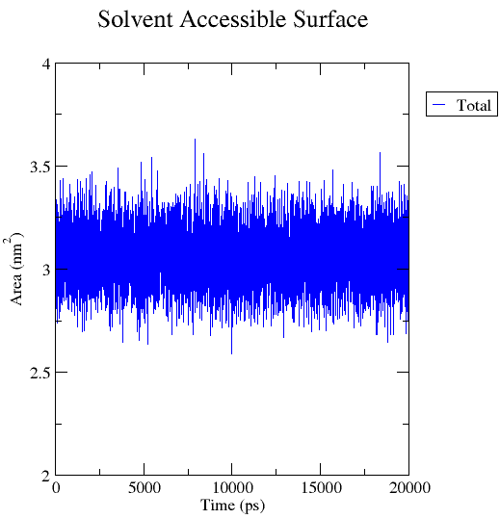
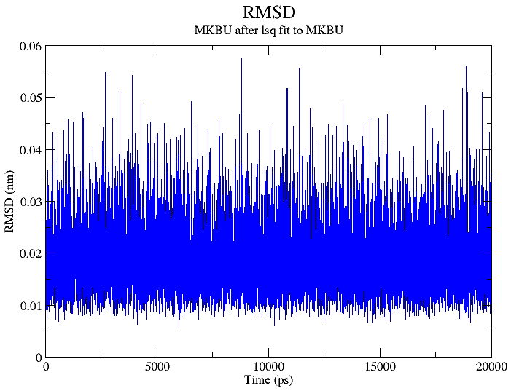
Figure S6. RMSD of 6-chlorpteridine
Figure S7. Solvent Accessible Surface Area for 6-chlorpteridine

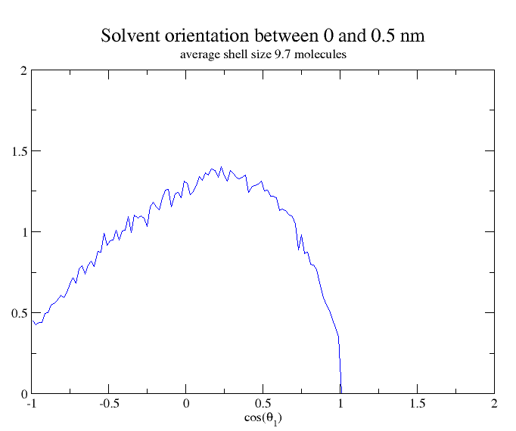
Figure S8. Solvent Orientation around Solute and average number of solvent molecules in shell size between 0 and 0.5 nm for 6-chlorpteridine

Table S4. The whole Dataset.
Name | Log S ¹  (Mol/L) | LogP* | LJ  (KJ/Mol) | Coulombic  (KJ/Mol) | LJ_t  (KJ/Mol) | Coulombic_t  (KJ/Mol) | DGSolv  (KJ/Mol.nm²) | Hbond* | RMSD  (nm) | SASA  (nm²) | Sorient* | Avg Shell* | LogP Ref.
ethambutol | 0.545 | -0.1 | -53.8593 | -162.182 | 19796.4 | -120840 | 15.55316 | 6.134087 | 0.1478678 | 4.426875 | 0.19 | 9.3 | ²
antipyrine | 0.53 | 0.26 | -68.9557 | -84.8548 | 19823.3 | -120476 | 11.73782 | 2.156084 | 0.05373792 | 3.847618 | -0.15 | 7.9 | ³
2-dimethylaminopteridine | 0.36 | 0.3 | -77.8959 | -52.0792 | 19818.2 | -120391 | 10.76234 | 1.759324 | 0.06350577 | 3.476041 | -0.53 | 8.3 | ²
petridine | 0.021 | -0.6 | -57.2365 | -48.318 | 19839.6 | -120568 | 3.188739 | 1.478652 | 0.01199085 | 2.826951 | 0.33 | 9.6 | ²
7-dimethylaminopteridine | -0.021 | 0.3 | -74.5891 | -68.9227 | 19815.6 | -120380 | 10.23808 | 2.275472 | 0.05574505 | 3.430767 | -0.19 | 8.9 | ²
2-methylpteridine | -0.09 | 0.2 | -62.9375 | -50.1991 | 19830.8 | -120540 | 7.208658 | 1.623838 | 0.01723349 | 3.028971 | 0.25 | 9.2 | ²
Cefamandole | -0.143 | -0.9 | -110.686 | -276.092 | 19631.5 | -120468 | 11.28607 | 8.150585 | 0.2194776 | 6.516877 | 0.09 | 5 | ²
2-chlorpteridine | -0.699 | -0.1 | -65.231 | -49.3591 | 19826.1 | -120483 | 7.689612 | 1.321068 | 0.01830258 | 3.094331 | 0.25 | 9.5 | ²
Propranolol | -0.714 | 3 | -84.3952 | -109.066 | 19745.9 | -120351 | 15.3832 | 3.106989 | 0.1548172 | 4.980794 | 0.05 | 7.3 | ²
7-ethyltheophylline | -0.757 | -0.2 | -77.402 | -83.1659 | 19795.9 | -119922 | 13.89575 | 3.0004 | 0.05815845 | 3.686381 | -0.01 | 6.9 | ²
7-methylpteridine | -0.854 | 0.2 | -62.6098 | -50.647 | 19835.8 | -120573 | 6.896756 | 1.643036 | 0.01590888 | 3.019758 | 0.03 | 9.4 | ²
7-chlorpteridine | -0.876 | 0.3 | -65.7893 | -41.574 | 19835.6 | -120576 | 7.381779 | 1.221378 | 0.02574581 | 3.08067 | 0.27 | 9.7 | ²
Caffeine | -0.877 | -0.1 | -72.6541 | -83.6895 | 19829.6 | -120108 | 11.98528 | 2.985601 | 0.04122651 | 3.467431 | 0.17 | 7.2 | ²
Paracetamol | -0.878 | 0.5 | -31.783 | -159.209 | 19845.4 | -120498 | 7.312606 | 4.816418 | 0.04841351 | 3.320152 | 0.15 | 10.6 | ²
7-methoxypteridine | -0.91 | 0.1 | -66.8734 | -65.1097 | 19840.8 | -120385 | 6.681669 | 2.086191 | 0.03252416 | 3.189008 | -0.23 | 9.8 | ²
Isbufylline | -0.942 | 0.8 | -86.15 | -84.2046 | 19772.7 | -119742 | 17.07411 | 3.024898 | 0.08320945 | 4.119321 | 0.21 | 6.7 | ²
4-dimethylpteridine | -1.02 | 0.3 | -73.9594 | -64.9714 | 19836.4 | -120329 | 10.58218 | 2.149985 | 0.06040195 | 3.42981 | 0.15 | 7.6 | ²
2-methoxypteridine | -1.112 | 0.1 | -66.4942 | -63.4147 | 19840 | -120457 | 6.79711 | 2.130187 | 0.03253076 | 3.223689 | -0.45 | 9.2 | ²
4-methoxypteridine | -1.112 | 0.1 | -65.1301 | -65.3646 | 19818.4 | -120260 | 6.826786 | 2.154685 | 0.03836392 | 3.198611 | 0.03 | 8.5 | ²
6-chlorpteridine | -1.124 | 0.3 | -65.7073 | -42.7278 | 19822.1 | -120531 | 7.226351 | 1.239176 | 0.01867539 | 3.060437 | 0.23 | 9.7 | ²
Cytosine | -1.159 | -1.7 | -21.3698 | -161.652 | 19871.3 | -119445 | 0.8536565 | 4.953705 | 0.03913853 | 2.633985 | -0.41 | 11.9 | ²
5-methyl-5-allylbarbiturate | -1.16 | 0.363 | -40.5688 | -132.187 | 19808.9 | -119605 | 4.074323 | 4.922108 | 0.05504603 | 3.455362 | 0.49 | 7.4 | ⁴
1-propyltheobromine | -1.207 | 0.8 | -83.028 | -82.1232 | 19811.1 | -120000.2 | 15.8011 | 2.975102 | 0.04135193 | 3.953448 | 0.13 | 6.7 | ²
5-methyl-5-ethylbarbiturate | -1.228 | 0.08 | -38.4566 | -130.408 | 19836.8 | -119740 | 6.068245 | 4.921408 | 0.02430988 | 3.205443 | 0.47 | 8.2 | ⁴
Theophylline | -1.347 | -0.09 | -62.1926 | -100.833 | 19839 | -120208 | 8.051222 | 3.631337 | 0.03973271 | 3.300687 | -0.09 | 7.5 | ³
5,5-diethylbarbiturate | -1.396 | 0.666 | -41.4138 | -130.893 | 19832.2 | -119571 | 7.729311 | 5.002 | 0.05448966 | 3.386012 | 0.57 | 7.3 | ⁴
5-methylcytosine | -1.444 | -0.8 | -27.2323 | -160.36 | 19870.4 | -119762 | 4.150608 | 4.976102 | 0.03743368 | 2.798761 | 0.29 | 10.6 | ²
4-hydroxypteridine | -1.471 | -0.8 | -39.7384 | -139.153 | 19851.6 | -120295 | 1.978798 | 3.759924 | 0.02343078 | 2.967393 | 0.29 | 9.8 | ²
5-ethyl-5-propylbarbiturate | -1.491 | 1.2 | -48.5248 | -125.831 | 19819.5 | -119686 | 9.523943 | 4.89591 | 0.06624868 | 3.650744 | 0.53 | 7.1 | ²
Uracil | -1.493 | -1.1 | -20.9956 | -124.952 | 19884 | -120290 | 0.6453667 | 4.514449 | 0.0127561 | 2.584119 | 0.29 | 12.5 | ²
Thymine | -1.499 | -0.6 | -25.4032 | -130.737 | 19869.2 | -120364 | 4.146707 | 4.681832 | 0.01946665 | 2.759528 | 0.51 | 11.6 | ²
pteridine-7-methyl thiol ether | -1.551 | 0.7 | -72.0601 | -54.6563 | 19824.1 | -120542 | 10.60659 | 1.662634 | 0.04917876 | 3.360314 | -0.03 | 9.2 | ²
7-i-butyl-8-methyltheophylline | -1.599 | 1.2 | -89.5054 | -85.9859 | 19776.2 | -119762 | 20.10238 | 3.167483 | 0.09335934 | 4.27998 | -0.03 | 6.2 | ²
5-ethyl-5-allylbarbiturate | -1.614 | 0.867 | -43.9639 | -131.134 | 19798.7 | -119382 | 5.714195 | 4.950705 | 0.08638721 | 3.638045 | 0.61 | 6.5 | ⁴
1-butyltheobromine | -1.625 | 1.2 | -88.173 | -85.1746 | 19772.3 | -119746 | 17.54339 | 3.051095 | 0.1015871 | 4.198999 | -0.09 | 6.9 | ²
cyclopropane 1’,5 spirobarbiturate | -1.655 | -0.266 | -35.2426 | -133.637 | 19848.7 | -119620 | 4.841001 | 4.907109 | 0.07273335 | 3.126235 | 0.57 | 9.1 | ⁴
Butethal | -1.661 | 1.7 | -54.0568 | -126.808 | 19806.1 | -119680 | 11.25437 | 4.89591 | 0.0722094 | 3.907128 | 0.43 | 6.9 | ⁵
Disopyramide | -1.701 | 3.2 | -114.432 | -81.0236 | 19726.4 | -119184 | 17.4553 | 2.49595 | 0.172777 | 5.817844 | -0.11 | 3.4 | ²
7-butyl-8-methyltheophylline | -1.745 | 1.2 | -92.1687 | -84.5753 | 19785.6 | -119846 | 20.47755 | 3.128787 | 0.07535712 | 4.349664 | 0.23 | 6.7 | ²
preridine-2-methyl thiol ether | -1.754 | 0.7 | -72.8186 | -51.6061 | 19816.9 | -120393 | 11.12283 | 1.491251 | 0.05495545 | 3.387232 | 0 | 8.9 | ²
salicylic acid | -1.804 | 2.23 | -14.0456 | -201.094 | 19880.9 | -120189 | 1.804674 | 5.111689 | 0.06427618 | 3.042053 | 0.95 | 10.7 | ³
cefroxanide | -1.889 | -2.3 | -87.606 | -220.437 | 19687.4 | -120669 | 11.44366 | 7.40046 | 0.1351882 | 5.646928 | 0.37 | 7 | ²
orotic acid | -1.935 | -1.4 | -19.0119 | -189.333 | 19868.4 | -120721 | -1.458146 | 6.313369 | 0.06745885 | 3.090874 | 0.57 | 10.8 | ²
Talbutal | -2.016 | 1.76 | -53.5112 | -128.997 | 19801.6 | -119481 | 8.890085 | 4.909709 | 0.09925979 | 4.035742 | 0.77 | 5.7 | ⁵
butalbital | -2.019 | 1.65 | -51.7255 | -133.601 | 19802.1 | -119477 | 8.958928 | 5.0007 | 0.07342431 | 4.045154 | 0.81 | 5.6 | ⁵
5,5-diallylbarbiturate | -2.077 | 1.146 | -45.0433 | -134.454 | 19801 | -119321 | 3.829069 | 4.964504 | 0.05873697 | 3.896388 | 0.87 | 6 | ⁴
5-allyl-5-butylbarbiturate | -2.11 | 2 | -54.9789 | -130.868 | 19769.2 | -119391 | 9.246321 | 4.979302 | 0.06729612 | 4.140512 | 0.45 | 6.4 | ²
Cyclobarbital | -2.116 | 1.2 | -56.6315 | -134.51 | 19816.8 | -119395 | 11.30188 | 5.171983 | 0.1211642 | 3.98964 | -0.25 | 5.9 | ⁵
7-hydroxypteridine | -2.124 | -0.7 | -44.5278 | -126.708 | 19849.8 | -120416 | 1.851337 | 3.428757 | 0.01596873 | 2.969432 | -0.27 | 10 | ²
Butabarbital | -2.132 | 1.69 | -52.4019 | -123.8 | 19810.3 | -119597 | 10.73424 | 4.887911 | 0.103201 | 3.777773 | 0.63 | 6 | ⁵
5-ethyl-5-i-propylbarbiturate | -2.148 | 1.102 | -46.628 | -123.318 | 19820.7 | -119498 | 9.065664 | 4.879912 | 0.03866558 | 3.537046 | 0.67 | 6.3 | ⁴
5,5-diethyl-2-thiobarbiturate | -2.167 | 1.5 | -56.5672 | -92.3851 | 19802.8 | -119930 | 15.32606 | 3.258374 | 0.06275091 | 3.593543 | 0.51 | 7.5 | ²
Chlordizaepoxide | -2.176 | 2.4 | -101.148 | -68.7786 | 19706.4 | -119784 | 16.46976 | 2.758024 | 0.09077726 | 5.062886 | 0.07 | 5.4 | ²
Adenine | -2.177 | -0.1 | -44.7545 | -114.257 | 19832.2 | -120241 | 1.728037 | 3.991801 | 0.02252599 | 2.878366 | -0.57 | 9.9 | ²
Secobarbital | -2.223 | 2.15 | -59.5265 | -126.923 | 19768.3 | -119426 | 10.61222 | 4.90411 | 0.1063316 | 4.271319 | 0.73 | 5.5 | ⁵
5-ethyl-5-(3-methylbut-2 enyl)barbiturate | -2.253 | 1.725 | -53.9286 | -133.491 | 19788.6 | -119069 | 11.80916 | 5.089991 | 0.1344254 | 3.942477 | 0.69 | 5.8 | ⁴
Hypoxanthine | -2.289 | -0.5 | -35.9214 | -131.709 | 19858.8 | -120494 | 1.449986 | 4.429357 | 0.01403748 | 2.824542 | 0.21 | 10.9 | ²
vinbarbital | -2.296 | 1.7 | -55.371 | -134.549 | 19799.6 | -119281 | 11.7781 | 5.167083 | 0.1353817 | 4.013364 | 0.75 | 6.4 | ²
2-aminopteridine | -2.298 | -0.5 | -59.9628 | -61.7464 | 19834.3 | -120211 | 2.462598 | 2.405459 | 0.02205532 | 3.063528 | -0.55 | 8.9 | ²
7-aminopteridine | -2.313 | -0.5 | -55.8661 | -80.5921 | 19843.4 | -120285 | 2.331595 | 3.006099 | 0.02205089 | 3.05024 | -0.45 | 9.2 | ²
Benzocaine | -2.32 | 1.9 | -58.818 | -74.838 | 19827.5 | -120212 | 9.165907 | 2.557544 | 0.09421586 | 3.642114 | -0.29 | 9.4 | ²
5-ethyl-5-pentylbarbiturate | -2.34 | 2.22 | -59.7727 | -127.237 | 19794.1 | -119579 | 12.98834 | 4.929807 | 0.1013756 | 4.148677 | 0.41 | 6.5 | ⁵
5-ethyl-5-phenylbarbiturate | -2.34 | 1.434 | -56.6611 | -139.476 | 19799.3 | -119127 | 5.62214 | 4.932607 | 0.09360167 | 4.080874 | 0.37 | 6.3 | ⁴
6-aminopteridine | -2.343 | -0.5 | -56.9974 | -72.3429 | 19816.8 | -120788 | 2.340347 | 2.778422 | 0.02260001 | 3.055238 | -0.19 | 9.3 | ²
cyclobutane-1’,5-spirobarbiturate | -2.349 | 0.242 | -40.4445 | -132.346 | 19816.3 | -119558 | 6.124444 | 4.960404 | 0.05231718 | 3.261528 | 0.53 | 8.8 | ⁴
pteridine-4-methyl thiol ether | -2.365 | 0.7 | -70.757 | -57.3147 | 19813.9 | -120309 | 10.72944 | 1.671333 | 0.05234791 | 3.346862 | 0.07 | 8 | ²
5-allyl-5-phenylbarbiturate | -2.369 | 1.692 | -61.1397 | -136.962 | 19762.6 | -118835 | 4.245689 | 4.79962 | 0.09252727 | 4.353705 | 0.35 | 6.2 | ⁴
5-methyl-5-phenylbarbiturate | -2.38 | 0.911 | -52.9464 | -141.779 | 19838.8 | -119525 | 4.238261 | 4.844216 | 0.08944546 | 3.909653 | 0.15 | 7 | ⁴
5-ethyl-5-(1-methylbutyl)barbiturate | -2.387 | 2.1 | -58.1341 | -122.586 | 19802.9 | -119579 | 12.39892 | 4.885211 | 0.1043817 | 4.025926 | 0.37 | 5.3 | ⁴
5,5-dipropylbarbiturate | -2.41 | 1.75 | -53.0424 | -128.526 | 19820.6 | -119672 | 11.31813 | 4.939106 | 0.0913998 | 3.883796 | 0.55 | 6.7 | ⁶
5-methyl-5-(3-methylbut-2-enyl)barbiturate | -2.602 | 1.171 | -49.867 | -134.784 | 19801.8 | -119307 | 9.935564 | 5.075892 | 0.0800278 | 3.746348 | 0.55 | 6.2 | ⁴
RTI12 | -2.62 | 1.17 | -94.6108 | -68.6899 | 19766.5 | -119708 | 14.03521 | 2.370663 | 0.02384485 | 4.456376 | -0.13 | 5.3 | ⁷
pteridine-4-thiol | -2.646 | -0.2 | -58.616 | -81.9342 | 19831.3 | -120331 | 7.886532 | 1.642536 | 0.01945373 | 3.133548 | 0.25 | 9.1 | ²
Butallylonal | -2.647 | 2.58 | -64.1102 | -131.819 | 19787.6 | -119420 | 8.619635 | 4.907509 | 0.08756926 | 4.159731 | 0.71 | 4.9 | ⁵
5-ethyl-5-(3-methylbutyl)barbiturate | -2.658 | 2.07 | -58.7279 | -128.72 | 19784.6 | -119584 | 12.7688 | 4.964504 | 0.1202279 | 4.128531 | 0.39 | 6.3 | ⁴
pteridine-7-thiol | -2.706 | -0.1 | -57.9348 | -84.3301 | 19850.7 | -120637 | 7.685277 | 1.606639 | 0.01902732 | 3.157365 | -0.13 | 10.2 | ²
6-hydroxypteridine | -2.714 | -0.7 | -42.2909 | -121.001 | 19847 | -120839 | 1.892793 | 3.342866 | 0.01963951 | 2.984559 | 0.41 | 10.2 | ²
Phenolphthalein | -2.9 | 3.6 | -70.1669 | -214.855 | 19705.8 | -120114 | 6.479258 | 6.224978 | 0.1020037 | 5.348964 | -0.09 | 5.6 | ²
Heptabarbital | -2.906 | 2.03 | -69.1713 | -131.017 | 19782.3 | -119277 | 12.55717 | 5.111089 | 0.1523299 | 4.129788 | -0.13 | 5.1 | ⁵
Hydrocortisone | -2.97 | 1.55 | -111.695 | -42.6461 | 19690.1 | -119830 | 15.10261 | 3.148785 | 0.07168466 | 5.236798 | 0.05 | 3.9 | ⁸
cycloheptane-1’,5-spirobarbiturate | -2.982 | 1.786 | -56.589 | -127.283 | 19806.9 | -119700 | 10.32277 | 4.892011 | 0.05616943 | 3.762713 | 0.47 | 6.5 | ⁴
Hexethal | -3.049 | 3.08 | -65.4395 | -127.346 | 19796.8 | -119562 | 14.6632 | 4.915408 | 0.101135 | 4.395132 | 0.25 | 6.3 | ⁵
Alclofenac | -3.125 | 2.48 | -60.0093 | -118.9 | 19786.1 | -120288 | 10.58039 | 3.59874 | 0.1324545 | 4.311474 | -0.01 | 8.3 | ⁹
ketoprofen | -3.155 | 3.12 | -71.0162 | -127.333 | 19751.9 | -120085 | 8.422974 | 3.946605 | 0.1686125 | 4.837865 | 0.09 | 6.4 | ⁹
cyclohexane-1’,5-spirobarbiturate | -3.168 | 1.363 | -51.22 | -128.355 | 19803.1 | -119701 | 8.700871 | 4.891711 | 0.08005804 | 3.588326 | 0.33 | 7.2 | ⁴
RTI14 | -3.193 | 2.43 | -88.7089 | -78.4878 | 19743.8 | -119904 | 14.10235 | 2.957004 | 0.02493772 | 4.605785 | -0.05 | 5.6 | ⁷
5-ethyl-5-heptylbarbiturate | -3.168 | 3.64 | -69.8597 | -129.358 | 19794 | -119594 | 16.23962 | 4.985101 | 0.1481357 | 4.591534 | 0.37 | 6.2 | ⁵
RTI8 | -3.324 | 2.59 | -93.7482 | -66.5628 | 19771.4 | -119771 | 14.20278 | 2.092991 | 0.03038652 | 4.474313 | -0.15 | 5.3 | ⁷
Nitrofurantion | -3.38 | -0.5 | -71.0361 | -135.354 | 19761.3 | -120229 | 1.261873 | 4.532047 | 0.1246979 | 4.0954 | 0.11 | 7.1 | ²
Isoguanine | -3.401 | -1.7 | -27.3502 | -235.157 | 19874.3 | -119985 | 0.5173115 | 6.905209 | 0.02708216 | 3.024432 | -0.49 | 10.4 | ²
Ibuprofen | -3.42 | 4.43 | -62.4074 | -98.5946 | 19795.7 | -120193 | 15.2219 | 2.833117 | 0.1370024 | 4.218623 | 0.11 | 7.9 | ³
Deoxycorticosterone | -3.45 | 2.9 | -108.753 | -25.4997 | 19716.5 | -119991 | 20.15555 | 1.645735 | 0.0513061 | 5.073879 | 0.13 | 4.1 | ⁸
cyclopentane-1’,5-spirobarbiturate | -3.462 | 0.913 | -64.3345 | -39.7518 | 19813.7 | -120098 | 7.420932 | 2.687731 | 0.0485495 | 3.407455 | 0.09 | 7 | ⁴
5-ethyl-5-(cyclohexylidene-2-ethyl)barbiturate | -3.529 | 2.82 | -64.8798 | -126.177 | 19754.6 | -119120 | 14.56898 | 4.957804 | 0.1438215 | 4.289676 | 0.63 | 4.5 | ⁴
Bumetanide | -3.562 | 2.8 | -98.1489 | -173.569 | 19685 | -120165 | 9.374353 | 6.277872 | 0.1299246 | 5.999963 | 0.03 | 6 | ²
Guanine | -3.577 | -1.1 | -45.308 | -129.079 | 19835.2 | -119686 | 0.634581 | 4.882312 | 0.02098821 | 3.06042 | -0.25 | 9.4 | ²
Trimazosin | -3.638 | 1.2 | -133.589 | -205.775 | 19645.4 | -120152 | 26.87395 | 7.894111 | 0.1975617 | 6.843981 | 0.11 | 7.6 | ²
desipramine | -3.658 | 4.9 | -104.169 | -42.9637 | 19760.9 | -120140 | 18.73771 | 0.6887311 | 0.06956083 | 5.03991 | 0.05 | 6.2 | ²
5-ethyl-5-(1-methylbutyl)barbiturate | -3.679 | 3.026 | -56.8633 | -128.494 | 19821.7 | -119572 | 12.49086 | 4.994201 | 0.03304646 | 4.033186 | 0.47 | 5.5 | ⁴
Triamcinolone | -3.68 | 1.03 | -53.481 | -320.722 | 19751.7 | -120371 | 10.37354 | 9.959104 | 0.04190396 | 5.482306 | -0.31 | 5 | ⁸
RTI7 | -3.68 | 3.52 | -86.6996 | -59.4046 | 19771.4 | -120154 | 11.83043 | 1.859514 | 0.0312212 | 4.294003 | -0.23 | 6.1 | ⁷
Flurbiprofen | -3.74 | 3.26 | -69.1263 | -102.703 | 19772.7 | -120002 | 9.017268 | 2.687931 | 0.1427255 | 4.62206 | 0.19 | 7.8 | ³
RTI6 | -3.762 | 2.73 | -94.0868 | -96.089 | 19752 | -120312 | 14.41414 | 3.686131 | 0.0405558 | 4.597753 | -0.45 | 6.8 | ⁷
Betamethasone | -3.762 | 1.94 | -62.6167 | -277.4 | 19707.6 | -120048 | 14.64781 | 8.40206 | 0.05814144 | 5.490895 | 0.71 | 5 | ⁸
pentazocine | -3.803 | 4.03 | -90.0742 | -98.017 | 19740.9 | -120128 | 22.86019 | 2.550445 | 0.08439765 | 5.014078 | -0.11 | 4.6 | ¹⁰
11a-hydroxyprogesterone | -3.82 | 2.36 | -81.9268 | -164.674 | 19738.4 | -119995 | 20.35222 | 5.119988 | 0.06364196 | 5.033823 | 0.15 | 5 | ⁸
uric acid | -3.925 | -1.9 | -9.02316 | -250.278 | 19850.3 | -119951 | -1.003659 | 8.188581 | 0.01715543 | 3.138637 | 0.85 | 11.8 | ²
Oxazepam | -3.952 | 2.2 | -75.4209 | -171.487 | 19761.7 | -120574 | 9.401795 | 5.091391 | 0.03411022 | 4.866171 | 0.07 | 6.6 | ²
Methyltestosterone | -3.99 | 3.36 | -10.056 | -20.4045 | 19748 | -120170 | 21.3062 | 1.446155 | 0.02833363 | 4.763954 | 0.03 | 4 | ³
Griseofulvin | -4.072 | 2.18 | -102.92 | -119.58 | 19727.3 | -119357 | 22.95856 | 4.091291 | 0.04416894 | 5.229809 | -0.29 | 5.6 | ¹⁰
testosterone | -4.07 | 3.32 | -75.352 | -139.006 | 19775.9 | -120403 | 19.69733 | 4.320668 | 0.02461295 | 4.592958 | 0.29 | 4.1 | ³
Triazolam | -4.09 | 2.42 | -111.336 | -79.6722 | 19707.3 | -120132 | 18.30433 | 2.49625 | 0.03288272 | 5.115404 | 0.23 | 4.8 | ³
triamcinolone diacetate | -4.13 | 1.92 | -103.365 | -253.536 | 19658.4 | -120032 | 17.93823 | 8.360864 | 0.08461385 | 6.504486 | 0.75 | 4.5 | ⁸
Naproxen | -4.155 | 3.18 | -70.2933 | -104.732 | 19776.3 | -120164 | 12.37133 | 3.216178 | 0.1330308 | 4.377691 | -0.21 | 7.9 | ⁹
Perphenazine | -4.155 | 4.2 | -133.886 | -108.94 | 19671.2 | -120098 | 28.1536 | 2.953305 | 0.1519523 | 6.43522 | 0.35 | 7.2 | ²
5,5-diphenylbarbiturate | -4.196 | 1.957 | -72.2685 | -143.139 | 19739 | -118663 | 3.944313 | 4.829017 | 0.1185196 | 4.718652 | -0.21 | 5.2 | ⁴
cortisone acetate | -4.21 | 2.1 | -89.9258 | -215.494 | 19732.6 | -120224 | 19.44212 | 6.651035 | 0.1196215 | 5.751557 | 0.13 | 4.7 | ⁸
Promazine | -4.301 | 4.5 | -117.051 | -27.368 | 19738 | -120096 | 22.41835 | 0.1154885 | 0.08933757 | 5.105699 | 0.07 | 7 | ²
prednisolone acetate | -4.37 | 2.4 | -82.6682 | -247.853 | 19704.7 | -120024 | 17.07086 | 7.763724 | 0.128085 | 5.824482 | -0.29 | 5.4 | ⁸
prochlorperazine | -4.398 | 4.9 | -143.379 | -37.346 | 19659.4 | -119869 | 29.88852 | 0.6756324 | 0.1093383 | 5.969876 | 0.25 | 7.4 | ²
Dihydroequilin | -4.402 | 3.2 | -59.8488 | -169.285 | 19775.7 | -120162 | 15.39179 | 4.774623 | 0.02904017 | 4.566115 | -0.01 | 5.4 | ²
Progesterone | -4.42 | 3.87 | -81.9268 | -164.674 | 19738.4 | -119995 | 20.35222 | 5.119988 | 0.06364196 | 5.033823 | 0.15 | 5 | ⁸
Amitriptyline | -4.456 | 5 | -107.976 | -29.0181 | 19727.5 | -120178 | 20.58447 | 0.2390761 | 0.09283808 | 5.183859 | -0.11 | 5.2 | ²
prasterone acetate | -4.458 | 3.8 | -112.942 | -25.2071 | 19705.2 | -119978 | 23.48033 | 1.329567 | 0.04167606 | 5.171113 | 0.25 | 4 | ²
5-ethyl-5-nonylbarbiturate | -4.462 | 4.13 | -82.2436 | -128.985 | 19762.6 | -119598 | 19.88282 | 4.971603 | 0.1597015 | 5.100163 | 0.27 | 6.4 | ⁵
Ethinylestradiol | -4.554 | 3.7 | -67.4379 | -170.332 | 19778 | -120314 | 18.79717 | 4.665833 | 0.03574324 | 4.930823 | -0.05 | 4.9 | ²
cyclodecane-1’,5-spirobarbiturate | -4.585 | 3.148 | -73.6709 | -131.173 | 19767.3 | -119478 | 15.10924 | 4.964004 | 0.1141432 | 4.465358 | -0.03 | 4.5 | ⁴
deoxycorticosterone acetate | -4.63 | 3.08 | -109.361 | -11.953 | 19711 | -120269 | 23.90873 | 3.787821 | 0.1320198 | 5.642602 | 0.19 | 4.5 | ⁸
RTI13 | -4.634 | 2.31 | -94.751 | -68.4392 | 19766.5 | -119708 | 14.02991 | 2.353865 | 0.02285254 | 4.455448 | -0.13 | 5.2 | ⁷
Dihydroequilenin | -4.642 | 2.9 | -61.7004 | -174.528 | 19790.7 | -120209 | 14.2608 | 4.706129 | 0.02796804 | 4.563152 | -0.17 | 6 | ²
Thiopropazate | -4.699 | 4.8 | -162.02 | -77.2216 | 19596.2 | -119680 | 31.95418 | 1.9968 | 0.255452 | 7.019682 | 0.21 | 7.6 | ²
betamethasone-17-valerate | -4.71 | 3.49 | -98.5396 | -229.311 | 19682.9 | -119876 | 22.16762 | 7.353265 | 0.09394735 | 6.457491 | -0.01 | 2.9 | ⁸
Stanolone | -4.743 | 3.7 | -75.2744 | -129.366 | 19779.6 | -120340 | 20.67066 | 3.994301 | 0.02176372 | 4.552991 | 0.09 | 4.1 | ²
pecazine | -4.745 | 5.6 | -119.726 | -27.9745 | 19703.7 | -119912 | 23.02284 | 0.1682832 | 0.1013379 | 5.222295 | -0.17 | 5.7 | ²
noretindrone acetate | -4.8 | 3.5 | -100.464 | -101.163 | 19727.3 | -120157 | 24.70967 | 3.058994 | 0.07315102 | 5.380581 | 0.31 | 4.1 | ²
Indoprofen | -4.824 | 2.77 | -83.7425 | -145.778 | 19758.3 | -119998 | 11.21045 | 4.351365 | 0.1071558 | 5.056443 | -0.07 | 9 | ⁹
RTI2 | -4.849 | 1.88 | -99.2673 | -74.2827 | 19742.1 | -119569 | 16.11263 | 2.346965 | 0.07251576 | 4.661253 | -0.31 | 3.8 | ⁷
RTI3 | -4.871 | 3.79 | -104.4 | -100.938 | 19731.6 | -119594 | 20.41445 | 3.652535 | 0.05715038 | 5.041393 | -0.55 | 5.7 | ⁷
dexamethasone acetate | -4.9 | 2.91 | -86.933 | -255.465 | 19685.2 | -120103 | 18.16944 | 7.754125 | 0.1276255 | 5.988784 | 0.87 | 5.2 | ⁸
Estriol | -4.955 | 2.5 | -51.294 | -240.041 | 19778.3 | -120256 | 13.53087 | 7.0016 | 0.04378375 | 4.75222 | 0.13 | 5 | ²
Diclofenac | -5.097 | 4.4 | -79.4155 | -109.938 | 19753.1 | -120118 | 13.47434 | 2.838016 | 0.1037966 | 4.772056 | -0.01 | 6.4 | ⁹
RTI1 | -5.153 | 3.43 | -94.0051 | -118.269 | 19752.3 | -119661 | 16.78802 | 4.338266 | 0.03763328 | 4.801612 | -0.13 | 6.1 | ⁷
Equilenin | -5.153 | 3.5 | -71.3135 | -123.85 | 19772.1 | -120148 | 15.79799 | 3.518148 | 0.03300613 | 4.486547 | -0.11 | 5.5 | ²
fenbufen | -5.301 | 3.15 | -73.5456 | -133.798 | 19760.3 | -120314 | 8.106924 | 3.908609 | 0.1619091 | 4.87004 | -0.01 | 8.1 | ⁹
Fluopromazine | -5.301 | 5.2 | -124.66 | -24.9711 | 19704.9 | -120018 | 21.07088 | 0.07949205 | 0.1568562 | 5.564203 | 0.03 | 6.6 | ²
stanolone acetate | -5.348 | 4.2 | -111.616 | -25.0528 | 19728 | -120081 | 24.43345 | 1.276372 | 0.03450153 | 5.067829 | 0.05 | 3.5 | ²
cyclododecane-1’,5-spirobarbiturate | -5.796 | 3.51 | -76.6158 | -135.39 | 19763.5 | -119625 | 16.48731 | 5.114589 | 0.09856651 | 4.617328 | -0.35 | 4 | ⁴
Thioridazine | -5.824 | 5.9 | -137.817 | -38.7459 | 19645.5 | -119780 | 30.06835 | 0.3258674 | 0.09036932 | 5.858469 | 0.05 | 6.1 | ²
7-propyltheophylline | 0.017 | 0.4 | -82.6439 | -85.3255 | 19771.3 | -119740 | 15.63204 | 3.039196 | 0.06670763 | 3.948986 | 0.11 | 7 | ²
Aminopyrine | -0.36 | 0.8 | -88.8413 | -74.9993 | 19757 | -120309 | 18.62018 | 2.09839 | 0.03163608 | 4.404435 | -0.37 | 7 | ³
4-methylpteridine | -0.466 | 0.2 | -62.6778 | -49.9515 | 19847.5 | -120568 | 6.970778 | 1.605739 | 0.01337198 | 3.011682 | 0.13 | 8.7 | ²
1-ethyltheobromine | -0.719 | 0.3 | -76.808 | -82.4244 | 19820.4 | -119991 | 13.9536 | 2.948805 | 0.08168558 | 3.686504 | -0.05 | 6.7 | ²
6-methoxypteridine | -1.139 | 0.1 | -66.6729 | -58.7974 | 19811.7 | -120702 | 6.595463 | 1.949005 | 0.03648354 | 3.205445 | 0.01 | 9.5 | ²
acetylsalicylic acid | -1.6 | 1.21 | -47.5931 | -118.896 | 19824.5 | -120216 | 5.515263 | 3.890211 | 0.06286854 | 3.569326 | -0.17 | 8.2 | ³
5-i-propyl-5-allylbarbiturate | -1.708 | 1.366 | -48.3575 | -129.964 | 19815.2 | -119485 | 7.215065 | 4.959504 | 0.106904 | 3.814614 | 0.69 | 6 | ⁴
5,5-dimethylbarbiturate | -1.742 | -0.4 | -35.4612 | -130.982 | 19858.1 | -120024 | 4.440863 | 4.889011 | 0.0271236 | 3.026024 | 0.47 | 9.5 | ⁴
7-butyltheophylline | -1.805 | 0.7 | -88.6336 | -85.4876 | 19754.5 | -119680 | 17.3792 | 3.027497 | 0.09268717 | 4.195279 | 0.07 | 7.1 | ²
cycloethane-1’,5-spirobarbiturate | -1.886 | 3.148 | -32.5049 | -125.11 | 19859.7 | -119759 | 3.496597 | 4.733927 | 0.05923382 | 2.976573 | 0.67 | 9.7 | ⁴
2-hydroxypteridine | -1.947 | -0.8 | -45.9116 | -113.42 | 19838.6 | -120328 | 1.880077 | 3.409759 | 0.01844453 | 2.986537 | 0.27 | 9.8 | ²
4-aminopteridine | -2.313 | -0.5 | -56.7658 | -71.9965 | 19856.3 | -120171 | 2.679979 | 2.713429 | 0.02228827 | 3.047729 | -0.03 | 8.8 | ²
Phenobarbital | -2.322 | 1.48 | -56.1658 | -138.465 | 19799.9 | -119122 | 5.500497 | 4.906009 | 0.1031413 | 4.069243 | 0.59 | 6.1 | ³
prostaglandin E2 | -2.47 | 2.82 | -74.5435 | -261.183 | 19775.8 | -120267 | 16.45118 | 8.546645 | 0.2847325 | 6.312773 | 0.31 | 5.6 | ³
Xanthine | -2.483 | -0.7 | -29.3497 | -158.704 | 19848.1 | -120000 | 0.3009658 | 5.852115 | 0.01732401 | 2.978485 | 0.51 | 10.6 | ²
Theobromine | -2.523 | -0.8 | -56.3758 | -116.088 | 19832.7 | -119899 | 8.310113 | 4.131387 | 0.02576171 | 3.306375 | 0.23 | 8.6 | ²
5-i-propyl-5-(3-methylbut-2-enyl)barbiturate | -2.593 | 2.234 | -59.314 | -126.355 | 19816 | -119177 | 13.39708 | 4.934307 | 0.1153204 | 4.123152 | 0.61 | 5.4 | ⁴
pteridine-2-thiol | -2.629 | -0.2 | -63.1228 | -62.7543 | 19818.7 | -120319 | 8.064571 | 1.290271 | 0.03030325 | 3.171972 | 0.13 | 9.7 | ²
Reposal | -2.696 | 1.7 | -59.73 | -132.858 | 19794.4 | -119151 | 12.94987 | 5.127987 | 0.1532112 | 4.20423 | -0.31 | 4.7 | ²
5,5-di-i-propylbarbiturate | -2.766 | 1.634 | -51.388 | -121.863 | 19846.6 | -119591 | 10.54578 | 4.828417 | 0.08515779 | 3.666105 | 0.53 | 5.6 | ⁴
Quinidine | -2.812 | 2.9 | -97.5829 | -124.936 | 19721.3 | -120353 | 17.95527 | 4.042296 | 0.04079617 | 5.436667 | -0.35 | 6.2 | ²
RTI11 | -2.86 | 1.7 | -95.2458 | -80.3553 | 19746.2 | -119736 | 15.06729 | 2.671333 | 0.0422558 | 4.612876 | -0.23 | 4.5 | ⁷
RTI9 | -3.043 | 2.23 | -93.5153 | -72.9203 | 19739.2 | -119838 | 15.98275 | 2.627337 | 0.02908742 | 4.428284 | -0.09 | 6.7 | ⁷
cyclopentane-1’,5-spirobarbiturate | -3.06 | 0.913 | -64.437 | -39.5027 | 19817.5 | -120143 | 7.431694 | 2.679032 | 0.04838088 | 3.409963 | 0.13 | 7 | ⁴
Prednisolone | -3.18 | 1.62 | -66.2382 | -252.979 | 19750.6 | -120225 | 13.78473 | 8.529047 | 0.07688655 | 5.317512 | 0.19 | 5.3 | ⁸
corticosterone | -3.24 | 1.94 | -75.3971 | -201.265 | 19750.7 | -120154 | 17.66773 | 6.789721 | 0.08633686 | 5.204085 | 0.69 | 5.2 | ⁸
Cortisone | -3.27 | 1.42 | -65.0161 | -249.298 | 19759.5 | -120306 | 15.9259 | 7.619638 | 0.07726943 | 5.261269 | 0.11 | 4.4 | ⁸
5-t-butyl-5-(3-methylbut-2-enyl)barbiturate | -3.551 | 2.563 | -63.3677 | -130.043 | 19794.6 | -118615 | 14.8083 | 4.967203 | 0.06199307 | 4.324936 | 0.37 | 5.3 | ⁴
Dexamethasone | -3.59 | 1.83 | -115.477 | -44.8482 | 19735.1 | -120177 | 14.16868 | 2.879312 | 0.04388759 | 5.459908 | 0.01 | 3.7 | ⁸
Lorazepam | -3.604 | 2.4 | -77.8381 | -175.033 | 19724.6 | -120458 | 11.89277 | 5.064994 | 0.03338171 | 4.966953 | 0.03 | 5.4 | ²
Diazepam | -3.754 | 2.82 | -99.0964 | -65.616 | 19720.9 | -120155 | 15.45013 | 1.759324 | 0.03784536 | 4.786838 | 0.11 | 6 | ¹⁰
Fenclofenac | -3.854 | 4.8 | -80.7018 | -110.985 | 19754.8 | -120170 | 14.68946 | 3.054395 | 0.1439273 | 4.768089 | 0.19 | 7.2 | ⁹
5-ethyl-5-octylbarbiturate | -3.943 | 3.85 | -76.4019 | -130.848 | 19745.1 | -119384 | 18.05398 | 4.989101 | 0.1431421 | 4.84191 | 0.29 | 6.5 | ⁵
Phenytoin | -3.99 | 1.92 | -67.9877 | -135.618 | 19761.9 | -120005 | 5.499169 | 4.462454 | 0.1202375 | 4.563904 | -0.05 | 6.3 | ¹⁰
Prasterone | -4.064 | 3.2 | -75.0032 | -129.397 | 19760.8 | -120279 | 19.28207 | 3.989301 | 0.02220929 | 4.618073 | 0.11 | 4.1 | ²
Imipramine | -4.187 | 4.8 | -114.199 | -35.5628 | 19730.6 | -120061 | 22.22022 | 0.2914709 | 0.0966367 | 5.210787 | 0.01 | 6.5 | ²
Promethazine | -4.26 | 4.8 | -112.26 | -29.2038 | 19768.9 | -120378 | 20.98798 | 0.2853715 | 0.06599612 | 4.935933 | -0.17 | 6 | ²
RTI5 | -4.272 | 2.93 | -91.1076 | -91.9206 | 19761 | -119658 | 17.29857 | 3.445455 | 0.03146403 | 4.777492 | -0.25 | 5.4 | ⁷
triamcinolone acetonide | -4.31 | 2.31 | -86.7759 | -231.605 | 19677.6 | -119982 | 17.16507 | 7.659334 | 0.05277452 | 5.823564 | -0.03 | 3.4 | ⁸
hydrocortisone acetate | -4.34 | 2.19 | -84.9066 | -249.98 | 19728.9 | -120089 | 19.22512 | 7.822418 | 0.1337726 | 5.818114 | -0.21 | 5.4 | ⁸
Trifluoperazine | -4.523 | 5 | -142.55 | -36.7591 | 19653.8 | -119869 | 24.6586 | 0.6151385 | 0.1431069 | 6.141808 | 0.03 | 6.4 | ²
norethindrone | -4.63 | 3 | -76.8654 | -138.817 | 19772.5 | -120377 | 21.02632 | 4.147885 | 0.03138522 | 4.844761 | 0.23 | 4.3 | ²
RTI4 | -4.706 | 3.67 | -88.5766 | -74.7051 | 19746.4 | -120003 | 17.34255 | 1.013699 | 0.03668407 | 4.452003 | -0.19 | 5.6 | ⁷
Estradiol | -4.845 | 4 | -60.5279 | -174.919 | 19782.2 | -120237 | 16.59821 | 4.838616 | 0.02579034 | 4.551386 | -0.09 | 5.4 | ²
Sulindac | -5 | 3.02 | -95.5005 | -158.939 | 19678.5 | -119885 | 13.88503 | 4.579442 | 0.1473951 | 5.84883 | 0.01 | 7.1 | ⁹
Chlorpromazine | -5.097 | 5.2 | -124.016 | -26.9348 | 19674.6 | -119715 | 26.20452 | 0.2005799 | 0.08096088 | 5.334022 | 0.17 | 7.1 | ²
testosterone acetate | -5.184 | 3.9 | -112.232 | -25.5879 | 19684.2 | -119853 | 23.45126 | 1.284172 | 0.04867773 | 5.112966 | 0.27 | 4.3 | ²
equilin | -5.282 | 2.9 | -70.9569 | -124.451 | 19771.8 | -120146 | 15.80314 | 3.558144 | 0.02694973 | 4.485675 | 0.01 | 5.5 | ²
methyltestosterone acetate | -5.284 | 4.84 | -115.514 | -28.6 | 19702 | -119958 | 23.84231 | 1.512549 | 0.03241376 | 5.179387 | 0.09 | 3.8 | ¹¹
danazol | -5.507 | 4.53 | -92.2399 | -127.01 | 19715.3 | -120193 | 20.78327 | 4.053795 | 0.03241697 | 5.260432 | 0.19 | 4.1 | ¹⁰
estrone | -5.53 | 3.1 | -71.8132 | -127.925 | 19801.9 | -120330 | 17.09474 | 3.572243 | 0.02697135 | 4.478023 | 0.11 | 5.5 | ²
*: Dimensionless parameter
References:

1. Huuskonen, J., Salo, M. & Taskinen, J. Aqueous Solubility Prediction of Drugs Based on Molecular Topology and Neural Network Modeling. J Chem Inf Comput Sci 38, 450–456 (1998).
2. Kim, S. et al. PubChem 2019 update: improved access to chemical data. Nucleic Acids Res 47, D1102–D1109 (2019).
3. Yalkowsky, S. H., Valvani, S. C. & Roseman, T. J. Solubility and Partitioning VI: Octanol Solubility and Octanol-Water Partition Coefficients. J Pharm Sci 72, 866–870 (1983).
4. Prankerd, R. J. & Mckeown, R. H. international journal of pharmaceutics ELSEVIER Physico-chemical properties of barbituric acid derivatives: IV. Solubilities of 5,5disubstituted barbituric acids in water. Int J Pharm 112, 1–15 (1994).
5. Pinal, R. & Yalkowsky, S. H. Solubility and Partitioning VII: Solubility of Water Barbituric acid (BA). American Pharmaceutical Association Journal of Pharmaceutical Sciences 7987, 75–85 (1987).
6. Henry Mckeown, R. Substituent Effects on Partition Coefficients of Barbituric Acids. Journal of Pharmaceutical Sciences vol. 77 (1988).
7. More Lock, M. M., Choi, L. L., Bells, G. L. & Wright, J. L. Estimation and Correlation of Drug Water Solubility with Pharmacological Parameters Required for Biological Activity. Ingelheim Pharmaceuticals, Inc 175,.
8. Yalkowsky, S. H. & Valvani, S. C. Solubility and partitioning I: Solubility of nonelectrolytes in water. J Pharm Sci 69, 912–922 (1980).
9. Fini, A., Fazio, G. & Feroci, G. Solubility and solubilization properties of non-steroidal anti-inflammatory drugs. Int J Pharm 126, 102 (1995).
10. D. Mithani Sabena, Bakatselou Vassiliki, N. TenHoor Christopher & B. Dressman Jennifer. Estimation of the Increase in Solubility of Drugs as a Function of Bile Salt Concentration. pharmaceutical Research 13, 163–167 (1996).
11. Wishart, D. S. et al. DrugBank 5.0: A major update to the DrugBank database for 2018. Nucleic Acids Res 46, D1074–D1082 (2018).

