SUPPLEMENTARY INFORMATION 1. Soundscape properties.
The forest and industrial soundscapes were each 30-minutes in length, consisting of six five-minute recordings from distinct locations within each environment. Sound recordings were taken using a Zoom H2n device with M/S (Mis-Side) settings and the sample rate set at 48kHz. The sounds were recorded from areas where people tend to be within the industrialised and forest environments. This provided a realistic and ecologically valid representation of how people experience the soundscape, capturing the full range of ambient sounds rather than isolate specific sources. As such, the distance varied between the recording device and the individual sound sources. The forest recording was characterised by gentle natural sounds such as bird calls, rain and running water, while the industrial soundscape featured persistent noise from vehicles, traffic, machinery and human activity. This contrast between the two environments is visualised in the waveform diagrams provided in Figure S1 and the spectrograms provided in Figure S2.
Both soundscapes were analysed to compare their acoustic properties. Acoustic analyses included two measures of amplitude (unweighted decibels relative to full scale; dBFS, A-weighted dBFS), one measure of perceived loudness (loudness units relative to full scale; LUFS) and two measures related to spectral properties (spectral centroid and spectral rolloff). All analyses were performed in Python 3.13, using the library “soundfile” (version 0.13.1) to read in the soundscapes as numeric arrays, using the library “librosa” (version 0.11.0) to perform A-weighting and the spectral analyses, and using the library “pyloudnorm” (version 0.1.1) to perform the LUFS calculation. The LUFS calculation used K-weighting (boosting high frequencies and rolling off lower frequencies) to better represent subjective loudness perception and additionally adheres to the ITU-R BS.1770 loudness standard, which is commonly used in broadcast media (e.g., television, radio, streaming services). The spectral analyses used a Fast Fourier Transform (FFT) window of 2048 samples with a hop length of 512 samples and a Hanning window. Spectral centroid characterises the centre of mass of a spectrum and is calculated by taking each frame of a normalized magnitude spectrogram, treated as a distribution over frequency bins, and then extracting the mean (centroid) for each frame. Spectral rolloff frequency was defined for each frame as the centre frequency for a spectrogram bin such that at least 99% of the energy of the spectrum in each frame was contained in this bin and the bins below. By setting the spectral rolloff value close to 100%, the reported values provide an approximation of the maximum present frequency, averaged across frames for each soundscape.
Across all amplitude and loudness measures, the forest soundscape exhibited characteristics indicative of a quieter environment (Table S1). The unweighted amplitude for the forest soundscape was -43.54 dBFS compared to -17.48 dBFS for the industrial soundscape. For the A-weighted amplitude and the loudness units relative to full scale, which better approximate perceived loudness as they use frequency weighting based on the frequency sensitivity of human hearing, the results were similar. A-weighted amplitude of the forest soundscape was -48.97, compared to -24.04 for the industrial soundscape. Integrated loudness (LUFS) was similarly lower for the forest soundscape (-41.28) compared to the industrial soundscape (-13.25).
In terms of the spectral measures, the forest soundscape had a higher spectral centroid and a higher spectral rolloff compared to the industrial soundscape (Table S1). This suggests that the forest soundscape, despite being quieter than the industrial soundscape, could be characterised as a “brighter” sound, given the association between spectral centroid and perceived brightness¹. These findings also conceptually align with previous work, which found that nature soundscapes had a significantly higher spectral centroid compared to urban soundscapes².
Broadband, or wideband, noise, described the distribution of sound energy over a broad range of frequencies. Broadband noise was defined as spectral energy distributed across several frequency range. For this study, it was defined across the range of ≥2 kHz to 20 kHz with a relatively flat spectral profile, indicating the absence of dominant tonal peaks. We analysed the full 30-minute recordings using spectrogram outputs to identify time segments where this criterion was met. The proportion of these segments relative to the total recording duration was then calculated and expressed as the percentage of time during which broadband noise was present. The presence of broadband noise was significantly lower in the forest soundscape (34.9%) than in the industrial soundscape (83.5%). The intensity of broadband noise is represented in the spectrograms below, where lighter colours (e.g., light blue) indicate low intensity, while darker colours (e.g., deep red or purple) signify higher intensity. Vertical lines spreading across multiple frequency bands further illustrate the presence of broadband noise.
Overall, the forest soundscape represents a quieter auditory environment. The absence of overwhelming and continuous broadband noise, coupled with lower acoustic intensity³. In contrast, the industrial soundscape reflects a dense, noisy and more consistently energetically charged environment characterised by loud, low-frequencies and broadband noise⁴.

Acoustic Property | Forest Soundscape | Industrial Soundscape
Unweighted dBFS | -43.54 | -17.48
A-Weighted dBFS | -48.97 | -24.04
Loudness (LUFS) | -41.28 | -13.25
Spectral Centroid (Hz) | 4557 | 3468
Spectral Rolloff (Hz) | 21904 | 16219
Table S1. Summary of the acoustic properties of the forest and industrial soundscapes related to amplitude and frequency. The forest soundscape was lower in amplitude compared to the industrial soundscape but contained a relatively greater distribution of higher frequencies.

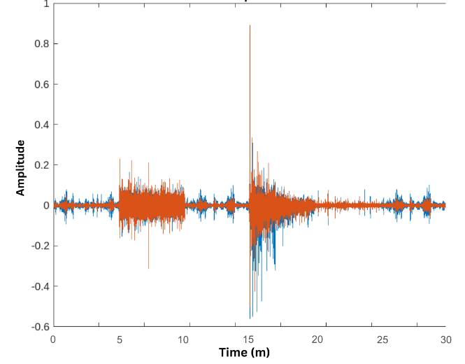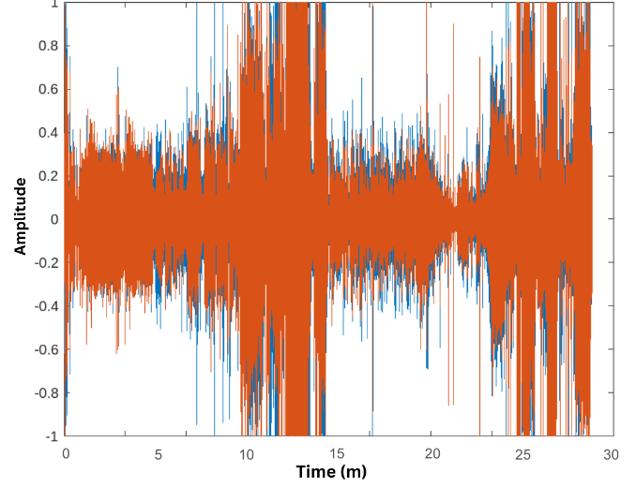
Figure S1. Waveform diagrams contrasting the amplitude and acoustic intensity of the forest (left) and industrial (right) soundscapes. The forest soundscape demonstrates lower amplitude and less consistent intensity, dominated by natural sounds such as bird calls, rain and running water. In contrast, the industrial soundscape shows greater amplitude and consistent intensity, reflecting persistent urban noise from vehicles, traffic, and machinery. Produced using MATLAB v2024_b.

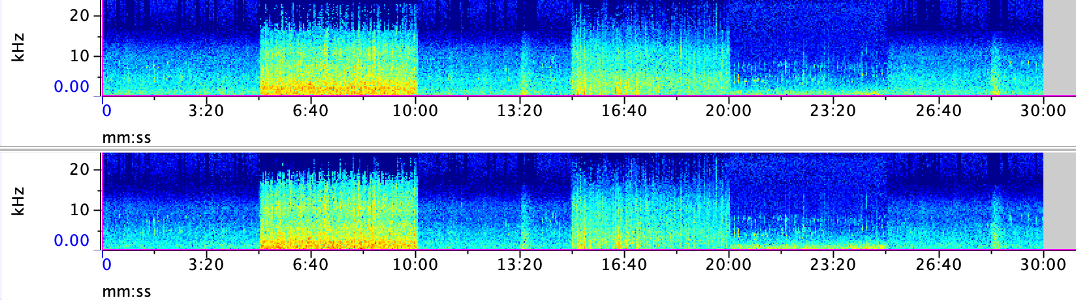
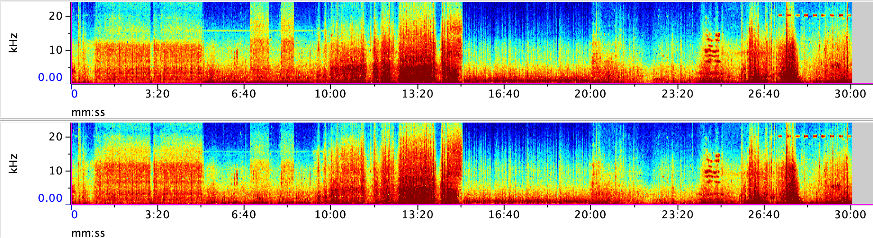

Figure S2. Spectrograms depicting the frequency, intensity and broadband noise characteristics of the forest (upper two bars) and industrial (lower two bars) soundscapes. In the forest soundscape, lower broadband noise (34.9%) is represented by sparse vertical lines and lower intensity (light blue colouration). The industrial soundscape shows a higher percentage of broadband noise (83.5%), with dense vertical lines and greater intensity (deep red/purple colouration), indicating the dominance of noise sources across multiple frequency bands. Produced using Raven Lite Version 2.0.4.
SUPPLEMENTARY INFORMATION 2. Mood data.
EXPERIMENT 1: RANDOMISED CONTROLLED TRIAL (Nature n=50, Industrial n=50)
 | Pre-Nature  Mean (SD) | Post-Nature  Mean (SD) | Pre-Industrial  Mean (SD) | Post-Industrial  Mean (SD) | Pre- vs Post- Nature  (Δ, 95% CI, |d|) | Pre- vs Post-Industrial  (Δ, 95% CI, |d|) | ΔNature vs ΔIndustrial  (Δ, 95% CI, |d|) | Post-Nature vs Post-Industrial (Δ, 95% CI, |d|)
TMD | 97.6 (10.4) | 91.0 (9.3) | 97.6 (9.8) | 101.2 (13.2) | -6.5, [-9.0, -4.2]***, 0.8 | 3.6 [0.3, 6.9]*, 0.3 | -10.2 [-14.2, -6.2]***, 1.0 | -10.2 [-14.7, -5.7]***, 0.9
Tension | 3.3 (2.6) | 1.3 (2.4) | 3.3 (2.6) | 4.8 (3.8) | -2.1 [-2.8, -1.3]***, 0.8 | 1.5 [0.6, 2.4]**, 0.5 | -3.5 [-4.7, -2.4]***, 1.2 | -3.5 [-4.8, -2.2]***, 1.1
Anger | 1.4 (2.8) | 0.7 (2.3) | 0.8 (1.3) | 1.5 (2.5) | -0.7 [-1.1, -0.2]**, 0.4 | 0.7 [0.1, 1.4]*, 0.3 | -1.4 [-2.2, -0.6]***, 0.7 | -0.9 [-1.8, 0.1]**, 0.4
Fatigue | 4.3 (3.1) | 2.6 (2.1) | 5.0 (3.4) | 5.1 (3.8) | -1.7 [-2.4, -0.9]***, 0.6 | 0.1 [-0.6, 0.8], 0.0 | -1.8 [-2.8, -0.8]**, 0.7 | -2.5 [-3.7, -1.2]**, 0.8
Depression | 1.4 (2.2) | 0.5 (1.6) | 1.4 (1.7) | 1.2 (1.9) | -0.8 [-1.3, -0.4]***, 0.5 | -0.2 [-0.6, 0.2], 0.1 | -0.7 [-1.3, 0.3], 0.4 | -0.7 [-1.4, 0.0]**, 0.4
Confusion | 4.0 (3.0) | 1.7 (2.1) | 4.0 (2.7) | 3.4 (3.0) | -2.3 [-3.0, -1.6]***, 0.9 | -0.7 [-1.3, 0.0], 0.0 | -1.6 [-2.6, -0.7]**, 0.7 | -1.6 [-2.7, -0.6]**, 0.6
Vigour | 4.3 (3.4) | 3.5 (2.6) | 3.7 (3.0) | 3.1 (2.5) | -0.8 [-1.6, 0.0]*, 0.3 | -0.7 [-1.4, 0.0]*, 0.3 | -0.1 [-1.2, 0.5], 0.1 | 0.4 [-0.6, 1.4], 0.2
ERA | 12.5 (2.9) | 12.4 (2.8) | 13.3 (2.5) | 11.7 (2.6) | -0.1 [-0.8, 0.5], 0.1 | -1.5 [-2.3, -0.8]***, 0.6 | -1.4 [-2.4, -0.4]**, 0.6 | 0.6 [-0.4, 1.7], 0.2
***p < 0.001; **p < 0.01; *p < 0.05.

EXPERIMENT 2: CROSSOVER TRIAL (n=30)
 | Pre-Nature  Mean (SD) | Post-Nature  Mean (SD) | Pre-Industrial  Mean (SD) | Post-Industrial  Mean (SD) | Condition*Time Interaction  F(1,29), Partial η² | Pre- vs Post-Nature  (Δ, 95% CI) | Pre vs Post-Industrial  (Δ, 95% CI) | Post-Nature vs Post-Industrial  (Δ, 95% CI)
TMD | 100.0 (13.2) | 94.8 (11.1) | 100.1 (15.8) | 101.4 (12.8) | 5.381*, 0.157 | -5.2 [-8.2, -2.3]** | 1.3 [-2.9, 5.5] | -6.6 [-10.9, -2.3]**
Tension | 4.3 (3.9) | 1.9 (2.5) | 3.9 (3.9) | 4.2 (3.5) | 8.685**, 0.230 | -2.4 [-3.4, -1.4]*** | 0.3 [-1.2, 1.9] | -2.4 [-3.7, -1.0]**
Anger | 1.3 (2.2) | 0.3 (0.9) | 1.1 (2.3) | 1.2 (1.6) | 6.115*, 0.174 | -1.0 [-1.7, -0.4]** | -0.1 [-0.7, 0.6] | -0.9 [-1.4, -0.4]**
 | Pre-Nature  Mean (SD) | Post-Nature  Mean (SD) | Pre-Industrial  Mean (SD) | Post-Industrial  Mean (SD) | Condition*Time Interaction  F(1,29), Partial η² | Main effect of Time, Pre-Post (Δ, 95% CI) | Main effect of Condition, Nature-Industrial  (Δ, 95% CI)
Fatigue | 6.8 (3.5) | 5.4 (3.7) | 7.1 (4.4) | 6.7 (4.4) | 2.876, 0.090 | -0.9 [-1.5, -0.2]* | 0.8 [-0.5, 2.2]
Depression | 1.2 (2.0) | 0.6 (1.6) | 1.4 (2.7) | 1.3 (2.9) | 1.302, 0.043 | -0.4 [-0.8, 0.0] | 0.5 [-0.1, 1.1]
Confusion | 4.1 (3.0) | 3.1 (2.5) | 3.8 (3.1) | 3.0 (2.2) | 0.145, 0.005 | -0.9 [-1.4, -0.4]*** | -0.2 [-1.0, 0.5]
Vigour | 4.2 (3.7) | 3.5 (3.1) | 4.2 (3.1) | 3.2 (2.8) | 0.420, 0.014 | -0.8 [-1.4, -0.2]* | -0.2 [-1.0, 0.7]
ERA | 13.4 (3.4) | 12.9 (3.3) | 13.0 (3.2) | 11.8 (2.7) | 1.787, 0.058 | -0.9 [-1.5, -0.3]** | -0.8 [-1.6, 0.1]
***p < 0.001; **p < 0.01; *p < 0.05.
Table S2. Pre- and Post-Trial Mood data. Experiment 1 data reports Wilcoxon signed rank test and Mann Whitney U Test analyses of Pre vs Post-Nature, Pre vs Post-Industrial and Post-Nature vs Post-Industrial. Experiment 2 reports a 2x2 repeat measures ANOVA. For variables exhibiting a significant interaction effect of Time and Condition (i.e., TMD, Tension and Anger), post-hoc tests are reported, with Bonferroni correction applied. For variables that did not exhibit a significant interaction effect of Time and Condition, the Main Effects of Time and Condition are reported. Abbreviations: TMD = total mood disturbance, a composite measure of mood.
SUPPLEMENTARY INFORMATION 3. Physiological stress data.
EXPERIMENT 1: RANDOMISED CONTROLLED TRIAL (Nature n=50, Industrial n=50)
 | Pre-Nature  Mean (SD) | Post-Nature  Mean (SD) | Pre-Industrial  Mean (SD) | Post-Industrial  Mean (SD) | Pre- vs Post-Nature  (Δ, 95% CI, |d|) | Pre- vs Post-Industrial  (Δ, 95% CI, |d|) | ΔNature vs ΔIndustrial  (Δ, 95% CI, |d|) | Post-Nature vs Post-Industrial (Δ, 95% CI, |d|)
Cortisol† | 26.3 (14.1) | 17.1 (10.0) | 25.5 (17.0) | 14.1 (7.6) | -9.3, [-12.3, -6.3]***, 1.2 | -11.4, [-15.9, -6.9]***, 1.0 | -2.2, [-7.4, 3.1], 0.2 | -3.6 [-8.6, 1.2], 0.4
Systolic BP | 112.1 (10.9) | 112.7 (9.6) | 112.7 (10.7) | 110.4 (10.1) | 0.6, [-1.1, 2.3], 0.1 | -2.3, [-4.1, -0.5]**, 0.4 | -2.9, [-5.3, -0.4]*, 0.5 | -2.3 [--6.2, 1.6], 0.2
Diastolic BP | 65.9 (8.2) | 65.9 (7.8) | 65.3 (6.9) | 66.6 (5.90 | 0.0, [-1.8, 1.8], 0.0 | 1.3, [-0.1, 2.7]*, 0.3 | 1.3, [-0.9, 3.5], 0.2 | 0.7 [-2.1, 3.4], 0.1
Heart Rate | 68.0 (10.2) | 65.8 (10.1) | 69.3 (11.1) | 67.1 (9.5) | -2.1, [-3.5, -0.8]**, 0.4 | -2.1, [-3.7, -0.6]**, 0.4 | 0.0, [-2.1, 2.1], 0.0 | 1.3 [-2.5, 5.2], 0.1
RMSSD | 46.3 (20.1) | 59.0 (27.8) | 47.5 (24.6) | 56.7 (31.6) | 12.7, [6.6, 18.8]***, 0.6 | 9.3, [2.8, 15.7]**, 0.4 | 3.4, [-5.3, 12.2], 0.2 | 2.3, [-9.5, 14.1], 0.1
Log(HF) | 2.9 (0.4) | 3.0 (0.3) | 2.8 (0.5) | 2.9 (0.5) | 0.2, [0.1, 0.3]***, 0.5 | 0.1, [0.0, 0.2]**, 0.4 | 0.0, [-0.1, 0.2], 0.1 | 0.1, [0.0, 0.3], 0.3
Log(LF) | 3.2 (0.3) | 3.3 (0.3) | 3.2 (0.3) | 3.2 (0.3) | 0.1, [0.0, 0.2], 0.3 | 0.1, [0.0, 0.1], 0.2 | 0.0, [-0.1, 0.1], 0.1 | 0.0, [-0.1, 0.2], 0.1
HF/LF | 2.6 (1.9) | 2.1 (1.4) | 2.9 (2.0) | 2.5 (1.7) | -0.5, [-1.1, 0.1], 0.2 | -0.5, [-1.1, 0.2], 0.2 | -0.3, [-1.0, 0.3], 0.2 | -0.3, [-1.0, 0.3], 0.2
***p < 0.001; **p < 0.01; *p < 0.05.
†Cortisol: Nature n = 29, Industrial n = 27.

EXPERIMENT 2: CROSSOVER TRIAL (n=30)
 | Pre-Nature  Mean (SD) | Post-Nature  Mean (SD) | Pre-Industrial  Mean (SD) | Post-Industrial  Mean (SD) | Condition*Time Interaction.  F(1,29), Partial η² | Main effect of Time. F(1,29), Partial η² | Main effect of Condition. F(1,29), Partial η²
Cortisol† | 0.8 (0.5) | 0.5 (0.3) | 0.7 (0.6) | 0.7 (0.7) | 3.413, 0.112 | 8.831**, 0.246 | 0.666, 0.024
Systolic BP | 114.3 (11.6) | 113.7 (10.8) | 114.3 (12.9) | 113.4 (12.6) | 0.013, 0.000 | 0.635, 0.021 | 0.007, 0.000
Diastolic BP | 69.1 (8.9) | 70.9 (7.9) | 71.4 (7.5) | 69.9 (7.8) | 1.6, 0.05 | 0.016, 0.001 | 0.416, 0.014
Heart Rate | 69.1 (9.2) | 67.1 (9.3) | 69.7 (10.3) | 66.5 (10.9) | 0.904, 0.030 | 7.965**, 0.215 | 0.992, 0.000
RMSSD | 50.7 (23.8) | 65.2 (30.6) | 53.9 (33.3) | 62.7 (29.8) | 1.191, 0.039 | 13.198**, 0.313 | 0.016, 0.001
Log(HF) | 3.0 (0.4) | 3.1 (0.5) | 3.0 (0.4) | 3.1 (0.4) | 0.003, 0.000 | 8.040**, 0.217 | 0.009, 0.000
Log(LF) | 3.2 (0.4) | 3.3 (0.4) | 3.3 (0.4) | 3.3 (0.3) | 6.022*, 0.172 | 3.154, 0.098 | 1.012, 0.034
HF/LF | 2.2 (1.3) | 1.9 (1.3) | 2.5 (1.3) | 2.0 (1.5) | 0.154, 0.005 | 4.270*, 0.128 | 1.155, 0.038
***p < 0.001; **p < 0.01; *p < 0.05. Wilcoxon signed-rank test.
†Cortisol: n = 28, F(1,27).
Table S3. Pre- and Post-Trial physiological stress data. Experiment 1 data reports Wilcoxon signed rank test and Mann Whitney U Test analyses of Pre vs Post-Nature, Pre vs Post-Industrial and Post-Nature vs Post-Industrial. Experiment 2 reports a 2x2 repeat measures ANOVA. No variables exhibited a significant interaction effect of Time and Condition. For variables not exhibiting a significant interaction effect of Time and Condition, the Main Effects of Time and Condition are reported. Abbreviations: RMSSD = the Root mean square of successive differences, indicative of parasympathetic activity and vagal tone; HF = High Frequency activity, indicative of parasympathetic nervous system activity; LF = low frequency activity and HF/LF = ratio of high to low frequency activity, both indicating sympathetic nervous system activity.

SUPPLEMENTARY INFORMATION 4 Self-reported restorative measures and mental bandwidth.

 | Experiment 1 (Nature n=50, Industrial n=50) |  |  |  |  | Experiment 2 (n=30)
 | Post-Nature  Mean (SD) | Post-Industrial  Mean (SD) | Post-Nature vs Post-Industrial (Δ, 95% CI, |d|) |  |  | Post-Nature  Mean (SD) | Post-Industrial  Mean (SD) | Post-Nature vs Post-Industrial (Δ, 95% CI, |d|)
Perceived Restorativeness Scale – Away (PRS-A) | 3.3 (1.3) | 2.1 (1.2) | 1.2, [0.7, 1.7]***, 1.0 |  |  | 3.3 (1.1) | 2.4 (1.3) | 0.9, [0.4, 1.5]**, 0.6
Perceived Restorativeness Scale – Extent (PRS-E) | 3.1 (1.1) | 2.4 (1.1) | 0.7, [0.3, 1.2] ***, 0.7 |  |  | 2.9 (1.0) | 2.7 (1.1) | 0.2, [-0.3, 0.7], 0.1
Perceived Restorativeness Scale – Fascination (PRS-F) | 3.1 (1.0) | 2.4 (1.1) | 0.7, [0.3, 1.2]**, 0.7 |  |  | 3.0 (0.8) | 2.6 (1.0) | 0.4, [0.0, 0.8]*, 0.4
Mental Bandwidth Scale – Self-awareness (MBS-SA) | 3.0 (0.7) | 2.7 (0.8) | 0.3, [0.0, 0.6], 0.4 |  |  | 2.6 (0.8) | 2.6 (0.9) | 0.0, [-0.4, 0.4], 0.0
Mental Bandwidth Scale – Planning (MBS-P) | 3.5 (1.1) | 3.2 (1.1) | 0.3, [-0.1, 0.8], 0.3 |  |  | 3.0 (1.1) | 2.8 (1.1) | 0.2, [-0.3, 0.7], 0.1
Mental Bandwidth Scale – Daydreaming (MBS-D) | 2.8 (1.0) | 2.8 (0.9) | 0.0, [-0.4, 0.4], 0.0 |  |  | 3.6 (1.1) | 3.0 (1.0) | 0.6, [0.2, 1.1]*, 0.5
***p < 0.001; **p < 0.01; *p < 0.05.
Experiment 1: All Wilcoxon signed rank tests. Experiment 2: Paired-samples t-tests and Wilcoxon signed-rank tests.
Table S4. Post-Trial Questionnaire data. Experiment 1 and 2 data report Paired Samples t-tests and Wilcoxon signed rank test (N MBS-D, U PRS-A, U MBS-SA) analyses of Post-Nature vs Post-Industrial.

SUPPLEMENTARY INFORMATION 5. Cognitive and immune function data.
EXPERIMENT 1: RANDOMISED CONTROLLED TRIAL (Nature n=49, Industrial n=50)
 | Pre-Nature  Mean (SD) | Post-Nature  Mean (SD) | Pre-Industrial  Mean (SD) | Post-Industrial  Mean (SD) | Pre vs Post-Nature  (Δ, 95% CI, |d|) | Pre vs Post-Industrial  (Δ, 95% CI, |d|) | ΔNature vs ΔIndustrial  (Δ, 95% CI, |d|) | Post-Nature vs Post-Industrial (Δ, 95% CI, |d|)
DPrime | 1.6 (0.6) | 1.8 (0.5) | 1.4 (0.6) | 1.7 (0.6) | 0.2, [-0.1, 0.4]**, 0.5 | 0.3, [0.2, 0.4]***, 0.7 | 0.1, [-0.1, 0.3], 0.2 | 0.2, [-0.1, 0.4], 0.3
Hit Prop | 0.5 (0.2) | 0.6 (0.1) | 0.5 (0.1) | 0.6 (0.1) | 0.1, [0.0, 0.1]***, 0.5 | 0.1, [0.0, 0.1]***, 0.8 | 0.9, [0.0, 0.1], 0.2 | 0.0, [0.0, 0.1], 0.1
FA Prop | 0.1 (0.0) | 0.1 (0.0) | 0.1 (0.1) | 0.1 (0.1) | 0.0, [0.0, 0.0], 0.2 | 0.9, [0.0, 0.0], 0.2 | 0.0, [0.0, 0.0], 0.1 | 0.0, [-0.1, 0.0], 0.5
sIgA† | 242.3 (187.5) | 230.5 (195.6) | 227.5 (150.4) | 229.7 (183.4) | -11.8, [-95.8, -72.2], 0.1 | 2.1, [-60.4, 64.7], 0.0 | -13.9, [-117.1, 51.6], 0.1 | 0.9, [-93.1, 94.8], 0.0
***p < 0.001; **p < 0.01; *p < 0.05.
†sIgA: Nature n = 33, Industrial n = 32.

EXPERIMENT 2: CROSSOVER TRIAL (n=27)
 | Pre-Nature  Mean (SD) | Post-Nature  Mean (SD) | Pre-Industrial  Mean (SD) | Post-Industrial  Mean (SD) | Condition*Time Interaction  F(1,29), Partial η² | Pre vs Post-Nature  (Δ, 95% CI) | Pre vs Post-Industrial  (Δ, 95% CI) | Post-Nature vs Post-Industrial  (Δ, 95% CI)
DPrime | 1.9 (0.9) | 2.5 (0.9) | 2.2 (0.9) | 2.5 (0.8) | 5.641*, 0.178 | 0.6 [0.3, 0.8]*** | 0.3 [0.1, 0.4]** | 0.0 [-0.3, 0.3]
 | Pre-Nature  Mean (SD) | Post-Nature  Mean (SD) | Pre-Industrial  Mean (SD) | Post-Industrial  Mean (SD) | Condition*Time Interaction  F(1,29), Partial η² | Main effect of Time, F(1,29), Partial η² | Main effect of Condition, F(1,29), Partial η²
Hit Prop | 0.6 (0.2) | 0.8 (0.2) | 0.7 (0.2) | 0.8 (0.2) | 3.186, 0.109 | 29.840***, 0.534 | 1.146, 0.042
FA Prop | 0.1 (0.1) | 0.1 (0.0) | 0.1 (0.1) | 0.1 (0.0) | 2.198, 0.078 | 8.652**, 0.250 | 1.731, 0.062
sIgA† | 231.5 (91.4) | 287.6 (151.2) | 236.0 (117.9) | 244.2 (100.4) | 2.811, 0.094 | 3.596, 0.118 | 1.272, 0.045
***p < 0.001; **p < 0.01; *p < 0.05. Wilcoxon signed-rank test.
†sIgA: n = 28, F(1,27).
Table S5. Pre- and Post-Trial cognitive and immune function data. Experiment 1 data reports Wilcoxon signed rank test and Mann Whitney U Test analyses of Pre vs Post-Nature, Pre vs Post-Industrial and Post-Nature vs Post-Industrial. Experiment 2 reports a 2x2 repeat measures ANOVA. DPrime exhibited a significant interaction effect of Time and Condition, so post-hoc tests are reported, with Bonferroni correction applied. For variables not exhibiting a significant interaction effect of Time and Condition, the Main Effects of Time and Condition are reported. Key: DPrime = accuracy within the test of cognitive function; Hit Prop = proportion of successful selections within the cognitive function test; FA Prop = proportion of incorrect selections within the cognitive function test.

https://python-soundfile.readthedocs.io/
10.5281/zenodo.15006942
10.5281/zenodo.7506922

