Elevated co-expression of TIMM17A and NMT1 is associated with poor survival in non-small cell lung cancer
Alfred A. Chan ¹, Kamya Sankar ², Karen L. Reckamp ², Begoña Díaz ^{*1,3,4}, Delphine J. Lee ^{*1,4,5}
1. The Lundquist Institute for Biomedical Innovation at Harbor-UCLA Medical Center, Torrance, California 90502, USA
2. Department of Medicine, Cedars-Sinai Medical Center, Los Angeles, CA, USA.
3. Division of Hematology and Oncology at Harbor-UCLA Medical Center, David Geffen School of Medicine at UCLA, Los Angeles, California, USA
4. Jonsson Comprehensive Cancer Center, UCLA, Los Angeles, California, USA
5. Division of Dermatology at Harbor-UCLA Medical Center, David Geffen School of Medicine at UCLA, Los Angeles, California.
*co-senior

Corresponding Author
Delphine J. Lee
Chief and Program Director
Medicine/Dermatology
delphine.lee@lundquist.org
p: (424) 571-7763

THE LUNDQUIST INSTITUTE
1124 West Carson Street,
Torrance, CA 90502
https://lundquist.org

Key Words: The Cancer Genome Atlas, Lung Adenocarcinoma, NMT1, TIMM17A, Survival

Supplemental Figure S1 – Association between high NMT1 and poor survival was dependent on also having high expression of TIMM17A.
Among patients with high TIMM17A (Right), those with high NMT1 (Red) had significantly lower overall survival compared to those with low NMT1 (Green). Among patients with Low TIMM17A (Left), there were no such differences in overall survival by NMT1 expression, with high overlaps in their confidence intervals.

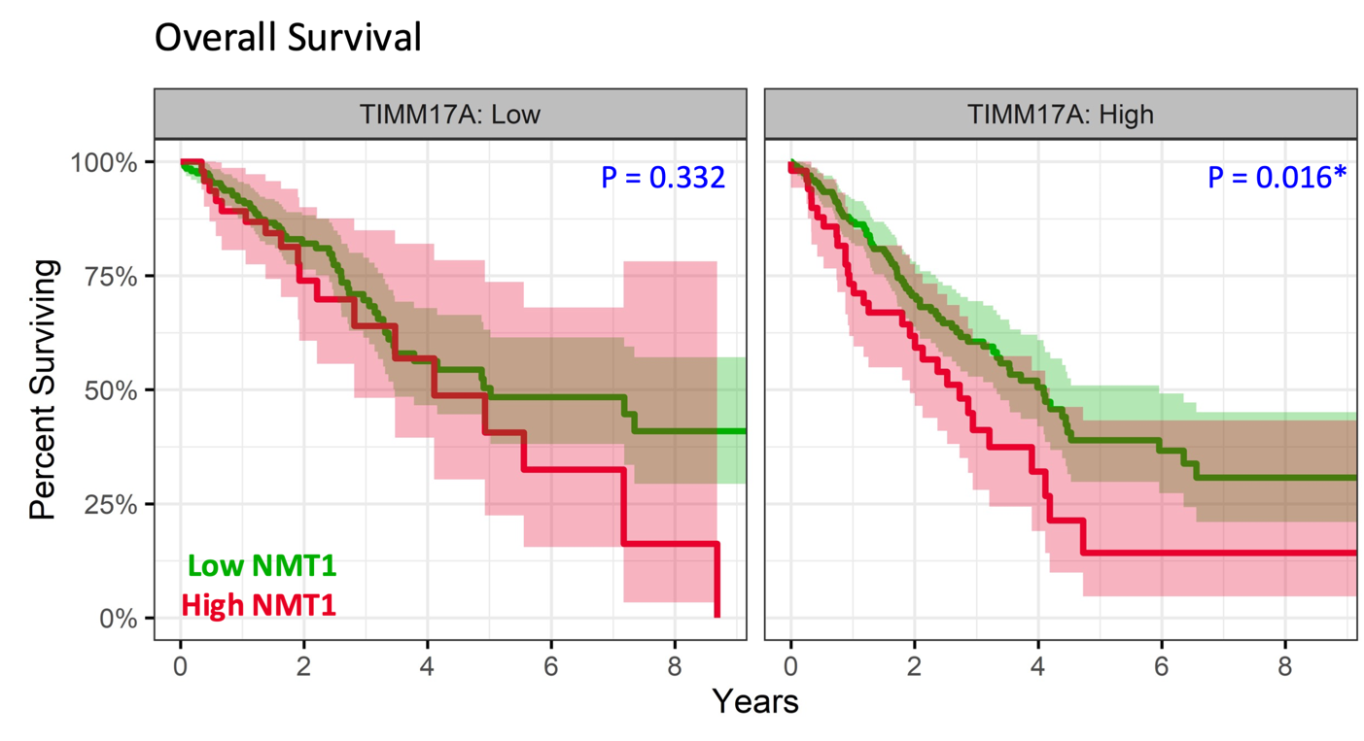

Supplemental Figure S2 – TIMM17A and NMT1 were each associated with worse overall survival in OncoSG ever-smokers
Kaplan-Meier plot comparing high (red) versus low (green) expression of NMT1 (left) and TIMM17A (right) by RNAseq in the OncoSG validation dataset of ever-smokers (comparable to TCGA, which has 85% ever-smokers). Shading in their respective colors represent 95% confidence interval. Hazard Ratios (HR), their 95% confidence intervals (CI), and P-values were calculated using multivariable cox-regression models adjusted for age (mean±SD: 64.1±10.0), gender (n: Male=49, Female=13), and tumor stage (n: I=35, II=11, III=13, IV=1). High TIMM17A and high NMT1 were each associated with worse overall in the ever-smoker subset of OncoSG. NMT1 was split at the 60th percentile and TIMM17A was split at the 50th percentile based on an optimal cutoff tested at every 10 percentiles amongst ever-smokers

