Supplementary Table 1: Basic information of GEO datasets used in the study
GSE number | Platform | Species | Samples
GSE151839 | GPL570 | Homo sapiens | 10 controls and 10 obese patients
GSE28042 | GPL6480 | Homo sapiens | 45 controls and 75 IPF patients
GSE24206 | GPL570 | Homo sapiens | 6 controls and 11 IPF patients
GSE53845 | GPL6480 | Homo sapiens | 8 controls and 40 IPF patients

Supplementary Table 2: Chow composition of high fat diet
High fat diet | G % | Kcal %
Protein | 24 | 20
Fat | 24 | 45
Carbohydrate | 41 | 35

Supplementary Table 3: Sequences of primers for qRT-PCR
Genes | Forward sequence (5’-3’) | Reverse sequence (5’-3’)
NLRC4 | ACAGTTGTCTCTCATGGACAAAG | TTGGCAAGGCTCTCCTGG
SPI1 | TGCTTCCCTTATCCACCCTTG | TCTTCTTGCTGCCTGTCTCC
NCF2 | CATGTTCAATGGACAGGAAGATACC | GAGCTTCAGTTCCTTGGGCT
GAPDH | TGACCACAGTCCATGCCATC | GACGGACACATTGGGGGTAG

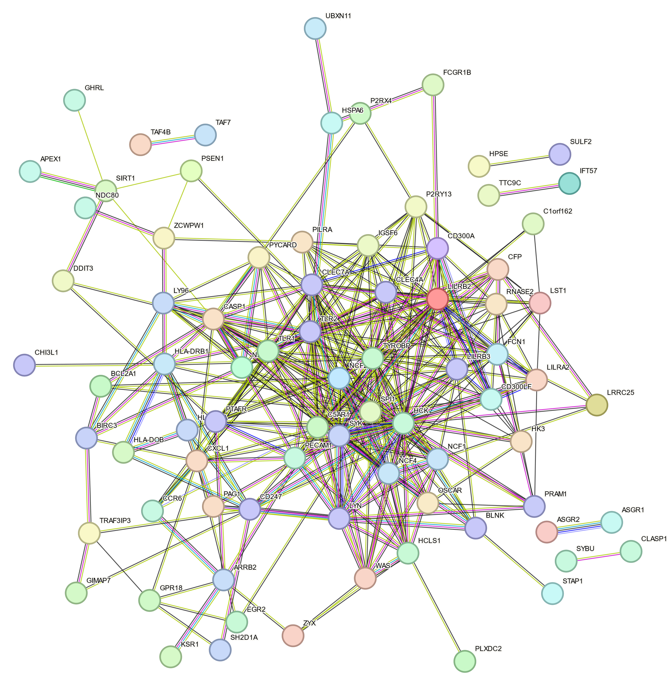
Supplementary Figure 1 The PPI network of shared genes.

