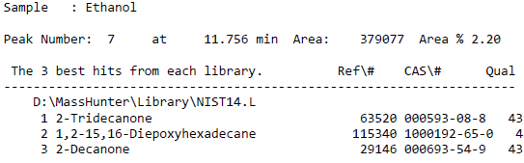
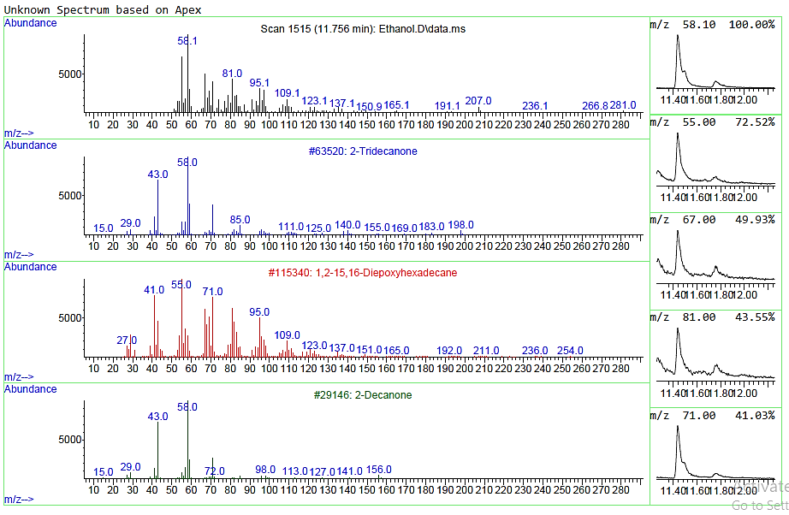

Fig S1. Representative mass spectrum and library identification for Peak 7 in the ethanol extract of Persea americana leaves. Corresponding compound identities are presented in Table 2.

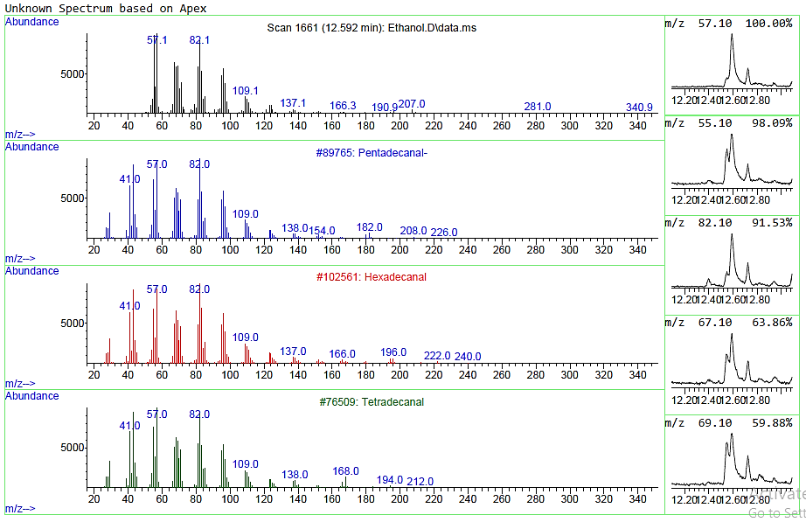
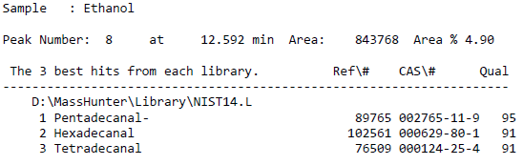
Fig S2. Representative mass spectrum and library identification for Peak 8 in the ethanol extract of Persea americana leaves. Corresponding compound identities are presented in Table 2.

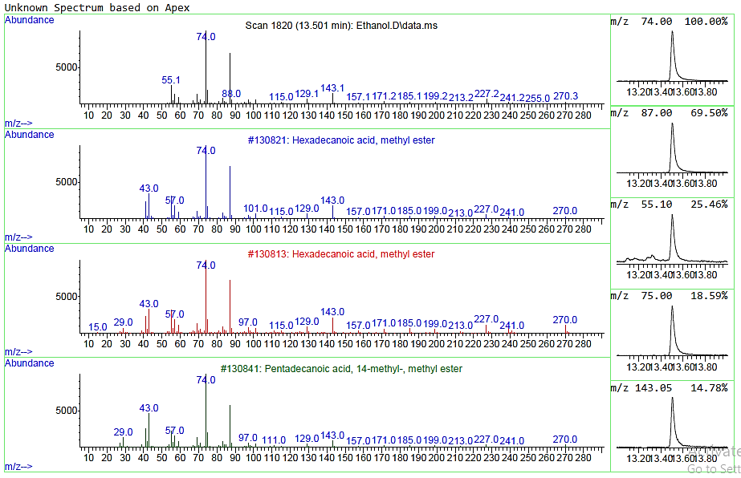
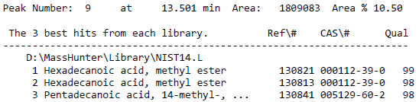
Fig S3. Representative mass spectrum and library identification for Peak 9 in the ethanol extract of Persea americana leaves. Corresponding compound identities are presented in Table 2.

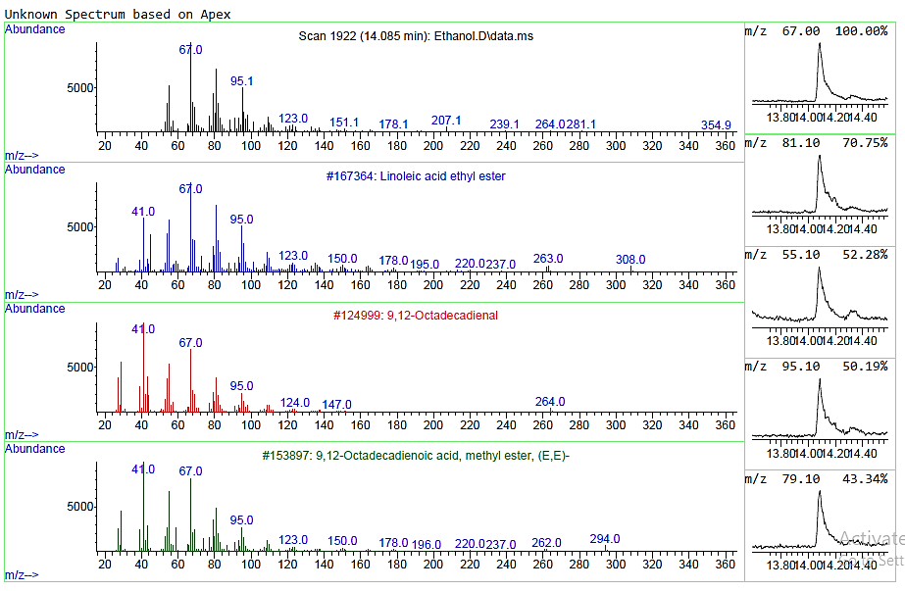
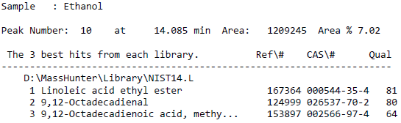
Fig S4. Representative mass spectrum and library identification for Peak 10 in the ethanol extract of Persea americana leaves. Corresponding compound identities are presented in Table 2.
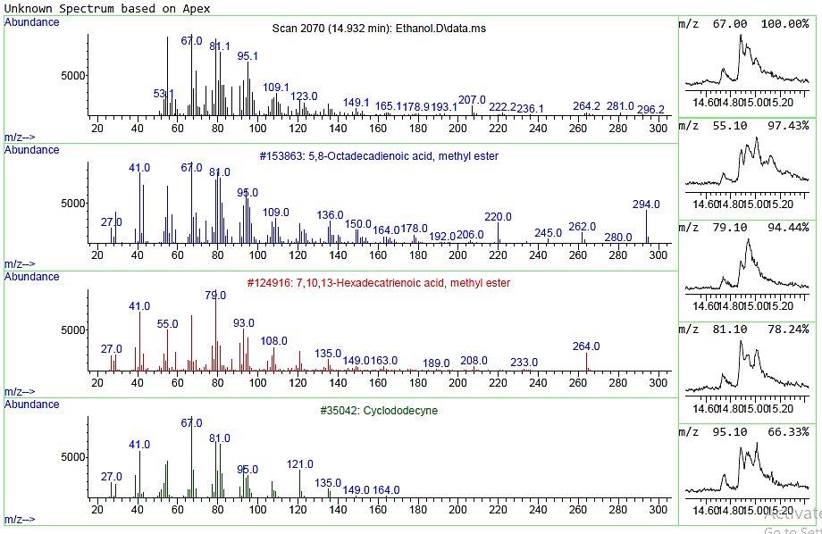
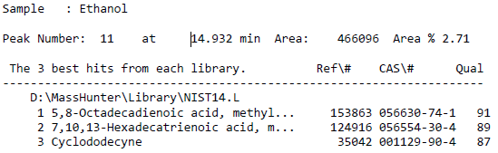
Fig S5. Representative mass spectrum and library identification for Peak 11 in the ethanol extract of Persea americana leaves. Corresponding compound identities are presented in Table 2.

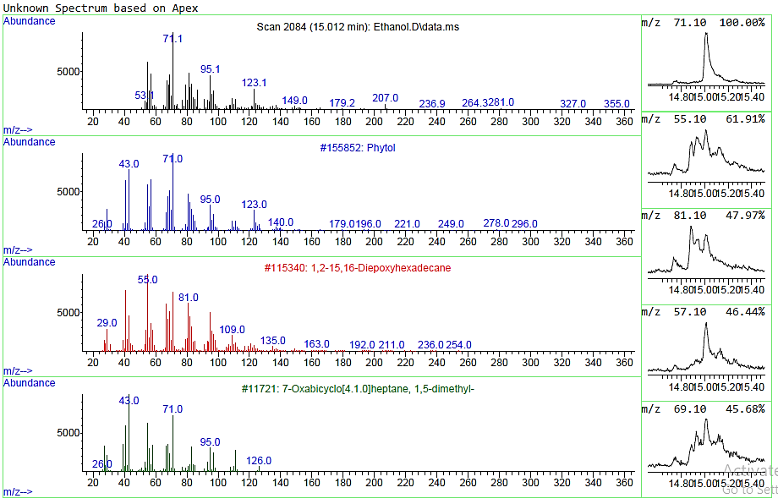
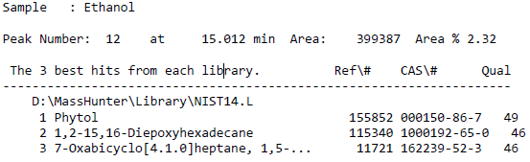
Fig S6. Representative mass spectrum and library identification for Peak 12 in the ethanol extract of Persea americana leaves. Corresponding compound identities are presented in Table 2.
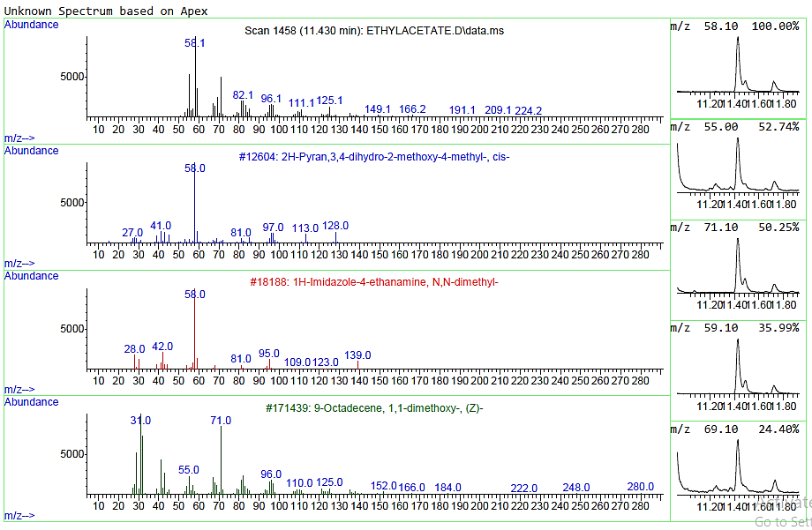
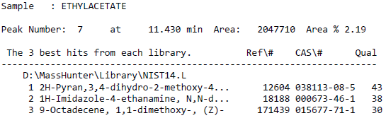
Fig S7. Representative mass spectrum and library identification for Peak 7 in the ethyl acetate extract of Persea americana leaves. Corresponding compound identities are presented in Table 3.

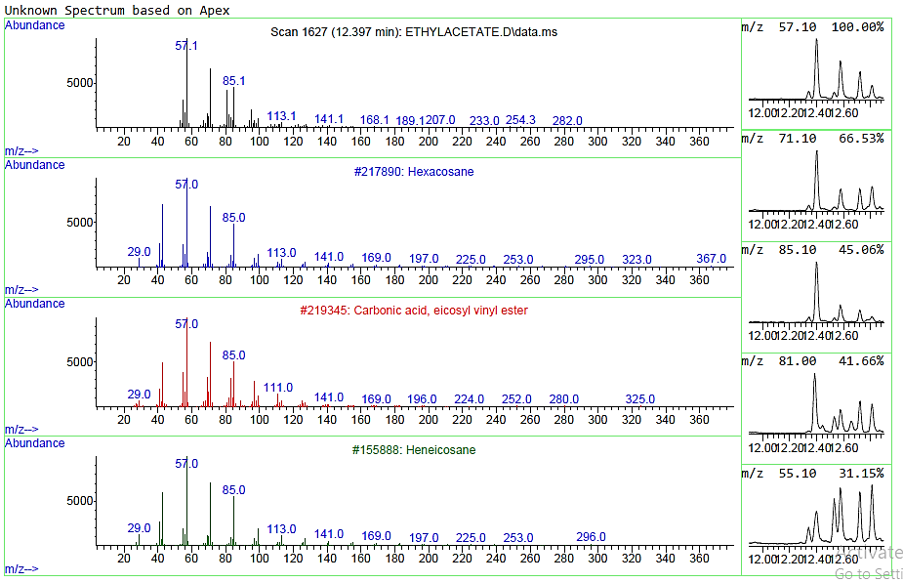
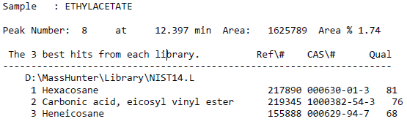
Fig S8. Representative mass spectrum and library identification for Peak 8 in the ethyl acetate extract of Persea americana leaves. Corresponding compound identities are presented in Table 3.
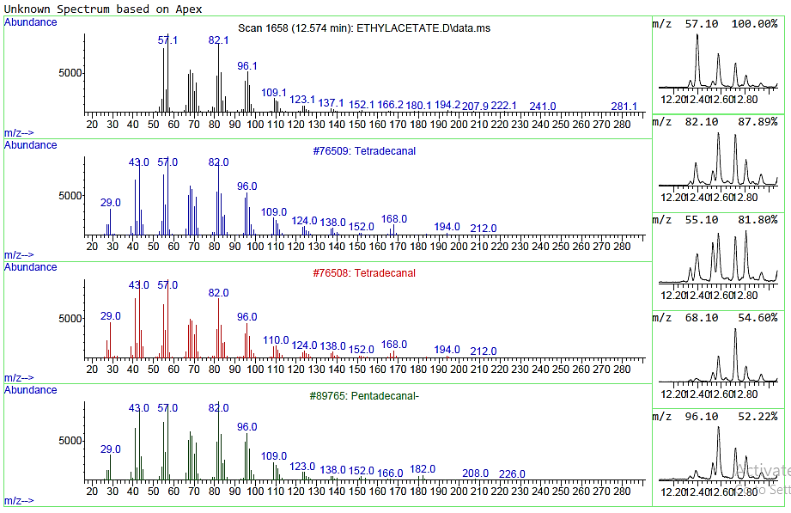
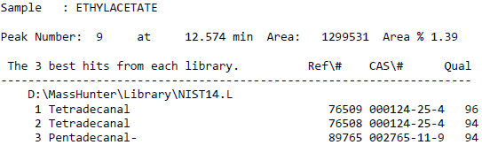
Fig S9. Representative mass spectrum and library identification for Peak 9 in the ethyl acetate extract of Persea americana leaves. Corresponding compound identities are presented in Table 3.

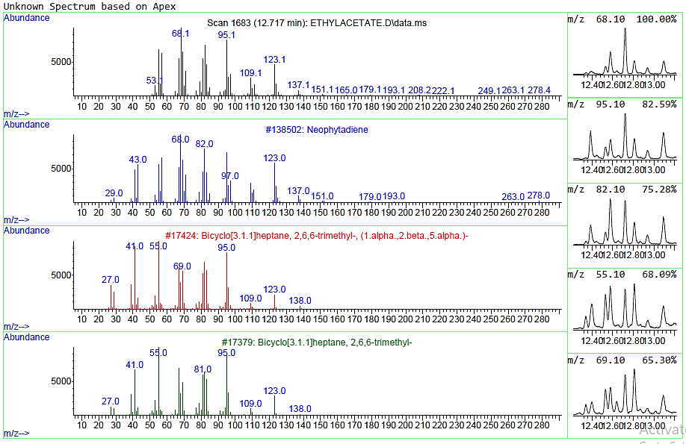
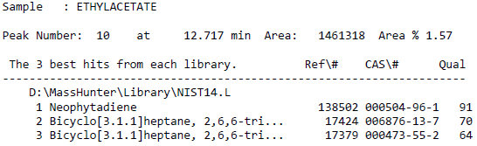
Fig S10. Representative mass spectrum and library identification for Peak 10 in the ethyl acetate extract of Persea americana leaves. Corresponding compound identities are presented in Table 3.
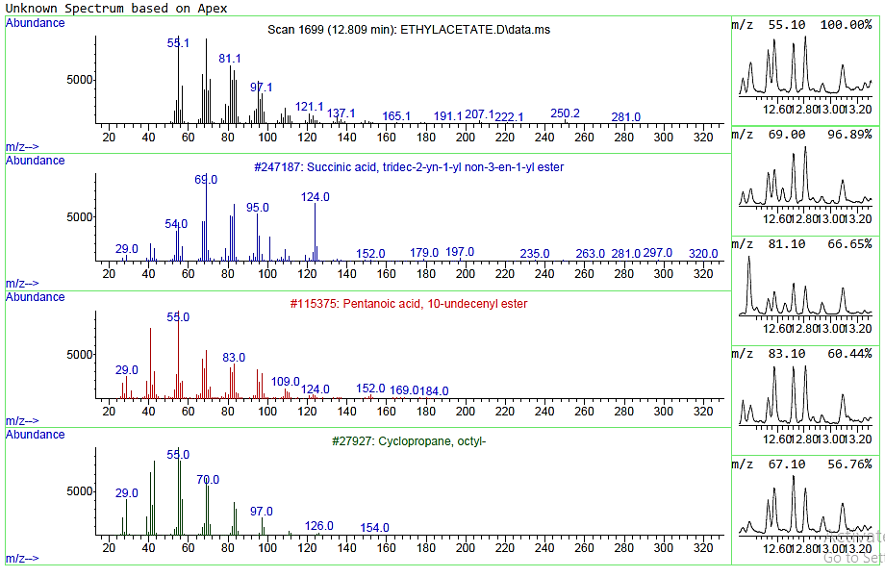
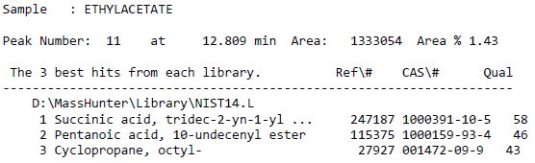
Fig S11. Representative mass spectrum and library identification for Peak 11 in the ethyl acetate extract of Persea americana leaves. Corresponding compound identities are presented in Table 3.

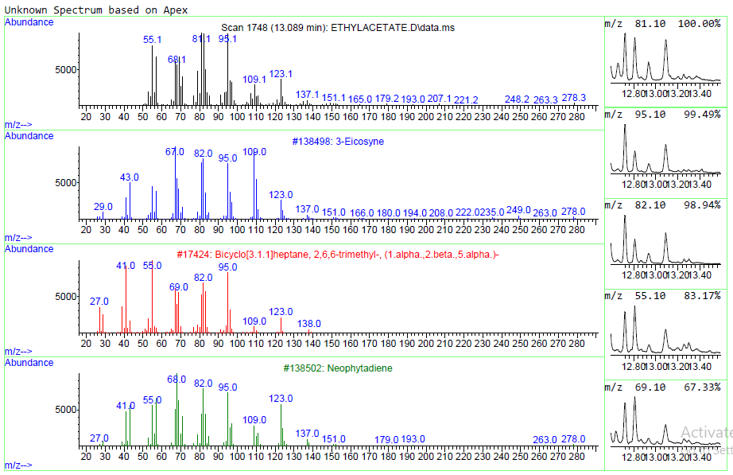
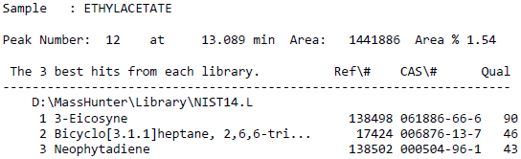
Fig S12. Representative mass spectrum and library identification for Peak 12 in the ethyl acetate extract of Persea americana leaves. Corresponding compound identities are presented in Table 3.
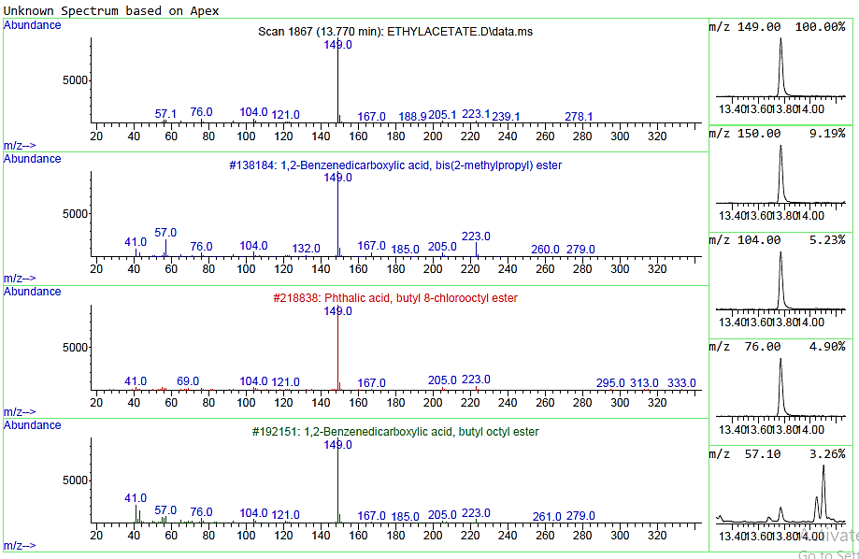
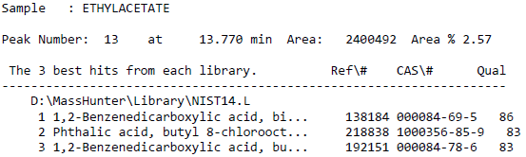
Fig S13. Representative mass spectrum and library identification for Peak 13 in the ethyl acetate extract of Persea americana leaves. Corresponding compound identities are presented in Table 3.

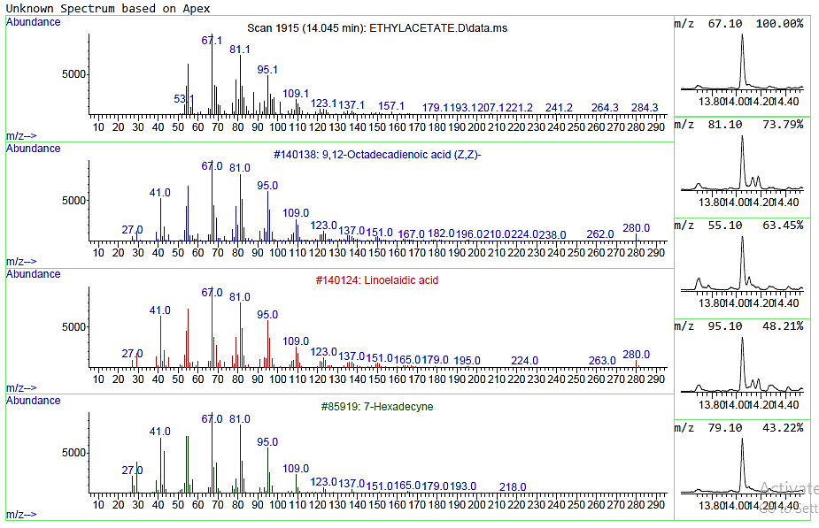
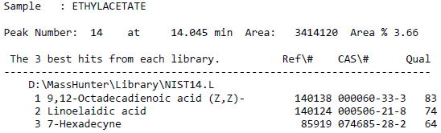
Fig S14. Representative mass spectrum and library identification for Peak 14 in the ethyl acetate extract of Persea americana leaves. Corresponding compound identities are presented in Table 3.
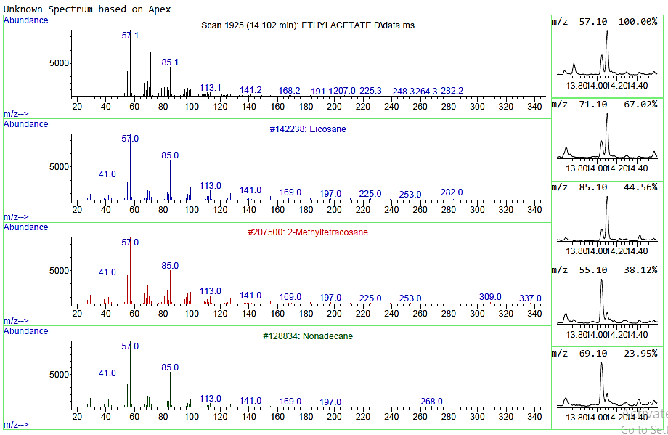
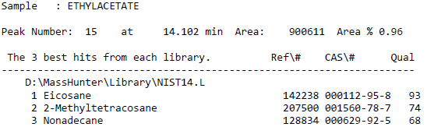
Fig S15. Representative mass spectrum and library identification for Peak 15 in the ethyl acetate extract of Persea americana leaves. Corresponding compound identities are presented in Table 3.
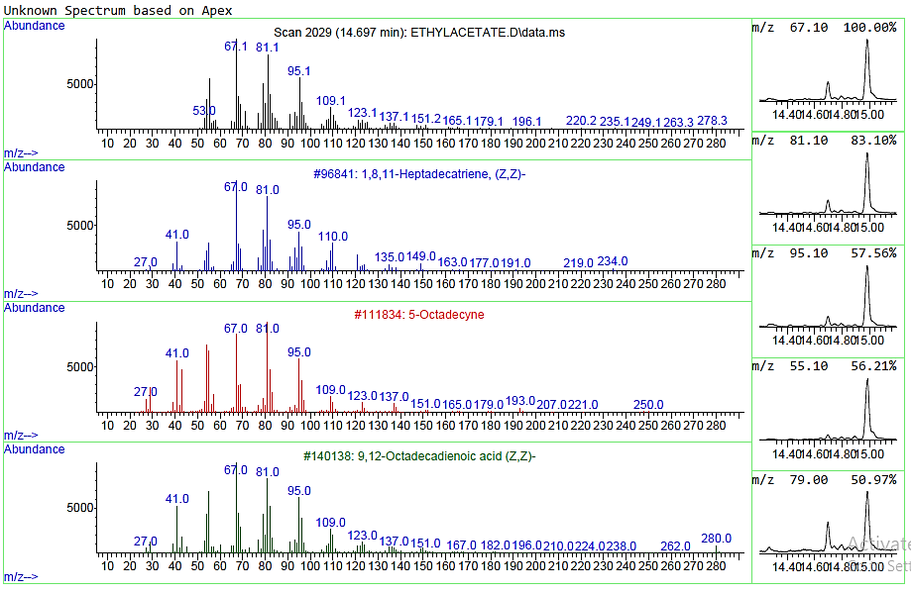
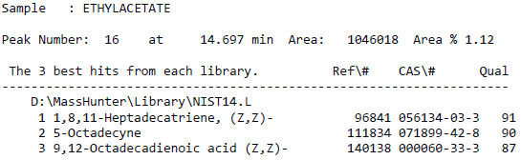
Fig S16. Representative mass spectrum and library identification for Peak 16 in the ethyl acetate extract of Persea americana leaves. Corresponding compound identities are presented in Table 3.
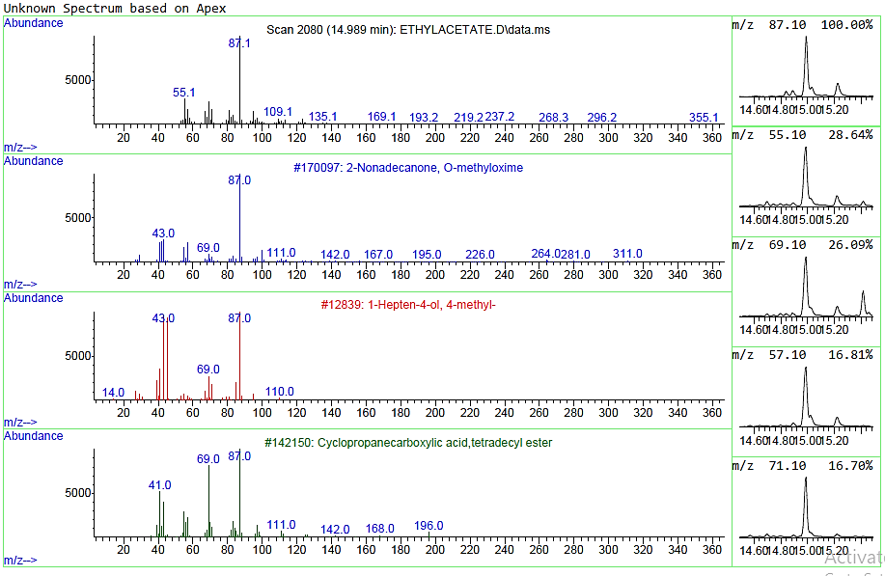
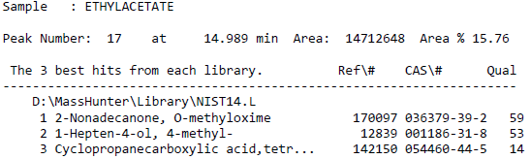
Fig S17. Representative mass spectrum and library identification for Peak 17 in the ethyl acetate extract of Persea americana leaves. Corresponding compound identities are presented in Table 3.

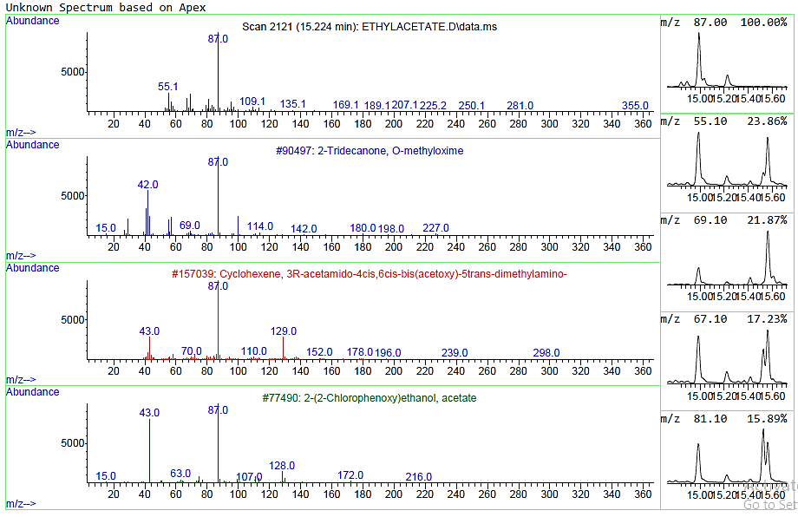
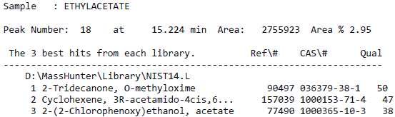
Fig S18. Representative mass spectrum and library identification for Peak 18 in the ethyl acetate extract of Persea americana leaves. Corresponding compound identities are presented in Table 3.
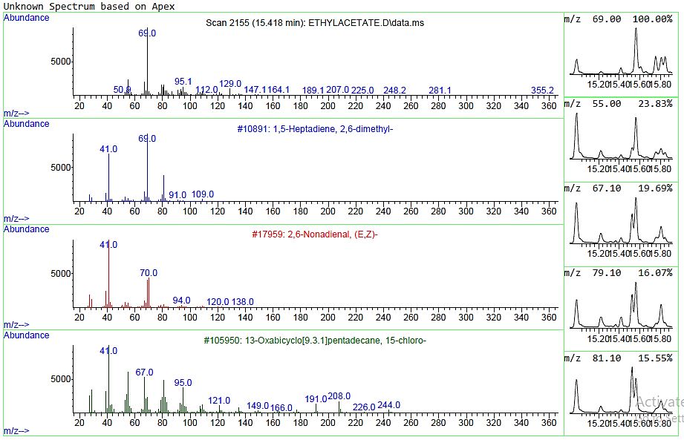
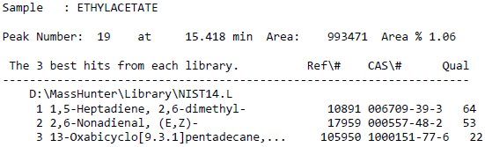
Fig S19. Representative mass spectrum and library identification for Peak 19 in the ethyl acetate extract of Persea americana leaves. Corresponding compound identities are presented in Table 3.

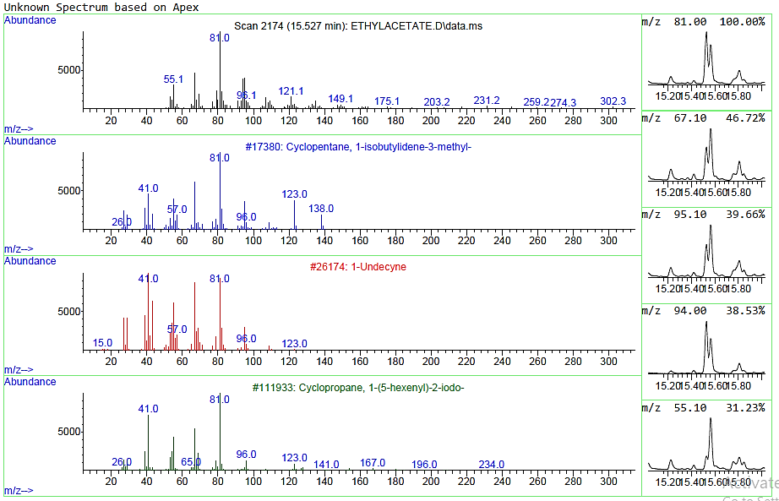
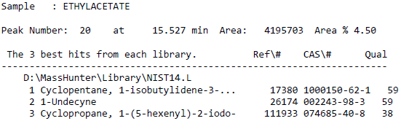
Fig S20. Representative mass spectrum and library identification for Peak 20 in the ethyl acetate extract of Persea americana leaves. Corresponding compound identities are presented in Table 3.
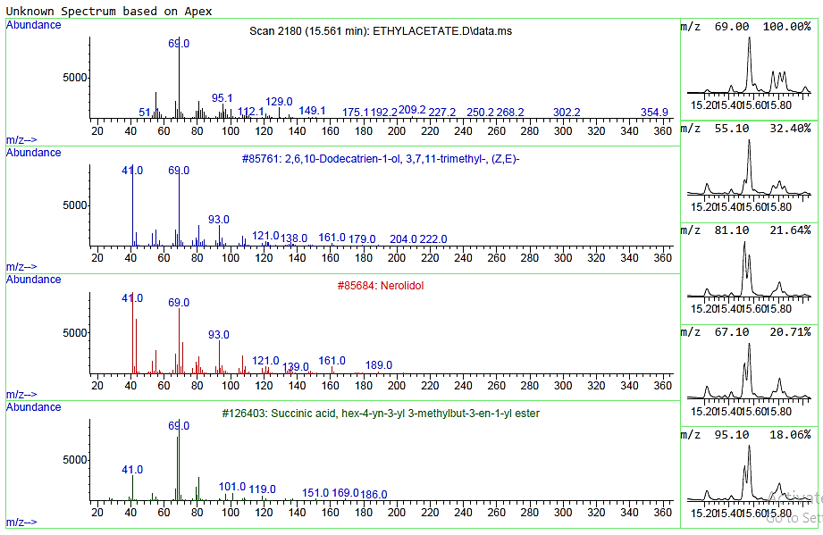
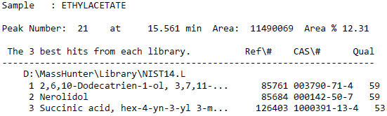
Fig S21. Representative mass spectrum and library identification for Peak 21 in the ethyl acetate extract of Persea americana leaves. Corresponding compound identities are presented in Table 3.

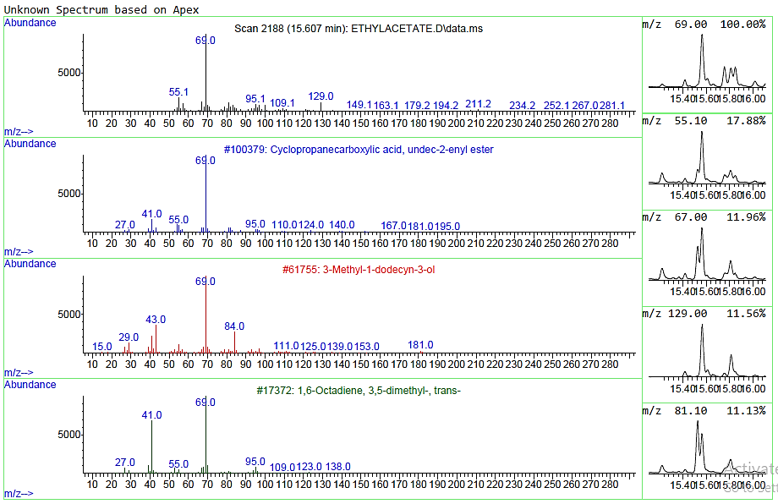
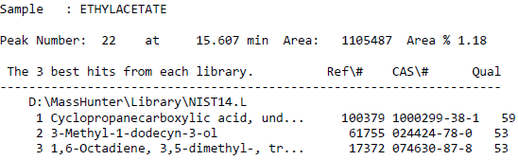
Fig S22. Representative mass spectrum and library identification for Peak 22 in the ethyl acetate extract of Persea americana leaves. Corresponding compound identities are presented in Table 3.
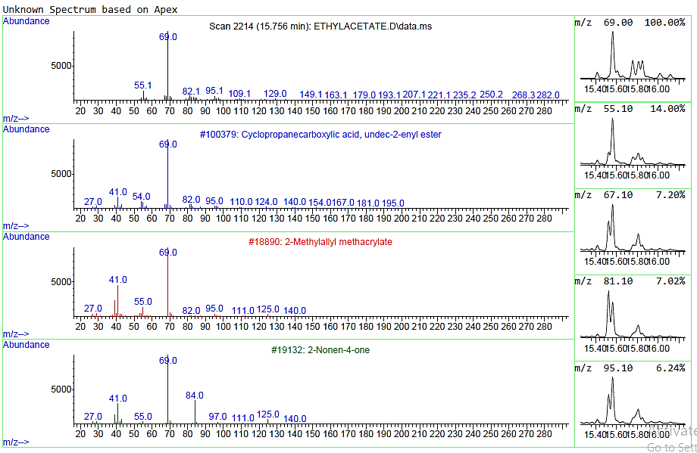
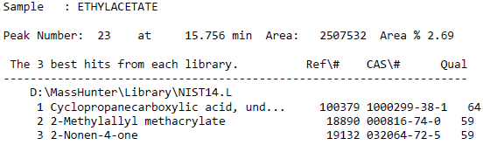
Fig S23. Representative mass spectrum and library identification for Peak 23 in the ethyl acetate extract of Persea americana leaves. Corresponding compound identities are presented in Table 3.
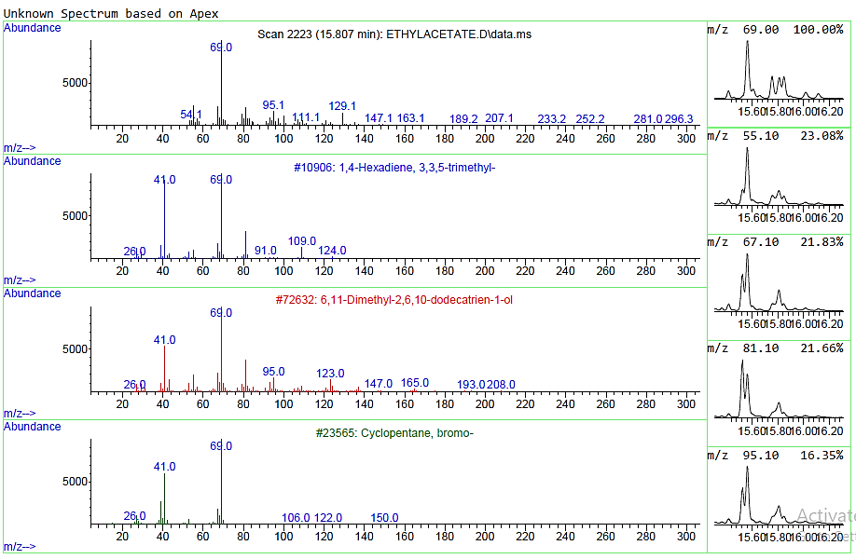
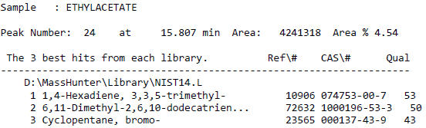
Fig S24. Representative mass spectrum and library identification for Peak 24 in the ethyl acetate extract of Persea americana leaves. Corresponding compound identities are presented in Table 3.
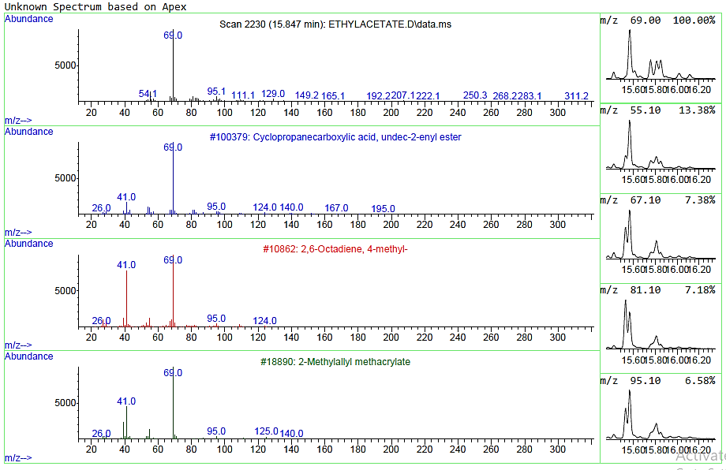
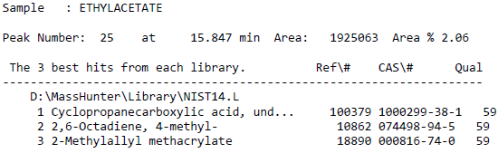
Fig S25. Representative mass spectrum and library identification for Peak 25 in the ethyl acetate extract of Persea americana leaves. Corresponding compound identities are presented in Table 3.

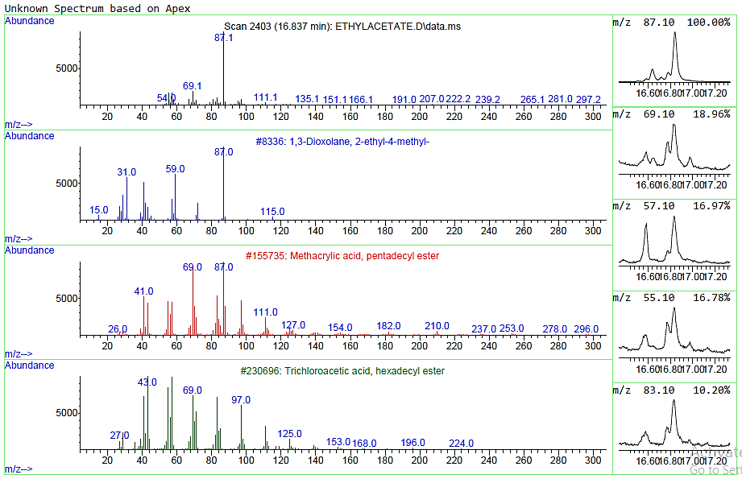
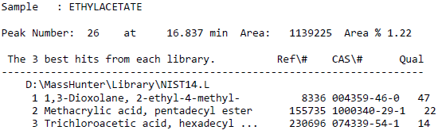
Fig S26. Representative mass spectrum and library identification for Peak 26 in the ethyl acetate extract of Persea americana leaves. Corresponding compound identities are presented in Table 3.
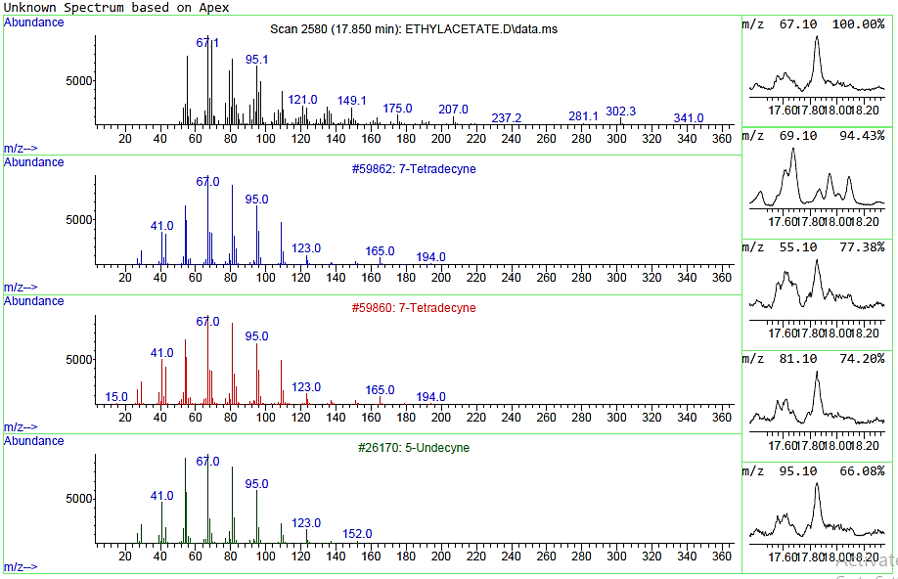
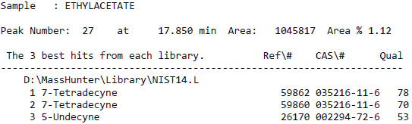
Fig S27. Representative mass spectrum and library identification for Peak 27 in the ethyl acetate extract of Persea americana leaves. Corresponding compound identities are presented in Table 3.
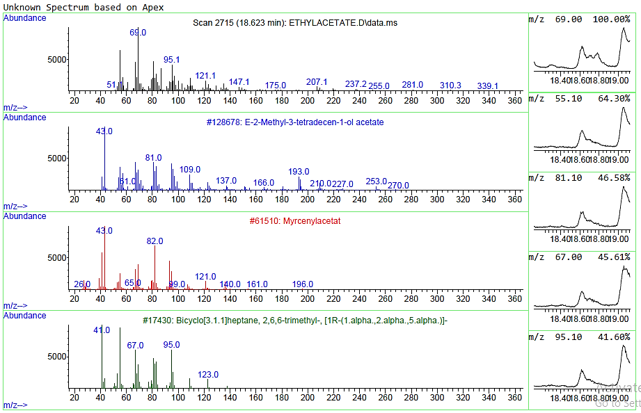
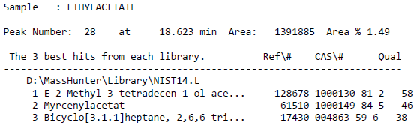
Fig S28. Representative mass spectrum and library identification for Peak 28 in the ethyl acetate extract of Persea americana leaves. Corresponding compound identities are presented in Table 3.
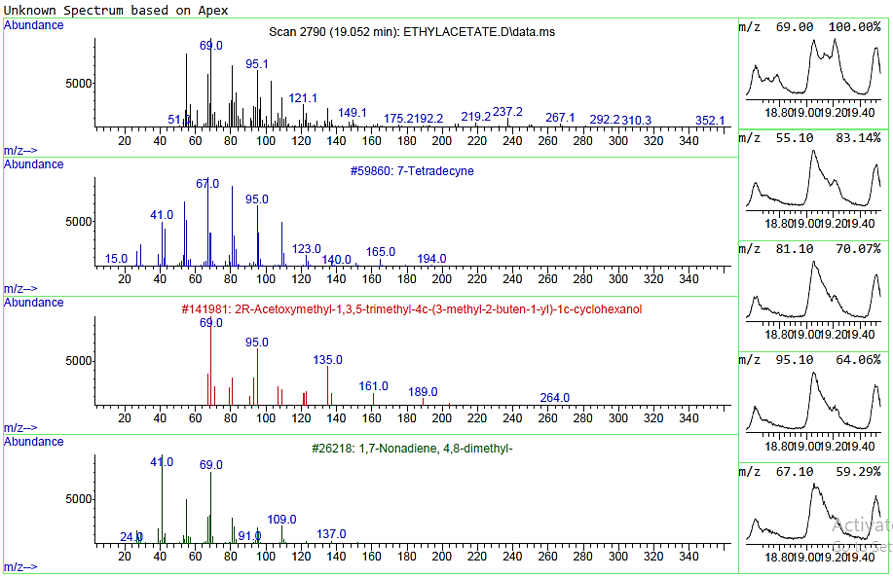
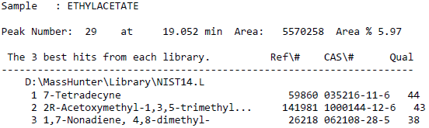
Fig S29. Representative mass spectrum and library identification for Peak 29 in the ethyl acetate extract of Persea americana leaves. Corresponding compound identities are presented in Table 3.
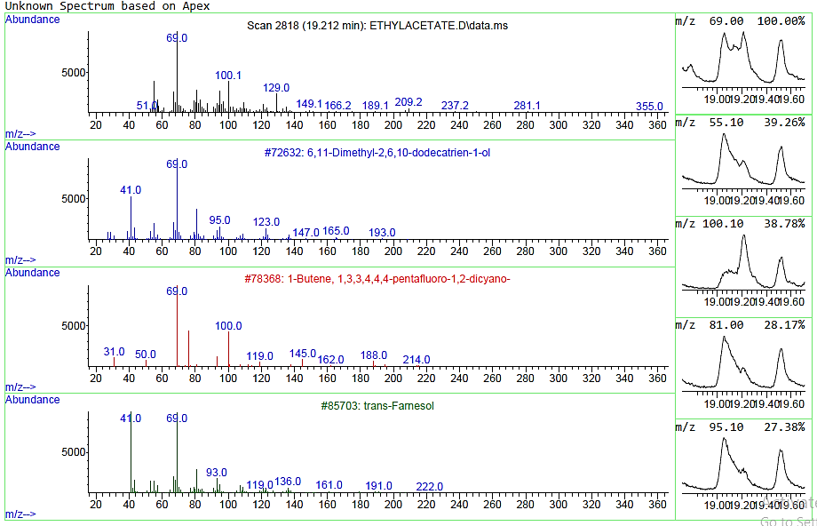
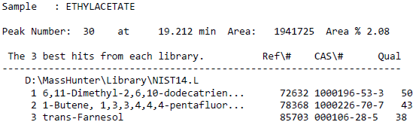
Fig S30. Representative mass spectrum and library identification for Peak 30 in the ethyl acetate extract of Persea americana leaves. Corresponding compound identities are presented in Table 3.
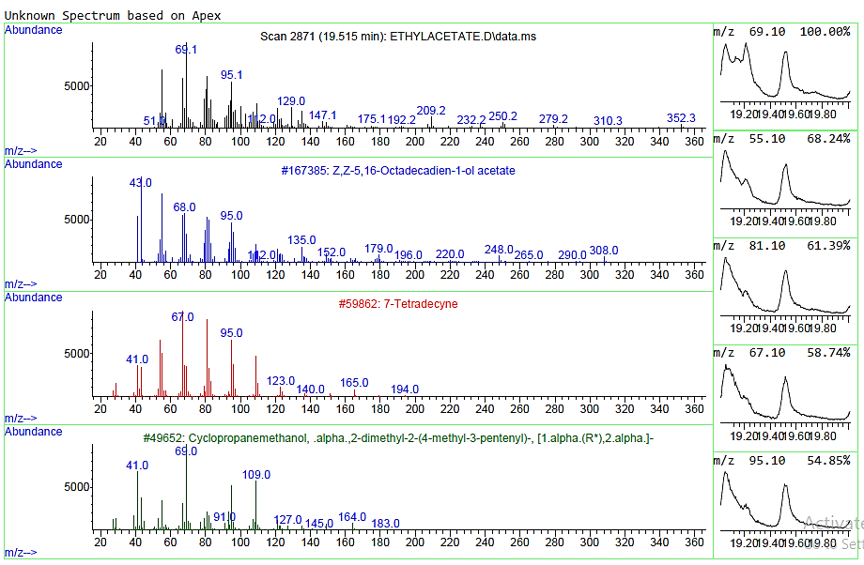
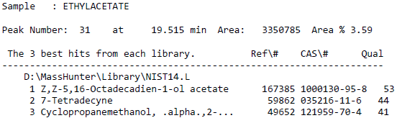
Fig S31. Representative mass spectrum and library identification for Peak 31 in the ethyl acetate extract of Persea americana leaves. Corresponding compound identities are presented in Table 3.

