455 A Supplementary Material

456 A.1 Data structure
457 The dataset for this study encompasses Airbnb listings from 80 cities worldwide. For each of the eight geographic regions of
458 North America, South America, Europe, Africa, West Asia, South Asia, East Asia, and Oceania, we begin by selecting the
459 five most populous cities in which Airbnb is active. Then for each of these large cities, we select a local city nearby with a
460 relatively small population that has a sufficiently large number of Airbnb listings for training and testing purposes. This sample
461 provides us with a list of cities representing different geographic regions, cultures, and climates. Table A.1 presents a list
462 of selected cities and the number of listings in the sample. The downloaded dataset contains posted images of an average
463 of 33,212 listings for large cities and 16,177 listings for small cities. We start with 640,000 downloaded images and after
464 processing and balancing the dataset, this results in a total of over 400,000 images for the selected four rooms. We then use the
465 described machine learning model to identify pictures of kitchens, living rooms, bedrooms, and bathrooms.
466
Regions | Large Cities | Small Cities | #Listings  (large, small)
North America | Mexico City, New York City, Los Angeles,  Toronto, Chicago | Toluca, Albany, Bakers- field, Quebec, Madison | (238692,  127698)
South America | Sao Paulo, Buenos Aires,  Rio de Janeiro, Lima, Bo- gota | Piracicaba, Cordoba, Vi-  toria, Trujillo, Ibague | (173660,  39776)
Europe | London, Berlin, Madrid,  Milan, Paris | Bath, Heidelberg,  Malaga, Siena, Bordeaux | (128428,  116561)
Africa | Kinshasa, Cairo, Abidjan,  Nairobi, Cape Town | Gaborone, Luxor, Ya-  moussoukro, Nakuru, Paarl | (165324,  71735)
Middle East | Istanbul, Riyadh, Ankara,  Dubai, Lahore | Eskisehir, Manama, Yere-  van, Sharjah, Islamabad | (195063,  74133)
South Asia | Delhi, Mumbai, Dhaka,  Chennai, Kolkata | Amritsar, Varanasi, Syl-  het, Lalitpur, Kandy | (115590,  59045)
East Asia | Tokyo, Seoul, Osaka,  Hong Kong, Bangkok | Miyakami, Suncheon,  Okayama, Hualien, Pattaya | (152907,  62884)
Oceania | Sydney, Melbourne,  Auckland, Jakarta, Adelaide | Sunshine Coast, Can-  berra, Wellington, Den- pasar, Margaret River | (158830,  95275)

467

Table S1. List of selected cities and number of downloaded images per city.

468 A.2 Visual Difference and Socioeconomic connectivity
469 Socioeconomic connectivity is proxied by the number of flights between the pairs of cities. This information is obtained from
470 the dataset ICAO Data+ M2: Traffic By Flight Stage [51]. The International Civil Aviation Organization (ICAO) collects air
471 transport statistics data from all of its 193 member states. These include passenger and flight counts for and between airports,
472 fleet and personnel data for carriers, financial data and the like. We use this dataset to query the number of direct flights between
473 every city pair for large cities in our dataset. Since not all large cities have directs flights between them, we use a subset of 238
474 city pairs for our analysis. Due to these limiatations, we only report data for large cities. The number of flights between cities is
475 used as a metric for capturing the strength of the socioeconomic connectivity between them. In line with our other findings, our
476 analysis reveals an inverse correlation between visual difference and air traffic (Figure S1).

477 A.3 Residual Analysis for Section 2.2.4
478 This section supports the analysis performed in Section 2.2.4 which aimed to explore the difference in the impact of geography
479 and degree of globalization on visual profile and object composition in interiors. Specifically, we hypothesized that degree of
480 globalization is more connected with the object composition of interiors, while geographic distance is more connected with the
481 visual appearance of interiors.
482 One major issue hindering this comparison is the inability to properly decouple the appearance of objects from their typology.
483 While the object composition dataset we collected indeed counts the occurrences of objects by type, the ‘visual differences’

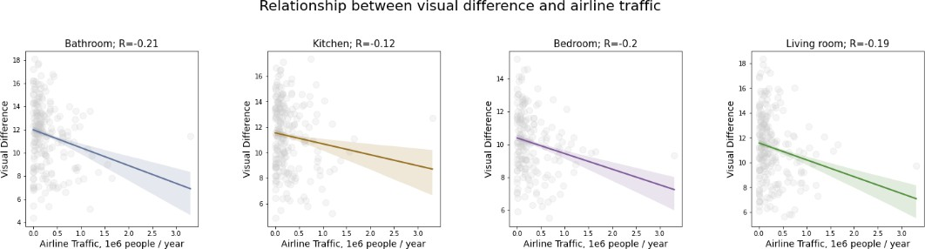

Figure S1. Relationship between visual differences and airline traffic for 4 room types in large cities.

484 between images come from a neural network’s latent space that considers the image as a whole. Therefore, the ‘visual
485 differences’ in fact encompass both the appearance of objects and their composition (occurrence) in images.
486 In order to decouple the ‘true visual appearance’ factor from the composite one, we calculated a residual of the visual appearance
487 with respect to the object [52]. Considering V as a model describing the visual distinctiveness between given city pairs and O
488 as a model describing the difference in object composition, we obtained RV = V (O) → ↑V ↓(O) as the value of V that is not
489 described by its relationship with O. We called the model RV residual visual factor as a measure of visual differences that
490 does not include object morphology. In Figure 6 we visualized the differences of residual visual, visual, and objects as plotted
491 against geographic distance and the difference in degree of globalization. For the plots of residual visual, visual, and object
492 differences plotted against geographic distance, the correlation is strong for the residual visual and visual differences but is
493 very weak for object difference. At the same time, the plots in the same order against the difference in globalization show an
494 increase in correlation towards the object difference.
495 Although we used the residual visual factor to illustrate the difference anecdotally, we exploited the difference in Akaike
496 Information Criterion (AIC) to confirm the significance of this difference [53]. AIC is a common method for best model
497 selection widely applied in a variety of domains, from environmental studies [54] to sociology [55]. We computed the AIC for
498 difference in globalization with respect to visual difference and object composition and obtained a difference for each type of
499 room. We repeated the same experiment for geographic distance. The objective of computing AIC difference was to explore
500 whether adding another external variable (visual difference to object composition) could make the model significantly more
501 informative. The result in AIC differences are stored in Tables S2 and S3. Considering that the difference above 2-5 AIC values
502 is considered significant [56], we see that for difference in globalization, object composition is significantly more informative
503 in 3 out of 4 rooms, and visual appearance is more informative for geographic distance for all 4 room types.
504

505

506
! AIC = AIC(SocioEconomicProximity|ResidualVisualDifference)→
AIC(SocioEconomicProximity|ObjectDifference)
Room type | ! AIC
Bathroom | -98.1
Bedroom | 38.67
Living room | 6.2
Kitchen | 117.6

507

Table S2. A table of differences between the AIC value for a regression model of difference in globalization vs visual difference and the AIC value for a regression model of Socioeconomic Proximity vs object difference, exploring how better the object distance is for predicting socioeconomic distance as opposed to visual difference, with a significant difference being larger than 2. In 3 out of 4 room types, object difference is a significantly better explanation than visual difference

 | Kitchen | Living Room | Bathroom | Bedroom
Accuracy | 0.4465 | 0.4374 | 0.4453 | 0.4291
F1 Score | 0.4416 | 0.4416 | 0.4457 | 0.4293
Precision | 0.4497 | 0.4422 | 0.4520 | 0.4330
Recall | 0.4340 | 0.4448 | 0.4442 | 0.4297
Table S4. Large Cities Classification Metrics

 | Kitchen | Living Room | Bathroom | Bedroom
Accuracy | 0.4698 | 0.4512 | 0.4352 | 0.4598
F1 Score | 0.4445 | 0.4333 | 0.4116 | 0.4589
Precision | 0.4613 | 0.4496 | 0.4169 | 0.4623
Recall | 0.4420 | 0.4298 | 0.4098 | 0.4615
Table S5. Small Cities Classification Metrics

508
! AIC = AIC(GeographicProximity|ResidualVisualDifference)→
AIC(GeographicProximity|ObjectDifference)
Room type | ! AIC
Bathroom | -25.3
Bedroom | -23.2
Living room | -42.0
Kitchen | -69.7

Table S3. A table of differences between the AIC value for a regression model of Geographic Proximity vs visual difference and the AIC value for a regression model of Geographic Proximity vs object difference, exploring how better the object distance is for predicting socioeconomic distance as opposed to visual difference, with a significant difference being larger than
2. In 4 out of 4 room types, object difference is a significantly worse explanation than visual difference

509 A.4 Regional Classification Accuracies
510 Tables S4 and S5 present the accuracy, F1 score, precision, and recall for the classification of images into the 8 defined
511 geographic regions.

512 A.5 Regional Affinities in latent space representations
513 As discussed in Fig 2, latent space (t-SNE) representations of visual identities of cities display clear regional affinities. While
514 we have discussed kitchens in the paper, figures S2,S3 and S4 illustrate the clustering patterns for the other room types analyzed.
515

516 A.6 Relationship Between Geographic Distance and KOF Difference
517 See Figure S5.

518 A.7 Contextualizing the Airbnb dataset with regards to other external datasets
519 We calculated the average distances of both Airbnb and non-Airbnb samples to their respective city centroids. We found that the
520 differences in these average distances were within the standard deviation of Airbnb samples, indicating that the visual qualities
521 of Airbnb data align with those of other rental platforms (Table S6).

Table S6. Summary of Airbnb data and external dataset comparisons.

City | Room Type | External Dataset | Samples (Airbnb) | Samples (Exter- nal) | Avg Dist  to Cen- troid (Airbnb) | Avg Dist  to Cen- troid (Exter- nal) | Difference | STD  (Airbnb)
seoul | bathroom | ohou | 400 | 141 | 46.61 | 50.04 | 3.43 | 18.28

City | Room Type | External Dataset | Samples (Airbnb) | Samples (Exter- nal) | Avg Dist  to Cen- troid (Airbnb) | Avg Dist  to Cen- troid (Exter- nal) | Difference | STD  (Airbnb)
seoul | bathroom | zigbang | 400 | 128 | 46.61 | 50.04 | 3.43 | 18.28
chicago | bathroom | zillow | 400 | 29 | 53.34 | 45.71 | -7.63 | 24.26
chicago | bathroom | craigslist | 400 | 77 | 53.34 | 45.71 | -7.63 | 24.26
newYork | bathroom | craigslist | 400 | 37 | 50.77 | 45.33 | -5.44 | 22.36
losAngeles | bathroom | craigslist | 400 | 72 | 56.04 | 46.69 | -9.35 | 26.03
seoul | bedroom | ohou | 400 | 282 | 51.19 | 34.07 | -17.12 | 22.74
seoul | bedroom | zigbang | 400 | 27 | 51.19 | 34.07 | -17.12 | 22.74
chicago | bedroom | zillow | 400 | 32 | 49.85 | 43.04 | -6.81 | 23.02
chicago | bedroom | craigslist | 400 | 25 | 49.85 | 43.04 | -6.81 | 23.02
newYork | bedroom | craigslist | 400 | 13 | 47.67 | 44.2 | -3.47 | 20.65
losAngeles | bedroom | craigslist | 400 | 21 | 48.45 | 45.46 | -3 | 21.42
seoul | kitchen | ohou | 400 | 188 | 54.58 | 60.38 | 5.81 | 24.94
seoul | kitchen | zigbang | 400 | 63 | 54.58 | 60.38 | 5.81 | 24.94
chicago | kitchen | zillow | 400 | 59 | 57.67 | 57.29 | -0.38 | 25.07
chicago | kitchen | craigslist | 400 | 101 | 57.67 | 57.29 | -0.38 | 25.07
newYork | kitchen | craigslist | 400 | 34 | 56.39 | 57 | 0.62 | 24.33
losAngeles | kitchen | craigslist | 400 | 99 | 59.66 | 58.37 | -1.29 | 26.37
seoul | living room | ohou | 400 | 111 | 51.85 | 45.66 | -6.19 | 21.02
seoul | living room | zigbang | 400 | 9 | 51.85 | 45.66 | -6.19 | 21.02
chicago | living room | zillow | 400 | 45 | 56.11 | 51.62 | -4.49 | 25.2
chicago | living room | craigslist | 400 | 38 | 56.11 | 51.62 | -4.49 | 25.2
newYork | living room | craigslist | 400 | 8 | 54.81 | 50.49 | -4.32 | 24.14
losAngeles | living room | craigslist | 400 | 31 | 54.74 | 49.64 | -5.1 | 23.58

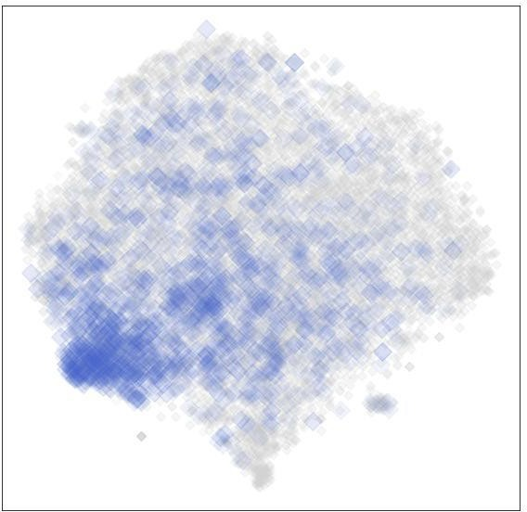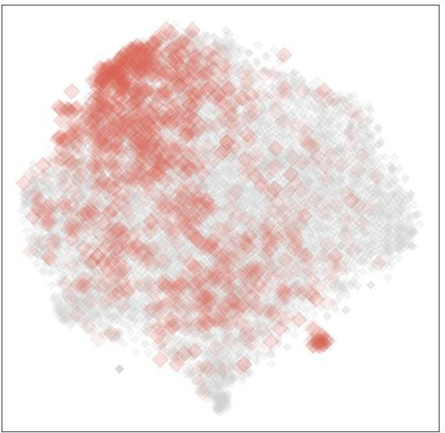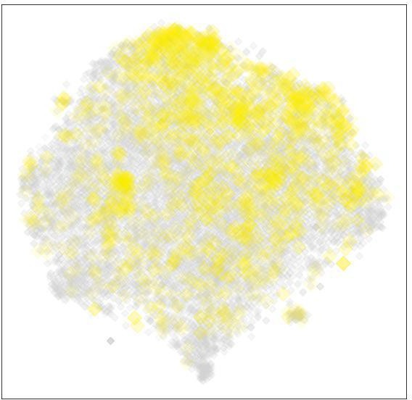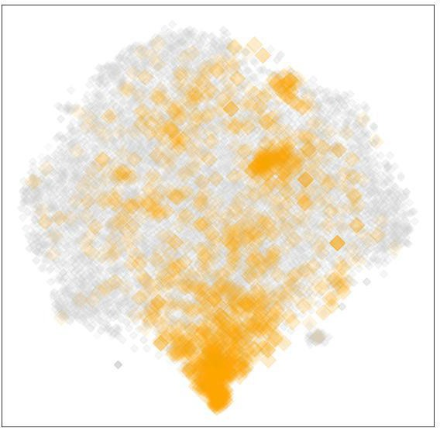
North America Europe Middle East East Asia
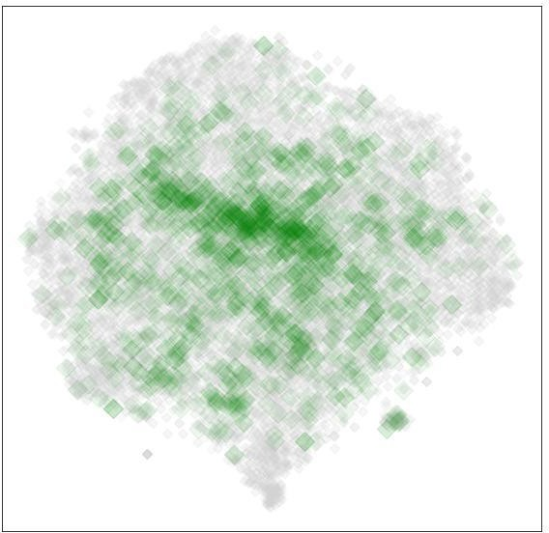
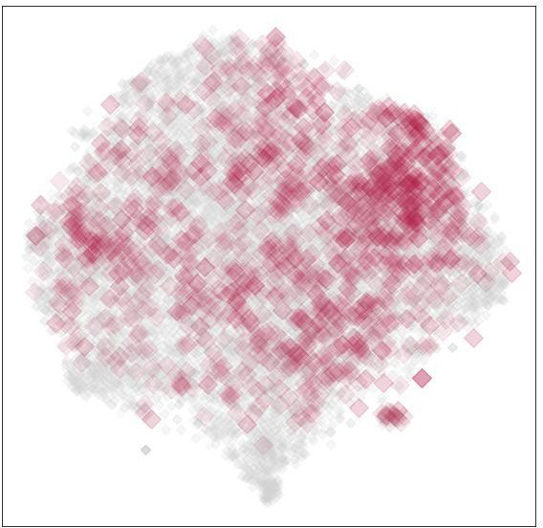
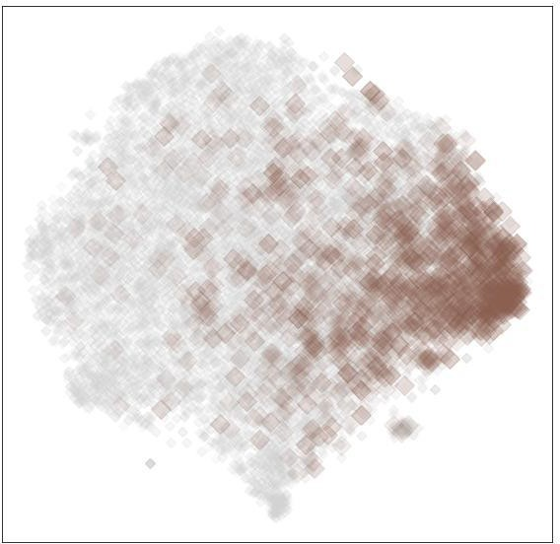
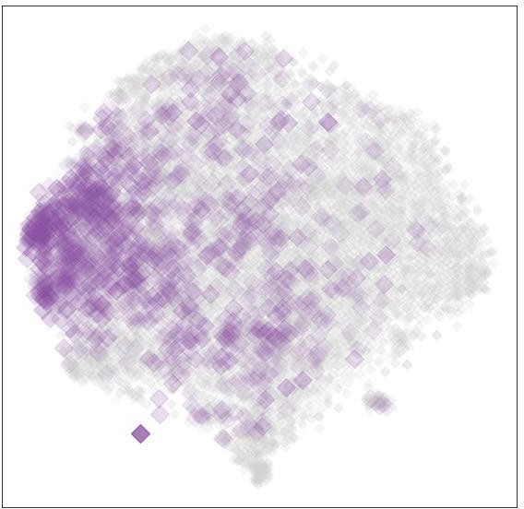
South America Africa South Asia Oceania

Figure S2. Latent space (t-SNE) representations of visual identities of bathrooms.

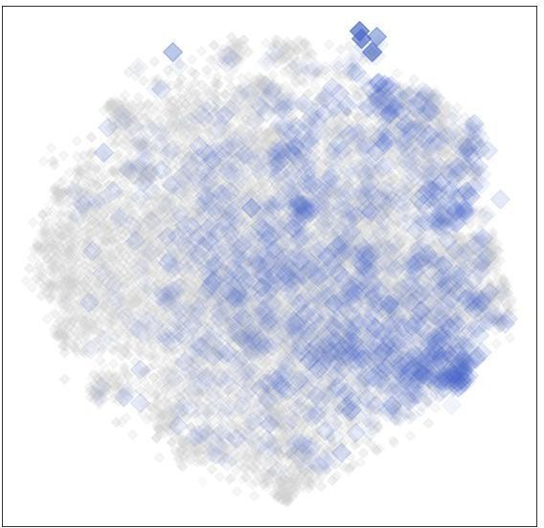
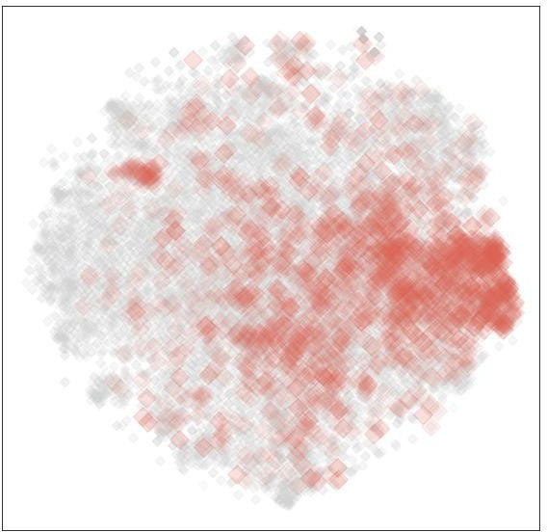
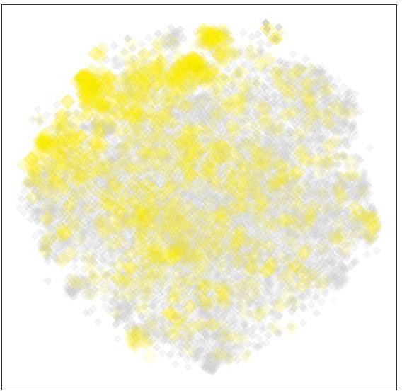
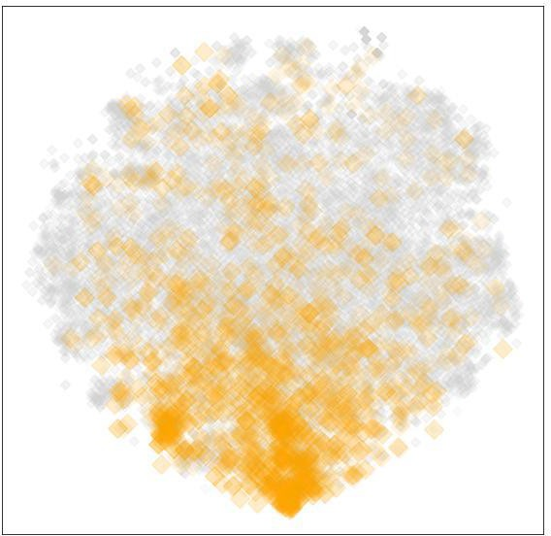
North America Europe Middle East East Asia
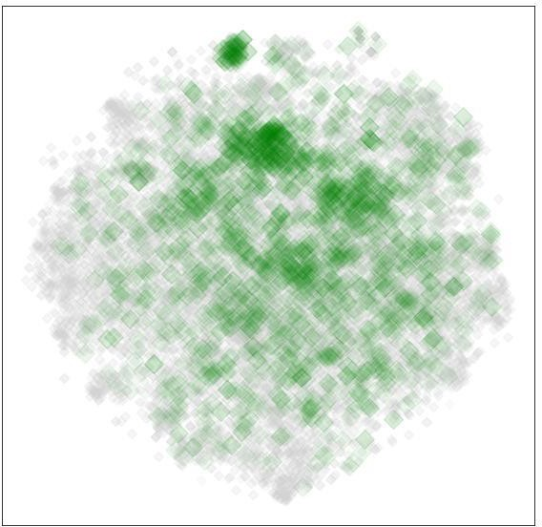
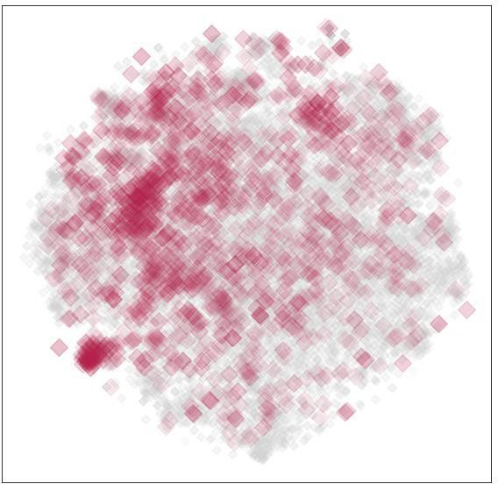
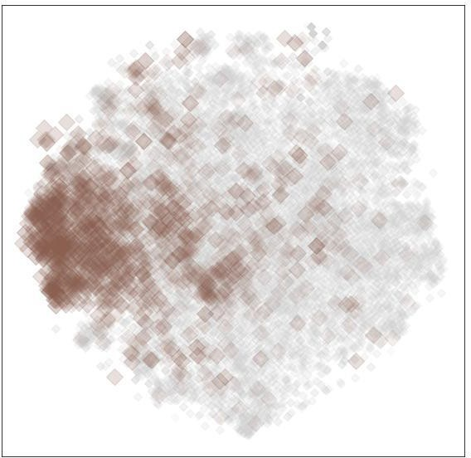
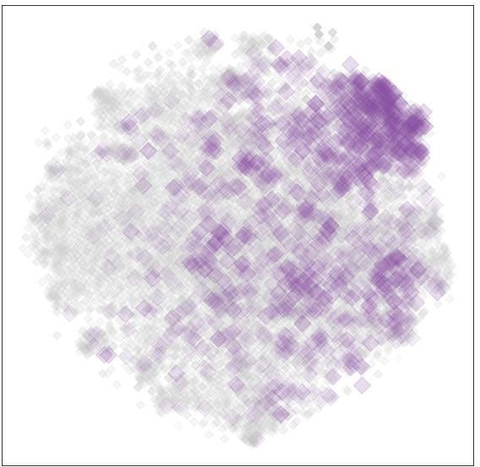
South America Africa South Asia Oceania

Figure S3. Latent space (t-SNE) representations of visual identities of bedrooms.

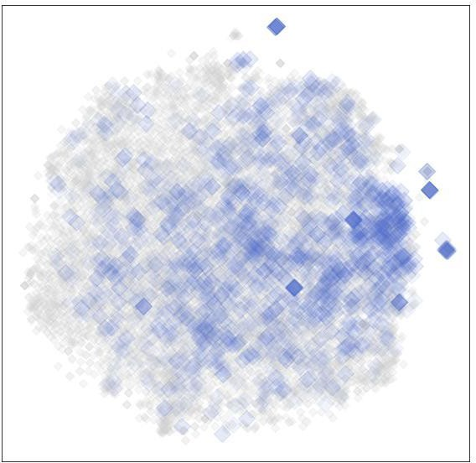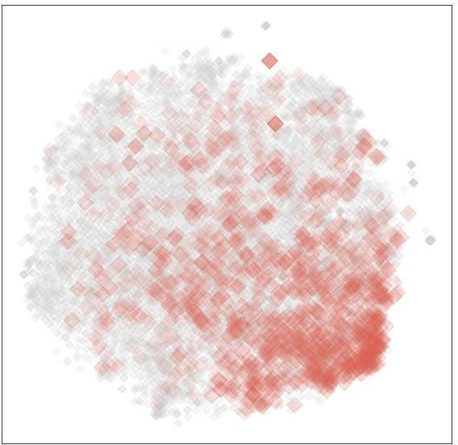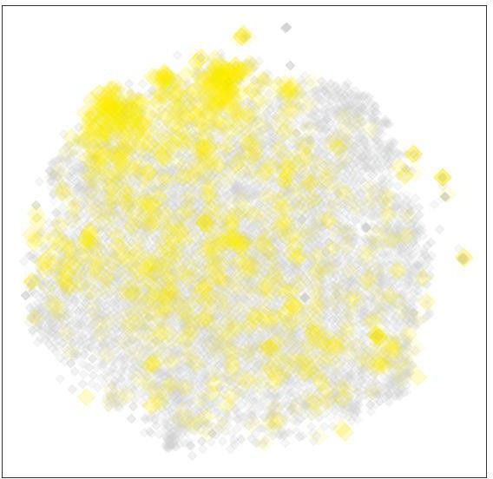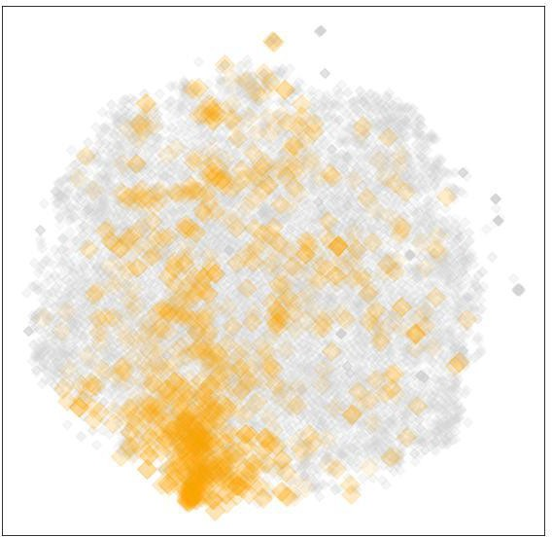
North America Europe Middle East East Asia
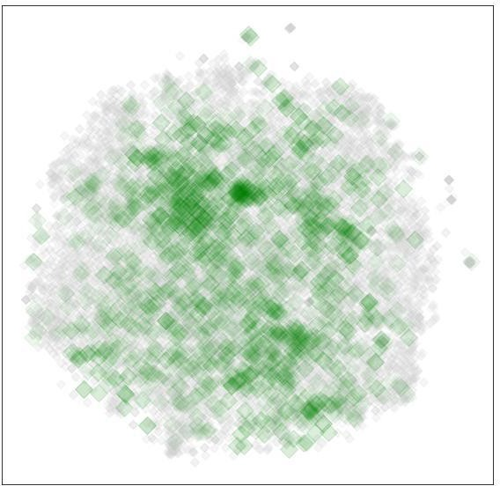
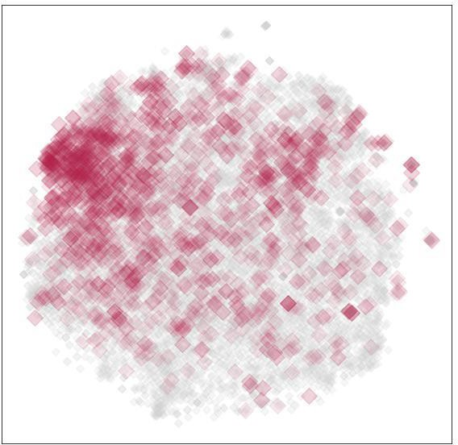
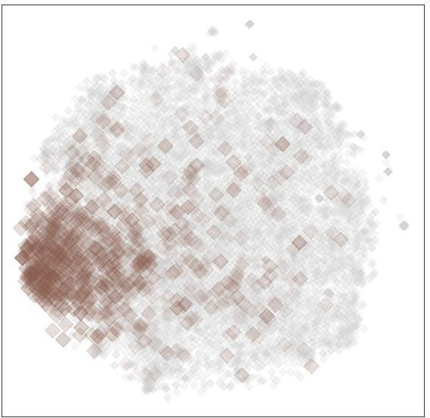
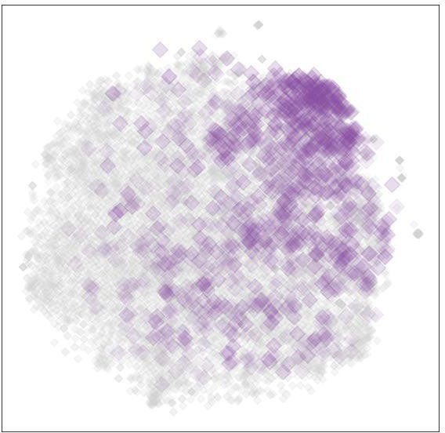
South America Africa South Asia Oceania

Figure S4. Latent space (t-SNE) representations of visual identities of living rooms.

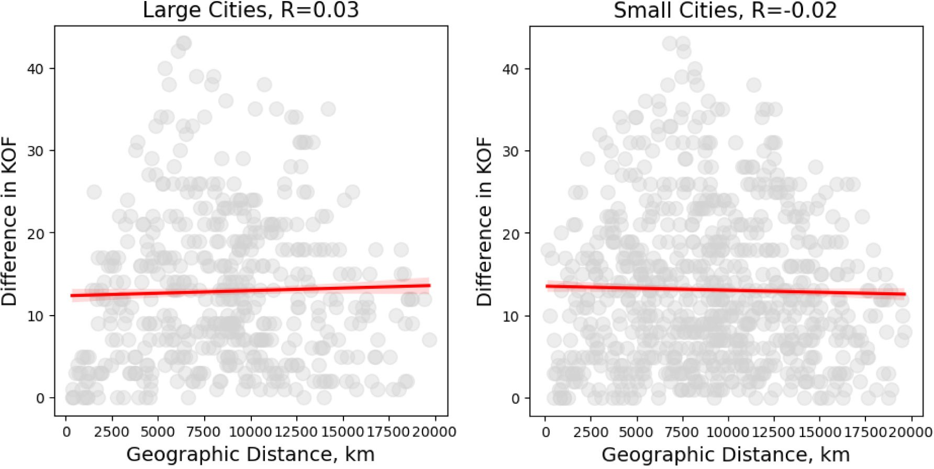

Figure S5. A scatterplot of the relationship between the geographic distance and difference in KOF index between large cities (left) and small cities (rigth) in the dataset. The plot confirms that there is no relationship between geographic distance and difference in the rates of globalization as described by the KOF Index

