Supplementary Materials
Enhancing Theory of Mind in Autism through Humanoid Robot Interaction in a Randomized Controlled Trial
Davide Ghiglino^{1*}, Federica Floris²⁻³, Davide De Tommaso¹, Nicola Severino Russi¹, Alessia Frulli¹, Silvia Moretti¹, Agnieszka Wykowska¹
¹ Social Cognition in Human-Robot Interaction, Istituto Italiano di Tecnologia, Genova, Italy
² Piccolo Cottolengo Genovese di Don Orione, Via Paverano 55, 16143, Genova, Italy
³ SIDiN, Società Italiana Disturbi del Neurosviluppo, Via Gordigiani 58, 50127, Firenze, Italy
Corresponding Author
*Davide Ghiglino
Via Enrico Melen 83, 16152 Genova, Italy
Phone: +39 010 8172242
Email: davide.ghiglino@iit.it

- Study Summary
This clinical trial is part of a larger research program on social cognition and autism, conducted at the Istituto Italiano di Tecnologia in collaboration with clinical partners in Genova, Italy. The study investigates whether a humanoid robot (iCub) can support the development of Theory of Mind (ToM) skills in children with Autism Spectrum Disorder (ASD).
The trial was carried out in a real-world clinical setting using a randomized, two-period crossover design. Children received both robot-assisted and traditional therapy in alternating sequences, allowing within-subject comparisons. An additional human-assisted control group was included to isolate the effect of the robotic medium.
The research aligns with CONSORT 2010 standards for randomized trials and complies with ethical guidelines approved by CET Liguria (Protocol Version 3, March 2024). The study was registered prospectively under ISRCTN15341724.
- Trial Design and Randomization Process
This study followed a randomized, two-period crossover design and adheres fully to the CONSORT 2010 guidelines for reporting randomized trials. A detailed checklist outlining compliance with each CONSORT item is provided as an annex. The trial was prospectively registered on ISRCTN and received ethical approval prior to commencement.
Randomization was performed at the individual level using a simple, unrestricted sequence generated by blinded clinical staff not involved in assessments or therapy. Allocation was concealed until the point of assignment. Participants were randomly allocated to one of two sequences: robot-assisted therapy followed by traditional therapy, or the reverse. An additional non-randomized control group received the same content delivered by a human therapist replicating the robot’s actions, to control for interaction effects.
A schematic overview of participant flow and group assignment is shown in Figure S1. This figure illustrates group allocation, intervention sequences, timepoints for NEPSY-II assessments (T0, T1, T2), and sample size per condition. No deviations from the planned randomization or crossover occurred, and no participants withdrew from the study.
This design ensured that each participant experienced both interventions, enabling within-subject comparison while minimizing inter-individual variability. Outcome assessors were blinded to group assignment to reduce bias.
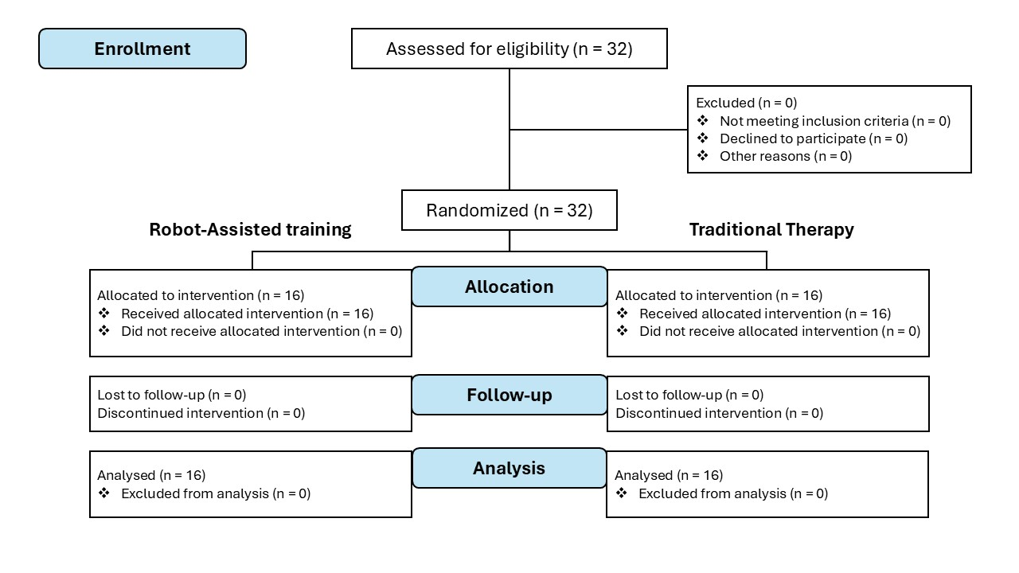
Figure S1. CONSORT Flow Diagram: This diagram outlines the flow of participants through each stage of the two-period crossover trial. A total of 32 participants were assessed for eligibility, all of whom were randomized into two groups. Group 1 initially received robot-assisted training while Group 2 received traditional therapy. After the first period, the groups crossed over to receive the alternate treatment. No participants were excluded, lost to follow-up, or discontinued from the study, ensuring complete data for analysis across both groups.
- Participants and Demographics
A total of 46 children with Autism Spectrum Disorder (ASD) participated in the study. Thirty-two were recruited from Centro Boggiano Pico and enrolled in the randomized crossover trial. An additional group of fourteen children was recruited from PHILOS Accademia Pedagogica to serve as an active control for between-group comparisons. This second group followed a separate protocol and was not randomized, as the primary aim was to assess differences attributable to the robot-mediated format rather than individual variability across treatment sequences.

All participants had a confirmed ASD diagnosis based on ADI-R and ADOS-2, and were between 5 and 9 years of age. Eligibility criteria included consistent clinical attendance and the ability to engage with structured sessions. Children with significant sensory, behavioral, or neurological comorbidities were excluded.
No participants withdrew, and adherence across all phases was complete. The demographic and clinical profiles of both groups are presented in Table S1, allowing comparison across randomized and non-randomized cohorts.

Group | Age | Gender Distribution | Verbal Ability Distribution
Control (Human-Assisted) | 6.97 ± 0.87 | 11 M / 3 F | Non-verbal: 3, Emerging verbal: 7, Verbal 4
Randomized (Crossover) | 7.36 ± 0.95 | 23 M / 9 F | Non-verbal: 6, Emerging verbal: 10, Verbal: 16

Table S1. Summary of participant demographics by study group, including age, gender distribution, and verbal ability level.

- Summary of Primary and Secondary Outcomes
The primary outcome was change in Theory of Mind skills, assessed using the NEPSY-II Social Perception subscale. Scores were collected at three timepoints: baseline (T0), after the first intervention phase (T1), and after the second (T2).
Secondary outcomes included session adherence, engagement (based on therapist reports), and comparative analysis of robot- vs. human-assisted delivery. These measures were used to evaluate the acceptability and feasibility of the robot-mediated approach in clinical settings.
- Summary of results
Robot-assisted therapy led to greater improvements in Theory of Mind performance compared to both traditional and human-assisted conditions, as measured by the NEPSY-II. These effects were consistent across timepoints and not explained by intervention order.
Children showed higher engagement during robot-led sessions, suggesting that predictable and embodied interactions may enhance attention and responsiveness in ASD interventions.
Future work will examine long-term effects, generalization across contexts, and integration of adaptive robot behaviors in clinical and educational environments.
Research Transparency Statement
Preregistration: The study was prospectively registered with the ISRCTN registry under ID ISRCTN15341724 (DOI: 10.1186/ISRCTN15341724).
Materials: All stimuli and scripted scenarios used during the intervention are original and adapted to the clinical setting. Due to ethical constraints and pending publication, these materials are not publicly available but can be provided for review upon request.
Data: Raw clinical data contain sensitive information and are retained by the clinical centers under strict confidentiality agreements. An anonymized dataset including NEPSY-II scores and study group variables is publicly available at: https://osf.io/6dcra
Analysis Scripts: All code used for data cleaning and statistical modeling is available at the same OSF repository: https://osf.io/6dcra
General Disclosures
Conflicts of Interest: The authors declare no conflicts of interest related to this work.
Funding: This research was conducted through a collaboration between the Istituto Italiano di Tecnologia (IIT) and Don Orione Italia, and was supported by the Fit for Medical Robotics (Fit4MedRob) project (PNRR MUR Cod. PNC0000007 – CUP: B53C22006960001).
Artificial Intelligence: No artificial intelligence-assisted technologies were used in the research process or in the creation of this article.
Ethics: The study received ethical approval from the Comitato Etico Regione Liguria. Informed consent for participation and publication was obtained from the legal guardians of all participants.

