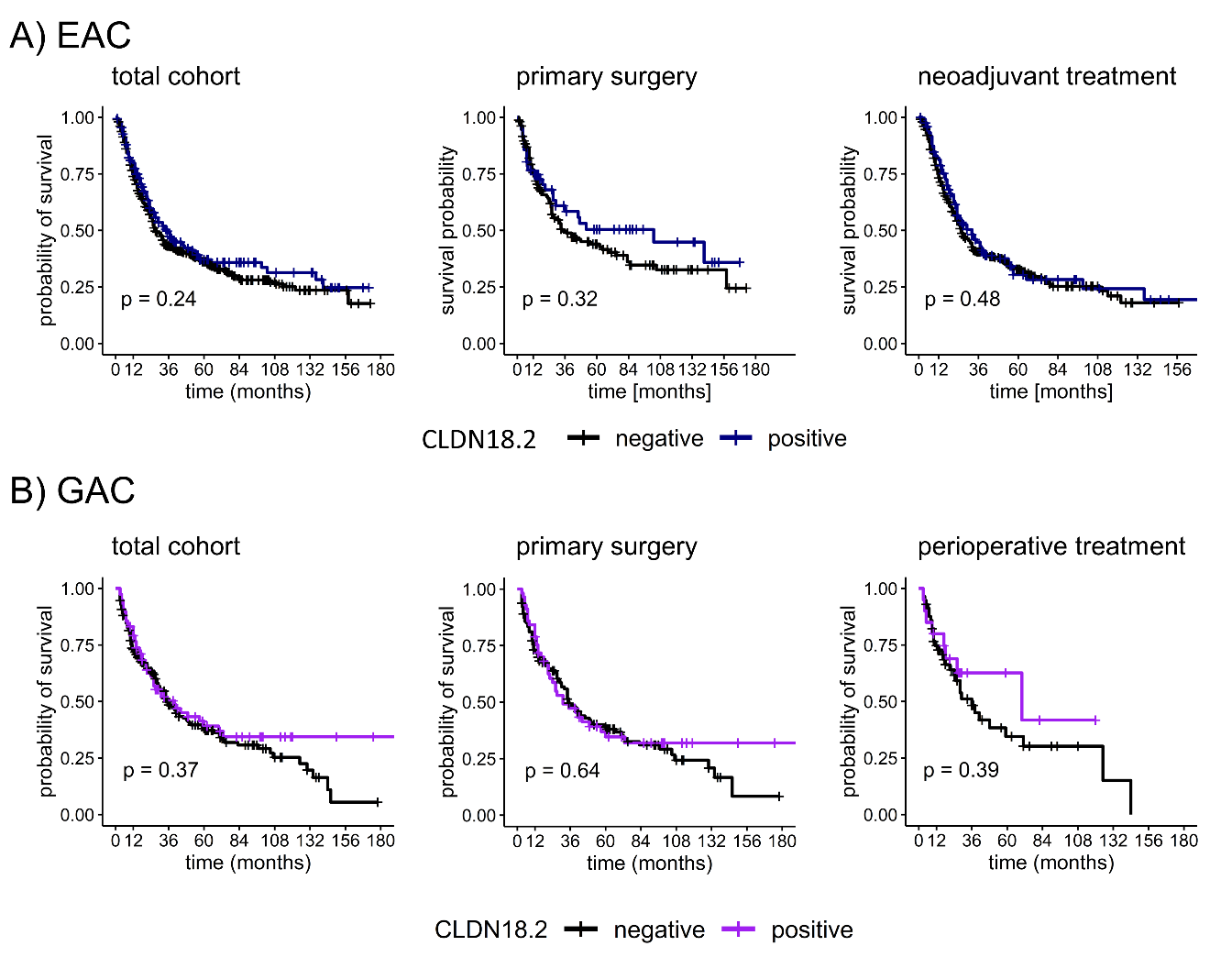
Supplementary Figure 1: CLDN18.2 expression and overall survival in EAC and GAC cohorts
The expression of CLDN18.2 was not associated with the overall survival in the EAC cohorts, neither in the total cohorts nor in the cohorts receiving primary surgery or the cohort receiving neoadjuvant or perioperative treatment (n= 522).

