Sample Information
16.955
21.839
Analyzed by : Admin
Analyzed : 9/2/2022 2:38:01 PM
Sample Name : Pumpkin seed oil
Data File : D:\GCMS DATA\GC-MS Data\Jamia\Rupali ghosh\Pumpkin seed oil.qgd

Chromatogram Pumpkin seed oil D:\GCMS DATA\GC-MS Data\Jamia\Rupali ghosh\Pumpkin seed oil.qgd
21..450341

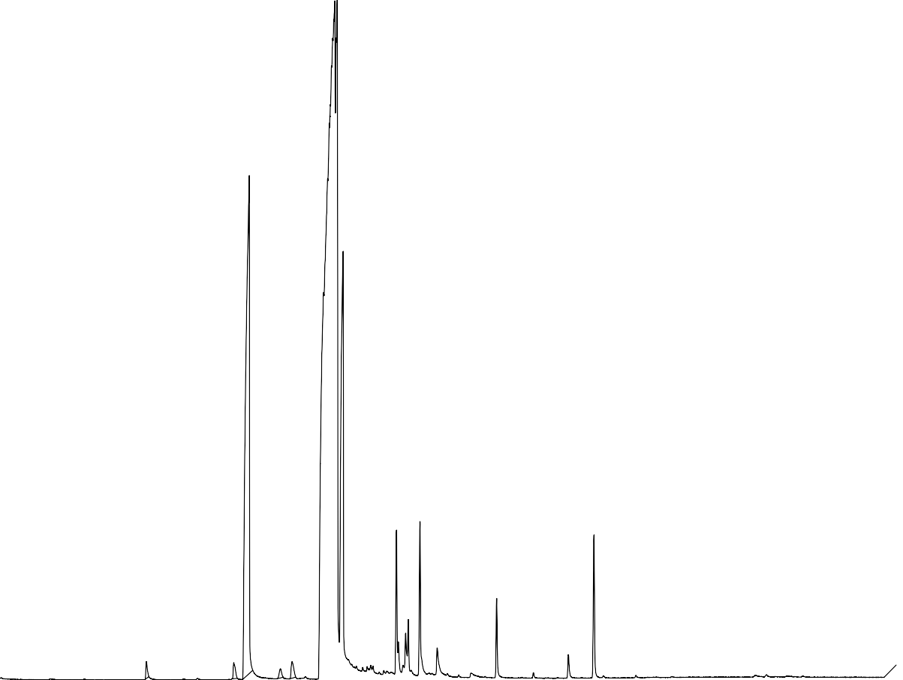

TIC*1.00
20,000,000
11.612
16.156
18.583
19.192
24.615
25.835
24.709
25.2059.1228
26.732
28.494
29.821
31.733
33.553
34.882

10.0 20.0 30.0 40.0 50.0
Min

Figure S1: Chromatogram of GC-MS of the pumpkin seed oil (PSO)

Peak Report TIC
Peak# | R.Time | Area | Area% | Name
1 | 11.612 | 2000025 | 0.39 | Methyl tetradecanoate
2 | 16.156 | 2632245 | 0.52 | 9-HEXADECENOIC ACID, METHYL ESTER, (Z)-
3 | 16.955 | 143231454 | 28.28 | HEXADECANOIC ACID, METHYL ESTER
4 | 18.583 | 1718914 | 0.34 | (Z)-Methyl heptadec-9-enoate
5 | 19.192 | 3318955 | 0.66 | Heptadecanoic acid, methyl ester
6 | 21.404 | 189480714 | 37.41 | 9,12-OCTADECADIENOIC ACID (Z,Z)-

7 | 21.531 | 30891427 | 6.10 | 9-Octadecenoic acid, methyl ester, (E)-
8 | 21.839 | 73014271 | 14.41 | Methyl stearate
9 | 24.615 | 10810441 | 2.13 | HEXADECADIENOIC ACID, METHYL ESTER
10 | 24.709 | 1048291 | 0.21 | OXIRANEOCTANOIC ACID, 3-OCTYL-, METHYL ESTER, TRANS-
11 | 25.091 | 2540513 | 0.50 | 9-Octadecenoic acid, 12-hydroxy-, methyl ester, [R-(Z)]-
12 | 25.228 | 2898345 | 0.57 | cis-11-Eicosenoic acid, methyl ester
13 | 25.835 | 15227745 | 3.01 | EICOSANOIC ACID, METHYL ESTER
14 | 26.732 | 3695714 | 0.73 | 1,1,4A,7-TETRAMETHYL-2,3,4,4A,5,6,7,8-OCTAHYDRO-1H-BENZO[A]CYCLOHEPTE
15 | 28.494 | 664727 | 0.13 | Cyclopropaneoctanoic acid, 2-[[2-[(2-ethylcyclopropyl)methyl]cyclopropyl]methyl]-, methyl
16 | 29.821 | 7019475 | 1.39 | Docosanoic acid, methyl ester
17 | 31.733 | 451671 | 0.09 | Tricosanoic acid, methyl ester
18 | 33.553 | 2322811 | 0.46 | Tetracosanoic acid, methyl ester
19 | 34.882 | 13581338 | 2.68 | Squalene
 |  | 506549076 | 100.00

Table S1: Compounds identified by GC-MS analysis of Pumpkin seed oil.

