Supplementary Materials
Metabolic profile changes in patients with rheumatoid arthritis detected using mass spectrometry
Xue Wu^{1,2,*}, Qi Yang^{1,2,*}, Shanshan Li^{1,2}, Peng Yang^{1,2,#}, Zhengqi Liu^{1,2,#}, Zhitu Zhu^{3,4,#}
¹ Guizhou University of Traditional Chinese Medicine, Guiyang, Guizhou 550025, China;
² The Second Affiliated Hospital of Guizhou University of Traditional Chinese Medicine, Guiyang, Guizhou 550003, China;
³ Liaoning Provincial Key Laboratory of Clinical Oncology Metabonomics, Jinzhou Medical University, Jinzhou, China;
⁴ The First Affiliated Hospital of Jinzhou Medical University, Jinzhou, China.

*Contributed equally to this article.
#Corresponding authors. Address correspondence to: Zhitu Zhu, The First Affiliated Hospital of Jinzhou Medical University, Jinzhou, Liaoning, 121000, China. E-mail: zhituzhu12@163.com. Zhengqi Liu, The Second Affiliated Hospital of Guizhou University of Traditional Chinese Medicine, Guiyang, Guizhou, China 550003. E-mail: lzhengqi12@163.com. Peng Yang, The Second Affiliated Hospital of Guizhou University of Traditional Chinese Medicine, Guiyang, Guizhou, 550003, China. E-mail:1874660968@qq.com.

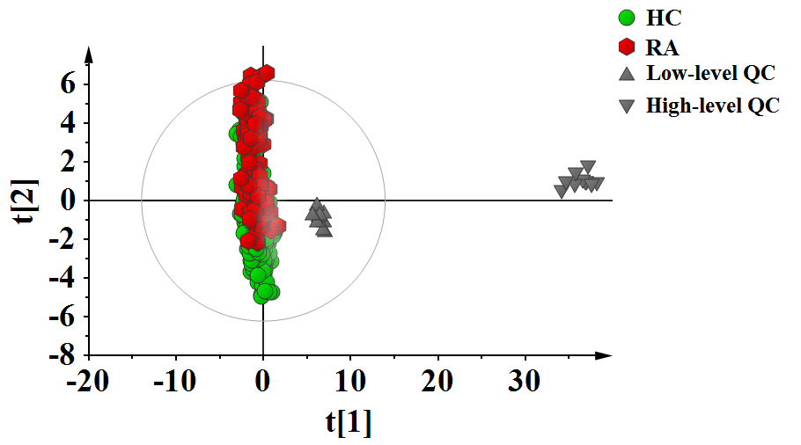
Figure S1 PCA scores plots based on the data of metabolomics analysis. Abbreviation: HC: healthy control; RA: rheumatoid arthritis; QC, quality control; PCA: principal component analysis.

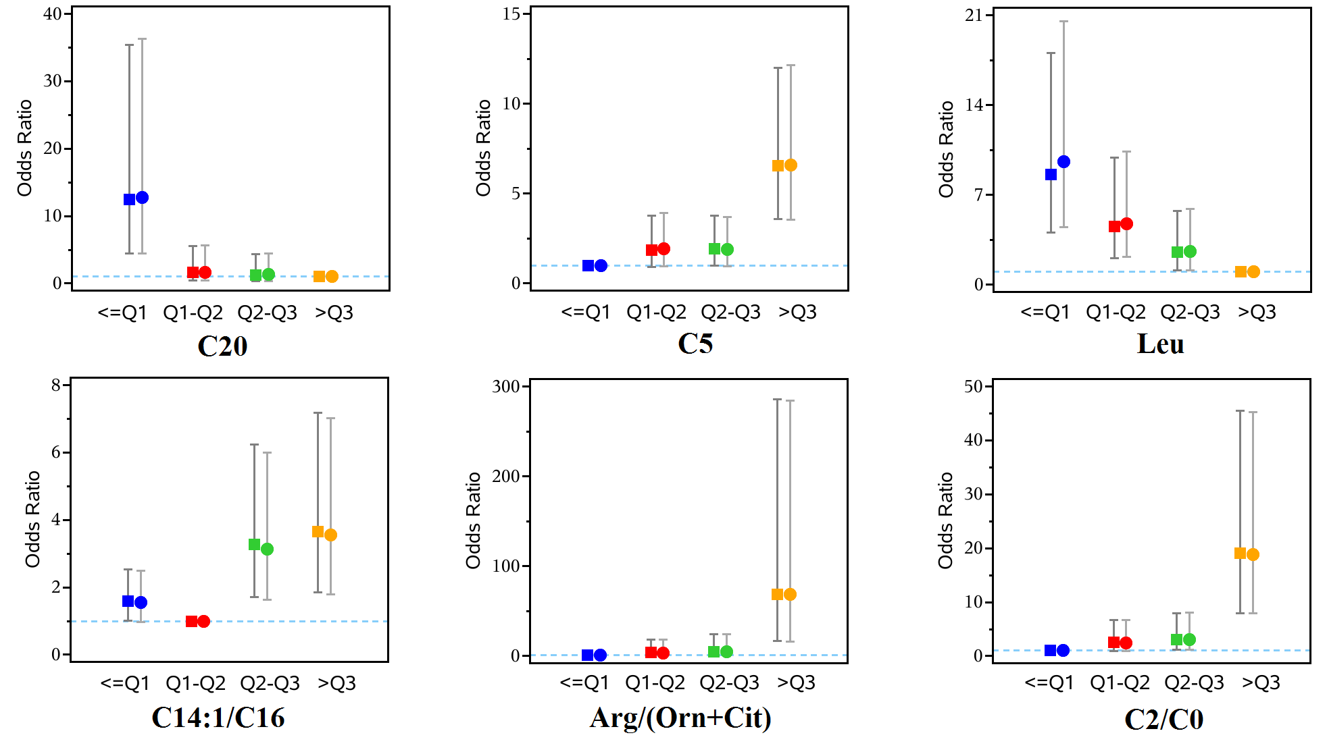
Figure S2 Odds ratios of RA according to quartile of C20, C5, Leu, C14:1/C16, Arg/(Orn+Cit), C2/C0. Levels of C20 (Q1:0.040, Q2:0.050, Q3:0.070), C5 (Q1:0.070, Q2:0.095, Q3:0.120), Leu (Q1:98.170, Q2:116.105, Q3:147.740), C14:1/C16 (Q1:0.089, Q2:0.126, Q3:0.169), Arg/(Orn+Cit) (Q1:0.041, Q2:0.066, Q3:0.102), C2/C0 (Q1:0.230, Q2:0.299, Q3:0.378) were divided into quartile groups. A test of trend was calculated based on quartiles of C20 ( P_{trend}<0.0001 in univariate and multivariate analyses), C5(P_{trend}<0.0001 in univariate and multivariate analyses), Leu (P_{trend}<0.0001 in univariate and multivariate analyses), C14:1/C16 (P_{trend}=0.0005 and P_{trend}=0.0011 in univariate and multivariate analyses, respectively), Arg/(Orn+Cit) (P_{trend}<0.0001 in univariate and multivariate analyses) and C2/C0 (P_{trend}<0.0001 in univariate and multivariate analyses). The left square was derived from univariate analysis, and the right circle was derived from multivariate analysis that adjusted for DBP and glycaemia.

Table S1 Detected metabolites in HC and RA groups
Metabolites | HC(N=382) |  | RA(N=151)
Leu/Ala | 0.775±0.263 |  | 0.702±0.337
Asp | 40.593±17.189 |  | 43.003±19.354
Val/Phe | 3.448±0.840 |  | 2.815±0.796
C16-OH | 0.046±0.030 |  | 0.025±0.018
Met/Leu | 0.173±0.098 |  | 0.161±0.047
Hcy | 8.805±1.044 |  | 9.267±1.212
C14DC | 0.028±0.017 |  | 0.024±0.012
Orn/Cit | 2.253±1.801 |  | 1.726±1.248
Met | 20.737±12.779 |  | 15.407±4.661
C5DC/C16 | 0.094±0.060 |  | 0.113±0.085
C4/C2 | 0.019±0.010 |  | 0.014±0.007
Pro | 320.900±197.176 |  | 390.459±183.999
Arg | 5.144±3.955 |  | 14.349±9.041
C5/C2 | 0.012±0.006 |  | 0.011±0.007
C5DC/C5-OH | 0.361±0.266 |  | 0.545±0.520
C20 | 0.052±0.025 |  | 0.027±0.019
(Gln+Gly)/(Cit+Arg) | 8.159±4.088 |  | 6.203±2.991
Pro/Glu | 2.761±1.817 |  | 2.939±1.782
Leu/Phe | 2.927±0.784 |  | 2.271±0.598
C8 | 0.109±0.076 |  | 0.079±0.052
Gln/Glu | 0.078±0.224 |  | 0.071±0.037
(Leu+Val)/Ala | 1.677±0.496 |  | 1.556±0.706
Ala | 170.117±52.273 |  | 162.925±66.163
Tyr/Cit | 2.238±0.984 |  | 1.953±1.056
C22 | 0.069±0.036 |  | 0.052±0.027
Ala/Glu | 1.477±0.724 |  | 1.175±0.500
C3 | 1.277±0.562 |  | 1.386±0.723
C5 | 0.101±0.042 |  | 0.140±0.056
Cit | 22.361±7.894 |  | 22.568±8.812
C10 | 0.148±0.116 |  | 0.105±0.071
Trp | 50.991±18.175 |  | 53.520±13.221
C4/C3 | 0.151±0.079 |  | 0.150±0.078
Gly/Ala | 1.240±0.572 |  | 1.397±0.760
C5DC/C8 | 0.827±0.475 |  | 1.124±0.685
Arg/(Orn+Cit) | 0.088±0.075 |  | 0.262±0.157
C18 | 0.524±0.164 |  | 0.456±0.160
Ala/Lys | 2.386±1.939 |  | 1.013±0.724
C3/C0 | 0.041±0.018 |  | 0.052±0.027
Glu | 132.725±53.622 |  | 147.292±49.663
Cit/Phe | 0.541±0.215 |  | 0.534±0.225
Lys | 129.600±193.439 |  | 195.354±89.836
C5DC | 0.077±0.045 |  | 0.080±0.054
(C16+C18)/C0 | 0.046±0.017 |  | 0.046±0.016
C4DC | 0.578±0.250 |  | 0.453±0.250
C12 | 0.078±0.040 |  | 0.054±0.027
C4-OH | 0.069±0.033 |  | 0.066±0.049
Gly | 195.411±74.657 |  | 192.394±60.190
C16 | 0.902±0.334 |  | 0.802±0.316
Met/Phe | 0.492±0.274 |  | 0.360±0.110
C26 | 0.032±0.015 |  | 0.025±0.013
C0/C18 | 65.378±23.092 |  | 66.518±24.658
C2/C0 | 0.315±0.119 |  | 0.589±0.288
C5-OH/C8 | 2.980±1.905 |  | 3.191±2.653
C4/C8 | 1.969±1.150 |  | 2.792±1.529
Arg/Orn | 0.185±0.215 |  | 0.491±0.325
C5/C0 | 0.003±0.001 |  | 0.005±0.005
C6 | 0.073±0.034 |  | 0.066±0.037
C5/C3 | 0.089±0.045 |  | 0.119±0.062
Cit/Ala | 0.144±0.067 |  | 0.155±0.066
C8/C10 | 0.870±0.468 |  | 0.842±0.354
Val | 144.076±32.866 |  | 120.214±30.863
C5-OH | 0.255±0.122 |  | 0.192±0.130
C5-OH/C0 | 0.008±0.004 |  | 0.008±0.006
Cys | 1.554±0.740 |  | 1.404±0.847
Phe | 44.018±13.693 |  | 44.755±12.909
Pip | 248.997±147.149 |  | 335.735±199.130
Ser | 55.284±14.927 |  | 63.318±21.934
C5-OH/C4DC | 0.496±0.268 |  | 0.511±0.339
C26/C20 | 0.741±0.613 |  | 1.241±1.016
C16-OH/C16 | 0.055±0.038 |  | 0.033±0.027
C14:1/C16 | 0.137±0.070 |  | 0.095±0.066
C4 | 0.173±0.075 |  | 0.179±0.077
C5:1 | 0.058±0.030 |  | 0.037±0.027
C3/Met | 0.071±0.066 |  | 0.097±0.058
C3/C2 | 0.141±0.064 |  | 0.099±0.056
C3/C16 | 1.515±0.695 |  | 1.912±0.999
Orn | 49.299±46.046 |  | 36.227±25.473
C24 | 0.050±0.021 |  | 0.036±0.021
Pro/Ala | 2.091±1.594 |  | 2.709±1.528
Leu | 124.188±37.022 |  | 98.357±28.856
Phe/Tyr | 0.995±0.319 |  | 0.962±0.290
Cit/Arg | 6.663±5.194 |  | 2.453±2.696
C8/C2 | 0.012±0.009 |  | 0.005±0.006
C2 | 9.745±3.632 |  | 15.784±7.873
C14 | 0.087±0.043 |  | 0.065±0.028
C16:1-OH | 0.061±0.031 |  | 0.042±0.021
Thr | 24.801±7.887 |  | 29.177±10.402
His | 82.141±87.357 |  | 75.689±39.594
Tyr | 45.919±12.511 |  | 47.737±14.595
C14:1 | 0.117±0.063 |  | 0.072±0.040
C14-OH | 0.049±0.027 |  | 0.031±0.021
C0 | 32.241±9.561 |  | 28.159±9.034
Asn | 72.532±20.097 |  | 69.214±19.535
C0/(C16+C18) | 23.742±7.246 |  | 23.701±7.732
Gln | 9.136±25.116 |  | 9.935±5.162
Abbreviation: HC, Healthy control; RA, rheumatoid arthritis; VIP,variable importance in projection; FC, Fold Change; Ala, Alanine; Arg, Arginine; Asn, Asparagine; Asp, Aspartate; Cit, Citrulline; Cys, Cysteine; Gln, Glutamine; Glu, Glutamic; Gly, Glycine; Hcy, Homocysteine; His, Histidine; Leu, Leucine; Lys, Lysine; Met, Methionine; Orn, Ornithine; Phe, Phenylalanine; Pip, Piperamide; Pro, Proline; Ser, Serine; Thr, Threonine; Trp, Tryptophan; Tyr, Tyrosine; Val, Valine; C0, Free carnitine; C2, Acetylcarnitine; C3, Propionylcarnitine; C4, Butyrylcarnitine; C4-OH, Hydroxybutyrylcarnitine; C4DC, Succinyl-/methylmalonylcarnitine; C5, Isovalerylcarnitine; C5-OH, 3-Hydroxyisovalerylcarnitine; C5:1, Tiglylcarnitine; C6, Hexanoylcarnitine; C8, Octanoylcarnitine; C10, Decanoylcarnitine; C12, Lauroylcarnitine; C14, Myristoylcarnitine; C14-OH, 3-Hydroxyl-tetradecanoylcarnitine; C14DC, Tetradecanoyldiacylcarnitine; C14:1, Tetradecenoylcarnitine; C16, Palmitoylcarnitine; C16-OH, 3-Hydroxypalmitoylcarnitine; C16:1-OH, 3-Hydroxypalmitoleylcarnitine; C18, Octadecanoylcarnitine; C20, Arachidic carnitine; C22, Behenic carnitine; C24, Tetracosanoic carnitine; C26, Hexacosanoic carnitine.

 | Parameters | VIP | Log2(Fold Change) | Adjust p-value
1 | C16-OH | 1.426 | -31.873 | 0.0217
2 | Arg | 2.260 | -2.581 | <0.0001
3 | C20 | 1.771 | -0.738 | 0.0002
4 | C5 | 1.690 | -5.497 | <0.0001
5 | Arg/(Orn+Cit) | 2.447 | -1.917 | <0.0001
6 | Ala/Lys | 1.319 | 1.476 | <0.0001
7 | C2/C0 | 2.228 | -4.573 | <0.0001
8 | C4/C8 | 1.164 | -0.425 | 0.0108
9 | Arg/Orn | 1.981 | -1.781 | <0.0001
10 | C5/C3 | 1.370 | -0.742 | <0.0001
11 | Val | 1.282 | 0.298 | 0.0050
12 | C16-OH/C16 | 1.185 | -3.708 | 0.0345
13 | C14:1/C16 | 1.183 | -5.446 | 0.0038
14 | C3/C2 | 1.335 | 0.572 | <0.0001
15 | Leu | 1.358 | 0.305 | 0.0074
16 | Cit/Arg | 1.574 | 1.105 | <0.0001
17 | C8/C2 | 1.518 | -2.371 | 0.0217
18 | C2 | 1.923 | -0.330 | 0.0083
19 | C14:1 | 1.337 | -4.321 | 0.0108
Abbreviation: RA, rheumatoid arthritis; VIP,Variable importance in projection; Ala, Alanine; Arg, Arginine; Cit, Citrulline;Leu, Leucine; Lys, Lysine; Orn, Ornithine; Val, Valine; C0, Free carnitine; C2, Acetylcarnitine; C3, Propionylcarnitine; C4, Butyrylcarnitine; C5, Isovalerylcarnitine; C8, Octanoylcarnitine;C14:1, Tetradecenoylcarnitine; C16, Palmitoylcarnitine; C16-OH, 3-Hydroxypalmitoylcarnitine; C20, Arachidic carnitine.
Table S2 Altered metabolites in RA in the training set

