In Vivo Anti-Inflammatory Evaluation of Oxadiazole Derivatives Bearing Flurbiprofen Moiety Using Experimental and Computational Approaches
Kosar Shaheen^{aϯ}, Aftab Alam^{bϯ}, Ahmed A. Elhenawy^{c}, Irfan Amir Khan^{d}, Fayaz Ur Rahman^{e}, Abid Ali^{f}, Munir Ur Rehman^{g}, Abdullah F. AlAsmari^{h}, Fawaz Alasmari^{h}, Manzoor Ahmad^{i*}, Momin Khan^{a*}
ªDepartment of Chemistry, Abdul Wali Khan University Mardan, Khyber Pakhtunkhwa 23200, Pakistan
^{b}Department of Chemistry, Rawalpindi Women University, Rawalpindi, Pakistan
^{c}Chemistry Department, Faculty of Science, Al-Azhar University, Cairo, Egypt
^{d}Cardiovascular Research Group, Department of Pharmacy, COMSATS University Islamabad, Abbottabad Campus-22060, Khyber Pakhtunkhwa, Pakistan
^{e}Department of Pharmacy, Abbottabad University of Science and Technology, Khyber Pakhtunkhwa Pakistan 22500, Pakistan
^{f}Department of Zoology, Abdul Wali Khan University Mardan, Mardan, 23200 Pakistan
^{g}Heilongjiang Provincial Key Laboratory of CO₂ Resource Utilization and Energy Catalytic Materials, School of Material Science and Chemical Engineering, Harbin University of Science and Technology, No. 4 Linyuan Road, Harbin 150040, People’s Republic of China
^{h}Department of Pharmacology and Toxicology, College of Pharmacy, King Saud University, Riyadh 11451, Saudi Arabia
^{i}Department of Chemistry, University of Malakand, P.O. Box 18800, Dir Lower, Khyber Pakhtunkhwa, Pakistan
Corresponding Authors: mominkhan@awkum.edu.pk; manzoorahmad@uom.edu.pk;
^{ϯ}These authors equally contributed to the work

Supporting Information’s

Table-S1: The compounds prompted anti-inflammatory activity in succeeding order more potent to less potent using an initial dose of 0.1 ml.
C. No | Structures | Before  Carrageenan | After Carrageenan | After 30 min | After 1 hr | After 2 hr | % Decrease
Normal control | -- | 1.8 mm | 1.8 mm | 1.8 mm | 1.8 mm | 1.8 mm | --
Negative control | -- | 2.0 mm | 5.0 mm | 4.7 mm | 4.5 mm | 4.5 mm | 54.74 Increase
Flurbiprofen |  | 0.20 mm | 0.40 mm | 0.28 mm | 0.26 mm | 0.22 mm | 90.01 Decrease
10 |  | 2.0 mm | 3.5 mm | 3.3 mm | 3.0 mm | 2.4 mm | 83.33
3 |  | 1.5 mm | 3.5 mm | 3.2 mm | 3.2 mm | 3.0 mm | 66.66
5 |  | 1.9 mm | 3.8 mm | 3.7 mm | 3.7 mm | 3.6 mm | 55.55
9 |  | 1.8 mm | 2.7 mm | 2.3 mm | 2.1 mm | 2.0 mm | 33.33
2 |  | 1.6 mm | 3.1 mm | 2.8 mm | 2.2 mm | 2.1 mm | 30.00
7 |  | 1.9 mm | 3.0 mm | 3.0 mm | 2.8 mm | 2.2 mm | 26.66
6 |  | 2.1 mm | 3.3 mm | 3.0 mm | 2.2 mm | 3.4 mm | 13.33
8 |  | 2.2 mm | 3.5 mm | 2.4 mm | 2.0 mm | 2.7 mm | 10.00
4 |  | 2.1 mm | 3.1 mm | 3.3 mm | 3.3 mm | 2.9 mm | 3.33

Table-S2: calculated docking energies in kcal/mol including binding-affinity”ΔG”; energy H-interaction for protein; EInt.: H-interaction affinity into receptor, for 10, 3, 5, 9, 2, 7 and flurbiprofen.
C. No | ΔG | RMSD | H. B | E.Int.
10 | -7.596 | 1.900 | -45.076 | -28.994
3 | -8.305 | 1.878 | -47.779 | -28.199
5 | -7.402 | 1.898 | -38.764 | -27.150
9 | -8.339 | 1.069 | -38.196 | -30.071
2 | -7.387 | 0.623 | -35.743 | -32.337
7 | -7.300 | 2.237 | -38.107 | -28.838
Flurbiprofen | -7.541 | 1.346 | -41.966 | -28.622

Reactivity Indices
Reactivity indices play a crucial role in predicting and comprehending the behavior of most active (10, 3, 5, 9, 2, and 7) based on flurbiprofen across diverse chemical reactions with the biological target. These indices offer valuable insights into the probability of investigated oxadiazoles based on flurbiprofen engaging in specific types of reactions or interactions with other biological molecules. Commonly reactivity indices was conducted using the time dependent Density Functional Theory (TD-DFT) approach, employing the same wb97x-d3 a DFT function and 6-311g++** (d,p) basis set for calculations. Within the DFT framework, the HOMO and LUMO energy levels were determined. Subsequently, these energy level values were employed to calculate the energy gap values “Eg= EHOMO - ELUMO”, ionization potential “IP = -EHOMO”, electron affinity “EA = -ELUMO”, hardness “η = (-ELUMO–EHOMO)/2”, softness “σ = 1/η”, electronegativity “χ = -(IP+EA)/2”, and electrophilicity “ω = µ2/2η”. The resulting calculated values are presented in Figure-S1. The lower Softness value of 0.27 implies that the studied molecule is very soft and more polarizable as well [1].
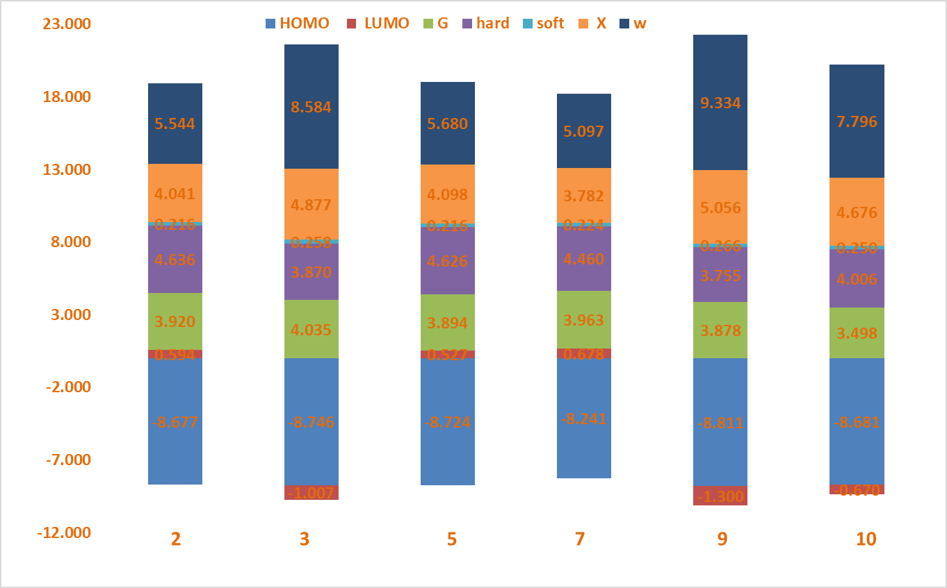
Figure-S1: Reactivity indices based on HOMO /LUMO Energy levels for oxadiazole 10, 3, 5, 9, 2, and 7 based on flurbiprofen
The energy gap (E_{g}) of most active six oxadiazole flurbiprofen derivatives depends on the type of substituent attached to the oxadiazole fragments the substituents are (2-NO₂-C₆H₄) for 10, (4-NO₂−C₆H₄) for 3, (C₆H₅) for 5, (4-NO₂−C₆H₄) for 9, (SH) for 2, and (2,OCH₃-4, OC₂H₅-C₆H₄) for 7, respectively. The structure of these compounds is shown in Table-1. The band gap (Eg) of oxadiazoles 10, 3, 5, 9, 2, and 7, which have different substituents on the phenyl ring, is shown in Figure-S1. The order of Eg values is: 3 > 7 > 2 > 5 > 9 > 10. This shows the effect of phenyl ring substitution on the band gap of the compounds. The energy gap variations of the molecules influence their inhibition of inflammation character. The energy gap variations also indicate how the electronic properties and chemical structure of the investigated flurbiprofen affect their biological activity [2]. The most active compound 10 with inhibition percentage 83.33 % showed lowest Eg. The chemical hardness (η) and softness (σ) are crucial properties for determining the chemical stability and the biological reactivity of the six oxadiazole flurbiprofen derivatives 10, 3, 5, 9, 2, and 7. The results indicate they compounds possess chemical hardness (η) or stability properties in the reverse order with Eg: 2 > 5 > 7 > 10 > 3 > 9. From the results it was obvious the oxadiazole which hasn’t aromatic substituted shows the lowest chemical stability compared to other compounds. On the other hand, the softness (σ) properties of the molecules were found to be order with Eg: 9 > 3 > 10 > 7 > 5 > 2. The softness (σ) is closely related to their biological activity because the softer molecule has more reactivity. Moreover, chemical hardness (η) can be an indication of charge transfer resistance. In general, compounds with larger Eg values, relatively high hardness and lower softness values were found to be less chemically active, while those with lower (Eg and η) and higher (σ) values were found to be more active. This is due to softness of a molecule is indicative of its responsiveness to changes in electron density and its ability to participate in reactions involving electron transfer. Soft molecules are often more reactive in reactions where electron movement plays a significant role. The bioactivity enhancement of the compound is governed by the lowering of the electrophilicity index and with an increment in the maximum charge transfer index. A much lower electrophilicity index value implies that the studied compound is highly bioactive and non-toxic 9 > 3 > 10 > 5 > 2 > 7, as shown in figure-S1. Additionally, the six investigated flurbiprofen derivatives have different electronegativity (χ) values, which reflect their ability to attract electrons from the biological target molecule. Electronegativity is a property of an atom that determines how strongly it pulls a shared pair of electrons in a chemical bond. The electronegativity (χ) values of the investigated compounds were arranged in ascending order as electrophilicity follows: 9 (ώ = 5.056 eV) > 3 (χ = 4.877 eV) > 10 (χ = 4.676 eV) > 5 (χ = 3.782 eV) > 2 (χ = 4.041 eV) > 7 (χ = 4.098 eV). The data provided indicates a clear trend where
Topological and Laplacian Electron Density for Oxadiazole Derivatives (10, 3, 5, 9, 2, and 7)
The Laplacian electron density is a quantity that measures the curvature of the electron density distribution in a molecule or a solid. It is defined as the divergence of the gradient of the electron density, or equivalently, as the Laplacian operator applied to the electron density. The Laplacian electron density can provide useful information about the bonding and reactivity of a system, as well as its electronic structure and properties. For example, regions with negative Laplacian electron density indicate charge accumulation or lone pairs, while regions with positive Laplacian electron density indicate charge depletion or antibonding interactions. Figure-S2 displays the Laplacian electron density map for 10, 3, 5, 9, 2, and 7 compounds. The red colour shows highly negative charges on elements like nitrogen of oxadiazole core, which are electron-rich sites and attract electrophiles. The blue color indicates small positive charges on carbon atoms in substituted phenyl groups, which are electron-poor sites and attract nucleophiles. The green colour represents high positive charges due to the valence electrons of hydrogen atoms. The blue color indicates antibonding interactions with biological media.
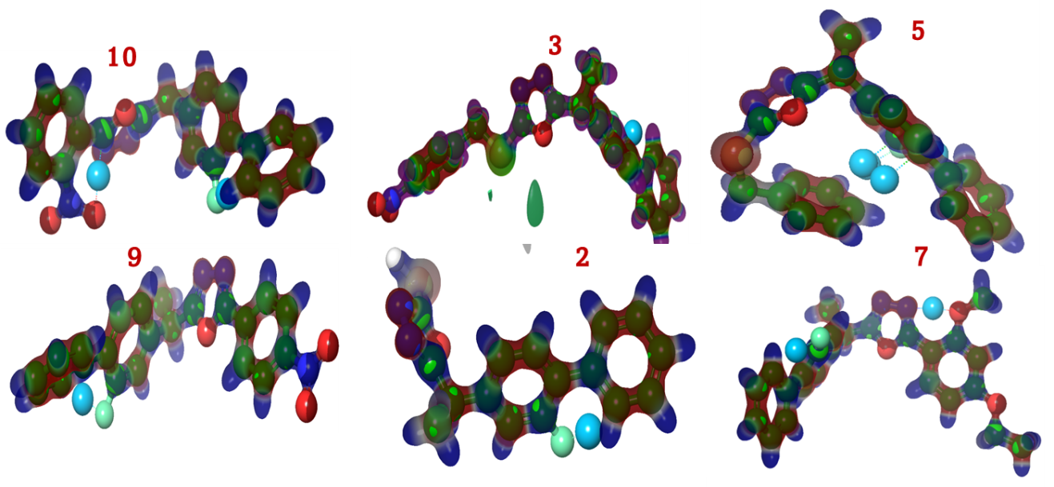
Figure-S2: Laplacian density maps of for oxadiazole 10, 3, 5, 9, 2, and 7 based on flurbiprofen
Topology Analysis for oxadiazole 10, 3, 5, 9, 2, and 7 based on flurbiprofen. The nature of the intramolecular interactions in the investigation compounds based on flurbiprofen 10, 3, 5, 9, 2, and 7, which was investigated using topological analysis of the atoms in the molecule (Figure-S3). According to Atoms in Molecule (AIM) analysis the presence of bond critical path (BCP) and ring critical path (RCP) as green isosurface, that ensures that the bond between the atoms. The blue dot represented the non-covalent interaction NCI. Figure-S3 illustrates the Bond Critical path (BCP) between two phenyl rings of flurbiprofen, forming other stable six-membered ring through HC•••CH interactions for all investigated compounds. Additionally, other BCPs are observed between the nitrogen of oxadiazole and a carbon of thiomethyl fragment for compound 10 and 3 group, resulting in a five-membered ring S−C•••N. Similarly, interactions as O−N•••CH phenyl at 9 and CH₃O-HC•••CH phenyl at 7, which lead to the formation of five-membered rings. Moreover, the isosurface manifested within oxadiazole, phenyl rings for flurbiprofen and was also present in substituted aromatic rings, which are essential to furnish RCP for all investigated compounds. The total electron density p_((r) ) and Laplacian (∇^2 p_((r) )) describe the nature of bonds. Total electron density is given by the expression, 1/4 ∇^2 p_((r) )=G(r)+γ{r} where G(r) and V(r) are Lagragian kinetic energy and potential energy densities at critical points, respectively. The values ∇^2 p_((r) )> 0 and G(rBCP)+V(rBCP) > 0, that indicate that the bond is a weak bond. Ratio of G(r BCP)/V(r BCP) indicates that the hydrogen bond has a non-covalent nature, which represented in blue dot (Figure-S3). The common F•••H-C interaction observed in compounds 10, 3, 5, 9, 2, and 7, is noteworthy. Particularly, most active 10, featuring a 2-nitrophenyl group, forms a noncovalent bond between the oxygen of nitro and H atom of oxadiazole group (N•••H-C). In contrast, compound 5 exhibits an additional H-interaction between the π electron of CH=CH and phenyl fragments (CH=CH•••HC). These weak interactions are pivotal as they contribute to stabilization in biological media.
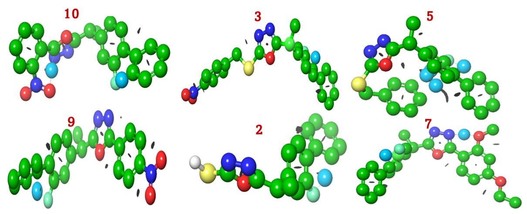
Figure-S3: BCP, RCB and NCI for oxadiazole 10, 3, 5, 9, 2, and 7 based on flurbiprofen

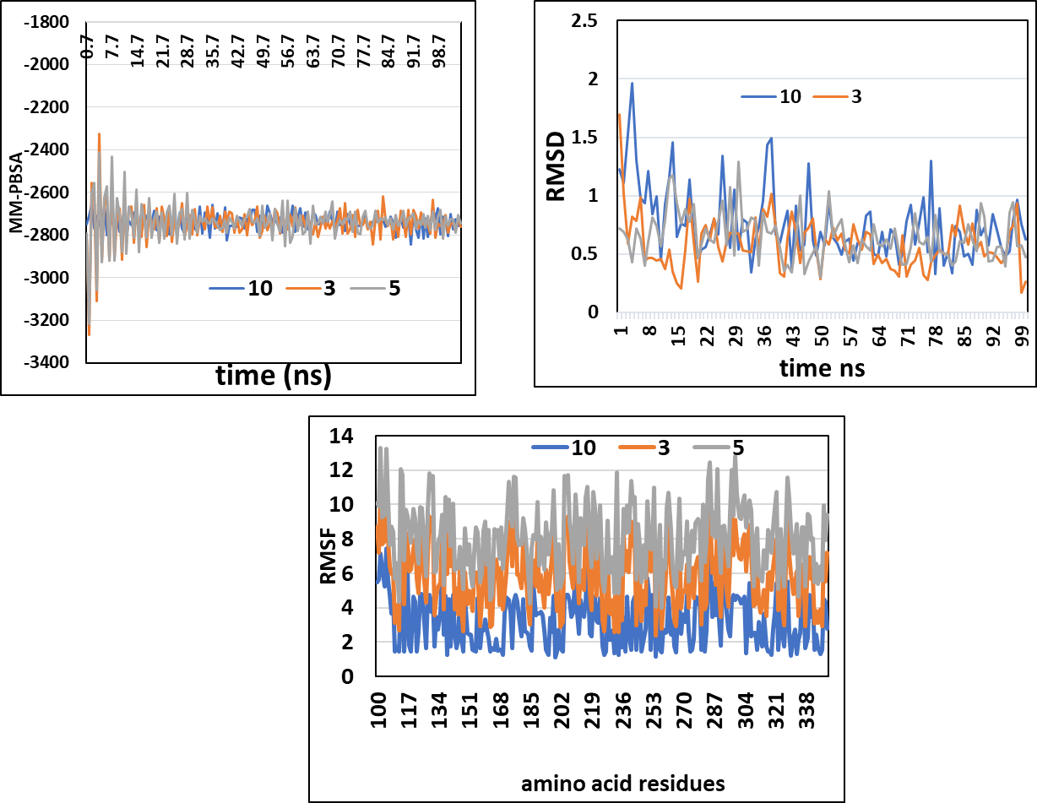
Figure-S4: MD trajectories for 10, 3, and 5 - protein at 0-100ns simulation time.
References
[1] N. Ullah, A. Alam, Zainab, A.A. Elhenawy, S. Naz, M.S. Islam, S. Ahmad, S.A.A. Shah, M. Ahmad, Investigating Novel Thiophene Carbaldehyde Based Thiazole Derivatives as Potential Hits for Diabetic Management: Synthesis, In Vitro and In Silico Approach, ChemistrySelect 9(8) (2024) e202304601.
[2] M. Waheed, S. Idris, F. Jan, A. Alam, M. Ibrahim, A.F. AlAsmari, M. Alharbi, F. Alasmari, M. Khan, Exploring the synthesis, structure, spectroscopy and biological activities of novel 4-benzylidene-1-(2-(2, 4-dichloro phenyl) acetyl) thiosemicarbazide derivatives: An integrated experimental and theoretical investigation, Saudi Pharmaceutical Journal 31(12) (2023) 101874.

Spectral Data of the Compounds (2-10)
5-(1-(2-Fluoro-[1,1'-biphenyl]-4-yl)ethyl)-1,3,4-oxadiazole-2-thiol (2)
Yield: 88 %; amorphous solid with yellow color; M.P.: 157-160 ˚C; ¹H-NMR (400 MHz, DMSO-d₆): δ 7.51 (m, 2H), 7.46 (d, J = 8.0 Hz, 1H), 7.42 (m, 2H), 7.35 (m, 1H), 7.18 (m, 1H), 7.13 (d, J = 1.6 Hz, 1H), 4.31 (q, J = 7.2 Hz, 1H), 1.66 (d, J = 7.2 Hz, 3H); ¹³C-NMR (100 MHz, DMSO-d₆; ppm; δ): 163.2, 158.6, 140.7, 136.5, 129.4, 129.2, 127.6, 126.2, 123.8, 115.2, 38.2, 20.4. EI-MS m/z (% rel. abund.): 300 (M⁺, 100), 152 (4), 170 (14), 178 (23), 199 (100), 210 (20), 225 (21), 225 (21), 242 (4), 268 (4), 285 (18); Anal. Calcd for C₁₆H₁₃FN₂OS: N = 9.33; H = 4.36; C = 63.98; Found: N = 9.35; H = 4.33; C = 63.96.
2-(1-(2-Fluoro-[1,1'-biphenyl]-4-yl)ethyl)-5-((4-nitrobenzyl)thio)-1,3,4-oxadiazole (3)
Yield: 71 %; amorphous solid with yellow color; M.P.: 117-119 ˚C; ¹H-NMR (400 MHz, DMSO-d₆): δ 8.14 (d, J = 8.4 Hz, 2H), 7.65 (d, J = 8.8 Hz, 2H), 7.53 (m, 6H), 7.26 (d, J = 11.6 Hz, 1H), 7.18 (d, J = 8.0 Hz, 1H), 4.58 (s, 2H), 4.55 (q, J = 7.2 Hz, 1H), 1.63 (d, J = 7.2 Hz, 3H); ¹³C-NMR (100 MHz, DMSO-d₆; ppm; δ): 163.2, 158.6, 146.3, 143.2, 140.7, 136.5, 130.3, 129.4, 129.2, 127.9, 127.6, 126.2, 123.9, 123.8, 115.2, 38.2, 38.1, 20.4. EI-MS m/z (% rel. abund.): 435 (M⁺, 44), 78 (6), 89 (3), 106 (3), 136 (4), 183 (8), 199 (100), 210 (9), 225 (22), 300 (9). Anal. Calcd for C₂₃H₁₈FN₃O₃S: N = 9.65; H = 4.17; C = 63.44. Found: N = 9.63; H = 4.15; C = 63.46.
2-((2-Chloro-4-fluorobenzyl)thio)-5-(1-(2-fluoro-[1,1'-biphenyl]-4-yl)ethyl)-1,3,4-oxadiazole (4)
Yield: 72%; amorphous solid with brown color; ¹H-NMR (400 MHz, DMSO-d₆): δ 7.51 (m, 8H), 7.28 (dd, J = 11.6 Hz, J'= 1.2 Hz, 1H), 7.21 (dd, J = 1.2 Hz, J = 8.0 Hz, 1H), 7.15 (dt, J = 8.8 Hz, J = 2.4 Hz, 1H), 4.57 (q, J = 6.8 Hz, 1H), 4.50 (s, 2H), 1.65 (d, J = 7.2 Hz, 1H); ¹³C-NMR (100 MHz, DMSO-d₆; ppm; δ): 163.2, 162.7, 158.6, 140.7, 136.5, 134.6, 130.7, 129.4, 128.8, 127.9, 126.2, 123.8, 117.8, 115.2, 113.6, 38.2, 33.0, 20.4. EI-MS m/z (% rel. abund.): 442 (M⁺, 10), 444 (M⁺², 5), 83 (20), 107 (13), 143 (93), 160 (12), 178 (27), 183 (23), 199 (92), 210 (26), 225 (37), 256 (16), 407 (100). Anal. Calcd for C₂₃H₁₇ClF₂N₂OS: N = 6.33; H = 3.87; C = 62.37; Found: N = 6.35; H = 3.85; C = 62.39.
2-(Benzylthio)-5-(1-(2-fluoro-[1,1'-biphenyl]-4-yl)ethyl)-1,3,4-oxadiazole (5)
Yield: 63%; amorphous solid with pale yellow color; M.P.: 101-102˚C; ¹H-NMR (400 MHz, DMSO-d₆): δ 7.54 (m, 3H), 7.49 (t, J = 6.8 Hz, 2H), 7.41 (m, 1H), 7.35 (dd, J = 8.0 Hz, J = 2.0 Hz, 2H), 7.28 (m, 4H), 7.20 (dd, J = 8.0 Hz, J = 1.6 Hz, 1H), 4.59 (q, J = 7.2 Hz, 1H), 4.44 (s, 2H), 1.65 (d, J = 7.2 Hz, 3H); ¹³C-NMR (100 MHz, DMSO-d₆; ppm; δ): 163.2, 158.6, 140.7, 137.1, 136.5, 129.4, 128.7, 127.9, 127.7, 127.6, 123.8, 115.2, 38.2, 38.1, 20.4. EI-MS m/z (% rel. abund.): 390 (M⁺, 72), 65 (12), 77 (6), 91 (100), 105 (8), 122 (5), 132 (31), 165 (7), 178 (21), 199 (92), 210 (30), 225 (95). Anal. Calcd for C₂₃H₁₉FN₂OS: N = 7.17; H = 4.90; C = 70.75. Found: N = 7.15; H = 4.91; C = 70.73.
2-(1-(2-Fluoro-[1,1'-biphenyl]-4-yl)ethyl)-5-(3-nitrophenyl)-1,3,4-oxadiazole (6)
Yield: 82 %; amorphous solid with off-white color; ¹H-NMR (CDCl₃; δ, 400 MHz, ppm): 1.45 (d, J = 7.1 Hz, 3H), 3.61 (q, J = 7.1 Hz, 1H), 7.30-7.32 (m, 5H), 7.58 (d, J = 7.9 Hz, 1H), 7.80 (d, J = 7.1 Hz, 1H), 7.85-7.83 (m, 2H), 8.14 (d, J = 8.3 Hz, 1H), 8.35 (t, J = 8.4 Hz, 1H), 8.61 (d, J = 8.3 Hz, 1H); ¹³C-NMR (100 MHz, DMSO-d₆; ppm; δ): 164.5, 163.2, 158.6, 148.4, 140.7, 136.5, 133.6, 130.1, 129.4, 129.2, 127.9, 127.6, 127.0, 126.2, 123.9, 123.8, 122.8, 115.2, 38.9, 20.4. HR-ESI-MS [M + H]⁺ calculated for C₂₂H₁₆FN₃O₃, 389.1176, found 389.3791; Anal.Calcd for C₂₂H₁₆FN₃O₃ (389.12) C, 67.86; H, 4.14; F, 4.88; N, 10.79; O, 12.33; Found: C, 67.87; H, 4.17; N, 10.80.
2-(4-Ethoxy-2-methoxyphenyl)-5-(1-(2-fluoro-[1,1'-biphenyl]-4-yl)ethyl)-1,3,4-oxadiazole (7)
Yield: 80 %; amorphous solid with white color; ¹H-NMR (CDCl₃; δ, 400 MHz, ppm): 1.41 (d, J = 6.8 Hz, 3H), 1.80 (t, J = 6.8 Hz, 3H), 3.49 (q, J = 6.8 Hz, 1H), 3.61 (q, J = 6.6 Hz, 2H), 3.66 (s, 3H), 7.10-7.13 (m, 5H), 7.22 (d, J = 7.2 Hz, 1H), 7.31 (d, J = 7.2 Hz, 2H), 7.45-7.49 (m, 3H); ¹³C-NMR (100 MHz, DMSO-d₆; ppm; δ): 164.5, 163.2, 160.4, 158.6, 157.9, 140.7, 136.5, 129.4, 129.2, 129.1, 127.9, 127.6, 126.2, 123.8, 115.2, 107.2, 104.3, 98.9, 64.6, 56.1, 38.9, 20.4, 14.8. HR-ESI-MS [M + H]⁺ calculated for C₂₅H₂₃FN₂O₃, 418.1693, found 418.4601; Anal.Calcd for C₂₅H₂₃FN₂O₃ (418.17) C, 71.76; H, 5.54; F, 4.54; N, 6.69; O, 11.47; Found: C, 71.8; H, 5.55; N, 6.67.
2-(3-ethoxy-4-methoxyphenyl)-5-(1-(2-fluoro-[1,1'-biphenyl]-4-yl)ethyl)-1,3,4-oxadiazole (8)
Yield: 85 %; amorphous solid with off-white color; ¹H-NMR (CDCl₃; δ, 400 MHz, ppm): 1.43 (d, J = 7.1 Hz, 3H), 1.81 (t, J = 6.9 Hz, 3H), 3.45 (q, J = 6.9 Hz, 1H), 3.61 (q, J = 7.1 Hz, 2H), 3.66 (s, 3H), 7.14-7.17 (m, 5H), 7.25 (d, J = 7.3 Hz, 1H), 7.32 (d, J = 7.3 Hz, 2H), 7.51-7.53 (m, 3H); ¹³C-NMR (100 MHz, DMSO-d₆; ppm; δ): 164.5, 163.2, 158.6, 149.9, 147.1, 140.7, 136.5, 129.4, 129.2, 127.9, 127.6, 126.2, 123.8, 119.0, 115.2, 112.4, 110.6, 107.5, 64.9, 56.1, 38.9, 20.4, 14.8. HR-ESI-MS [M + H]⁺ calculated for C₂₅H₂₃FN₂O₃, 418.1693, found 418.4601; Anal.Calcd for C₂₅H₂₃FN₂O₃ (418.17) C, 71.76; H, 5.54; F, 4.54; N, 6.69; O, 11.47; Found: C, 71.77; H, 5.52; N, 6.71.
2-(1-(2-Fluoro-[1,1'-biphenyl]-4-yl)ethyl)-5-(4-nitrophenyl)-1,3,4-oxadiazole (9)
Yield: 82 %; amorphous solid with white color; ¹H-NMR (CDCl₃; δ, 400 MHz, ppm): 1.44 (d, J = 6.7 Hz, 3H), 3.41 (q, J = 6.7 Hz, 1H), 7.11-7.13 (m, 5H), 7.52-7.55 (m, 3H), 7.73 (d, J = 8.5 Hz, 2H), ), 8.67 (d, J = 8.5 Hz, 2H); ¹³C-NMR (100 MHz, DMSO-d₆; ppm; δ): 164.5, 163.2, 158.6, 147.9, 140.7, 136.5, 132.2, 130.9, 129.4, 129.2, 128.8, 127.9, 127.6, 126.2, 123.8, 115.2, 38.9, 20.4. HR-ESI-MS [M + H]⁺ calculated for C₂₂H₁₆FN₃O₃, 389.1176, found 389.1176; Anal.Calcd for C₂₂H₁₆FN₃O₃ (389.12) C, 67.86; H, 4.14; F, 4.88; N, 10.79; O, 12.33; Found: C, 67.88; H, 4.11; N, 10.80.
2-(1-(2-Fluoro-[1,1'-biphenyl]-4-yl)ethyl)-5-(2-nitrophenyl)-1,3,4-oxadiazole (10)
Yield: 82 %; amorphous solid with Off-white color; ¹H-NMR (CDCl₃; δ, 400 MHz, ppm): 1.31 (d, J = 6.4 Hz, 3H), 3.42 (q, J = 6.4 Hz, 1H), 7.24-7.29 (m, 5H), 7.39 (t, J = 8.2 Hz, 1H), 7.42 (d, J = 8.6 Hz, 1H), 7.83-7.85 (m, 3H), 7.87 (t, J = 8.5 Hz, 1H), 8.22 (d, J = 8.5 Hz, 1H); ¹³C-NMR (100 MHz, DMSO-d₆; ppm; δ): 164.5, 163.2, 158.6, 146.9, 140.7, 136.5, 135.3, 131.6, 129.6, 129.4, 129.2, 128.4, 127.9, 127.6, 126.2, 124.4, 123.8, 115.2, 38.9, 20.4. HR-ESI-MS [M + H]⁺ calculated for C₂₂H₁₆FN₃O₃, 389.1176, found 389.3791; Anal.Calcd for C₂₂H₁₆FN₃O₃ (389.12) C, 67.86; H, 4.14; F, 4.88; N, 10.79; O, 12.33; Found: C, 67.85; H, 4.16; N, 4.90.

