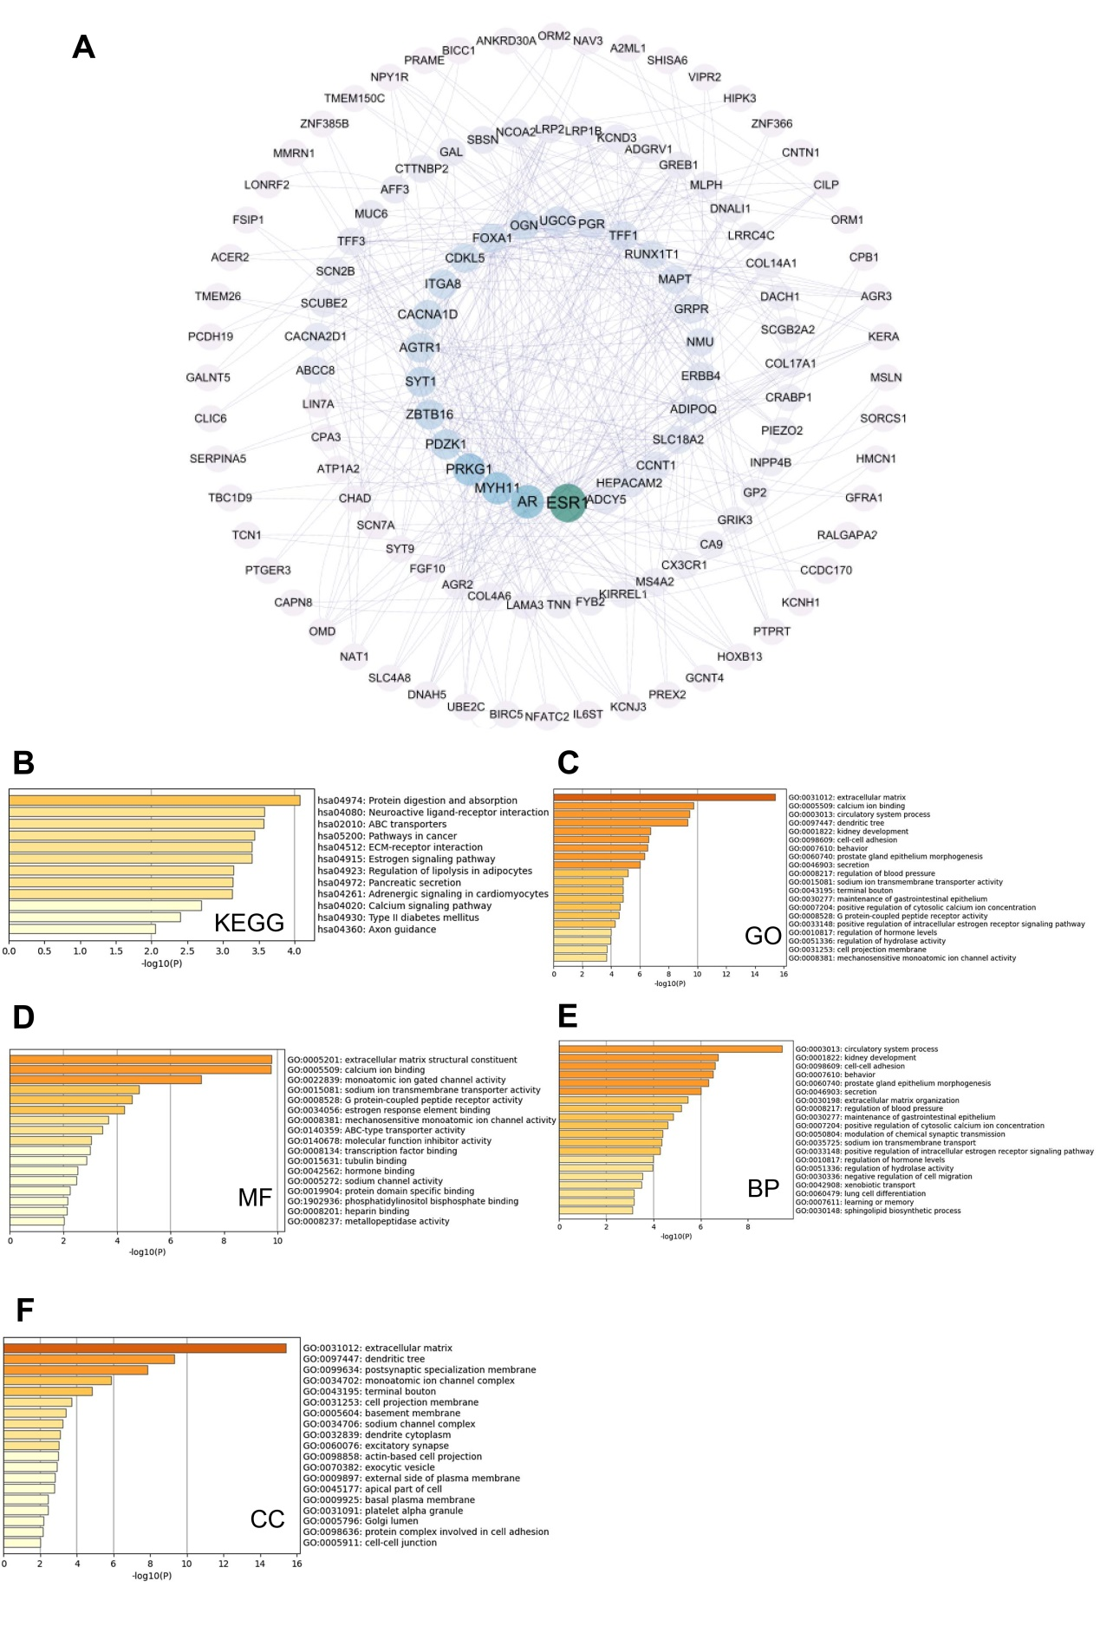
Supplementary Fig. 1: PPI network and pathway enrichment of PRDX family genes in breast cancer. (A) PRDX family co-expressed genes and their correlations exhibited in the form of a PPI network. (B-F) Enrichment analysis of PRDXs family co-expressed genes concerning KEGG analysis, GO analysis, Molecular Functions, Biological Processes, and Cell Components.

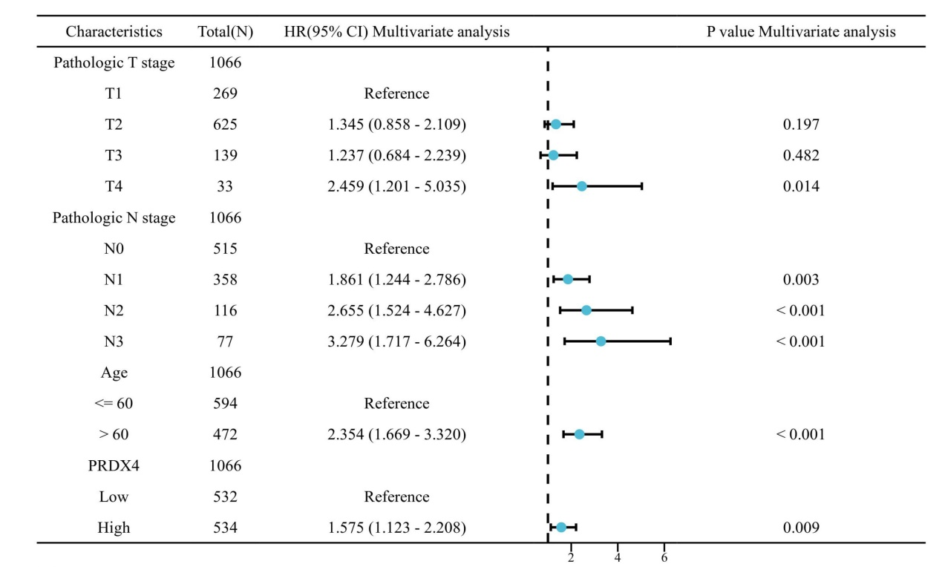
Supplementary Fig. 2: Multivariate COX regression analysis was carried out to analyze the association between expression of PRDX4 and overall survival of breast cancer.

