Supplementary Figures

Miniaturized Scalable Arrayed CRISPR Screening in Primary Cells Enables Discovery at the Single Donor Resolution

Authors
Miti A. Patel^{1†}, Brittany P. Boribong^{1†}, Hugo Sinha¹, Bin Xiao^{2,3}, Keqiang Xie⁴, Philippe Q.N. Vo¹, Andrew B. Chin¹, Ayoub Ellouzi¹, Samuel R. Little^{5,6}, Steve C.C. Shih^{5,6,7}, Hao Wu⁴, William J. Muller^{2,3}, Alison Hirukawa^{1*}
†authors contributed equally *corresponding author’s email: alison@drop-genie.com

Affiliations
¹DropGenie, Cambridge, Massachusetts, USA
²Department of Biochemistry, McGill University, Canada
³Rosalind and Morris Goodman Cancer Institute, McGill University, Canada
⁴Full Circles Therapeutics, Cambridge, Massachusetts, USA
⁵Department of Electrical and Computer Engineering, Concordia University, Montréal, Québec, Canada
⁶Centre for Applied Synthetic Biology, Concordia University, Montréal, Québec, Canada
⁷Department of Biology, Concordia University, Montréal, Québec, Canada
Supplementary Figure 1.
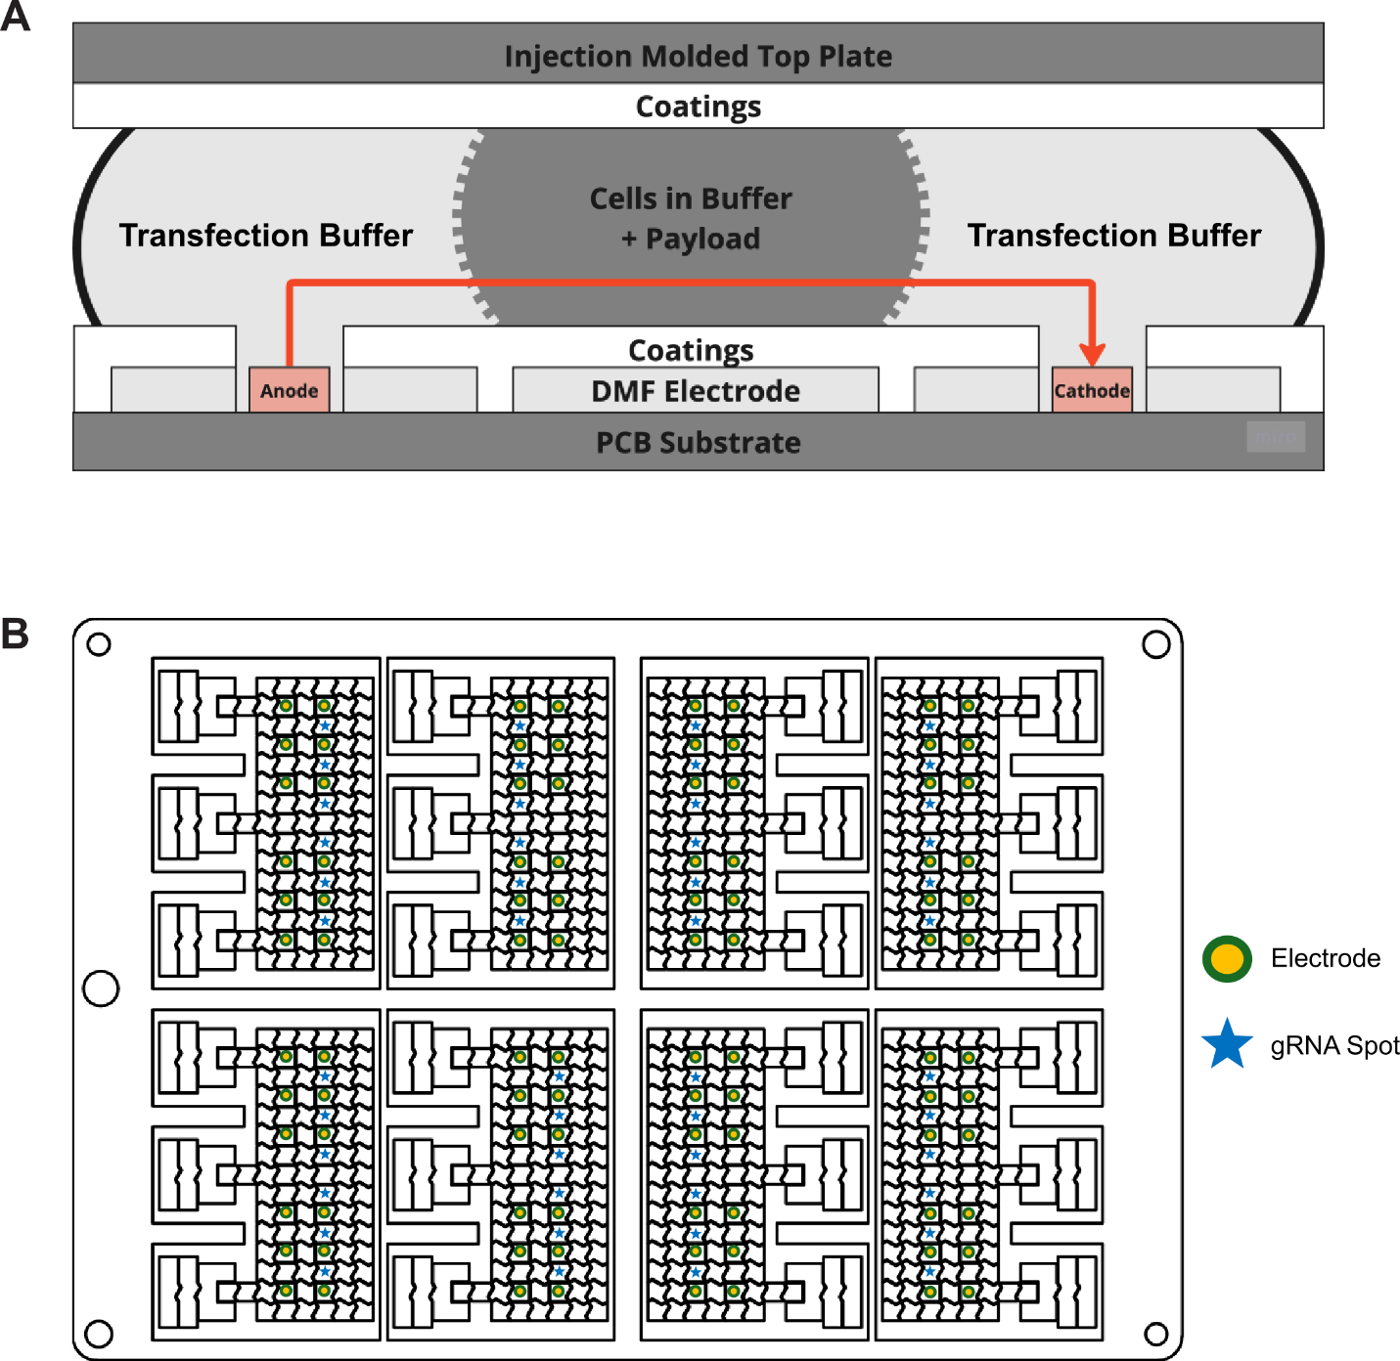

(A) Schematic illustrating the tri-drop structure utilized to electroporate cells with the included payload within the sample. Transfection buffer is moved over the anodes and cathodes on the substrate, sandwiching the cells with payload prior to electroporation. Post-electroporation, the entire tri-drop, including the cells, is moved to the offloading ports to be collected.
(B) Schematic displaying the location of the guide RNA spots placed on the substrate, as marked by the blue stars, relevant to the locations of the electrodes, marked by green and yellow circles.

Supplementary Figure 2.

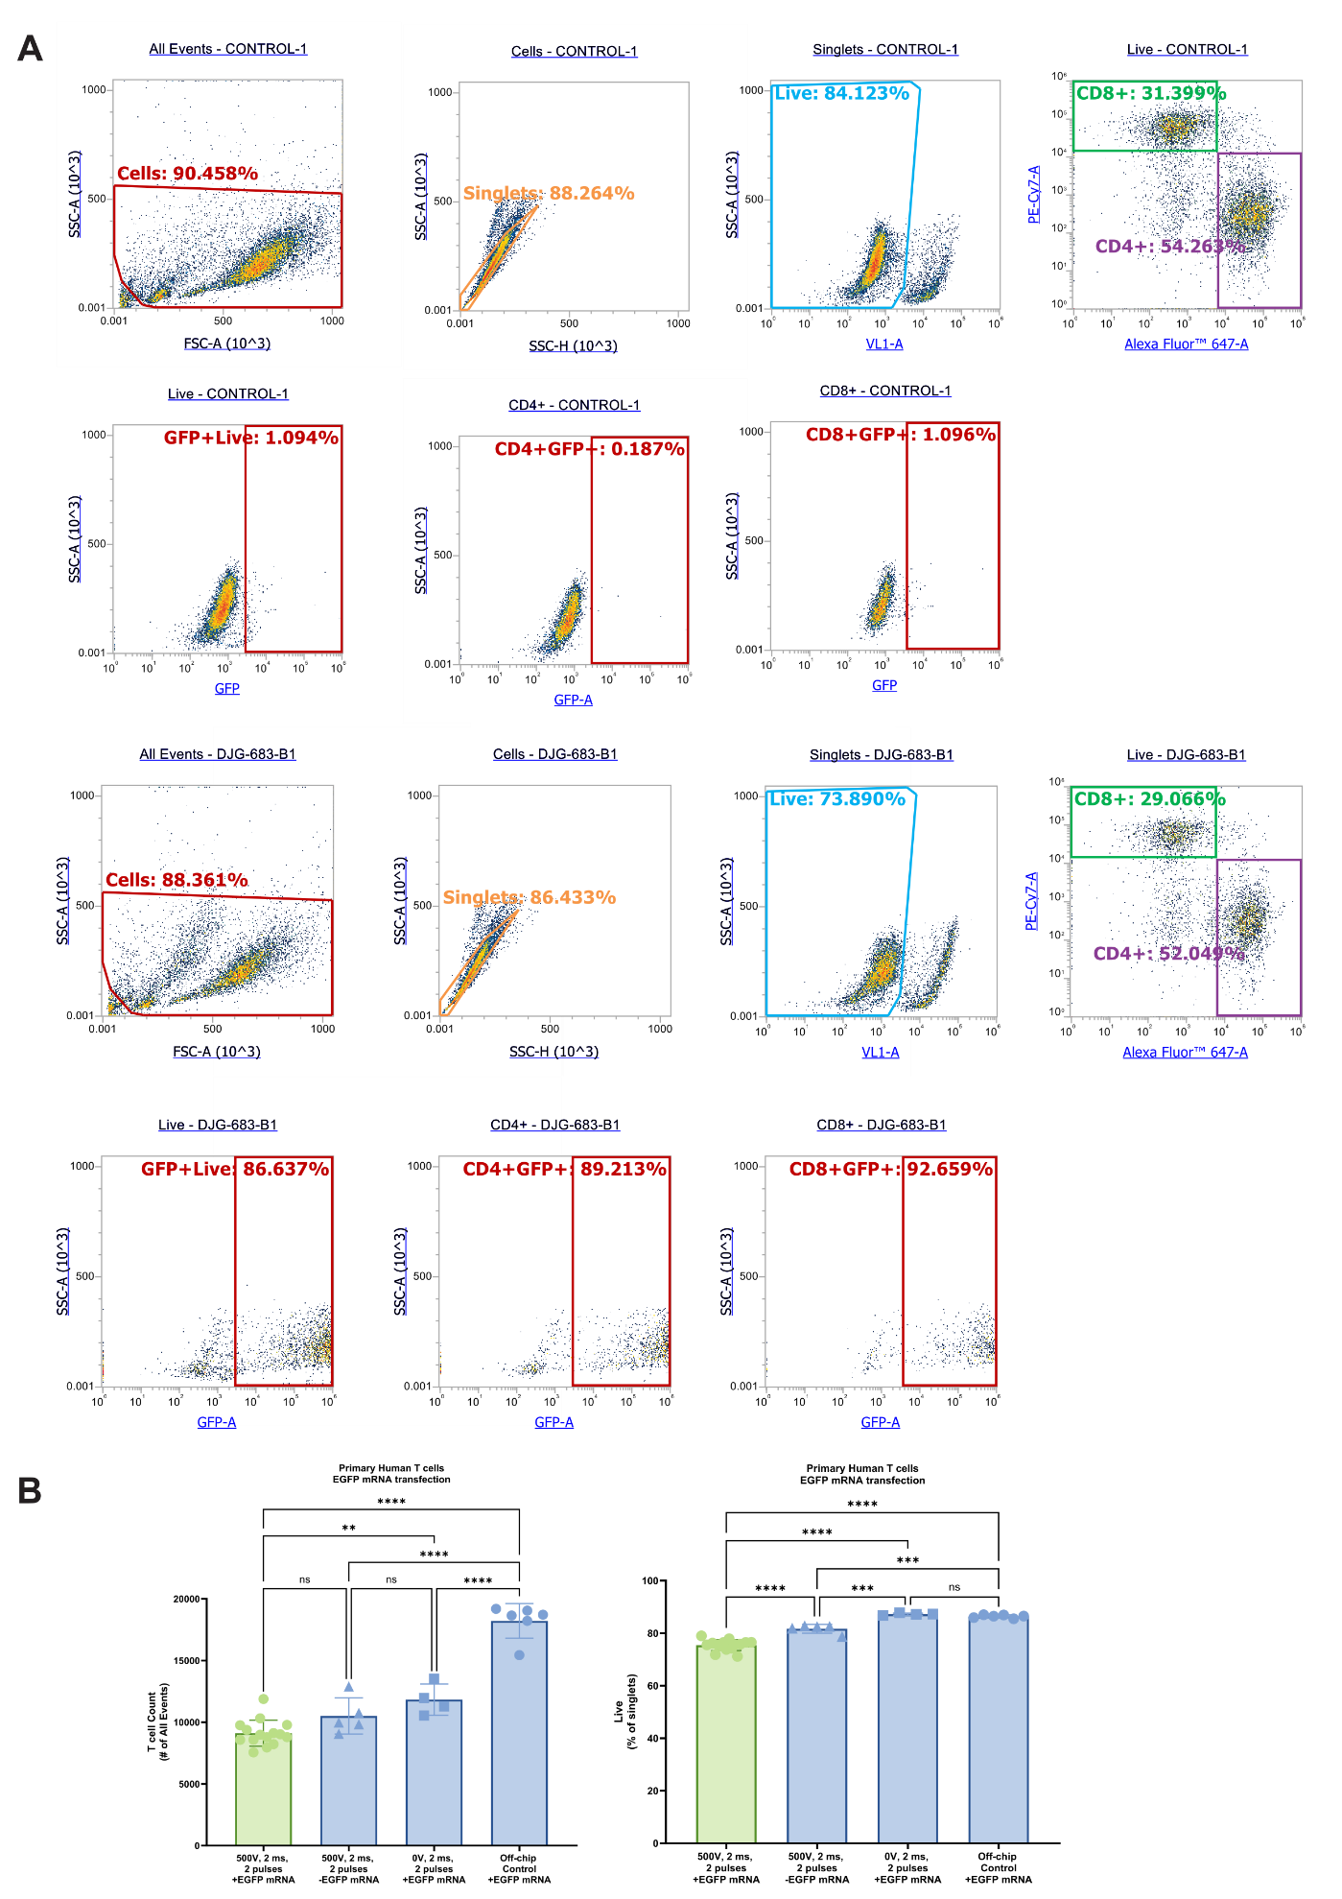
(A) Representative gating strategy for quantification of GFP expression in T cells. FSC/SSC is used to exclude debris and SSC-A/SSC-H is used to select singlets. Live cells were identified using Ghost Dye 450, and CD4+ and CD8+ T cell populations were distinguished based on CD4 AF647 and CD8 PE-Cy7 staining. GFP expression was analyzed within live CD4+ and CD8+ populations. (Top) GFP+ cells gated on CD4+ and CD8+ populations are shown in a control sample. (Bottom) GFP+ cells gated on CD4+ and CD8+ populations are shown in an experimental sample.
(B) (Left) T cell counts 24 hours post-transfection, showing initial cell input for on-chip samples are <10,000 cells/edit. (Right) Viability of T cells 24 hours post-transfection (N=4-15). Statistics were calculated using One-way ANOVA with multiple comparisons. Statistical significance is defined as ns = not significant, ∗p < 0.05, ∗∗p < 0.01, ∗∗∗p < 0.001, and ∗∗∗∗p < 0.0001. Mean values and SD are presented.
Supplementary Figure 3. Validation of MBNL1 knockout in primary human myoblasts by Western blot.

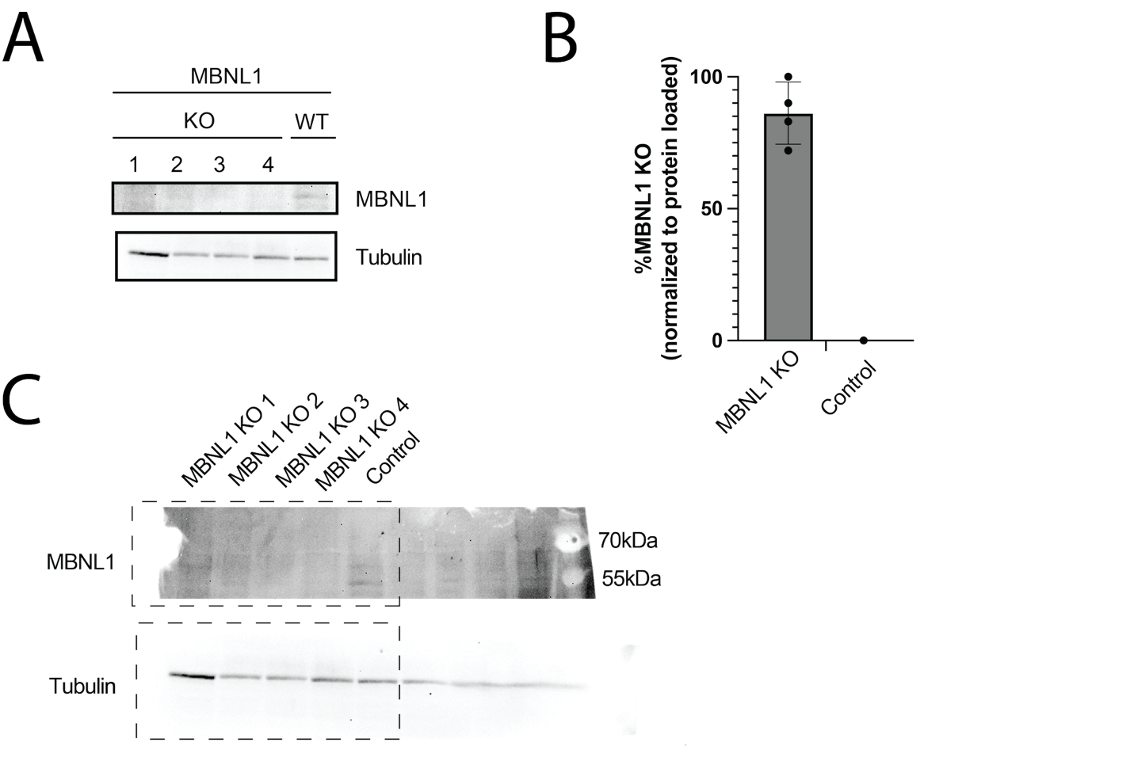
Western blot analysis of MBNL1 protein levels in CRISPR-edited and control myoblasts.
(A) Representative Western blot. Whole-cell lysates from bulk-edited cells (KO) and a donor-matched non-targeting control pool (WT) were resolved by SDS-PAGE and probed with anti-MBNL1. Lysates from three independent electroporations were pooled per lane to obtain sufficient protein. Complete loss of the ~42 kDa MBNL1 band is observed in the KO sample, confirming efficient genome editing. α-Tubulin serves as a loading control.
(B) Densitometric quantification of MBNL1 reduction. Band intensities were measured in ImageJ, background-subtracted (three blank regions per lane), and normalized to the corresponding tubulin signal. Bars represent the mean ± SD of four independent KO clones (n = 4); the average reduction of MBNL1 (KO) relative to control was 86 ± 12 %.
(C) Uncropped blots corresponding to panel A. Full-length membranes for MBNL1 and tubulin are shown; dashed rectangles delineate the regions displayed in panel A. Molecular-weight markers (70 kDa and 55 kDa) are indicated for reference.

Supplementary Figure 4. Representative flow cytometry gating of primary T-cells.
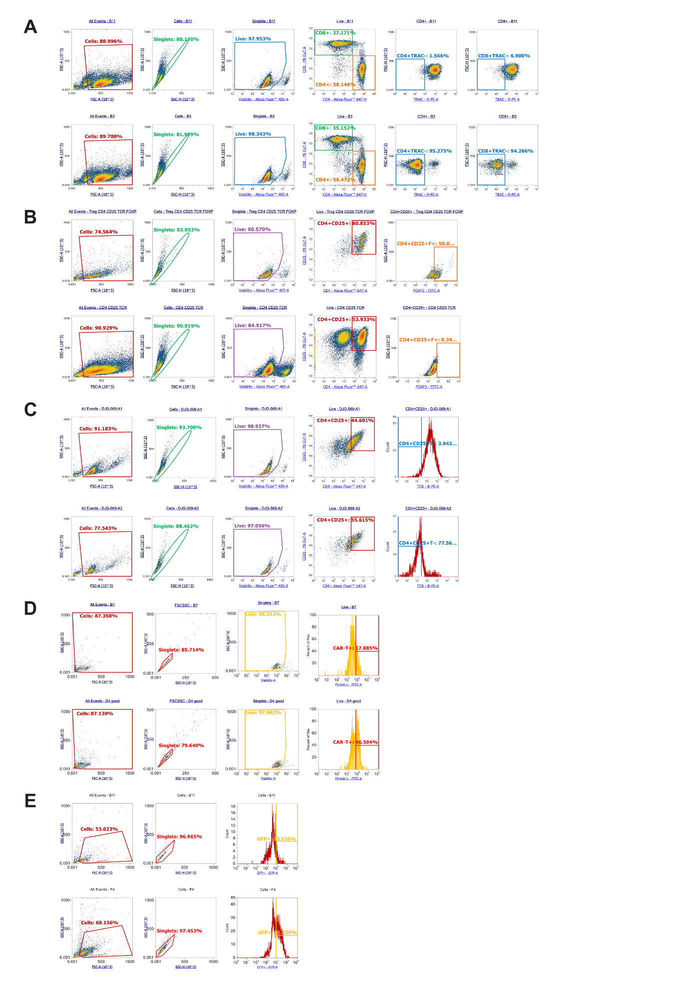
(A) Flow cytometry analysis was performed to evaluate knockout of the TCR α/β. Representative gating strategy is shown, where FSC/SSC is used to exclude debris and SSC-A/SSC-H is used to select singlets. Live cells were identified using Ghost Dye 450, and CD4+ and CD8+ T cell populations were distinguished based on CD4 AF647 and CD8 PE-Cy7 staining. TRAC KO was measured on the PE channel within live CD4+ and CD8+ populations, where percent negative represents percent knock out. (Top) TRAC- cells gated on CD4+ and CD8+ populations are shown in a control sample. (Bottom) TRAC- cells gated on CD4+ and CD8+ populations are shown in an experimental sample.
(B) Flow cytometry analysis was performed to evaluate the proportion of regulatory T cells (Tregs) in the vial received from the donor, 3 days post thaw. In the experimental condition with purified Tregs on the date of the experiment, 74% of cells were live, with 90% of live cells expressing CD4. Among these, 72.8% co-expressed FOXP3 and CD25, confirming Treg identity. These results indicate that 67% of live cells in the donor vial are CD4+CD25+FOXP3+ Tregs, demonstrating a high proportion of Tregs in the experimental sample.
(C) Flow cytometry analysis was performed to evaluate knockout of the TCR α/β. Representative gating strategy is shown, where FSC/SSC is used to exclude debris and SSC-A/SSC-H is used to select singlets. Live cells were identified using Ghost Dye 450, and CD4+ and CD25+ Treg populations were distinguished based on CD4 AF647 and CD25 PE-Cy7 staining. TRAC KO was measured on the PE channel within live CD4+ and CD8+ populations, where percent negative represents percent knock out. (Top) TRAC- cells gated on CD4+ and CD25+ populations are shown in a control sample. (Bottom) TRAC- cells gated on CD4+ and CD25+ populations are shown in an experimental sample.
(D) Flow cytometry analysis was performed to evaluate GFP-positive cells to determine knock-in efficiency. Representative gating strategy is shown, where FSC/SSC is used to exclude debris and SSC-A/SSC-H is used to select singlets. GFP-positive cells were gated on the singlet population. GFP-positive cells are shown in a (Top) control and (Bottom) experimental sample.
(E) Flow cytometry analysis was performed to evaluate cells expressing Protein L to confirm generation of Anti-HER2 CAR-T cells. Representative gating strategy is shown, where FSC/SSC is used to exclude debris and SSC-A/SSC-H is used to select singlets. Live cells were identified using Ghost Dye 450. Protein L expressing cells were measured on the FITC channel. Protein L expression is shown in a (Top) control and (Bottom) experimental sample.
Supplementary Figure 5. Miniaturized arrayed CRISPR screen in CD4+ T cells
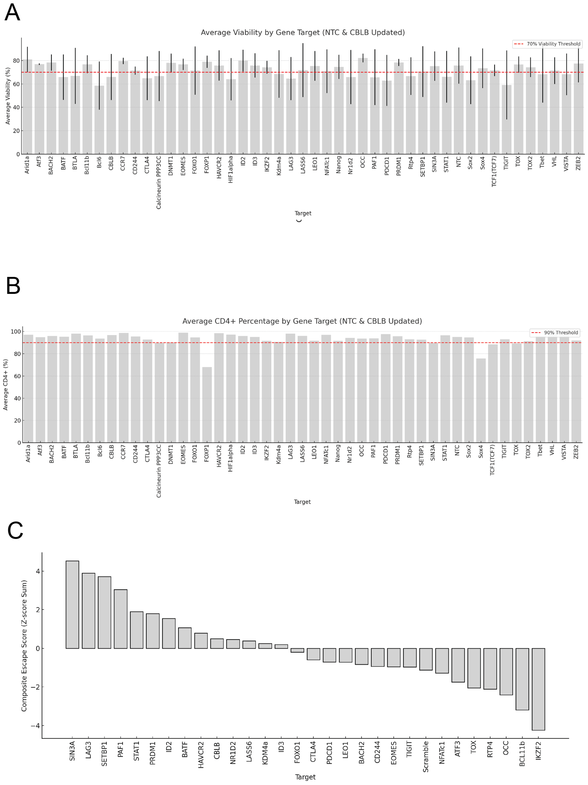

(A) Viability of CD4⁺ T cells following 3 weeks of stimulation under each perturbation (N=3-4). Mean values and SD are presented. Red line indicates 70% viability.
(B) Average percentage of CD4⁺ cells per condition (N=3-4). Mean values and SD are presented. Red line indicates 90% CD4+ T cells.
(C) Composite escape score reveals KO targets that resist T cell exhaustion. Bar plot showing the composite escape score for each gene knockout (KO) target, calculated by summing z-score normalized values for IFNγ and TNFα secretion (ELISA) and % LAG3-CD4+T cells (flow cytometry). These metrics collectively represent functional, non-exhausted T cell states. CRISPR KO targets with average viability < 70% and CD4+ <90% were excluded. Higher scores indicate stronger escape from T cell exhaustion.

