Network-based approach identifies key genes associated with tumor heterogeneity in HPV positive and negative head and neck cancer patients
Sumeet Patiyal¹ and Piyush Agrawal²*

- Cancer Data Science Laboratory, National Cancer Institute, NIH, Bethesda, MD 20814, USA
- Division of Medical Research, SRM Medical College Hospital and Research Centre, SRM Institute of Science and Technology, Kattankulathur, Chennai.

* Corresponding author

Corresponding Author Details

Piyush Agrawal. Ph.D.
Address: Division of Medical Research, SRM Medical College Hospital and Research Centre, SRMIST, Kattankulathur, Chennai
Email: piyusha@srmist.edu.in, apiyush74@gmail.com
ORCID: 0000-0003-2075-1111

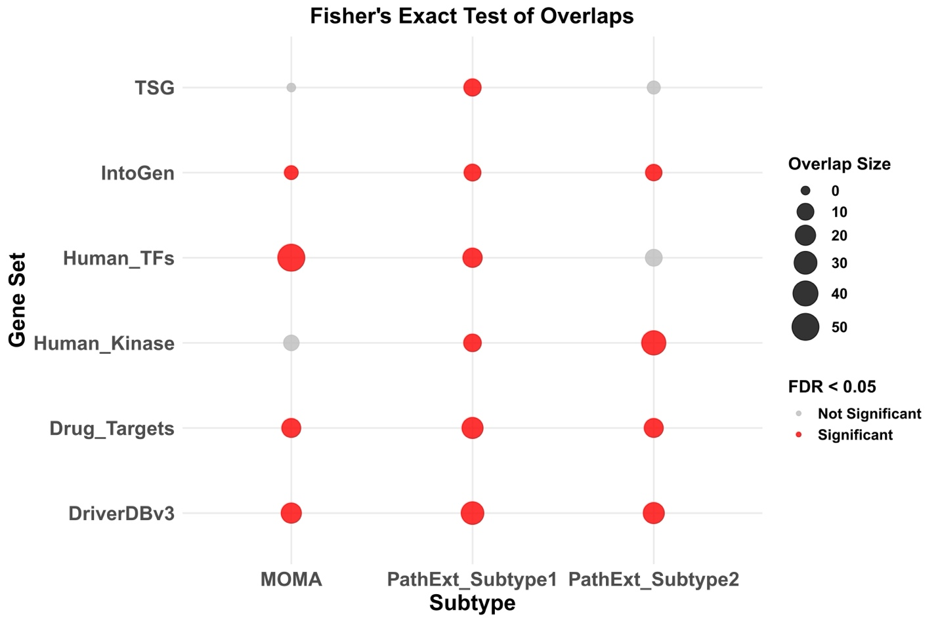
Supplementary Figure S1. Comparative analysis of PathExt with MOMA. Overlap analysis of 140 head and neck specific master regulators from MOMA with top100 genes form PathExt subtypes were performed. Fisher’s exact test was implemented, and odds ratio (OR) was computed. Dot represents the size of OR, red color signifies significant overlap whereas grey color signifies non-significant overlap.
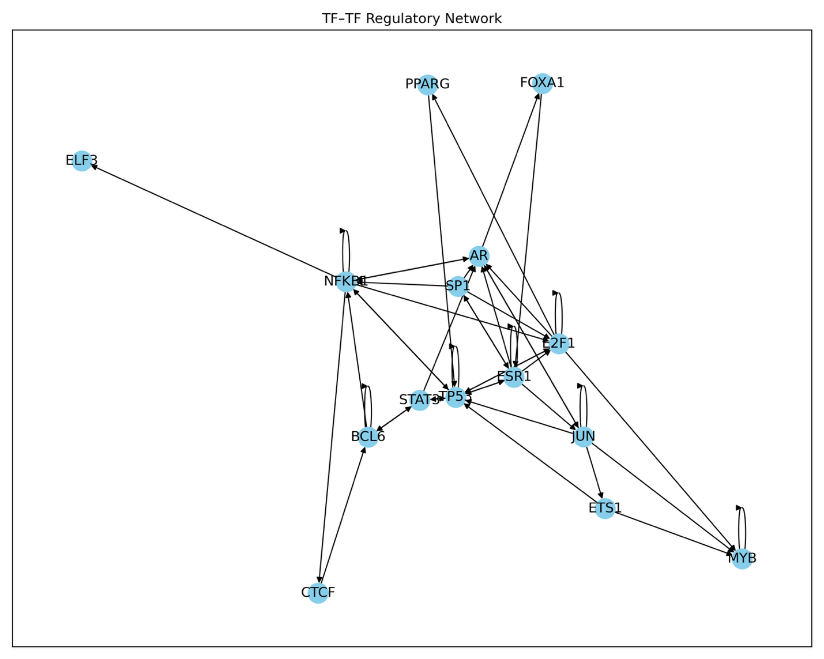
Supplementary Figure S2. TF-TF regulator network was created using Trrust tool. The network was created using TFs present in PathExt top100 genes in subtype 1.
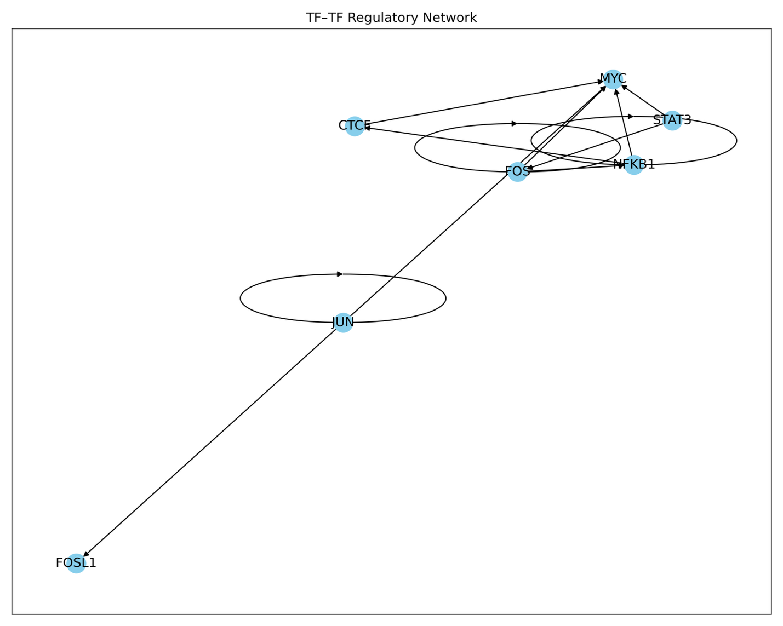
Supplementary Figure S3. TF-TF regulator network was created using Trrust tool. The network was created using TFs present in PathExt top100 genes in subtype 2.

