Supplementary materials

Modelling of Acid Brown 14 and Acid Yellow 36 dyes adsorption from water by self-nitrogen doped activated carbon

Mohamed A. El-Nemr^{1,2}, Mohamed A. Hassaan³, Murat Yılmaz⁴, Ahmed El Nemr³*

¹Department of Chemical Engineering, Faculty of Engineering, Minia University, Minia 61519, Egypt
²The Higher Canal Institute of Engineering and Technology, Al Salam 1 - Abu Bakr Al Siddiq Street, Suez, Egypt
³Environment Division, National Institute of Oceanography and Fisheries (NIOF), Kayet Bey, Elanfoushy, Alexandria, Egypt
⁴Osmaniye Korkut Ata University, Bahçe Vocational School, Department of Chemistry and Chemical Processing Technologies, Osmaniye, 80000, Türkiye

E-mail: mohamedelnemr1992@yahoo.com (M.A. El-Nemr), muratyilmaz@osmaniye.edu.tr (M. Yılmaz), mhss95@mail.com (M.A. Hassaan)

*Corresponding author: ahmedmoustafaelnemr@yahoo.com; ahmed.m.elnemr@gmail.com

 | 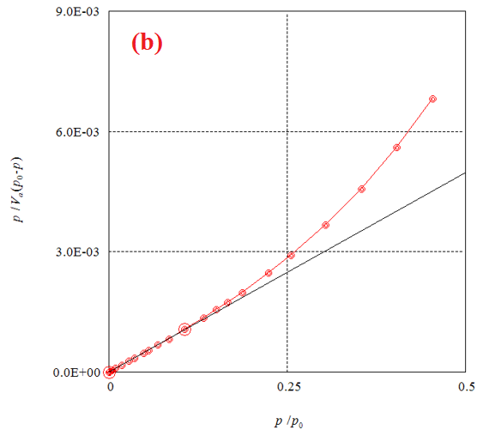
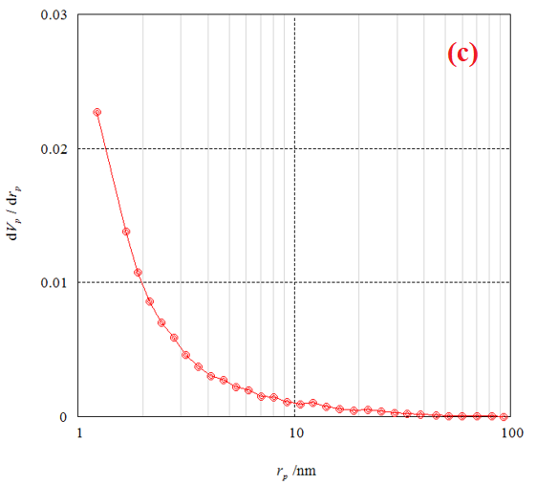 | 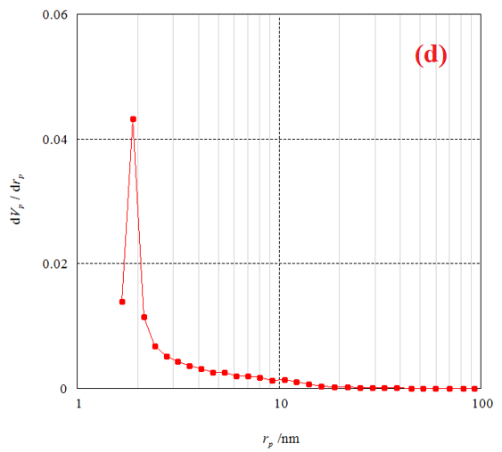
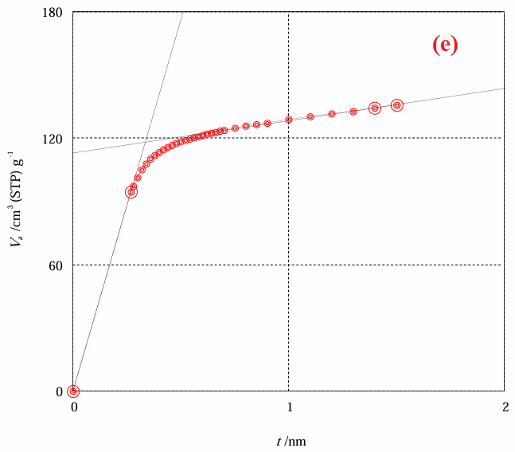 | 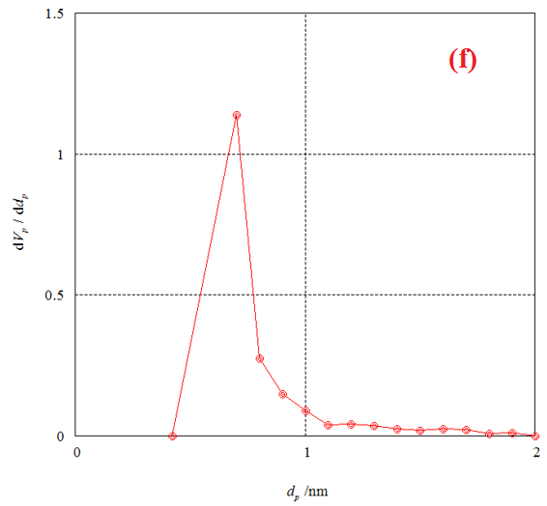
Figure S1. (a) Adsorption–desorption of AC7-800; (b) BET plot of AC7-800; (c) BJH plot by adsorption of AC7-800; (d) BJH plot by desorption of AC7-800; (e) t-plot of AC7-800; (f) MP plot of AC7-800.

Figure S2. The profiles of (a) LIM (b) FIM (c) TIM, and (d) HIM for AB14 dye of initial concentration (100 - 400 mg L^{–1}) on AC7-800 dosages (0.50 - 2.50 g L⁻¹) at 25±2 °C, contact time: 120 min).

Figure S3. The profiles of (a) LIM (b) FIM (c) TIM, and (d) HIM for AY36 dye of initial concentration (100 - 400 mg L^{–1}) on AC7-800 dosages (0.50 - 2.50 g L⁻¹) at 25±2 °C, contact time: 120 min).

Figure S4. The plot of (a) PFOM, (b) PSOM, (c) EM, (d) IPDM, and (e) FDM of adsorption of AB14 dye by AC7-800 adsorbent (C₀ = 100 - 400 mg L⁻¹, AC7-800 = 5.0 g L⁻¹, Temp. = 25±2 °C).

Figure S5. The plot of (a) PFOM (b) PSOM (c) EM (d) IPDM (e) FDM of adsorption of AY36 dye by AC7-800 adsorbent (C₀ = 100 - 400 mg L⁻¹, AC7-800 = 5.0 g L⁻¹, Temp. = 25±2 °C).

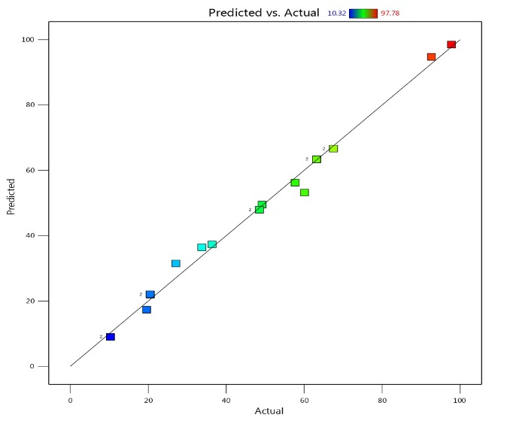 | 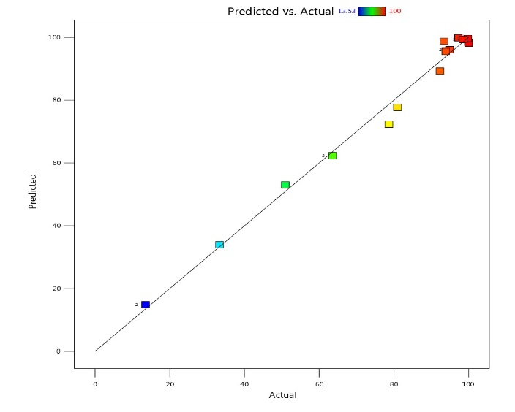
(a) | (b)
Figure S6. Plots between the experimental and predicted data for (a) AB14 dye adsorption, and (b) AY36 dye adsorption.

Table S1. Experimental design and RSM and ANN removal prediction percentage for adsorption of AB14 and AY36 dyes on AC7-800.

 | Factor 1 | Factor 2 | Factor 3 | Response |  |  | Response
 |  |  |  | AB14 dye removal % |  |  | AY36 dye removal %
 | A: AC7-800 dosage | B: Dye Conc. | C: Time | Experiment | RSM | ANN | Experiment | RSM | ANN
Run |  |  |  |  | Predicted | Predicted | Experiment | Predicted | Predicted
 | mg | mg/L | min | % | % | % | % | % | %
1 | 50 | 250 | 60 | 20.54 | 21.99 | 20.714 | 63.59 | 62.28 | 63.35
2 | 50 | 400 | 15 | 10.32 | 9.03 | 10.237 | 13.53 | 14.83 | 13.75
3 | 200 | 400 | 45 | 36.39 | 37.32 | 36.405 | 92.33 | 89.28 | 92.10
4 | 100 | 100 | 15 | 67.52 | 66.68 | 67.787 | 94.89 | 96.07 | 94.69
5 | 150 | 400 | 120 | 33.73 | 36.43 | 33.224 | 80.96 | 77.71 | 80.94
6 | 250 | 250 | 15 | 57.68 | 56.25 | 57.759 | 97.28 | 99.85 | 97.28
7 | 100 | 250 | 15 | 27.09 | 31.49 | 27.011 | 78.67 | 72.35 | 78.59
8 | 250 | 400 | 120 | 48.54 | 47.94 | 48.485 | 98.55 | 99.35 | 98.44
9 | 150 | 250 | 120 | 49.21 | 49.49 | 48.885 | 93.89 | 95.51 | 93.97
10 | 50 | 400 | 15 | 10.32 | 9.03 | 10.237 | 13.53 | 14.83 | 13.65
11 | 250 | 400 | 120 | 48.54 | 47.94 | 48.385 | 98.55 | 99.35 | 98.44
12 | 150 | 200 | 60 | 60.11 | 53.18 | 60.502 | 93.42 | 98.76 | 93.52
13 | 250 | 100 | 30 | 92.66 | 94.74 | 92.527 | 99.93 | 98.48 | 99.86
14 | 100 | 400 | 60 | 20.49 | 22.08 | 20.421 | 50.92 | 52.98 | 50.83
15 | 50 | 400 | 120 | 19.58 | 17.36 | 19.565 | 33.31 | 33.93 | 33.21
16 | 100 | 100 | 15 | 67.52 | 66.68 | 67.787 | 94.89 | 96.07 | 94.78
17 | 50 | 250 | 60 | 20.54 | 21.99 | 20.714 | 63.59 | 62.28 | 63.45
18 | 50 | 100 | 120 | 63.19 | 63.39 | 63.118 | 99.79 | 99.65 | 99.54
19 | 250 | 100 | 90 | 97.78 | 98.52 | 93.367 | 100 | 98.18 | 99.95
20 | 50 | 100 | 120 | 63.19 | 63.39 | 57.0177 | 99.79 | 99.65 | 99.54

Table S2. D-optimal design for AB14 dye adsorption using ANOVA and model fit summary.
Source | Value | Sum of Squares | df | Mean Square | F-value | p-value | Remarks | source | SD | R² | Adjusted R² | Predicted R² | PRESS | Remarks
Model | - | 12425.02 | 9 | 1380.56 | 138.36 | < 0.0001 | significant | - | - | - | - | - | - | -
A- AC7-800 dosage | - | 3294.49 | 1 | 3294.49 | 330.17 | < 0.0001 | - | - | - | - | - | - | - | -
B-Dye Conc. | - | 6441.48 | 1 | 6441.48 | 645.57 | < 0.0001 | - | - | - | - | - | - | - | -
C-Time | - | 148.32 | 1 | 148.32 | 14.86 | 0.0032 | - | - | - | - | - | - | - | -
AB | - | 27.55 | 1 | 27.55 | 2.76 | 0.1275 | - | - | - | - | - | - | - | -
AC | - | 2.39 | 1 | 2.39 | 0.2397 | 0.6350 | - | - | - | - | - | - | - | -
BC | - | 0.9538 | 1 | 0.9538 | 0.0956 | 0.7635 | - | - | - | - | - | - | - | -
A² | - | 43.03 | 1 | 43.03 | 4.31 | 0.0646 | - | - | - | - | - | - | - | -
B² | - | 488.48 | 1 | 488.48 | 48.96 | < 0.0001 | - | - | - | - | - | - | - | -
C² | - | 5.47 | 1 | 5.47 | 0.5485 | 0.4760 | - | - | - | - | - | - | - | -
Residual | - | 99.78 | 10 | 9.98 |  |  | - | - | - | - | - | - | - | -
Lack of Fit | - | 99.78 | 5 | 19.96 |  |  | - | - | - | - | - | - | - | -
Pure Error | - | 0.0000 | 5 | 0.0000 |  |  | - | - | - | - | - | - | - | -
Cor Total | - | 12524.80 | 19 |  |  |  |  | - | - | - | - | - | - | -
SD | 3.16 | - | - | - | - | - | - | - | - | - | - | - | - | -
Mean | 45.75 | - | - | - | - | - | - | - | - | - | - | - | - | -
C.V.% | 6.90 | - | - | - | - | - | - | - | - | - | - | - | - | -
R² | 0.9920 | - | - | - | - | - | - | - | - | - | - | - | - | -
Adjusted R² | 0.9849 | - | - | - | - | - | - | - | - | - | - | - | - | -
Predicted R² | 0.9722 | - | - | - | - | - | - | - | - | - | - | - | - | -
Adeq Precision | 40.0629 | - | - | - | - | - | - | - | - | - | - | - | - | -
Linear |  |  |  |  |  |  |  |  | 6.60 | 0.9443 | 0.9339 | 0.9209 | 990.71
2FI |  |  |  |  |  |  |  |  | 7.14 | 0.9471 | 0.9226 | 0.8927 | 1344.26
Quadratic |  |  |  |  |  |  |  |  | 3.16 | 0.9920 | 0.9849 | 0.9722 | 348.79 | Suggested
Cubic |  |  |  |  |  |  |  |  | 0.0000 | 1.0000 | 1.0000 |  | * | Aliased

Table S3. ANOVA and model fit summary for D-optimal design for AY36 dye adsorption
Source | Value | Sum of Squares | df | Mean Square | F-value | p-value | Remarks | source | SD | R² | Adjusted R² | Predicted R² | PRESS | Remarks
Model | - | 15746.04 | 9 | 1749.56 | 147.43 | < 0.0001 | significant | - | - | - | - | - | - | -
A-Time | - | 3969.74 | 1 | 3969.74 | 334.52 | < 0.0001 | - | - | - | - | - | - | - | -
B-Dose | - | 2858.10 | 1 | 2858.10 | 240.85 | < 0.0001 | - | - | - | - | - | - | - | -
C-Conc | - | 172.20 | 1 | 172.20 | 14.51 | 0.0034 | - | - | - | - | - | - | - | -
AB | - | 2229.99 | 1 | 2229.99 | 187.92 | < 0.0001 | - | - | - | - | - | - | - | -
AC | - | 131.17 | 1 | 131.17 | 11.05 | 0.0077 | - | - | - | - | - | - | - | -
BC | - | 7.96 | 1 | 7.96 | 0.6704 | 0.4320 | - | - | - | - | - | - | - | -
A² | - | 368.15 | 1 | 368.15 | 31.02 | 0.0002 | - | - | - | - | - | - | - | -
B² | - | 20.05 | 1 | 20.05 | 1.69 | 0.2228 | - | - | - | - | - | - | - | -
C² | - | 24.94 | 1 | 24.94 | 2.10 | 0.1778 | - | - | - | - | - | - | - | -
Residual | - | 118.67 | 10 | 11.87 |  |  | - | - | - | - | - | - | - | -
Lack of Fit | - | 118.67 | 5 | 23.73 |  |  | - | - | - | - | - | - | - | -
Pure Error | - | 0.0000 | 5 | 0.0000 |  |  | - | - | - | - | - | - | - | -
Cor Total | - | 15864.71 | 19 |  |  |  | - | - | - | - | - | - | - | -
SD | 3.44 | - | - | - | - | - | - | - | - | - | - | - | - | -
Mean | 78.07 | - | - | - | - | - | - | - | - | - | - | - | - | -
C.V.% | 4.41 | - | - | - | - | - | - | - | - | - | - | - | - | -
R² | 0.9925 | - | - | - | - | - | - | - | - | - | - | - | - | -
Adjusted R² | 0.9858 | - | - | - | - | - | - | - | - | - | - | - | - | -
Predicted R² | 0.9700 | - | - | - | - | - | - | - | - | - | - | - | - | -
Adeq Precision | 34.9024 | - | - | - | - | - | - | - | - | - | - | - | - | -
Linear |  |  |  |  |  |  |  |  | 14.75 | 0.7805 | 0.7393 | 0.6289 | 5886.73
2FI |  |  |  |  |  |  |  |  | 6.98 | 0.9601 | 0.9417 | 0.8921 | 1711.03
Quadratic |  |  |  |  |  |  |  |  | 3.44 | 0.9925 | 0.9858 | 0.9700 | 475.62 | Suggested
Cubic |  |  |  |  |  |  |  |  | 0.0000 | 1.0000 | 1.0000 |  | * | Aliased

