Supplementary Information

Article title: Reliability of a German telephone version of the Kansas City Cardiomyopathy Questionnaire (KCCQ)
Journal name: Scientific Reports
Author names: Martha Schutzmeier^{1*}, Viktoria Rücker¹, Jonas Widmann¹, Anna Grau¹, Caroline Morbach^{2,3}, John A. Spertus⁴, Jürgen Deckert¹, Stefan Störk^{2,3}, Peter U. Heuschmann^{1,5,6}
Affiliations:
¹ Julius-Maximilian University Würzburg, Institute for Clinical Epidemiology and Biometry, Würzburg, Germany
² Department Clinical Research & Epidemiology, Comprehensive Heart Failure Center Würz-burg, University Hospital Würzburg, Germany
³ Department Medicine I, University Hospital Würzburg, Germany
⁴ University of Missouri – Kansas City’s Healthcare Institute for Innovations in Quality and Saint Luke's Mid America Heart Institute, Kansas City, Missouri
⁵ Clinical Trial Centre Würzburg, University Hospital Würzburg, Germany;
⁶ Institute for medical Data Sciences, University Hospital Würzburg, Germany
E-mail address of the corresponding author: martha.nast@uni-wuerzburg.de

Table S1: Results of the KCCQ-12 for both ways of administration (n = 61)
 | KCCQ (median, IQR)
 | self - administered | telephone interview | p-Value
Domains
Physical Limitationª | 83.33 (66.66 - 91.66) | 83.33 (58.33 – 100) | 0.96
Symptom Frequency | 91.67 (66.66 – 95.83) | 83.33 (62.5 – 100) | 0.17
Quality of Life | 75 (62.5 – 100) | 75 (62.5 – 87.5) | 0.54
Social Limitationsª | 83.33 (50 – 100) | 83.33 (62.5 – 100) | 0.05
Scores
Clinical Summary Score | 85.42 (65.62 – 93.75) | 82.29 (67.70 – 93.75) | 0.40
Overall Summary Score | 81.25 (65.62 – 93.75) | 83.33 (66.66 – 90.62) | 0.98
KCCQ, Kansas City Cardiomyopathy Questionnaire; IQR, interquartile range, ªn = 60

Table S2: Test-retest reliability between telephone-assessed and self-administered KCCQ-12 (n = 61)
 | ICC | 95%-CI
Domains
Physical Limitationª | 0.67 | 0.64 – 0.71
Symptom Frequency | 0.77 | 0.74 – 0.80
Quality of Life | 0.83 | 0.79 – 0.86
Social Limitationsª | 0.71 | 0.67 – 0.74
Scores
Clinical Summary Score | 0.83 | 0.79 – 0.86
Overall Summary Score | 0.85 | 0.82 – 0.88
KCCQ, Kansas City Cardiomyopathy Questionnaire; ICC, non parametric intraclass correlation coefficient; CI, confidence interval, ªn = 60.

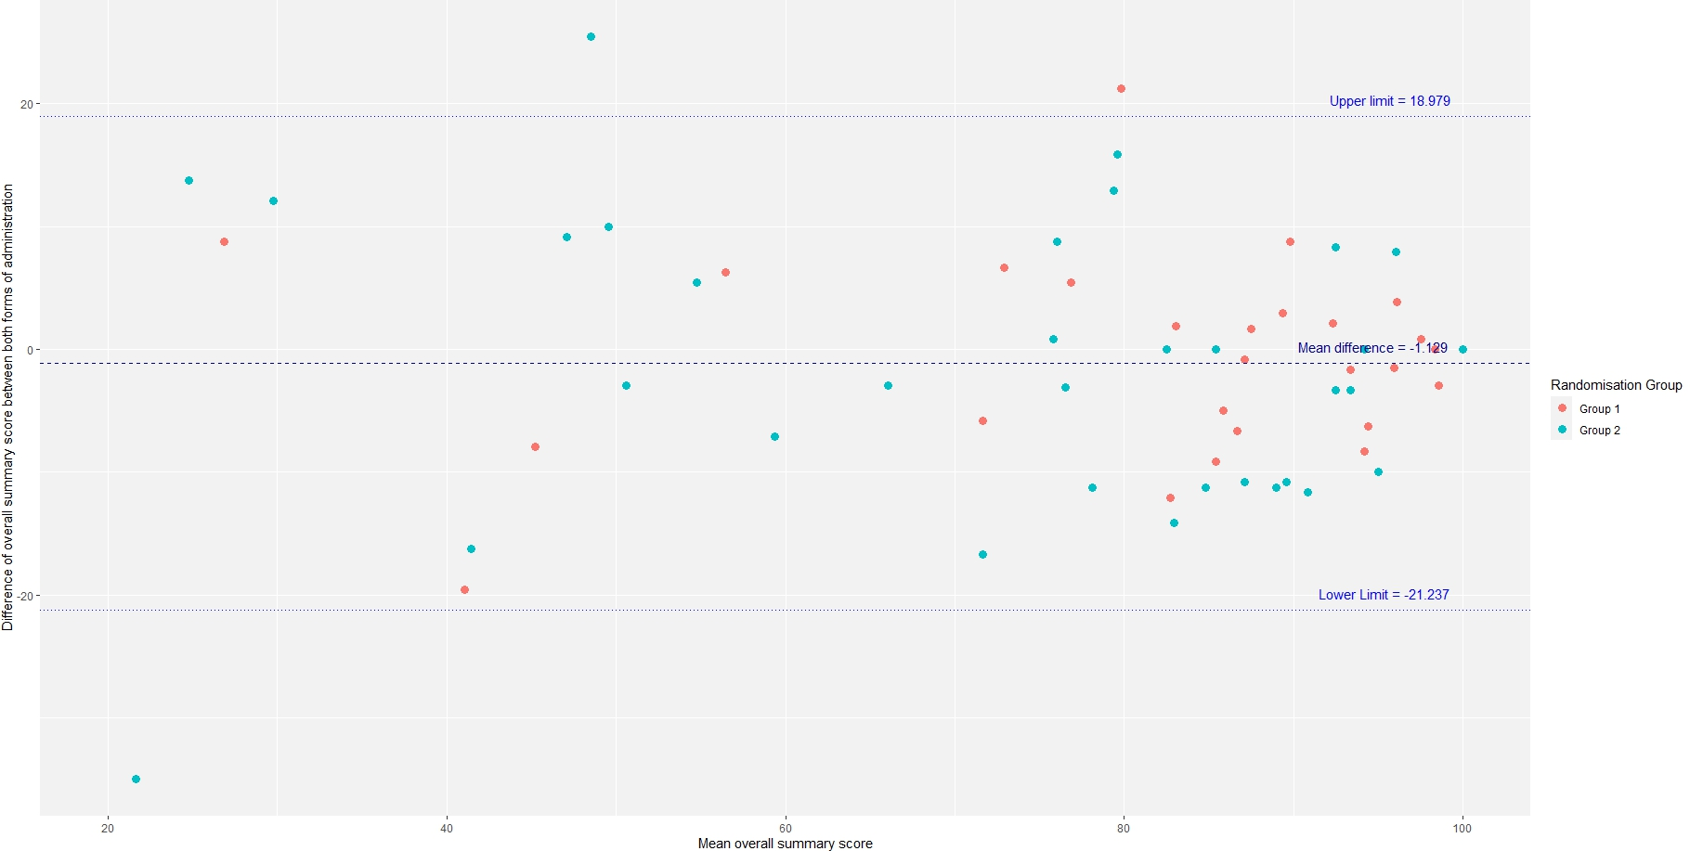
Figure S1 Comparison of the median overall summary score with the difference of the overall summary score between both forms of administration, according to randomization group
Group 1: self-administered questionnaire first; Group 2: telephone interview first.

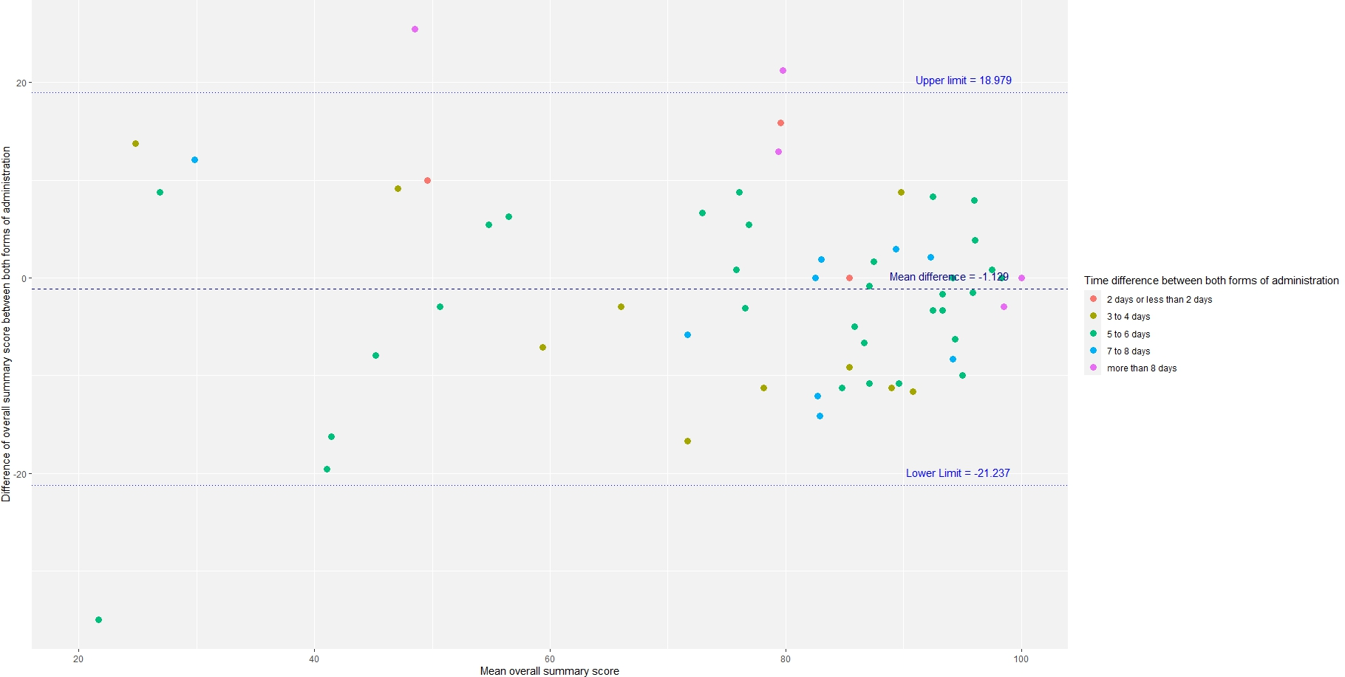
Figure S2 Comparison of the median overall summary score with the difference of the overall summary score between both forms of administration, according to time interval between administrations

