Supporting Information
Figure S1.
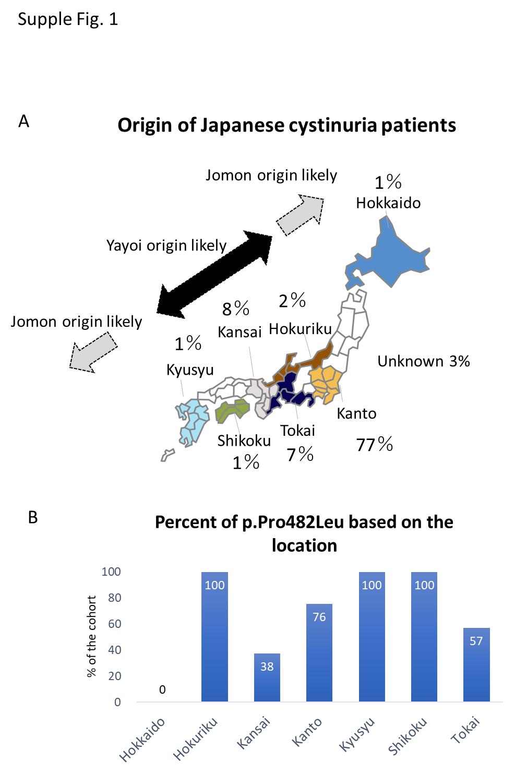

Figure S1. Origin of cystinuria patients
The percentage of origin of cystinuria patients were represented (A). 77% of patients were from Kanto area, followed by Kansai (8%) and Tokai (7%) area. Percentage of p.(Pro482Leu) based on the region. 100% of patients from Hokuriku, Kyusyu and Shikoku regions possessed p.(Pro482Leu) variant. Northern and southern part of Japan are more likely to be Jomon Origine (blue dot arrow), while mainland is more likely to be Yayoi origin (red dot arrow). The location of the specific region was illustrated (C).

Table S1. List of case with a single variant
Table S1. List of cases with a single variant
 | SLC3A1 |  | SLC7A9
 | Variants |  | Variants |  | Genotype | Cystine Conc (µmol/day)
1 | N442fs(hetero)1323dupT |  |  |  | Type A | 3034.6
2 |  |  | c.1399+4_1399+7delAGTA |  | Type B | 4094.2
3 |  |  | p.(Pro482Leu)(hetero)c.1445C>T |  | Type B | -
4 |  |  | p.(Pro482Leu)(hetero)c.1445C>T |  | Type B | 592.8
5 |  |  | p.(Pro482Leu)(hetero)c.1445C>T |  | Type B | -
6 |  |  | p.(Pro482Leu)(hetero)c.1445C>T |  | Type B | 1968.8
7 |  |  | p.(Ala354Thr)(hetero)c.1060G>A |  | Type B | -
8 |  |  | p.(Asn227Asp)(hetero)c.679A>G |  | Type B | -
 |  |  |  |  |  | 2501.7 (median)

Table S2. Original Data for the 101 Cystinuria patients

