Neutrophil-Derived Il1r2 Modulates Inflammation and Alleviates Acute Lung Injury by Promoting M2 Macrophage Polarization
Weiwei Ding¹, Hui Zhang¹, Bing Li¹, Xiaodong Xu¹,Yitian Yang¹, Luyao Zhang^{1*}
¹Department of Anesthesia and Perioperative Medicine, Henan Provincial People's Hospital, Zhengzhou University, Zhengzhou 450003,China

*Corresponding author: Luyao Zhang, Department of Anesthesiology and Perioperative Medicine, Henan Provincial People's Hospital, Zhengzhou 450003, China. Email: luyaozhang@126.com

Supplementary Table 1: Dataset information
GEO dataset | Platform | Model | Lung injury | Control
GSE6730 | GPL339 | RIR | 3 | 3
GSE2411 | GPL339 | LPS | 6 | 6
GSE269740 | GPL24247 | Sepsis | 3 | 3
GSE222957 | GPL23479 | LIR | 3 | 4
GSE216943 | GPL24247 | LPS | 6 | 6
GSE235367 | GPL30215 | HIR | 1 | 1
RIR, Renal ischemia reperfusion. LPS, Lipopolysaccharide. LIR, lung ischemia reperfusion. LIR, Hepatic ischemia reperfusion.

Supplementary Table 2: Primer sequences for the amplification
Primer name | Primer sequences（5'-3')
Cebpd
    Sense primer | CCGAGCCCTTCTCCATCATT
Antisense primer | CCACCATCAGCTGGTCCTTT
Hspa12b
Sense primer | CAGGAGTGAGGACGAGGAGG
Antisense primer | CAGGAGTGAGGACGAGGAGG
Pim1
Sense primer | TTCCTGCCAGATGACAGCAG
Antisense primer | GGACACAGCGAGATGGTGAA
Il1r2
Sense primer | AGTCCAGCTCCTGTCGACCT
Antisense primer | GCTCTCCGAGTGGGACATTT
β-actin
Sense primer | GTGACGTTGACATCCGTAAAGA
Antisense primer | GTAACAGTCCGCCTAGAAGCAC
IL, Interleukin
Supplementary Table 3: module Trait Cor
 | Con | ALI
MEblue | 0.725933154 | -0.725933154
MEturquoise | 0.934468413 | -0.934468413
MEyellow | 0.199956715 | -0.199956715
MEbrown | 0.74475098 | -0.74475098
MEgreen | 0.486081443 | -0.486081443
MElightgreen | -0.164801191 | 0.164801191
MEmagenta | -0.048811482 | 0.048811482
MEtan | -0.099593559 | 0.099593559
MEpurple | 0.25077962 | -0.25077962
MEgrey60 | 0.186411461 | -0.186411461
MEsalmon | 0.56545221 | -0.56545221
MEblack | 0.03011179 | -0.03011179
MElightcyan | -0.427770215 | 0.427770215
MEcyan | -0.670660466 | 0.670660466
MEpink | -0.555214073 | 0.555214073
MEred | -0.491508862 | 0.491508862
MEgreenyellow | -0.641720719 | 0.641720719
MEmidnightblue | -0.354264989 | 0.354264989
MEgrey | 0.058692537 | -0.058692537

Supplementary Table 4: module Trait P value
 | Con | ALI
MEblue | 3.80E-06 | 3.80E-06
MEturquoise | 1.54E-14 | 1.54E-14
MEyellow | 0.280810927 | 0.280810927
MEbrown | 1.55E-06 | 1.55E-06
MEgreen | 0.005564116 | 0.005564116
MElightgreen | 0.375646216 | 0.375646216
MEmagenta | 0.794279196 | 0.794279196
MEtan | 0.59399583 | 0.59399583
MEpurple | 0.173588196 | 0.173588196
MEgrey60 | 0.315340079 | 0.315340079
MEsalmon | 0.000916946 | 0.000916946
MEblack | 0.872249432 | 0.872249432
MElightcyan | 0.016372174 | 0.016372174
MEcyan | 3.65E-05 | 3.65E-05
MEpink | 0.00118672 | 0.00118672
MEred | 0.004984123 | 0.004984123
MEgreenyellow | 9.99E-05 | 9.99E-05
MEmidnightblue | 0.050541837 | 0.050541837
MEgrey | 0.753803852 | 0.753803852

Supplementary Figure1
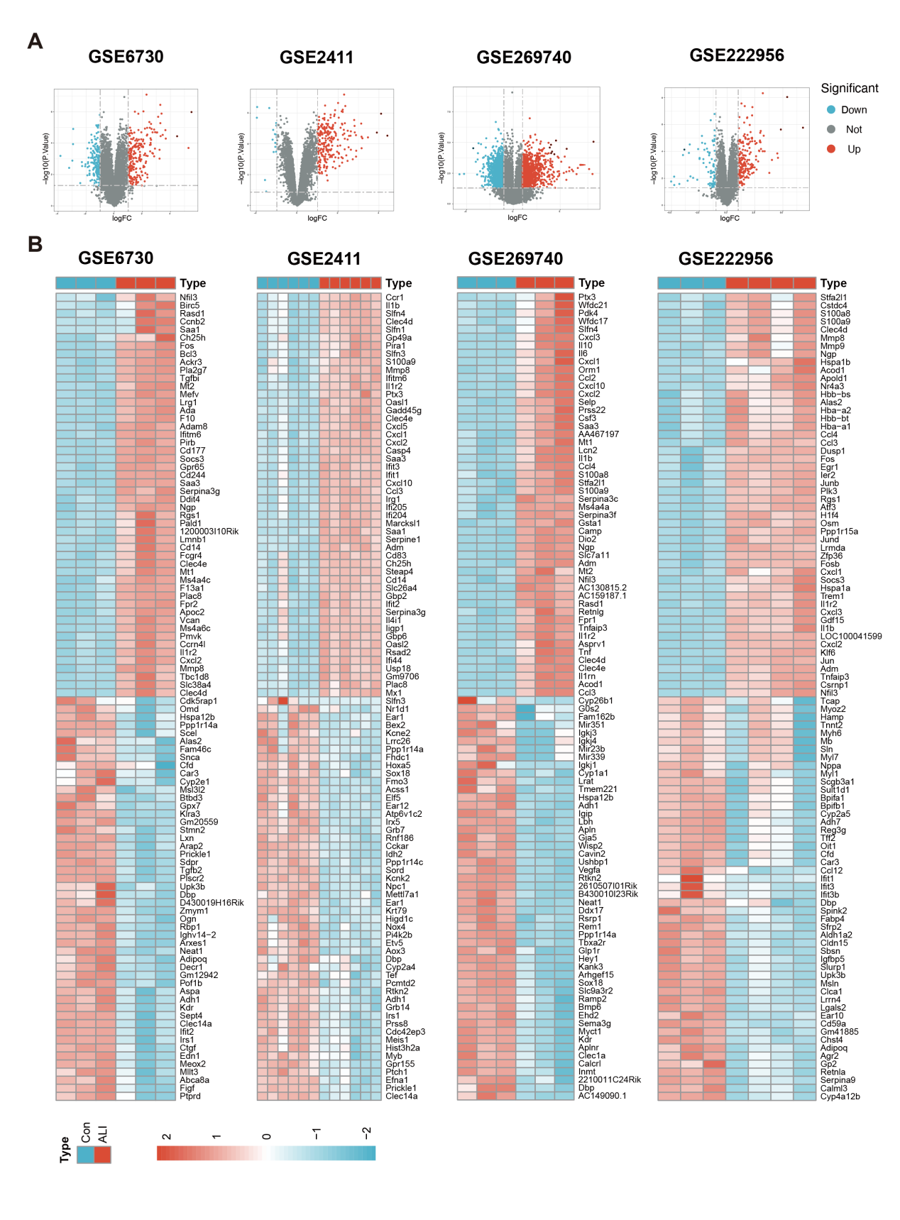Fig S1.(A) Volcano plot showing DEGs between ALI and control samples. (B) Heatmap showing the top 50 up- and down-regulated genes. DEGs, Differentially expressed genes.

Supplementary Figure2
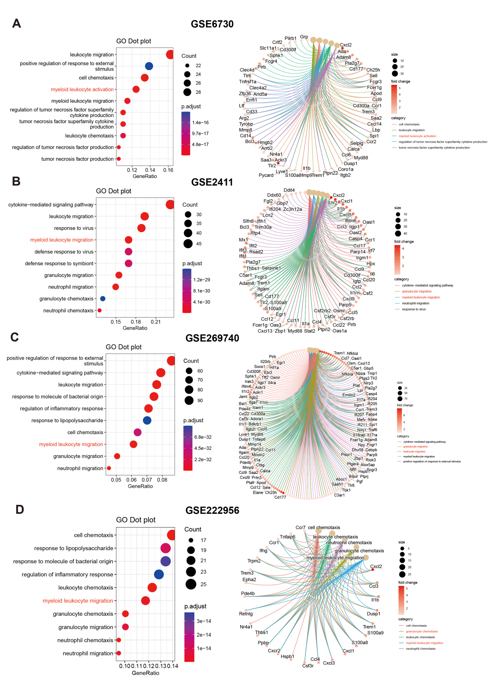Fig S2.(A) Top 10 GO enrichment pathways (left) and related genes (right) for the top 5 pathways in GSE6730. (B) Top 10 GO enrichment pathways (left) and related genes (right) for the top 5 pathways in GSE2411. (C) Top 10 GO enrichment pathways (left) and related genes (right) for the top 5 pathways in GSE269740. (D) Top 10 GO enrichment pathways (left) and related genes (right) for the top 5 pathways in GSE222956. GO, Gene ontology.

Supplementary Figure3
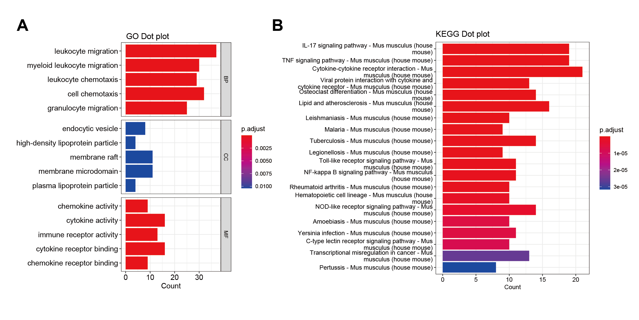Fig S3.(A) Top 5 GO (BP, CC, MF) enrichment pathways. (B) Top 20 KEGG enrichment pathways. GO , Gene Ontology. KEGG, Kyoto Encyclopedia of Genes and Genomes. BP, Biological process. CC, Cellular component. MF, Molecular function.
Supplementary Figure4
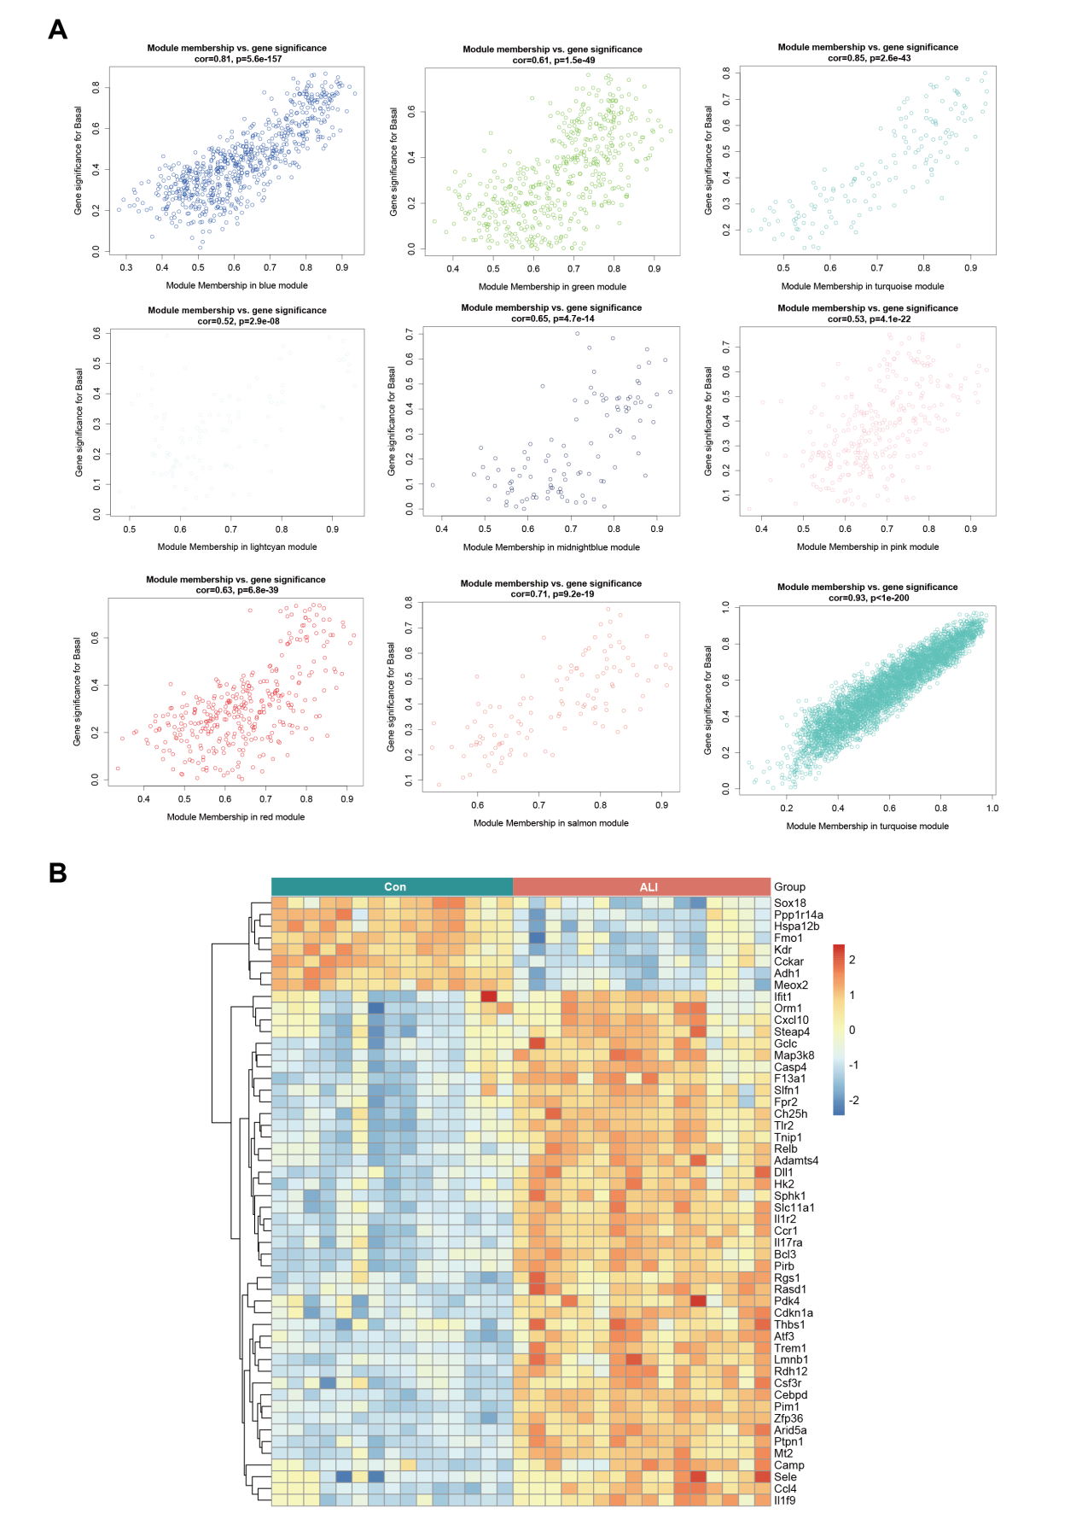
Fig S4.(A) The significance of genes related to ALI in module (a dot represents the genes in the module). (B) Heatmap showing the expression levels of 52 differentially expressed genes in the ALI and Con groups. ALI, Acute lung injury. Con, Control.
Supplementary Figure5
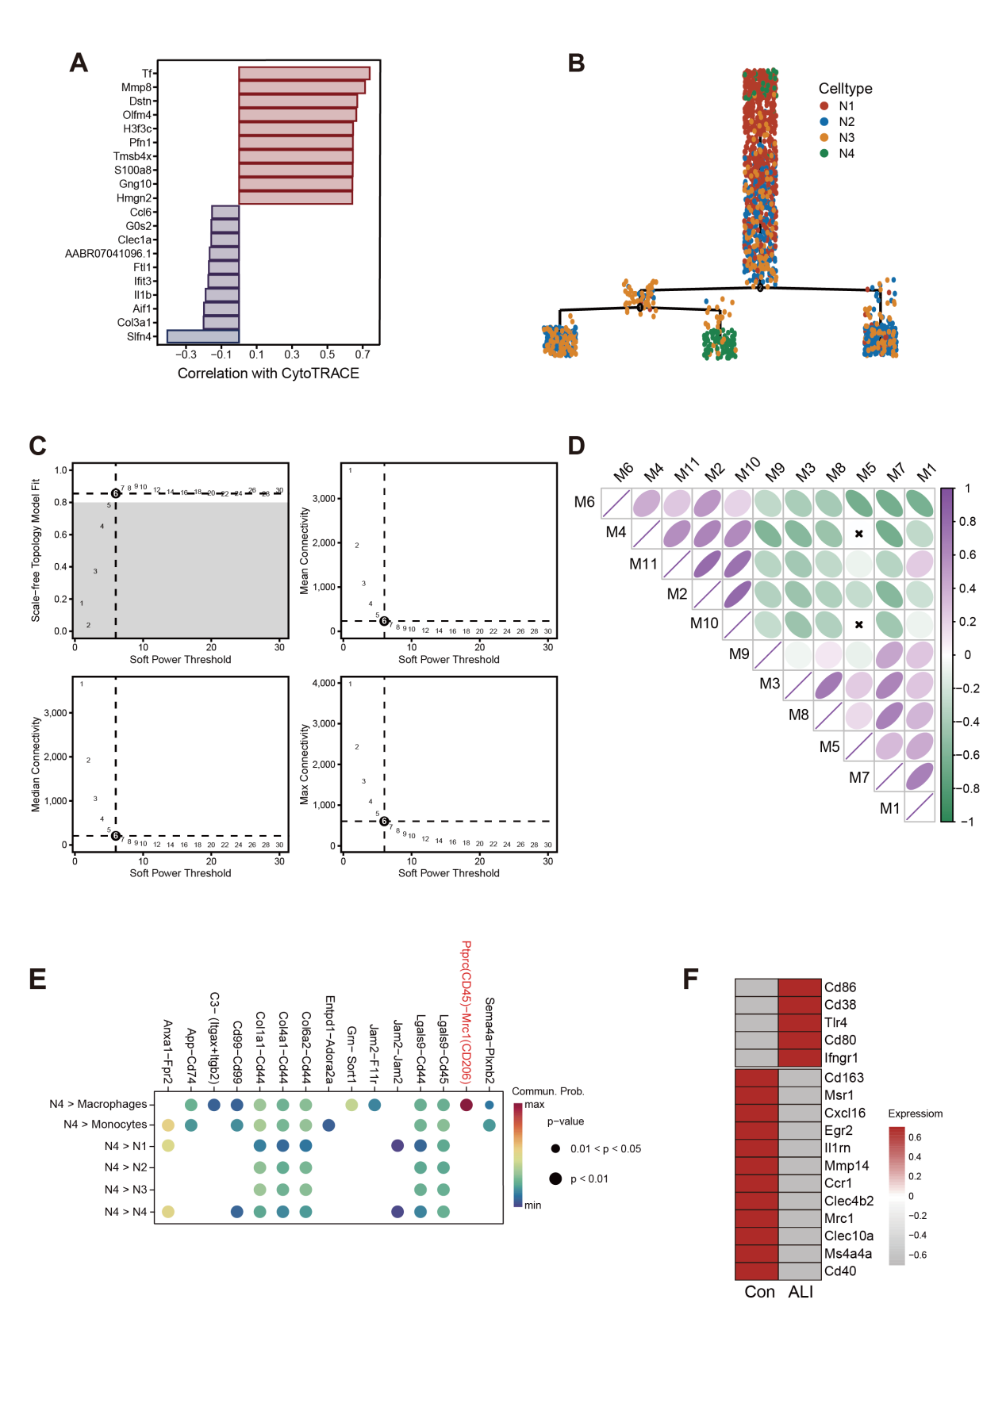

Fig S5.(A) Visualization of the top 10 genes most positively and negatively correlated with CytoTRACE scores. Genes are ranked based on their correlation coefficients. Positively correlated genes are associated with lower differentiation states (higher developmental potential), whereas negatively correlated genes are linked to more differentiated cell states. (B) The scatter plot shows the differentiation trajectory of the neutrophil subgroup. (C) Weighed gene co-expression network analysis was constructed among macrophages. (D) Correlation analysis between modules. (E) Receptor design for N4 neutrophils and other cell types as signal senders. (F) Heatmap showing the expression levels of macrophage polarization-related genes in ALI and control samples. All data are expressed as mean ± SD, P < 0.05 were considered statistically significant differences.

Supplementary Figure6

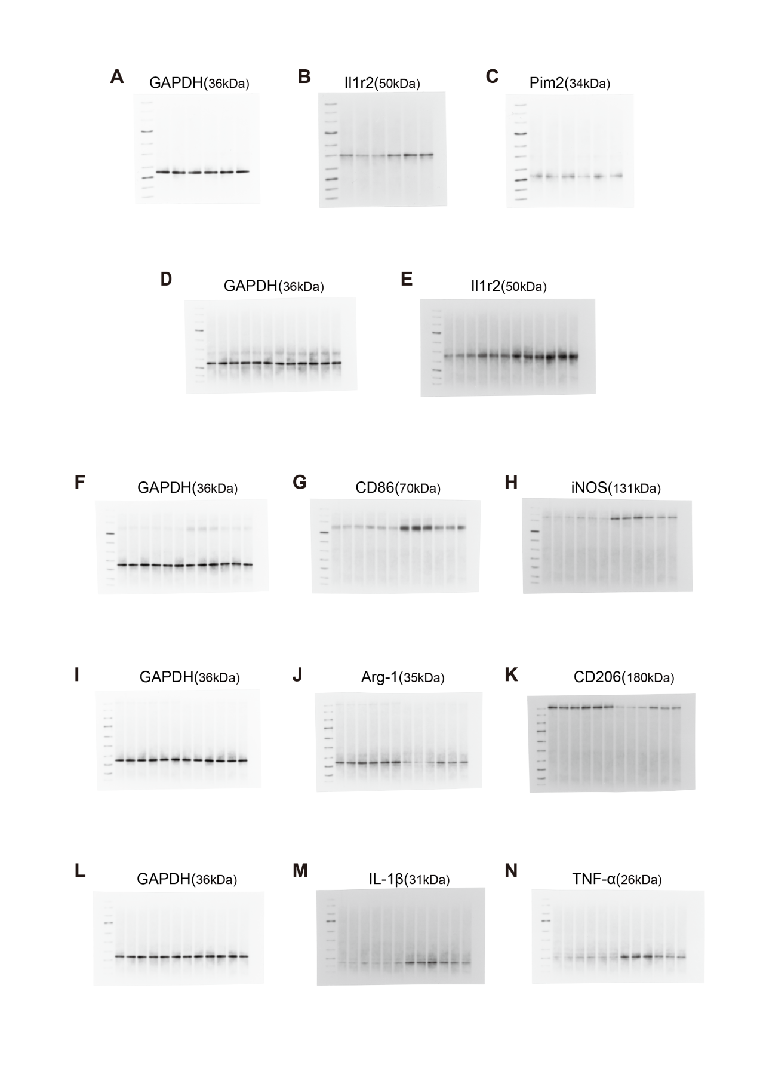Fig S6. (A-N) Full-length blots.

