SUPPLEMENTARY MATERIAL

Enhanced efficiency of zinc oxide hydroxyapatite nanocomposite in the photodegradation of methylene blue, ciprofloxacin and in wastewater treatment

Table of content
Figure No. | Figure caption | Page
Figure S1 | XRD pattern of ZnO@HAp post-degradation. | S2
Figure S2 | Kinetics plot of ciprofloxacin degradation with ZnO@HAp. | S2

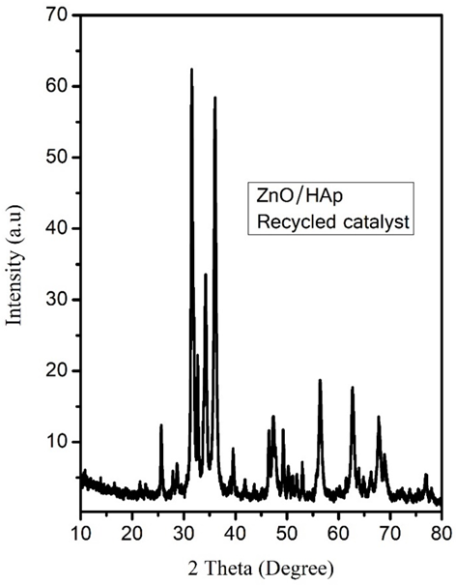

Figure S1. XRD pattern of ZnO@Hap post-degradation

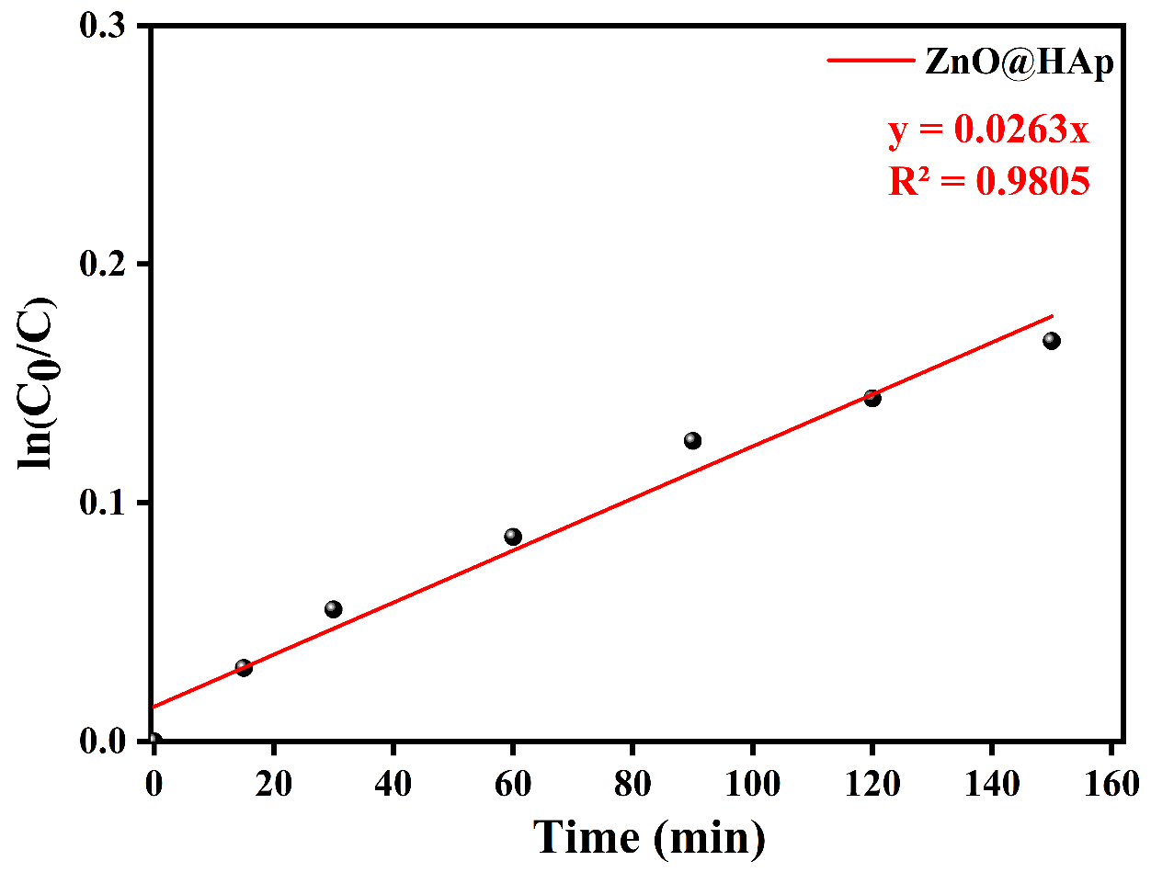

Figure S2. Kinetics plot of Ciprofloxacin degradation with ZnO@HAp
Figure S2: Effect of catalyst weight on degradation of methylene blue over ZnO@HAp. Condition: Catalyst amount 50 mg, 10 ppm solution,
(C)

