Figure S1. Age-specific treatment initiation rates for Mycobacterium avium complex pulmonary disease.

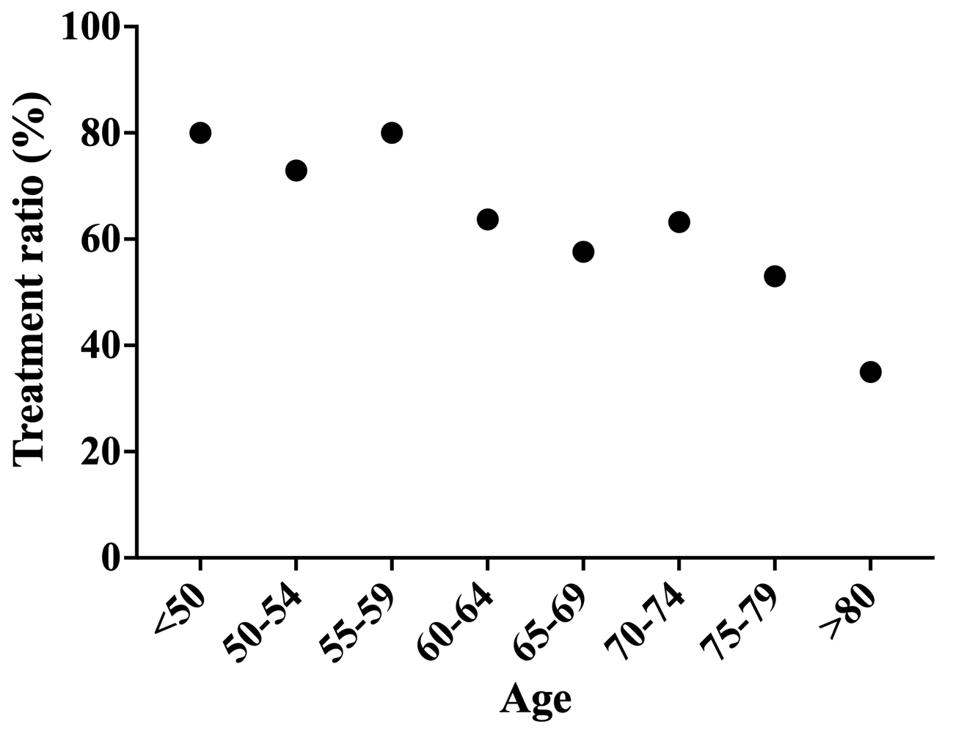
A downward trend was observed with increasing age.

