Supplemental Appendix

Proteomic Pathways Across the Ejection Fraction Spectrum in Heart Failure: an EXSCEL Trial Substudy

Anthony E. Peters, Maggie Nguyen, Jennifer Green, Ewan Pearson, John Buse, Harald Sourij, Adrian F. Hernandez, Naveed Sattar, Rury R. Holman, Robert J. Mentz, Svati H. Shah

Running head: Proteomic patterns across EF spectrum in HF

FUNDING SOURCES
EXSCEL was sponsored and funded by Amylin Pharmaceuticals, Inc., a wholly owned subsidiary of AstraZeneca.

Address for Correspondence:
Svati H. Shah
Duke Molecular Physiology Institute
300 N. Duke Street
Durham NC 27710
919-684-1808
svati.shah@duke.edu

Supplemental Figure 1. Consort diagram of statistical analysis approach
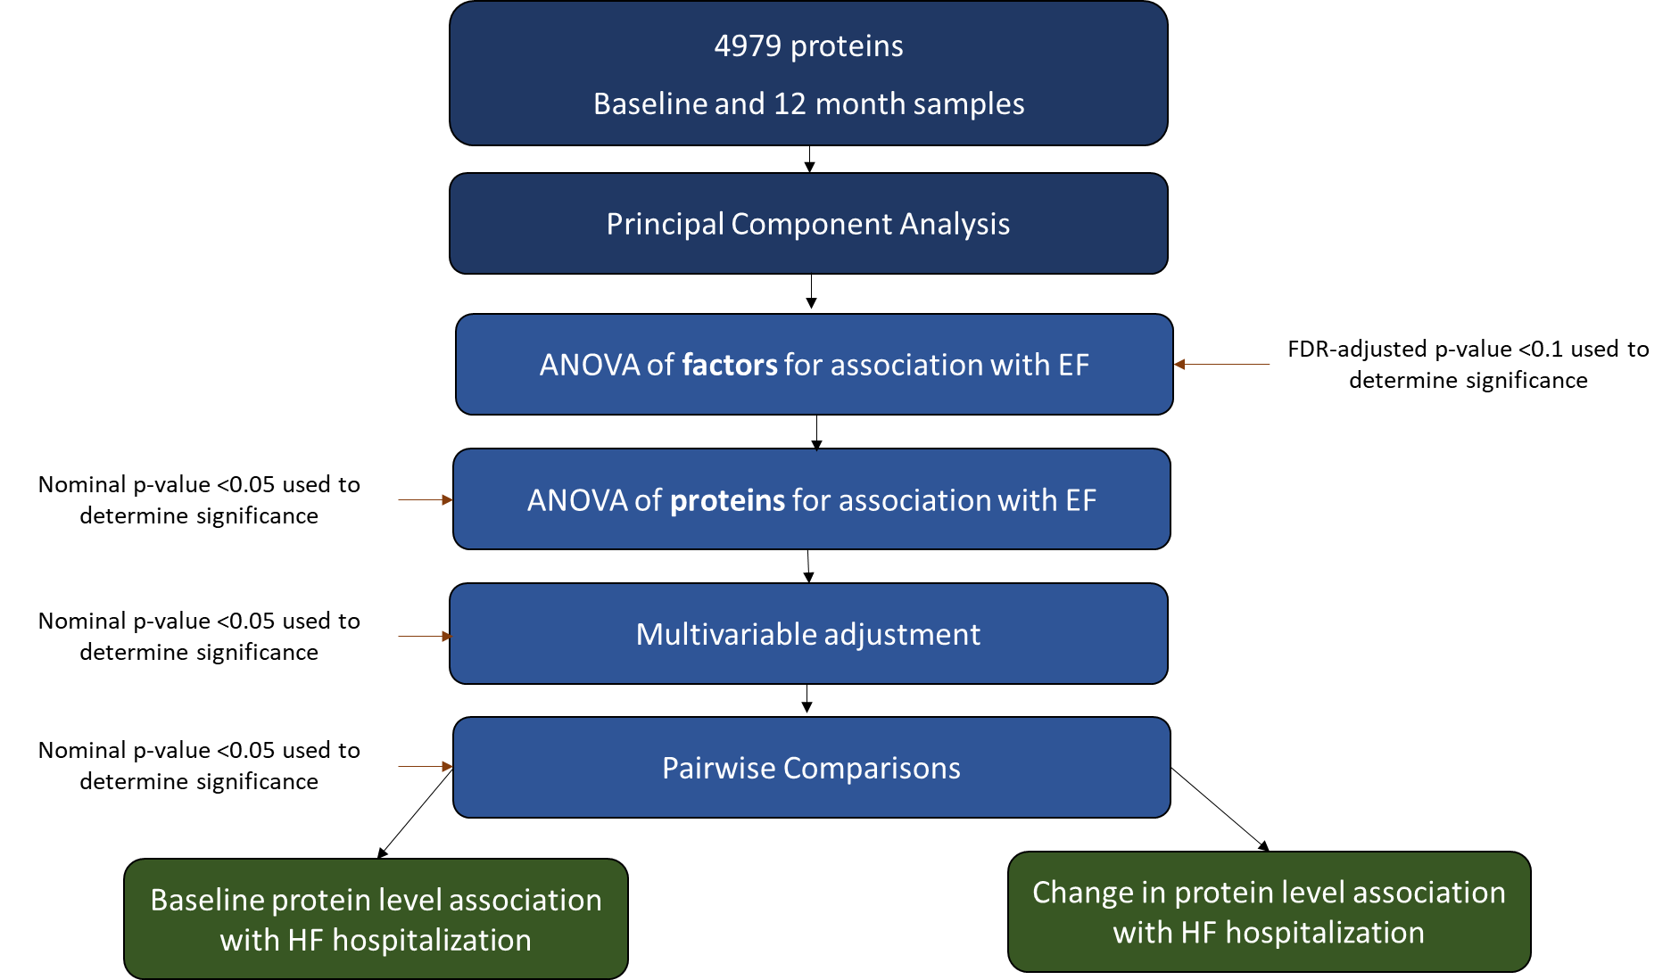

Supplemental Figure 2. Scree plot of principal components
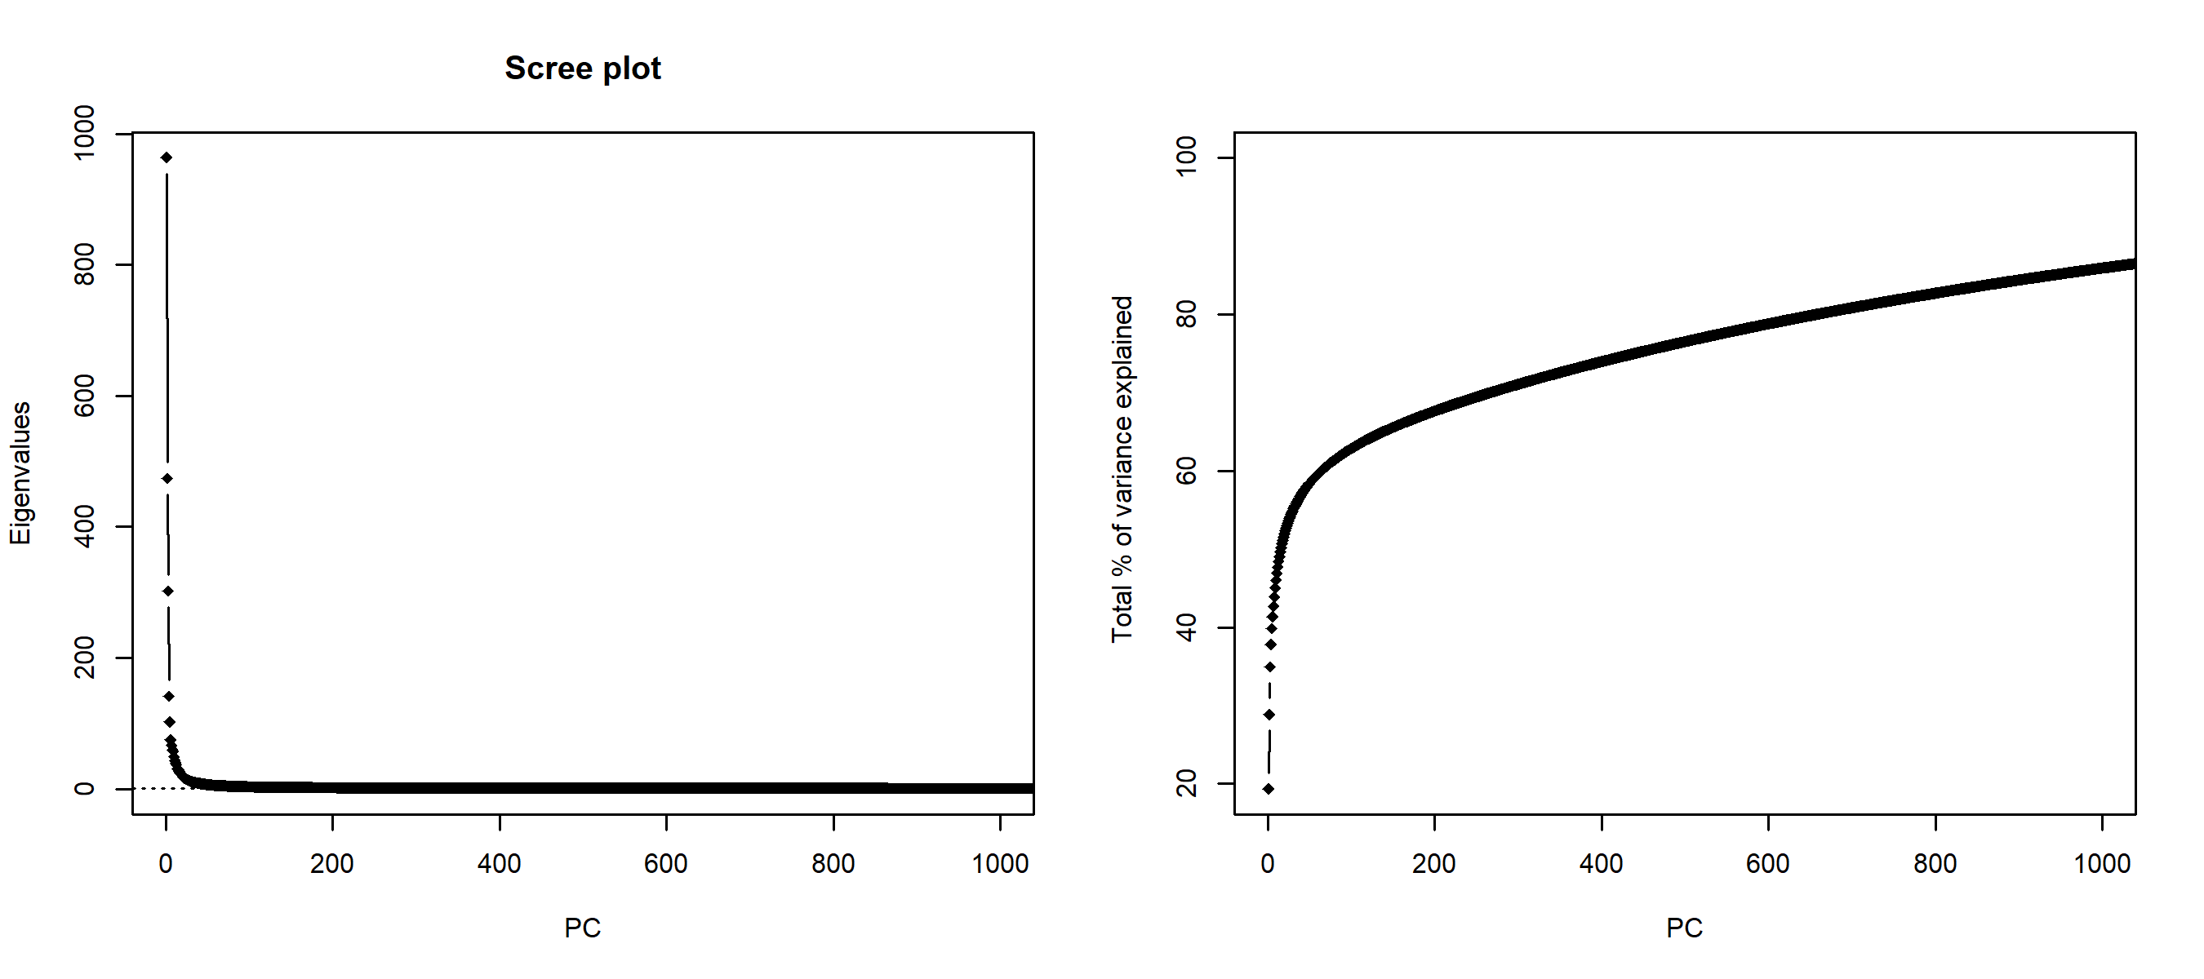

Supplemental Figure 3. PC-PC plots color-coded by plate run dates (split into three plots for ease of visualization)
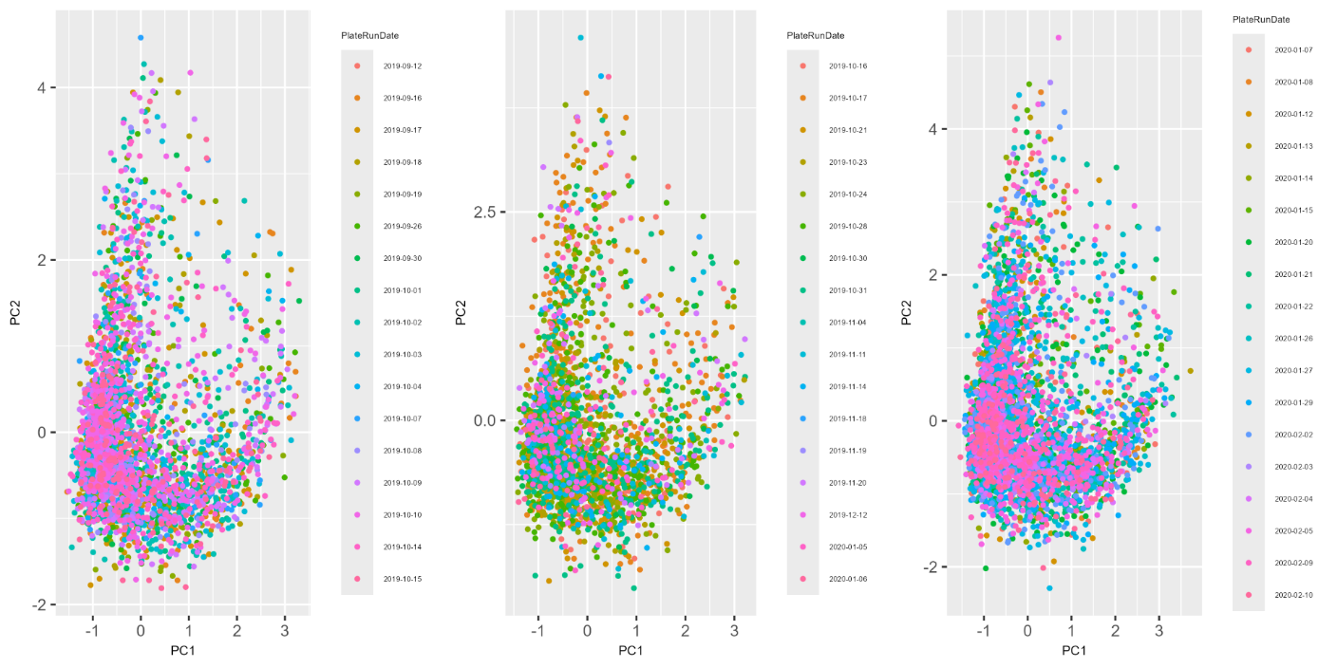

Supplemental Figure 4. Select plots of protein level across EF groups for proteins with similar levels in HFmrEF and HFpEF as compared to different levels in HFrEF
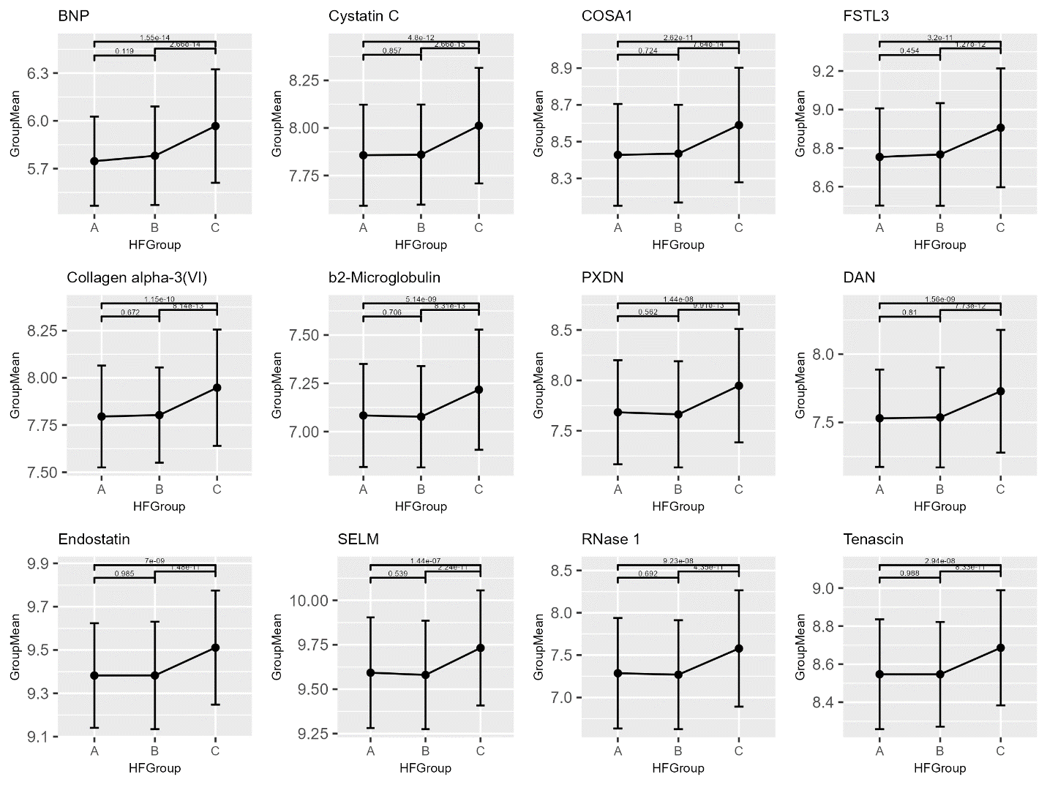
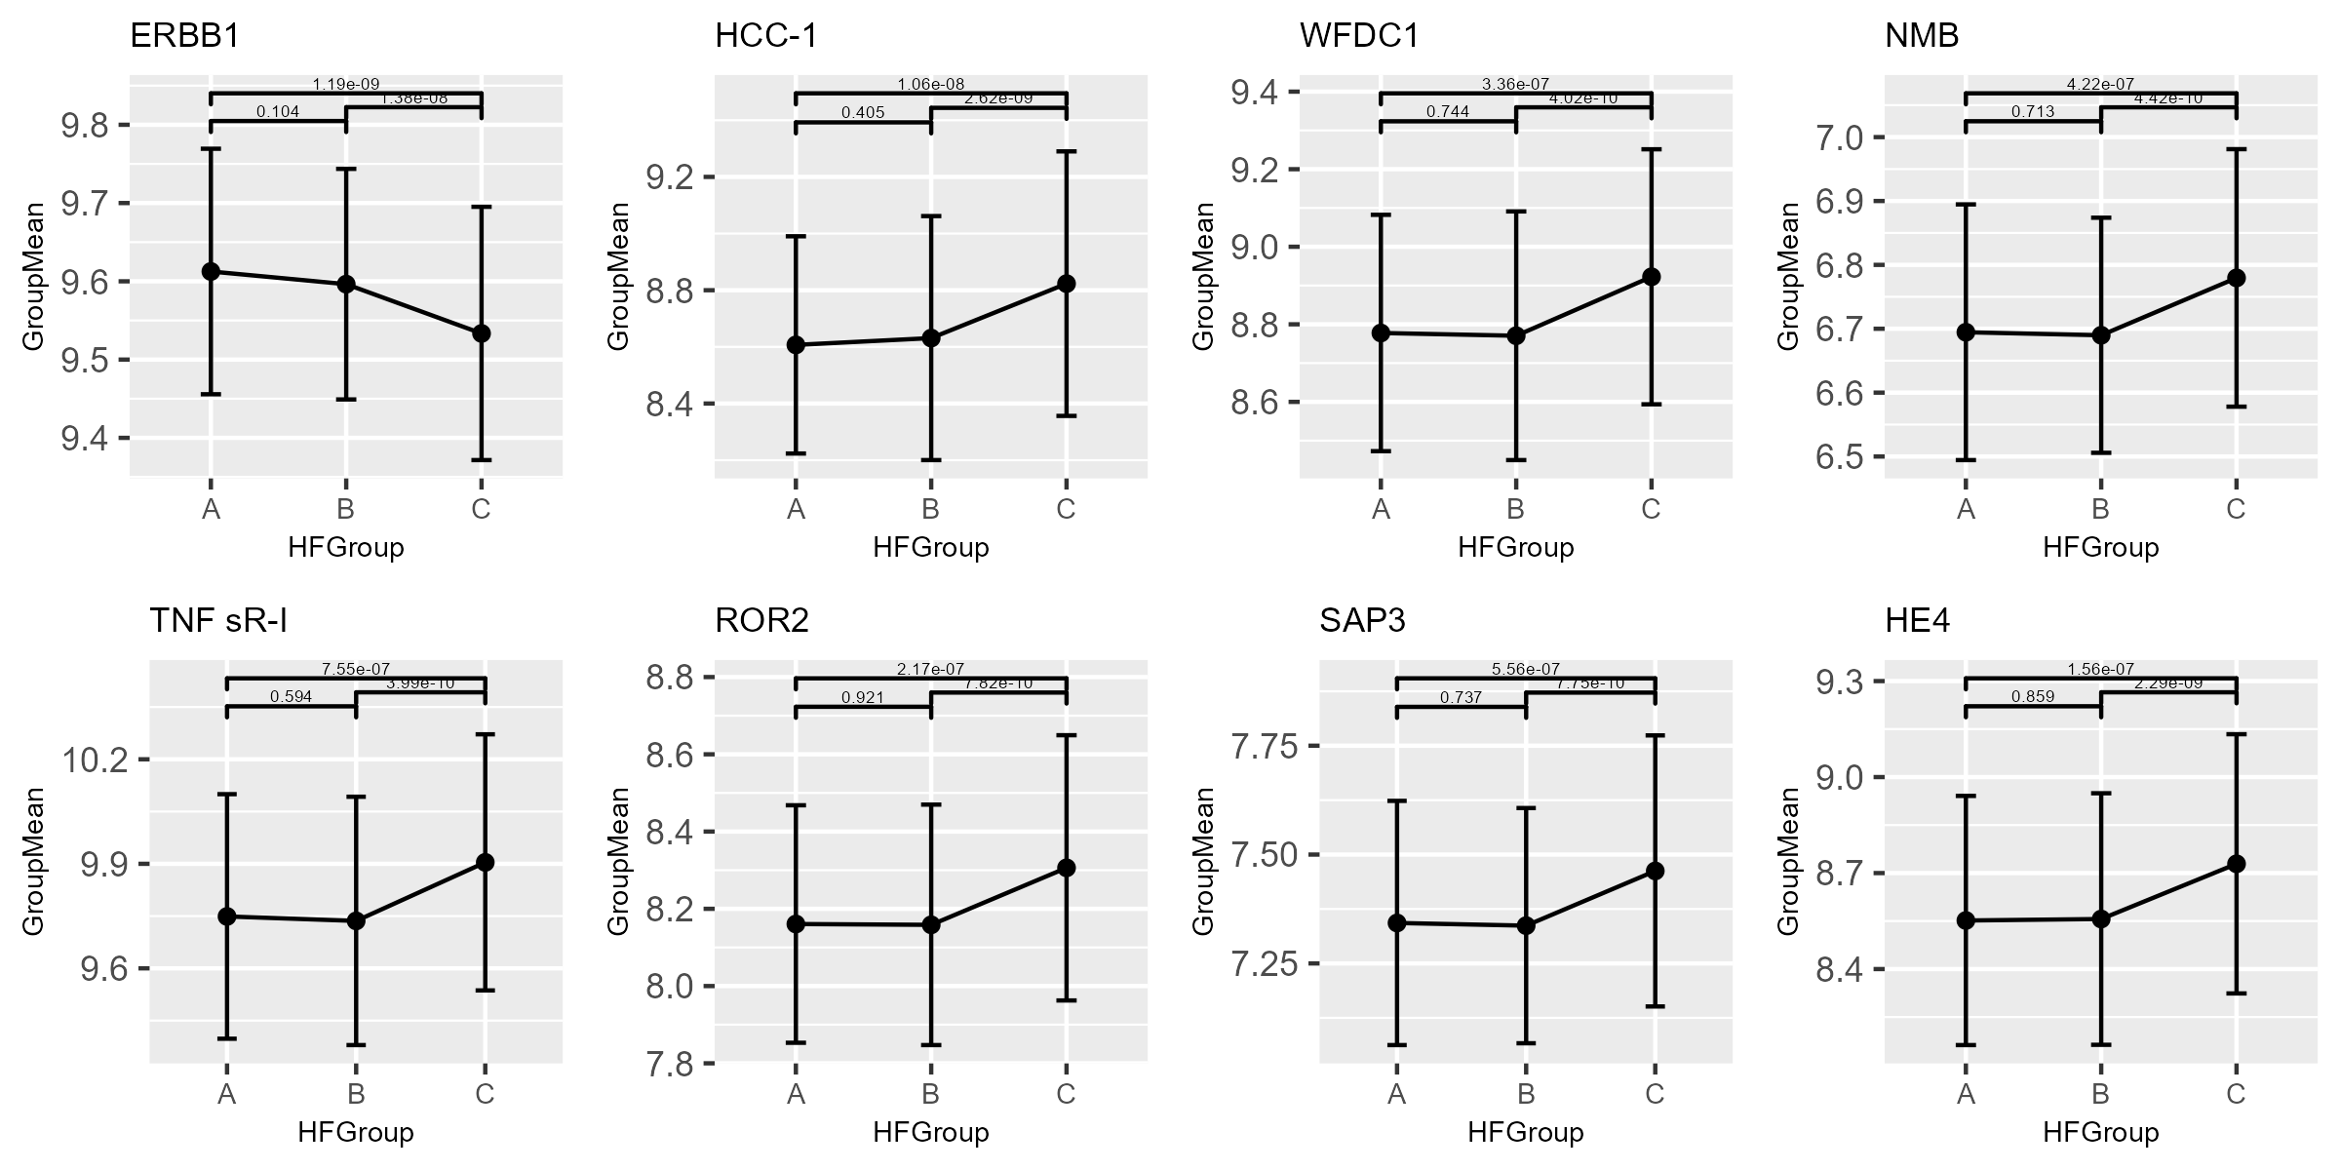
Group A=EF>55%, Group B=EF 40-55%, Group C=EF<40%
Supplemental Figure 5. Plots of protein level across EF groups for proteins with similar levels in HFmrEF and HFrEF as compared to different levels in HFpEF
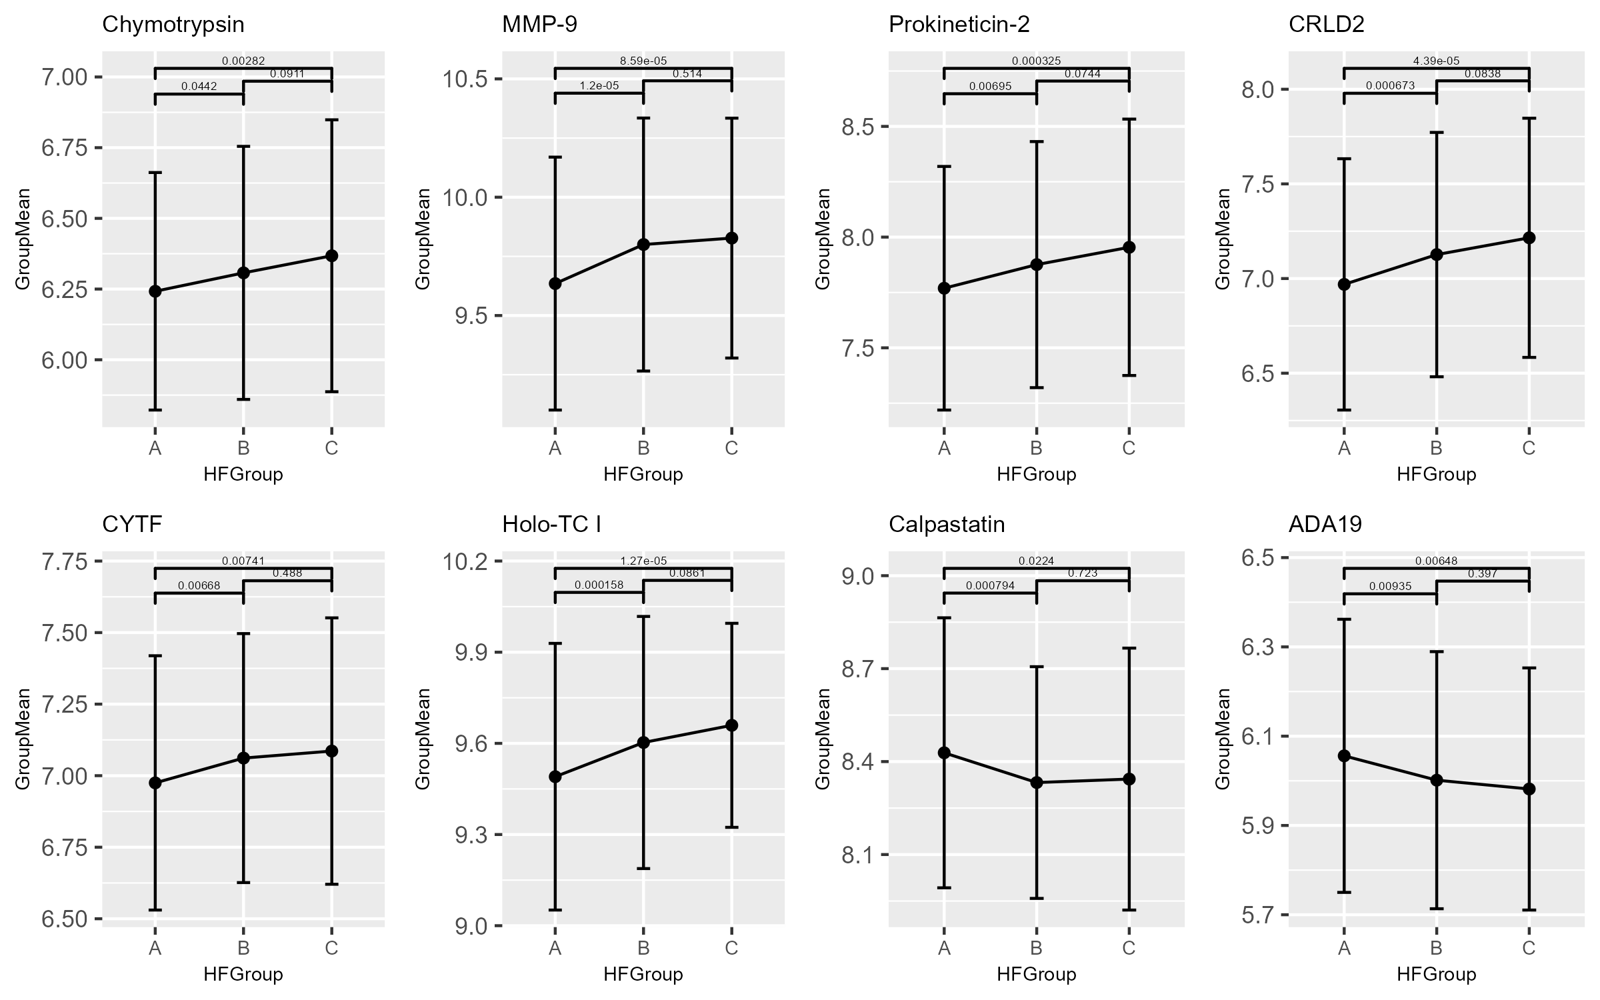
Group A=EF>55%, Group B=EF 40-55%, Group C=EF<40%

Supplemental Figure 6. Plots of protein level across EF groups for proteins with similar levels in HFpEF and HFrEF as compared to different levels in HFmrEF
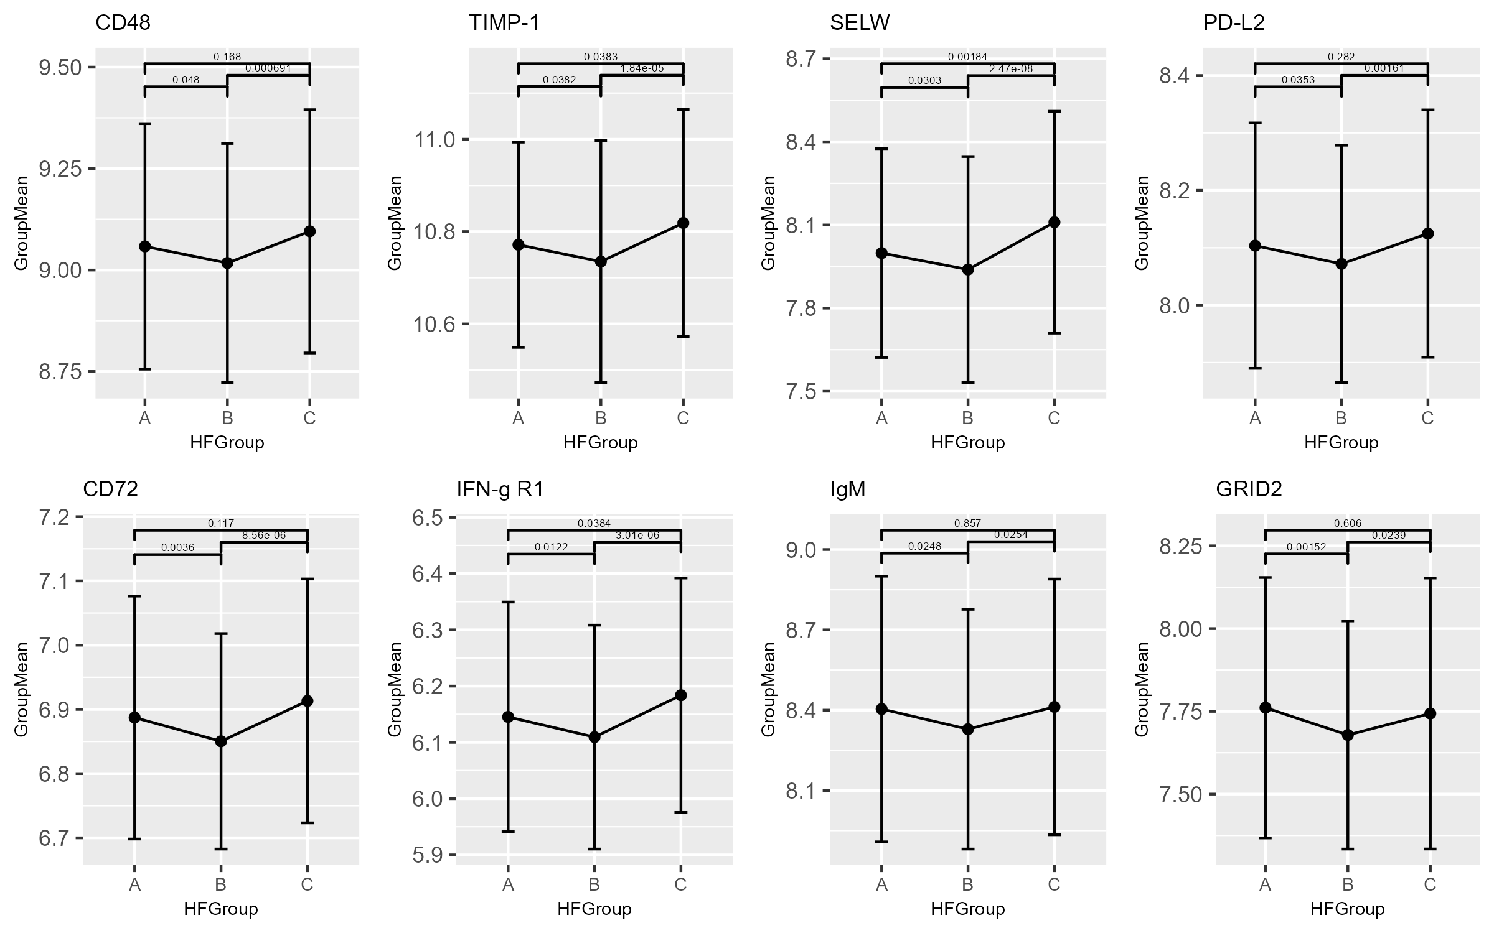
Group A=EF>55%, Group B=EF 40-55%, Group C=EF<40%

Supplemental Figure 7. Plots of protein level across EF groups for proteins with steadily increasing pattern of protein levels across declining EF groups*
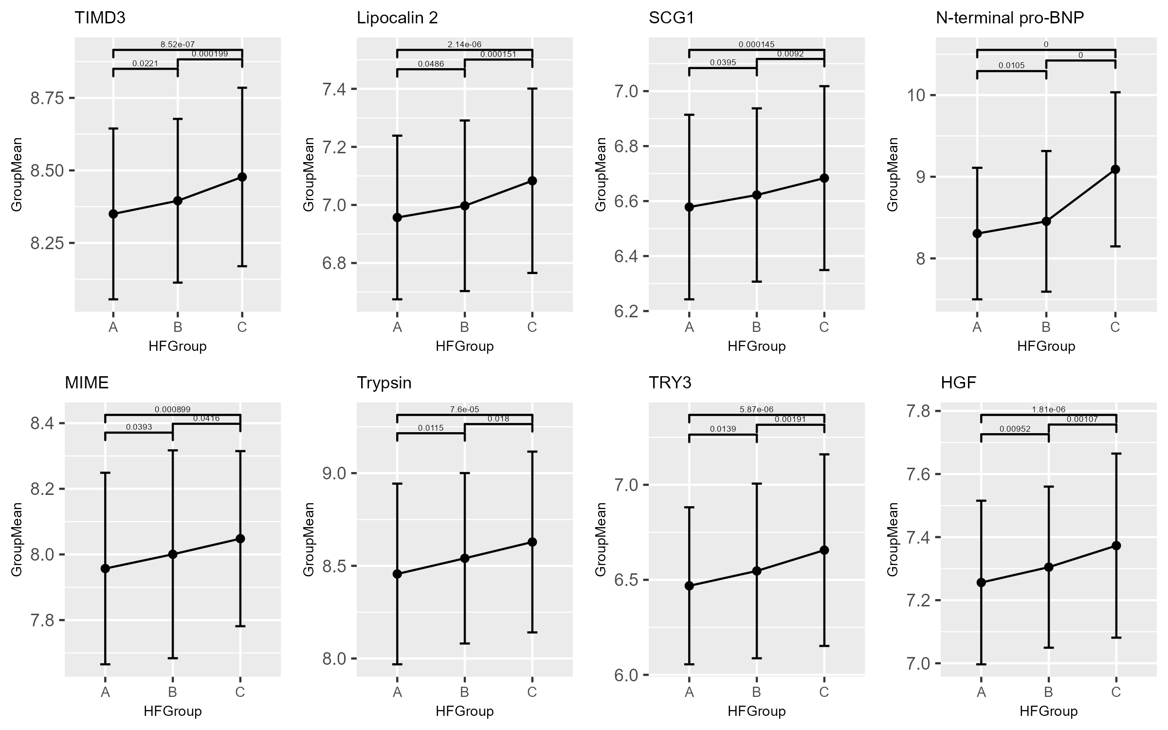
*Higher levels in HFrEF, intermediate in HFmrEF and lowest in HFpEF
Group A=EF>55%, Group B=EF 40-55%, Group C=EF<40%
Supplemental Figure 8.Volcano plot of results of multivariable Cox proportional hazards models for association between scaled change in protein expression over 12 months and time-to-incident heart failure hospitalization (hHF).
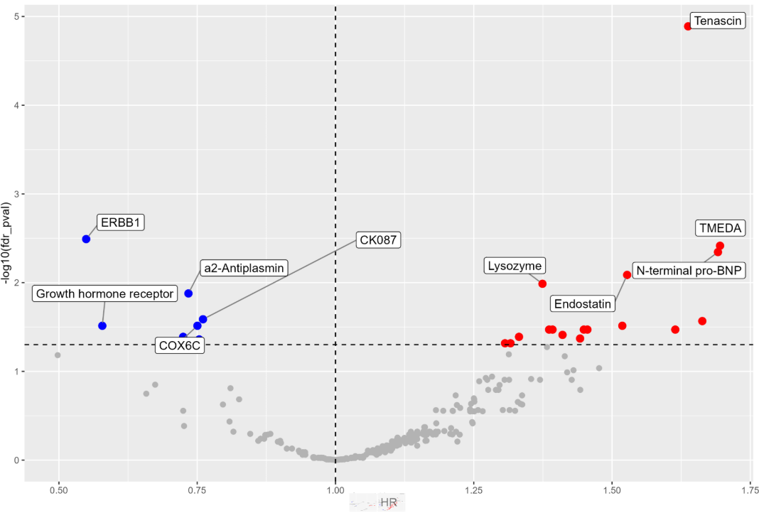
Supplemental Figure 9. Mean change over time of proteins for which change in levels from baseline to 12 months was associated with time-to-incident hHF - stratified by history of HF vs. no history of HF

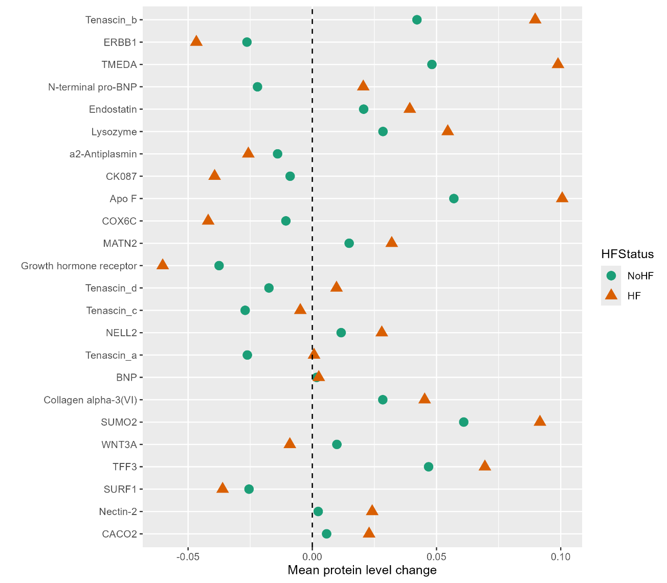

Right of the dotted line = increased protein level from BL to M12
Left of the dotted line = decreased protein level from BL to M12
*Tenascin a-d: Multiple Somamer reagents targeting different epitopes of the Tenascin-C protein

Supplemental Figure 10. Cox proportional hazard models for change in protein level (baseline to 12 month) with time-to-incident hHF
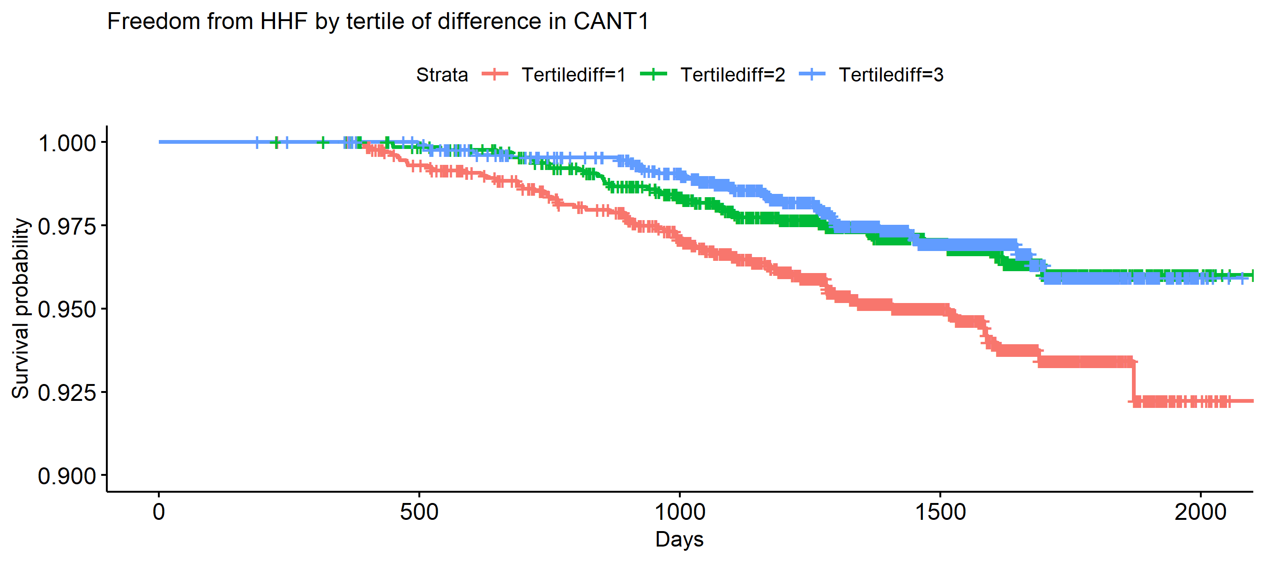
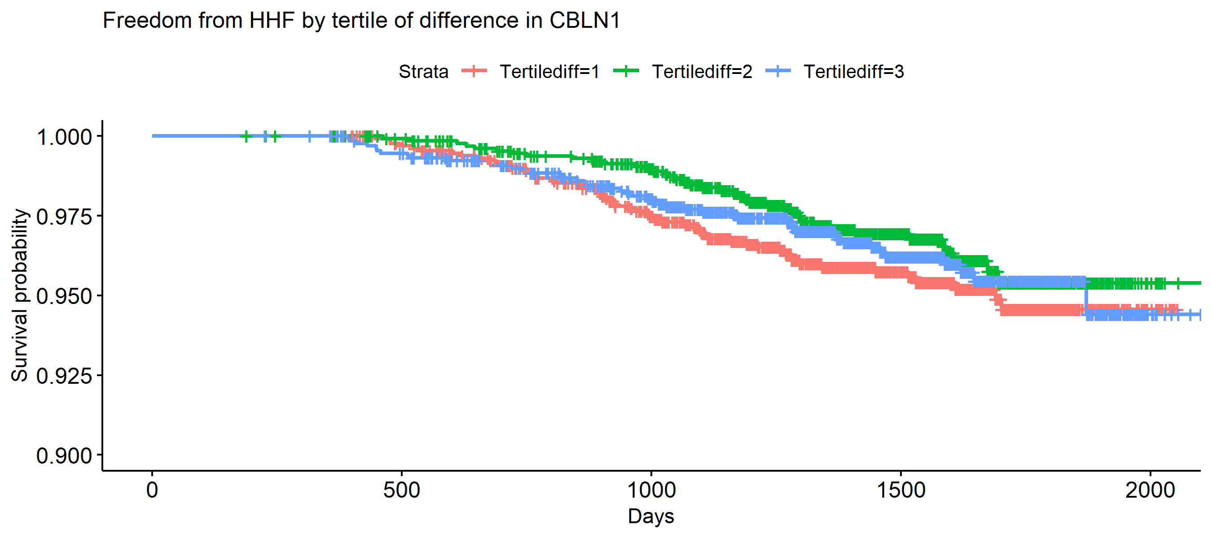
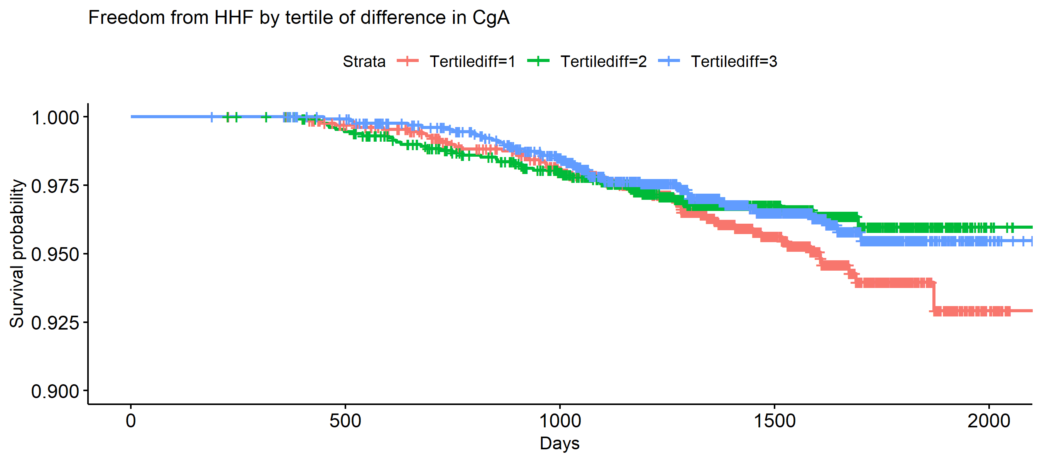
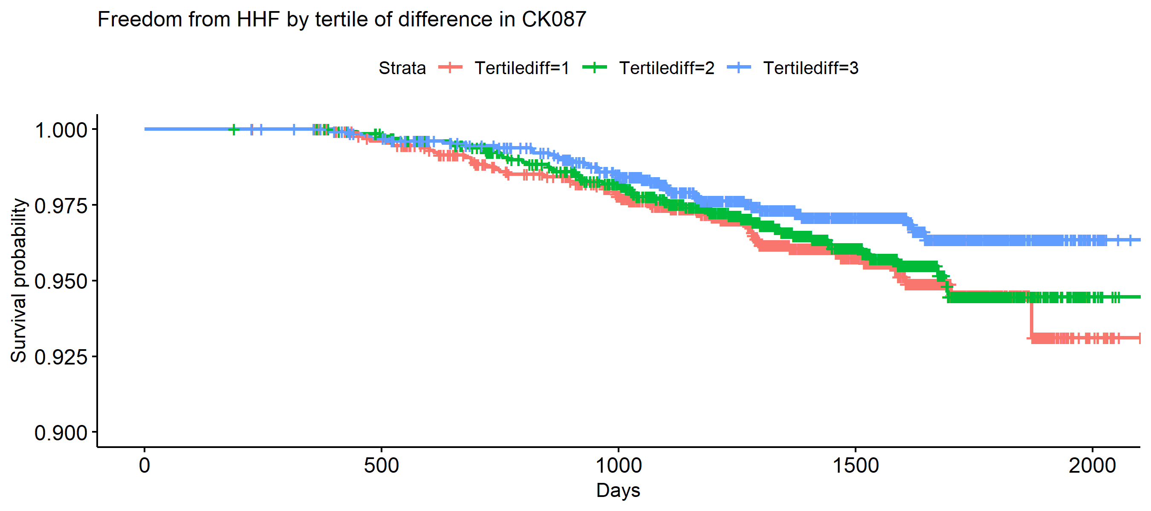
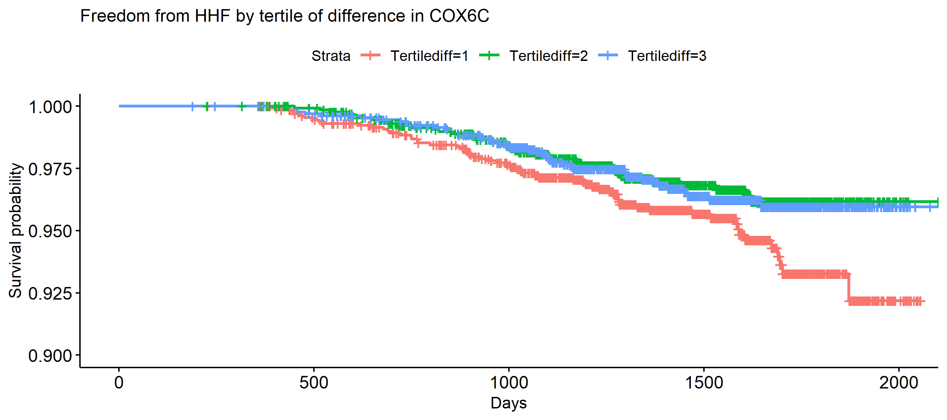
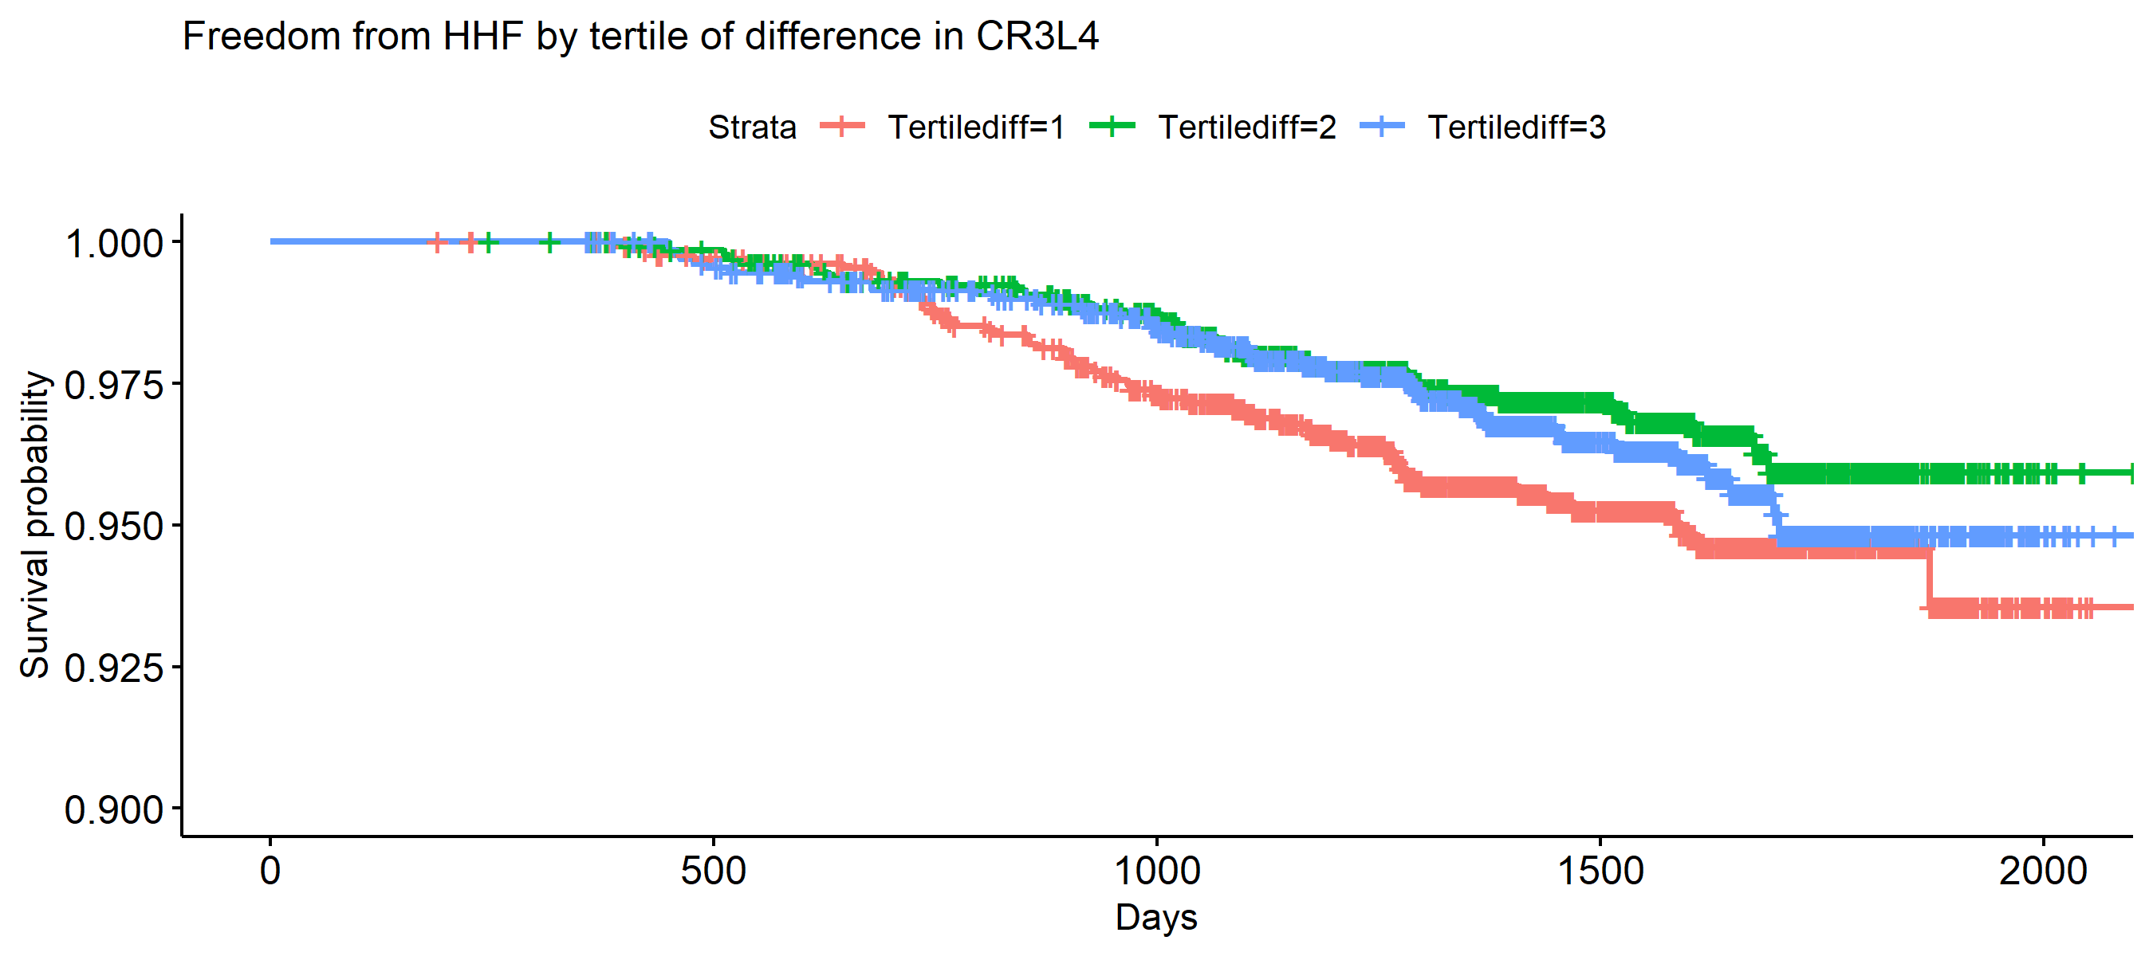
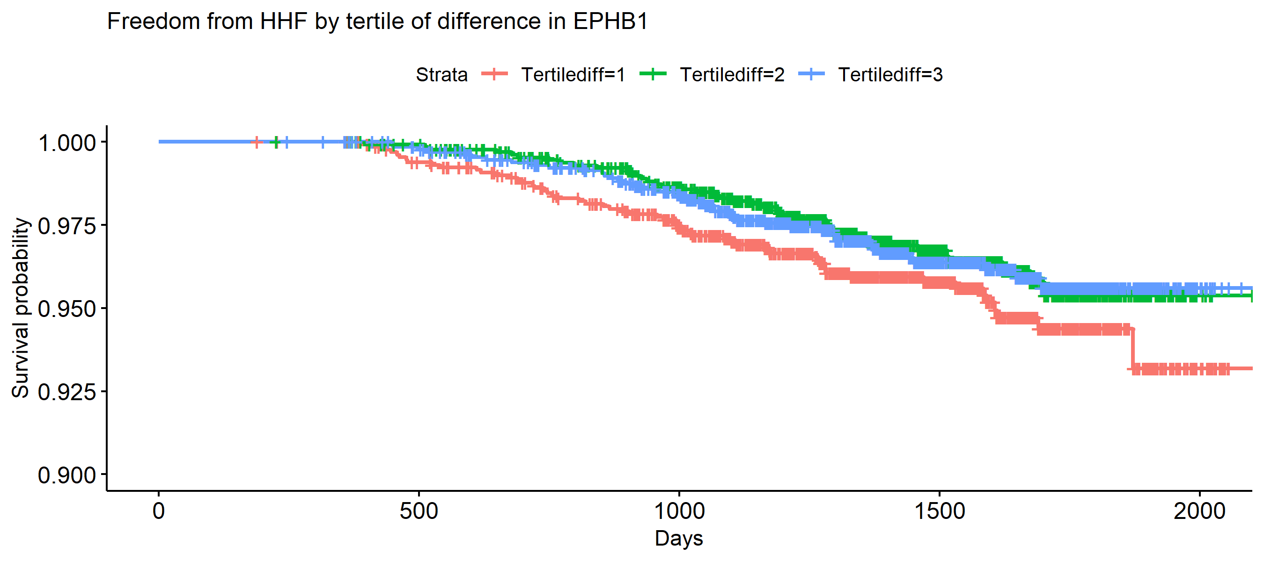
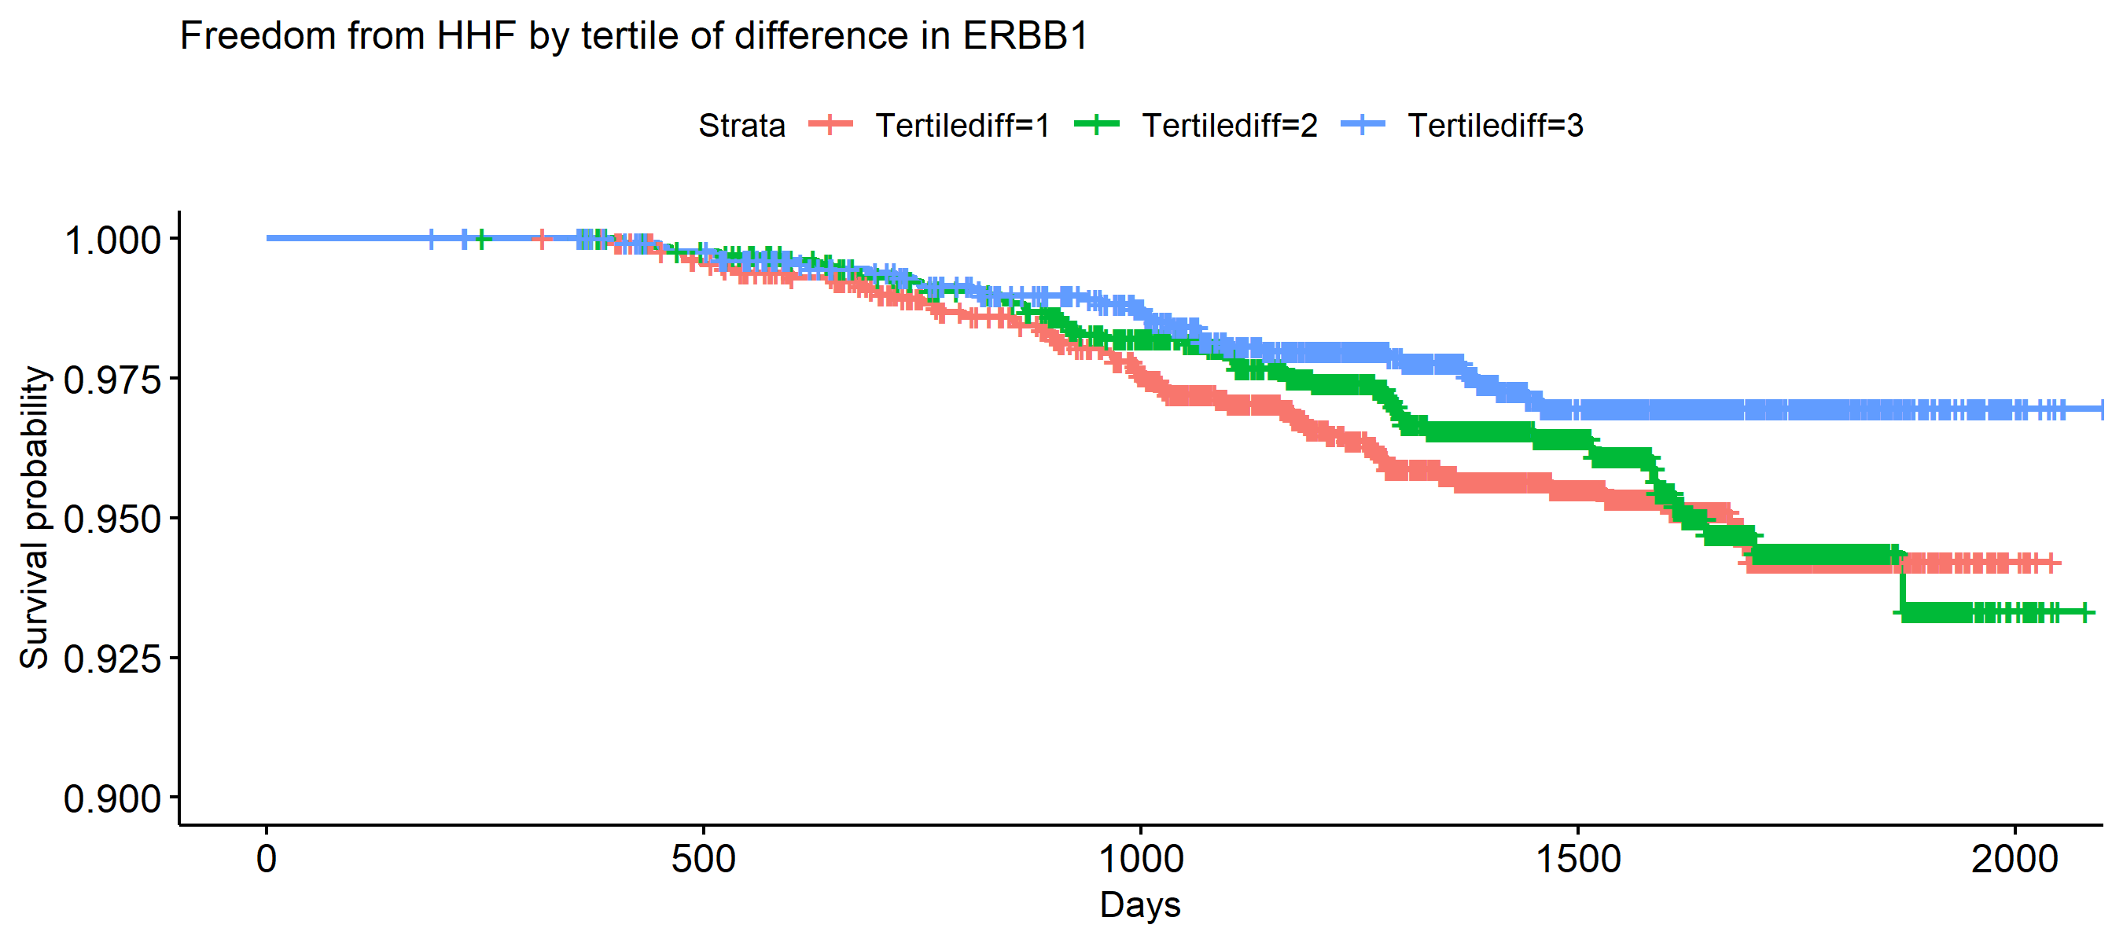
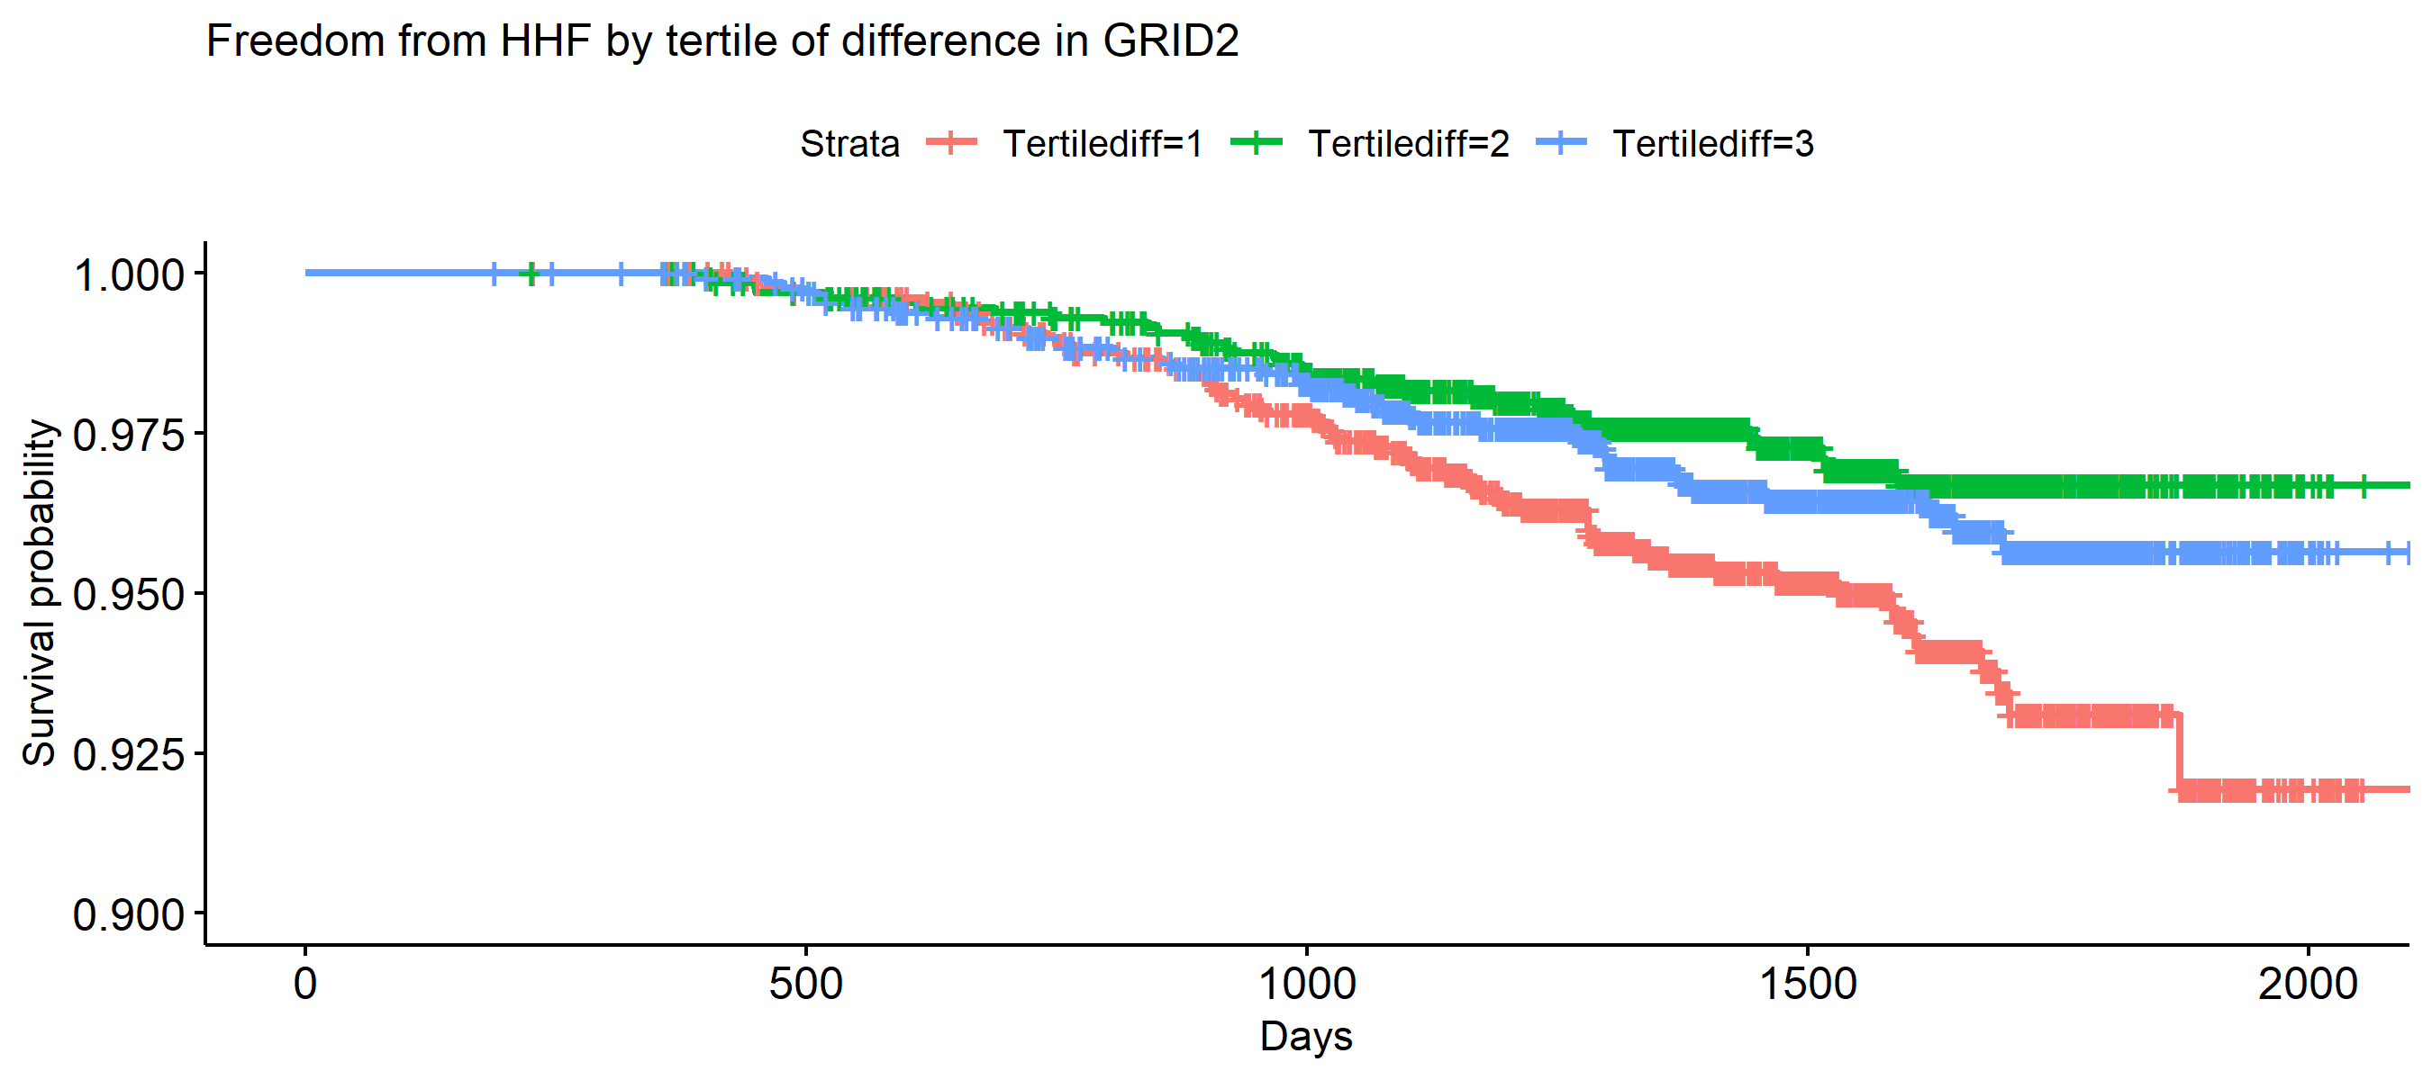
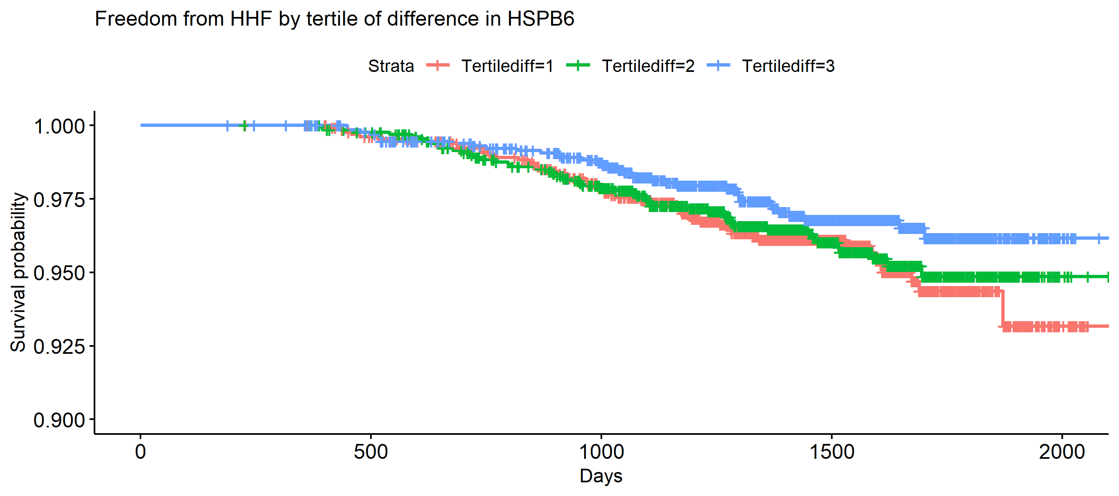
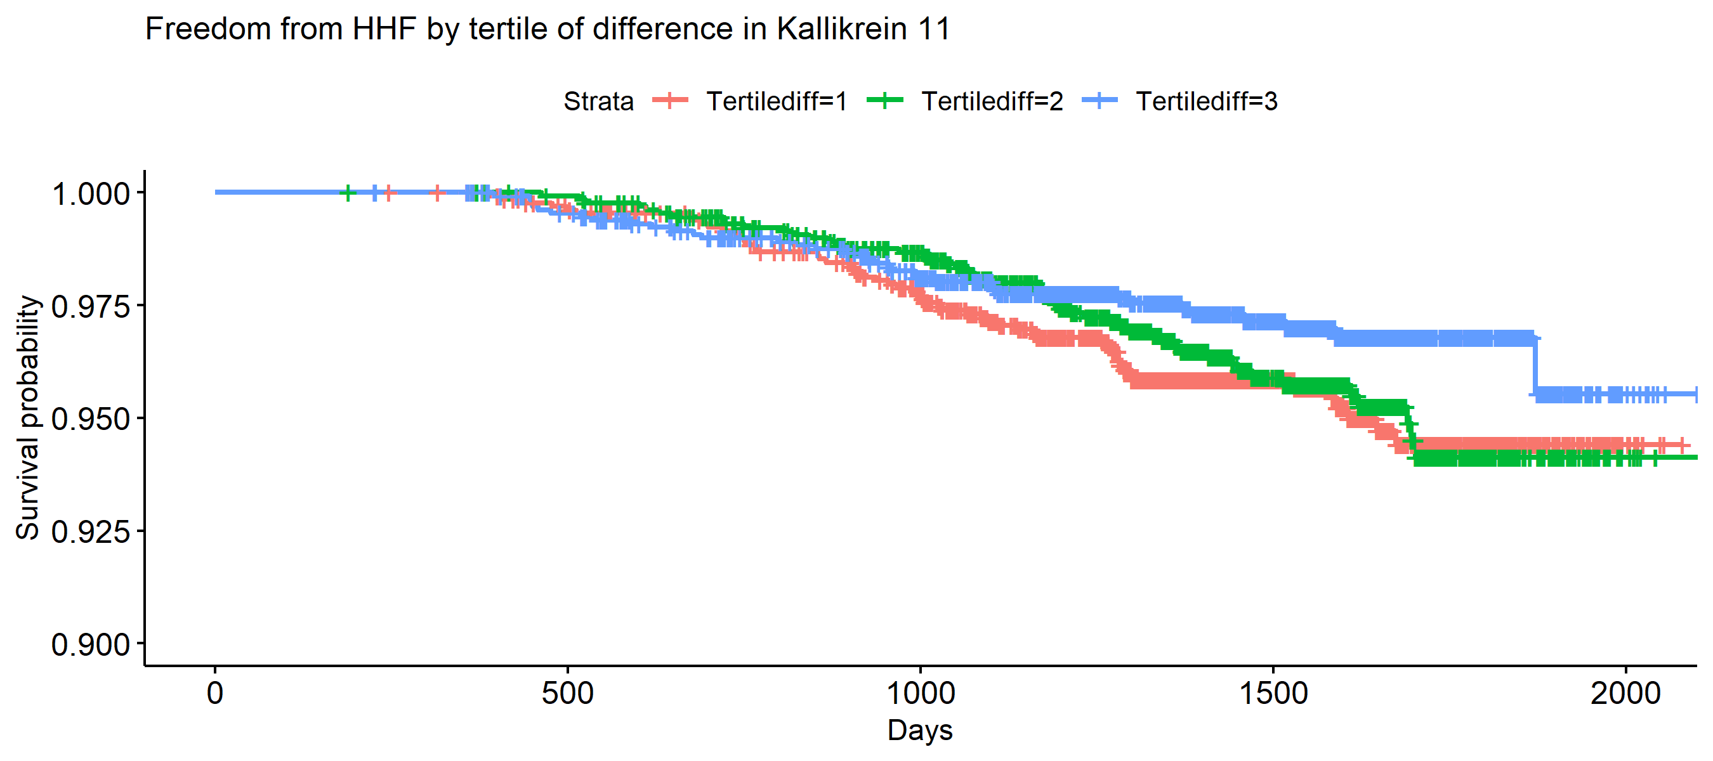
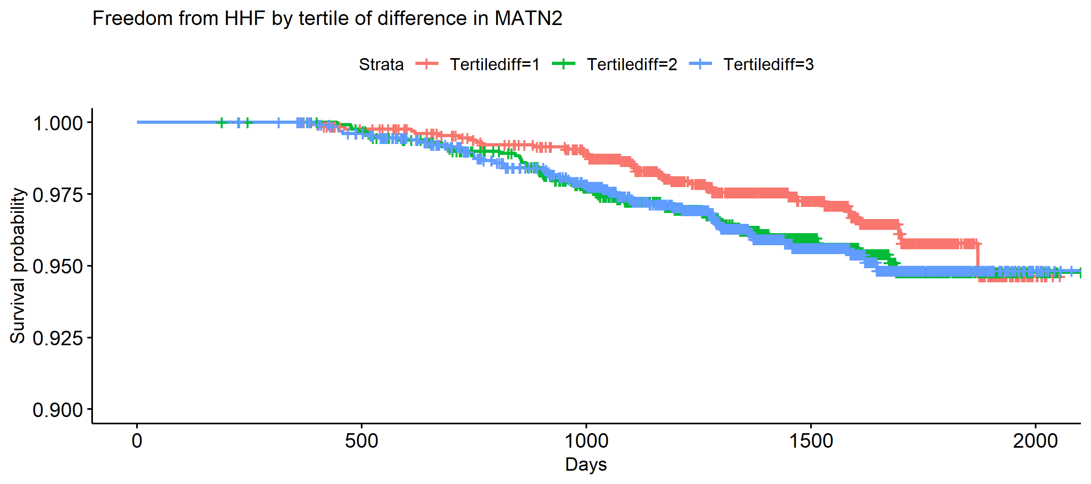
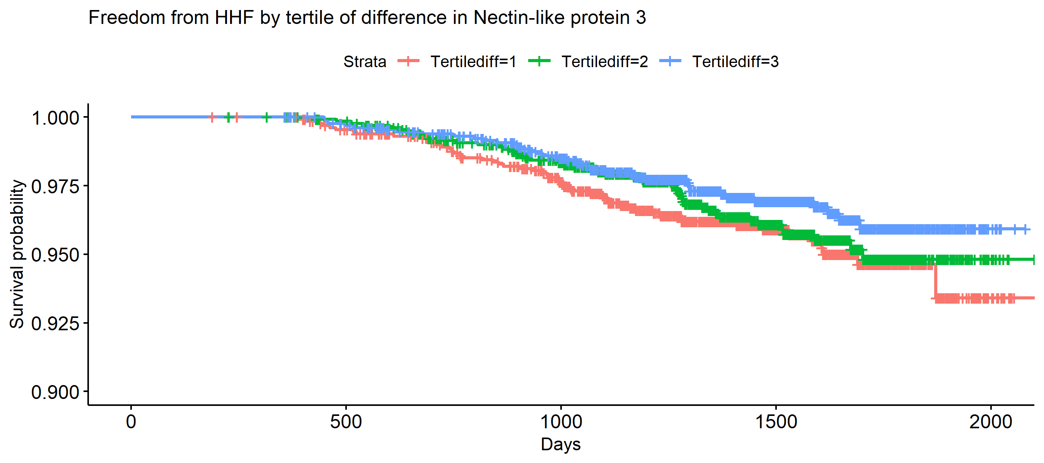
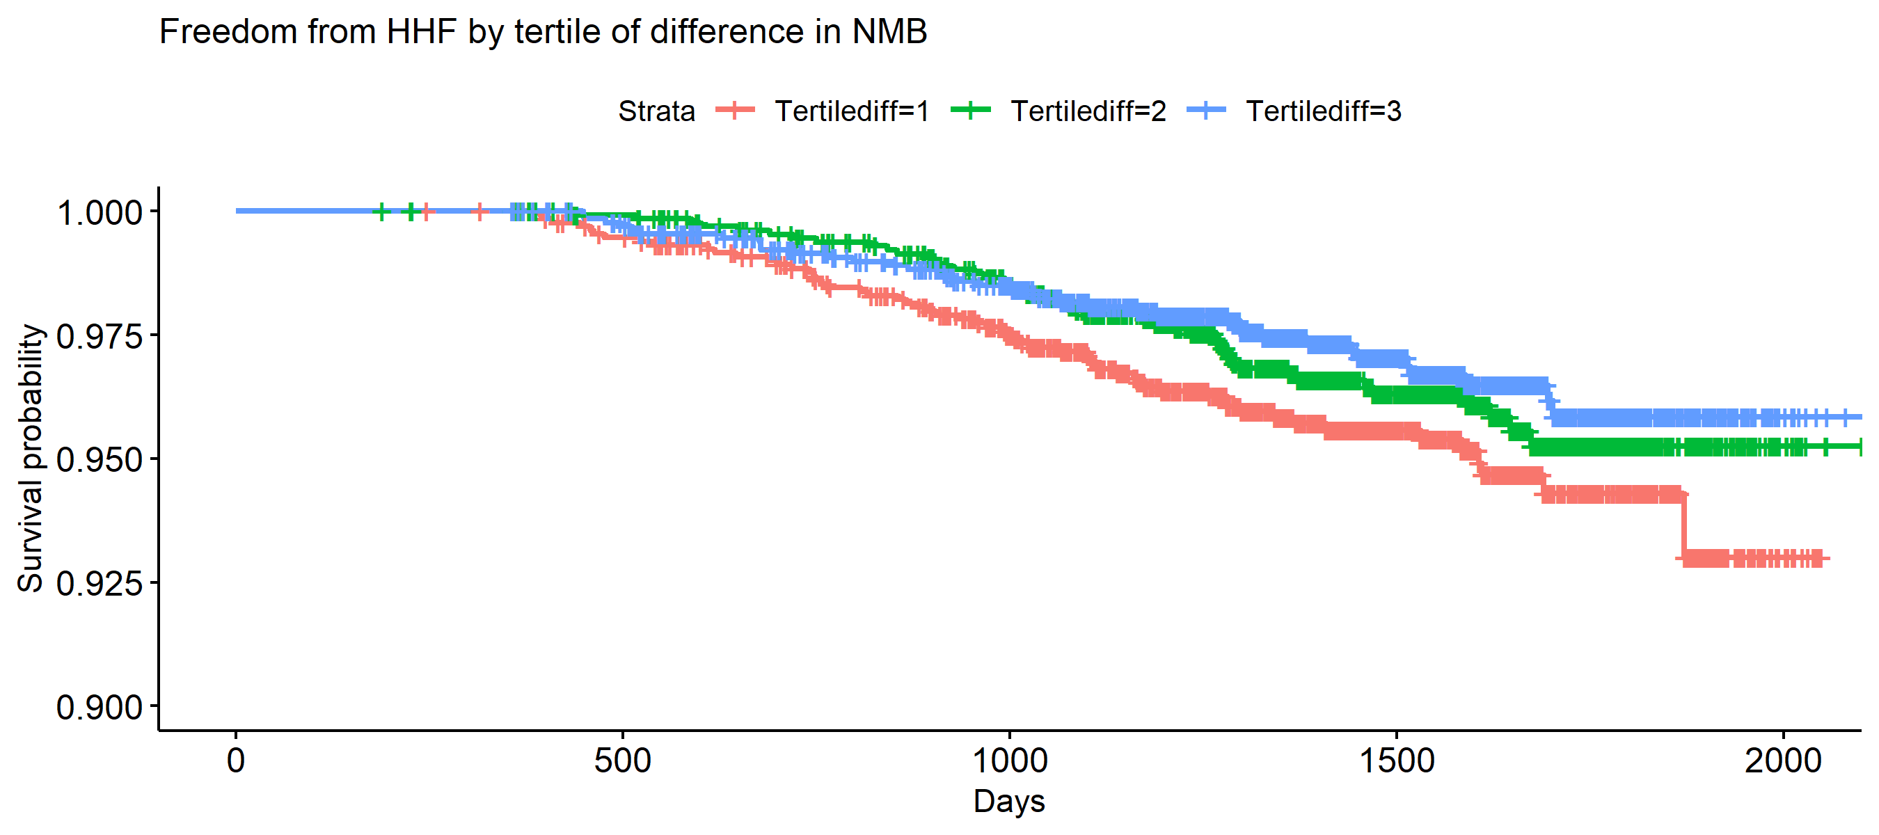
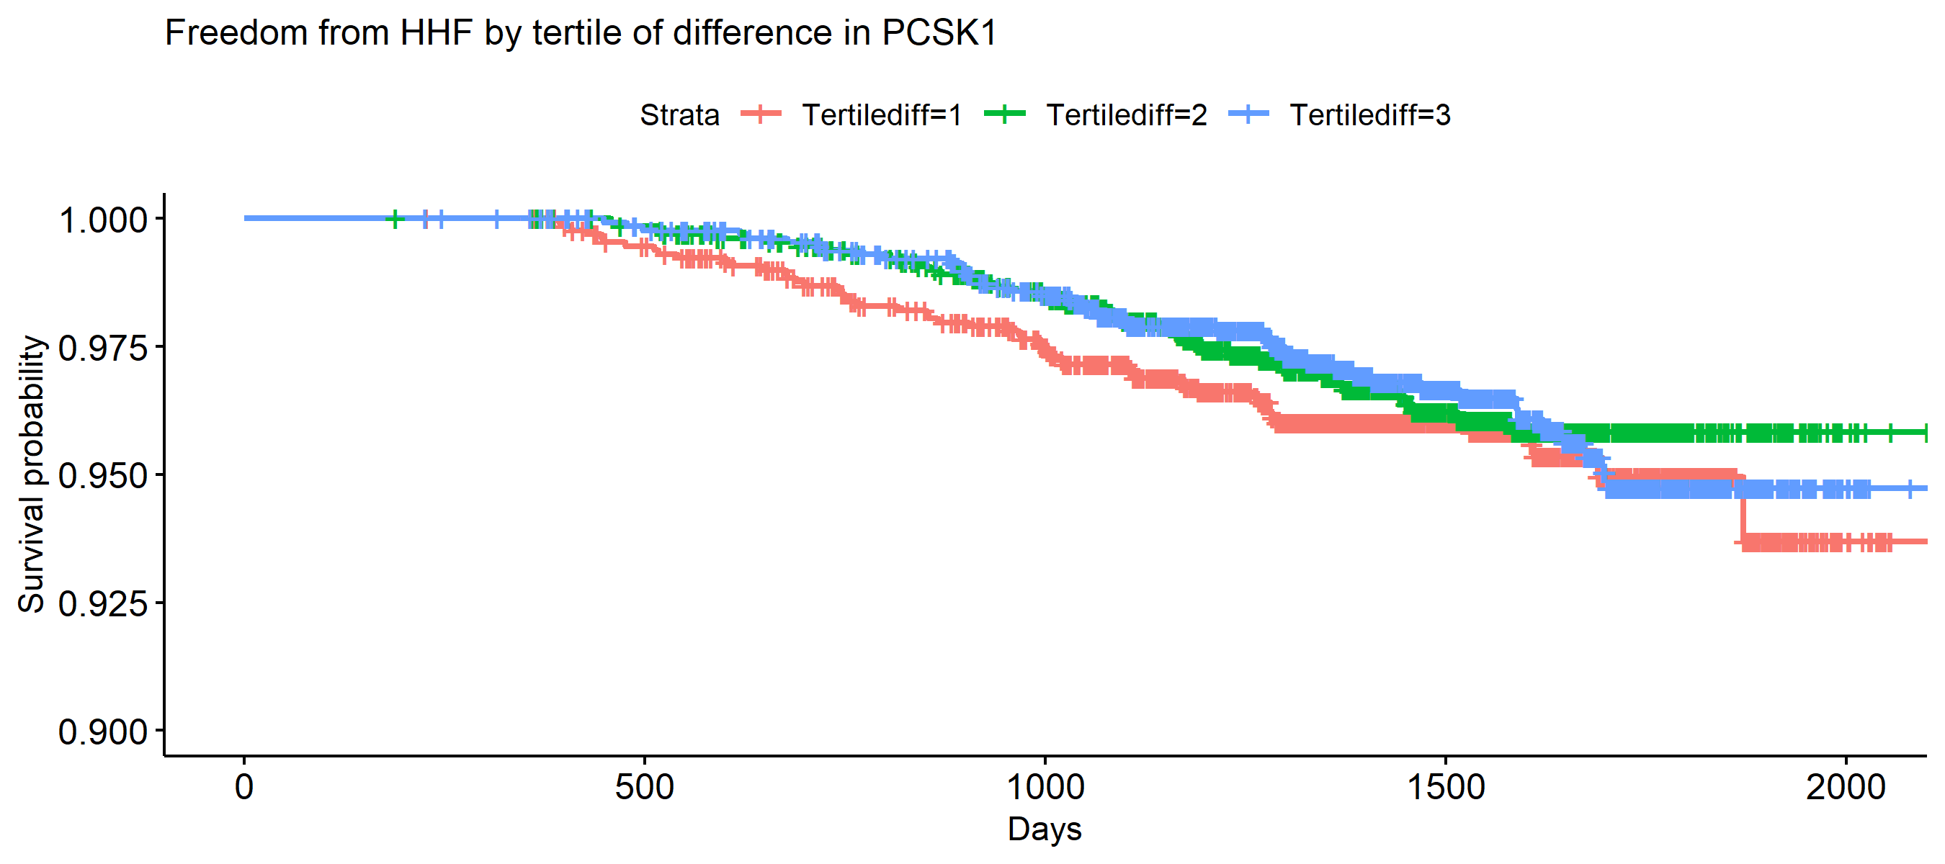
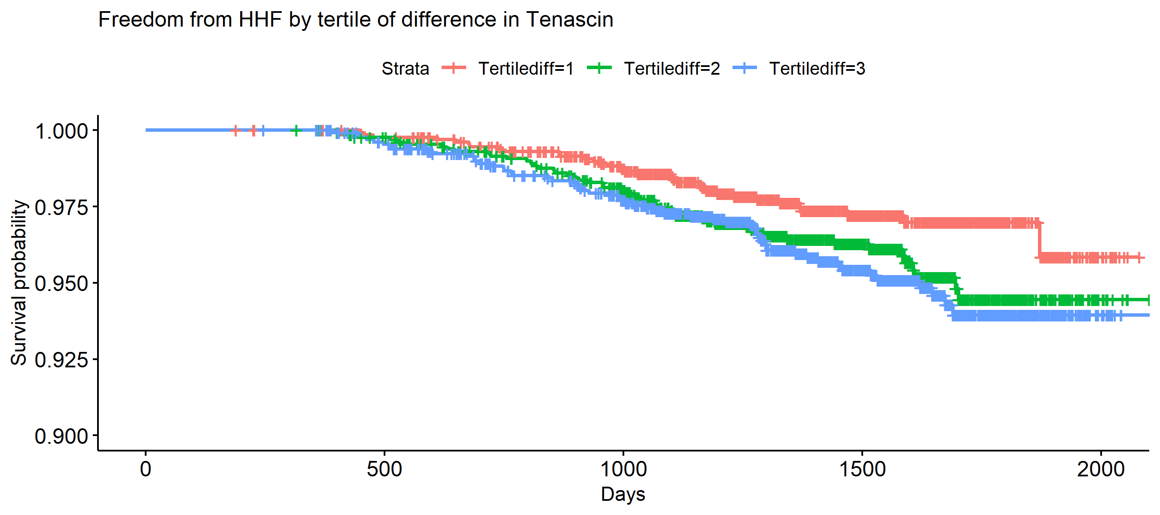
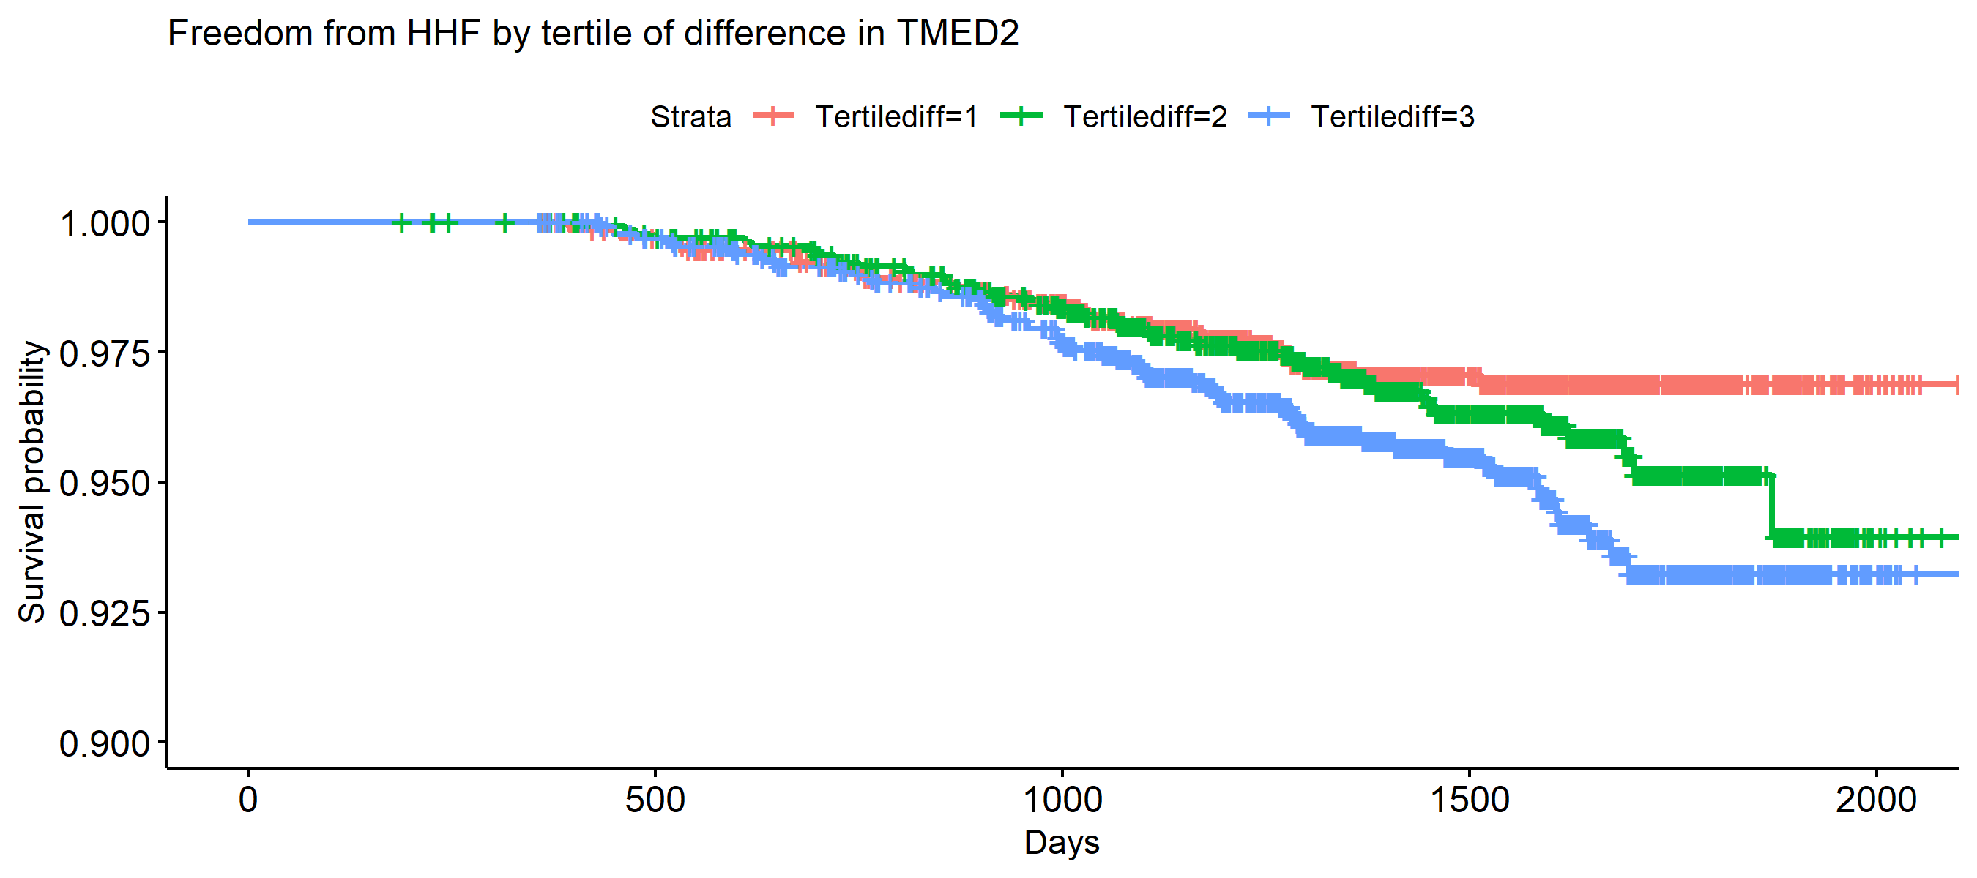
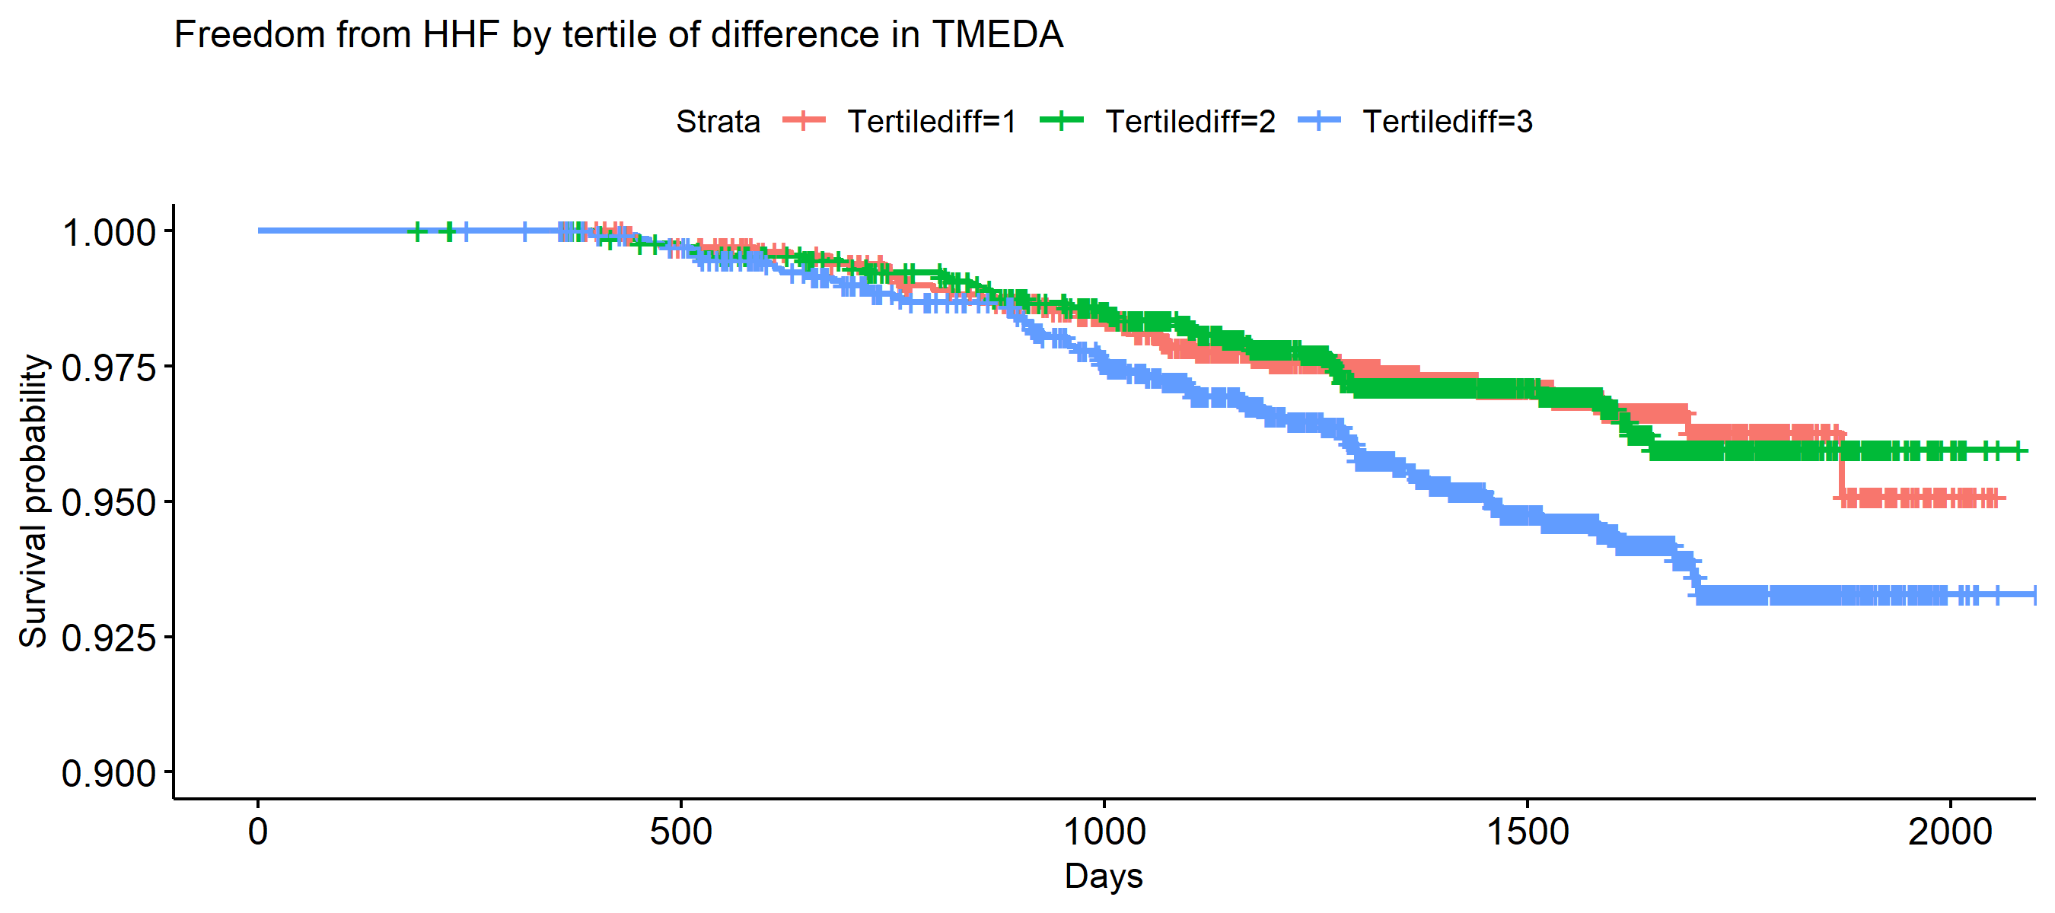
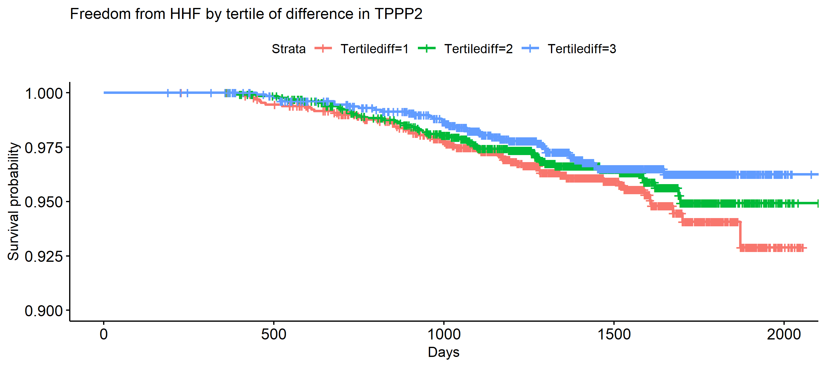
*Multiple other Somamer reagents targeting different epitopes of the Tenascin-C protein demonstrate similar patterns as displayed in the above Tenascin-C plot

Supplemental Figure 11. Volcano plot of results of multivariable Cox proportional hazards models for association between scaled baseline protein expression and time-to-incident heart failure hospitalization (hHF).
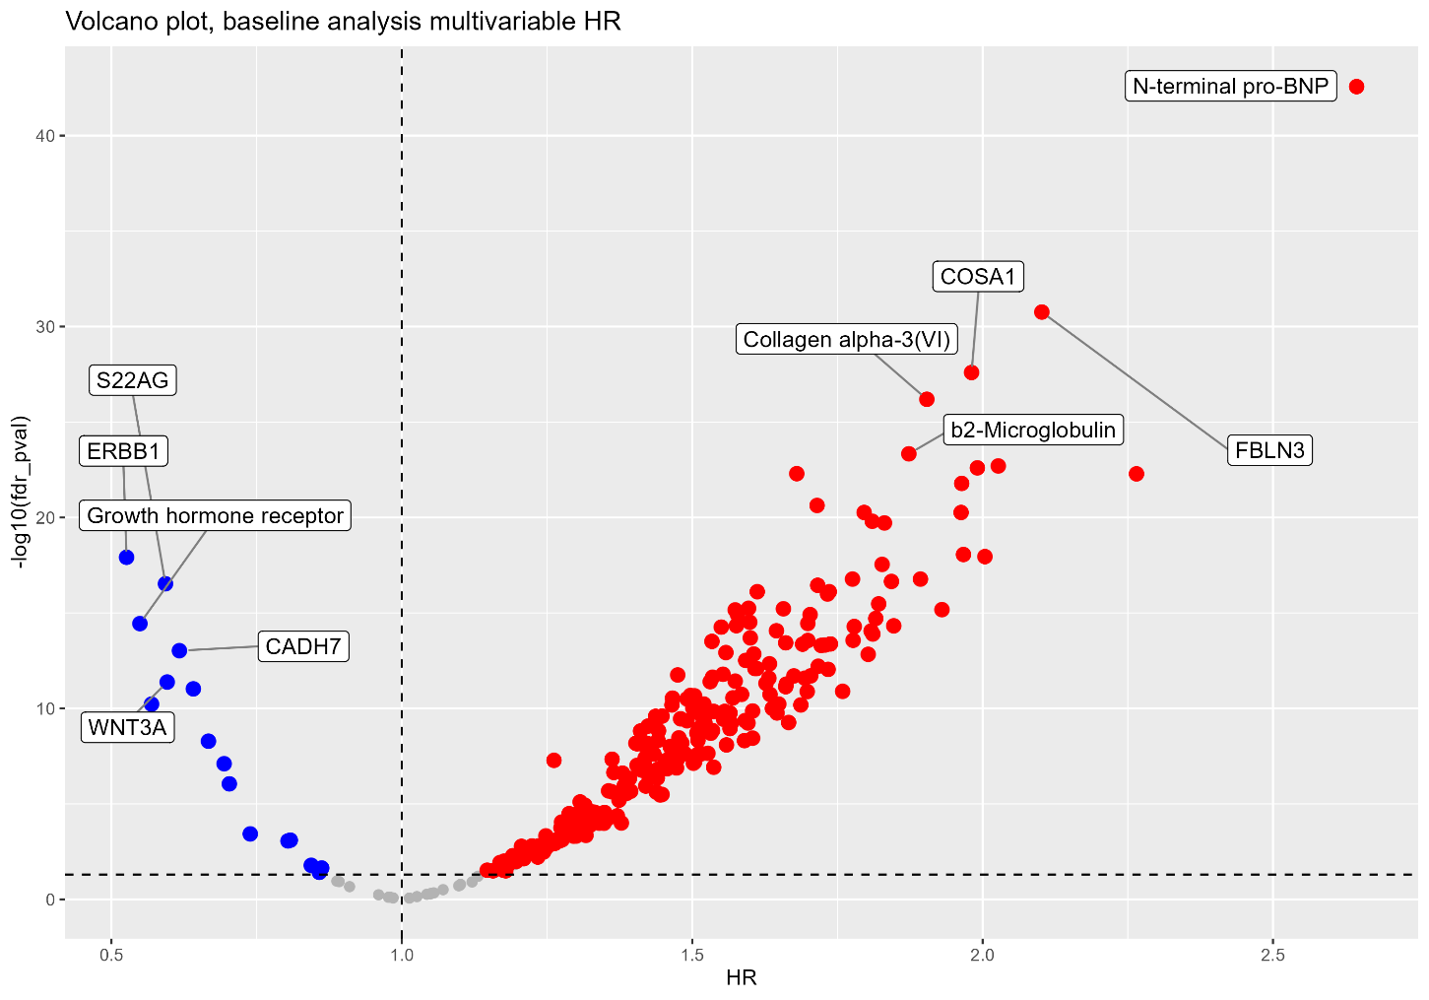

Supplemental Table 1. Baseline characteristics of subset of EXSCEL participants included in this analysis
 | Not included in this analysis  n = 13,553 | Included in this analysis  n = 1,119 | p-value
Age | 61.8 (9.4) | 63.18 (9.2) | <0.001
Male Sex | 8304 (61.3) | 845 (70.5) | <0.001
Self-Reported Race |  |  | <0.001
White | 10096 (74.5) | 1079 (90.0)
Black | 855 (6.3) | 23 (1.9)
Asian | 1409 (10.4) | 43 (3.6)
Hispanic | 1086 (8.0) | 48 (4.0)
Indian (American) or Alaska Native | 69 (0.5) | 4 (0.3)
Native Hawaiian or Other Pacific Islander | 33 (0.2) | 2 (0.2)
Region |  |  | <0.001
Asia Pacific | 1482 (10.9) | 47 (3.9)
Europe | 5989 (44.2) | 799 (66.6)
Latin America | 2690 (19.8) | 37 (3.1)
North America | 3392 (25.0) | 316 (26.4)
Smoking Status |  |  | 0.004
Current | 1588 (11.7) | 133 (11.1)
Former | 5267 (38.9) | 524 (43.7)
Never | 6691 (49.4) | 542 (45.2)
Medical history at baseline
Prior Cardiovascular Event at Randomization | 9717 (71.7) | 1065 (88.8) | <0.001
Hx of MI | 3986 (29.4) | 693 (57.8) | <0.001
Hx of Cerebrovascular Disease | 2246 (16.6) | 204 (17.0) | 0.73
Hx of Peripheral Arterial Disease | 2424 (17.9) | 200 (16.7) | 0.31
Hypertension | 11262 (83.1) | 1115 (93.0) | <0.001
Hyperlipidemia | 10654 (78.6) | 997 (83.2) | <0.001
Duration of Diabetes at BL | 13.12 (8.25) | 12.71 (8.5) | 0.10
Select HF medications at BL*
Angiotensin-converting enzyme inhibitor | 6434 (47.5) | 748 (62.4) | <0.001
Angiotensin receptor blocker | 4294 (31.7) | 312 (26.0) | <0.001
Beta Blocker | 7270 (53.6) | 941 (78.5) | <0.001
Diuretic Therapy | 5738 (42.3) | 705 (58.8) | <0.001
Body Mass Index (mean (SD)) | 32.57 (6.4) | 33.83 (6.6) | <0.001
Systolic BP at BL (mean (SD)) | 135.56 (17.0) | 134.32 (15.7) | 0.015
Diastolic BP at BL (mean (SD)) | 78.13 (10.3) | 77.87 (10.3) | 0.40
BL HbA1c (%) (mean (SD)) | 8.11 (0.96) | 8.15 (0.97) | 0.24
Creatinine (mg/dl) (mean (SD)) | 0.97 (0.28) | 1.05 (0.30) | <0.001
Estimated GFR at BL (mean (SD)) | 81.91 (20.2) | 77.37 (21.0) | <0.001
Values are reported as mean (SD) or n (%)
*Data on angiotensin receptor-neprilysin inhibitor utilization not available; data on sodium-glucose cotransporter-2 inhibitor available in a minority of participants – see Supplement
**Clinical NT-proBNP values available at baseline in 865/1199 participants; median [IQR] presented given values are skewed

Supplemental Table 2. Baseline medications of participants by ejection fraction group
 | HFpEF (n=284) | HFmrEF (n=704) | HFrEF (n=211) | p-value
Medications at baseline
Insulin | 142 (50.0%) | 334 (47.4%) | 115 (54.5%) | 0.19
Metformin | 191 (67.3%) | 504 (71.6%) | 124 (58.8%) | 0.002
Sulfonylurea | 100 (35.2%) | 256 (36.4%) | 54 (25.6%) | 0.014
Thiazolidinedione | 9 (3.2%) | 18 (2.6%) | 2 (0.9%) | 0.26
Non-sulfonylurea | 2 (0.7%) | 5 (0.7%) | 0 (0.0%) | 0.47
Alpha-glucosidase | 0 (0.0%) | 9 (1.3%) | 2 (0.9%) | 0.16
GLP-1 Analogues | 284 (100.0%) | 704 (100.0) | 211 (100.0%) | NA
SGLT-2 Inhibitors* | 0 (0.0%) | 1 (0.1%) | 0 (0.0%) | 0.71
Aspirin | 221 (77.8%) | 526 (74.7%) | 160 (75.8%) | 0.59
Vitamin K antagonist | 21 (7.4%) | 90 (12.8%) | 43 (20.4%) | <0.001
Statin | 228 (80.3%) | 596 (84.7%) | 179 (84.8%) | 0.21
Ezetimibe | 10 (3.5%) | 44 (6.2%) | 17 (8.1%) | 0.091
Fibrate | 12 (4.2%) | 60 (8.5%) | 11 (5.2%) | 0.031
Niacin | 9 (3.2%) | 14 (2.0%) | 4 (1.9%) | 0.49
Fish oil | 13 (4.6%) | 56 (8.0%) | 21 (10.0%) | 0.063
Chronic Non-Steroidal Anti-Inflammatory Drugs | 8 (2.8%) | 27 (3.8%) | 12 (5.7%) | 0.26
Hormone Replacement Therapy | 6 (2.1%) | 18 (2.6%) | 13 (6.2%) | 0.016
*Available data in only 41.1% of participants

Supplemental Table 3
Participants with hospitalization/mortality events by ejection fraction group
 | HFpEF (n=284) | HFmrEF (n=704) | HFrEF (n=211)
HF hospitalization | 13 (4.6%) | 48 (6.8%) | 38 (18.0%)
Total (first and recurrent) HF hospitalizations | 17 | 74 | 86
Cardiovascular death | 17 (6.0%) | 35 (5.0%) | 24 (11.4%)
All-cause death | 23 (8.1%) | 54 (7.7%) | 33 (15.6%)

Supplemental Table 4. Factors by principal component analysis (PCA)
*See attached Excel file
Supplemental Table 5. Overrepresentation analysis for proteins with HFmrEF-HFrEF concordance
 | Pathway size | Significant genes in pathway | Nominal p-value | Select genes
Systemic lupus erythematosus | 48 | 13 | <0.001 | H2AW, H3C8
Starch and sucrose metabolism | 21 | 4 | 0.002 | AMY1C, UGT1A8
Folate biosynthesis | 10 | 2 | 0.02 | ALPG, ALPL
Drug metabolism cytochrome P450 | 26 | 6 | 0.02 | GSTM3, UGT1A8
Glutathione metabolism | 29 | 3 | 0.03 | GSR, GSTM4
Metabolism of xenobiotics by cytochrome P450 | 29 | 3 | 0.03 | GSTM3, UGT1A8
Complement | 129 | 7 | 0.04 | IRFs, TNFAIP3
Pathogenic E. coli infection | 24 | 3 | 0.02 | ABL1, NCL
Hematopoietic cell lineage | 65 | 5 | 0.02 | CD3G, IL4R
ARVC | 25 | 3 | 0.02 | DAG1, ITGBs
Extracellular matrix receptor interaction | 47 | 4 | 0.03 | CHAD, ITGB5s
Dilated cardiomyopathy | 29 | 3 | 0.03 | DAG1, ITGBs
Glycosphingolipid biosynthesis | 13 | 2 | 0.04 | B3GALT2, FUT2
Hypertrophic cardiomyopathy | 34 | 3 | 0.05 | DAG1, ITGBs
Allograft rejection | 134 | 7 | 0.04 | IL18, MMP9

