Supplementary Figures

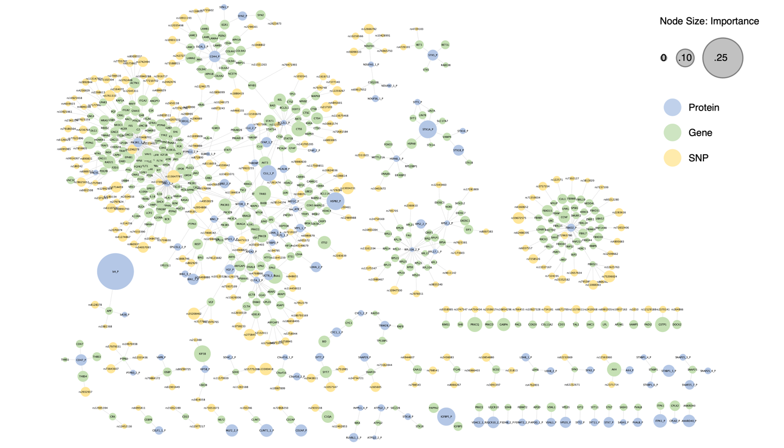
Figure S1. The prior network annotated with connected features (# node=765) selected by Modularity-Logistic without threshold setting on feature weight.

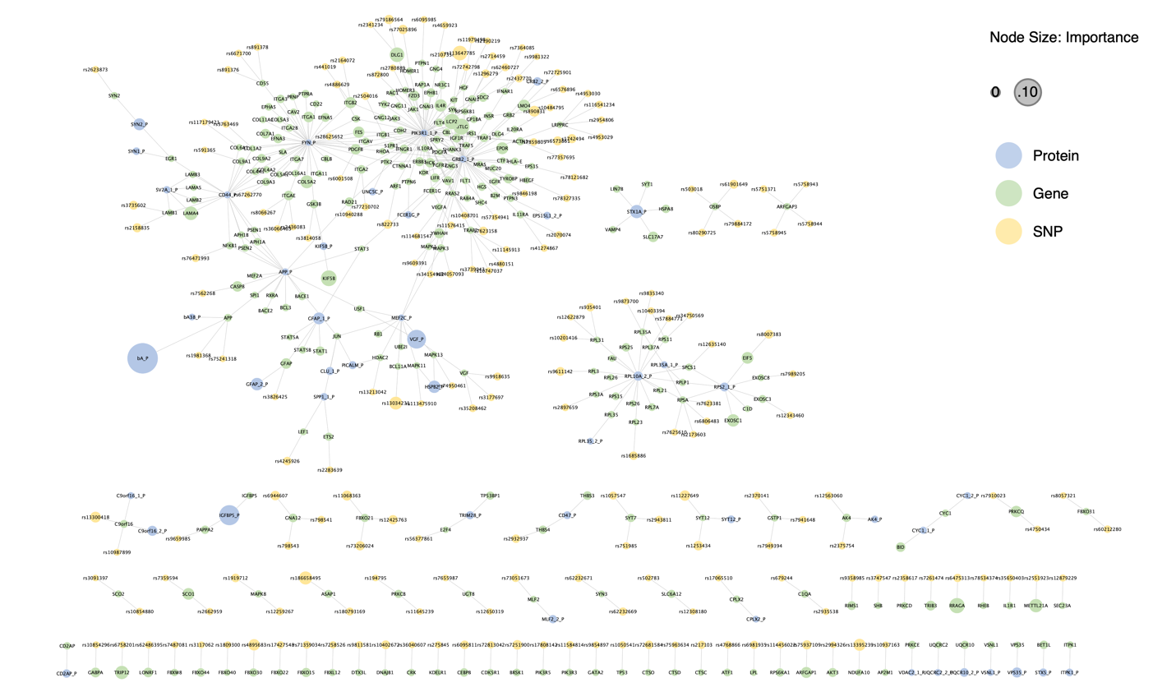
Figure S2. Connected features (# node=506) identified by Elastic-Logistic were mapped to the prior network.

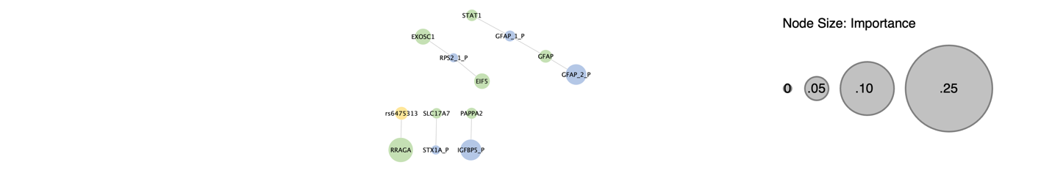
Figure S3. The prior network overlaid with connected features (# node=13) identified by Laplacian-Logistic.

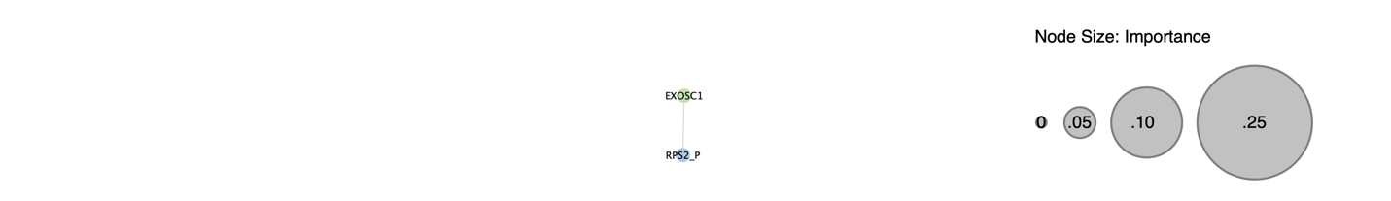
Figure S4. The connected features (# node=2) identified using Lasso- Logistic were mapped to the prior network.

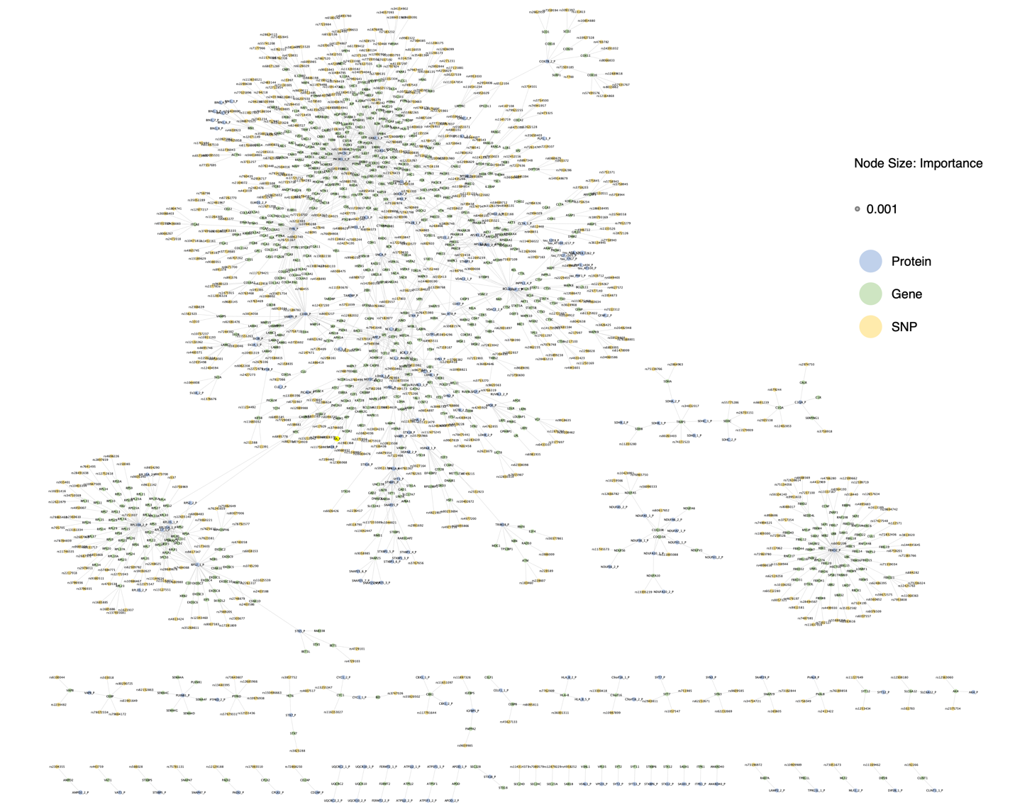

Figure S5. All connected features (# node=1725) identified using Random Forest were placed on the prior.
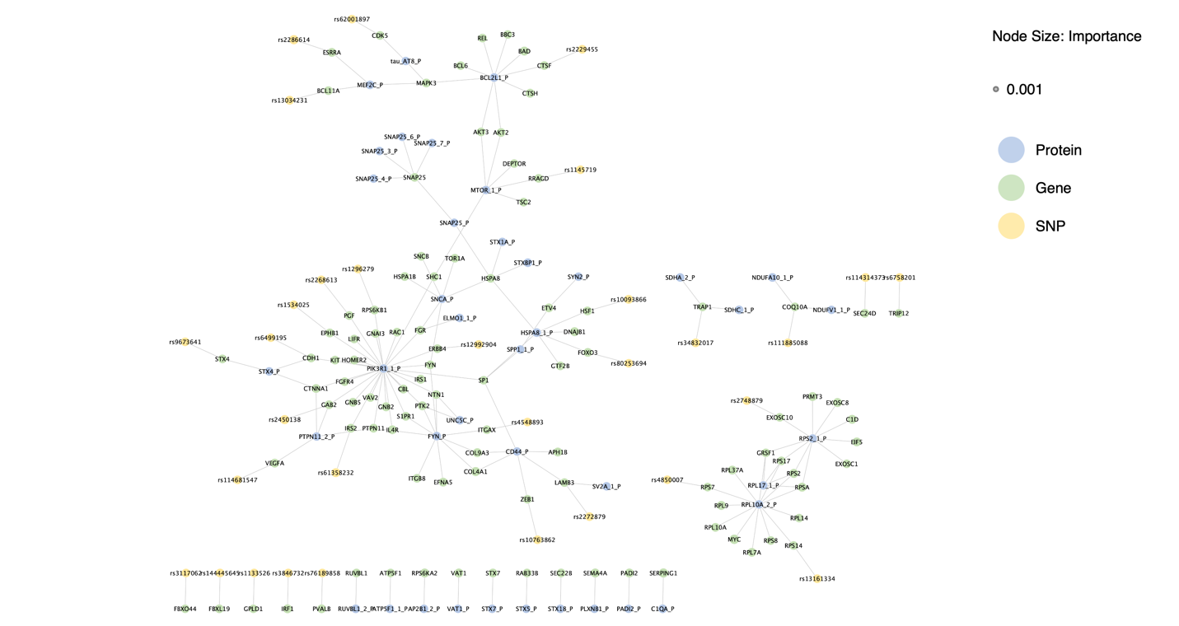

Figure S6. All connected features (# node=172) identified using MOGONet.

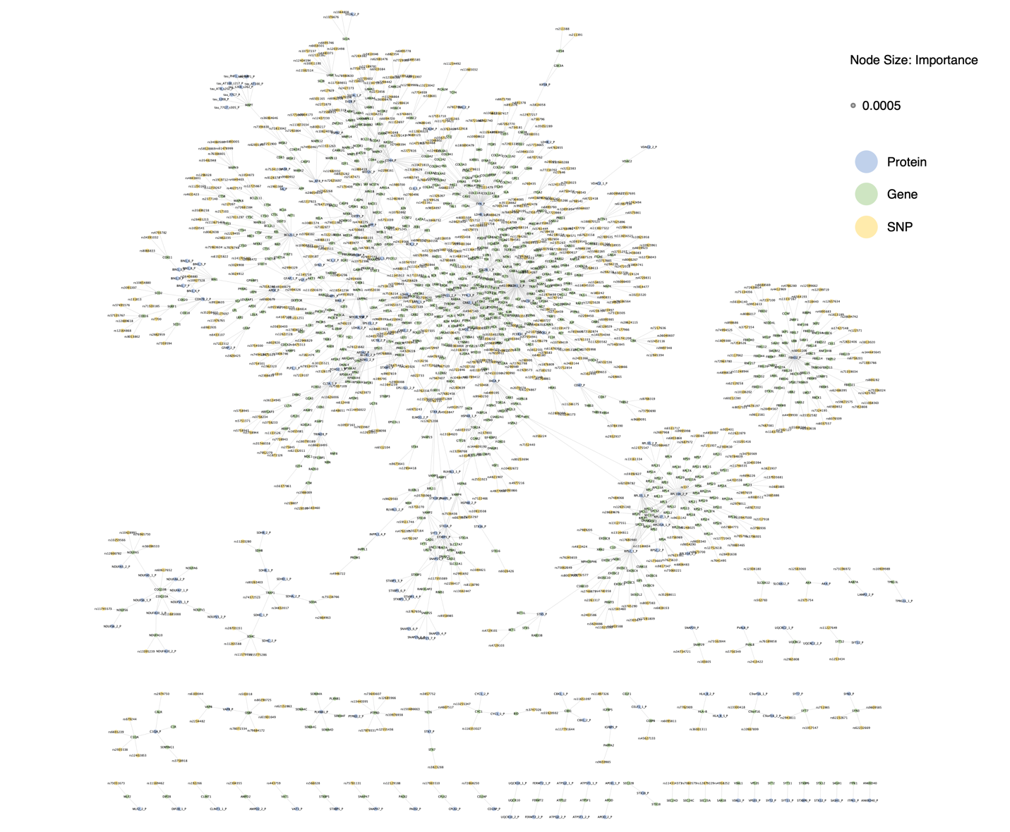
Figure S7. All connected features (# node=1742) identified using MLP.

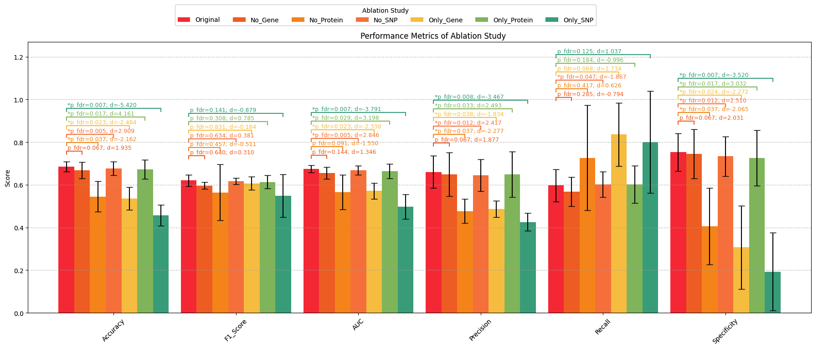
Figure S8. Ablation analysis of the fine-tuned TransFuse highlights the contribution of each -omics type. FDR corrected p-values and effect size d were calculated using paired t-test. The removal of protein expression results in the most significant decline in classification performance, indicating its crucial role in the final model.

