Supplementary Materials
Article title: A Nostalgia Brain-Music Interface for Enhancing Nostalgia, Well-Being, and Memory Vividness in Younger and Older Individuals

Authors: Yuna Sakakibara^{1,2&}, Tomohiro Kusutomi¹, Sotaro Kondoh^{1,2,3,4}, Takahide Etani^{1,2,5,6}, Saori Shimada^{1,3}, Yasuhiko Imamura¹, Yasushi Naruse¹, Shinya Fujii^{1,3&}, Takuya Ibaraki^{1,7*}

¹ VIE, Inc., Kanagawa, Japan
² Graduate School of Media and Governance, Keio University, Kanagawa, Japan
³ Faculty of Environment and Information Studies, Keio University, Kanagawa, Japan
⁴ Japan Society for the Promotion of Science, Tokyo, Japan
⁵ School of Medicine, College of Medical, Pharmaceutical and Health Science, Kanazawa University, Ishikawa, Japan
⁶ Advanced Research Center for Human Science, Waseda University, Saitama, Japan
⁷ NTT Data Institute of Management Consulting, Inc., Tokyo, Japan

&Co-corresponding author
E-mail: sakakibara.aa@keio.jp (YS)
E-mail: fujii.shinya@keio.jp (SF)

*Corresponding author
E-mail: ibarakit@nttdata-strategy.com (TI)

The release years of each song in the young participants' song pool

The release years were retrieved using the Spotify API and MusicBrainz API by searching for song titles and artist names. For unmatched songs, release years were determined through manual online searches.

Released Age | 1942-1947 | 1947-1952 | 1952-1957 | 1957-1962 | 1962-1967 | 1967-1972 | 1972-1977 | 1977-1982 | 1982-1987
Number of songs | 1 | 0 | 3 | 2 | 6 | 7 | 19 | 29 | 23
Released Age | 1987-1992 | 1992-1997 | 1997-2002 | 2002-2007 | 2007-2012 | 2012-2017 | 017-2023 | unknown
Number of songs | 35 | 82 | 180 | 279 | 423 | 1205 | 5154 | 32
Table S1. Number of songs in the younger participants’ music pool by release year. Release years were identified using the Spotify API and MusicBrainz API based on song titles and artist names. For unmatched songs, release years were determined through manual online searches.

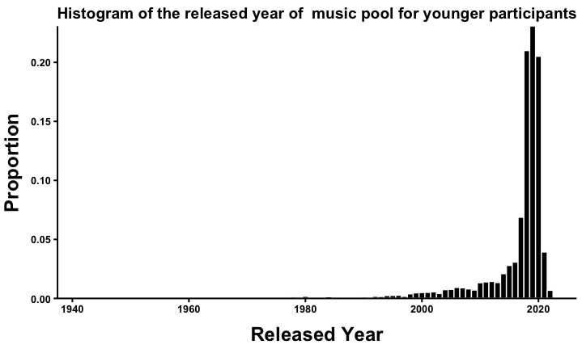
Figure S1. Histogram of the number of songs in the younger participants’ music pool by release year. The y-axis indicates the proportion of songs, and the x-axis represents the release year. Songs with unknown release years were excluded from the figure.

