Supplementary files
Supplement Table S1. Sampling localities and coordinates.
Code | Locality | Latitude | Longitude | Altitude
Sta 1 | Kocaçay Creek | 39.227500 | 27.858333 | 290
Sta 2 | Kuzuludede Creek | 39.441396 | 27.632960 | 257
Sta 3 | Sarıbeyler Reservoir | 39.411667 | 27.610556 | 227
Sta 4 | Yağcılı/Büyükdere Creeks Connection | 39.356111 | 27.594167 | 179
Sta 5 | Sevişler Reservoir | 39.271016 | 27.567150 | 177
Sta 6 | Yağcılı Creek | 39.188056 | 27.487778 | 68
Sta 7 | Bakırçay River 1 | 39.178056 | 27.481944 | 68
Sta 8 | Karadere Kınık Creek | 39.089722 | 27.421944 | 67
Sta 9 | Bakırçay River 2 | 39.112222 | 27.273889 | 32
Sta 10 | Çınarlıdere Creek | 39.258333 | 27.314722 | 114
Sta 11 | Çaltıkoru Reservoir | 39.239079 | 27.302043 | 108
Sta 12 | İlyas Creek | 39.216389 | 27.333889 | 63
Sta 13 | Kestel Reservoir | 39.142500 | 27.196944 | 119
Sta 14 | Bakırçay River 3 | 39.053056 | 27.111111 | 15
Sta 15 | Bakırçay River 4 | 38.952500 | 27.009722 | 5

Supplement Table S2. Physicochemical parameters of the stations.
Stations |  | Temperature | pH | DO | DO | Conductivity | Salinity
 |  | (°C) |  | (mg/L) | (%) | (µS) | (ppt)
Sta 1 | min-max. | 9.3-24.5 | 7.72-8.35 | 6.7-10.7 | 84-108 | 565-798 | 0.2-0.3
Sta 1 | aver. | 16.3 | 8.1 | 9.2 | 98.5 | 719 | 0.27
Sta 2 | min-max. | 9.1-22 | 7.76-8.56 | 8.3-11.4 | 99-121 | 436-666 | 0.1-0.3
Sta 2 | aver. | 16.4 | 8.2 | 10.1 | 109.3 | 570.2 | 0.2
Sta 3 | min-max. | 7.6-28.2 | 7.98-9.37 | 8.2-14.6 | 98-170 | 273-420 | 0.1
Sta 3 | aver. | 18.4 | 8.5 | 10.6 | 119.2 | 340.5 | 0.1
Sta 4 | min-max. | 11.6-21.5 | 7.75-8.2 | 7.5-9.8 | 88-110 | 589-711 | 0.2-0.3
Sta 4 | aver. | 18.3 | 8.0 | 8.9 | 97.6 | 628.2 | 0.22
Sta 5 | min-max. | 6.9-27.2 | 7.84-8.64 | 8.3-13.3 | 95-141 | 387-900 | 0.1-0.4
Sta 5 | aver. | 18.1 | 8.3 | 11.1 | 119.5 | 527.5 | 0.17
Sta 6 | min-max. | 8.2-18.7 | 8.09-8.27 | 8.1-10.9 | 85-106 | 476-588 | 0.1-0.2
Sta 6 | aver. | 15.4 | 8.1 | 9.5 | 96.4 | 548 | 0.17
Sta 7 | min-max. | 9-28.5 | 7.76-8.18 | 3.9-9.1 | 51-80 | 911-977 | 0.4
Sta 7 | aver. | 18.8 | 7.9 | 6.8 | 71.2 | 952.7 | 0.4
Sta 8 | min-max. | 6.4-22.8 | 8.49-9.22 | 10-18 | 94-101 | 227-726 | 0.1-0.3
Sta 8 | aver. | 13.9 | 8.7 | 13.5 | 97.9 | 536 | 0.2
Sta 9 | min-max. | 7.9-21.6 | 7.76-8.17 | 6.3-11.2 | 65-94 | 473-968 | 0.1-0.4
Sta 9 | aver. | 16.6 | 7.9 | 8 | 81.3 | 738.7 | 0.27
Sta 10 | min-max. | 7.7-20.6 | 8.29-8.57 | 8.9-10.6 | 98-109 | 371-568 | 0.1-0.2
Sta 10 | aver. | 16.2 | 8.4 | 9.7 | 102.5 | 469.6 | 0.13
Sta 11 | min-max. | 7.8-29.1 | 8.22-8.65 | 7.7-10.4 | 96-116 | 331-389 | 0.1
Sta 11 | aver. | 19.8 | 8.4 | 9.3 | 105.1 | 359 | 0.1
Sta 12 | min-max. | 8.4-22 | 7.97-8.77 | 8.8-13.7 | 97-158 | 394-465 | 0.1
Sta 12 | aver. | 17.1 | 8.4 | 12.1 | 127.3 | 426.5 | 0.1
Sta 13 | min-max. | 7-27.2 | 8.21-8.84 | 7.9-11.5 | 95-113 | 336-343 | 0.1
Sta 13 | aver. | 18.5 | 8.4 | 9.7 | 103.9 | 339 | 0.1
Sta 14 | min-max. | 6.5-23 | 7.82-8.05 | 4.7-10.2 | 43-91 | 505-910 | 0.2-0.4
Sta 14 | aver. | 16.1 | 7.9 | 6.7 | 67.6 | 708.5 | 0.3
Sta 15 | min-max. | 7.6-24 | 7.74-8.05 | 5.5-9.6 | 58-84 | 514-943 | 0.2-0.4
Sta 15 | aver. | 17 | 7.8 | 7.2 | 73.7 | 726.7 | 0.3

Supplement Table S3. PERMANOVA results for community composition based on Bray-Curtis distance. (a) Overall model results for the effects of pH, N_bound, and Stream_Order on community composition. (b) Results by constrained axes (CAP1 and CAP2). (c) Results by individual terms (pH, N_bound, and Stream_Order). All analyses were performed in R using the capscale function (vegan package) with 999 permutations.
(a) | Df | Sum of Sqs | F | Pr(>F)
Model | 2 | 1.4789 | 2.1698 | 0.001
Residuals | 44 | 14.994

(b) | Df | Sum of Sqs | F | Pr(>F)
CAP1 | 1 | 1.1119 | 3.2627 | 0.005
CAP2 | 1 | 0.3670 | 1.0768 | 0.348
Residuals | 44 | 14.994

(c) | Df | Sum of Sqs | F | Pr(>F)
pH | 1 | 0.8491 | 2.4915 | 0.009
N_bound | 1 | 0.4835 | 2.3919 | 0.423
Stream_Order | 1 | 0.6298 | 1.8481 | 0.038
Residuals | 44 | 14.994

Supplement Table S4. The numbers of fish sampled in the Bakırçay River drainage according to stations. The species status is given (native, regionally endemic, non-native) along with the IUCN status.
Species | Stations |  |  |  |  |  |  |  |  |  |  |  |  |  |  | TIN | TIN%
Species | 1 | 2 | 3 | 4 | 5 | 6 | 7 | 8 | 9 | 10 | 11 | 12 | 13 | 14 | 15 | TIN | TIN%
A. anguilla  Native (CR) | --- | --- | --- | --- | --- | 6 | --- | --- | --- | --- | --- | 1 | --- | --- | 1 | 8 | 0.23
A. boyeri  Non-native (LC) | --- | --- | --- | --- | 15 | --- | --- | --- | --- | --- | --- | --- | --- | --- | --- | 15 | 0.44
C. fahireae  Native (LC) | 11 | 7 | 1 | 37 | --- | 21 | --- | 2 | 8 | 5 | --- | 90 | --- | 6 | 1 | 189 | 5.53
A. attalus  Regionally endemic (EN) | 1 | 25 | 31 | 22 | --- | 31 | --- | 2 | 4 | 14 | --- | 4 | 1 | 2 | 1 | 138 | 4.04
B. pergamonensis  Regionally endemic (LC) | 21 | 12 | --- | 76 | --- | --- | --- | --- | 3 | 12 | --- | 1 | --- | 5 | --- | 130 | 3.81
C. bergamae  Regionally endemic (NT) | --- | --- | --- | 2 | --- | 3 | --- | 10 | 2 | 5 | --- | --- | --- | --- | 1 | 23 | 0.67
C. carpio  Non-native (VU) | --- | --- | 1 | --- | --- | --- | --- | --- | --- | --- | --- | --- | --- | --- | --- | 1 | 0.03
C. gibelio  Non-native (LC) | --- | --- | --- | --- | --- | --- | 16 | --- | --- | --- | 3 | --- | 37 | --- | 6 | 62 | 1.82
C. holmwoodii  Regionally endemic (VU) | --- | 95 | --- | 102 | --- | 26 | --- | 4 | 19 | 1 | --- | --- | --- | 2 | 6 | 255 | 7.47
L. lydianus  Native (LC) | --- | --- | --- | --- | --- | 1 | 1 | --- | --- | --- | --- | 3 | --- | --- | 2 | 7 | 0.20
P. smyrnaeus  Regionally endemic (LC) | --- | --- | --- | 10 | --- | 291 | 64 | --- | 41 | --- | 1 | 39 | --- | 6 | 3 | 455 | 13.32
P. parva  Non-native (LC) | --- | 5 | 311 | --- | 77 | 2 | 1 | --- | --- | --- | --- | --- | 17 | 1 | --- | 414 | 12.12
R. amarus  Native (LC) | 76 | --- | --- | 44 | 1 | 11 | 1 | 1 | --- | --- | --- | 10 | 33 | 47 | 65 | 289 | 8.46
S. fellowesii  Native (LC) | 181 | 93 | --- | 158 | --- | 34 | --- | 113 | 82 | 47 | --- | 103 | 39 | 94 | --- | 944 | 27.64
K. caucasica  Non-native (LC) | --- | --- | --- | --- | --- | --- | --- | --- | --- | --- | --- | --- | --- | --- | 1 | 1 | 0.03
O. theophilii  Regionally endemic (LC) | 12 | 44 | --- | 123 | --- | 28 | --- | 112 | --- | 39 | --- | 123 | --- | --- | --- | 481 | 14.08
G. holbrooki  Non-native (LC) | --- | --- | --- | --- | --- | --- | --- | --- | --- | --- | --- | --- | --- | --- | 3 | 3 | 0.09
TIN:Total individual number.

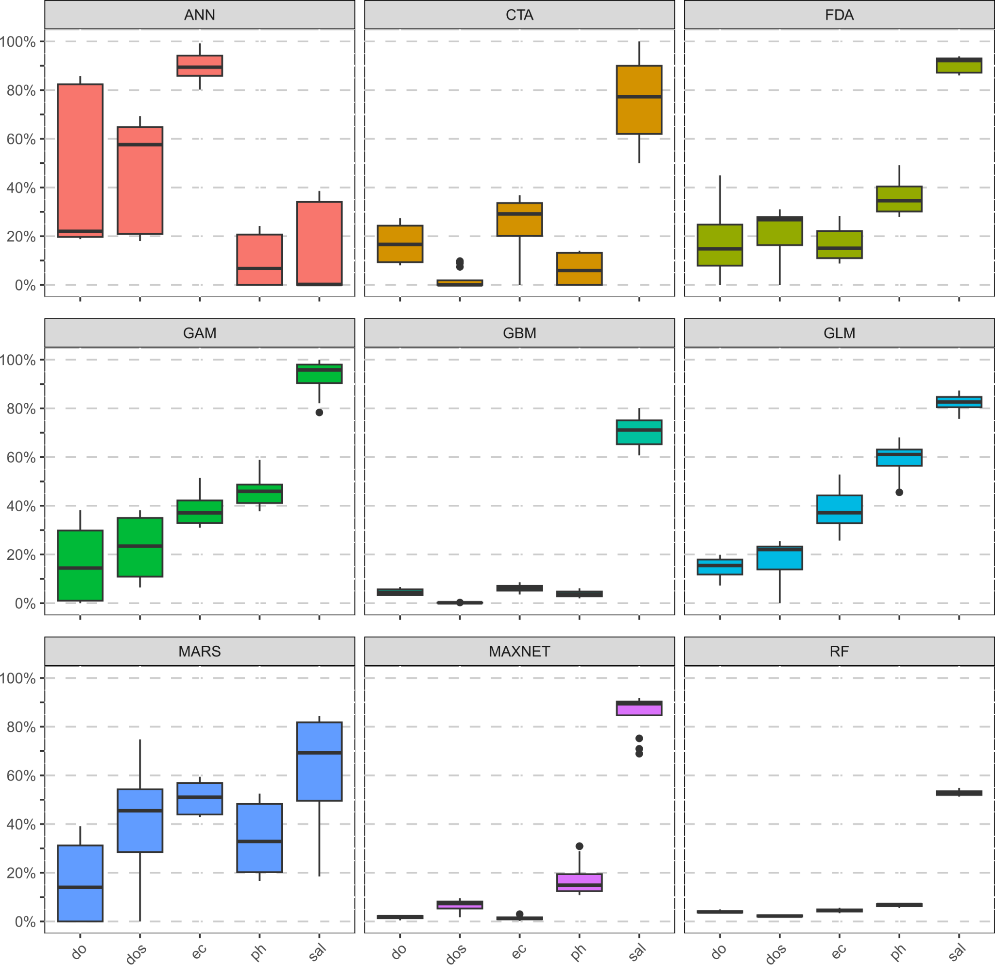
Supplement Figure S1. Contribution value in distribution modelling of physicochemical parameters.

