Supplementary Table ST1. Details of Asian Zebu Cattle breeds used in the study
Breed Name | Image | Description
Alambadi (India)  (Tamil Nadu Veterinary and Animal Sciences University, Chennai, India) | 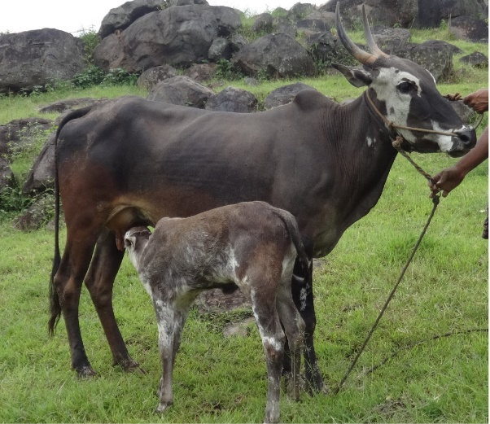 | - Mainly found in the hilly regions of the Dharmapuri and Krishnagiri districts of Tamil Nadu, with some presence along the border of Karnataka  - Dual Purpose (Milk/Draught)  - Medium sized  - Grey coat with white markings  - Good for milk and draught work  (Manomohan et al., 2021; Ware, 1942)
Bargur (India)  (Tamil Nadu Veterinary and Animal Sciences University, Chennai, India) | 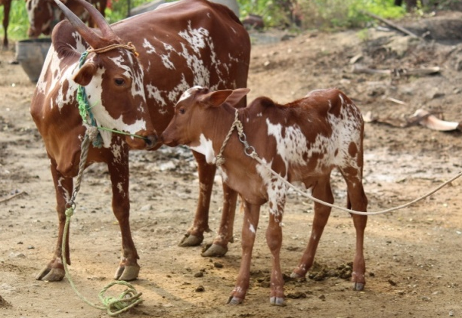 | - Found in and around the Bargur hills, specifically in the Bhavani and Anthiyur taluks of Erode district in Tamil Nadu  - Used for Draught  - Medium sized (smaller and compact)  - Coat colour typically red and white or red with white spots. Sometimes dark brown coat with white patches  - Well adapted to hilly terrain, have speed and endurance in trotting  - Aggressive nature, fiery, restless, and difficult to train  (Ganapathi, 2009; Pundir, 2009)
Deoni (India)  (Tamil Nadu Veterinary and Animal Sciences University, Chennai, India) | 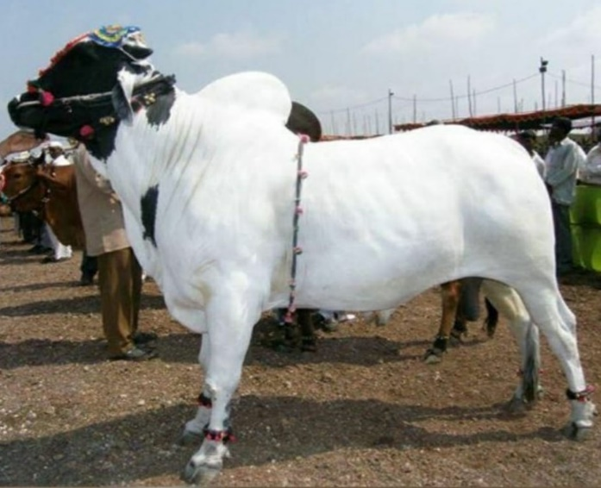 | - Found in Maharashtra , distributed in Bidar and Gulbarga districts of Karnataka; Medak district of Andhra Pradesh; Latur, Parbhani, Nanded and Osmanabad districts of Maharashtra  - Dual purpose breed (Milk/Draught)  - Large sized  - Mainly has 3 strains based on coat color  - Wannera (white coat colour with black colour at the sides of face)  - Shevera (white coat with irregular black spots)  - Balankya (white coat with black spots on lower side of the body)  - High milk yield, good draught capacity  (Dongre VB, 2017; Kuralkar SV, 2014)
Hallikar (India)  (Tamil Nadu Veterinary and Animal Sciences University, Chennai, India) | 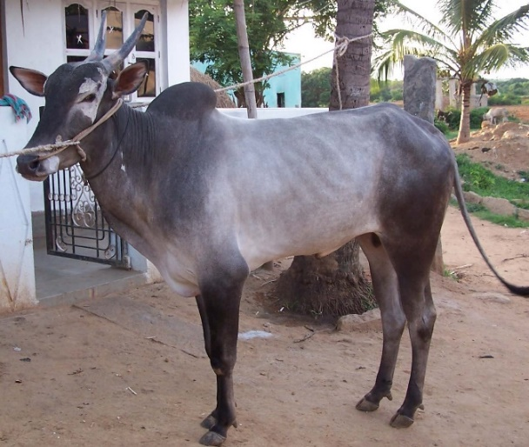 | - Distributed in the districts of Mysore, Tumkur, Chitradurga, Mandya, Kolar and Hassan in Karnataka state of South India  - Draught breed  - Large sized  - A sturdy, powerful and docile breed that can work on average 8.18h/day  (P. R. A. S. K. S. G. M. A. K. Singh PK, 2008)
Kangayam (India)  (Tamil Nadu Veterinary and Animal Sciences University, Chennai, India) | 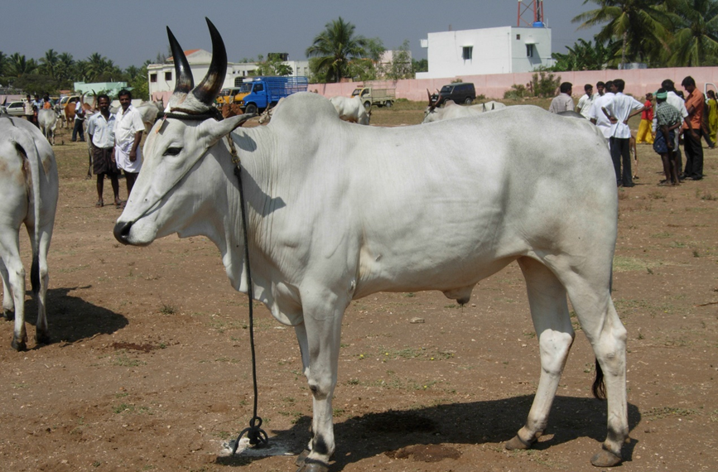 | - Kangayam, Dharapurm, Perundurai, Karur and Palani areas of Tamil Nadu located in southern India  - Draught breed  - Medium-sized  - Usually has white or grey coat, darker at forequarters, lighter in hindquarters  - Well adapted to drought prone areas and can thrive under scanty rations  (Natarajan A, 2012)
Ongole (India)  (Tamil Nadu Veterinary and Animal Sciences University, Chennai, India) | 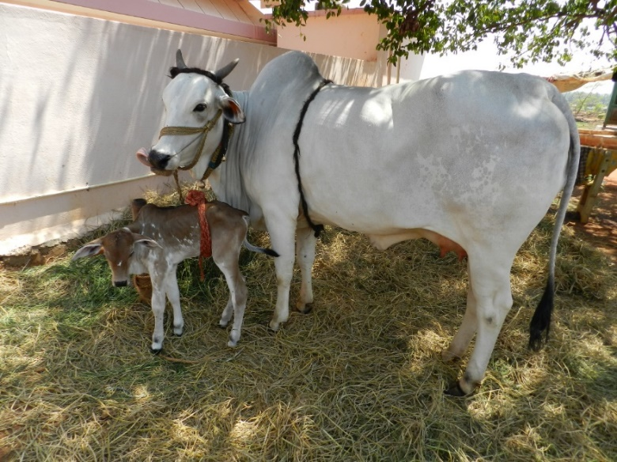 | - Found in Andhra Pradesh distributed in the Nellore and Guntur districts of Andhra Pradesh  - Dual Purpose breed (Milk/Draught)  - Large sized  - White or light grey coat  - High milk production, prized for draught work (heavy cartwork  (Joshi & Phillips, 1953)
Pullikulam (India)  (Tamil Nadu Veterinary and Animal Sciences University, Chennai, India) | 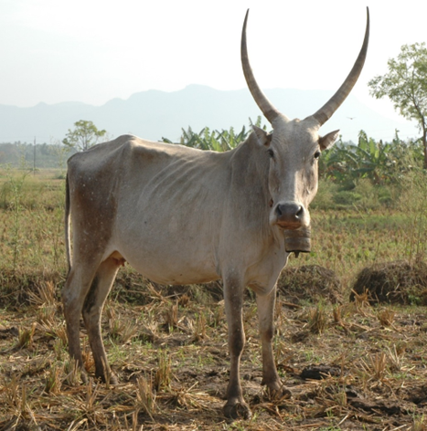 | - Found in Sivaganga, Madurai, and Virudhunagar districts in southern Tamil Nadu.  - Dual purpose (Meat/Draught)  - Medium sized  - They have a grey or fawn coat.  - Known for their strong physique  Singh et. al, (2012)
Punganar (India)  (Tamil Nadu Veterinary and Animal Sciences University, Chennai, India) | 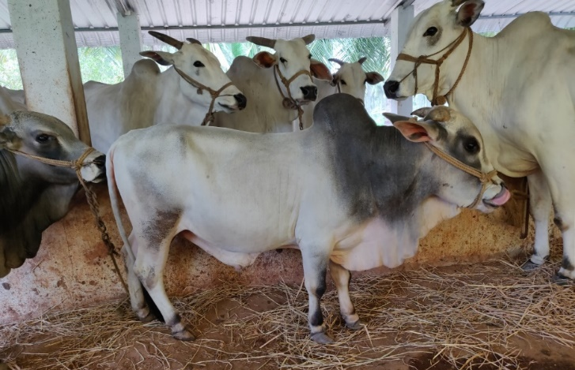 | - Unique to South India distributed in Vayalpad, Madanaspalli and Palamaneru taluks of Chittoor district of Andhra Pradesh  - Dairy breed  - Small sized (60-100cm)  - They have white, light grey coat  - They are known as efficient milk producers and one of the world's shortest breeds  (Nath , 1993)
Umbalacheri (India)  (Tamil Nadu Veterinary and Animal Sciences University, Chennai, India) | 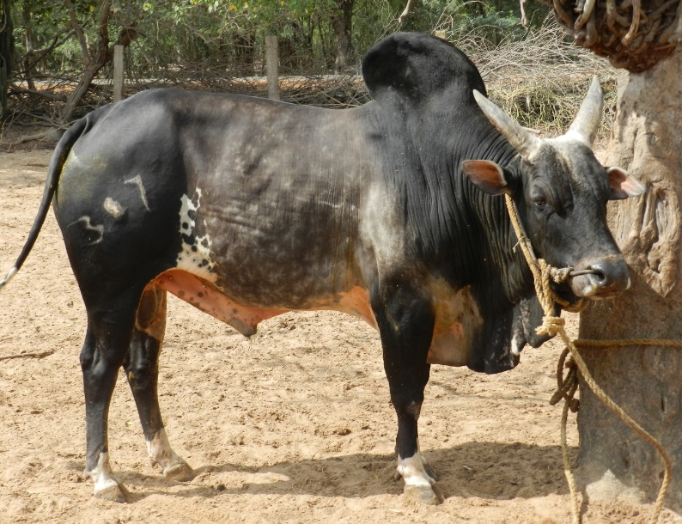 | - Found in the Eastern coastal areas of Tamil Nadu state particularly in Thiruvarur and parts of Nagapattinam districts  - Draught breed  - Medium sized  - Coat color is particularly red  - They are known for their ability to work in mashy paddy fields  (Rajendran R, 2008)
Vechur (India)  (Tamil Nadu Veterinary and Animal Sciences University, Chennai, India) | 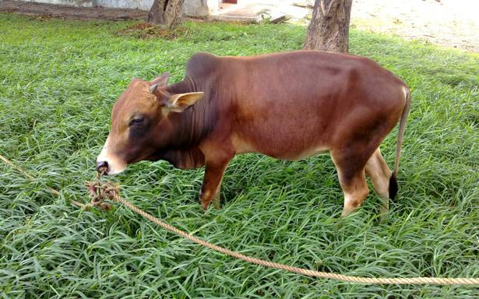 | - They are unique to South India and are distributed in and around Vaikom in the Kottayam, District of Kerala  - Dairy breed  - Small size (60-100cm)  - They have a light brown or white coat  - They are known as the smallest cattle breed that have high milk quality  (Iype S., 1996)
Brahman (Cambodia)  (National Animal Health and Production Research Institute, Phnom Penh, Cambodia) | 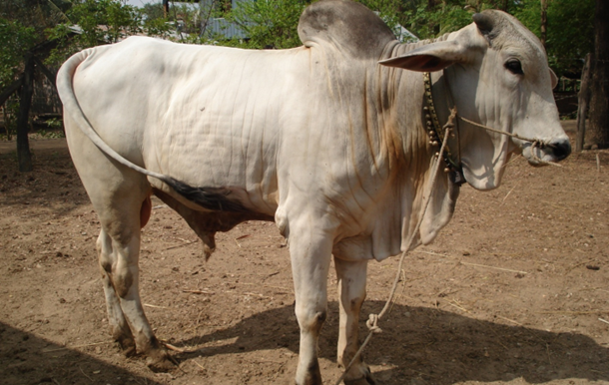 | - Globally distributed but mainly found in Siem Reap areas  - Dual Purpose (Milk/Meat)  - Large  - Grey, white, or red coat, with distinct hump  - Heat-tolerant, disease-resistant, good for beef production  (Namikawa , 2006)
Kdarm Red (Cambodia)  (National Animal Health and Production Research Institute, Phnom Penh, Cambodia) | 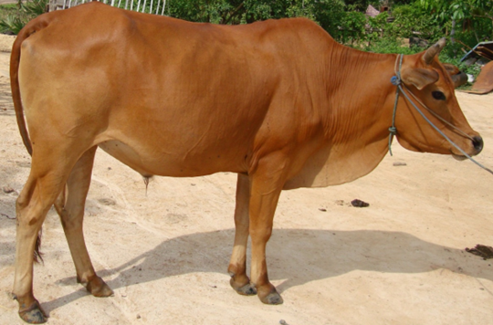 | - Found in all regions of Cambodia  - Dual Purpose (Milk/Draught)  - Medium sized  - Reddish coat  (Namikawa T., 2006)
Kdarm White (Cambodia)  (National Animal Health and Production Research Institute, Phnom Penh, Cambodia) | 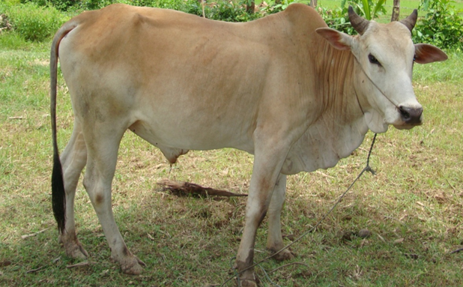 | - Found in all regions of Cambodia  - Dual Purpose (Milk/Draught)  - Medium sized  - White coat  (Namikawa, 2006)
Batu Harak (Sri Lanka)  (Faculty of Veterinary Medicine and Animal Science, University of Peradeniya, Peradeniya, Sri Lanka) | 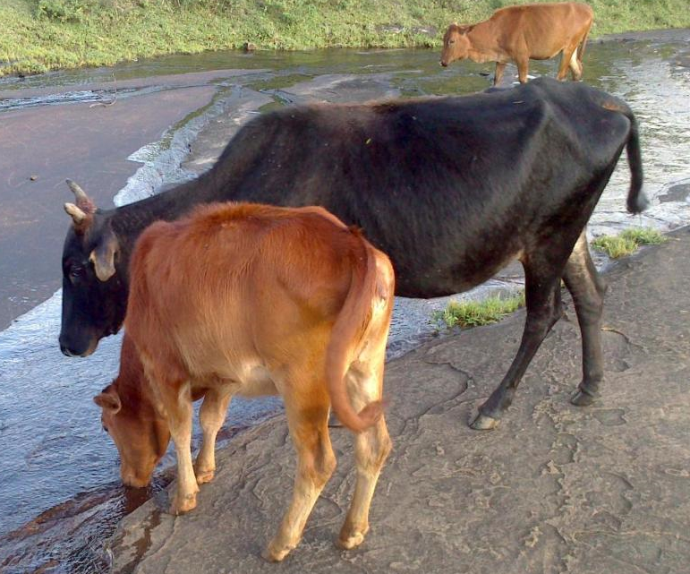 | - Found in the dry zone (Northern, Eastern and Southeastern part of Sri Lanka)  - Draught  - Medium sized  - Grey or white coat  - Known for high endurance in draught work  (Silva P, 2008)
Thawalam (Sri Lanka)  (Faculty of Veterinary Medicine and Animal Science, University of Peradeniya, Peradeniya, Sri Lanka) | 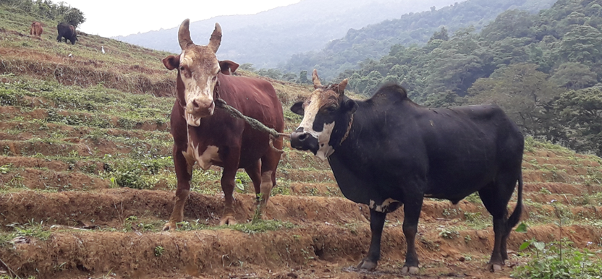 | - Found in Central and Uva provinces of Sri Lanka  - Draught  - Large sized  - Brown or black coat  - Used for heavy draught work  (Chandrasiri ADN, 2004)
White Cattle (Sri Lanka)  (Faculty of Veterinary Medicine and Animal Science, University of Peradeniya, Peradeniya, Sri Lanka) | 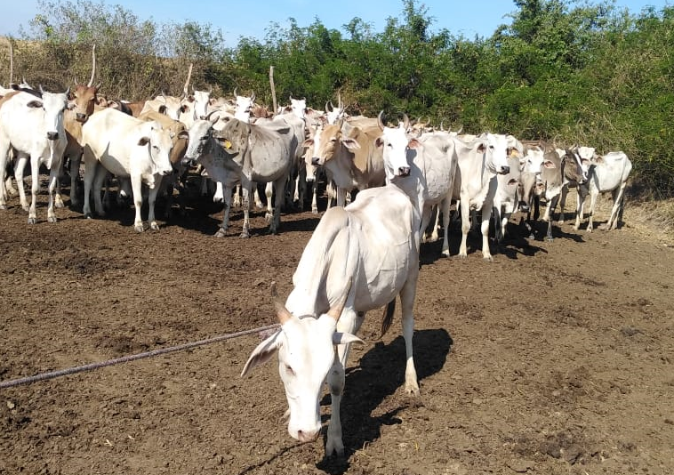 | - Found in the Eastern Province and the North Central Province of Sri Lanka  - Draught  - Medium sized  - White coat  - Primarily used in draught operations  (Shanjayan N, 2015)
Pyar Zein (Myanmar)  (Livestock Breeding and Veterinary Department, Yangon, Myanmar) | 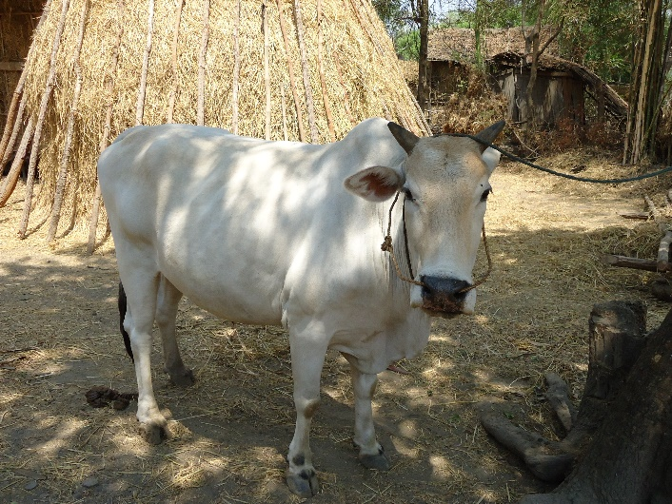 | - Found primarily in the central and southern regions of Myanmar, particularly around the Irrawaddy River delta and the coastal areas  - Dual Purpose (Milk/Draught)  - Medium sized  - Grey or white coat  - Known for good milk yield  (Win et al., 2020)
Shwe Ni Gyi  (Livestock Breeding and Veterinary Department, Yangon, Myanmar) | 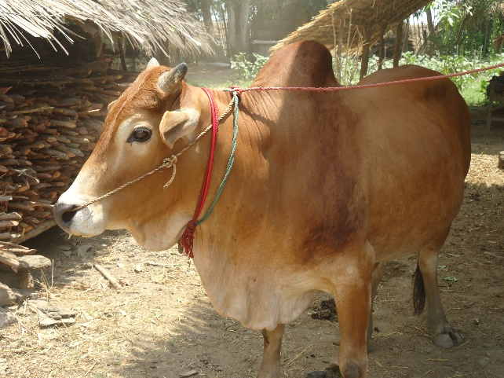 | - Found in all parts of Myanmar  - Dual Purpose (Milk/Draught)  - Medium  - Reddish-brown coat  - Adapted to local climates
Shwe Ni  (Livestock Breeding and Veterinary Department, Yangon, Myanmar) | 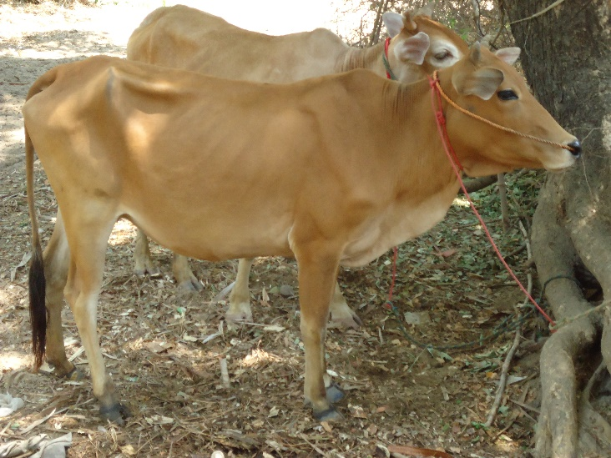 | - Primarily found in the central dry zone, specifically around the Pakokku Township in the Magway Region.  - Dual Purpose (Milk/Draught)  - Medium sized  - Mostly red or pied, brown coat  - Dewlap is larger in males than females  - Used in rural areas for milk and draught  (Win et al., 2020)
Achai (Pakistani)  (Department of Biological Sciences, Virtual University of Pakistan, Islamabad, Pakistan) | 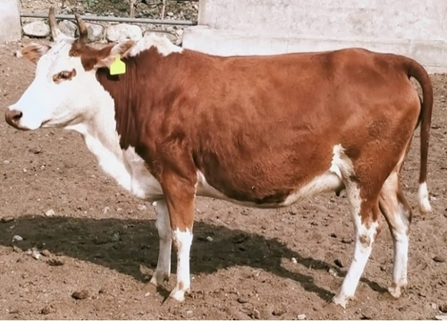 | - Found in northwestern Hindu Kush Mountains of the Khyber Pakhtunkhwa province  - Dairy breed  - Small sized  - Coat colour is red, brown coat  - Known for small size and milk yield  (Faraz, 2020)
Bhagnari (Pakistani)  (Department of Biological Sciences, Virtual University of Pakistan, Islamabad, Pakistan) | 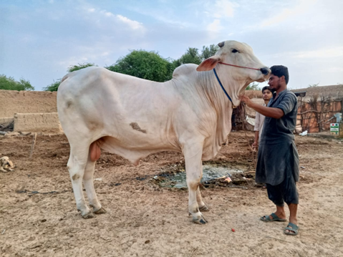 | - Found mainly in three districts, Bhag, Kacchi, and Ustta Muhammad in Balochistan province  - Draught  - Large sized  - White or light grey coat  - Known as a strong draught breed  (Faraz, 2020)
Cholistani (Pakistani)  (Department of Biological Sciences, Virtual University of Pakistan, Islamabad, Pakistan) | 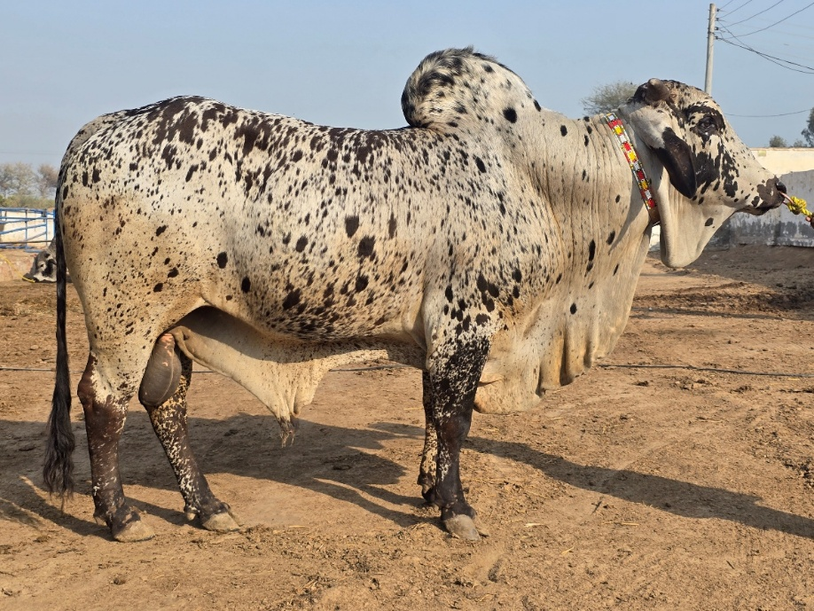 | - Found in Cholistan Desert region, specifically in the areas around Rahim Yar Khan, Bahawalpur, and Bahawalnagar in the Punjab province  - Dual Purpose (Milk/Draught)  - Large sized  - Brown or grey coat  - Favoured for draught work, adapted to local climates  (Faraz, 2020)
Dhani (Pakistani)  (Department of Biological Sciences, Virtual University of Pakistan, Islamabad, Pakistan) | 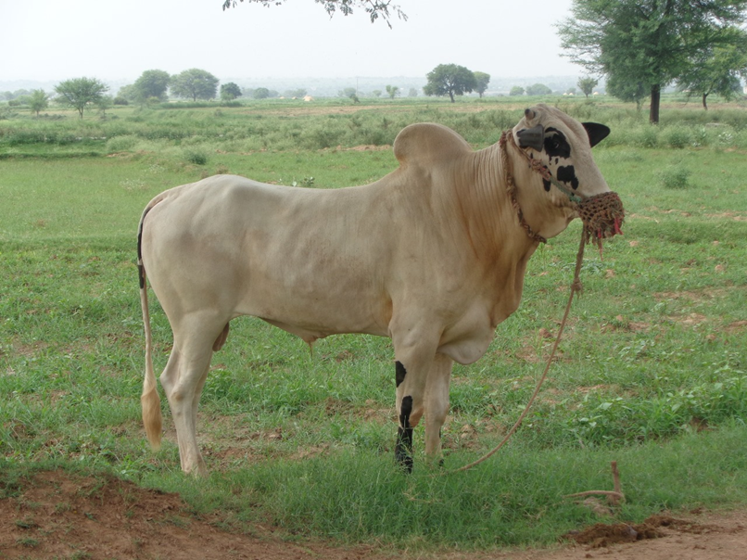 | - Mainly found in Attock, Chakwal, Rawalpindi, Jhelum, Mianwali, and Sargodha Districts of the Punjab province  - Draught  - Medium  - Brown or grey coat  - Used for draught work, adapted to local climates  (Faraz, 2020)
Dajal (Pakistani)  (Department of Biological Sciences, Virtual University of Pakistan, Islamabad, Pakistan) | 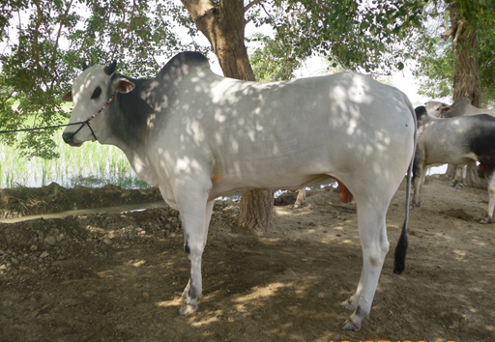 | - Found mainly in Dajal, Dera Ghazi Khan and Rajan Pur districts of Punjab province  - Dual Purpose (Milk/Draught)  - Small sized  - White coat  - Known for milk production and draught work  (Faraz, 2020)
Red Sindhi (Pakistani)  (Department of Biological Sciences, Virtual University of Pakistan, Islamabad, Pakistan) | 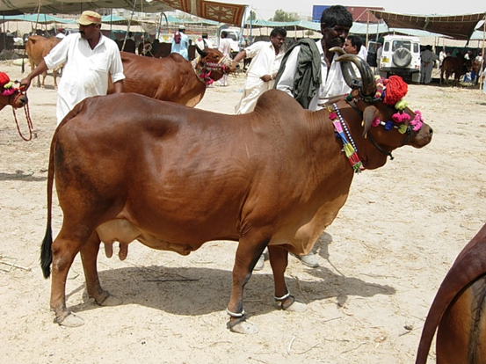 | - Found in Sindhi region particularly around Karachi and Hyderabad districts in Pakistan;  - Dairy  - Medium sized  - Reddish-brown coat  - Excellent dairy breed, high milk production  (Khan et al., 2008)
Sahiwal (Pakistani)  (Department of Biological Sciences, Virtual University of Pakistan, Islamabad, Pakistan) | 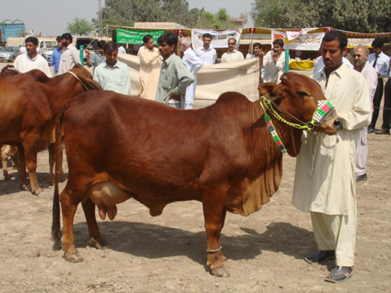 | - Transboundary breed  - Found in Sahiwal district formerly part of the Montgomery district of Punjab in Pakistan; In India, the breed is distributed in Fazilka and Abohar region of Punjab, Sirsa district of Haryana and Sri Ganganagar district of Rajasthan  - Dairy  - Large sized  - Reddish-brown coat, some white patches  - Renowned dairy breed, high milk yield (Khan et al., 2008)
Tharparkar (Pakistani)  (Department of Biological Sciences, Virtual University of Pakistan, Islamabad, Pakistan) | 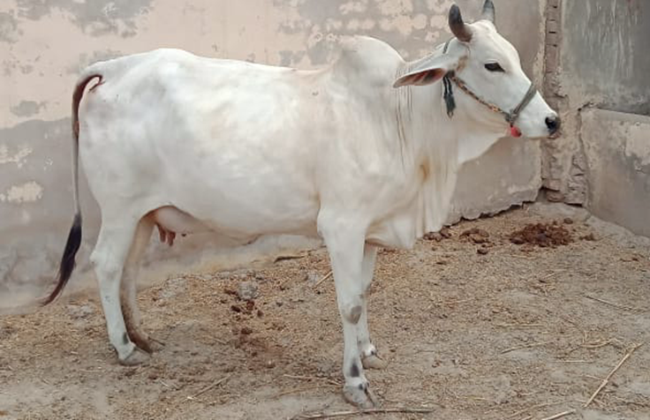 | - Transboundary breed  - Found in Tharparkar District in Sindh province of Pakistan and in India, the breed is found along the Indo-Pak border covering western Rajasthan and up to Rann of Kutch in Gujarat  - Dual Purpose (Milk/Draught)  - Large sized  - White or grey coat  - Heat-tolerant, used for both milk and draught  (Khan et al., 2008)
REFERENCES
Chandrasiri ADN. (2004). The state of animal genetic resources in Sri Lanka. A joint publication of Department of Animal Production and Health and the office of the FAO representative in Sri Lanka and Maldives.
Dongre VB, G. R. S. V. K. L. D. S. K. V. (2017). Present status and future prospects of Deoni Cattle. Indian Journal of Animal Sciences, 87(7), 800–803.
Faraz, A. (2020). Beef breeds of Pakistan. https://www.researchgate.net/publication/338790137
Ganapathi, P. R. R. S. A. T. (2009). Distribution and Population Status of Bargur Cattle. Indian Veterinary Journal, 86, 971–972.
Iype S. (1996). The Vechur Cattle of Kerala. Animal Genetic Resources Information., 18, 59–63.
Joshi N.R, P. R. W. (1953). Zebu cattle of India and Pakistan. FAO Agriculture Studies No. 19, Food and Agricultural Organization of the United Nations, Rome, Italy. pp. 14–29; 1953. . Rome, Italy, 14–29.
Kuralkar SV, B. P. C. M. K. P. D. SA. (2014). Phenotypic characteristics, production and reproduction performance of Deoni cattle in its native tract. . Indian Journal of Animal Sciences, 84(1), 75–77.
Manomohan, V., Saravanan, R., Pichler, R., Murali, N., Sivakumar, K., Sudhakar, K., Nachiappan, R. K., & Periasamy, K. (2021). Legacy of draught cattle breeds of South India: Insights into population structure, genetic admixture and maternal origin. PLoS ONE, 16(5 May). https://doi.org/10.1371/journal.pone.0246497
Namikawa T., M. H. , T. K. , N. K. , T. Y. ,. (2006). Coat-color variations of cattle observed in the fields of Cambodia, and withers-height and other traits in the native cattle subjected to further experimental analyses. Rep. Soc. Res. Native Livestock, 23, 31–44.
Natarajan A, S. K. V. K. (2012). Productivity performance of Kangayam cattle. Indian Journal of Animal Sciences., 82(11), 1440–1441.
Nath NM. (1993). Punganur – The Miniature Bos indicus cattle. . Animal Genetic Resources Information, 11, 54–59.
Pundir, R. K. , K. P. , S. P. K. , & V. V. (2009). Bargur cattle: status, characteristics and performance. . The Indian Journal of Animal Sciences, 79(7), 800–803.
Rajendran R, R. T. T. A. N. M. T. P. (2008). Morphobiometrical characteristics and management of Umblachery cattle from coastal region of Tamilnadu, India. . Livestock Research for Rural Development., 20–40.
Sajjad Khan, M., Rehman, Z.-U., Khan, M. A., & Ahmad, S. (2008). GENETIC RESOURCES AND DIVERSITY IN PAKISTANI CATTLE. In Vet. J (Vol. 28, Issue 2).
Shanjayan N, L. L. (2015). A morphometric analysis of indigenous white cattle (Thamankaduwa breed) in the Eastern province of Sri Lanka with a description of a novel character. 5th International Symposium-IntSym.
Silva P, H. H. C. A. (2008). Indigenous cattle types and production systems in Sri Lanka. Economic Review, 34, 25–28.
Singh PK, P. R. A. S. K. S. G. M. A. K. (2008). Phenotypic characterization and performance evaluation of Hallikar cattle in its native tract. Indian Journal of Animal Sciences, 78(2), 211–214.
Singh PK, P. R. K. P. V. P. (2012). Management and physical features of migratory Pulikulam cattle of Tamil Nadu. Indian Journal of Animal Sciences., 82(12), 1587–1590.
Ware. (1942). A further survey of some important breeds of cattle and buffaloes in India. . Imperial Council of Agricultural Research.
Win S.H, Htut A.Y, & Aye M.A. (2020). On-farm phenotypic characterization of Shwe Ni and Pyar Zein in Salin and Pakokku Township. Myan. J. Vet. Anim. Sci, 1(1). https://doi.org/10.1002/0000.12345

Supplementary Table ST2: List of genes associated with highly differentiated SNP loci (top 05%) between dairy and draught type zebu cattle along with Gene Ontology: Biological Process and KEGG pathways
Draught vs Dairy
Database | p-Value | Method | Input | Description
GO: BP | 0.0064 | FST | CD1D, CD1A, CD1B, CD1E, CD1B5 | Immune response
GO: BP | 0.011 | FST | XBP1, CSH2, GH1, GHRH, PRL, PRP3, PRP-VII | Milk production
GO: BP | 0.013 | FST | TIMP2, AHSG, FETUB,HRG, KNG1, SERPINB1, SERPINB10, SERPINB12, SERPINB2, SERPINB5, SERPINB7, SERPINB9, SERPINE2, SERPINB6 | Immune response
GO: BP | 0.015 | FST | BPIFA1, CXCL8, H2BC11, S100A12, GRO1, CXCL2, CXCL3, CXCL5, CHGA, HRG, PGLYRP1, PGLYRP4 | Immuneresponse
GO: BP | 0.016 | FST | CD1D, CD1A, CD1B, CD1E, CD1B5 | Immune response
GO: BP | 0.025 | FST | EYA1, SIX1, HOXB1, HOXB2, HOXB3, HOXB4, HOXB5, HOXB6, HOXB7, HOXB8, HOXB9,MEGF8, ZEB1 | Physiology and Growth
GO: BP | 0.028 | FST | BCL2, TOP1, GATA4, JUN, TIGAE, BLOC1S3, CTNNB1, DRD2, EMX2, GCLM, NFATC2, p2RX7, RPP21, SRp68, SLC1A2, THBS1, TGFB2, TP53I13, VAV3 | Physiology, Adaptation
GO: BP | 0.032 | FST | C1QTNF9, ACOX1, ALOX12, ALOX15, PRKAA1 | Physiology: mitochondrial aerobic processes (energy)
GO: BP | 0.033 | FST | BEST3, BEST4, CLCA1, CLCA2, CLCA4, CLCA3, CLIC5, GABRA4, GABRG1, GLRA1, PACC1, SLC26A8, SLC4A1, TTYH3 | Physiology,regulation of extracellular volume and blood pressure
GO: BP | 0.033 | FST | CCR1, CCR6, CCR9, CXCCR2, CXCR6, RCAN3, TNFSF11, XCR1, ACKR3, BHLHA15, CXCR1, PLCG2, PPP1R9B, P2RX4, RCAN2, SPHK1, SAMD14 | Physiology: signal transduction, regulation of skeletal muscle contraction
GO: BP | 0.038 | FST | CLEC7A, DDRGK1, DHX9, FER, NLRC4, RAB7B, RBCK1, TRAF6, TNFSF11, CIB1, CAT, CLOCK, CLU, CRNN, IRAK2, IRAK3, IL18RAP, PLCG2, PRL, PRKD1, RIPK1, RIPK2, RNF25, SLCO3A1, SPHK1, TRAPPC9, TRIM13, TRIM14, TRIM15, TRIm8, UBE2V1 | Physiology: regulation of various physiological processes. Innate and adaptive immune response
GO: BP | 0.042 | FST | ACAN, CANT1, CHST10, CHST11, CHST12, FOXL1, IGF1 | Aiding in wound healing, embryo development, Lubricating fluid in joints
GO: BP | 0.042 | FST | BLK, EPHB2, FER, FES, KIT, MERTK, SHC1, SHC3, SRC, CSF1R, EGFR, FGFR1, FGFR2, FGFR4, FRS2, INSR, KDR, LMTK2, NGF, NTRK3, PDGFRA, PTK2, PTK6, PTPRT, STAP1, SRMS, SAMD10, SMAd12, TIE1 | Signal transduction
GO: BP | 0.045 | FST | BCL2, CLEC7A, CD93, FAT3, LPP, SHC1, CDH2, CDH23, CTNNB1, CTNND2, CNTN1,DSC1, DSC2, DSC3, DSG1, DSG3, DSG4, ELMO2, EGFR, NEO1, NEGR1, PKP1, PKP4, PDPN, ROBO4, TCAM1, VNN1 | Dynamic changes in cell arrangements
GO: BP | 0.046 | FST | BRAT1, CLK2, COP1, EYA1, ABRAXAS1, AEN, MTA1, NHEJ1, NABP1, RFWD3, UIMC1 | cellular abiotic stimulus (Adaptation)
GO: BP | 0.048 | FST | BCAR3, RAF1, SHC1, FOXO1, GSK3A, GPLD1, GRB14, GRB2, PHIP, PTPN1, PTPRa, PDK2, SLCA28, SOGA1, STXBB4 | Regulates glucose, lipid, and energy homeostasis, predominantly via action on liver, skeletal muscle, and adipose tissue
GO: BP | 0.048 | FST | AQP10, AQP2, AQP3, AQP4, AQP5, AQP7
GO: BP | 0.048 | FST | SIX1, SIX4, FRS2, PRKDC, SERPINB5, UHRF1 | Physiology
GO: BP | 0.048 | FST | H2BC11, S100A12, CHGA, C6, C7, C9, PGLYRP1, PGLYRP4
GO: BP | 0.048 | FST | FAIM2, RPGRIP1L, ATRN, CNTN1, CDK5R2, EN1, GBX2, PTPRS | Nervous system development
GO: BP | 0.049 | FST | 50 genes (DDX4, FKBP6, GLI1, H1-6, KIT, MERTK, MYCBPAP, GALNT3, SLC25A31, SLC26A8, SPATA20, SPATA6L, TDRP, TPPP2, TDRD1, TDRD5, UBR2, USP42, ZNF296) | Reproduction
KEGG_PATHWAY | 0.0034 | FST | AKT3, BRAF, BCL2, BCL2L1, RAF1, SHC1, SHC3, RC, EGFR, EIF4EBP1, FGFR2, GAS6, GRB2, IGF1, IL6R, KDR, NRG2, NF1, PTEN, PIK3CD, PLCG1, PLCG2, PDGFC, PDGFRA, PDGFA, TGFA | Cell homeostasis
KEGG_PATHWAY | 0.0047 | FST | 51 genes ( CTNNB1, CSF1R, DRD2, EFNA1, EFNA3, EFNA4, EGFR, FGF23, ID1, IGF1, INSR, ITGA2B, KDR, MAPK13, MAPK14, NGF, PIK3CD, PLCG1, PDGFC, PDGFR3) | Cell physiology and morphology
KEGG_PATHWAY | 0.0049 | FST | 42 genes (AKT3, CXCL8, CXCR2, GNA12, GNAS, KITLG, KIT, RAF1, RAPGEF3, PLCG1, PLCG2, PLD2, PLPP1,PDGFC, PDGFRA, PDGFA, SPHK1 ) | Physiology, skeletal muscle mass size regulation
KEGG_PATHWAY | 0.0057 | FST | CDS1, CDS2, PLA2G2D1, DGKH, DGKG, DGK1, DGKQ, ETNPPL, GPAT3, GPAM, GPD2, LPIN3, LCLAT1, LPCAT1, LPCAT2, LYPLA2, PNPLA6, PNPLA7, PTDSS1, PLA2G2C, PLA2G2E, PLA2G2F, PLA2G4A, PLA2G5, PLD4, PLD2, PLPP1, PLPP5 | Stability against hypoxic stress, energy stress
KEGG_PATHWAY | 0.0058 | FST | FREM1, FRAS1, CHAD, COL1A1, COL6A1, GP9, GP1BA, HMMR, ITGA10, ITGA11, ITGA2B, ITGA3, ITGA6, ITGA8, ITGAV, ITGB4, LAMA1, LAMC1, LAMC3, NPNT, SV2B, SV2C, SDC4, THBS1, THBS3 | Cell physiology
KEGG_PATHWAY | 0.014 | FST | AKT3, BRAF, BCL2, JUN, RAP1B, RAC2, RAF1, RASGRF1, SHC1, SHC3, SRC, BIRC2, BIRC3, CAPN2, CTNNB1, CHAD, COL1A1, COL6A1, CCND2, EGFR, GRB2, IGF1, ITGA10, ITGA11, ITGA2B, ITGA3, ITGA6, ITGA8, ITGAV, ITGB4, ITGB6, KDR, LAMA1, LAMC3; MAPK10, MYL9, MYLK3, MYLK4, PTEN, PIK3CD, PDGFC, PDGFRA, PDGFA, PTK2, RELN, TLN2, THBS1, THBS3, VAV3 | Cell structure
KEGG_PATHWAY | 0.024 | FST | AKT3, BRAF, BCL2, JUN, RAP1B, RAF1, SHC1, SHC3, TRAF6, CAMK4, CALML4, FRS2, GRB2, IRAK2, IRAK3, IRAK4, MAPK10, MAPK13, MAPK14, MPA2K5, MAP3K1, MAP3K3, NGF, NTRK3, PIK3CD, PLCG1, PLCG2, RIPK2, RPS6KA1, RPS6KA2, SORT1 | Signal transduction to various cascades i.e JAT-STAT, MAPK
KEGG_PATHWAY | 0.024 | FST | ABL2, AKT3, BCL2L1, GNG13, GNG4, GNG5, KITLG, KIT, RAP1B, RASA3, RASAL2, RAC2, RAF1, RALGAPB, RASGRF1, SHC1, SHC3, TBK1, PLA2G2D1, CALML4, CSF1R, EFNA1, EFNA3, EFNA4, EGFR, FGFR1, FGFR2, FGFR4, GRB2, IGF1, INSR, KDR, MAPK10, NGF, NF1, PIK3CD, PLA2G2C, PLA2G2E, PLA2G2F, PLA2G4A, PLA2G5,PLCG1, PLCG2, PLD2, PDGFC, PLD2, PDGFC, PDGFRA, PDGFA, RGL1, STK4, TGFA | Cell Physiology
KEGG_PATHWAY | 0.026 | FST | GNAI1, GNAO1, GNG13, GNG4, GNG5, GABARAPL1, SRC, ADCZ1, ADCZ2, ADCZ6, CACNA1B, CACNA1S, GABRR3, GABRA2, GABRA4, GABRB1, GABRG1, GABBR2, GLS, PLCL1, SLC32A1, SLC38A1, SLC38A2
KEGG_PATHWAY | 0.027 | FST | AKT3, BRAF, BCL2, E2F1, GPER1, GNAS, JUN, RAF1, SHC1, SHC3, SRC, ADCY1, ADCY2, ADCY6, EGFR, GRB2, HBEGF, IGF1, JAG2, MMP2, MAPK10, MAPK13, MAPK14, NCOA3, PIK3CD, PTK2 | Reproduction, milk production, Thermoregulation
KEGG_PATHWAY | 0.029 | FST | BNIP3L, BCL2L1, CCZ1, E2F1, GABARAPL1, JUN, OPA1, RAB7B, SRC, TBK1, AMFR, ATG9A, CALCOCO2, CSNK2A1, CSNK2A2, MITF, MARCHF5, MTX1, MAP1LC3A, MAP1LC3B, MAPK10, OPTN, RHOT2, SIAH1, TOMM20, TOMM40, USP15 | Longevity
KEGG_PATHWAY | 0.029 | FST | GNAS, ADCY1, ADCY2, ADCY6, ADRB1, CACNA2D3, CACNA2D3, CACNB3, DES, DTNA, IGF1, ITGA10, ITGA11, ITGA2B, ITGA3, ITGA6, ITGA8, ITGAV, ITGB4, ITGB6, LAMA1, SGCA, SGCG, SSPN, SNTA1, TGFB2, TPM3 | Abnormality in the myocardium
KEGG_PATHWAY | 0.039 | FST | GNAS, JUN, RAF1, SRC, ADCY1, ADCY2, ADCY6, CACNA1S, EGFR, GNRHR, GRB2, HBEGF, ITPR1, ITPR2, MMP14, MMP2, MAPK10, MAPK13, MAPK14, MAP3K1, MAP3K3, PLA2G4A, PLD2 | Reproductive system
KEGG_PATHWAY | 0.040 | FST | AKAP13, BRAF, BCL2, GNA12, GNAI1, GNAS, RAF1, ARHGEF1, TNFSF11, ADCY1, ADCY2, ADCY6, ARRB2, CREB3L2, CYP24A1, EGFR, FGF23, FGFR1, HBEGF, ITPR1, ITPR2, MMP14, MMP15, MMP24, NR4A2, PLD2, SLC34A1, VDR | Calcium and phosphorus homeostasis. Bone resorption
KEGG_PATHWAY | 0.045 | FST | AKT3, GNAI1, GNAS, POU1F1, RAF1, SHC1, SHC3, ADCY1, ADCY2, ADCY6, CREB3L2, CACNA1S, GRB2, GH1, GHRH, ITPR1, ITPR2, IGF1, IGFBP3, MAPK10, MAPK13, MAPK14, MAP3K1, PIK3CD, PLCG1, PLCG2, PTK2, STAT1, SSTR3, SSTR5 | Physiology and Growth
KEGG_PATHWAY | 0.046 | FST | AKT3, BRAF, GNAI1, RAF1, ADCY1, ADCY2, ADCY6, ANAPC1, ANAPC5, CDC16, CDC25B, CPEB2, CPEB3, HSP90AA1, IGF1, MAPK10, MAPK13, MAPK14, MAD1L1, PIK3CD, RPS6KA1, RPS6KA2, STK10 | Reproduction and Fertility
KEGG_PATHWAY | 0.047 | FST | 70 genes (AKT3, BCL2, BCL2L1, GNG13,PPP2R2A, PTK2, RELN, SGK1, SGK2, THBS1, THBS3) | Metabolism and Growth
KEGG_PATHWAY | 0.048 | FST | 36 genes ( CXCL3, HSP90AA1, ITPR1, ITPR2, IRAK4, MAP1LC3A, MAP1LC3B, MAVS, MAPK10, MAPK13, MAPK14, P2RX7, RIPK1, RIPK2, RNASEL, STAT1, TXNIP ) | Immune response, thermoregulation

Supplementary Table ST3: List of genes associated with highly differentiated SNP loci (top 05%) between large and small stature cattle along with Gene Ontology: Biological Process and KEGG pathways

Small statured vs Normal Size
Term | Database | p-Value | Fischer exact | Method | Input | Description
response to peptide hormone | GO: BP | 8.1E-4 | 6.2E-5 | FST | REG3A, REG3G, STAT1, STAT3, STAT5A, STAT5B | response to insect attacks or severe mechanical wounding.
regulation of heart contraction | GO: BP | 1.4E-3 | 1.3E-4 | FST | HOPX, CHRM2, GJA1, HBEGF, THRB, TH | Physiology
calcium-mediated signaling | GO: BP | 2.1E-3 | 6.3E-4 | FST | PDPK1, CCR1, CCR10, CCR2, CCR3, CCR5, CCRL2, ACKR3, ACKR4, EDNRB, KSR2, NCALD, NMUR1 | Skeletal muscle
positive regulation of intrinsic apoptotic signaling pathway | GO: BP | 2.4E-3 | 5.2E-4 | FST | BID, DDIT3, NHERF1, S100A8, S100A9, BECN1, CLU, SIAH1, TP53 | Homeostasis
exocytosis | GO: BP | 2.7E-3 | 9.9E-4 | FST | MIA3, WASHC3, CPLANE2, EXOC1L, EXOC1, MICAL3, KCNB1, SYT16, SYTL3, SZCN, STX1A, STX1B, STX2, STX4, TRIM72, UNC13B | Immune response
lysosomal transport | GO: BP | 6.7E-3 | 1.0E-3 | FST | ATP13A2, VPS52, GRN, HGSNAT, LYSET, PSAP
phospholipid scrambling | GO: BP | 7.5E-3 | 8.2E-4 | FST | PLSCR1, PLSCR2, PLSCR3, PLSCR5, SLC4A1
maintenance of gastrointestinal epithelium | GO: BP | 7.5E-3 | 8.2E-4 | FST | CRACD, NOD2, TFF1, TFF2, TFF3 | Gut homeostasis
protein localization to cell surface | GO: BP | 8.1E-3 | 1.9E-3 | FST | ANGPT1, CTNNB1, FGF10, GGA1, GGA3, NLGN2, PIGK, STX4
cell differentiation | GO: BP | 1.0E-2 | 6.8E-3 | FST | BCL7B, CXCL17, DDX41, DMRTC2, ETV3L, ETV3, ETV4, FKBP6, GNA12, NKX1-1, PBXIP1, PDLIM7, RBL1, RBL2, SMAD7, SRC, SOX12, SOX15, SOX18, ANGPT1, C15H11orf34, FGF10, FLNB, FSTL4, FOXB2, FOXL1, GRB2, ID2, KRTAP4-7, KRTAP9-2, NTRK1, NOTCH2, NR1D2, NR2E3, NR2F2, PPDPF, PTK6, PURA, RXRB, RXRG, RNF114, SEMA4C, SEMA6D, SLC26A8, SPEM1, SPATA6, SRMS, STX2, THRB, TBCB, TNK1, ZNF750, ZFPM2
cell division | GO: BP | 1.1E-2 | 5.8E-3 | FST | CKS1B, DIS3L2, DSN1, FBXO5, HAUS1, NDC80, RAN, ACTR8, ANAPC5, BECN1, BOD1, CDC26, CDC7, CDT1, CCDC124, CCNB1, CCNF, CCNT1, MAEA, MCMBP, NCAPH, PARD3, PARD6B, SPICE1, SYCP3, TEDC2, ZW10
negative regulation of endothelial cell apoptotic process | GO: BP | 1.1E-2 | 2.5E-3 | FST | PDPK1, BRAF, ANGPT1, KDR, NDNF, PAK4, RAMP2
embryonic skeletal system morphogenesis | GO: BP | 1.2E-2 | 3.4E-3 | FST | HOXB1, HOXB2, HOXB3, HOXB4, HOXB5, HOXB6, HOXB7, HOXB8, HOXB9 | Skeletal muscle
bicarbonate transport | GO: BP | 1.2E-2 | 2.2E-3 | FST | SLC26A8, SLC39A12, SLC4A1, SLC4A5, SLC4A7, SLC4A9
regulation of actin cytoskeleton organization | GO: BP | 1.4E-2 | 4.8E-3 | FST | DIXDDC1, IQGAP2, MLST8, RND1, RND2, ARHGEF19, SH3BP1, CDK10, CDK5R1, FZD10, RHOF
negative regulation of cell migration | GO: BP | 1.5E-2 | 6.3E-3 | FST | ADAM15, GTPBP4, NHERF1, SRGAP1, TCAF1, ABHD6, CLDN3, CYP1B1, DPEP1, DRD2, EMILIN2, MITF, OSBPL8, PTPRT, ZMYND8
anterior/posterior pattern specification | GO: BP | 1.5E-2 | 6.3E-3 | FST | YY1, EMX2, HELT, HOXB1, HOXB2, HOXB3, HOXB4, HOXB5, HOXB6, HOXB7, HOXB8, HOXB9, NR2F2, PCSK5, RING1
transmembrane receptor protein tyrosine kinase signaling pathway | GO: BP | 1.6E-2 | 7.4E-3 | FST | EPHA2, EPHA6, MERTK, SHC1, SHC2, SRC, DOK3, ERBB2, FRS2, INSRR, KDR, NTRK1, PTK6, PTPRT, SRMS, SMAD10, TNK1
thrombin-activated receptor signaling pathway | GO: BP | 1.7E-2 | 1.5E-3 | FST | F2RL1, IQGAP2, F2RL2, F2R | Immune response
cellular zinc ion homeostasis | GO: BP | 1.7E-2 | 4.1E-3 | FST | ATP13A2, MT2A, MT1A, SLC30A5, SLC39A12, SLC39A6, SLC39A7
negative regulation of transforming growth factor beta receptor signaling pathway | GO: BP | 1.8E-2 | 6.5E-3 | FST | PDPK1, LEMD3, PRDM16, RASL11B, SMAD7, CHST11, GLG1, SNX25, TGFB1I1, TP53, ZNF451 | Homeostasis
sensory perception of sound | GO: BP | 1.8E-2 | 8.5E-3 | FST | ATP6VOA4, ATP2B2, DDIT3, NHERF1, PKHD1L1, USH1G, CDH23, COL11A2, CRYM, HEXA, HOMER2, MYO7B, OTOA, SOBP, THRB, TMIE, TMPRSS3, WFS1 | Importancy in physic+zal structure
protein transport | GO: BP | 1.8E-2 | 1.1E-2 | FST | ARFGEF1, ARFGEF2, ARL3, DOP1A, FRAS1, MIA3, NSF, NECAP2, VPS52, WASHC3, ARRDC2, CHMP1A, CPLANE2, COG4, GOSR2, GGA1, JAKMIP1, KLHL20, KTN1, LMAN2L, MTX1, MYO1D, NUP50, NUP85, PIK3R2, RAMP2, SCAMP3, STAM, SLC15A4, SNX18, SNX20, SNX8, TIMM50, TIMM8B, TMED3
cerebellum development | GO: BP | 2.0E-2 | 4.1E-3 | FST | LMX1A, RPGRIP1L, CDK5RI, PDSS2, SEMA4C, TP53
cell-cell adhesion via plasma-membrane adhesion molecules | GO: BP | 2.0E-2 | 5.8E-3 | FST | CD177, ADGRL3, CDH11, CDH13, CDH15, CDH18, FGFRL1, MMP24
cytoplasmic mRNA processing body assembly | GO: BP | 2.1E-2 | 3.4E-3 | FST | LIMD1, LSM14A, LSM4, DYNC1H1, RC3H1
positive regulation of sperm capacitation | GO: BP | 2.1E-2 | 6.4E-4 | FST | BSP1, BSP3, BSP5 | Reproduction (sperm binder)
canonical Wnt signaling pathway involved in osteoblast differentiation | GO: BP | 2.1E-2 | 6.4E-4 | FST | WNT3, CTNNB1, FZD1 | Skeletal muscle
metanephros morphogenesis | GO: BP | 2.1E-2 | 6.4E-4 | FST | FRAS1, CTNNB1, FGF10
regulation of sodium ion transmembrane transport | GO: BP | 2.1E-2 | 6.4E-4 | FST | BPIFA1, SCN5A, SNTA1
canonical Wnt signaling pathway involved in mesenchymal stem cell differentiation | GO: BP | 2.1E-2 | 6.4E-4 | FST | WNT3, CTNNB1, FZD1
cell communication by chemical coupling | GO: BP | 2.1E-2 | 6.4E-4 | FST | PDLIM7, DBN1, GJA1
intracellular signal transduction | GO: BP | 2.2E-2 | 1.5E-2 | FST | PDPK1, ARFGEF2, BRAF, CDC42BPA, JAK3, MKNK1, MOK, NUAK1, RAB40B, ARHGAP29, ARHGEF4, ARHGEF5, STAC3, SHC1, SHC2, SRC, WNK4, ADCY2, ADCY6, ADCY7, ASB16, DCDC1, DCLK2, GUCY2D, IRAK3, MAST3, MAPK10, MAPK13, MAPK14, MYO 9A, NRG2, NOD2, PAK4, PREX1, PLEKHM1, PPP1R1B, RGS14, RGS7, STK38L, SGK2, SGK3, TGFBR3, UNC13B
proteasome-mediated ubiquitin-dependent protein catabolic process | GO: BP | 2.3E-2 | 1.3E-2 | FST | COP1, DDIT3, FBXL19, HERC2, RBCK1, TOPORS, BFAR, CTNNB1, CLOCK, GBA1, KLHL20, MAEA, KCTD2, KCTD5, PSMC4, PPP2R5C, RNF186, RNF34, SIAH1, TRIM72, UBE3D, VCP
axon guidance | GO: BP | 2.4E-2 | 1.2E-2 | FST | BOC, ENAH, EPHA2, EPHA6, KLF7, LMX1A, ARHGEF25, WNT3, CRMP1, CDK5R1, EFNA1, EFNA3, EFNA4, EFNB3, KIF5A, PALLD, SEMA4C, SEMA6D, SLIT3, TTC8
ephrin receptor signaling pathway | GO: BP | 2.4E-2 | 5.4E-3 | FST | ANKS1B, CDK5R1, EFNA1, EFNA3, EFNA4, EFNB3
cytoplasmic microtubule organization | GO: BP | 2.5E-2 | 8.3E-3 | FST | CLIP3, DCTN1, DYNC1H1, DST, STMN3, TUBG1, TUBG2, TUBGCP3, TUBGCP5
negative regulation of T-helper 17 cell differentiation | GO: BP | 2.6E-2 | 2.9E-3 | FST | SMAD7, ASCL2, RC3H1, ZBTB7B
glutathione biosynthetic process | GO: BP | 2.6E-2 | 2.9E-3 | FST | GGT7, GCLM, GSS, SLC1A2
positive regulation of mitochondrial translation | GO: BP | 2.7E-2 | 4.8E-3 | FST | CDK5RAP1, FASTKD2, FASTKD3, MPV17L2, COA3
phospholipid transport | GO: BP | 2.9E-2 | 8.1E-3 | FST | ABCG8, ATP8A1, ATP9A, PRELID1, MTTP, OSBPL8, PCTP
intrinsic apoptotic signaling pathway in response to DNA damage by p53 class mediator | GO: BP | 2.9E-2 | 8.1E-3 | FST | ATAD5, PYCARD, TOPORS, RPS27L, TP53, TP73, USP28
cochlea development | GO: BP | 3.4E-2 | 6.8E-3 | FST | ADAM10, CECR2, RPGRIP1L, KCNQ1, SOBP
activation of cysteine-type endopeptidase activity involved in apoptotic process | GO: BP | 3.5E-2 | 1.4E-2 | FST | BID, FASLG, PYCARD, S100A8, S100A9, CASP8AP2, F2R, HIP1, STAT1, VCP
glucose 6-phosphate metabolic process | GO: BP | 3.6E-2 | 4.8E-3 | FST | G6PC1, G6PC3, HK2
positive regulation of GTPase activity | GO: BP | 3.7E-2 | 1.9E-2 | FST | ADAP2, F2RL1, IQSEC1, RAB11FIP2, SH3BP1, TBC1D20, TSC2, F2R, ERBB2, FZD10, MYO9A, NTRK1, PREX1, RGS10, RGS14, RGS7, SNX18, TGM2
Golgi organization | GO: BP | 3.7E-2 | 1.8E-2 | FST | ARFGEF1, FBXW8, RAB43, ARHGAP21, TBC1D20, ATL2, COG4, GOLGA5, LMAN1, LMAN2L, LMAN2, TMED9, TMED3, ZW10
response to cadmium ion | GO: BP | 3.9E-2 | 2.4E-3 | FST | HAAO, GSS, SLC34A1
JAK-STAT cascade involved in growth hormone signaling pathway | GO: BP | 3.9E-2 | 2.4E-3 | FST | STAT3, STAT5A, STAT5B | Physical growth
positive regulation of cytosolic calcium ion concentration involved in phospholipase C-activating G-protein coupled signaling pathway | GO: BP | 4.0E-2 | 1.2E-2 | FST | F2RL1, GPR17, GPR65, F2RL2, F2R, DRD2, OPRL1
vesicle fusion | GO: BP | 4.1E-2 | 1.4E-2 | FST | EEA1, FER1L5, GOSR2, SYT4, STX1A, STX1B, STX2, STX4
positive regulation of histone H3-K4 methylation | GO: BP | 4.3E-2 | 1.1E-2 | FST | BRCA1, KANSL2, KANSL3, AUTS2, CTNNB1, KAT8
ion homeostasis | GO: BP | 4.3E-2 | 9.2E-3 | FST | WNK4, SLC4A1, SLC4A5, SLC4A7, SLC4A9
adherens junction assembly | GO: BP | 4.8E-2 | 7.5E-3 | FST | SMAD7, CTNNB1, RAMP2, TBCD
positive regulation of stem cell differentiation | GO: BP | 4.8E-2 | 7.5E-3 | FST | HOXB4, NUDT21, PTN, TCF15
regulation of T cell differentiation | GO: BP | 4.8E-2 | 7.5E-3 | FST | BRAF, CCR2, PRELID1, BOLA-DOA
cAMP biosynthetic process | GO: BP | 4.8E-2 | 7.5E-3 | FST | ADCY2, ADCY6, ADCY7
Endocrine resistance | KEGG_PATHWAY | 5.7E-6 | 1.6E-6 | FST | BRAF, E2F1, MDM2, SHC1, SHC2, SRC, ADCY2, ADCY6, ADCY7, CDKN2C, DLL3, ERBB2, GRB2, HBEGF, MMP2, MED1, MAPK10, MAPK13, MPK14, NOTCH2, NCOA3, PIK3R2,TP53
Prolactin signaling pathway | KEGG_PATHWAY | 1.1E-3 | 3.7E-4 | FST | SHC1, SHC2, SRC, CSH2, CYP17A2, GRB2, INS, MAPK10, MAPK13, MPK14, PIK3R2, STAT1, STAT3, STAT5A, STAT5B, TH | Milk production
Rap1 signaling pathway | KEGG_PATHWAY | 3.0E-3 | 1.6E-3 | FST | AKT3, RAF1, SRC, DRD2, EGFR, FGF23, FGFR1, IGF1, PIK3CD, PDGFA, | regulation of mammary gland development and lactation.
Th1 and Th2 cell differentiation | KEGG_PATHWAY | 5.6E-3 | 2.3E-3 | FST | JAK3, DLL3, IKBKB, IL12RB1, BOLA-DMA, BOLA-DOA, BOLA-DOB, MAPK10, MAPK13, MPK14, NOTCH2, RBPJ, STAT1, STAT4, STAT5A, STAT5B | Immune response
Th17 cell differentiation | KEGG_PATHWAY | 1.2E-2 | 5.6E-3 | FST | JUN; HSP90AA1, IFNGR2, IL23A, IL6ST, MAPK10, STAT6 | Immune response
Metabolic pathways | KEGG_PATHWAY | 1.2E-2 | 9.9E-3 | FST | ATP5F1B, ATP5PO, ATP5PD, HDDC3, NDUFB1, NDUFA4L2, ACSM1, ANPEP, CHPF2, CS, KMT2C, MAN2A2, NOS3, PTEN, GALNT11, GALNTL5,
Progesterone-mediated oocyte maturation | KEGG_PATHWAY | 1.5E-2 | 6.6E-3 | FST | BRAF, ADCY2, ADCY6, ADCY7, ANAPC1, ANAPC5, CDC26, CCNB1, HSP90AA1, INS, MAPK10, MAP13, MApk14, MAD1L1, PIK3R2 | Fertility
Mitophagy - animal | KEGG_PATHWAY | 1.7E-2 | 7.8E-3 | FST | BCL2L13, E2F1, NBR1, SRC, AMFR, BECN1, BECN2, CALCOCO2, CSNKK2A1, MITF, MTX1, MAP1LC3C, MAPK10, RHOT1, SIAH1, TP53, VCP | Immune response
Estrogen signaling pathway | KEGG_PATHWAY | 1.7E-2 | 8.7E-3 | FST | GNAO1, SHC1, SHC2, SRC, ADCY2, ADCY6, ADCY7, EBAG9, GRB2, HSP90AA1, HBEGF, KRT12, KRT20, KRT23, KRT39, KRT40, MMP2, NCOA3, PIK3R2, TFF1 | Reproduction
Growth hormone synthesis, secretion and action | KEGG_PATHWAY | 3.5E-2 | 1.8E-2 | FST | SHC1, SHC2, ADCY2, ADCY6, ADCY7, GRB2, GHRH, IRS2, MAPK10, MAPK13, MAPK13, MAPK14, MAP3K1, PIK3R2, STAT1, STAT3, STAT5A, STAT5B | Growth
Glycolysis / Gluconeogenesis | KEGG_PATHWAY | 3.6E-2 | 1.5E-2 | FST | ACSS2, ADH7, DLAT, GALM, G6PC1, G6PC3, GPI, HK2, MINPP1, PKLR, PKM | Energy metabolism
Carbon metabolism | KEGG_PATHWAY | 3.9E-2 | 2.0E-2 | FST | CSS2, DLAT, FH, GPI, HK2, ME1, MCEE, PHGDH, PGP, PSPH, PCCA, PKLR, PKM, SHMT2, SDHB, SDHD | Physiology
Melanogenesis | KEGG_PATHWAY | 4.0E-2 | 2.0E-2 | FST |  | Coat color
Relaxin signaling pathway | KEGG_PATHWAY | 4.1E-2 | 2.2E-2 | FST | GNAO1, SHC1, SHC2, SRC, ADCY2, ADCY6, ADCY7, COL4A1, COL4A2, EDNRB, GRB2, INSL3, MMP2, MAPK10, MAPK13, MAPK14, NOS1, PIK3R2 | Reproduction

Supplementary Figure SF1: Observed heterozygosity for Asian Zebu and taurine populations using different LD thresholds.
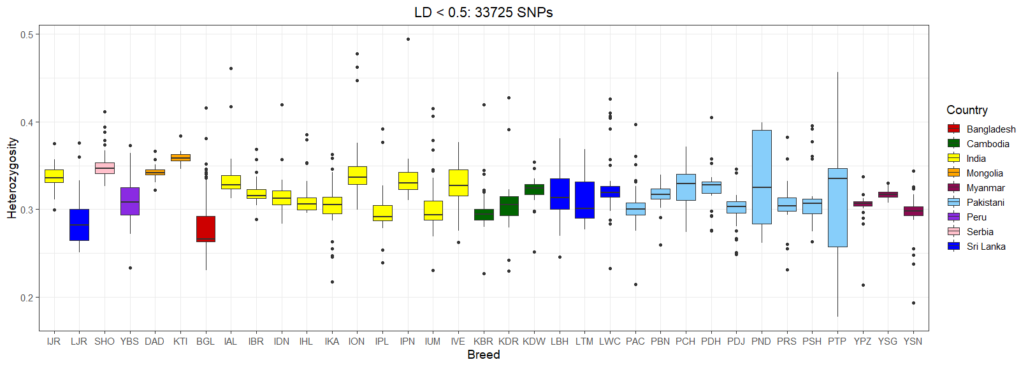
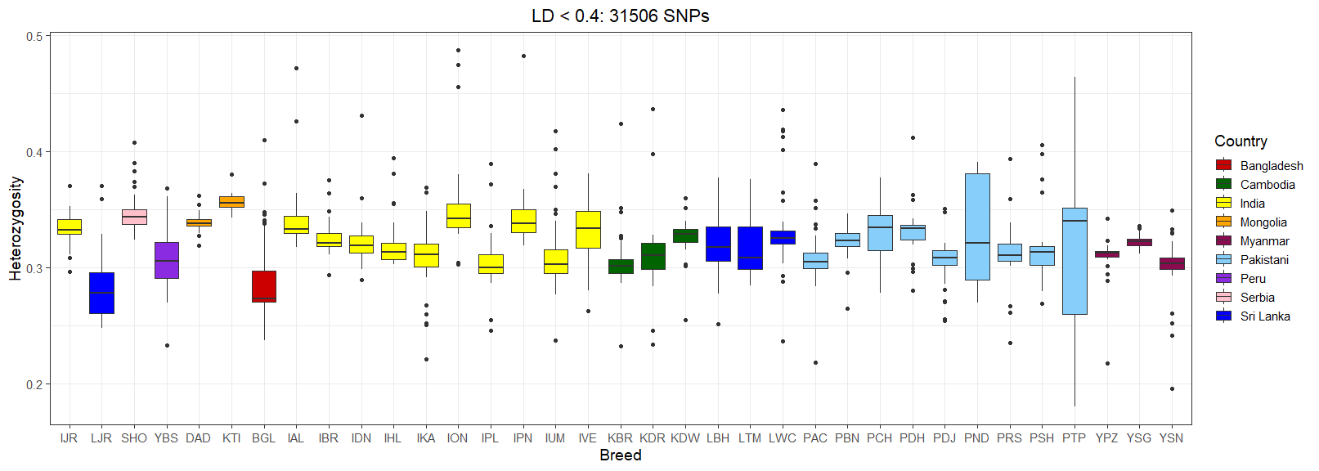
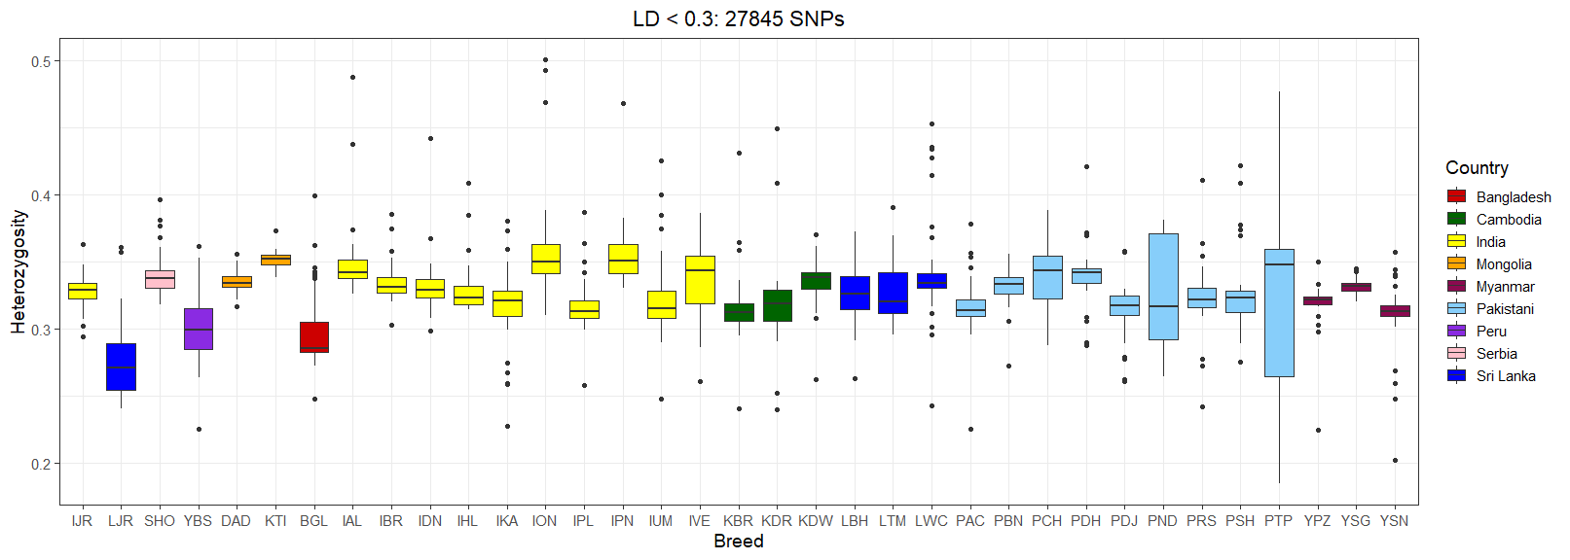
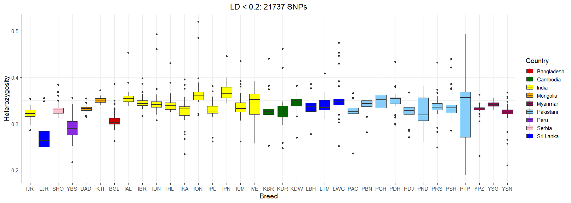

Supplementary Figure SF2. Cross-validation error across different values of K (number of ancestral populations) estimated using ADMIXTURE.
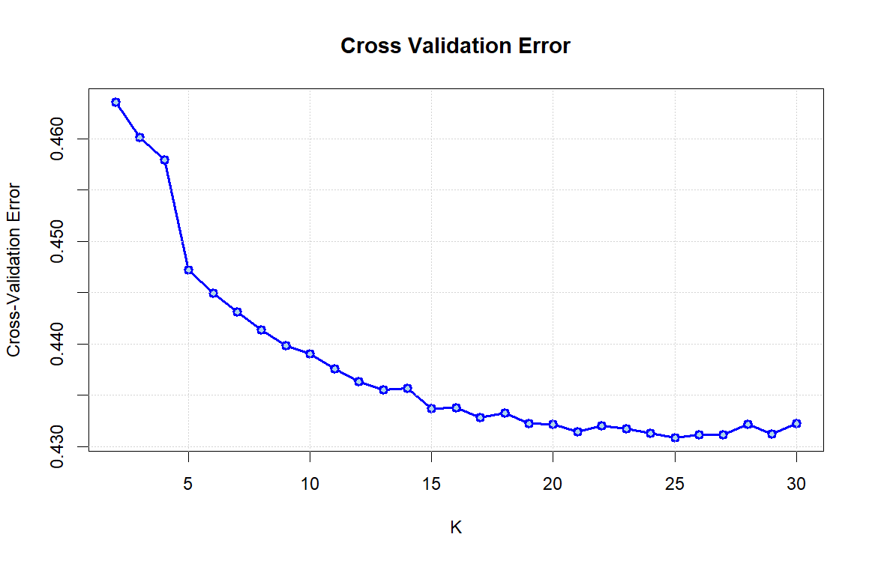

Supplementary Figure SF3. Treemix analysis of Zebu and taurine outgroup populations (a) model assuming k = 1000 and up to 5 migrations (b) Residual plot for 5 migrations model.
