Supplementary Information
Title: OsWNK9 regulates the expression of key transcription factors, phytohormonal, and transporters genes to improve salinity stress tolerance in rice

Yogesh Negi, Kundan Kumar*

Department of Biological Sciences, Birla Institute of Technology & Science Pilani, K. K. Birla Goa Campus, Goa-403726, India

*Corresponding author: Kundan Kumar (kundan@goa.bits-pilani.ac.in)

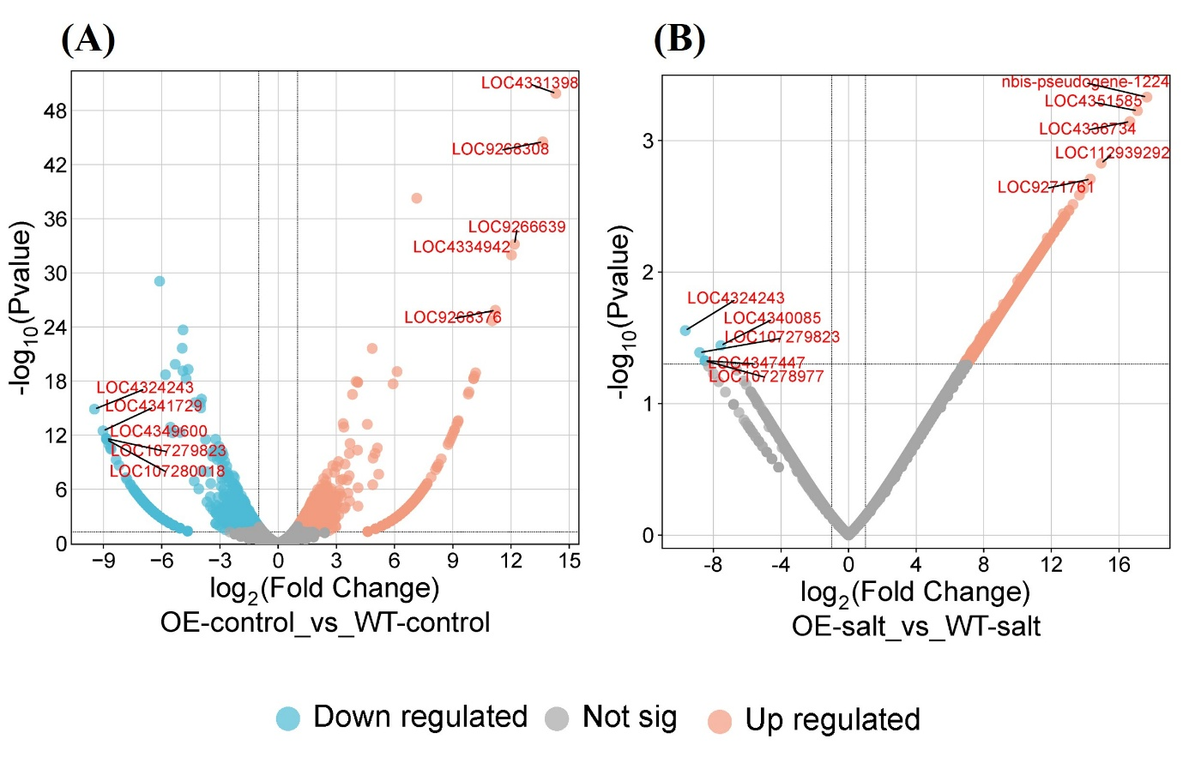
Fig. S1 Volcano plot of differentially expressed genes under (A) control (no NaCl) and (B) salinity stress (150 mM NaCl) between wild-type (WT) rice genotype and overexpression line of rice OsWNK9 (OE). Red dots represent upregulated genes, blue dots represent downregulated genes, and gray dots represent genes that were not differentially expressed (P < 0.05). The Top 5 upregulated and Top 5 downregulated genes are labelled with the gene ID.

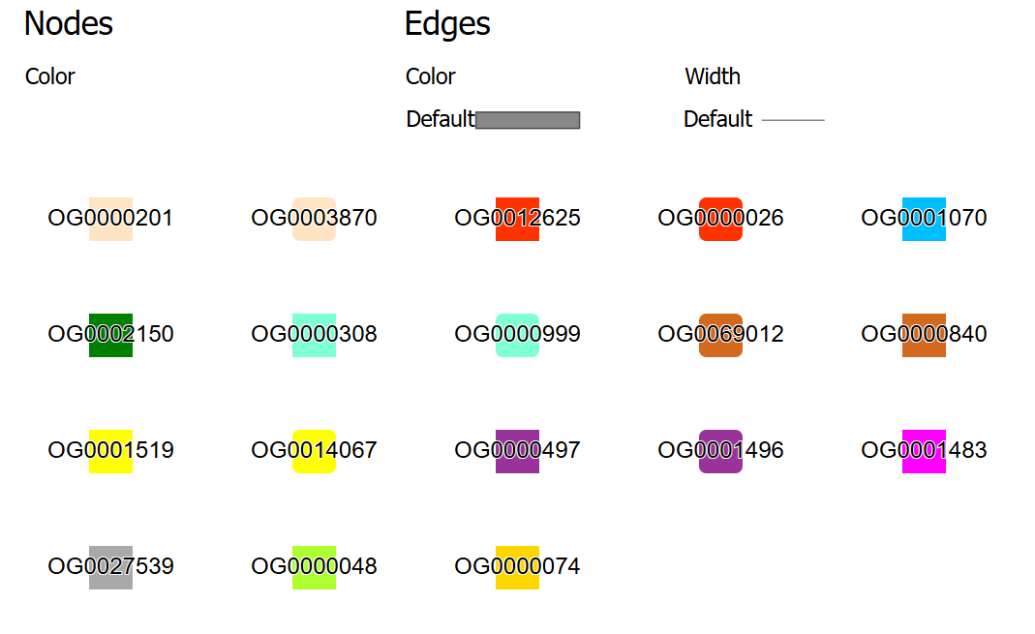
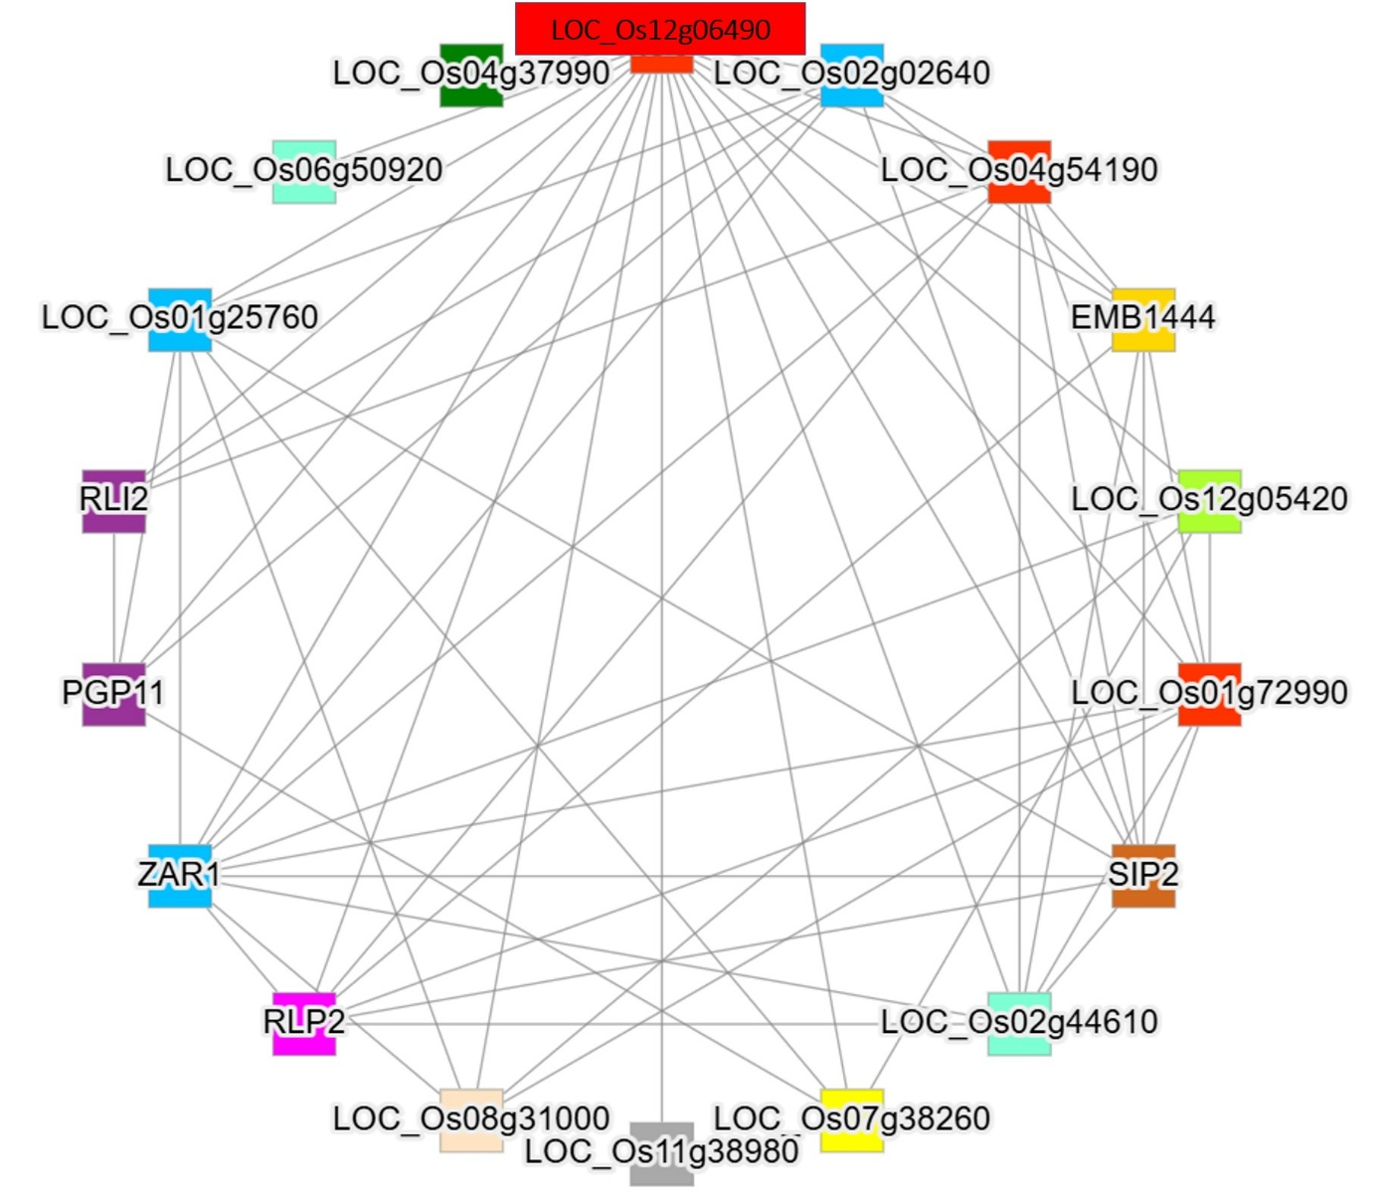
Fig. S2 Coexpression network analysis of the OsWNK9 gene. The network includes OsWNK9 (LOC_Os12g06490) and additional coexpressed genes identified via a co-expression network built using the conekt online tool (https://conekt.sbs.ntu.edu.sg/custom_network/).
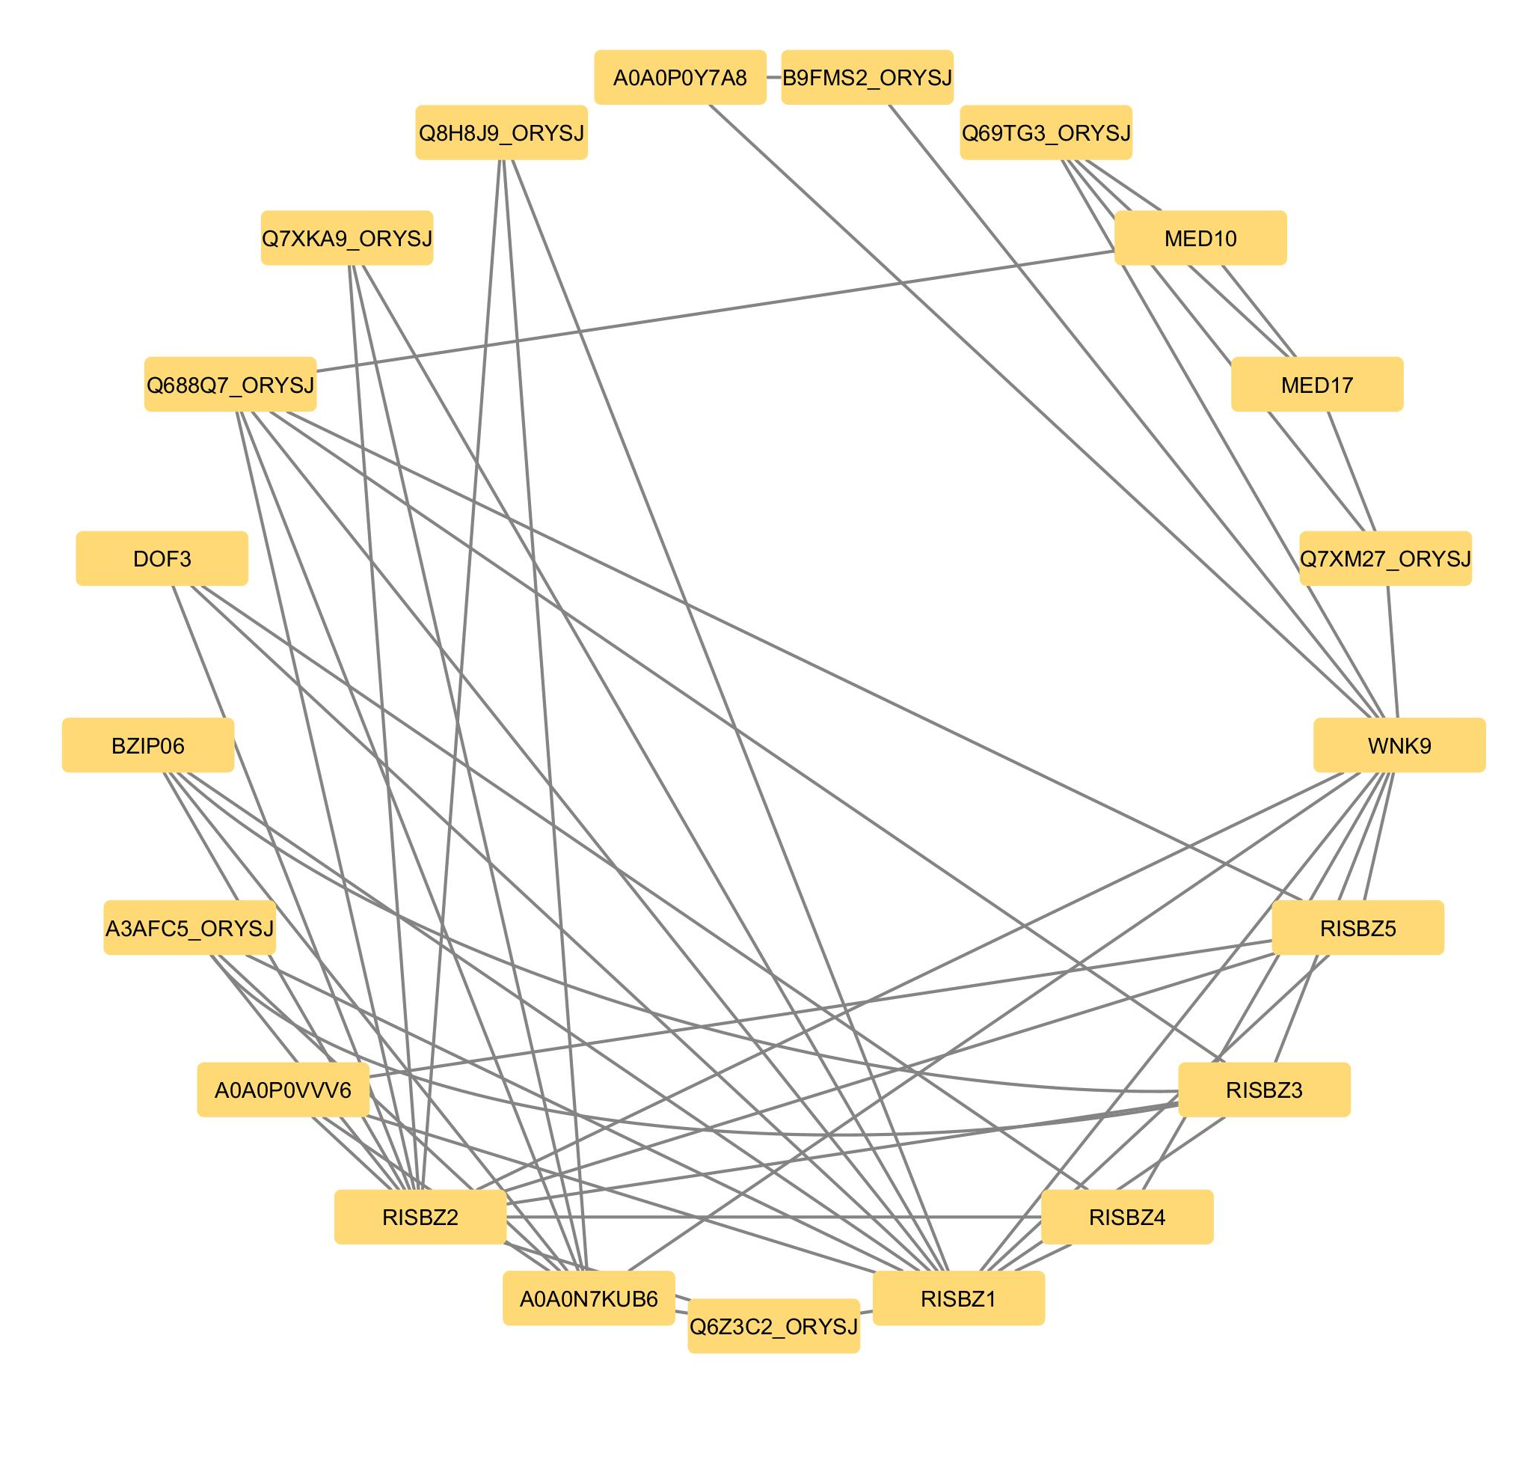
Fig. S3 Predicted protein–protein interaction (PPI) network of OsWNK9 and associated transcription factors. The network includes OsWNK9 (WNK9), bZIP family members (RISBZ1–5, BZIP06), DOF3, Mediator subunits (MED10, MED17), and additional co-regulatory proteins identified via interaction prediction. Nodes represent proteins, and edges represent predicted interactions. The PPI network was mined using STRING-DB and represented using Cytoscape.

