ICU environment as a reservoir of KPC-ST307-Klebsiella pneumoniae high-risk clone resistant to ceftazidime-avibactam
Marta Hernández-García^{1,2*}, Marta Nieto-Torres¹, Natalia Guerra-Pinto^{1,2}, Juan Antonio Castillo-Polo¹, Javier Saez de la Fuente³, Malkoa Michelena¹, Manuel Ponce-Alonso^{1,2}, Cruz Soriano-Cuesta⁴, Cristina Díaz-Agero⁵, Rafael Cantón^{1,2*}, Teresa M. Coque^{1,2}, Patricia Ruiz-Garbajosa^{1,2}
¹Servicio de Microbiología, Hospital Ramón y Cajal and Instituto Ramón y Cajal de Investigación Sanitaria (IRYCIS), Madrid, Spain
²CIBER de Enfermedades Infecciosas (CIBERINFEC), Instituto Salud Carlos III (ISCIII), Madrid, Spain.
³Servicio de Farmacia, Hospital Universitario Ramón y Cajal and Instituto Ramón y Cajal de Investigación Sanitaria (IRYCIS), Madrid, Spain.
⁴Unidad de Cuidados Intensivos, Hospital Ramón y Cajal, Madrid, Spain
⁵Servicio de Medicina Preventiva y Salud Publica, Hospital Universitario Ramon y Cajal and Instituto Ramón y Cajal de Investigación Sanitaria (IRYCIS), Madrid, Spain

*Corresponding authors: Rafael Cantón (rafael.canton@salud.madrid.org) and Marta Hernandez-García (martahernandez1986@gmail.com). Hospital Universitario Ramón y Cajal. Carretera de Colmenar Km 9,1. 28034-Madrid. Spain

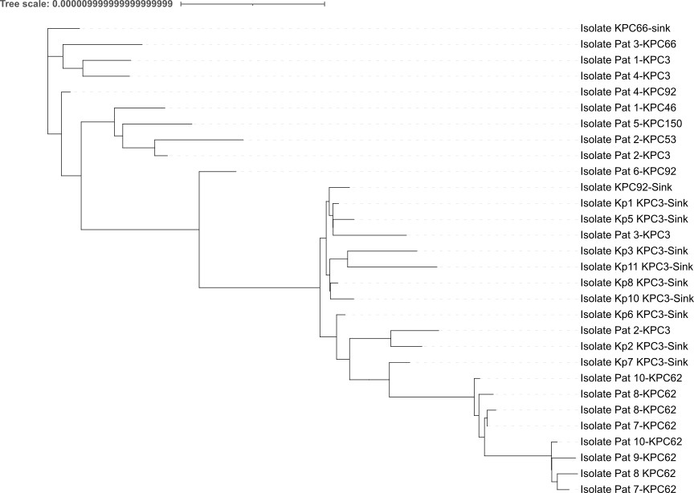
Figure S1. Core-genome maximum-likelihood phylogenetic tree constructed with all KPC-ST307-Kp isolates (ST307-K. pneumoniae NCTN00000000 was used as the reference genome).

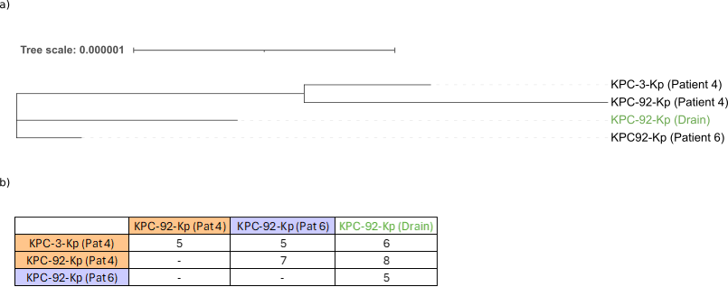
Figure S2. a) Core-genome maximum-likelihood phylogenetic tree constructed with the hybrid genome assemblies of the environmental KPC-92-Kp (used as the reference genome) and the clinical KPC-3- and KPC-92-Kp isolates from patients 4 and 6. b) Matrix table with the number of SNPs or INDELs for each pairwise comparison. The threshold number of SNPs defined for K. pneumoniae to be genetically related is ≤18 SNPs.

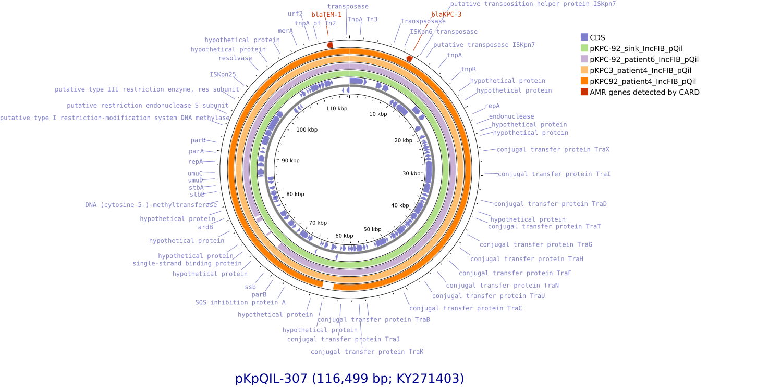
Figure S3. Reconstruction of the plasmid carrying bla_{KPC-3} or bla_{KPC-92} that was detected in the environmental KPC-92-Kp and the clinical KPC-3- and KPC-92-Kp isolates from patients 4 and 6. The pKpQIL-307 plasmid (accession number KY271403) previously described by Villa et al [5] was used as the reference plasmid.

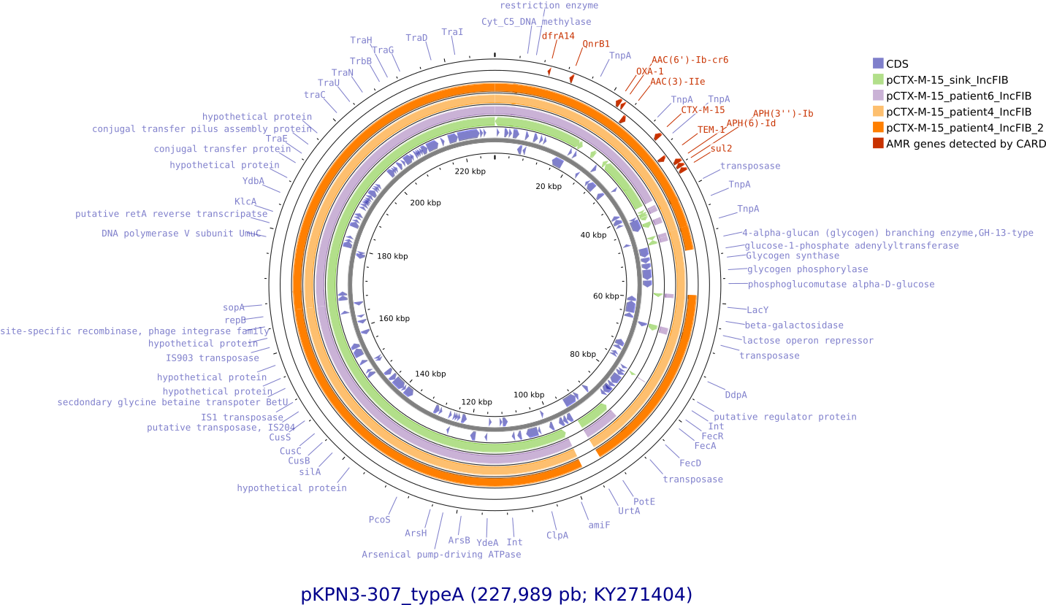

Figure S4. Reconstruction of the plasmid carrying bla_{CTX-M-15} that was detected in the environmental KPC-92-Kp and the clinical KPC-3- and KPC-92-Kp isolates from patients 4 and 6. The pKPN3-307_typeA plasmid (accession number KY271404) previously described by Villa et al [5] was used as the reference plasmid.

