Table S1. Univariate logistic regression analysis of risk factors on death or NDI in preterm infants at a corrected age of 24 months
Variables | OR (95%CI) | P-value | Variables | OR (95%CI) | P-value
Gestational age | 0.783 (0.663-0.925) | 0.004 | Asphyxiation at birth | 0.755 (0.407-1.401) | 0.373
30-31^{6/7} | 1.00 | - | Early noninvasive ventilation | 0.514 (0.262-1.008) | 0.053
28-29^{6/7} | 2.045 (1.035-4.042) | 0.039 | IVH grade>II | 3.778 (1.952-7.313) | <0.001
<28 | 3.629 (1.701-7.742) | 0.001 | PVL | 12.602 (6.440-24.660) | <0.001
Birth weight | 0.998 (0.997-0.999) | 0.002 | 2001 BPD | 1.748 (1.329-2.298) | <0.001
≥1500 | 1.00 | - | Non-BPD | 1.00 | -
1000-1499 | 3.070 (1.251-7.537) | 0.014 | Mild BPD | 2.574 (0.614-10.795) | 0.196
<1000 | 5.410 (2.010-14.561) | 0.001 | Moderate BPD | 2.593 (0.702-9.579) | 0.153
Male | 0.903 (0.508-1.607) | 0.729 | Severe BPD | 5.631 (2.329-13.617) | <0.001
Assisted reproduction | 1.364 (0.508-3.661) | 0.538 | 2018 BPD | 2.169 (1.630-2.887) | <0.001
Cesarean delivery | 0.603 (0.339-1.075) | 0.086 | Non-BPD | 1.00 | -
SGA | 1.137 (0.427-3.027) | 0.796 | Grade Ⅰ BPD | 2.212 (0.758-6.452) | 0.146
EUGR at 36 weeks’ PMA | 1.781 (0.923-3.433) | 0.085 | Grade Ⅱ BPD | 2.127 (0.872-5.188) | 0.097
Pregnancy hypertension | 0.538 (0.223-1.299) | 0.168 | Grade Ⅲ BPD | 10.954 (4.828-24.855) | <0.001
PROM | 1.483 (0.823-2.670) | 0.189 | 2019 BPD | 2.395 (1.798-3.191) | <0.001
Placental abruption | 0.692 (0.239-2.002) | 0.497 | Non-BPD | 1.00 | -
Gestational diabetes | 1.335 (0.383-4.653) | 0.650 | Grade 1 BPD | 2.199 (0.948-5.100) | 0.067
Antenatal corticosteroids | 0.900 (0.406-1.993) | 0.795 | Grade 2 BPD | 5.009 (1.971-12.728) | 0.001
Surfactant use | 1.481 (0.798-2.748) | 0.213 | Grade 3 BPD | 13.761 (5.541-34.178) | <0.001
SGA, small for gestational age; EUGR, extrauterine growth restriction; PMA, postmenstrual age; PROM, premature rupture of membranes; IVH, intraventricular hemorrhage; PVL, periventricular leukomalacia; BPD, bronchopulmonary dysplasia.

Table S2. Predictive values of the different prediction models
Variables | AUC (95%CI) | Sensitivity (%) | Specificity (%)
2001 BPD | 0.669 (0.600-0.739) | 75.0 | 55.7
2018 BPD | 0.724 (0.647-0.802) | 48.1 | 88.4
2019 BPD | 0.723 (0.646-0.801) | 51.9 | 82.9
PVL | 0.692 (0.602-0.781) | 44.2 | 94.1
2001 BPD + PVL | 0.784 (0.718-0.851) | 44.2 | 94.1
2018 BPD + PVL | 0.817 (0.746-0.887) | 75.0 | 83.1
2019 BPD + PVL | 0.820 (0.749-0.890) | 76.9 | 78.3

Figure S1. ROC curves to predict death or NDI in different definitions of BPD and their combination with PVL. A shows the predictive value of the 2001 NICHD definition and its combination with PVL for death or NDI. B shows the predictive value of the 2018 NICHD definition and its combination with PVL for death or NDI. C shows the predictive value of the 2019 Jensen definition and its combination with PVL for death or NDI.

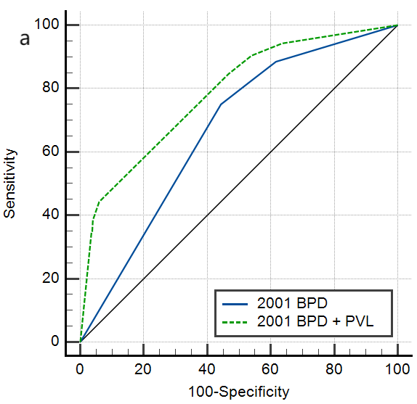
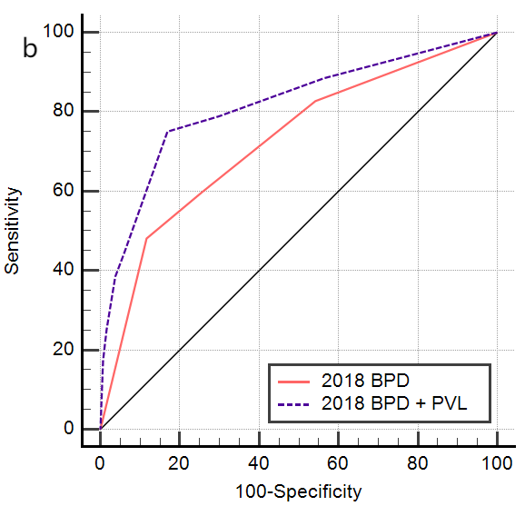
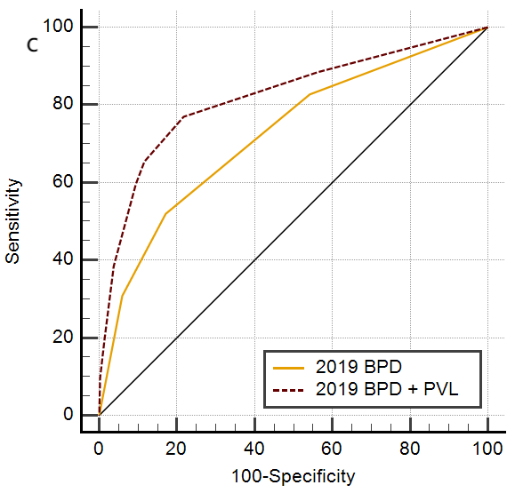
Table S3. Comparison between individual BPD diagnostic definitions and BPD diagnostic definitions combined with PVL.
 | Difference  between areas | SE | 95%CI | z | P-value
2001 BPD vs. 2001 BPD + PVL | 0.115 | 0.030 | 0.056-0.174 | 3.808 | <0.001
2018 BPD vs. 2018 BPD + PVL | 0.091 | 0.031 | 0.031-0.151 | 2.987 | 0.003
2019 BPD vs. 2019 BPD + PVL | 0.096 | 0.029 | 0.040-0.152 | 3.373 | <0.001

