Steam Activated Hydrochar from Wine Waste for the Removal of Pharmaceutical Micropollutants from Water

Lucio Zaccarielloª, Annarita Travaglino^{b}, Angelo Fenti^{b*}, Giovanni Falcoª, Simona Galoppo^{b}, Domenico Palmaª, Antonella Giarra^{c}, Maria Toscanesi^{c}, Marco Trifuoggi^{c,d}, Pasquale Iovinoª

ª Department of Environmental, Biological and Pharmaceutical Sciences and Technologies, University of Campania “Luigi Vanvitelli”, Via Vivaldi 43, 81100 Caserta, Italy
^{b} Department of Engineering, University of Campania “Luigi Vanvitelli”, Via Roma 29, 81031 Aversa (CE), Italy
^{c} Department of Chemical Sciences, University of Naples Federico II, Via Vicinale Cupa Cintia 26, 80126 Naples, Italy
^{d} CeSMA – Advanced Metrological and Technological Services Centre, University of Naples Federico II, Corso Nicolangelo Protopisani, 80146 Naples, Italy

*Corresponding author:
Angelo Fenti, Department of Engineering, University of Campania “Luigi Vanvitelli”, Via Roma 29, 81031 Aversa, Italy; Tel: +39 0823274148; E-mail: angelo.fenti@unicampania.it.

Table S1. DCF adsorption test on hydrochar produced during HTC treatments conducted at different operative conditions, and physically activated by steam.

Exp. runs # | HTC  T (°C) | Steam activation* | Mass of hydrochar (mg) | Volume (ml) | Adsorbent dosage  (g L⁻¹)
1 | 200 | / | 10 | 50 | 0.2
2 | 200 | / | 20 | 50 | 0.4
3 | 200 | / | 30 | 50 | 0.6
4 | 200 | / | 40 | 50 | 0.8
5 | 200 | / | 50 | 50 | 1.0
6 | 230 | / | 10 | 50 | 0.2
7 | 230 | / | 20 | 50 | 0.4
8 | 230 | / | 30 | 50 | 0.6
9 | 230 | / | 40 | 50 | 0.8
10 | 230 | / | 50 | 50 | 1.0
11 | 260 | / | 10 | 50 | 0.2
12 | 260 | / | 20 | 50 | 0.4
13 | 260 | / | 30 | 50 | 0.6
14 | 260 | / | 40 | 50 | 0.8
15 | 260 | / | 50 | 50 | 1.0
16 | 230 | yes | 10 | 50 | 0.2
17 | 230 | yes | 20 | 50 | 0.4
18 | 230 | yes | 30 | 50 | 0.6
19 | 230 | yes | 40 | 50 | 0.8
20 | 230 | yes | 50 | 50 | 1.0

*Steam activation conditions: steam flow rate of 5 g min⁻¹ at a temperature of 900 °C for 15 minutes.

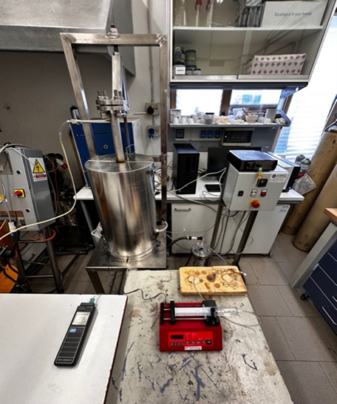

Fig. S1. Hydrochar steam activation apparatus.

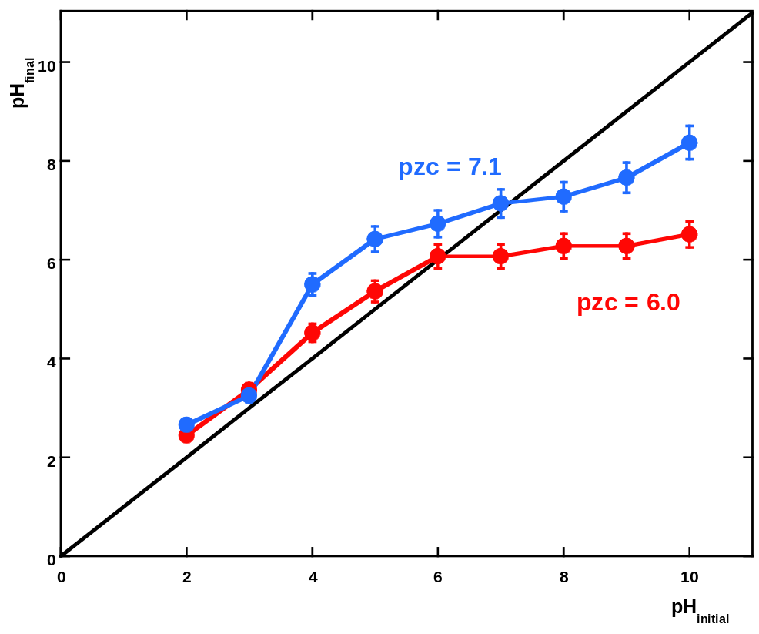
Fig. S2. Plot of the point of zero charge of i) HC-230 (red line), ii) steam-activated HC-230 (blue line).

Table S2. BET analyses of the HC-200, HC-230, HC-260, and of steam-activated HC-230 samples.

Sample | S_{BET} (m²/g) | Error (± m²/g)
HC-200 | 17.44 | ± 0.20
HC-230 | 49.41 | ± 0.51
HC-260 | / | /
SA-HC-230 | 728 | ± 0.5

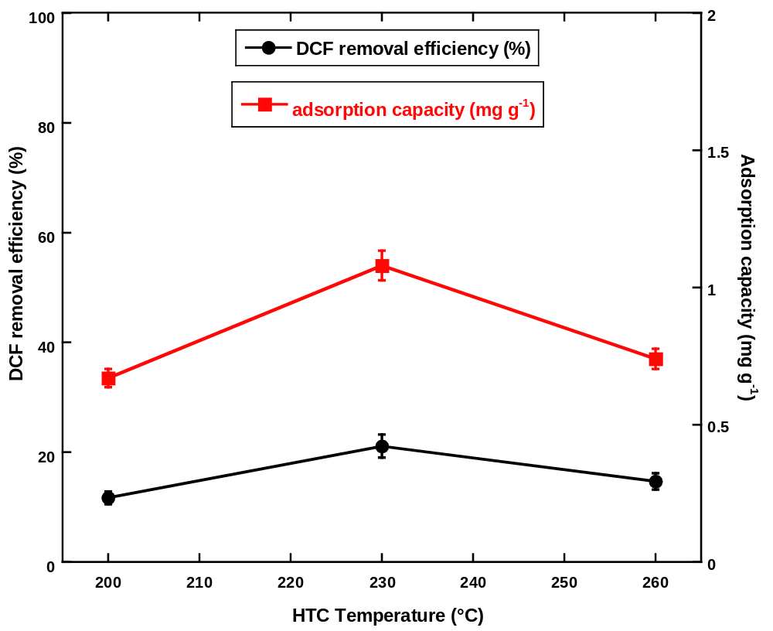
Fig. S3. The effect of HTC temperature on DCF removal efficiencies (%) and adsorption capacity (mg g⁻¹); initial DCF concentration = 5.0 mg L⁻¹; pH = 9.0 ± 0.1; adsorbent dosage = 1.0 g L⁻¹.

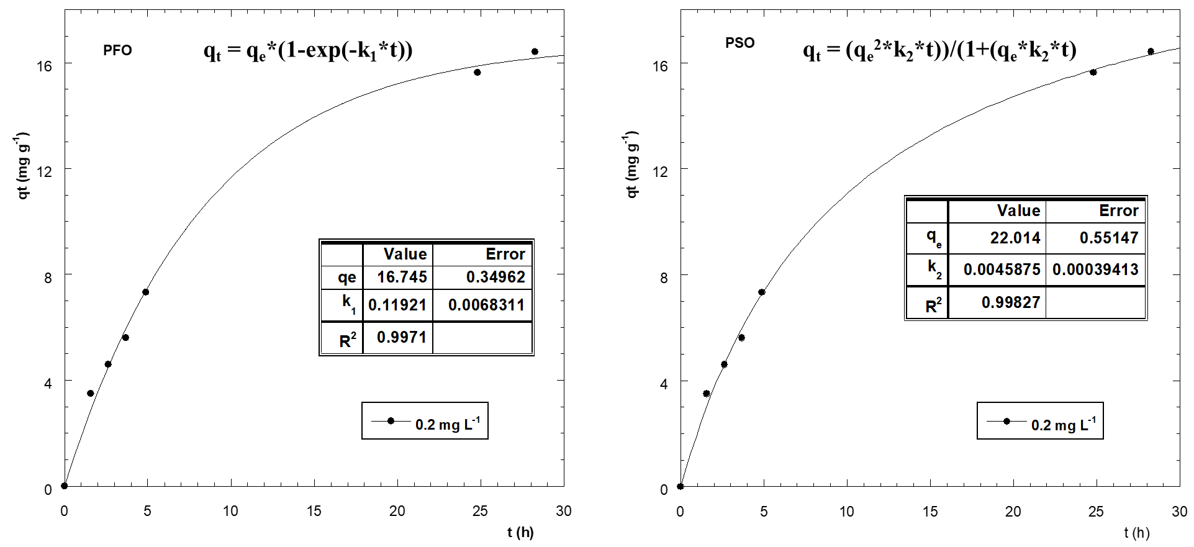

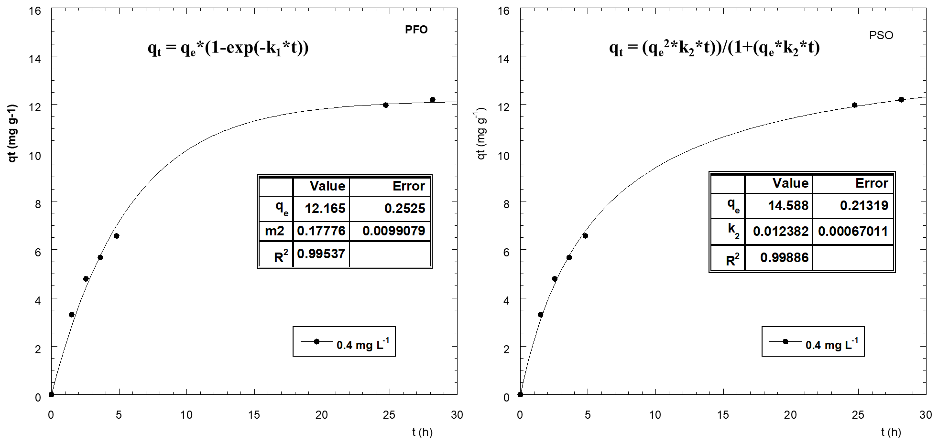

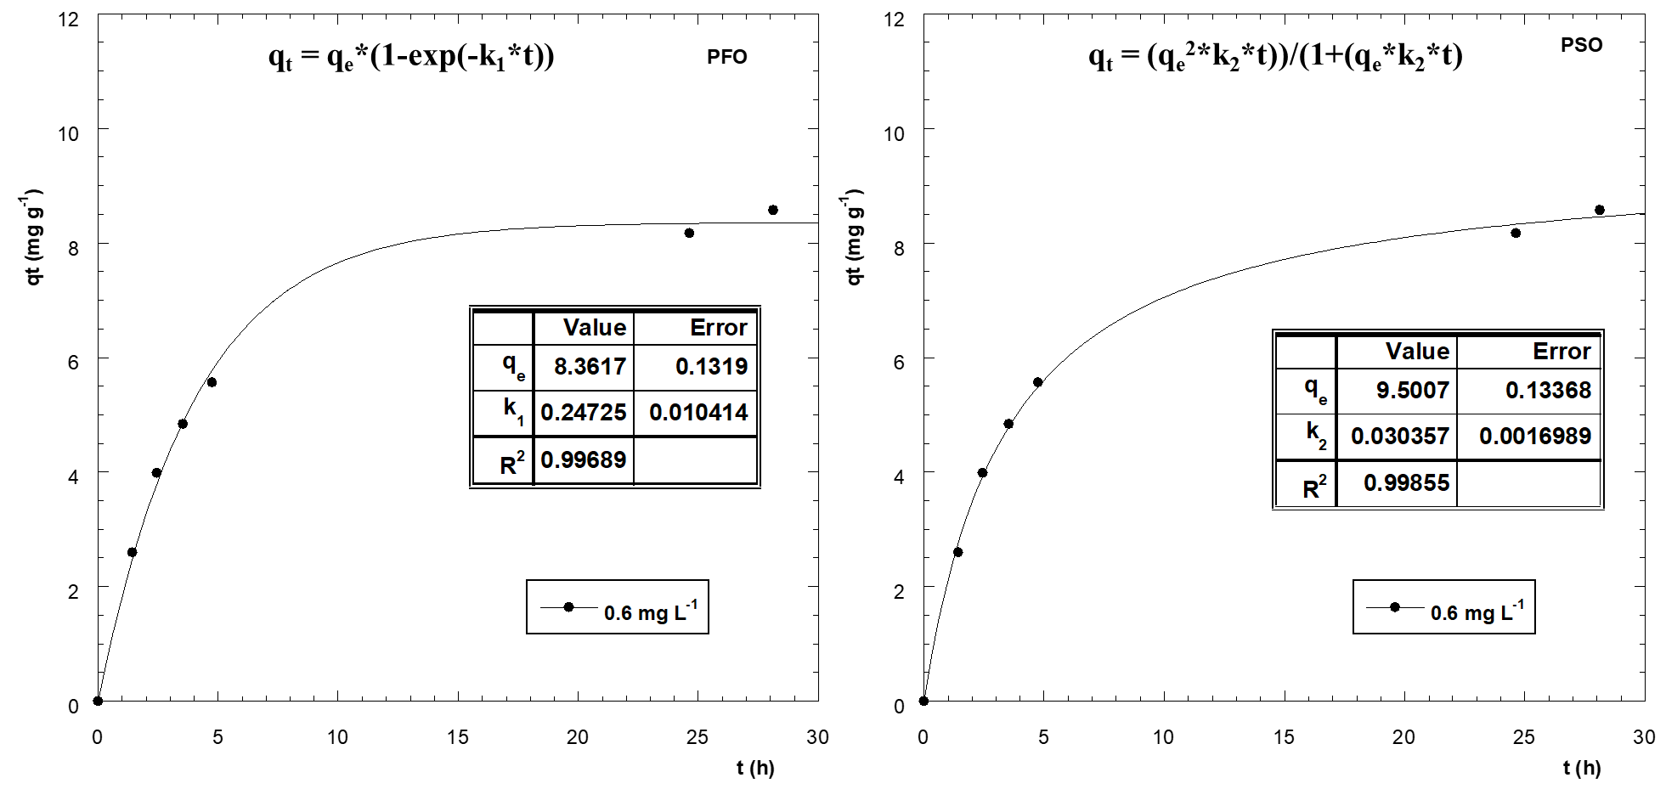
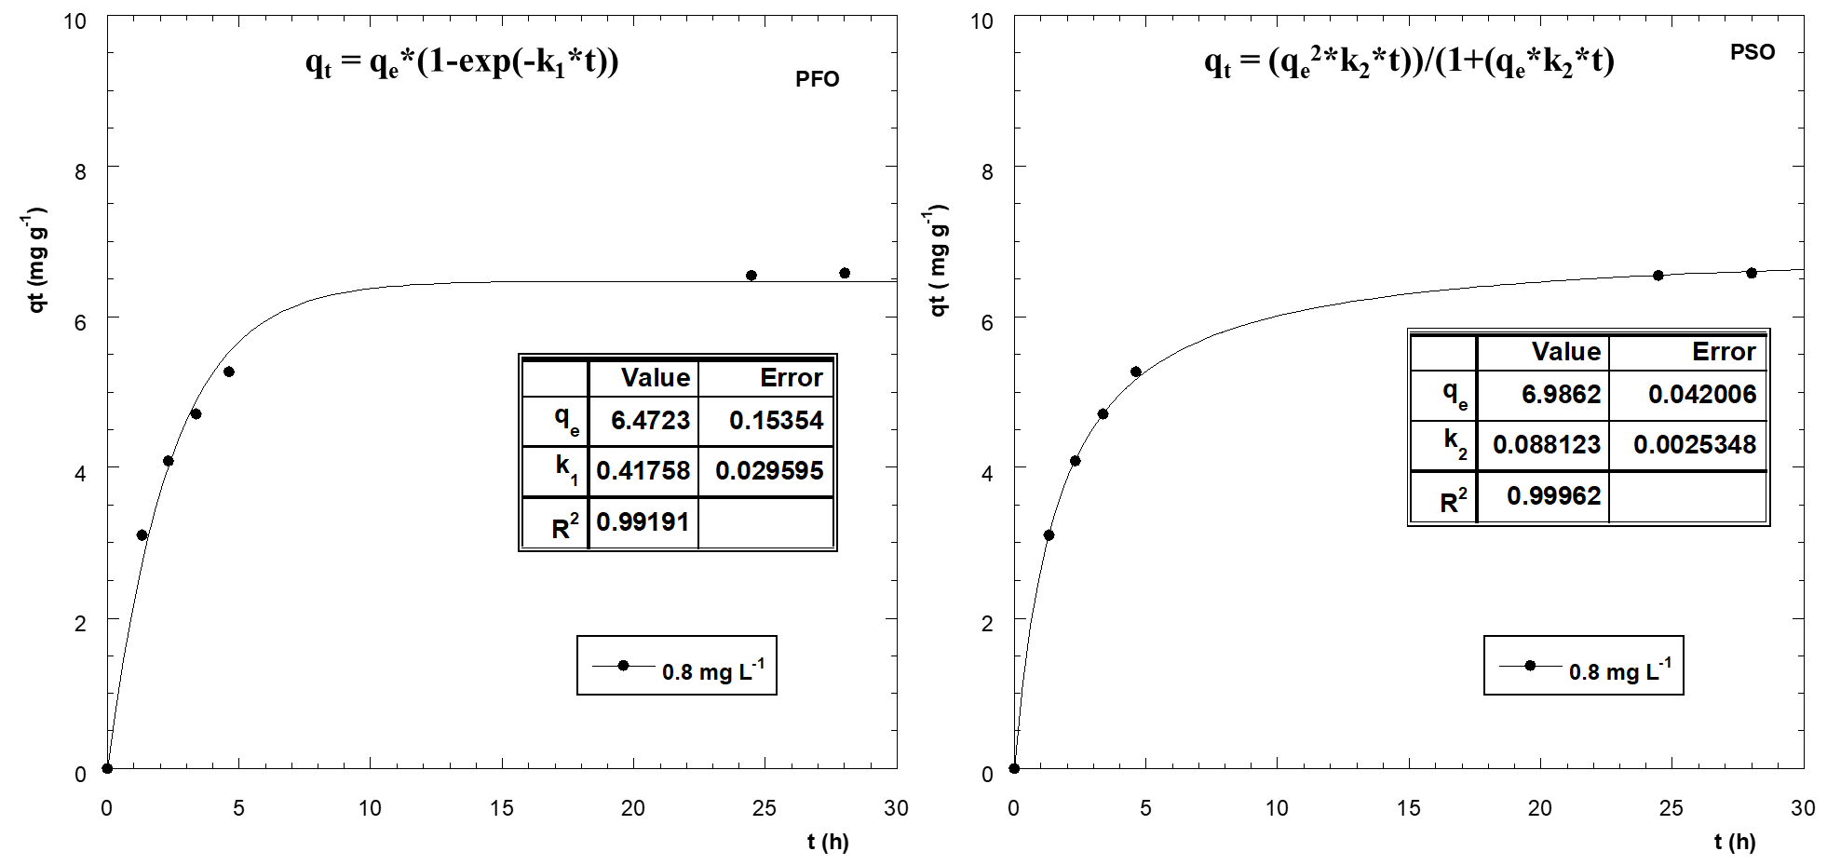

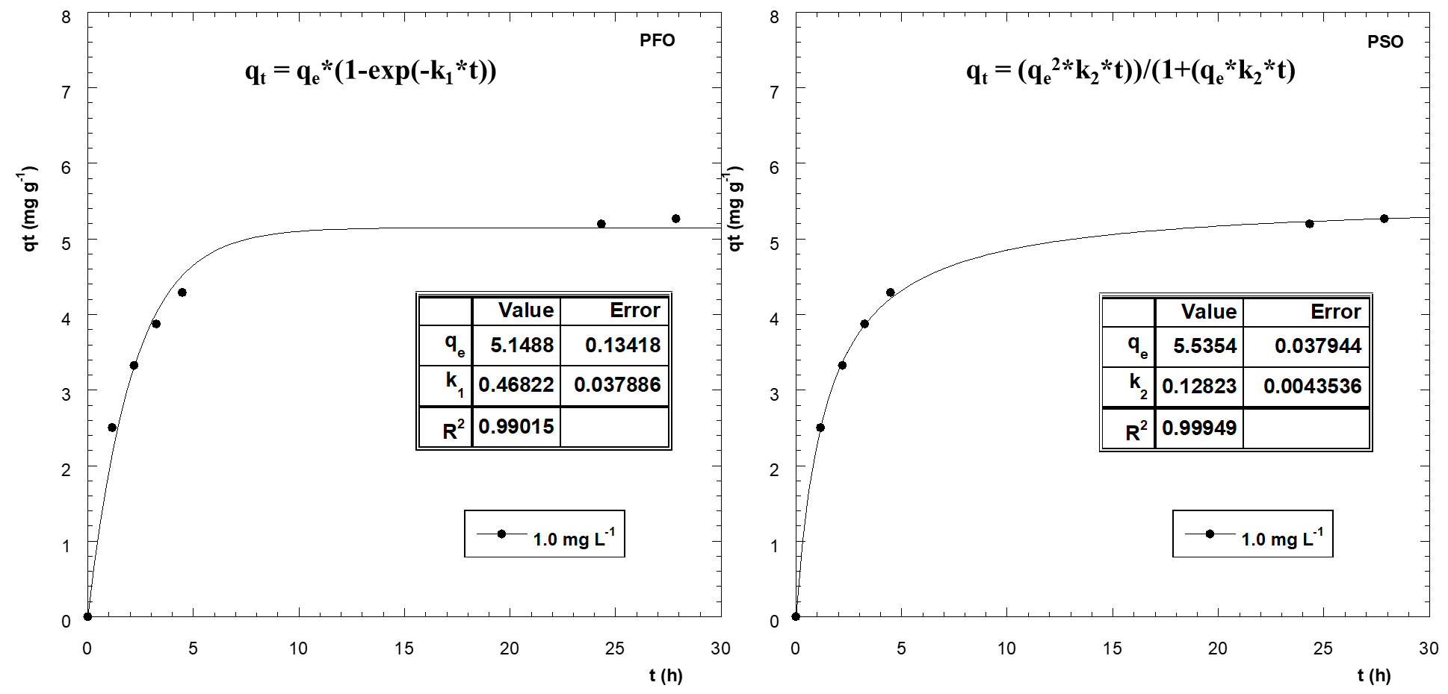

Fig. S4. Pseudo-first and pseudo-second order fitting procedures for the DCF adsorption experimental data onto steam-activated HC-230 at different adsorbent dosage.

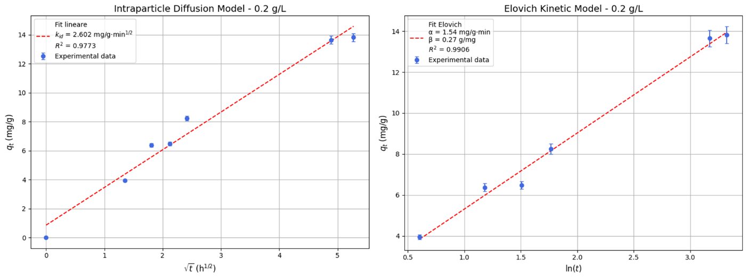
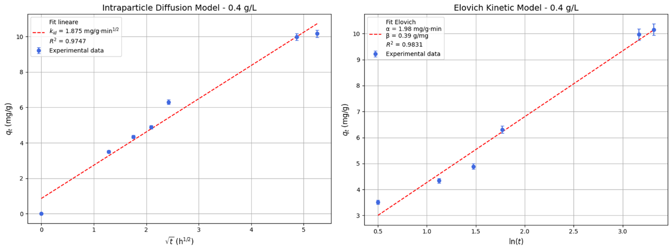

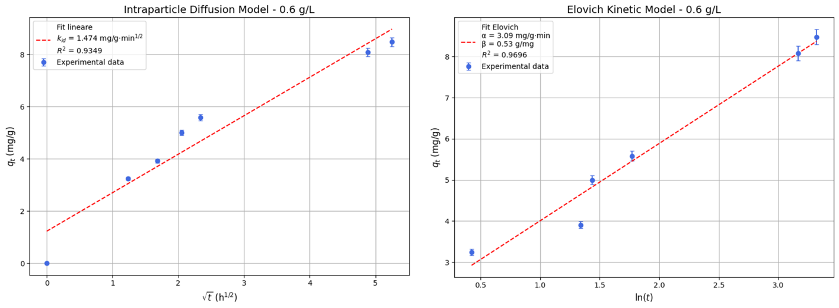

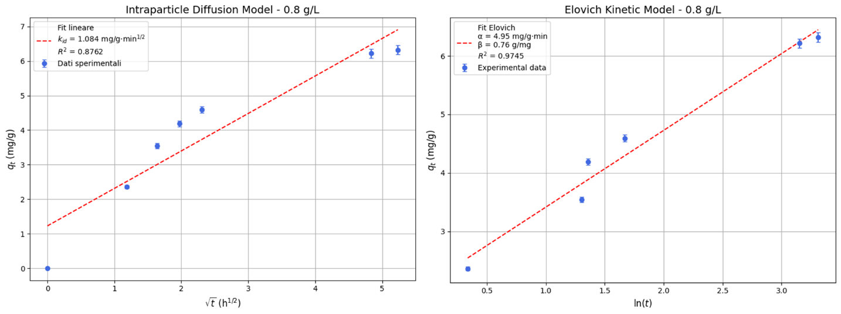

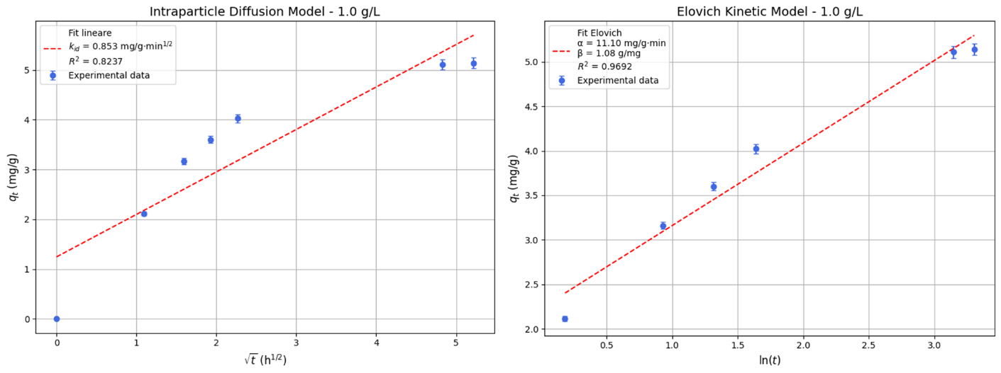

Fig. S5. Intra-particle diffusion and Elovich fitting procedures for the DCF adsorption experimental data onto steam-activated HC-230 at different adsorbent dosage.

Table S3. Adsorption isotherm parameters for DCF adsorption onto steam-activated HC-230.

Adsorbent | q_{e}  (mg g⁻¹) | Lanngmuir |  |  | Freundlich
Adsorbent | q_{e}  (mg g⁻¹) | q_{max}  (mg g⁻¹) | k_{L}  (L mg⁻¹) | R² | k_{F}  (mg^{1-1/n} L^{1/n} g⁻¹) | 1/n |  | R² |  | q_{max}⁽¹⁾  (mg g⁻¹)
Steam-activated HC-230 | 22.01 | 25.19 | 8.97 | 0.971 | 23.6 | 0.347 |  | 0.896 |  | 42.89
Steam-activated HC-230 | 22.01 | Dubinin-Radushkevich |  |  | Temkin
Steam-activated HC-230 | 22.01 | q_{max}  (mg g⁻¹) | B_{D-R}  (mol² kJ⁻²) | R² | B  (J mol⁻¹) |  | K_{T}  (L g⁻¹) |  | R²
Steam-activated HC-230 | 22.01 | 25.91 | 2.15x10⁻² | 0.964 | 5.236 |  | 88.11 |  | 0.954

- $q_{max}=k_{F}{C_{0}}^{1/n}$

