Supplementary data:
Impact of Carbohydrate Sources on the Longevity and Physiological Traits of the European Honey Bee Workers

Table S1. Percentage of sugar content of each type of sugar in honey and other artificial feeds used to provide honey bees. Carbohydrate composition is based on information from the literature.

Treatment code | Fructose | Glucose | sucrose | Maltose | Moisture | Others *
Maltose 50% | 0.00 | 0 | 0 | 49.99 | 50 | 0.01
Acacia honey | 38 | 33.1 | 6.1 | ND | 18.2 | 4.6
Corn syrup | 0.00 | 0.79 | 0.83 | 57.08 | 22.8 | 18.5
Brown sugar 50% | 0.15 | 0.32 | 42.18 | ND | 50 | 7.33
White sugar 50% | 0.00 | 0.00 | 49.99 | ND | 50 | 0.01
Chestnut honey | 36.2 | 26 | 2.7 | ND | 17.2 | 17.9
Oligosaccharide | 1.00 | 15.45 | 12.15 | ND | 21.8 | 49.6
* "Others" include oligosaccharides, polysaccharides, unlisted minor sugars (e.g., galactose, raffinose), sugar alcohols, and other non-sugar constituents such as acids and proteins.

Table S2. Letal time 50% (LT₅₀) for caged honey bee with different type of carbohydrat

Carbohydrate | LT ₅₀ (day)
White sugar | 19.12
Brown sugar | 12.79
Maltose | 15.61
Corn syrup | 26.5
Acacia honey | 22.7
Chestnut honey | 15.71
Oligosaccharide | 3.67

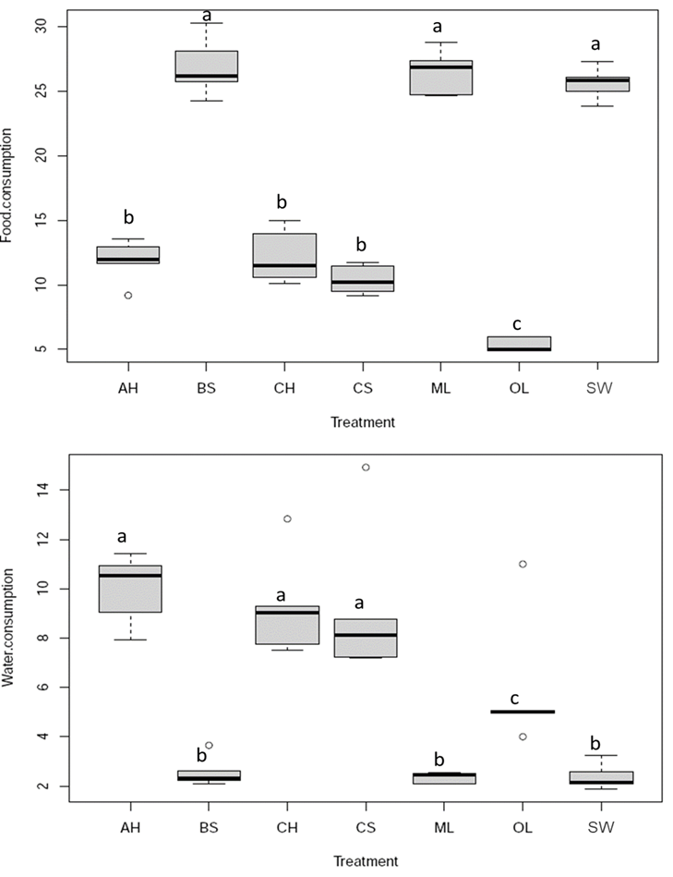
Figure S1. Food and water consumption in different treatment. Acacia honey (AH), brown sugar (BS), chestnut honey (CH), corn syrup (CS), maltose (MA), oligosaccharide (OL), and sugar solution (SW).

Table S3. T test analysis for HPG size between 7 and 14 days old caged honey bees.
Treatments | Mean | Paired Differences |  | T value | df | P value
Treatments | Mean | Std. Deviation | Std. Error mean | T value | df | P value
Acacia honey | 0.00025 | 0.0350 | 0.00049 | 0.514 | 49 | 0.609
Brown sugar | -0.0021 | 0.045767 | 0.0006471 | 3.321 | 49 | 0.002
Chestnut honey | -0.0314 | 0.0386 | 0.00055 | 5.744 | 49 | 0.000
Corn syrup | -0.0041 | 0.0031814 | 0.0004499 | 9.192 | 49 | 0.000
Maltose | -0.0037 | 0.0068002 | 0.0009617 | 3.851 | 49 | 0.000
White sugar | -0.0026 | 0.0033703 | 0.0004766 | -5.618 | 49 | 0.000

Table S4. Primer list. Primers for genes associated with development in honey bees and housekeeping gene provided along with their Gen Bank accession numbers, melting temperatures (Tm) used, and calculated primer efficiencies.
Target gene | Gene description | Primer sequence forward and reverse | Tm (°C)
Vg | Vitellogenin | TCAAGGATTGCGTGGAGGAC  AAAGGGCTATAAGGGCGTCG | 62.9  61.8
Ilp1 | Insulin-like peptide 1 | CGTCGTCCTGGCAAGATGT  TTTGTTCGATGACACCGGCA | 62.5  61.9
Ilp2 | Insulin-like peptide 2 | ATGGAGATGGATGATTATATGGCA  ACTCCTCTGTCGTGCAAGATT | 57  60.2
Act | Actin | TCCGAAGGCCAATCGTGAAA  CCGGTAGTACGTCCAGAAGC | 62.2  62.5

Table S5. The percentage of core gut microbiome in honey bees fed with different type of carbohydrates (P<0.05).
phylum | Family | Genus | Maltose | Acacia honey | Corn syrup | Brown sugar | White sugar | Chestnut honey
Proteobacteria | Rhizobiales | Bartonella | 66.7 ± 0.08^{b} | 26.2 ± 0.06^{c} | 84.5 ± 0.07ª | 63.8 ± 0.1^{b} | 61.9 ± 0.09^{b} | 6.03 ± 0.07^{d}
 | Orbaceae | Friscella | 11.3 ± 0.05^{b} | 49.6 ± 0.1ª | 0^{b} | 12.5 ± 0.1^{b} | 16.7 ± 0.03^{b} | 43.3 ± 0.2ª
 | Neisseriaceae | Snodgrassella | 4.8 ± 0.03^{bc} | 5 ± 0.008^{bc} | 0^{c} | 4.05 ± 0.02^{bc} | 6.4 ± 0.03^{b} | 14.7 ± 0.03ª
 | Orbaceae | Gilliamella | 5.2 ± 0.06ª | 3.1 ± 0.03ª | 5.3 ± 0.07ª | 9 ± 0.06ª | 5.5 ± 0.02ª | 10.1 ± 0.1ª
 | Acetobacteraceae | Commensalibacter | 0.2 ± 0.004ª | 5.7 ± 0.07ª | 0ª | 1.6 ± 0.02ª | 0.2 ± 0.002ª | 0.2 ± 0.003ª
 | Acetobacteraceae | Bombella | 0.06 ± 0.0006^{b} | 0.3 ± 0.002^{b} | 0.7 ± 005^{b} | 0.5 ± 0.003^{b} | 1.2 ± 0.01^{ab} | 5.2 ± 0.05ª
Firmicutes | Lactobacillaceae | Lactobacillus | 9.1 ± 0.04^{b} | 8.5 ± 0.02^{b} | 8.8 ± 0.01^{b} | 6 ± 0.01^{b} | 6.1 ± 0.008^{b} | 18.6 ± 0.006ª
Actinobacteriota | Bifidobacteriaceae | Bifidobacterium | 0.3 ± 0.001^{ab} | 0.1 ± 0.0007^{ab} | 0.08 ± 0.001^{b} | 0.5 ± 0.001ª | 0.5 ± 0.003ª | 0.2 ± 0.004^{ab}

Table S6. Sequence quality control analysis of gut microbiome experiment.

Sample-id | Input | Filtered | Percentage of input passed filter | Denoised | Merged | Percentage of input merged | Non-chimeric | Percentage of input non-chimeric
AH1 | 168142 | 151703 | 90.2 | 150433 | 146644 | 87.2 | 33832 | 20.1
AH2 | 180480 | 163663 | 90.6 | 162249 | 157633 | 87.3 | 43011 | 23.8
AH3 | 155020 | 140322 | 90.5 | 139585 | 136329 | 87.9 | 40018 | 25.8
BS1 | 165118 | 149470 | 90.5 | 148237 | 144444 | 87.4 | 35922 | 21.7
BS2 | 200924 | 180039 | 89.6 | 178297 | 173313 | 86.2 | 43596 | 21.7
BS3 | 187039 | 170038 | 90.9 | 168135 | 161928 | 86.5 | 34204 | 18.2
CH1 | 174614 | 158409 | 90.7 | 157173 | 152734 | 87.4 | 26901 | 15.4
CH2 | 182572 | 165780 | 90.8 | 164631 | 159087 | 87.1 | 25968 | 14.2
CH3 | 177067 | 160653 | 90.7 | 159768 | 156650 | 88.4 | 38263 | 21.6
CS1 | 161491 | 146876 | 90.9 | 146453 | 144977 | 89.7 | 58504 | 36.2
CS2 | 181230 | 163845 | 90.4 | 163458 | 160788 | 88.7 | 59841 | 33.02
CS3 | 171669 | 155931 | 90.8 | 155407 | 153935 | 89.6 | 56702 | 33.03
MA1 | 178154 | 159249 | 89.3 | 157999 | 152486 | 85.5 | 43866 | 24.6
MA2 | 158693 | 144142 | 90.8 | 143131 | 138696 | 87.4 | 33277 | 20.9
MA3 | 155757 | 140453 | 90.1 | 139308 | 134906 | 86.6 | 42041 | 26.9
WS1 | 127657 | 115791 | 90.7 | 114467 | 109862 | 86.06 | 25775 | 20.1
WS2 | 179200 | 162110 | 90.4 | 160502 | 154398 | 86.1 | 43071 | 24.04
WS3 | 168954 | 153810 | 91.04 | 152614 | 146263 | 86.5 | 41957 | 24.8
New1 | 185542 | 107371 | 57.8 | 107037 | 105932 | 57.09 | 25535 | 13.7
New2 | 224583 | 127268 | 56.6 | 126651 | 125652 | 55.9 | 28769 | 12.80
New3 | 168597 | 113724 | 67.4 | 113559 | 113421 | 67.2 | 26196 | 15.5

