Supplementary data
Table S1. The soil physical and chemical characteristics of the experimental ﬁeld (at Dalgan) before planting.
Texture | Clay  (%) | Silt  (%) | Sand (%) | K (mg/kg) | P (mg/kg) | N  (%) | O.C. (%) | pH | EC (dS/m)
loamy | 41 | 48 | 11 | 284 | 6.3 | 0.17 | 1.08 | 7.6 | 2.12

Fig. S1. The thermo-pluviometric trend diagram at the research ﬁeld (Dalgan, Sistan va Balouchestan province, Iran).

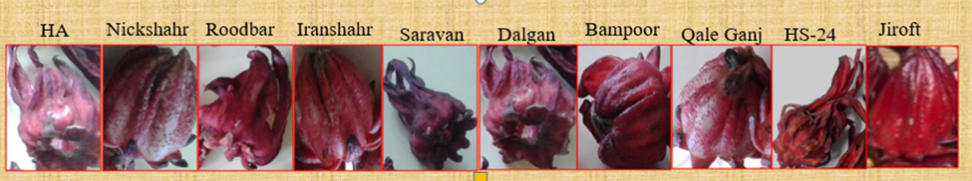
Fig. S2. The variation of different varieties of Hibiscus sabdarifa L. sepal

Table S2. Hyperparameter search space used for GridSearchCV tuning of Multilayer Perceptron (MLP) and Random Forest (RF) models.
Model | Hyperparameter | Search Space | Description
RF | n_estimators | [50, 100] | Number of trees in the forest
RF | max_depth | [3, 5, 10] | Maximum depth of each decision tree
RF | min_samples_split | [2, 5] | Minimum number of samples required to split an internal node
MLP | hidden_layer_sizes | [(5,5), (10,10), (20,20)] | Number of neurons in the hidden layers
MLP | activation | ['relu', 'tanh'] | Activation function used in the hidden layers
MLP | alpha | [0.0001, 0.05, 1] | L2 regularization term (penalty)

Table S3. 10-fold cross-validation R² scores and standard deviations for each ML model (RF and MLP).
Model | R² (10-Fold CV) | Std
Random Forest | 0.6006 | 0.2058
MLP | 0.5951 | 0.2239

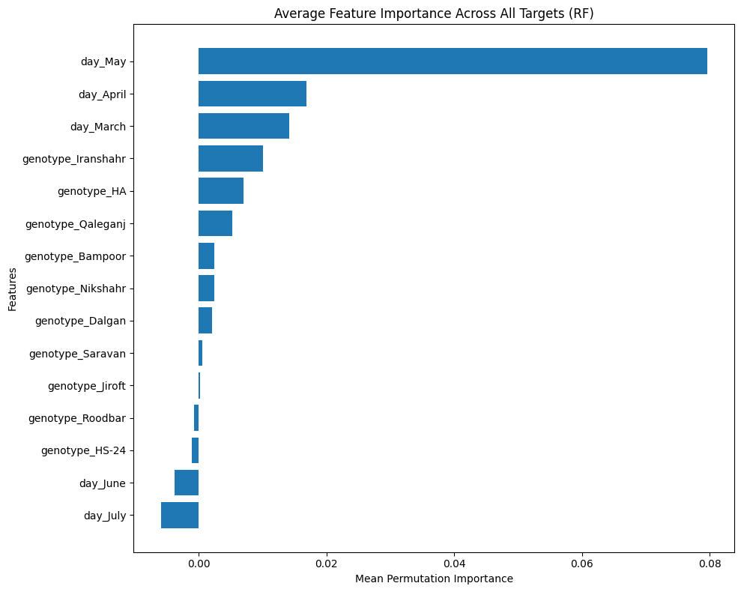
Fig S3. Bar plot of average feature importance across all target traits as determined by the RF model using permutation-based analysis. Planting dates (particularly May, April, and March) showed the highest importance scores, indicating their dominant role in predicting Roselle morphological traits. Among genotypes, Iranshahr, HA, and Qaleganj had relatively higher contributions.

