Plasmid-mediated quinolone resistance among extended-spectrum β-lactamase-producing Escherichia coli and Klebsiella pneumoniae isolated from hospitalized patients, hospital environment and wastewaters in Cameroon
Patrice Landry Koudoum¹, Raspail Carrel Founou^{1,2,3}, Luria Leslie Founou^{2,4,5,6}, Megane Daina Foueyem¹, Giresse Wilfried Guemkam¹, Richard Deuguen¹, Gisele Ateba Nke^{7,8}, Hortense Gonsu^{9,10} & Simeon Pierre Choukem^{11, 12}

¹Department of Microbiology- Haematology and Immunology, Faculty of Medicine and Pharmaceutical Sciences, University of Dschang, Dschang, Cameroon;
²Antimicrobial Research Unit, School of Health Sciences, College of Health Sciences, University of KwaZulu-Natal, Durban 4000, South Africa;
³ Antimicrobial Resistance and Infectious Disease (ARID) Research Unit, Research Institute of Centre of Expertise and Biological Diagnostic of Cameroon (CEDBCAM-RI), Yaoundé, Cameroon;
⁴Reproductive, Maternal, Newborn and Child Health (ReMARCH) Research Unit, Research
Institute of the Centre of Expertise and Biological Diagnostic of Cameroon (CEDBCAM-RI); Yaoundé, Cameroon;
⁵Bioinformatics & Applied Machine Learning Research Unit, EDEN Biosciences Research Institute (EBRI), EDEN Foundation, Yaoundé Cameroon;
⁶ Infection & Global Health Division, School of Medicine, University of St Andrews, St Andrews, United Kingdom;
⁷Yaoundé Central Hospital, Yaoundé Cameroon;
⁸Faculty of Medicine and Pharmaceutical Sciences, University of Douala, Douala, Cameroon;
⁹Faculty of Medicine and Biomedical Sciences, University of Yaoundé 1, Yaoundé, Cameroon;
¹⁰University Teaching Hospital of Yaoundé, Yaoundé, Cameroon;
¹¹Department of Internal Medicine and Specialties, Faculty of Medicine and Pharmaceutical Sciences, University of Dschang, Dschang, Cameroon;
¹²Health and Human Development (2HD) Research Network, Douala, Cameroon.

#Corresponding author
Dr Raspail Carrel Founou
Email: czangue@yahoo.fr
Keywords: Hospital-acquired infection, Hospital environment, Extended-Spectrum β-Lactamase, Enterobacterales, Plasmid-Mediated Quinolone Resistance, One Health.
Running title: Plasmid-mediated quinolone resistance among ESBL-E. coli and K. pneumoniae in Yaoundé, Cameroon.

LIST OF SUPPLEMENTARY TABLES AND FIGURES

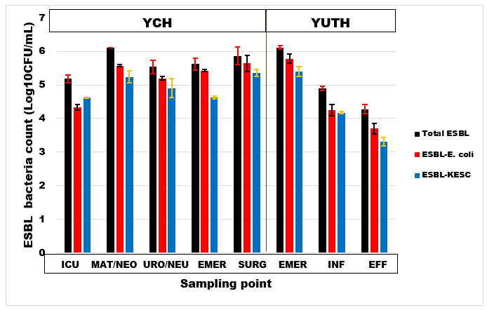
Supplementary figure S1: Extended-Spectrum β-Lactamase-Enterobacterales (ESBL-E) count (in log10CFU/mL) in hospital wastewaters. ICU= Intensive Care Unit, MAT= Maternity, NEO= Neonatology, URO= Urology, NEU= Neurology EMER= Emergency, SURG= Surgery, INF= Influent, EFF= Effluent and KESC= Klebsiella, Enterobacter, Serratia and Citrobacter.

Supplementary table S1: Antibiotic resistance rates of ESBL-E. coli and K. pneumoniae isolated from hospitalized patients, hospital environment and wastewaters.
Source |  | β-Lactams n (%) |  |  |  | Fluoroquinolones n (%) |  | Other antibiotics n (%)
Source | AMC | CTX | FEP | ATM | MEM | CIP | LEV | CHL | CN | FF | FOX | SXT | TET
 | ESBL-E. coli
Hospitalized patients n=26 | 26 (100.00) | 25 (96.15) | 26 (100.00) | 25 (96.15) | 2 (7.69) | 26 (100.00) | 22 (84.62) | 12 (46.15) | 14 (53.85) | 17 (65.38) | 19 (73.08) | 23 (88.46) | 25 (96.15)
Environment n=11 | 11 (100.00) | 11 (100.00) | 11 (100.00) | 11 (100.00) | 2 (18.18) | 7 (63.63) | 5 (45.45) | 3 (27.27) | 2 (18.18) | 0 | 6 (54.54) | 11 (100.00) | 11 (100.00)
Wastewaters n=38 | 38 (100.00) | 38 (100.00) | 38 (100.00) | 38 (100.00) | 12 (31.58) | 34  (89.47) | 31 (81.58) | 11 (28.95) | 14 (36.84) | 6 (15.79) | 24 (63.16) | 34 (89.47) | 37 (97.36)
Total N=75 | 75 (100.00) | 74 (98.67) | 75 (100.00) | 74 (98.67) | 16 (21.33) | 67  (89.33) | 58 (77.33) | 26 (34.67) | 30 (40.00) | 23 (30.67) | 49 (65.33) | 68 (90.67) | 73 (97.33)
 | ESBL-K. pneumoniae
Hospitalized patients n=31 | 31 (100.00) | 31 (100.00) | 31 (100.00) | 29 (93.55) | 12 (38.71) | 26  (83.87) | 28 (90.32) | 21 (67.74) | 26 (83.87) | 19 (61.29) | 26 (83.87) | 29 (93.55) | 31 (100.00)
Environment n=34 | 34 (100.00) | 34 (100.00) | 34 (100.00) | 34 (100.00) | 9 (26.47) | 26  (76.47) | 23 (67.64) | 9 (26.47) | 7 (20.59) | 4 (11.76) | 22 (64.71) | 32 (94.11) | 33 (97.06)
Wastewaters n=42 | 42 (100.00) | 42 (100.00) | 42 (100.00) | 42 (100.00) | 20 (47.62) | 41  (97.62) | 33 (78.57) | 16 (38.10) | 19 (45.24) | 13 (30.95) | 28 (66.67) | 42 (100.00) | 40 (95.23)
Total N=107 | 107 (100.00) | 107 (100.00) | 107 (100.00) | 105 (98.13) | 41 (38.32) | 92  (85.98) | 84 (78.50) | 46 (42.99) | 52 (48.60) | 36 (33.65) | 76 (71.03) | 103 (96.26) | 104 (97.20)
Overall  N= 182 | 182 (100) | 181 (99.45) | 182 (100.00) | 179 (98.35) | 57 (31.32) | 160  (87.91) | 142 (78.02) | 72  (39.56) | 82 (45.06) | 59 (32.42) | 125 (68.68) | 171 (93.96) | 177 (97.25)
AMC=amoxicillin-clavulanic acid, FEP=cefepime, CTX=cefotaxime, ATM=aztreonam, TET=tetracycline, SXT/TMP=trimethoprim-sulfamethoxazole, CIP=ciprofloxacin, LEV=levofloxacin, FOX=cefoxitin, CN=gentamicin, CHL= chloramphenicol, MEM=meropenem, and FF=Fosfomycin.
Supplementary table S2: Resistance patterns of ESBL-E. coli
_{Resistance pattern} | _{No ATB} | _{No families} | _{HP} | _{HEV} | _{HWW}
AMC-ATM-CHL-CIP-CN-CTX-FEP-FOS-FOX-MEM-LEV-SXT/TMP-TET | ₁₃ | ₇ | ₁ | ₀ | ₀
AMC-ATM-CHL-CIP-CN-CTX-FEP-FOS-FOX-LEV-SXT/TMP-TET | ₁₂ | ₇ | ₃ | ₀ | ₂
AMC-ATM-CHL-CIP-CN-CTX-FEP-FOX-MEM-LEV-SXT/TMP-TET | ₁₂ | ₆ | ₀ | ₁ | ₁
AMC-ATM-CHL-CIP-CTX-FEP-FOS-FOX-MEM-LEV-SXT/TMP-TET | ₁₂ | ₆ | ₁ | ₀ | ₀
AMC-ATM-CHL-CIP-CN-CTX-FEP-FOX-LEV-SXT/TMP-TET | ₁₁ | ₆ | ₁ | ₀ | ₀
AMC-ATM-CHL-CIP-CN-CTX-FEP-FOS-FOX-SXT/TMP-TET | ₁₁ | ₇ | ₁ | ₀ | ₀
AMC-ATM-CHL-CIP-CN-CTX-FEP-MEM-LEV-SXT/TMP-TET | ₁₁ | ₆ | ₀ | ₀ | ₂
AMC-ATM-CHL-CIP-CTX-FEP-FOS-FOX-LEV-SXT/TMP-TET | ₁₁ | ₆ | ₁ | ₀ | ₀
AMC-ATM-CHL-CIP-CTX-FEP-FOX-MEM-LEV-SXT/TMP-TET | ₁₁ | ₅ | ₀ | ₀ | ₁
AMC-ATM-CIP-CN-CTX-FEP-FOS-FOX-LEV-SXT/TMP-TET | ₁₁ | ₆ | ₃ | ₀ | ₀
AMC-ATM-CIP-CN-CTX-FEP-FOX-MEM-LEV-SXT/TMP-TET | ₁₁ | ₅ | ₀ | ₁ | ₃
AMC-ATM-CIP-CTX-FEP-FOS-FOX-MEM-LEV-SXT/TMP-TET | ₁₁ | ₅ | ₀ | ₀ | ₁
AMC-ATM-CHL-CIP-CN-CTX-FEP-FOS-FOX-TET | ₁₀ | ₅ | ₁ | ₀ | ₀
AMC-ATM-CHL-CIP-CN-CTX-FEP-LEV-SXT/TMP-TET | ₁₀ | ₆ | ₀ | ₀ | ₂
AMC-ATM-CHL-CIP-CTX-FEP-FOS-FOX-SXT/TMP-TET | ₁₀ | ₆ | ₁ | ₀ | ₀
AMC-ATM-CIP-CN-CTX-FEP-FOS-FOX-LEV-SXT/TMP | ₁₀ | ₅ | ₀ | ₀ | ₁
AMC-ATM-CIP-CN-CTX-FEP-FOS-FOX-SXT/TMP-TET | ₁₀ | ₆ | ₀ | ₀ | ₁
AMC-ATM-CIP-CN-CTX-FEP-FOS-LEV-SXT/TMP-TET | ₁₀ | ₆ | ₁ | ₀ | ₀
AMC-ATM-CIP-CN-CTX-FEP-FOX-LEV-SXT/TMP-TET | ₁₀ | ₅ | ₁ | ₀ | ₂
AMC-ATM-CIP-CTX-FEP-FOS-FOX-LEV-SXT/TMP-TET | ₁₀ | ₅ | ₂ | ₀ | ₀
AMC-ATM-CIP-CTX-FEP-FOX-MEM-LEV-SXT/TMP-TET | ₁₀ | ₄ | ₀ | ₁ | ₃
AMC-ATM-CHL-CIP-CTX-FEP-FOX-SXT/TMP-TET | ₉ | ₅ | ₀ | ₀ | ₁
AMC-ATM-CHL-CIP-CTX-FEP-LEV-SXT/TMP-TET | ₉ | ₅ | ₀ | ₁ | ₀
AMC-ATM-CIP-CN-CTX-FEP-FOS-LEV-TET | ₉ | ₅ | ₁ | ₀ | ₀
AMC-ATM-CIP-CN-CTX-FEP-FOX-LEV-SXT/TMP | ₉ | ₄ | ₁ | ₀ | ₀
AMC-ATM-CIP-CN-CTX-FEP-FOX-SXT/TMP-TET | ₉ | ₅ | ₀ | ₁ | ₀
AMC-CHL-CIP-FEP-FOS-FOX-LEV-SXT/TMP-TET | ₉ | ₆ | ₁ | ₀ | ₀
AMC-ATM-CIP-CTX-FEP-FOX-LEV-SXT/TMP-TET | ₉ | ₄ | ₁ | ₁ | ₅
AMC-ATM-CHL-CIP-CTX-FEP-SXT/TMP-TET | ₈ | ₅ | ₀ | ₁ | ₀
AMC-ATM-CIP-CTX-FEP-LEV-SXT/TMP-TET | ₈ | ₄ | ₄ | ₁ | ₅
AMC-ATM-CHL-CTX-FEP-FOX-MEM-TET | ₈ | ₃ | ₀ | ₀ | ₁
AMC-ATM-CHL-CTX-FEP-FOX-SXT/TMP-TET | ₈ | ₄ | ₀ | ₀ | ₁
AMC-ATM-CHL-CTX-FEP-SXT/TMP-TET | ₇ | ₄ | ₀ | ₁ | ₀
AMC-ATM-CTX-FEP-FOX-SXT/TMP-TET | ₇ | ₃ | ₀ | ₂ | ₁
_{AMC-ATM-CHL-CIP-CTX-FEP-TET} | ₇ | ₄ | ₁ | ₀ | ₀
_{AMC-ATM-CIP-CTX-FEP-LEV-TET} | ₇ | ₃ | ₀ | ₀ | ₃
AMC-ATM-CIP-CTX-FEP-SXT/TMP-TET | ₇ | ₄ | ₀ | ₀ | ₁
AMC-ATM-CTX-FEP-FOS-SXT/TMP-TET | ₇ | ₄ | ₀ | ₀ | ₁
Nº=Number, HP=Hospitalized patients, ATB=Antibiotics, HEV=Hospital Environment, HWW=Hospital wastewater. AMC=amoxicillin-clavulanic acid, FEP=cefepime, CTX=cefotaxime, ATM=aztreonam, TET=tetracycline, SXT/TMP=trimethoprim-sulfamethoxazole, CIP=ciprofloxacin, LEV=levofloxacin, FOX=cefoxitin, CN=gentamicin, CHL= chloramphenicol, MEM=meropenem, and FOS=Fosfomycin.

Supplementary table S3: Resistance patterns of ESBL-K. pneumoniae
Resistance pattern | Nº ATB | Nº families | HP | HEV | HWW
AMC-ATM-CHL-CIP-CN-CTX-FEP-FOS-FOX-MEM-LEV-SXT/TMP-TET | 13 | 7 | 4 | 0 | 3
AMC-ATM-CHL-CIP-CN-CTX-FEP-FOS-FOX-LEV-SXT/TMP-TET | 12 | 7 | 3 | 0 | 2
AMC-ATM-CHL-CIP-CN-CTX-FEP-FOS-FOX-MEM-LEV-TET | 12 | 6 | 1 | 0 | 0
AMC-ATM-CIP-CN-CTX-FEP-FOS-FOX-MEM-LEV-SXT/TMP-TET | 12 | 6 | 1 | 0 | 1
AMC-ATM-CHL-CIP-CN-CTX-FEP-FOX-MEM-LEV-SXT/TMP-TET | 12 | 6 | 3 | 2 | 4
AMC-ATM-CHL-CIP-CTX-FEP-FOS-FOX-MEM-LEV-SXT/TMP-TET | 12 | 7 | 0 | 1 | 0
AMC-ATM-CHL-CIP-CN-CTX-FEP-FOX-MEM-SXT/TMP-TET | 11 | 6 | 0 | 0 | 1
AMC-ATM-CHL-CIP-CN-CTX-FEP-MEM-LEV-SXT/TMP-TET | 11 | 7 | 0 | 0 | 1
AMC-ATM-CHL-CIP-CTX-FEP-FOS-FOX-LEV-SXT/TMP-TET | 11 | 6 | 0 | 0 | 1
AMC-ATM-CHL-CIP-CN-CTX-FEP-FOS-FOX-SXT/TMP-TET | 11 | 7 | 1 | 0 | 0
AMC-ATM-CHL-CIP-CN-CTX-FEP-FOS-LEV-SXT/TMP-TET | 11 | 7 | 2 | 0 | 0
AMC-ATM-CHL-CIP-CN-CTX-FEP-FOX-LEV-SXT/TMP-TET | 11 | 6 | 3 | 0 | 0
AMC-ATM-CHL-CIP-CTX-FEP-FOX-MEM-LEV-SXT/TMP-TET | 11 | 5 | 1 | 2 | 4
AMC-ATM-CHL-CN-CTX-FEP-FOX-MEM-LEV-SXT/TMP-TET | 11 | 6 | 1 | 0 | 0
AMC-ATM-CIP-CN-CTX-FEP-FOS-FOX-LEV-SXT/TMP-TET | 11 | 5 | 2 | 0 | 0
AMC-ATM-CIP-CN-CTX-FEP-FOX-MEM-LEV-SXT/TMP-TET | 11 | 5 | 1 | 1 | 2
AMC-ATM-CIP-CTX-FEP-FOS-FOX-MEM-LEV-SXT/TMP-TET | 11 | 5 | 0 | 0 | 1
AMC-ATM-CHL-CN-CTX-FEP-FOS-FOX-SXT/TMP-TET | 10 | 6 | 1 | 0 | 0
AMC-ATM-CHL-CIP-CTX-FEP-FOX-LEV-SXT/TMP-TET | 10 | 5 | 0 | 1 | 0
AMC-ATM-CIP-CN-CTX-FEP-FOS-FOX-SXT/TMP-TET | 10 | 6 | 0 | 0 | 1
AMC-ATM-CIP-CTX-FEP-FOX-MEM-LEV-SXT/TMP-TET | 10 | 4 | 0 | 2 | 2
AMC-ATM-CIP-CN-CTX-FEP-FOS-LEV-SXT/TMP-TET | 10 | 6 | 0 | 0 | 1
AMC-ATM-CIP-CN-CTX-FEP-FOX-LEV-SXT/TMP-TET | 10 | 5 | 0 | 0 | 1
AMC-ATM-CN-CTX-FEP-FOS-FOX-LEV-SXT/TMP-TET | 10 | 6 | 1 | 0 | 0
AMC-ATM-CIP-CTX-FEP-FOS-FOX-LEV-SXT/TMP-TET | 10 | 5 | 2 | 1 | 0
AMC-ATM-CHL-CIP-CTX-FEP-FOX-LEV-TET | 9 | 4 | 0 | 1 | 0
AMC-ATM-CHL-CN-CTX-FEP-FOS-SXT/TMP-TET | 9 | 6 | 1 | 0 | 0
AMC-ATM-CHL-CIP-CTX-FEP-LEV-SXT/TMP-TET | 9 | 5 | 0 | 1 | 0
AMC-ATM-CIP-CN-CTX-FEP-LEV-SXT/TMP-TET | 9 | 5 | 1 | 1 | 1
AMC-ATM-CIP-CTX-FEP-FOS-FOX-SXT/TMP-TET | 9 | 5 | 0 | 0 | 1
AMC-ATM-CN-CTX-FEP-FOX-LEV-SXT/TMP-TET | 9 | 5 | 0 | 1 | 0
AMC-ATM-CIP-CTX-FEP-FOS-LEV-SXT/TMP-TET | 9 | 5 | 0 | 1 | 2
AMC-ATM-CIP-CTX-FEP-FOX-LEV-SXT/TMP-TET | 9 | 4 | 0 | 7 | 1
AMC-ATM-CIP-CN-CTX-FEP-SXT/TMP-TET | 8 | 5 | 0 | 0 | 1
AMC-ATM-CIP-CTX-FEP-FOX-SXT/TMP-TET | 8 | 4 | 0 | 1 | 2
AMC-ATM-CIP-CTX-FEP-LEV-SXT/TMP-TET | 8 | 4 | 0 | 1 | 5
AMC-ATM-CIP-CTX-FEP-MEM-SXT/TMP-TET | 8 | 4 | 0 | 0 | 1
AMC-ATM-CN-CTX-FEP-MEM-SXT/TMP-TET | 8 | 4 | 0 | 1 | 0
AMC-ATM-CIP-CTX-FEP-FOS-SXT/TMP | 7 | 4 | 0 | 1 | 0
AMC-ATM-CHL-CTX-FEP-SXT/TMP-TET | 7 | 4 | 0 | 1 | 0
AMC-ATM-CIP-CTX-FEP-LEV-SXT/TMP | 7 | 3 | 0 | 0 | 1
AMC-ATM-CIP-CTX-FEP-SXT/TMP-TET | 7 | 4 | 0 | 1 | 1
AMC-ATM-CTX-FEP-FOX-SXT/TMP-TET | 7 | 3 | 0 | 2 | 0
AMC-CIP-CTX-FEP-FOX-LEV-TET | 7 | 3 | 1 | 0 | 0
AMC-ATM-CN-CTX-FEP-TET | 6 | 3 | 0 | 1 | 0
AMC-ATM-CTX-FEP-FOX-SXT/TMP | 6 | 2 | 0 | 0 | 1
AMC-ATM-CTX-FEP-SXT/TMP-TET | 6 | 3 | 0 | 3 | 0
AMC-CTX-FEP-LEV-SXT/TMP-TET | 6 | 4 | 1 | 0 | 0
Nº=Number, ATB=Antibiotics, HP=Hospitalized patients, HEV=Hospital Environment, HWW=Hospital wastewater. AMC=amoxicillin-clavulanic acid, FEP=cefepime, CTX=cefotaxime, ATM=aztreonam, TET=tetracycline, SXT/TMP=trimethoprim-sulfamethoxazole, CIP=ciprofloxacin, LEV=levofloxacin, FOX=cefoxitin, CN=gentamicin, CHL= chloramphenicol, MEM=meropenem, and FOS=Fosfomycin.

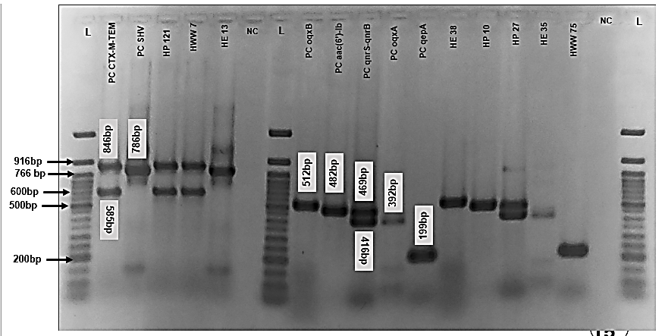
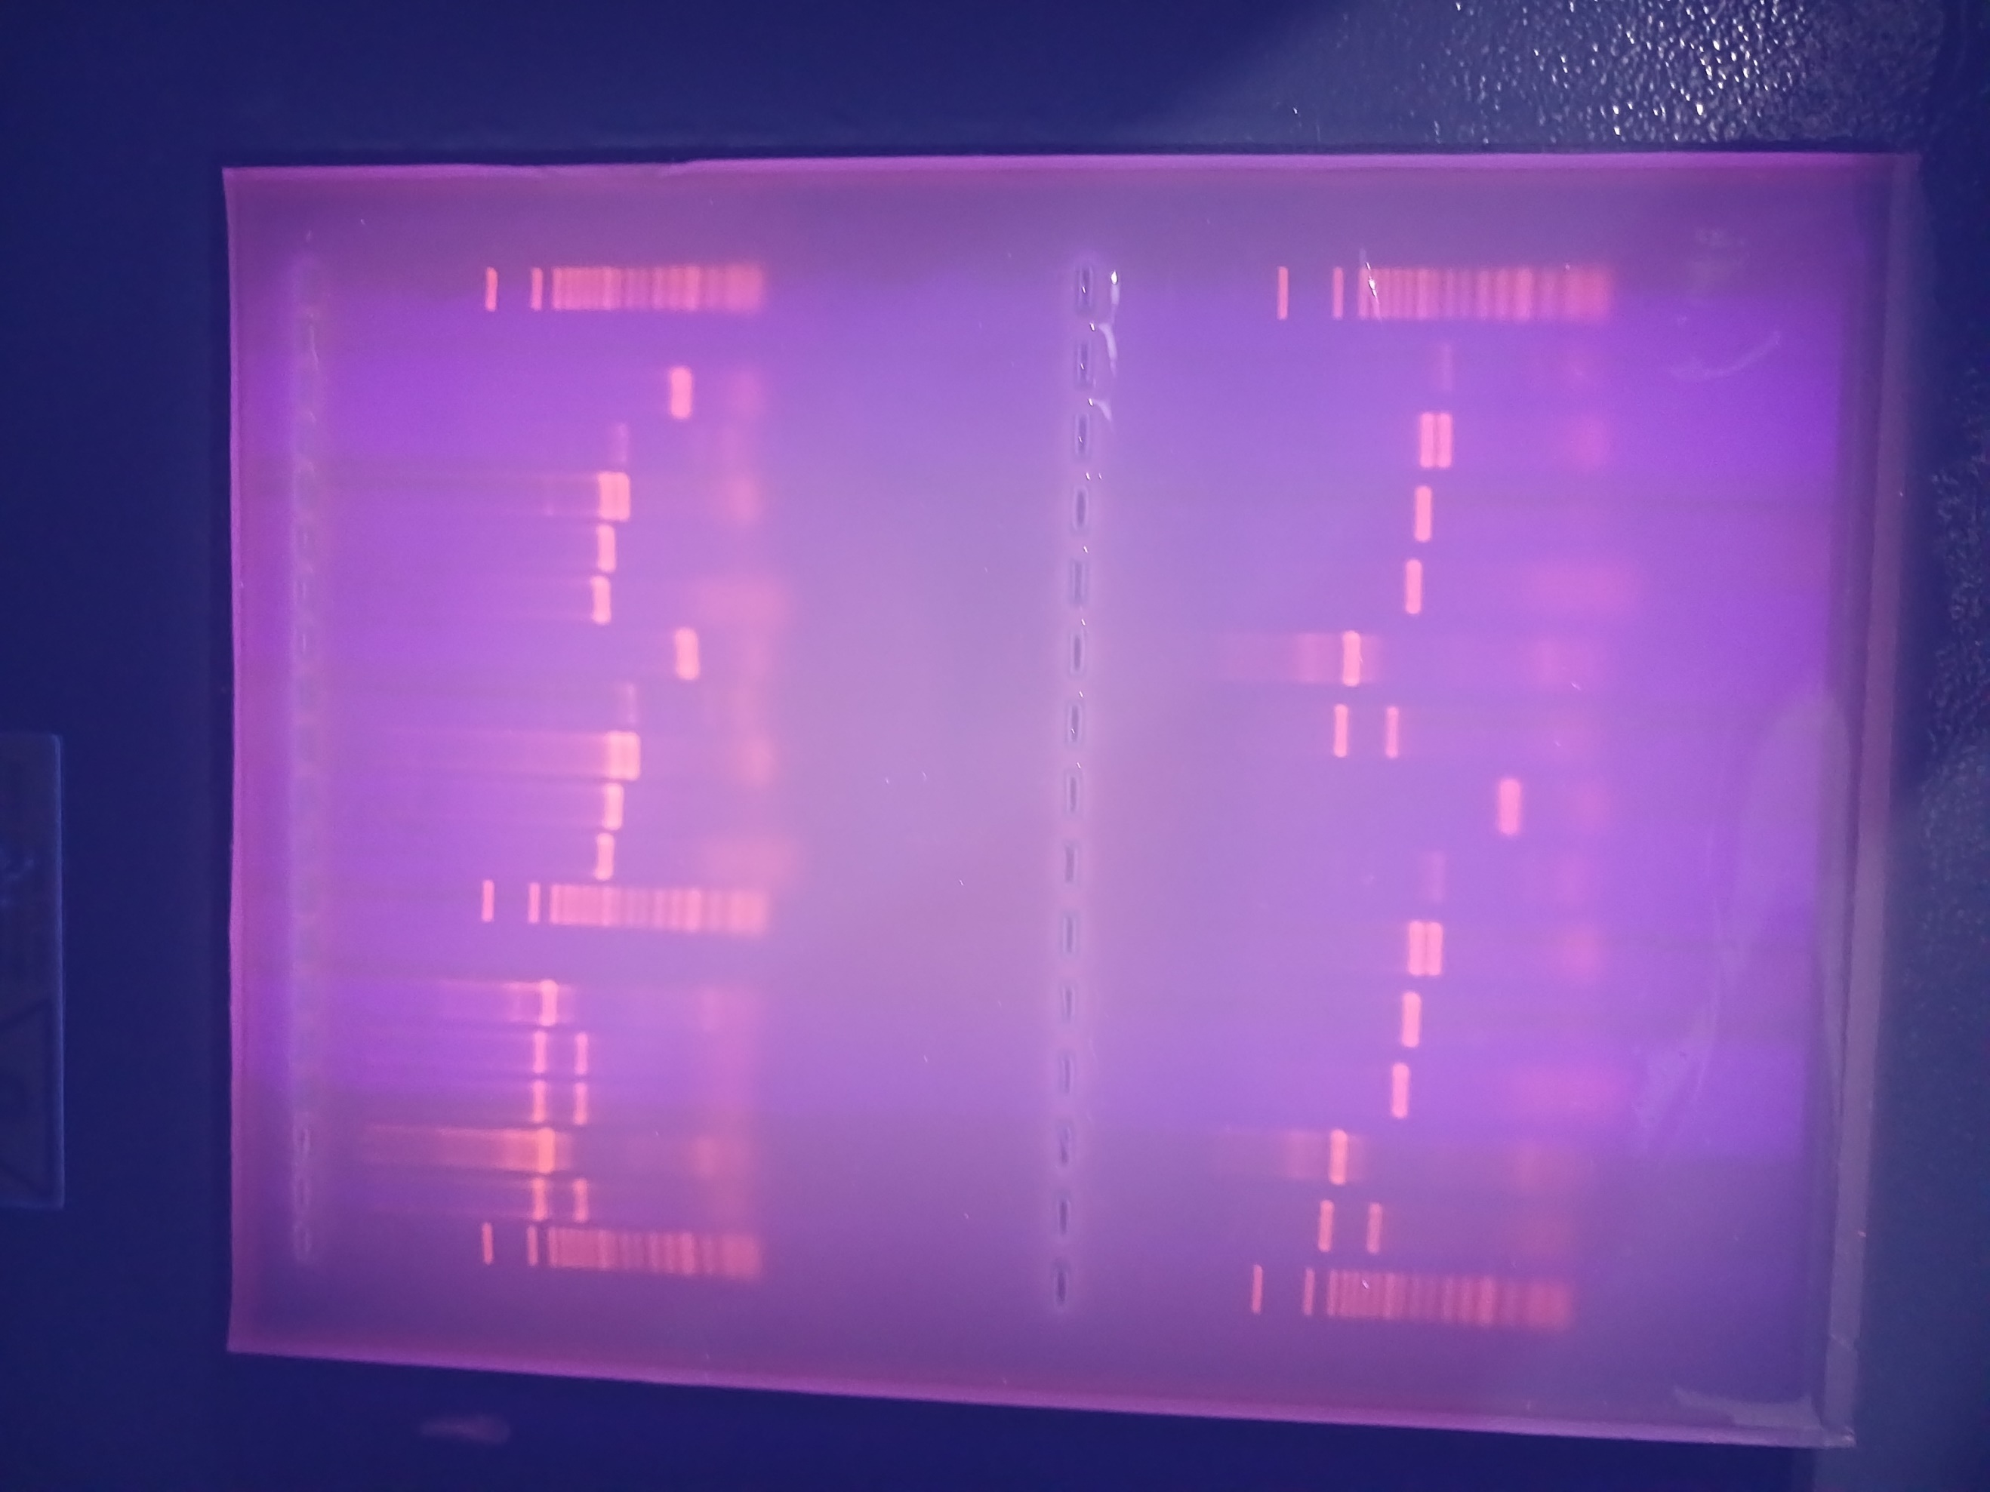
Supplementary Figure S2: (A) Cropped agarose gel electrophoresis of amplified β-lactamase (bla_{CTX-M}, bla_{TEM} & bla_{SHV)} and PMQR genes (aac(6')-Ib-cr, qnrB, qnrS, oqxA, oqxB & qepA) detected respectively among ESBL- and ciprofloxacin-resistant ESBL-E. coli and K. pneumoniae isolated from hospitalized patients, hospital environment and wastewaters. L=Ladder (50bp by Biolabs, New England), PC=Positive Control, NC=Negative Control (Nuclease-free water). (B) Original agarose gel image.
A
B

Supplementary table S4: β-lactamase gene combination frequency in ESBL-E. coli and ESBL-K. pneumoniae
β-Lactamase gene combination present | Source |  |  | Total
β-Lactamase gene combination present | Hospitalized patient | Hospital environment | Wastewater | Total
 | ESBL-Escherichia coli
At least one ESBL gene | 21/26 | 10/11 | 36/38 | 67/75
bla_{CTX-M} + bla_{SHV} | 0 | 1 | 2 | 3
bla_{CTX-M} + bla_{TEM} | 9 | 4 | 21 | 34
bla_{CTX-M} + bla_{TEM} + bla_{SHV} | 4 | 0 | 0 | 4
 | ESBL-Klebsiella pneumoniae
At least one ESBL gene | 26/31 | 28/34 | 33/42 | 87/107
bla_{TEM} + bla_{SHV} | 2 | 0 | 0 | 2
bla_{CTX-M} + bla_{SHV} | 3 | 6 | 1 | 10
bla_{CTX-M} + bla_{TEM} | 7 | 9 | 16 | 32
bla_{CTX-M} + bla_{TEM} + bla_{SHV} | 12 | 10 | 9 | 31

Supplementary table S5: Plasmid-Mediated Quinolone Resistance (PMQR) gene combination frequency detected among ciprofloxacin-resistant ESBL-E. coli and ESBL-K. pneumoniae
PMQR gene combinations | Hospitalized patient | Hospital environment | Wastewater | Total
 | Escherichia coli
At least one PMQR gene | 21/26 | 5/7 | 29/34 | 55/67
oqxA + oqxB | 1 | 0 | 0 | 1
oqxB + qepA | 0 | 0 | 1 | 1
qnrB + qnrS | 1 | 0 | 0 | 1
aac(6')-Ib-cr + oqxA | 1 | 1 | 0 | 2
aac(6')-Ib-cr + oqxB | 0 | 0 | 1 | 1
aac(6')-Ib-cr + qepA | 1 | 0 | 0 | 1
aac(6')-Ib-cr + qnrA + qepA | 1 | 0 | 0 | 1
aac(6')-Ib-cr + qnrB | 2 | 0 | 4 | 6
aac(6')-Ib-cr + qnrB + oqxA | 1 | 0 | 0 | 1
aac(6')-Ib-cr + qnrB + qnrS | 2 | 0 | 0 | 2
aac(6')-Ib-cr + qnrS | 0 | 0 | 7 | 7
aac(6')-Ib-cr + qnrS + oqxA + oqxB + qepA | 1 | 0 | 0 | 1
 | Klebsiella pneumoniae
At least one PMQR gene | 22/26 | 22/26 | 36/41 | 80/93
oqxA + oqxB | 1 | 0 | 2 | 3
qnrB + oqxA | 0 | 0 | 5 | 5
qnrB + oqxA + oqxB | 2 | 0 | 0 | 2
qnrB + oqxB | 0 | 0 | 1 | 1
qnrB + qnrS | 0 | 0 | 1 | 1
qnrS + oqxA | 0 | 0 | 2 | 2
qnrS + oqxA + oqxB | 0 | 1 | 1 | 2
qnrS + oqxB | 0 | 2 | 0 | 2
aac(6')-Ib-cr + oqxA | 1 | 1 | 3 | 5
aac(6')-Ib-cr + oqxA + oqxB | 2 | 1 | 1 | 4
aac(6')-Ib-cr + oqxB | 0 | 0 | 1 | 1
aac(6')-Ib-cr + qnrB | 2 | 1 | 3 | 6
aac(6')-Ib-cr + qnrB + oqxA | 3 | 2 | 4 | 9
aac(6')-Ib-cr + qnrB + oqxA + oqxB | 1 | 1 | 0 | 2
aac(6')-Ib-cr + qnrB + oqxA + oqxB + qepA | 0 | 1 | 0 | 1
aac(6')-Ib-cr + qnrB + oqxB | 1 | 4 | 0 | 5
aac(6')-Ib-cr + qnrB + qnrS + oqxA | 0 | 0 | 2 | 2
aac(6')-Ib-cr + qnrS | 1 | 0 | 1 | 2
aac(6')-Ib-cr + qnrS + oqxA | 4 | 2 | 0 | 6
aac(6')-Ib-cr + qnrS + oqxA + oqxB | 1 | 6 | 0 | 7
aac(6')-Ib-cr + qnrS + oqxB | 1 | 0 | 0 | 1

Supplementary table S6: Frequency of ESBL and PMQR gene combination in ciprofloxacin-resistant ESBL-E. coli
Frequency of ESBL and PMQR gene combination | Patient | HEV | HWW | Total
At least one ESBL and one PMQR gene | 19/26 | 5/7 | 29/34 | 53/67
bla_{TEM} + aac(6')-Ib-cr | 1 | 0 | 0 | 1
bla_{TEM} + qnrA | 1 | 0 | 0 | 1
bla_{CTX-M} + aac(6')-Ib-cr | 2 | 1 | 4 | 7
bla_{CTX-M} + aac(6')-Ib-cr + qnrA + qepA | 1 | 0 | 0 | 1
bla_{CTX-M} + aac(6')-Ib-cr + qnrB | 1 | 0 | 0 | 1
bla_{CTX-M} + aac(6')-Ib-cr + qnrB + qnrS | 1 | 0 | 0 | 1
bla_{CTX-M} + aac(6')-Ib-cr + qnrS | 0 | 0 | 4 | 4
bla_{CTX-M} + bla_{SHV} + aac(6')-Ib-cr + oqxA | 0 | 1 | 0 | 1
bla_{CTX-M} + bla_{SHV} + aac(6')-Ib-cr + qnrS | 0 | 0 | 2 | 2
bla_{CTX-M} + bla_{TEM} + aac(6')-Ib-cr | 2 | 2 | 6 | 10
bla_{CTX-M} + bla_{TEM} + aac(6')-Ib-cr + oqxB | 0 | 0 | 1 | 1
bla_{CTX-M} + bla_{TEM} + aac(6')-Ib-cr + qepA | 1 | 0 | 0 | 1
bla_{CTX-M} + bla_{TEM} + aac(6')-Ib-cr + qnrB | 1 | 0 | 4 | 5
bla_{CTX-M} + bla_{TEM} + aac(6')-Ib-cr + qnrB + oqxA | 1 | 0 | 0 | 1
bla_{CTX-M} + bla_{TEM} + aac(6')-Ib-cr + qnrB + qnrS | 1 | 0 | 0 | 1
bla_{CTX-M} + bla_{TEM} + aac(6')-Ib-cr + qnrS | 0 | 0 | 1 | 1
bla_{CTX-M} + bla_{TEM} + bla_{SHV} + aac(6')-Ib-cr + oqxA | 1 | 0 | 0 | 1
bla_{CTX-M} + bla_{TEM} + bla_{SHV} + aac(6')-Ib-cr + qnrS + oqxA + oqxB + qepA | 1 | 0 | 0 | 1
bla_{CTX-M} + bla_{TEM} + bla_{SHV} + oqxA | 1 | 0 | 0 | 1
bla_{CTX-M} + bla_{TEM} + bla_{SHV} + oqxA + oqxB | 1 | 0 | 0 | 1
bla_{CTX-M} + bla_{TEM} + oqxB + qepA | 0 | 0 | 1 | 1
bla_{CTX-M} + bla_{TEM} + qepA | 0 | 0 | 3 | 3
bla_{CTX-M} + bla_{TEM} + qnrB | 1 | 0 | 1 | 2
bla_{CTX-M} + bla_{TEM} + qnrS | 0 | 1 | 0 | 1
bla_{CTX-M} + qepA | 0 | 0 | 2 | 2
bla_{CTX-M} + qnrB + qnrS | 1 | 0 | 0 | 1

Supplementary table S7: Frequency of ESBL and PMQR gene combination in ciprofloxacin-resistant ESBL-Klebsiella pneumoniae
Frequency of ESBL and PMQR gene combination | Patient | HEV | HWW | Total
At least one ESBL and one PMQR gene | 24/26 | 21/26 | 30/41 | 75/93
bla_{SHV} + aac(6')-Ib-cr + qnrB + qnrS + oqxA | 0 | 0 | 1 | 1
bla_{TEM} + bla_{SHV} + aac(6’)-Ib-cr+ qnrS + oqxA | 1 | 0 | 0 | 1
bla_{TEM} + bla_{SHV} + aac(6’)-Ib-cr+ qnrS + oqxA + oqxB | 1 | 0 | 0 | 1
bla_{CTX-M} + aac(6’)-Ib-cr+ qnrB | 0 | 1 | 0 | 1
bla_{CTX-M} + aac(6’)-Ib-cr+ qnrB + qnrS + oqxA | 0 | 0 | 1 | 1
bla_{CTX-M} + aac(6’)-Ib-cr+ qnrS | 1 | 0 | 0 | 1
bla_{CTX-M} + bla_{SHV} + aac(6’)-Ib-cr+ oqxA + oqxB | 1 | 1 | 0 | 2
bla_{CTX-M} + bla_{SHV} + aac(6’)-Ib-cr+ qnrB + oqxA | 0 | 0 | 1 | 1
bla_{CTX-M} + bla_{SHV} + aac(6’)-Ib-cr+ qnrS + oqxA | 0 | 1 | 0 | 1
bla_{CTX-M} + bla_{SHV} + aac(6’)-Ib-cr+ qnrS + oqxA + oqxB | 0 | 2 | 0 | 2
bla_{CTX-M} + bla_{SHV} + oqxA + oqxB | 1 | 0 | 0 | 1
bla_{CTX-M} + bla_{SHV} + qnrB + oqxA + oqxB | 1 | 0 | 0 | 1
bla_{CTX-M} + bla_{TEM} + aac(6’)-Ib-cr+ oqxA | 1 | 0 | 2 | 3
bla_{CTX-M} + bla_{TEM} + aac(6’)-Ib-cr+ oqxA + oqxB | 1 | 0 | 0 | 1
bla_{CTX-M} + bla_{TEM} + aac(6’)-Ib-cr+ oqxB | 0 | 0 | 1 | 1
bla_{CTX-M} + bla_{TEM} + aac(6’)-Ib-cr+ qnrB | 1 | 0 | 3 | 4
bla_{CTX-M} + bla_{TEM} + aac(6’)-Ib-cr+ qnrB + oqxA | 0 | 0 | 1 | 1
bla_{CTX-M} + bla_{TEM} + aac(6’)-Ib-cr+ qnrB + oqxA + oqxB | 0 | 1 | 0 | 1
bla_{CTX-M} + bla_{TEM} + aac(6’)-Ib-cr+ qnrB + oqxA + oqxB + qepA | 0 | 1 | 0 | 1
bla_{CTX-M} + bla_{TEM} + aac(6’)-Ib-cr+ qnrB + oqxB | 2 | 3 | 0 | 5
bla_{CTX-M} + bla_{TEM} + aac(6’)-Ib-cr+ qnrS + oqxB | 1 | 0 | 0 | 1
bla_{CTX-M} + bla_{TEM} + bla_{SHV} + aac(6’)-Ib-cr+ oqxA | 0 | 1 | 1 | 2
bla_{CTX-M} + bla_{TEM} + bla_{SHV} + aac(6’)-Ib-cr+ oqxA + oqxB | 1 | 0 | 1 | 2
bla_{CTX-M} + bla_{TEM} + bla_{SHV} + aac(6’)-Ib-cr+ qnrB | 1 | 0 | 0 | 1
bla_{CTX-M} + bla_{TEM} + bla_{SHV} + aac(6’)-Ib-cr+ qnrB + oqxA | 3 | 1 | 2 | 6
bla_{CTX-M} + bla_{TEM} + bla_{SHV} + aac(6’)-Ib-cr+ qnrB + oqxA + oqxB | 1 | 0 | 0 | 1
bla_{CTX-M} + bla_{TEM} + bla_{SHV} + aac(6’)-Ib-cr+ qnrB + oqxB | 1 | 1 | 0 | 2
bla_{CTX-M} + bla_{TEM} + bla_{SHV} + aac(6’)-Ib-cr+ qnrS | 0 | 0 | 1 | 1
bla_{CTX-M} + bla_{TEM} + bla_{SHV} + aac(6’)-Ib-cr+ qnrS + oqxA | 3 | 1 | 0 | 4
bla_{CTX-M} + bla_{TEM} + bla_{SHV} + aac(6’)-Ib-cr+ qnrS + oqxA + oqxB | 1 | 4 | 0 | 5
bla_{CTX-M} + bla_{TEM} + bla_{SHV} + oqxB | 0 | 0 | 1 | 1
bla_{CTX-M} + bla_{TEM} + bla_{SHV} + qnrB + oqxA | 0 | 0 | 3 | 3
bla_{CTX-M} + bla_{TEM} + bla_{SHV} + qnrB + oqxA + oqxB | 1 | 0 | 0 | 1
bla_{CTX-M} + bla_{TEM} + bla_{SHV} + qnrS + oqxA + oqxB | 0 | 1 | 0 | 1
bla_{CTX-M} + bla_{TEM} + oqxA | 0 | 0 | 2 | 2
bla_{CTX-M} + bla_{TEM} + oqxA + oqxB | 0 | 0 | 2 | 2
bla_{CTX-M} + bla_{TEM} + oqxB | 0 | 0 | 1 | 1
bla_{CTX-M} + bla_{TEM} + qnrB + oqxA | 0 | 0 | 1 | 1
bla_{CTX-M} + bla_{TEM} + qnrB + qnrS | 0 | 0 | 1 | 1
bla_{CTX-M} + bla_{TEM} + qnrS + oqxA + oqxB | 0 | 0 | 1 | 1
bla_{CTX-M} + bla_{TEM} + qnrS + oqxB | 0 | 2 | 0 | 2
bla_{CTX-M} + qnrB + oqxB | 0 | 0 | 1 | 1
bla_{CTX-M} + qnrS + oqxA | 0 | 0 | 2 | 2

Targeted genes | Primers names | Sequence (5’-3’) | Amplicon size (bp) |  | Annealing Temp. |  | Ref.
bla_{CTX-M} | CTX-MU1  CTX-MU2 | CGATGTGCAGTACCAGTAA  TTAGTGACCAGAATCAGCGG |  | 585 |  | 47 °C | [1]
bla_{TEM} | TEM-F  TEM-R | CATTTCCGTGTCGCCCTTATTC  CCAATGCTTAATCAGTGAGGC |  | 846 |  | 47 °C | [2]
bla_{SHV} | SHV-F  SHV-R | AGCCGCTTGAGCAAATTAAAC  GTTGCCAGTGCTCGATCAGC |  | 786 |  | 58.8 °C | [2]
qnrA | qnrA-F  qnrA -R | ATTTCTCACGCCAGGATTTG  GATCGGCAAAGGTTAGGTCA |  | 516 |  | 55 °C | [3]
qnrB | qnrB-F  qnrB -R | GATCGTGAAAGCCAGAAAGG  ACGATGCCTGGTAGTTGTCC |  | 469 |  | 55 °C | [3]
qnrS | qnrS-F  qnrS -R | ACGACATTCGTCAACTGCAA  TAAATTGGCACCCTGTAGGC |  | 417 |  | 55 °C | [3]
aac(6')-Ib-cr | aac(6')-Ib-F  aac(6')-Ib-R | TTGCGATGCTCTATGAGTGGCTA  CTCGAATGCCTGGCGTGTTT |  | 482 |  | 48 °C | [4]
oqxA | oqxA-F  oqxA-R | CTCGGCGCGATGATGCT  CCACTCTTCACGGGAGACGA |  | 392 |  | 56 °C | [5]
oqxB | oqxB-F  oqxB-R | TTCTCCCCCGGCGGGAAGTAC  CTCGGCCATTTTGGCGCGTA |  | 512 |  | 48 °C | [5]
qepA | qepA-F  qepA-R | GCAGGTCCAGCAGCGGGTAG  CTTCCTGCCCGAGTATCGTG |  | 199 |  | 57 °C | [6]
ERIC | ERIC 1F  ERIC 2R | ATGTAAGCTCCTGGGGATTCAC AAGTAAGTGACTGGGGTGAGCG |  | variable |  | 60 °C | [7]
Supplementary Table S8: List of primers used for the detection of resistance genes and clonal relatedness.
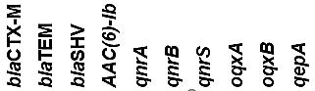
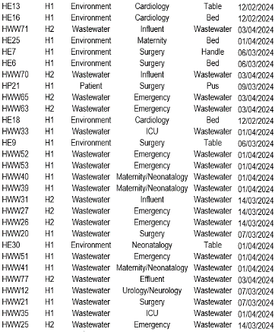
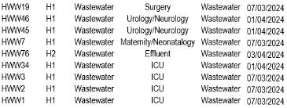
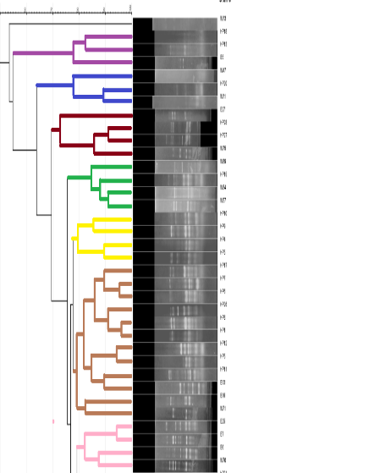
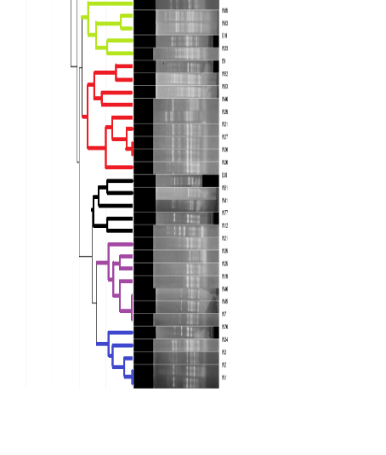
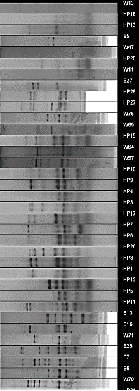
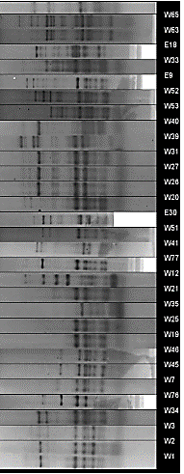
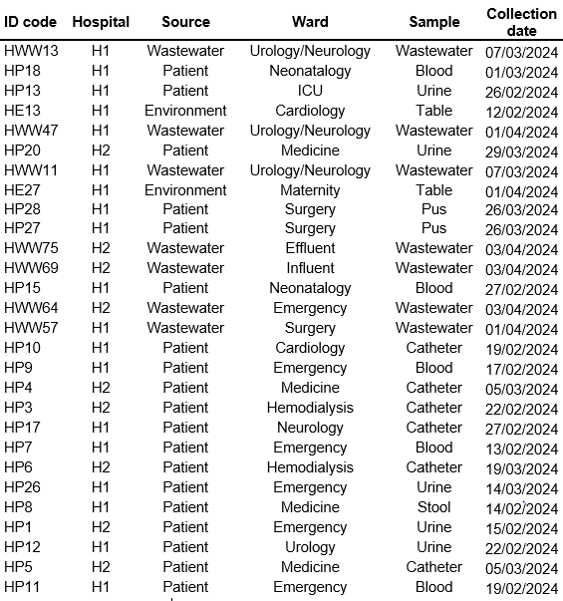
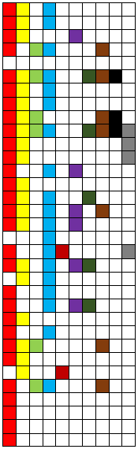
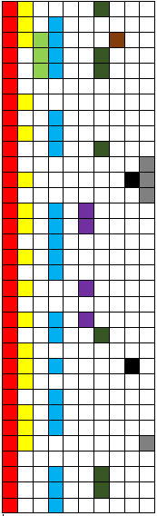
bp=base pair, Temp=Temperature, Ref=Reference.
E1
E2
E3
E4
E5
E6
E7
E8
E9
E10
E11
E12

Figure 9: Genetic relatedness of ESBL-E. coli (n=66) isolated from hospitalized patients,
the hospital environment and wastewaters of two healthcare centers of Yaoundé, Cameroon.
H1=Yaoundé Central Hospital, H2=Yaoundé University Teaching Hospital, ICU=Intensive Care Unit

References
[1]. Batchelor M, Hopkins K, Threlfall EJ, Clifton-Hadley FA, Stallwood AD, Davies RH, et al. bla(CTX-M) genes in clinical Salmonella isolates recovered from humans in England and Wales from 1992 to 2003. Antimicrob Agents Chemother. 2005;49(4):1319-22.
[2]. Strauß LM, Dahms C, Becker K, Kramer A, Kaase M, Mellmann A. Development and evaluation of a novel universal β-lactamase gene subtyping assay for blaSHV, blaTEM and blaCTX-M using clinical and livestock-associated Escherichia coli. J Antimicrob Chemother. 2015;70(3):710-5.
[3]. Robicsek A, Strahilevitz J, Sahm DF, Jacoby GA, Hooper DC. qnr prevalence in ceftazidime-resistant Enterobacteriaceae isolates from the United States. Antimicrob Agents Chemother. 2006;50(8):2872-4.
[4]. Park CH, Robicsek A, Jacoby GA, Sahm D, Hooper DC. Prevalence in the United States of aac(6')-Ib-cr encoding a ciprofloxacin-modifying enzyme. Antimicrob Agents Chemother. 2006;50(11):3953-5.
[5]. Kim HB, Wang M, Park CH, Kim EC, Jacoby GA, Hooper DC. oqxAB encoding a multidrug efflux pump in human clinical isolates of Enterobacteriaceae. Antimicrob Agents Chemother. 2009;53(8):3582-4.
[6]. Yamane K, Wachino J, Suzuki S, Arakawa Y. Plasmid-mediated qepA gene among Escherichia coli clinical isolates from Japan. Antimicrob Agents Chemother. 2008;52(4):1564-6.
[7]. Dimani BD, Founou RC, Zemtsa JR, Mbossi A, Koudoum PL, Founou LL, et al. Faecal carriage of multidrug-resistant and extended-spectrum β-lactamase-producing Enterobacterales in people living with HIV in Yaoundé, Cameroon. Journal of Global Antimicrobial Resistance. 2023;35:26-34.

