Supplementary Information files

Figure S1 Meta-Analysis Results of Plyometric Training on CMJ in Handball Players
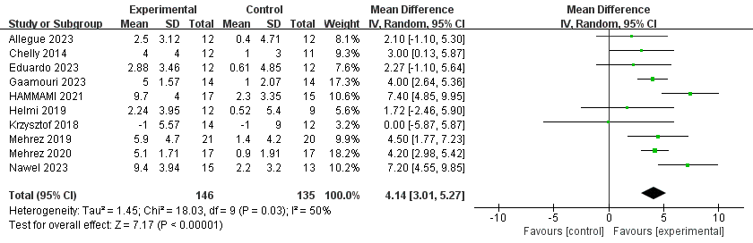

Figure S2 Meta-Analysis Results of Plyometric Training on SJ in Handball Players
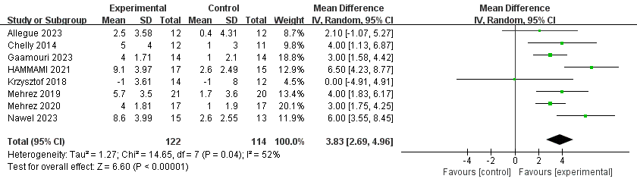

Figure S3 Meta-Analysis Results of Plyometric Training on CMJA in Handball Players
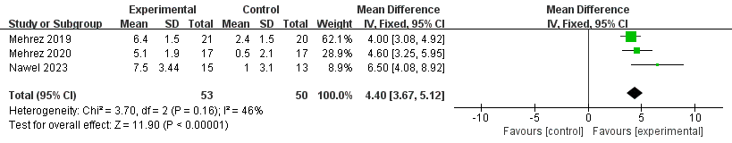

Figure S4 Meta-Analysis Results of Plyometric Training on 5JT in Handball Players
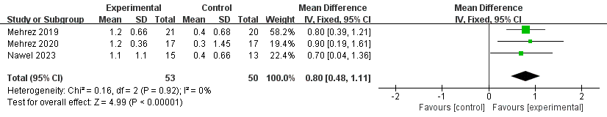

Figure S5 Meta-Analysis Results of Plyometric Training on COD in Handball Players
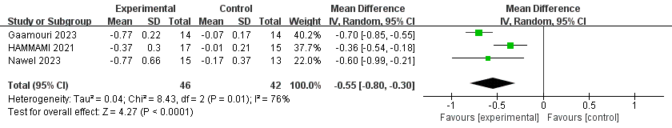

Figure S6 Meta-Analysis Results of Plyometric Training on 5m Performance in Handball Players
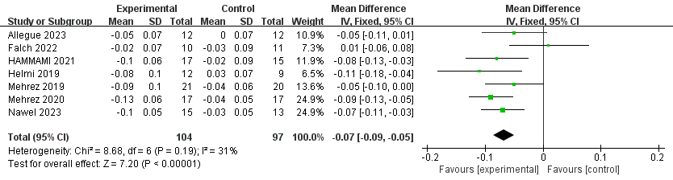

Figure S7 Meta-Analysis Results of Plyometric Training on 10m Performance in Handball Players
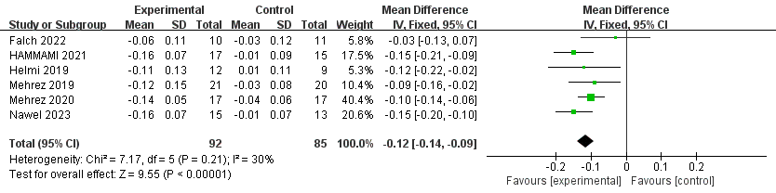

Figure S8 Meta-Analysis Results of Plyometric Training on 20m Performance in Handball Players
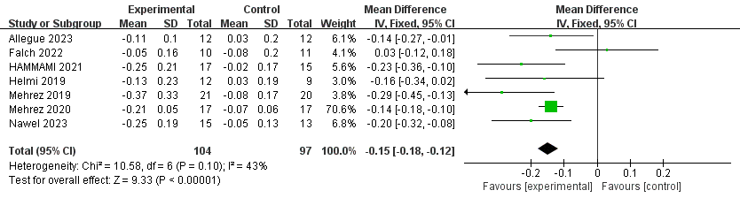

Figure S10 Meta-Analysis Results of Plyometric Training on 3-Step Running Throw in Handball Players
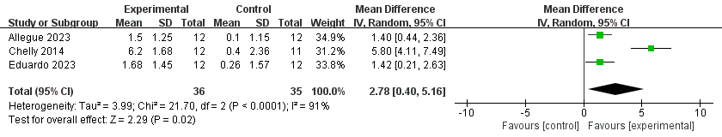

Figure S11 Meta-Analysis Results of Plyometric Training on Jumping Throw in Handball Players
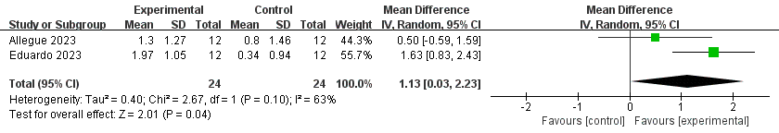

Figure S12 Meta-Analysis Results of Plyometric Training on Penalty Throw in Handball Players
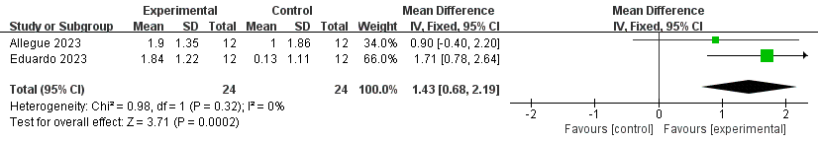

Figure S13 Meta-Analysis Results of Plyometric Training on RSA-TT in Handball Player
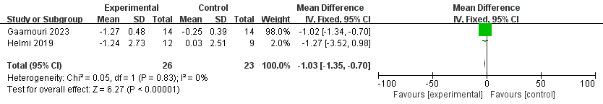

Figure S14 Meta-Analysis Results of Plyometric Training on RSA-MT in Handball Players
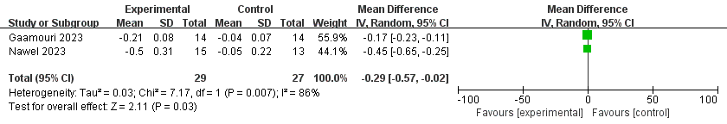

Figure S15 Meta-Analysis Results of Plyometric Training on RSA-BT in Handball Players
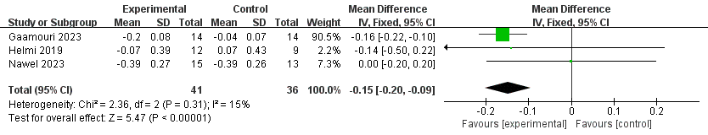

Figure S16 Meta-Analysis Results of Plyometric Training on RSA-FI in Handball Players
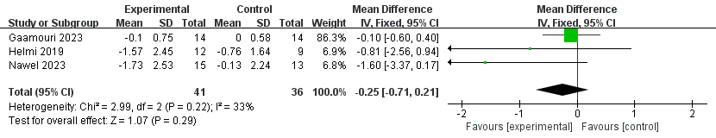

Figure S17 Meta-Analysis Results of Plyometric Training on Upper Limb Peak Power in Handball Players
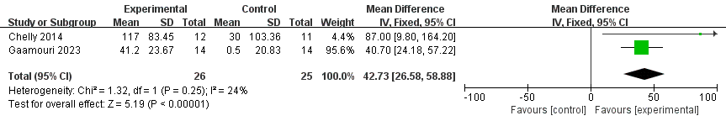

Figure S18 Meta-Analysis Results of Plyometric Training on Upper Limb Relative Peak Power in Handball Players
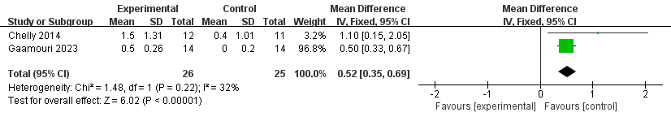

Figure S19 Meta-Analysis Results of Plyometric Training on Upper Limb Maximum Cadence in Handball Players
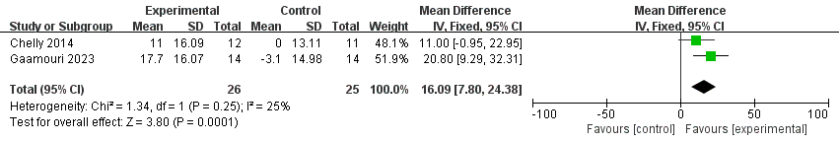

Figure S20 Meta-Analysis Results of Plyometric Training on Upper Limb Maximum Braking Force in Handball Players
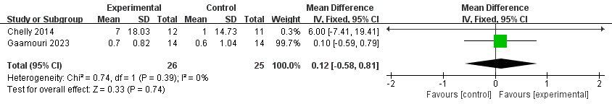

Figure S21 Meta-Analysis Results of Plyometric Training on Lower Limb Peak Power in Handball Players
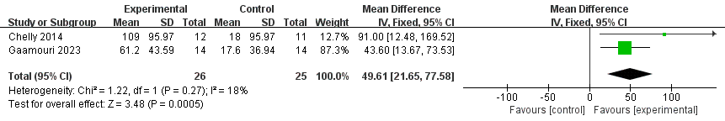

Figure S22 Meta-Analysis Results of Plyometric Training on Lower Limb Relative Peak Power in Handball Players
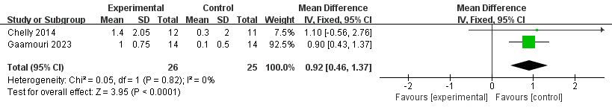

Figure S23 Meta-Analysis Results of Plyometric Training on Lower Limb Maximum Cadence in Handball Players
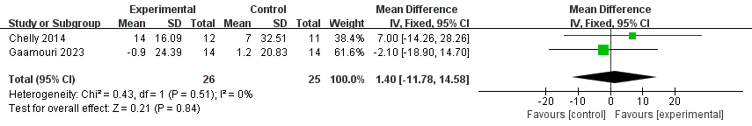

Figure S24 Meta-Analysis Results of Plyometric Training on Lower Limb Maximum Braking Force in Handball Players
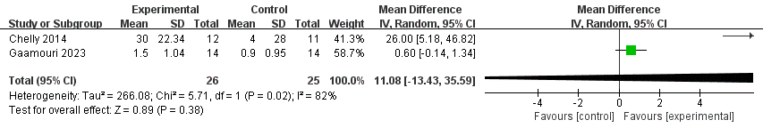

Figure S25 Meta-Analysis Results of Plyometric Training on Right Hand Grip Strength in Handball Players
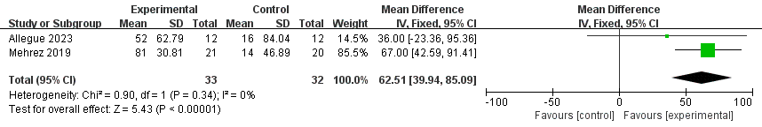

Figure S26 Meta-Analysis Results of Plyometric Training on Left Hand Grip Strength in Handball Players
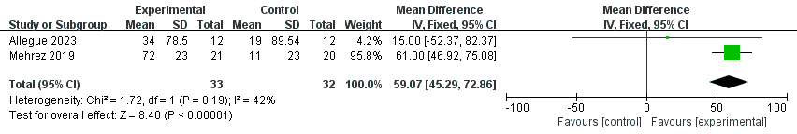

Figure S27 Meta-Analysis Results of Plyometric Training on Right Leg Balance Ability in Handball Players
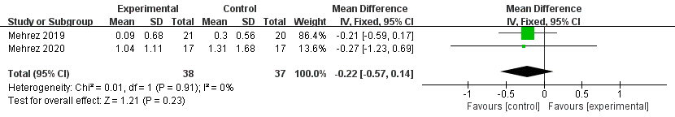

Figure S28 Meta-Analysis Results of Plyometric Training on Left Leg Balance Ability in Handball Players
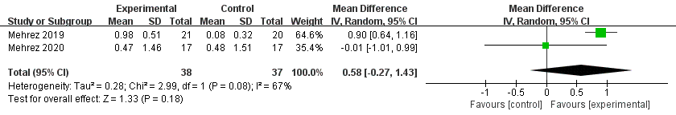

Figure S29 Subgroup Analysis Forest Plot of the Impact of Different Training Methods on CMJ
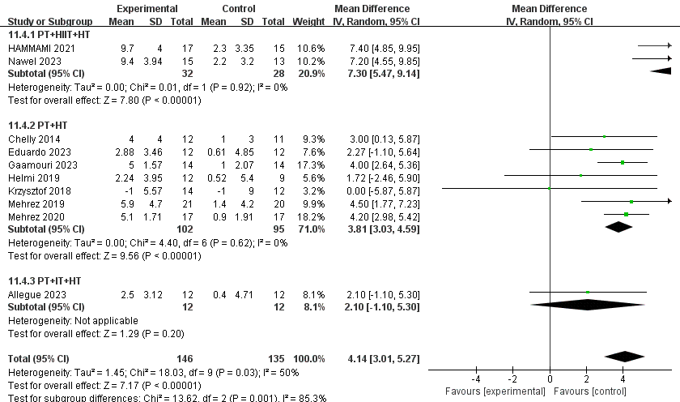

Figure S30 Subgroup Analysis Forest Plot of the Impact of Different Training Methods on SJ

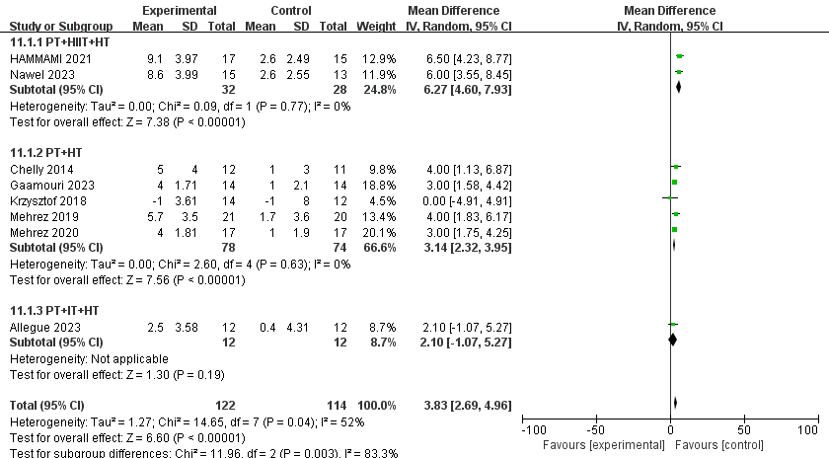

Figure S31 Subgroup Analysis Forest Plot of the Impact of Different Training Methods on CMJA

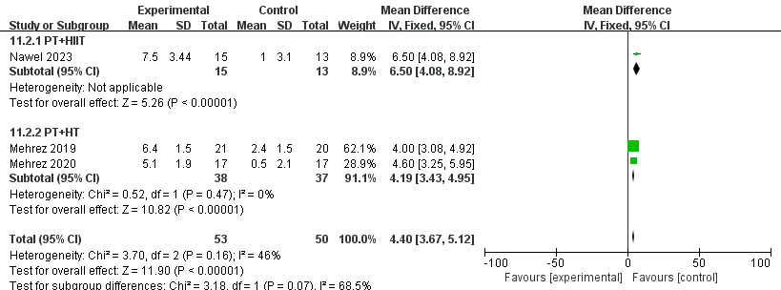

Figure S32 Subgroup Analysis Forest Plot of the Impact of Different Training Methods on 5JT

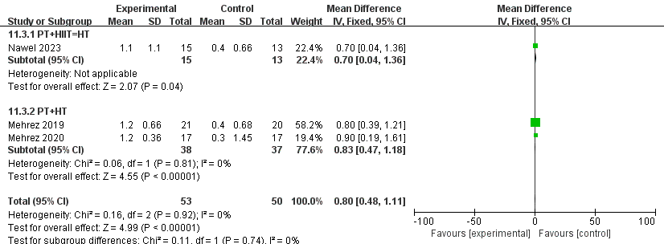

Figure S33 Subgroup Analysis Forest Plot of the Impact of Different Training Methods on 5M

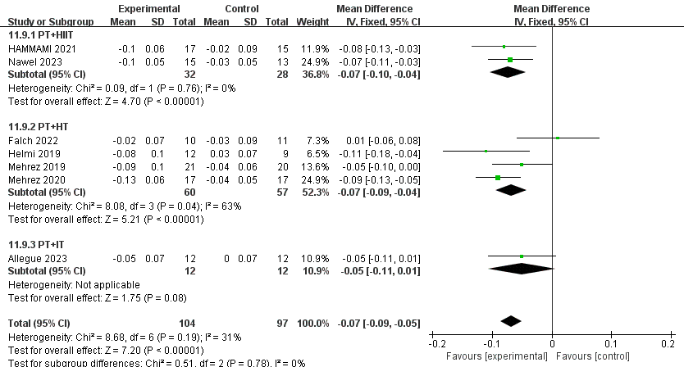

Figure S34 Subgroup Analysis Forest Plot of the Impact of Different Training Methods on 10M

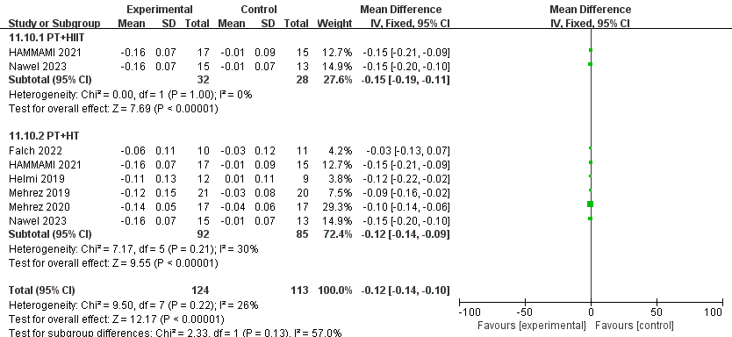

Figure S35 Subgroup Analysis Forest Plot of the Impact of Different Training Methods on 20M
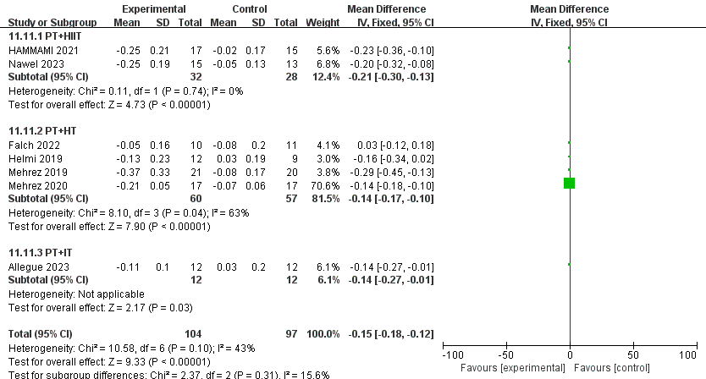
Figure S36 Subgroup Analysis Forest Plot of the Impact of Different Training Methods on RSA-FI

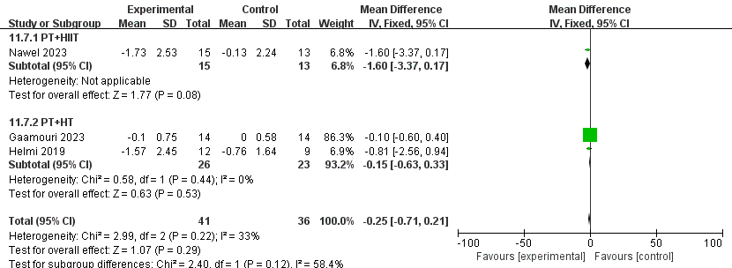
Figure S37 Subgroup Analysis Forest Plot of the Impact of Different Training Methods on RSA-BT

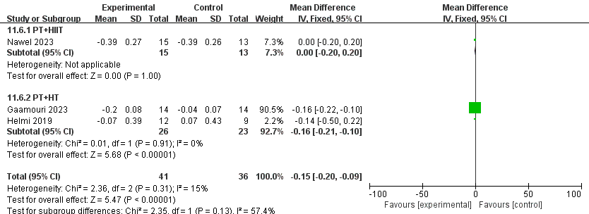

Figure S38 Subgroup Analysis Forest Plot of the Impact of Different Training Methods on RSA-MT

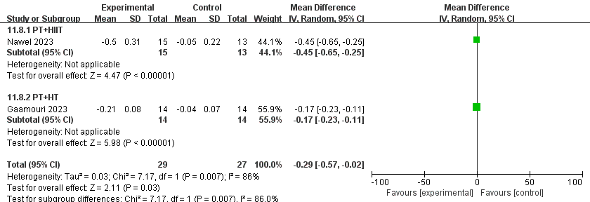
Figure S39 Subgroup Analysis Forest Plot of the Impact of Different Training Methods on T-HALF

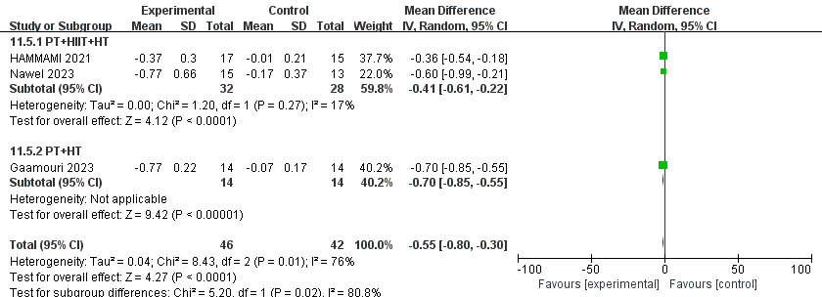

Figure S40 Forest plot of subgroup analysis on the impact of PT on CMJ in different gender groups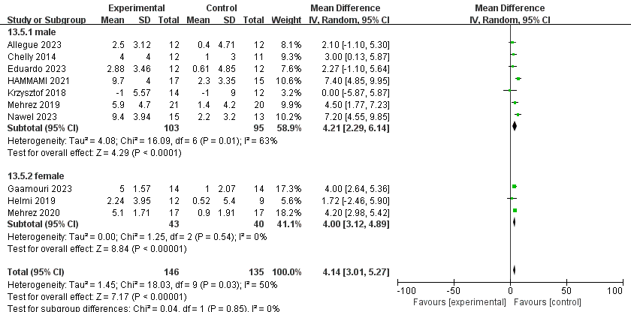
Figure S41 Forest plot of subgroup analysis on the impact of PT on CMJA in different gender groups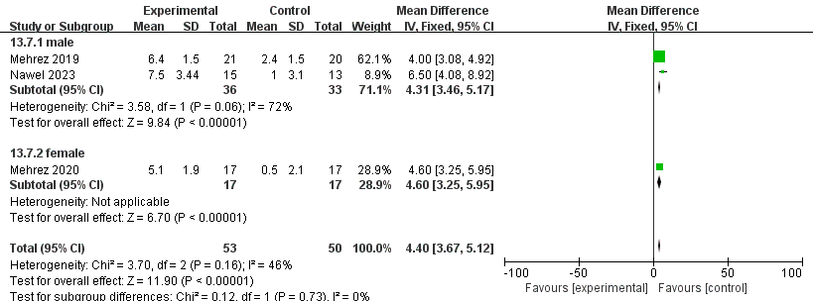

Figure S42 Forest plot of subgroup analysis on the impact of PT on SJ in different gender groups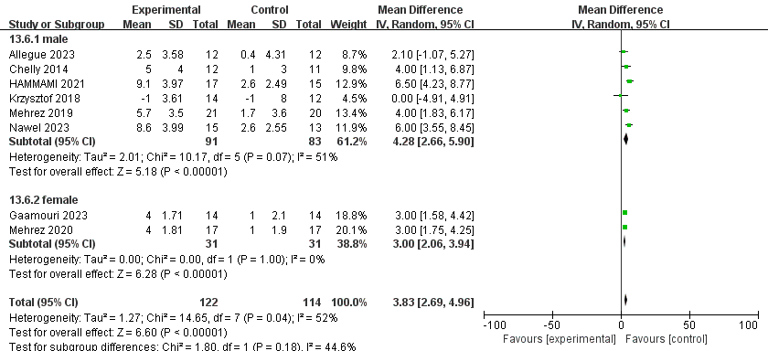
Figure S43 Forest plot of subgroup analysis on the impact of PT on 5JT in different gender groups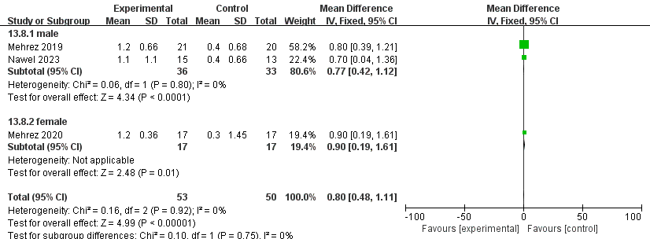

Figure S44 Forest plot of subgroup analysis on the impact of PT on 5M in different gender groups
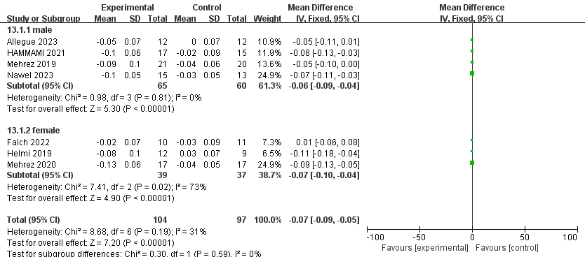
Figure S45 Forest plot of subgroup analysis on the impact of PT on 10M in different gender groups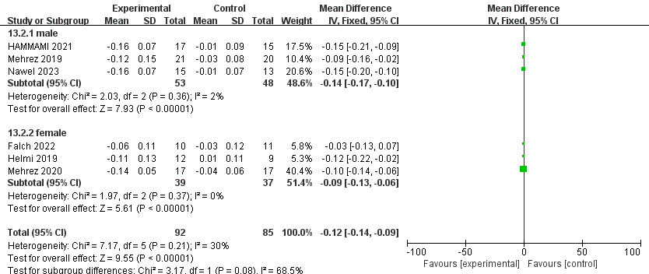
Figure S46 Forest plot of subgroup analysis on the impact of PT on 20M in different gender groups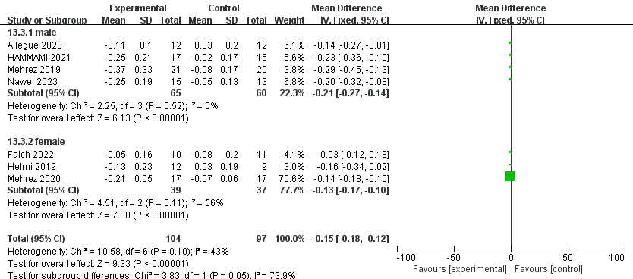
Figure S47 Forest plot of subgroup analysis on the impact of PT on T-HALF in different gender groups
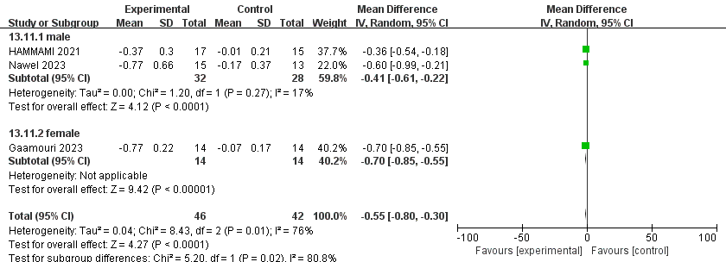
Figure S48 Forest plot of subgroup analysis on the impact of PT on upper limb maximum cadence in different gender groups
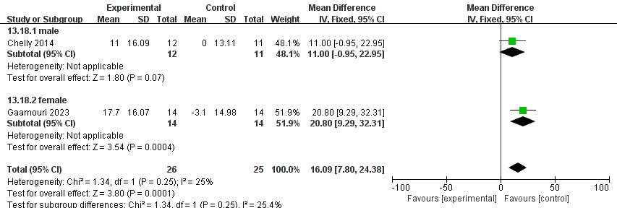

Figure S49 Forest plot of subgroup analysis on the impact of PT on lower limb maximum cadence in different gender groups
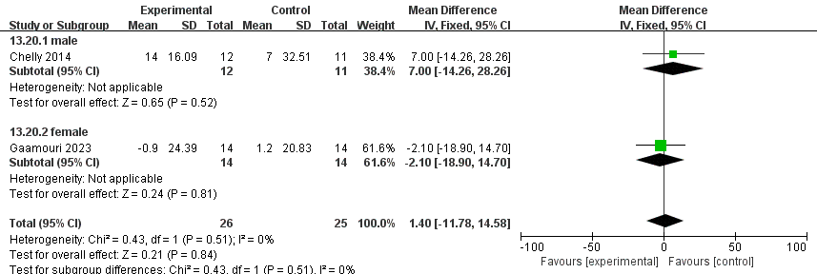
Figure S50 Forest plot of subgroup analysis on the impact of PT on upper limb relative peak power in different gender groups
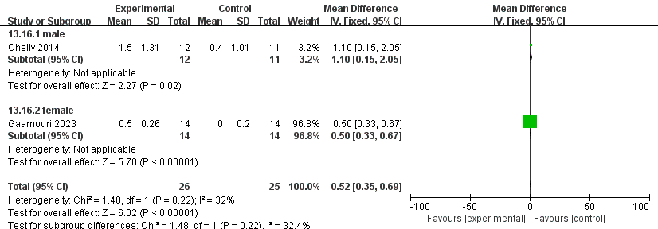
Figure S51 Forest plot of subgroup analysis on the impact of PT on lower limb relative peak power in different gender groups
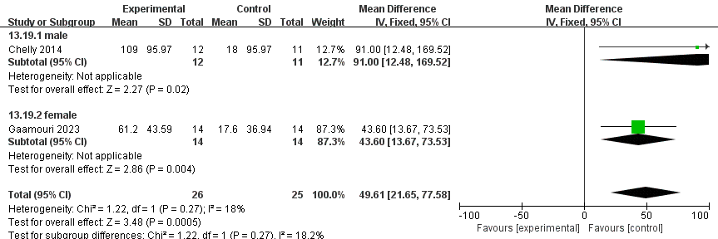
Figure S52 Forest plot of subgroup analysis on the impact of PT on upper limb peak power in different gender groups
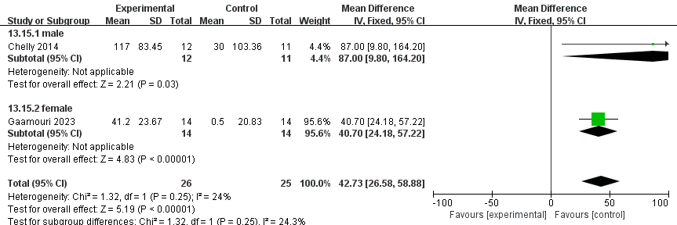
Figure S53 Forest plot of subgroup analysis on the impact of PT on lower limb peak power in different gender groups
Figure S54 Forest plot of subgroup analysis on the impact of PT on upper limb maximum cadence in different gender groups
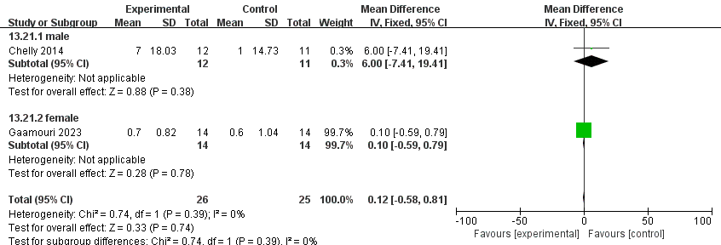
Figure S55 Forest plot of subgroup analysis on the impact of PT on lower limb maximum cadence in different gender groups
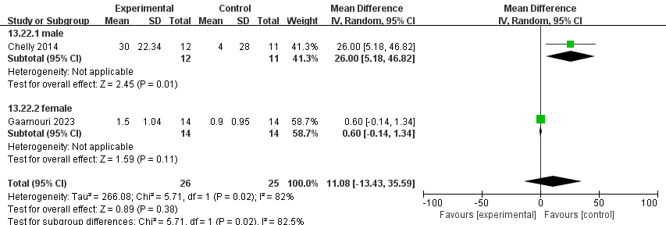
Figure S56 Forest plot of subgroup analysis on the impact of PT on RSA-MT in different gender groups
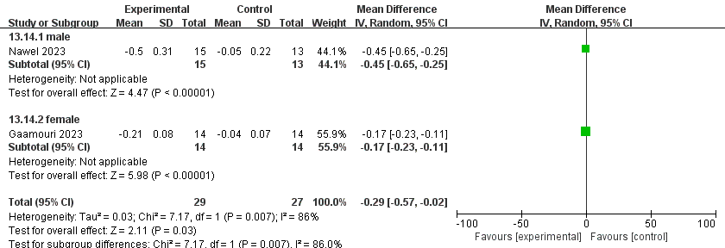
Figure S57 Forest plot of subgroup analysis on the impact of PT on RSA-FI in different gender groups

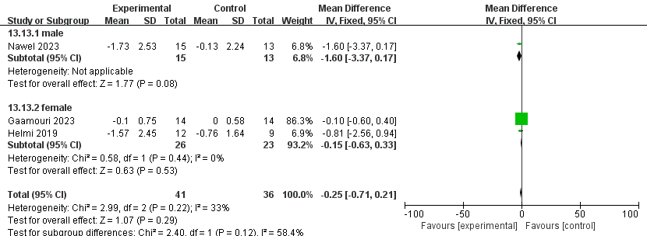
Figure S58 Forest plot of subgroup analysis on the impact of PT on RSA-BT in different gender groups

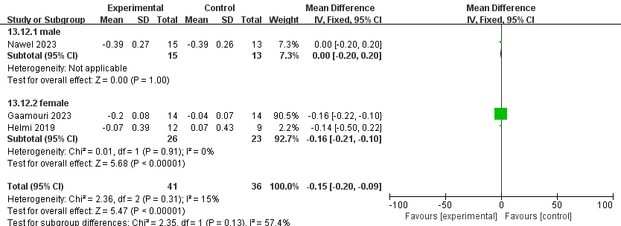
Figure S59 Forest plot of subgroup analysis on the impact of PT on left leg balance in different gender groups
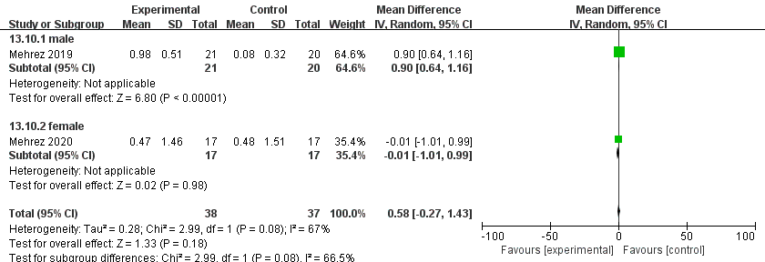

Figure S60 Forest plot of subgroup analysis on the impact of PT on right leg balance in different gender groups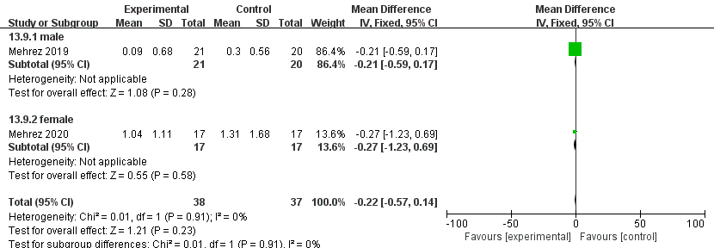

Figure S61 Forest plot of subgroup analysis on the impact of PT on 5M sprint in different age groups
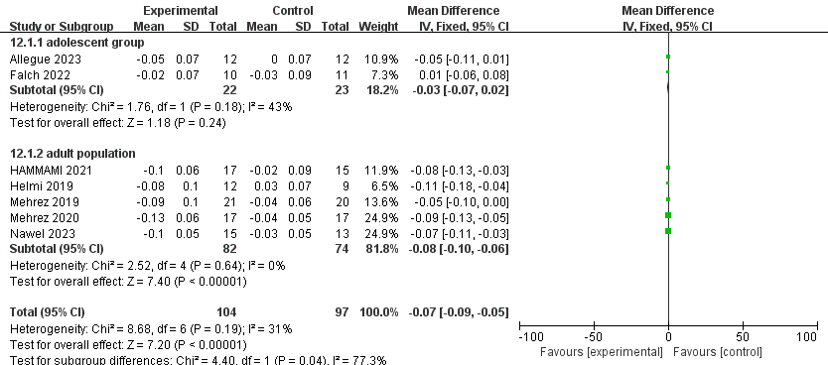
Figure S62 Forest plot of subgroup analysis on the impact of PT on 10M sprint in different age groups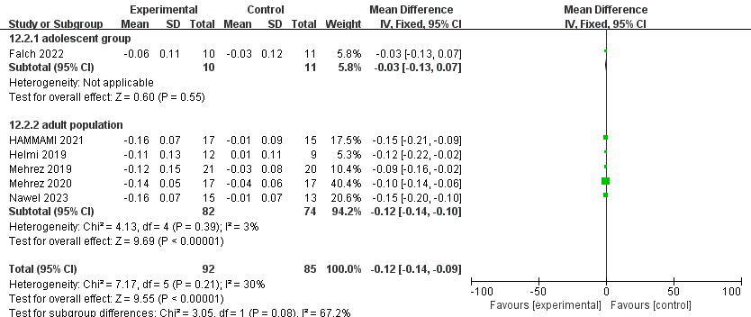
Figure S63 Forest plot of subgroup analysis on the impact of PT on 20M sprint in different age groups
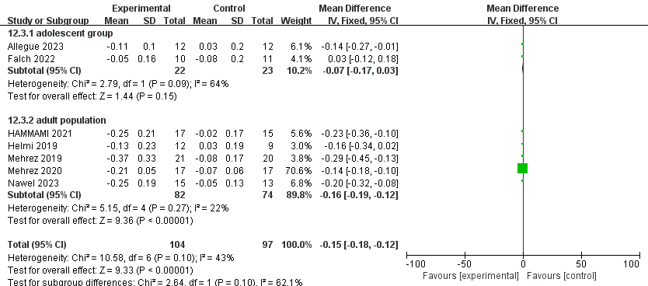
Figure S64 Forest plot of subgroup analysis on the impact of PT on CMJ in different age groups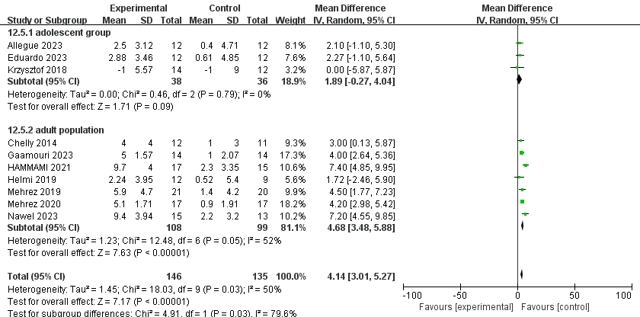
Figure S65 Forest plot of subgroup analysis on the impact of PT on SJ in different age groups
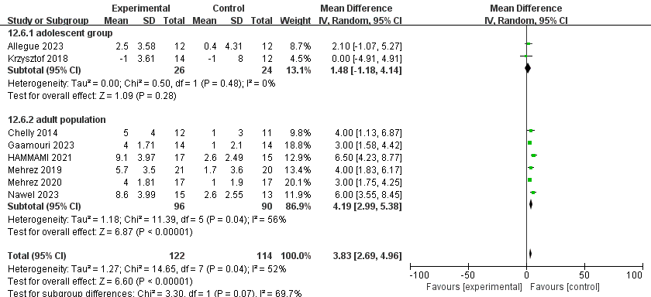
Figure S66 Forest plot of subgroup analysis on the impact of PT on 3RT in different age groups
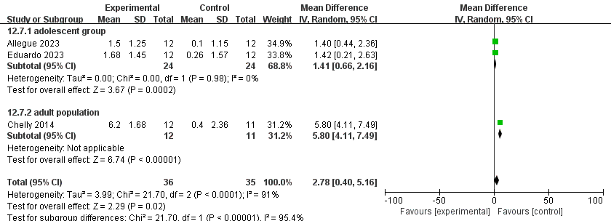
Figure S67 Forest plot of subgroup analysis on the impact of PT on left-hand grip strength in different age groups
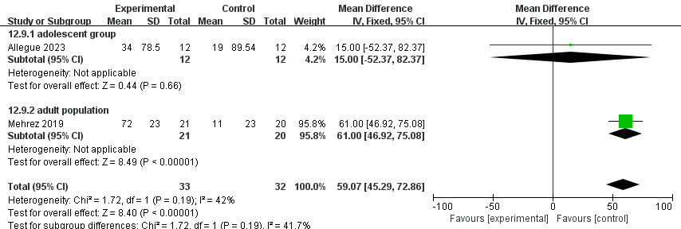

Figure S68 Forest plot of subgroup analysis on the impact of PT on right-hand grip strength in different age groups
