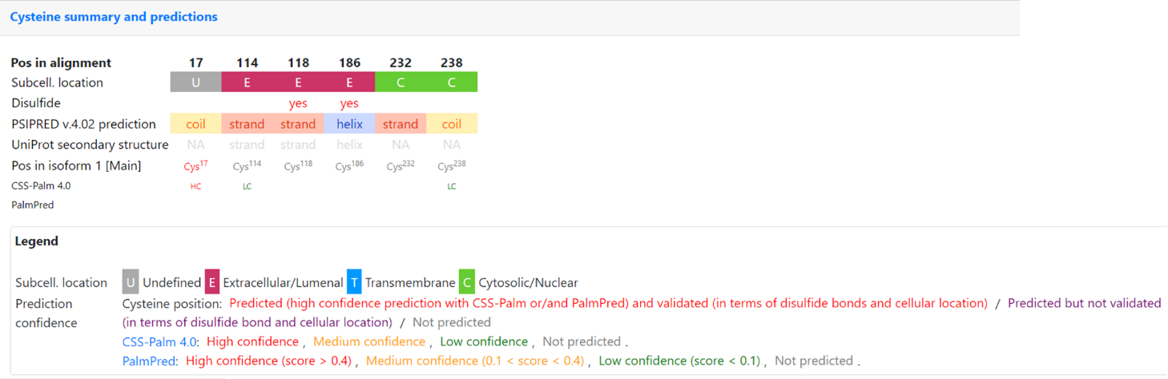

Supplementary Figure S1. Cysteine residues and predicted palmitoylation sites in EPCR, based on CSS-Palm and PalmPred. Cys17 shows high-confidence lipidation potential; Cys114 and Cys232/238 have low-confidence predictions.

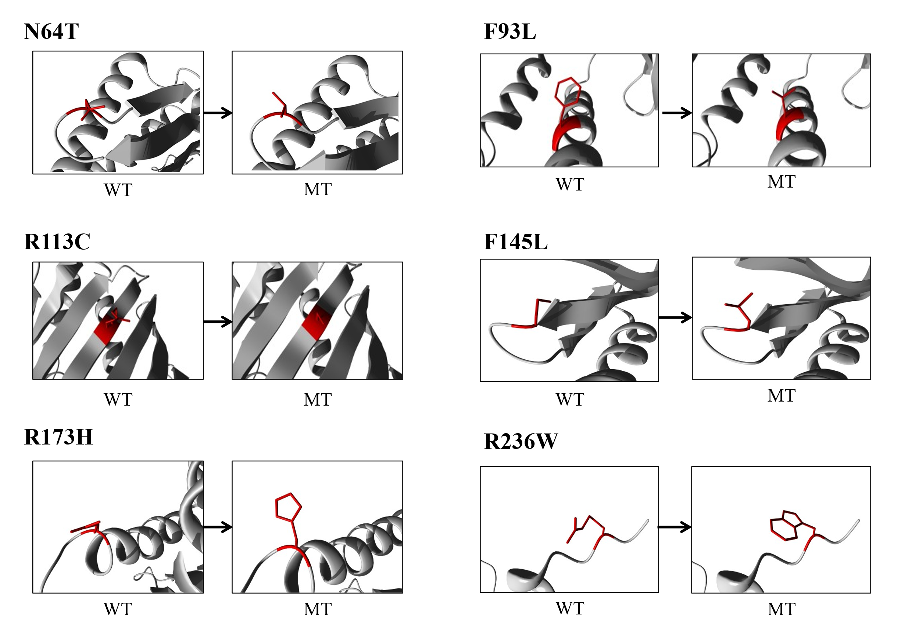

Supplementary Figure S2. Molecular visualization of the wild-type (left) and variant (right) amino acids of the EPCR protein. The residues colored red represent the wild-type and variant residues for each mutation: N64T, F93L, R113C, P145L, R173H, and R236W.

