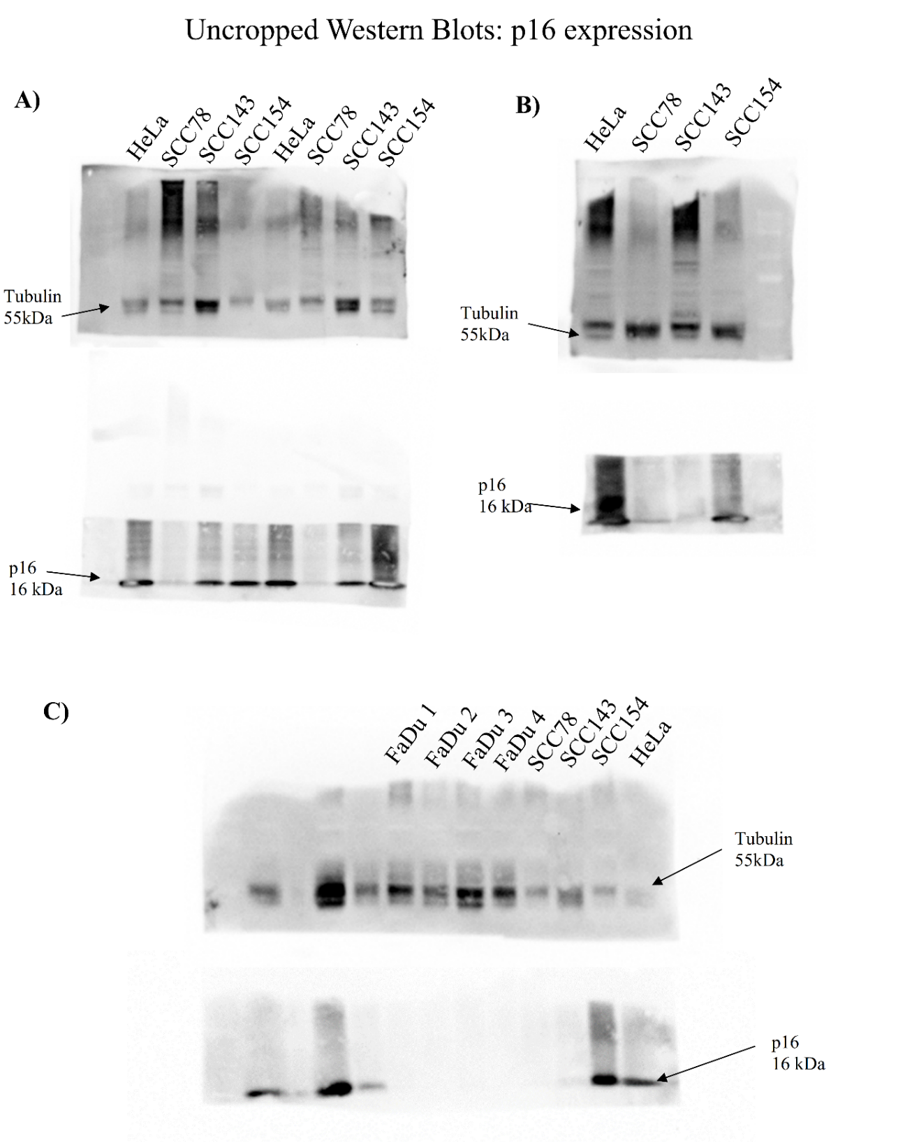
Supplementary Fig. 1 – Uncropped Western Blots for detection of p16 and Tubulin protein expressions. The following membrane blots were cut prior to hybridization with antibodies. A, B and C) Represents three different western blots membranes, showing replicates of p16 and tubulin protein expressions of different protein extractions of SCC78, SCC143, SCC154 and FaDu cell lines. A) is presented in Fig. 1-A showing the detection of p16 and Tubulin in SCC154 and Hela cell lines; B) a different protein extraction of SCC143, SCC78 and SCC154 indicating p16 and tubulin expression; C) is presented in Fig 1-B showing p16 and tubulin expression in FaDu, SCC78, SCC143, and SCC154 cell lines. p16 (16kDa) and tubulin (55kDa) are indicated in the figures by the arrows.
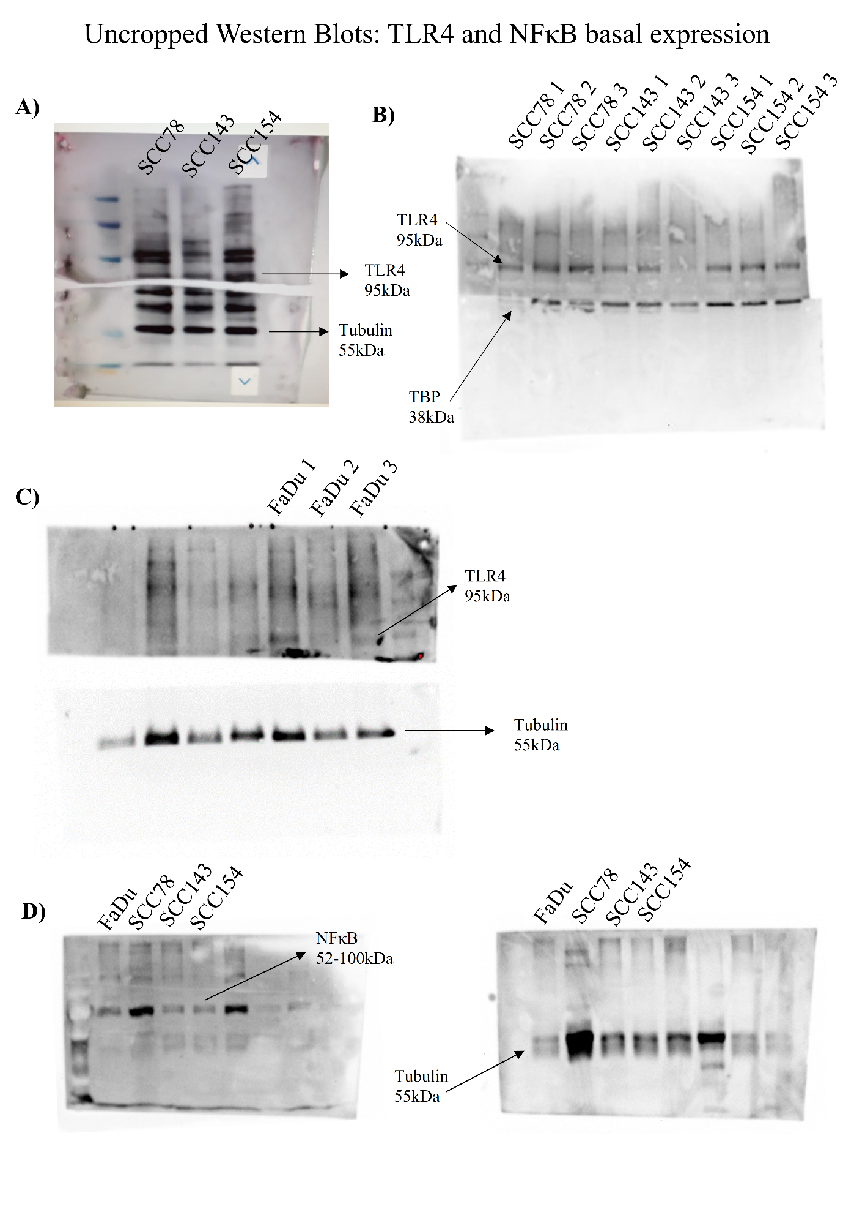
Supplementary Fig. 2 – Uncropped western blots for detection of TLR4, NFκB, Tubulin, and TBP protein expressions. The following membrane blots were cut prior to hybridization with antibodies. A, B and C) Represents three different western blots membranes, showing replicates of TLR4, TBP and tubulin protein expressions of different protein extractions of SCC78, SCC143, SCC154 and FaDu cell lines. A) is presented in Fig. 1-C showing the detection of TLR4 and Tubulin in SCC78, SCC143, and SCC154 cell lines; B) three different protein extractions of SCC78, SCC143 and SCC154 showing TLR4 and TBP expression; C) TLR4 and tubulin western blot of three different protein extractions of FaDu cell line, also presented in Fig. 1-C. TLR4 (95kDa), TBP (38kDa) and Tubulin (55kDa) are indicated by the arrows. D) Western Blot membrane showing NFκB ( and Tubulin (55kDa) expression in two different extractions of FaDu, SCC78, SCC143, and SCC154 cell lines.

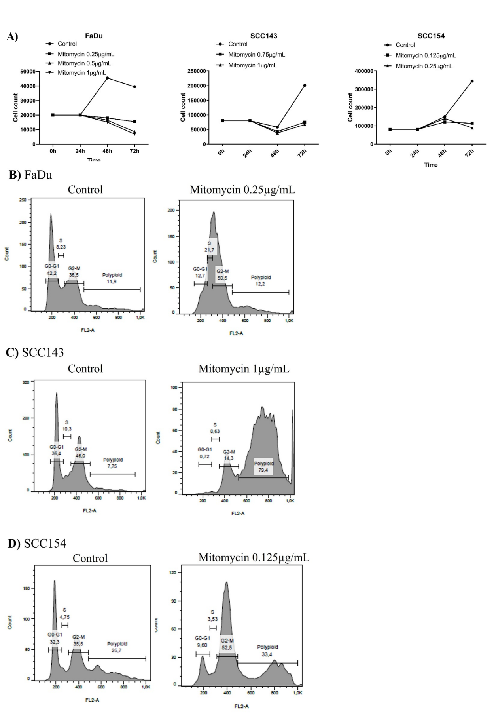
Supplementary Fig. 3 - Mitomycin-C proliferation and cell cycle inhibition. A) To test the efficacy of mitomycin C on cell proliferation, 1×10⁴, 4×10^{4,} and 1x10⁴ cells of SCC143, SCC154, and FaDu cell lines, respectively, were seeded in 24-well plates. After 24h from seeding, cells were treated with different concentrations of Mitomycin-C: 0.25µg/mL, 0.5µg/mL, and 1µg/mL in FaDu; 0.75µg/mL and 1µg/mL in SCC143; 0.125µg/mL and 0.25µg/mL in SCC154. After 24h and 48h from treatment, viable cells were counted. To test if mitomycin was efficiently arresting the cell cycle, 2x10⁵ cells were seeded in a 6-well plate. After 24h, cells were treated for 2h with B) 0.25 µg/mL in FaDu; C) 1 µg/mL in SCC43; D) 0.125 µg/mL in SCC154 of mitomycin C and analyzed by Flow cytometry. G0/G1, S, G2/M (mitosis), and polyploid.

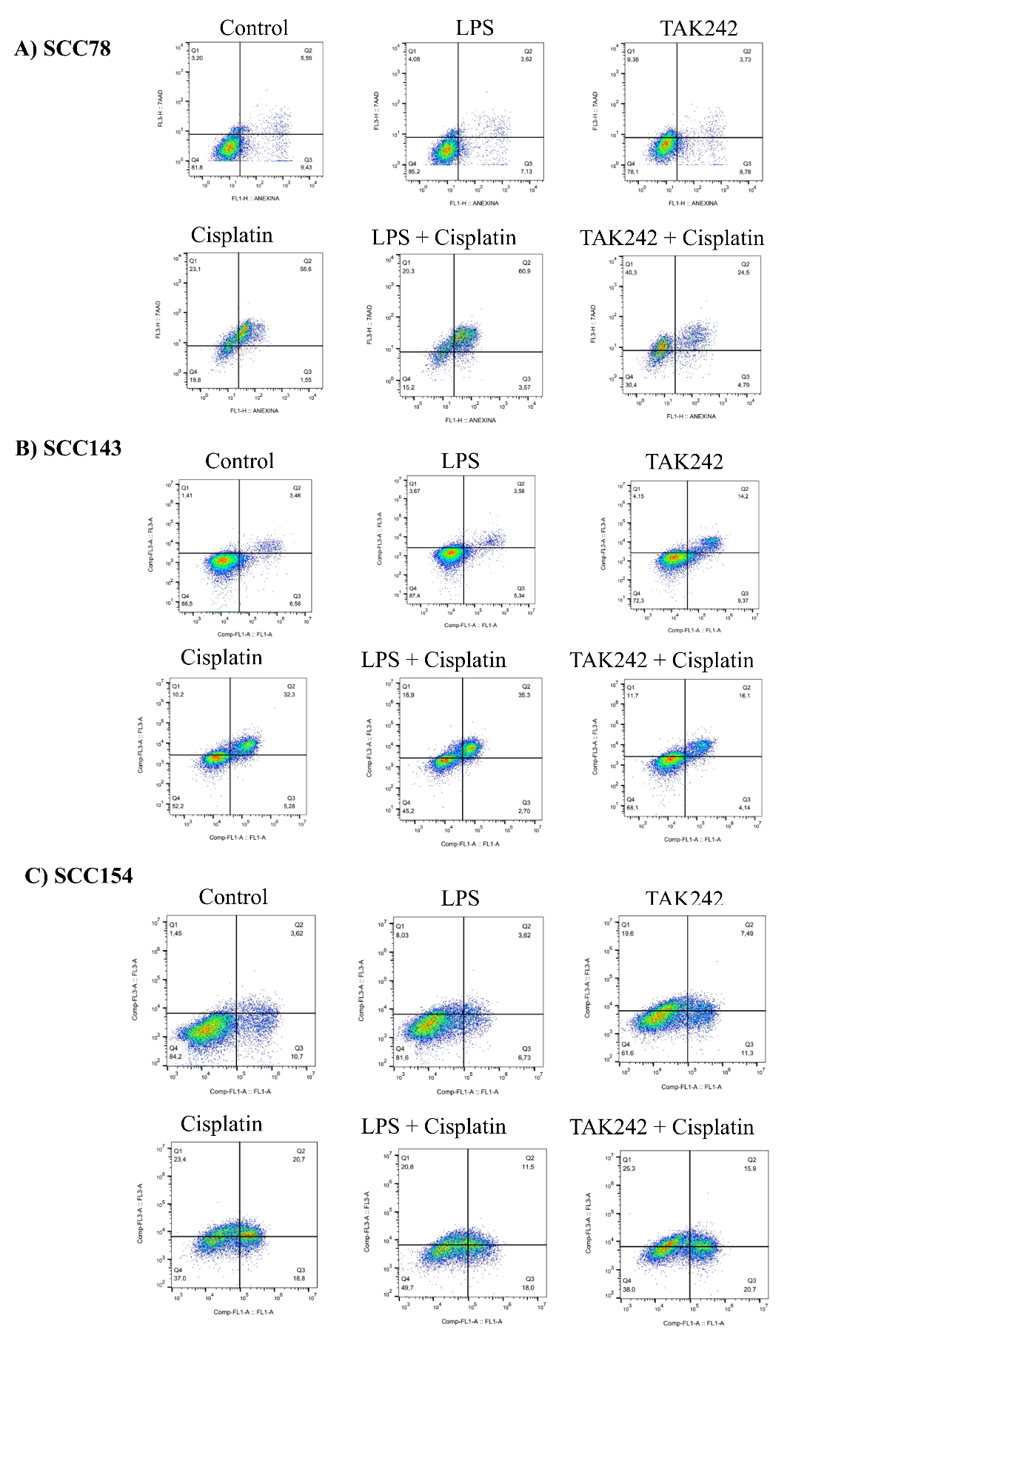
Supplementary Fig. 4 - Representative Flow Cytometry analysis of AnnexinV-FITC and 7AAD staining after 72h of LPS, TAK242, cisplatin treatment, and combinations. A) SCC78; B) SCC143 and C) SCC154.
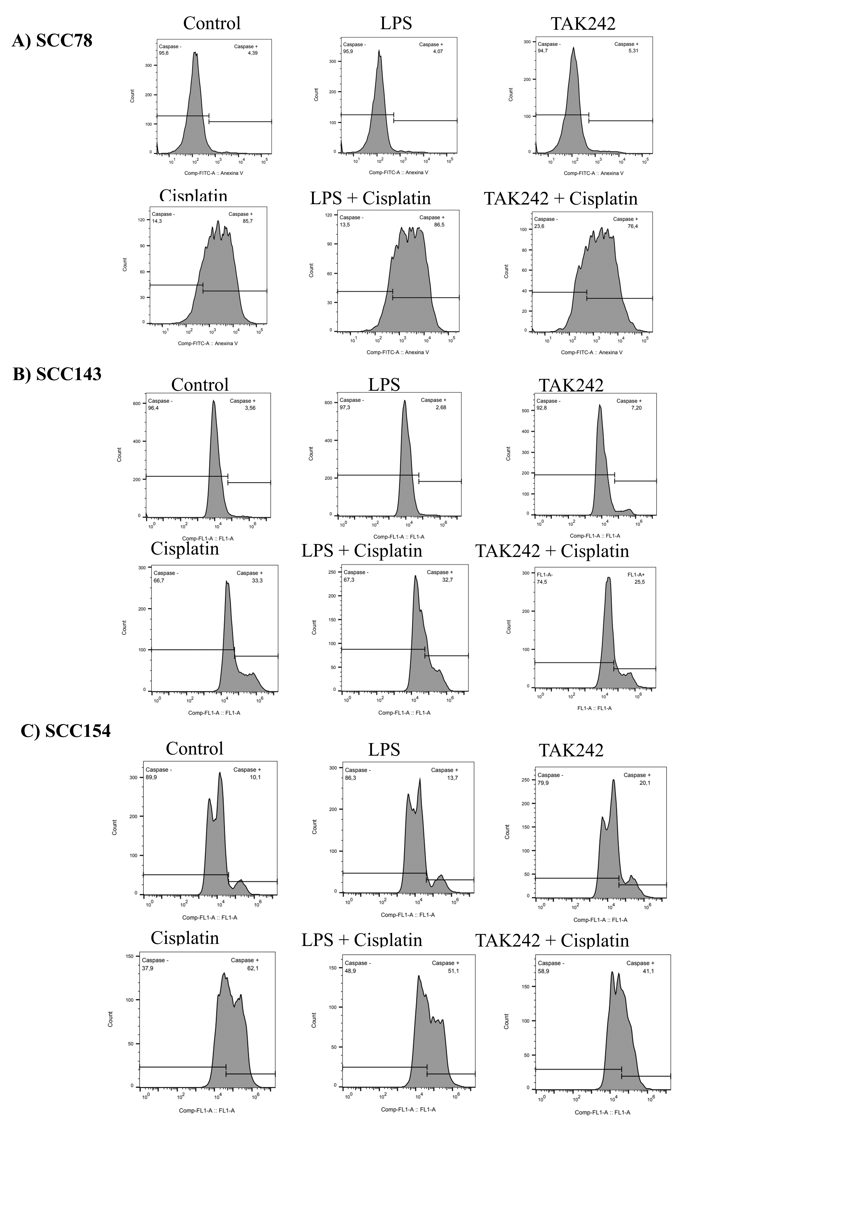
Supplementary Fig. 5 - Representative Flow Cytometry analysis of active caspase 3 positive staining after 72h of LPS, TAK242, cisplatin treatment, and combinations. A) SCC78; B) SCC143 and C) SCC154.

