Supplementary Material

 | Target AEs | Other AEs | Total
Tirofiban | a | b | a+b
Other Drugs | c | d | c+d
Total | a+c | b+d | n=a+b+c+d
Supplementary Table S1. Two-by-two contingency table for disproportionality analyses. Abbreviations: AEs, adverse events; a, the number of reports containing target AEs caused tirofiban; b, the number of reports containing other AEs caused by tirofiban; c, the number of reports containing target AEs caused by other drugs; d, the number of reports containing other AEs caused by other drugs; n, the total number of adverse events included in the background data analysis.

 | Formula | Threshold
ROR | 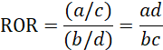  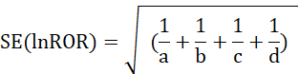  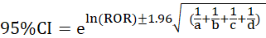 | a ≥ 3 and 95% CI (lower limit) > 1 suggests generation of 1 signal.
PRR | 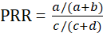  SE(lnPRR)=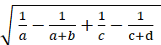  =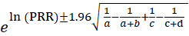  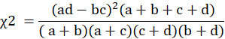 | Lower limit of the PRR confidence interval: a ≥ 3 and 95% CI (lower limit) > 1 suggests generation of 1 signal.  MHRA composite criterion method: a ≥ 3 and PRR value ≥ 2 and χ² ≥ 4 suggests generation of 1 signal
BCPNN | IC=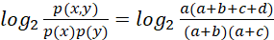  E(IC)=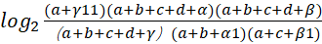  V(IC)=  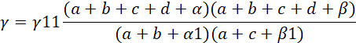  IC-2SD=E(IC)-2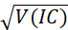  α1=β1=1；α=β=2；γ11=1 | The lower limit of the confidence interval (IC-2SD) is greater than 0, then 1 signal is prompted to be generated
MGPS | 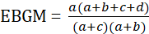  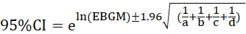 | EBGM05>2 prompts to generate 1 signal  EBGM05 indicates the lower limit of the EBGM 95% confidence interval
Supplementary Table S2. Formulas and thresholds of disproportionality analysis methods. Abbreviations: ROR, Reporting Odds Ratio; PRR, Proportional Reporting Ratio; BCPNN, Bayesian confidence propagation neural network; MGPS, Muti-item Gamma Poisson Shrinker; MHRA, Medicines and Healthcare Products Regulatory Agency. The results of the PRR lower confidence interval method for signal detection are almost the same as those of the ROR method, and the threshold of the MHRA composite standard method is commonly used for signal detection. In the summary report, the threshold of the MHRA composite standard method will be used as the threshold of the PRR method for signal detection.

