Supplementary Data
Taru Singh et al.: Integrating Computational Approaches to Uncover β-Lactamase-Associated Resistance in Diarrheagenic Escherichia coli from Pediatric Patients.

Table S1: Overview of the β-Lactamase Families of This Study and Their Phylogenetic Context
β-Lactamase | Class | Characteristics | Substrate Profile | Inhibitor Susceptibility | Clinical Relevance | Phylogeny | Global Prevalence
TEM | A | Most common in Gram-negative bacteria, confers resistance to penicillins and early cephalosporins. | Penicillins, early cephalosporins | Inhibited by clavulanic acid and tazobactam | Common in E. coli infections | Shares significant homology with other class A β-lactamases | Global
SHV | A | Shares ~68% identity with TEM-1, responsible for ampicillin resistance. | Penicillins, cephalosporins | Susceptible to β-lactamase inhibitors | Prevalent in Klebsiella pneumoniae | Evolved through mutations, leading to ESBL variants | Global
CTX-M | A | Globally prevalent, high activity against cefotaxime. | Extended-spectrum cephalosporins | Susceptible to avibactam, variable for others | Widespread in multidrug-resistant Enterobacteriaceae | Distinct lineage in class A β-lactamases | Highly prevalent in Asia, Europe, Americas
OXA | D | Hydrolyzes oxacillin and cloxacillin, poorly inhibited by clavulanic acid. | Oxacillin, cloxacillin, carbapenems | Poor inhibition by clavulanic acid; some inhibited by avibactam | Acinetobacter and carbapenem-resistant Pseudomonas | Broad evolutionary lineage, low homology with other classes | Global
NDM | B | Metallo-β-lactamase hydrolyzing carbapenems. | Carbapenems, cephalosporins | Not inhibited by clavulanic acid, inhibited by EDTA | Multidrug-resistant K. pneumoniae and E. coli infections | Separate evolutionary branch in metallo-β-lactamases | Emerging globally, especially in India and the Middle East
AmpC | C | Hydrolyzes cephalosporins, resistant to clavulanic acid. | Cephalosporins, penicillins | Poorly inhibited by clavulanic acid, partially inhibited by avibactam | Enterobacteriaceae, especially in nosocomial settings | Distinct class C lineage | Global

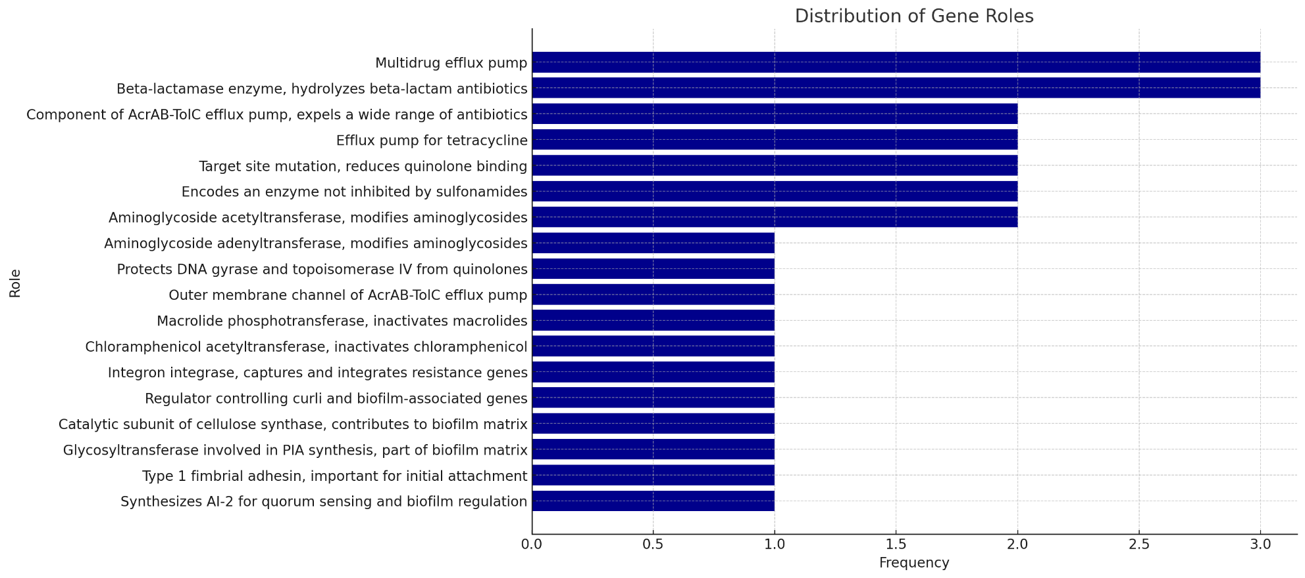
Figure S1: Comprehensive Analysis of DEC genes associated with MDR: The horizontal bar chart shows the frequency of different gene roles associated with antibiotic resistance, with bars representing the occurrence frequency of each role.

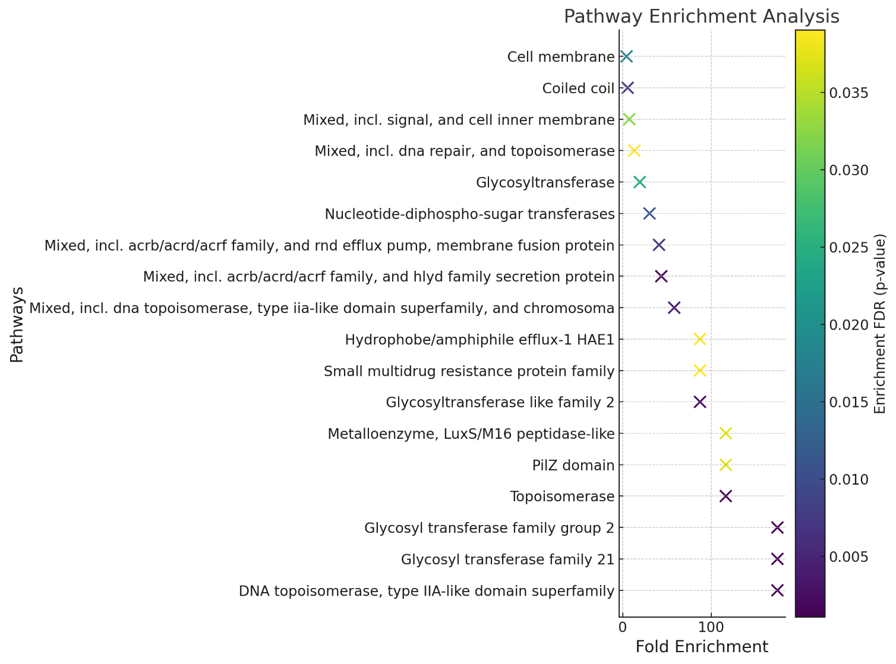
Figure S2: Comprehensive Analysis of DEC genes associated with MDR: The dot plot visualizes pathway enrichment analysis, displaying fold enrichment of pathways, with the color of the dots indicating p-values, thereby highlighting pathways with significant over-representation of genes.
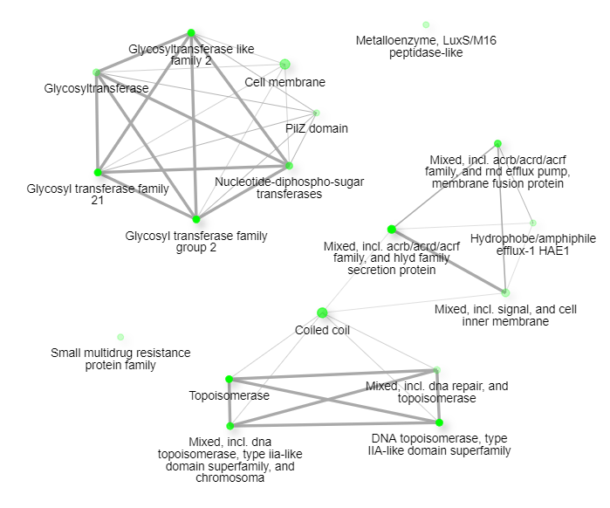
Figure S3: Comprehensive Analysis of DEC genes associated with MDR: The gene interaction network diagram illustrates interactions among antibiotic resistance genes, where node size reflects gene connectivity, and red nodes indicate genes with high centrality, such as bla_TEM, bla_SHV, and bla_CTX-M, critical in the resistance network.
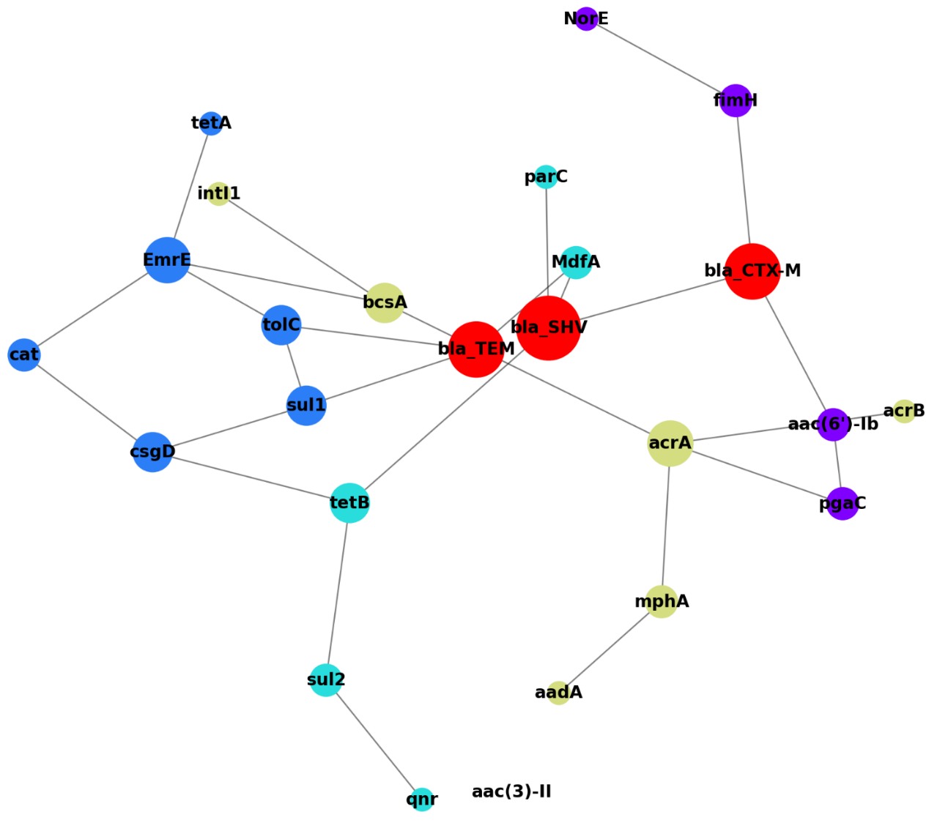
Figure S4: Comprehensive Analysis of DEC genes associated with MDR: The pathway interaction network diagram highlights the interactions between biological pathways, where node and edge sizes represent the strength of interactions. Key clusters involve pathways related to glycosyltransferase activity, cell membrane functions, efflux pumps, and DNA repair mechanisms, underscoring the interconnectedness of these pathways in contributing to antibiotic resistance.

