Supplementary Material
Appendix A.

Figure S1: Contributions of Climatic Factors to VHI Across Annual, Dry, and Wet Seasons in Southern Thailand. This figure displays the spatial distribution of significant positive and negative impacts of key climatic factors, LST, PPT, VPD, SM, and SR, on the Vegetation Health Index (VHI). Seasonal variations reveal that LST contributes positively during the wet season, while SM and SR play crucial roles across seasons, with varying effects on vegetation health based on moisture availability and energy balance.
Map preparation: All maps were generated using QGIS (version 3.28; QGIS.org, https://www.qgis.org).

Figure S2: Seasonal Impacts of Climatic Predictors on VCI in Southern Thailand.
This figure illustrates the influence of LST, PPT, VPD, SM, and SR on the Vegetation Condition Index (VCI) for annual, dry, and wet seasons. SR emerges as a primary driver, negatively impacting vegetation during high radiation periods but supporting growth when moisture is adequate.
Map preparation: All maps were generated using QGIS (version 3.28; QGIS.org, https://www.qgis.org).

Figure S3: Influence of Climatic Factors on TCI by Season in Southern Thailand.
Depicting the contributions of LST, PPT, VPD, SM, and SR to the Temperature Condition Index (TCI), this figure highlights LST as a dominant factor during the wet season, promoting vegetation health under moderate thermal conditions. SR and VPD also exhibit significant seasonal impacts, with SR benefiting vegetation in low-stress conditions and VPD demonstrating both positive and negative influences based on moisture demands.
Map preparation: All maps were generated using QGIS (version 3.28; QGIS.org, https://www.qgis.org).

Table S1: Annual kernel size (σ) values used for kNDVI calculation across Southern Thailand from 2000 to 2023. These values were determined using pixel-wise optimization based on spectral variability and vegetation characteristics specific to the study area.
Index | kernel size (σ) | year
0 | 0.274828 | 2000
1 | 0.272541 | 2001
2 | 0.267385 | 2002
3 | 0.283996 | 2003
4 | 0.268584 | 2004
5 | 0.265471 | 2005
6 | 0.280752 | 2006
7 | 0.277519 | 2007
8 | 0.27289 | 2008
9 | 0.286843 | 2009
10 | 0.285683 | 2010
11 | 0.285278 | 2011
12 | 0.292569 | 2012
13 | 0.294515 | 2013
14 | 0.282944 | 2014
15 | 0.291814 | 2015
16 | 0.276984 | 2016
17 | 0.29613 | 2017
18 | 0.288894 | 2018
19 | 0.290274 | 2019
20 | 0.285075 | 2020
21 | 0.294266 | 2021
22 | 0.281647 | 2022
23 | 0.287807 | 2023

Table S2: Seasonal kernel size (σ) values for kNDVI calculation across Southern Thailand from 2000 to 2023. The σ values were optimized for dry and wet seasons to reflect variations in vegetation conditions during distinct climatic periods.
Index | Season | Seasonal kernel size (σ) | year
0 | Summer | 0.27962 | 2000
1 | Spring | 0.288068 | 2000
2 | Autumn | 0.2713 | 2000
3 | Summer | 0.279055 | 2001
4 | Spring | 0.289266 | 2001
5 | Autumn | 0.266758 | 2001
6 | Summer | 0.278185 | 2002
7 | Spring | 0.277585 | 2002
8 | Autumn | 0.276591 | 2002
9 | Summer | 0.299779 | 2003
10 | Spring | 0.300057 | 2003
11 | Autumn | 0.281862 | 2003
12 | Summer | 0.284196 | 2004
13 | Spring | 0.276726 | 2004
14 | Autumn | 0.268891 | 2004
15 | Summer | 0.294131 | 2005
16 | Spring | 0.264713 | 2005
17 | Autumn | 0.269516 | 2005
18 | Summer | 0.295801 | 2006
19 | Spring | 0.298171 | 2006
20 | Autumn | 0.273603 | 2006
21 | Summer | 0.303861 | 2007
22 | Spring | 0.287235 | 2007
23 | Autumn | 0.263196 | 2007
24 | Summer | 0.296041 | 2008
25 | Spring | 0.289736 | 2008
26 | Autumn | 0.263527 | 2008
27 | Summer | 0.303312 | 2009
28 | Spring | 0.313163 | 2009
29 | Autumn | 0.27649 | 2009
30 | Summer | 0.308939 | 2010
31 | Spring | 0.296215 | 2010
32 | Autumn | 0.269263 | 2010
33 | Summer | 0.300415 | 2011
34 | Spring | 0.301996 | 2011
35 | Autumn | 0.282119 | 2011
36 | Summer | 0.299023 | 2012
37 | Spring | 0.301441 | 2012
38 | Autumn | 0.296972 | 2012
39 | Summer | 0.311635 | 2013
40 | Spring | 0.313981 | 2013
41 | Autumn | 0.287594 | 2013
42 | Summer | 0.298272 | 2014
43 | Spring | 0.29743 | 2014
44 | Autumn | 0.28626 | 2014
45 | Summer | 0.322545 | 2015
46 | Spring | 0.299186 | 2015
47 | Autumn | 0.286977 | 2015
48 | Summer | 0.300233 | 2016
49 | Spring | 0.274553 | 2016
50 | Autumn | 0.270783 | 2016
51 | Summer | 0.320733 | 2017
52 | Spring | 0.312478 | 2017
53 | Autumn | 0.2872 | 2017
54 | Summer | 0.296332 | 2018
55 | Spring | 0.316853 | 2018
56 | Autumn | 0.281393 | 2018
57 | Summer | 0.308004 | 2019
58 | Spring | 0.299623 | 2019
59 | Autumn | 0.288877 | 2019
60 | Summer | 0.307951 | 2020
61 | Spring | 0.295894 | 2020
62 | Autumn | 0.270653 | 2020
63 | Summer | 0.3172 | 2021
64 | Spring | 0.304543 | 2021
65 | Autumn | 0.292283 | 2021
66 | Summer | 0.294923 | 2022
67 | Spring | 0.310332 | 2022
68 | Autumn | 0.260195 | 2022
69 | Summer | 0.305573 | 2023
70 | Spring | 0.286002 | 2023
71 | Autumn | 0.28678 | 2023

Climatic sensitivity and driver contributions.
Temperature exerts the strongest climatic control on vegetation health across the study area. Its sensitivity coefficient is markedly negative (β LST = –3.3 ± 1.4 VHI unit °C⁻¹), and—when combined with an inter-annual temperature variability of 0.68 °C produces the largest absolute contribution (C LST ≈ –2.2 VHI units). After normalization, LST accounts for a median 51 % of the total climatic signal. Precipitation, soil moisture and vapor-pressure deficit each contribute median shares of 16–17 %, but with wider dispersion (SD ≈ 11–12 %), indicating spatial pockets where individual drivers become dominant. Indeed, single-pixel extremes reach R = 100 % for LST and 95 % for VPD, underscoring localized hotspots of single-factor influence. The full numerical ranges in Table S3 provide reference bounds for future modelling in comparable subtropical coastal forests.

Table S3: Study-area descriptive statistics of climatic sensitivities (β), inter-annual variability (Δ), absolute contributions (C = β·Δ) and normalized relative contributions (R) for each driver, 2001–2023. Values are calculated across every 30 meters pixel in the Southern Thiland after masking non-significant pixels (p ≥ 0.05). β units are VHI units per driver unit (°C for LST, mm yr⁻¹ for PPT, kPa for VPD, mm for SM); Δ shares the native units of each driver; C is in VHI units; R is the percentage of the summed absolute contributions of all four drivers. Negative β or C indicates that increases in the driver decrease VHI. †The large SD for β VPD reflects a small number of hotspot pixels with extreme coefficients (median = –0.54).
Metric | Driver | mean | median | sd | min | Max
β | LST | -3.3 | -3.2 | 1.4 | -14 | 9.4
β | PPT | -4.20E-04 | -5.50E-04 | 4.10E-03 | -0.034 | 0.033
β | SM | 3.10E-03 | 2.50E-03 | 0.038 | -0.71 | 0.59
β | VPD | 0.081 | -0.54 | 18 | -170 | 150
$$∆$$ | LST | 0.68 | 0.66 | 0.17 | 0.21 | 1.7
$$∆$$ | PPT | 270 | 270 | 56 | 180 | 460
$$∆$$ | SM | 30 | 29 | 7.9 | 4.5 | 49
$$∆$$ | VPD | 0.05 | 0.05 | 5.10E-03 | 0.03 | 0.064
C | LST | -2.2 | -2.2 | 1.1 | -12 | 7.2
C | PPT | -0.12 | -0.15 | 1.1 | -10 | 7.4
C | SM | 0.073 | 0.074 | 0.96 | -6.7 | 6
C | VPD | 7.20E-03 | -0.027 | 0.9 | -7 | 6.5
R | LST | 51 | 51 | 18 | 4.70E-03 | 100
R | PPT | 17 | 16 | 11 | 1.30E-04 | 86
R | SM | 16 | 14 | 12 | 7.20E-05 | 91
R | VPD | 15 | 14 | 11 | 2.30E-05 | 95

Figure S4: Spatial patterns of the five-driver metrics derived from Eqs 15–17. Columns show, from left to right, (β) climatic sensitivity; (R) normalised relative contribution; (P) significance mask of R (p < 0.05 = red, non-significant = grey); (Δ) inter-annual variability of the driver; and (C = β · Δ) absolute contribution. Rows correspond to the four candidate drivers: land-surface temperature (LST), precipitation (PPT), vapour-pressure deficit (VPD) and soil moisture (SM). All rasters are displayed at 30 meters resolution in WGS-84; colour ramps are centred on zero for β and C (diverging), scaled 0–1 for R and P (sequential), and stretched between the study-area minima and maxima for Δ.
Map preparation: All maps were generated using QGIS (version 3.28; QGIS.org, https://www.qgis.org).

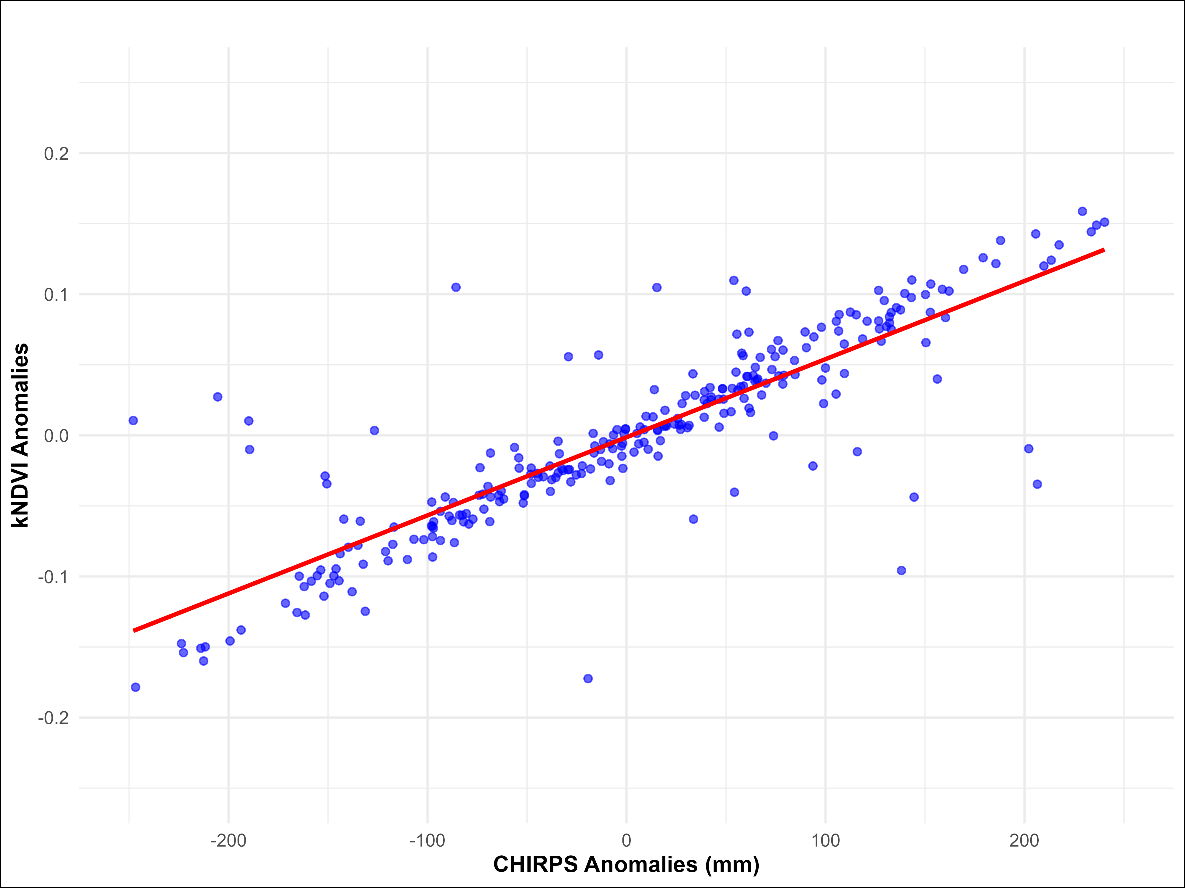
Figure S5. The relationship between kNDVI anomalies and CHIRPS anomalies. Each blue dot represents a monthly observation, while the red line shows the linear regression fit. The plot illustrates a significant positive correlation (R² = 0.76, p < 0.01), indicating that anomalies in precipitation are associated with anomalies in vegetation health indices.
Plot preparation: This figure was generated using R (version 4.3.1) within the RStudio environment (version 2023.06.1; https://posit.co ).

